

Sri Lanka Institute of information Technology

Programming Applications and Frameworks
IT3030


NELLi
..Network for Equipment, Labs and Location Incidents..
Smart Campus Operations Hub
2026

Group Details

IT Number | Name | Email | Contact Number
IT23183018 | Hirusha D G A D | it23183018@my.sliit.lk | 077 2424 521
IT23191006 | Cooray Y H | it23191006@my.sliit.lk | 070 6080 877

Submitted On : 2026-04-27
Table of Contents

1. Introduction 5
2. Aim and Objectives 6
2.1. Primary Aim 6
2.2. Objectives 6
2.3. Stakeholders Overview 7
2.3.1. Primary Stakeholders 7
2.3.2. Secondary Stakeholders 8
3. Solution Overview 10
3.1. Functional Scope 10
3.2. Technology Overview 11
4. System Architecture 12
4.1. Overall System Architecture 12
4.2. Backend Architecture 13
4.3. Frontend Architecture 15
5. System Dependencies 17
5.1. Backend Maven Dependencies 17
5.2. Frontend npm Dependencies 18
6. Database Architecture 19
6.1. Database Platform 19
6.2. Entity Relationship Overview 19
6.3. Core Entity Specifications 21
6.3.1. Users Table 21
6.3.2. Facilities Table 22
6.3.3. Bookings Table 22
6.3.4. Tickets Table 23
6.3.5. Supporting Tables 24
6.4. Key Database Constraints & Indexes 25
7. Project Timeline - Gantt Chart 26
8. Implemented Components 30
8.1. Module A : Facilities & Assets Catalogue 30
8.1.1. Backend Components 30
8.1.2. Frontend Components 32
8.1.3. Non-Functional Requirements of Module A 33
8.2. Module B : Booking Management 34
8.2.1. Backend Components 34
8.2.2 Frontend Components 37
8.2.2. Non-Functional Requirements of Module B 37
8.3. Module C : Maintenance & Incident Ticketing 38
8.3.1. Backend Components 38
8.3.2. Frontend Components 41
8.3.3. Non-Functional Requirements of Module C 42
8.4. Module D : Notifications & Email Service 42
8.4.1. Backend Components 43
8.4.2. Frontend Components 45
8.4.3. Non-Functional Requirements of Module D 46
8.5. Module E : Authentication & Authentication 46
8.5.1. Backend Components 47
8.5.2. Frontend Components 49
8.5.3. Non-Functional Requirements of Module E 50
8.6. Module F - QR Code Check-In for Approved Bookings (Innovative Feature) 50
8.6.1. Backend Implementation 50
8.6.2. Frontend Implementation 51
8.6.3. Non-Functional Requirements of Module F 51
8.7. Module G - Admin Analytics Dashboard (Innovative Feature) 52
8.7.1. Backend Components 52
8.7.2. Frontend Components 54
8.7.3. Non-Functional Requirements of Module G 55
9. REST API Architecture 56
9.1. API Design Principle 56
9.2. Complete Endpoint Inventory 56
9.3. Standardized Error Response Format 57
9.4. API Documentation 58
10. Testing & Quality Management w/ Postman 63
10.1. Testing Strategy 63
10.2. Backend Unit & Integration Tests 63
10.2.1. Service Layer Unit Tests 63
10.2.2. Controller Integration Tests 63
10.3. Postman Testing 64
10.3.1. Collection Structure 64
10.3.2. Test Scripts 65
10.3.3. Test Coverage Summary 65
9.4. Input Validation & Error Handling 66
11. Version Control w/ Github 67
11.1. Repository Structure (Source Code Links) 67
11.2. Branching Strategy 68
11.3. Complete Branch Registery 68
11.4. Commit Message Convention 71
11.5. GitFlow WorkFlow 72
11.6. Continuous Integration Pipeline 77
11.6.1. Github Actions Workflow 77
11.6.2. Workflow Configuration 77
11.3. CI Pipeline Stages 79
11.4. Secrets Management 80
12. Individual Contribution 81
12.1. HIRUSHA D G A D - Contribution Summary 81
12.1.1. Backend Contributions 81
12.1.2. Frontend Contributions 82
12.1.3. Key Technical Achievements 82
12.2. COORAY Y H - Contribution Summary 83
12.2.1. Backend Contributions 83
12.2.2. Frontend Contributions 84
12.2.3. Key Technical Achievements 84
13. Conclusion 86
14. Appendix 87
14.1. The Landing Page 87
14.2. Login & Register Pages 89
14.3. User Dashboard 90
14.4. Facilities Component 90
14.5. Booking Component 92
14.6. Ticketing Component 95
14.7. QR Code Verification Component 98
14.8. Admin Management Components 99
14.9. Admin Analytics Components 102

- Introduction

NELLi - Smart Campus Operations Hub is a full-stack, production-inspired web system developed for the IT3030 Programming Applications and Frameworks module at SLIIT. It addresses a real-world university challenges such as managing physical resources, bookings, and maintenance operations through a single, unified digital platform.

Modern universities manage dozens of facilities lecture halls, computer laboratories, meeting rooms, and specialist equipment across multiple buildings and departments. Traditionally, these are administered through fragmented spreadsheets, email chains, or disparate legacy systems. NELLi consolidates all these workflows into one cohesive platform, enabling role-based access, transparent audit trails, and real-time operational visibility.

The system was architected and implemented by a two-member team (Dineth and Yashodha) within a four-week sprint (24 March - 27 April 2026), delivering the full scope originally designed for a four-member group. The resulting application covers seven functional modules: Facilities Catalogue, Booking Management, Incident Ticketing, Notifications & Email, Authentication & Authorization, QR Code Check-In, and an Admin Analytics Dashboard.

The backend is built with Java Spring Boot following layered RESTful architecture principles, while the frontend is implemented with React (Vite), consuming the API through Axios service modules. Data persistence is provided by PostgreSQL hosted on Neon (cloud-managed), with JWT and OAuth 2.0 (Google Sign-In) securing all endpoints. Version control is managed via GitHub with structured feature branching and CI/CD via GitHub Actions.

- Aim and Objectives

  - Primary Aim

To design, develop, and demonstrate a production-quality web platform that digitizes and streamlines campus facility management, booking workflows, and maintenance operations for a university environment adhering to industry-standard RESTful API design, role-based access control, and modern frontend engineering practices.

  - Objectives

- Implement a comprehensive Facilities & Assets Catalogue supporting CRUD operations with search and filtering by type, capacity, and location.

- Develop a Booking Management system enforcing workflow states (PENDING → APPROVED/REJECTED → CANCELLED) with server-side conflict detection for overlapping time ranges.

- Build a Maintenance & Incident Ticketing system supporting full ticket lifecycle management, technician assignment, image attachments, and comment threads.

- Deliver a real-time Notification system integrated with an Email Service (Gmail SMTP) to alert users on booking outcomes, ticket status changes, and comment activity.

- Implement secure Authentication and Authorization using OAuth 2.0 (Google Sign-In) and JWT tokens, with role-based access control (USER / ADMIN / TECHNICIAN) enforced at every endpoint.

- Provide a QR Code Check-In system that generates unique QR codes for approved bookings, enabling physical verification at facility entry points.

- Develop an Admin Analytics Dashboard offering usage insights including top resources, peak booking hours, and ticket resolution metrics.

- Maintain a clean, traceable Git history with structured feature / debug / enhancement and automated CI checks via GitHub Actions.

- Produce comprehensive Postman test collections covering all REST endpoints with environment-specific variables.

- Deliver a well-structured, documented codebase that clearly separates backend and frontend responsibilities, enabling independent assessment of each team member's contributions.

  - Stakeholders Overview

The NELLi Smart Campus Operations Hub involves multiple stakeholders who interact with the system at different levels. Each stakeholder has specific goals, responsibilities, and system interactions.

2.3.1. Primary Stakeholders
1. Students / General Users (USER role)
- Book facilities such as lecture halls, labs, and meeting rooms
- Submit maintenance or incident tickets
- View booking status and receive notifications
- Use QR codes for check-in to approved bookings

2. University Administrative Staff (ADMIN role)
- Manage facilities and assets (create, update, delete)
- Approve or reject booking requests
- Assign maintenance tickets to technicians
- Monitor system usage via analytics dashboard
- Configure system-level operations and workflows

3. Maintenance Staff / Technicians (TECHNICIAN role)
- View assigned tickets
- Update ticket status (IN_PROGRESS, RESOLVED, etc.)
- Add resolution notes and comments
- Ensure timely issue resolution

2.3.2. Secondary Stakeholders
4. University Management / Decision Makers
- Use analytics dashboard insights for decision-making
- Monitor resource utilization and operational efficiency
- Evaluate performance metrics (ticket resolution time, peak usage, etc.)

5. System Developers (Project Team)
- Design, develop, test, and maintain the system
- Ensure system scalability, security, and performance
- Manage CI/CD pipelines and deployments

6. IT Support & Infrastructure Team
- Maintain servers, database, and network infrastructure
- Ensure uptime, backups, and system security
- Handle technical issues and system monitoring

External Stakeholders
7. Third-Party Service Providers
- Google OAuth 2.0 (authentication provider)
- Gmail SMTP (email notification service)
- Neon PostgreSQL (cloud database hosting)

Stakeholder Summary Table
Stakeholder | Role | Key Responsibilities
Students / Users | USER | Booking, ticket submission, QR check-in
Admin Staff | ADMIN | Approvals, management, analytics
Technicians | TECHNICIAN | Ticket resolution
Management | Viewer | Strategic insights
Developers | System Builders | Development & maintenance
IT Support | Infrastructure | Hosting & reliability
External Services | Service Providers | Authentication, email, DB

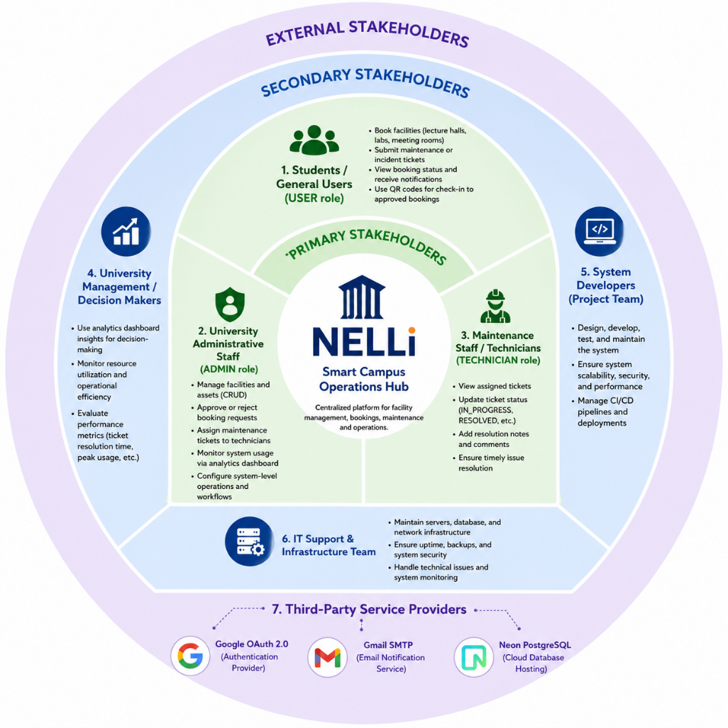
- Solution Overview

NELLi is structured as a three-tier system: a Spring Boot REST API (backend) , React/Vite single-page application (frontend) and Neon - Postgres SQL Serverless cloud-base database server (database). Communication between tiers is exclusively through the versioned JSON REST APIs. The platform defines three user roles such as USER, ADMIN, and TECHNICIAN each granted specific permissions across all modules.

  - Functional Scope

Module | Core Capability | Access Level
Module A  Facilities Catalogue | Resource management with metadata, search, filtering, and status control | USER (read) / ADMIN (write)
Module B  Booking Management | Resource reservation with workflow states, conflict checking, and admin approval | USER / ADMIN
Module C  Incident Ticketing | Fault reporting with attachments, technician assignment, comments | USER / ADMIN / TECHNICIAN
Module D  Notifications & Email | In-app and email notifications for all key events | USER / ADMIN
Module E  Auth & Authorization | OAuth 2.0 + JWT with role-based endpoint protection | All roles
Module F  QR Code Check-In | QR generation for approved bookings, scan-to-verify screen | USER / ADMIN
Module G  Admin Analytics | Dashboard with resource usage, booking trends, ticket KPIs | ADMIN only

  - Technology Overview

The stack was chosen to align with the assignment requirements and to reflect industry-standard enterprise web development practices:

Layer | Technology Choice
Backend Framework | Java 21 SE + Spring Boot 4.0.5
API Style | RESTful with layered architecture (Controller → Service → Repository + DTOs and Models)
Security | Spring Security + OAuth 2.0 (Google) + JWT (JJWT library)
Database | PostgreSQL 15 (hosted on Neon cloud-managed platform)
ORM | Spring Data JPA with Hibernate
File Storage | Local file system / configurable cloud adapter
Email | Spring Mail + Gmail SMTP
Frontend Framework | React 19 + Vite 8 bundler
Styling | Tailwind CSS 3 with custom dark/light theme
State Management | React Context API + custom hooks
HTTP Client | Axios with interceptors for token refresh
Animation | GSAP (GreenSock Animation Platform)
QR Code | qrcode.react (frontend) + zxing (backend scanning)
Charts/Analytics | Recharts
Build & CI | Maven (backend) + Vite (frontend) + GitHub Actions
Version Control | Git with GitHub
API Documentation | SpringDoc OpenAPI / Swagger UI

- System Architecture

  - Overall System Architecture

NELLi follows a classic three-layer client-server architecture with clear separation of concerns across the presentation, application, and data layers.

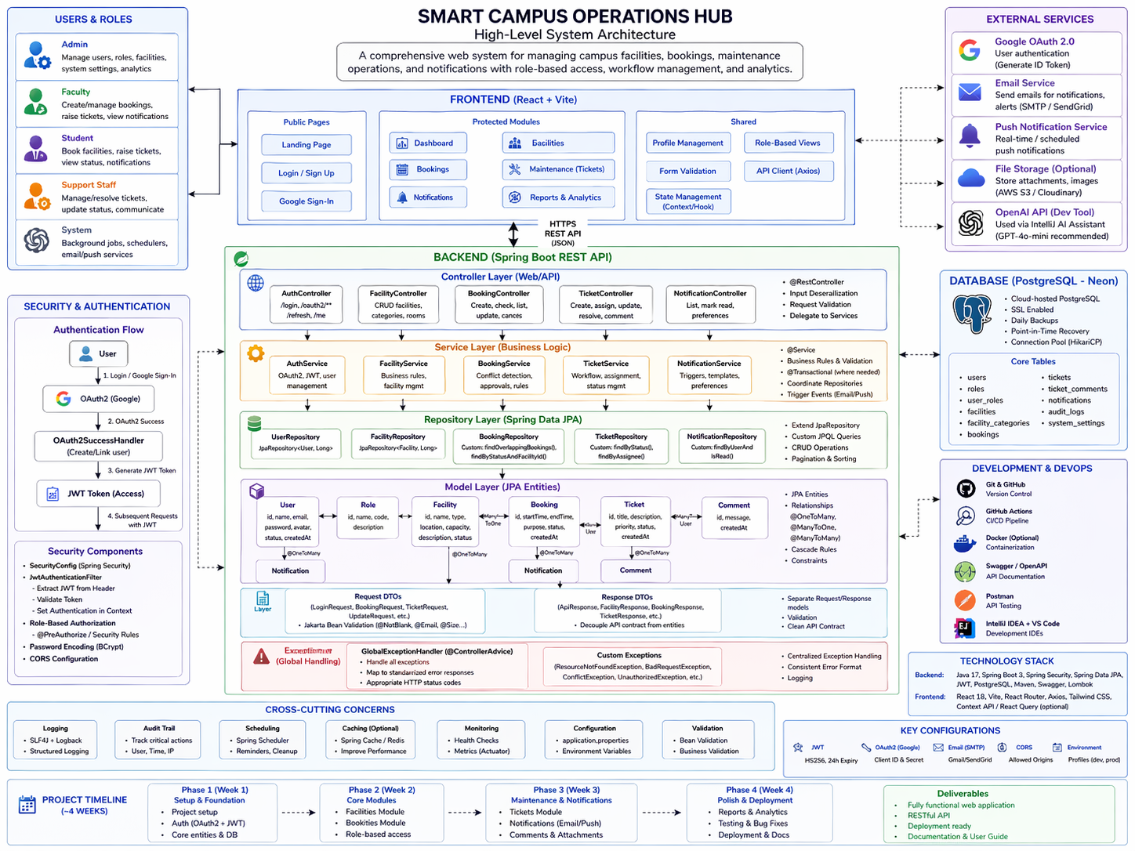

  - Backend Architecture

The Spring Boot application follows a strict layered pattern, ensuring separation between web/API concerns, business logic, and data access:

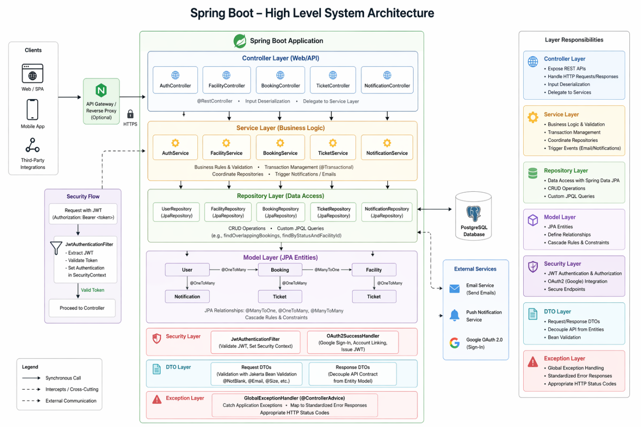

- Controller Layer
  - REST controllers annotated with @RestController expose API endpoints. Each controller is responsible for exactly one domain entity (AuthController, FacilityController, BookingController, TicketController, NotificationController). Controllers perform input deserialization and delegate all logic to the service layer.

- Service Layer
  - Contains all business logic. Services validate rules (e.g., booking conflict detection), coordinate between multiple repositories, and trigger notification and email events. Services use @Transactional where appropriate.

- Repository Layer
  - Spring Data JPA repositories extend JpaRepository<T, ID>, providing standard CRUD operations and custom JPQL queries (e.g., findOverlappingBookings, findByStatusAndFacilityId).

- Model Layer
  - JPA entities mapped to PostgreSQL tables. Relationships are defined using @ManyToOne, @OneToMany, and @ManyToMany annotations with appropriate cascade rules.

- Security Layer
  - JwtAuthenticationFilter intercepts requests to extract and validate JWT tokens. OAuth2SuccessHandler processes Google sign-in callbacks, creating or linking user accounts and issuing JWT tokens.

- DTO Layer
  - Separate request and response DTOs decouple the API contract from the entity model. Uses Jakarta Bean Validation (@NotBlank, @Email, @Size, etc.) for input validation.

- Exception Layer
  - GlobalExceptionHandler (@ControllerAdvice) catches application exceptions and maps them to standardized error responses with appropriate HTTP status codes.

  - Frontend Architecture

The React application is structured around domain-specific pages, reusable components, API service modules, and custom hooks:

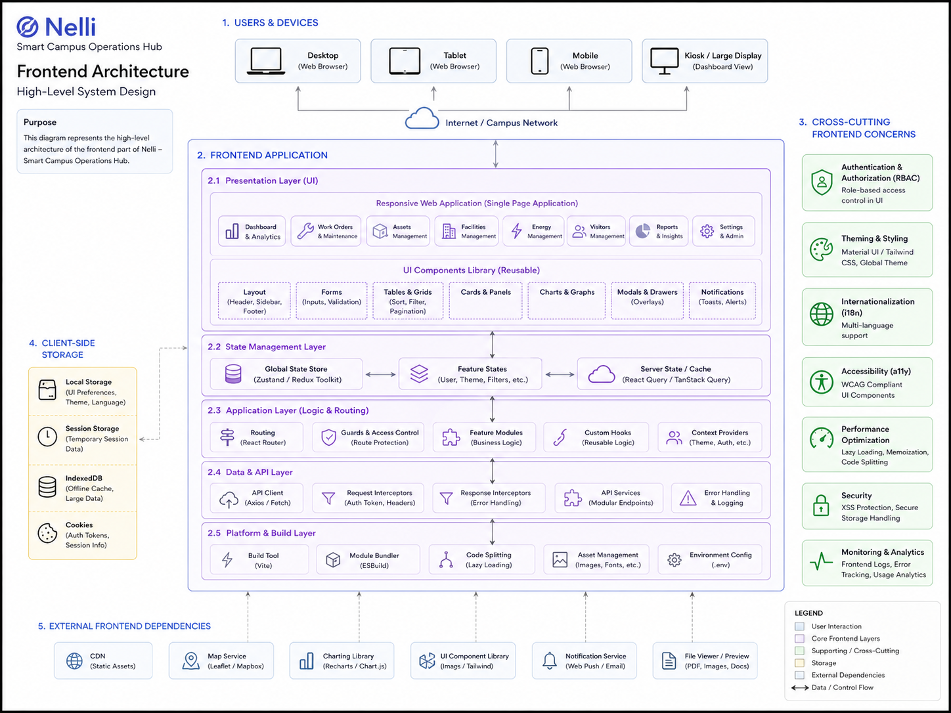

- Pages
  - Route-level components (Home, Dashboard, Facilities, Bookings, Tickets, Notifications, Admin pages) act as containers that orchestrate data fetching and child components.

- Components
  - Domain components (FacilityCard, BookingForm, TicketCard, CommentSection) and common UI atoms (Button, Input, Modal, Badge, Spinner) are reused across pages.

- API Services
  - Each domain has a dedicated service module (facilityApi.js, bookingApi.js, ticketApi.js, etc.) using an Axios instance configured with base URL and JWT interceptors.

- Context
  - AuthContext manages authentication state (user, token, role) globally. NotificationContext polls for unread notifications.

- Custom Hooks
  - useAuth, useFacilities, useBookings, useNotifications encapsulate data-fetching logic with loading and error states.

- Routes
  - AppRoutes.jsx defines all application routes. PrivateRoute and AdminRoute HOCs enforce authentication and role-based frontend access.

- System Dependencies

  - Backend Maven Dependencies

Dependency | Group ID | Version | Purpose
Spring Boot Starter Web | org.springframework.boot | 4.0.5 | REST controllers, JSON serialization
Spring Boot Starter Security | org.springframework.boot | 4.0.5 | Authentication & authorization
Spring Boot Starter OAuth2 Client | org.springframework.boot | 4.0.5 | Google OAuth 2.0 login
Spring Boot Starter Data JPA | org.springframework.boot | 4.0.5 | ORM & database access
Spring Boot Starter Validation | org.springframework.boot | 4.0.5 | Bean validation
Spring Boot Starter Mail | org.springframework.boot | 4.0.5 | Email notifications
PostgreSQL JDBC Driver | org.postgresql | 42.x | PostgreSQL connectivity
JJWT API | io.jsonwebtoken | 0.12.x | JWT creation & parsing
JJWT Impl | io.jsonwebtoken | 0.12.x | JWT implementation
SpringDoc OpenAPI | org.springdoc | 2.x | Swagger UI / API docs
Lombok | org.projectlombok | 1.18.x | Boilerplate reduction
ZXing Core | com.google.zxing | 3.5.x | QR code generation
MapStruct | org.mapstruct | 1.5.x | DTO-Entity mapping
Spring Boot Test | org.springframework.boot | 3.x | Testing framework

  - Frontend npm Dependencies

Package | Version | Category | Purpose
react | 19.2.4 | Core | UI component framework
react-dom | 19.x | Core | DOM rendering
vite | 8.0.1 | Build | Fast development server & bundler
axios | 1.6.2 | HTTP | API calls with interceptors
react-router-dom | 6.20.0 | Routing | Client-side routing
tailwindcss | 3.4.17 | Styling | Utility-first CSS framework
gsap | 3.12.4 | Animation | Professional UI animations
Charts js | 4.4.0 | Charts | Analytics dashboard charts
qrcode.react | 1.4.2 | QR | QR code rendering in React
react-hook-form | 7.x | Forms | Performant form management
date-fns | 3.x | Utils | Date formatting & manipulation
React Icons | 4.12.0 | Icons | Consistent icon library
@headlessui/react | 1.x | UI | Accessible UI primitives
React Toastify | 11.1.0 | UI | Toast notification UI

- Database Architecture

  - Database Platform

NELLi uses PostgreSQL 15 hosted on Neon, a serverless cloud-managed PostgreSQL service. Neon was selected over a local PostgreSQL instance for the following reasons:
- It eliminates local setup and maintenance overhead
- Provides a free tier sufficient for development and demonstration
- Enables both team members to connect to the same database instance remotely
- Offers built-in backups and point-in-time recovery.
- The connection is secured via SSL (sslmode=require)

  - Entity Relationship Overview
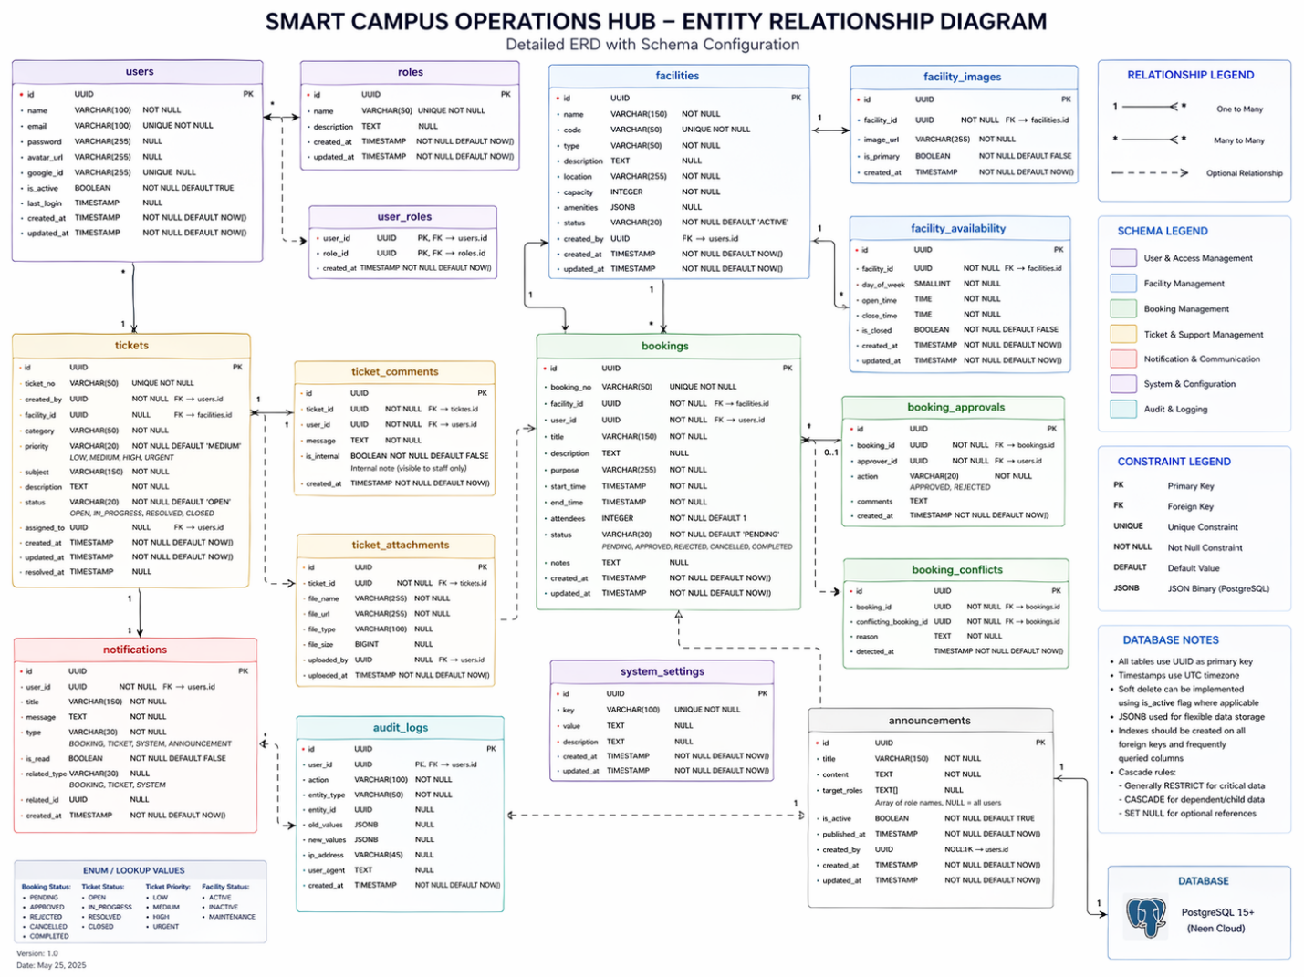

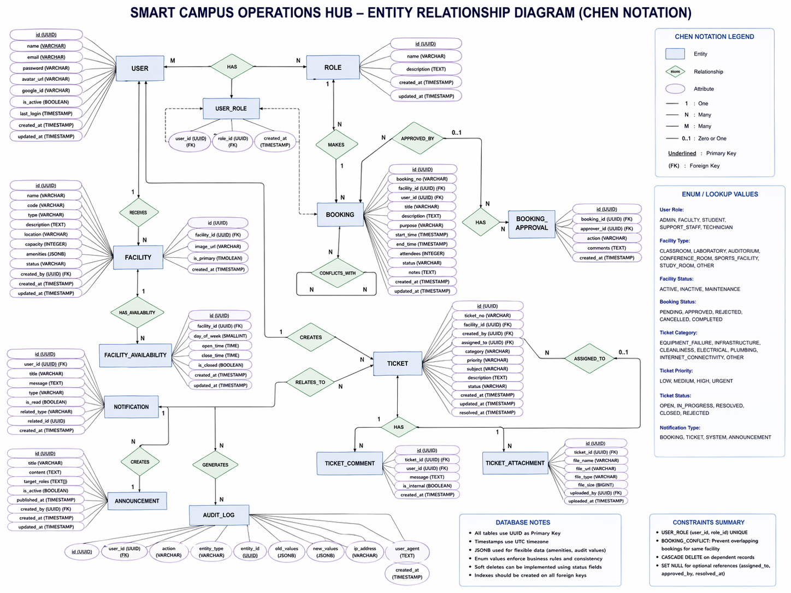

The database schema consists of ten primary tables, organized around five core domain entities.

  - Core Entity Specifications

    - Users Table

Column | Type & Constraints
id | UUID, PRIMARY KEY, DEFAULT gen_random_uuid()
email | VARCHAR(255), UNIQUE, NOT NULL
name | VARCHAR(255), NOT NULL
password_hash | VARCHAR(500), NULLABLE (NULL for OAuth-only users)
provider | VARCHAR(50), DEFAULT 'LOCAL' (LOCAL / GOOGLE)
provider_id | VARCHAR(255), NULLABLE (Google subject ID)
role | VARCHAR(50), NOT NULL, DEFAULT 'USER' (USER / ADMIN / TECHNICIAN)
is_active | BOOLEAN, DEFAULT TRUE
profile_picture_url | VARCHAR(500), NULLABLE
created_at | TIMESTAMP WITH TIME ZONE, DEFAULT CURRENT_TIMESTAMP
updated_at | TIMESTAMP WITH TIME ZONE, ON UPDATE

    - Facilities Table

Column | Type & Constraints
id | UUID, PRIMARY KEY
name | VARCHAR(255), NOT NULL
type | VARCHAR(100), NOT NULL (LECTURE_HALL / LAB / MEETING_ROOM / EQUIPMENT)
capacity | INTEGER, CHECK (capacity > 0), NULLABLE for equipment
location | VARCHAR(500), NOT NULL
description | TEXT, NULLABLE
status | VARCHAR(50), NOT NULL, DEFAULT 'ACTIVE' (ACTIVE / OUT_OF_SERVICE / MAINTENANCE)
availability_windows | JSONB - stores array of {dayOfWeek, startTime, endTime}
amenities | TEXT[], NULLABLE - e.g., {Projector, Whiteboard, AC}
image_url | VARCHAR(500), NULLABLE
created_by | UUID, FK → users(id)
created_at / updated_at | TIMESTAMP WITH TIME ZONE

    - Bookings Table

Column | Type & Constraints
id | UUID, PRIMARY KEY
facility_id | UUID, NOT NULL, FK → facilities(id)
user_id | UUID, NOT NULL, FK → users(id)
start_datetime | TIMESTAMP WITH TIME ZONE, NOT NULL
end_datetime | TIMESTAMP WITH TIME ZONE, NOT NULL
purpose | VARCHAR(500), NOT NULL
expected_attendees | INTEGER, NULLABLE
status | VARCHAR(50), NOT NULL, DEFAULT 'PENDING' (PENDING/APPROVED/REJECTED/CANCELLED)
admin_note | TEXT, NULLABLE - reason for rejection
qr_token | VARCHAR(500), NULLABLE - generated on approval
contact_email | VARCHAR(255), NULLABLE
created_at / updated_at | TIMESTAMP WITH TIME ZONE

    - Tickets Table

Column | Type & Constraints
id | UUID, PRIMARY KEY
ticket_number | VARCHAR(50), UNIQUE - e.g., TCK-2026-001234
facility_id | UUID, NOT NULL, FK → facilities(id)
reported_by | UUID, NOT NULL, FK → users(id)
assigned_to | UUID, NULLABLE, FK → users(id)
category | VARCHAR(100) (EQUIPMENT_FAILURE / STRUCTURAL / ELECTRICAL / PLUMBING / OTHER)
priority | VARCHAR(50) (LOW / MEDIUM / HIGH / CRITICAL)
status | VARCHAR(50), DEFAULT 'OPEN' (OPEN/IN_PROGRESS/RESOLVED/CLOSED/REJECTED)
description | TEXT, NOT NULL
resolution_notes | TEXT, NULLABLE
contact_email | VARCHAR(255), NULLABLE
contact_phone | VARCHAR(50), NULLABLE
first_response_at | TIMESTAMP, NULLABLE - SLA tracking
resolved_at | TIMESTAMP, NULLABLE
created_at / updated_at | TIMESTAMP WITH TIME ZONE

    - Supporting Tables

Table | Purpose & Key Columns
comments | Ticket comments: id, ticket_id (FK), user_id (FK), content TEXT, created_at, updated_at
attachments | Ticket image files: id, ticket_id (FK), file_name, file_url, file_size, uploaded_at
notifications | User alerts: id, user_id (FK), type ENUM, title, message, related_entity_type, related_entity_id, is_read BOOL, created_at

  - Key Database Constraints & Indexes

- Booking conflict check:
  - UNIQUE partial index on (facility_id, start_datetime, end_datetime) - supplemented by JPQL overlap query in BookingRepository.

- Ticket number sequence:
  - Database sequence or UUID-based generation with prefix TCK-YYYY-NNNNNN.

- Indexes:
  - All foreign keys are indexed; additional composite index on bookings(facility_id, status) and tickets(status, priority) for efficient filtering queries.

- Soft deletes:
  - facilities uses status = 'DELETED' rather than physical deletion, preserving referential integrity with historical bookings.

- Project Timeline - Gantt Chart

The project was executed over a four-week sprint from 24 March to 27 April 2026. The following table summarises the planned schedule. A visual Gantt chart is provided as a separate insert (Appendix A).

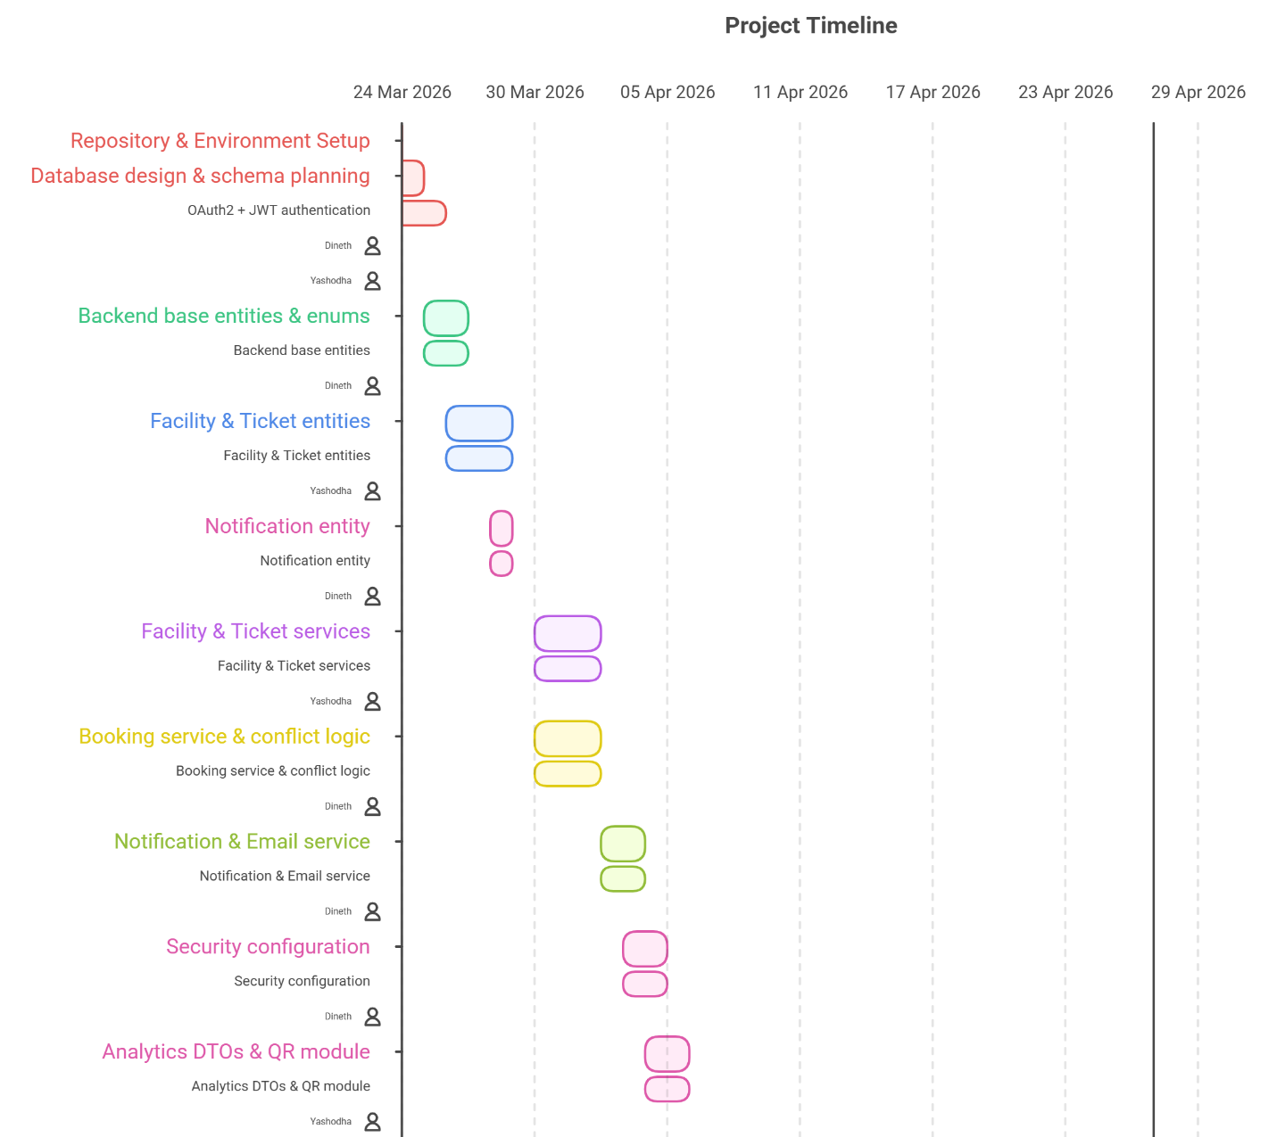

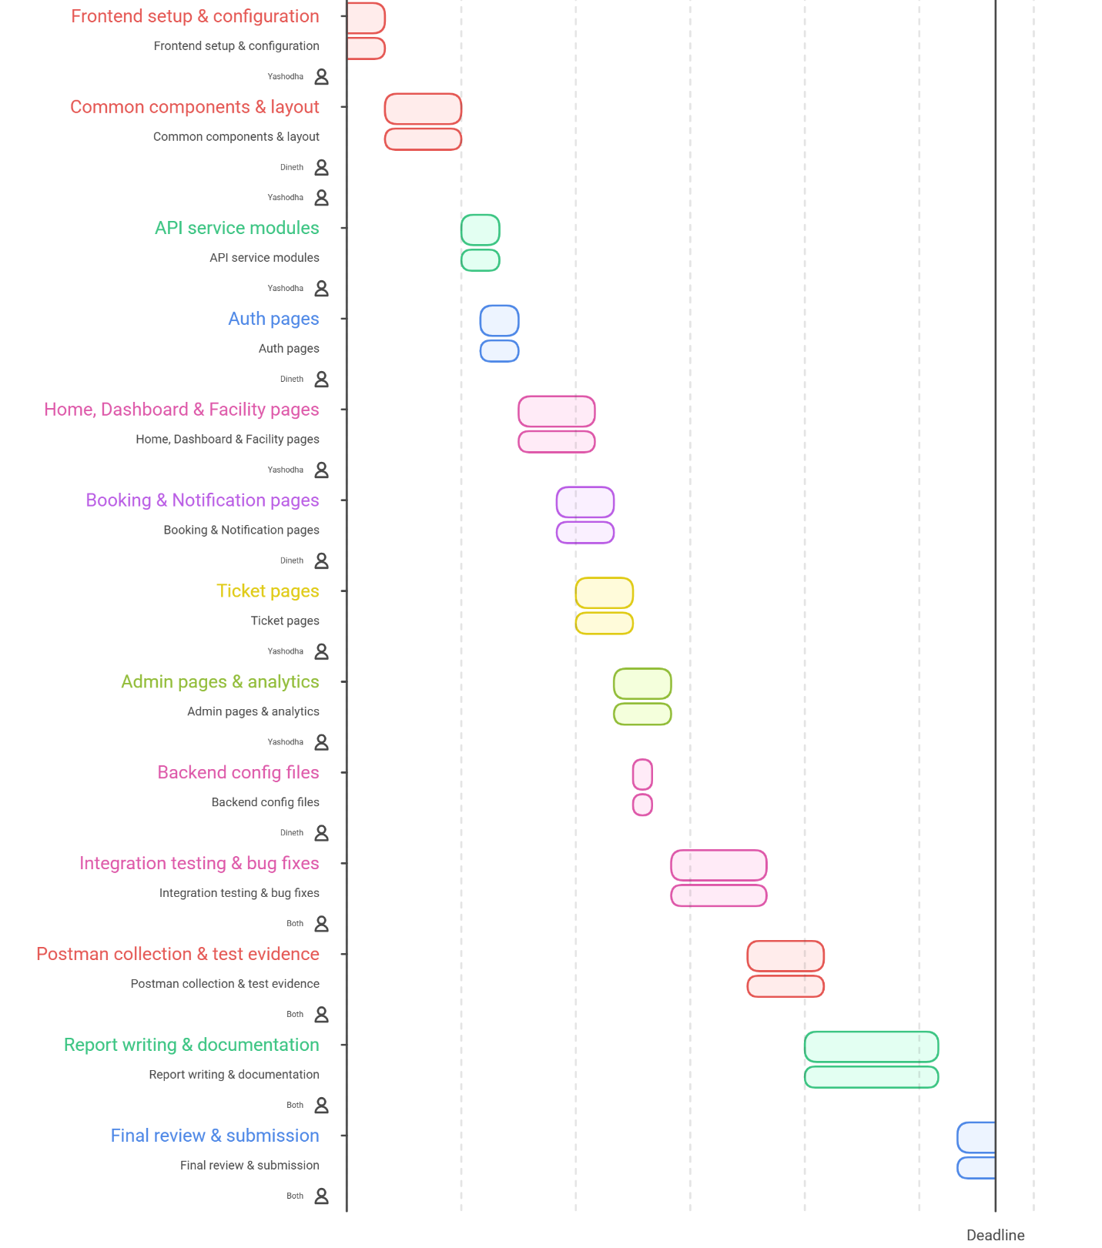

Phase / Task | Owner | Start Date | End Date
Repository & Environment Setup | Both | 24 Mar 2026 | 24 Mar 2026
Database design & schema planning | Both | 24 Mar 2026 | 25 Mar 2026
OAuth2 + JWT authentication (feature/001, 002) | Dineth / Yashodha | 24 Mar 2026 | 26 Mar 2026
Backend base entities & enums (feature/003, 005) | Dineth | 25 Mar 2026 | 27 Mar 2026
Facility & Ticket entities (feature/006, 008) | Yashodha | 26 Mar 2026 | 29 Mar 2026
Notification entity (feature/009) | Dineth | 28 Mar 2026 | 29 Mar 2026
Facility & Ticket services (feature/010, 012) | Yashodha | 30 Mar 2026 | 2 Apr 2026
Booking service & conflict logic (feature/011) | Dineth | 30 Mar 2026 | 2 Apr 2026
Notification & Email service (feature/013) | Dineth | 2 Apr 2026 | 4 Apr 2026
Security configuration (feature/014) | Dineth | 3 Apr 2026 | 5 Apr 2026
Analytics DTOs & QR module (feature/015) | Yashodha | 4 Apr 2026 | 6 Apr 2026
Frontend setup & configuration (feature/016) | Yashodha | 24 Mar 2026 | 26 Mar 2026
Common components & layout (feature/017, 018) | Dineth / Yashodha | 26 Mar 2026 | 30 Mar 2026
API service modules (feature/019) | Yashodha | 30 Mar 2026 | 1 Apr 2026
Auth pages (feature/020) | Dineth | 31 Mar 2026 | 2 Apr 2026
Home, Dashboard & Facility pages (feature/021, 022) | Yashodha | 2 Apr 2026 | 6 Apr 2026
Booking & Notification pages (feature/023, 025) | Dineth | 4 Apr 2026 | 7 Apr 2026
Ticket pages (feature/024) | Yashodha | 5 Apr 2026 | 8 Apr 2026
Admin pages & analytics (feature/026) | Yashodha | 7 Apr 2026 | 10 Apr 2026
Backend config files (feature/027) | Dineth | 8 Apr 2026 | 9 Apr 2026
Integration testing & bug fixes | Both | 10 Apr 2026 | 15 Apr 2026
Postman collection & test evidence | Both | 14 Apr 2026 | 18 Apr 2026
Report writing & documentation | Both | 17 Apr 2026 | 24 Apr 2026
Final review & submission | Both | 25 Apr 2026 | 27 Apr 2026

- Implemented Components

This section provides a detailed breakdown of every module implemented in the NELLi platform, covering backend Spring Boot components and frontend React components for each.

  - Module A : Facilities & Assets Catalogue
Implementation Done by COORAY Y H

Module A provides the foundational resource registry for NELLi. It enables administrators to maintain a comprehensive catalogue of all bookable university assets lecture halls, computer laboratories, meeting rooms, and equipment items. Regular users can browse, search, and inspect resources before creating bookings.
    - Backend Components

Entity: Facility.java

- JPA entity annotated with @Entity, @Table(name = "facilities").
- Fields: id (UUID), name, type (FacilityType enum), capacity (Integer), location, description, status (FacilityStatus enum), availabilityWindows (JSONB via @Type), amenities (String[]), imageUrl, createdBy (User FK), timestamps.
- FacilityType enum: LECTURE_HALL, LAB, MEETING_ROOM, EQUIPMENT.
- FacilityStatus enum: ACTIVE, OUT_OF_SERVICE, MAINTENANCE.
- AvailabilityWindow embedded object: dayOfWeek (DayOfWeek enum), startTime (LocalTime), endTime (LocalTime).

Repository: FacilityRepository.java

- Extends JpaRepository<Facility, UUID>.
- Custom JPQL queries: findByTypeAndCapacityGreaterThanEqualAndLocation(...) for multi-criteria search.
- findByStatus(FacilityStatus status) for admin status filtering.
- findById with status ACTIVE check to exclude soft-deleted resources.
Service: FacilityService.java

- createFacility(FacilityRequest request, UUID adminId) - validates admin role, maps DTO to entity, persists, returns FacilityResponse.
- updateFacility(UUID id, FacilityRequest request) - full update with validation.
- patchFacility(UUID id, Map<String, Object> patches) - partial update using reflection-based patching.
- deleteFacility(UUID id) - soft delete by setting status to DELETED; returns 204 No Content.
- searchFacilities(String type, Integer minCapacity, String location) - dynamic filtering with JPA Specification or custom JPQL.
- getFacilityAvailability(UUID facilityId, LocalDate date) - queries BookingRepository to return available time slots for the requested date.
Controller: FacilityController.java

Endpoint | Description
GET  /api/v1/facilities | List all active facilities; supports query params ?type=LAB&capacity=30&location=BuildingA
GET  /api/v1/facilities/{id} | Get single facility by ID with full metadata and HATEOAS links
POST  /api/v1/facilities | Create facility (ADMIN only) - returns 201 Created
PUT  /api/v1/facilities/{id} | Full update of facility metadata (ADMIN only)
PATCH  /api/v1/facilities/{id} | Partial update - e.g., status change only (ADMIN only)
DELETE  /api/v1/facilities/{id} | Soft delete facility - sets status to DELETED (ADMIN only)
GET  /api/v1/facilities/search | Advanced search with multiple query parameters
GET /api/v1/facilities/{id}/availability | Return available time slots for a specific date

DTOs

- FacilityRequest: name (@NotBlank), type (@NotNull), capacity (@Positive), location (@NotBlank), availabilityWindows (List<AvailabilityWindowDTO>), amenities (List<String>).
- FacilityResponse: all entity fields plus _links (HATEOAS: self, bookings, availability, tickets, update, delete).

    - Frontend Components

Pages

- Facilities.jsx - Grid/list view of all facilities with real-time search bar and filter panel (type dropdown, capacity slider, location text). On load, calls facilityApi.getFacilities() and renders FacilityCard components.
- FacilityDetails.jsx - Detail view showing full metadata, availability calendar, and embedded BookingForm for authenticated users.
- AdminFacilities.jsx - Admin-only management page with add/edit/delete capabilities; uses FacilityForm modal.

Components

- FacilityCard.jsx - Card component displaying type badge, capacity, location, status chip, and Book Now CTA button.
- FacilityFilter.jsx - Filter panel with controlled inputs synchronized to URL query parameters.
- FacilityForm.jsx - Modal form for creating/editing facilities with availability window builder (add/remove day-time range pairs).

API Service: facilityApi.js

- getFacilities(params) - GET /api/v1/facilities with query string parameters.
- getFacilityById(id) - GET /api/v1/facilities/{id}.
- createFacility(data) - POST /api/v1/facilities with Authorization header.
- updateFacility(id, data) - PUT /api/v1/facilities/{id}.
- deleteFacility(id) - DELETE /api/v1/facilities/{id}.
- getFacilityAvailability(id, date) - GET /api/v1/facilities/{id}/availability?date=...

    - Non-Functional Requirements of Module A

- Performance:
  - Facility search results must load within < 2 seconds for up to 10,000 records
- Scalability:
  - Must support increasing number of facilities without performance degradation
- Usability:
  - Intuitive filtering (type, capacity, location) with responsive UI
- Availability:
  - System must ensure 99% uptime for facility browsing
- Data Integrity:
  - Prevent invalid entries (e.g., negative capacity) using validation rules
- Security:
  - Only ADMIN users can modify facility data

  - Module B : Booking Management
Implementation Done by HIRUSHA D G A D

Module B implements the end-to-end resource booking workflow. Users submit booking requests specifying a facility, date/time range, and purpose. The system enforces conflict detection before persisting the request, then routes it through an admin approval workflow. Approved bookings trigger QR token generation and email notification.

    - Backend Components

Entity: Booking.java

- Fields: id (UUID), facility (ManyToOne @JoinColumn), user (ManyToOne), startDatetime (ZonedDateTime), endDatetime (ZonedDateTime), purpose, expectedAttendees, status (BookingStatus enum), adminNote, qrToken, contactEmail.
- BookingStatus enum: PENDING, APPROVED, REJECTED, CANCELLED.
- @PrePersist validation: endDatetime must be after startDatetime; endDatetime must be within facility availability windows.

Repository: BookingRepository.java

- findOverlappingBookings(UUID facilityId, ZonedDateTime start, ZonedDateTime end) - custom JPQL query checking for time range overlaps with APPROVED/PENDING status bookings.
- findByUserId(UUID userId, Pageable pageable) - paginated user booking history.
- findAllWithFilters(BookingStatus status, UUID facilityId, LocalDate date, Pageable pageable) - admin multi-filter query.

Service: BookingService.java

- createBooking(BookingRequest request, UUID userId) - Validates request; calls findOverlappingBookings to check for conflicts (throws BookingConflictException with HTTP 409 if conflict found); persists booking with PENDING status; triggers BOOKING_REQUESTED notification to admin users; triggers confirmation email to user.

- approveBooking(UUID bookingId, UUID adminId) - Transitions status to APPROVED; generates unique QR token (UUID-based, stored in booking.qrToken); triggers BOOKING_APPROVED notification and email to user.

- rejectBooking(UUID bookingId, String reason, UUID adminId) - Transitions to REJECTED; stores reason in adminNote; triggers BOOKING_REJECTED notification and email with rejection reason.

- cancelBooking(UUID bookingId, UUID userId) - Only owner or ADMIN can cancel; only PENDING or APPROVED bookings may be cancelled; transitions to CANCELLED.

- getMyBookings(UUID userId, Pageable pageable) - Returns paginated user bookings sorted by createdAt DESC.

- getAllBookings(BookingStatus status, UUID facilityId, LocalDate date, Pageable pageable) - Admin endpoint with multi-parameter filtering.

Controller: BookingController.java

Endpoint | Description
GET  /api/v1/bookings | List all bookings with filters (ADMIN) - ?status=PENDING&facilityId=...&date=...
GET  /api/v1/bookings/my-bookings | Current authenticated user's bookings (paginated)
GET  /api/v1/bookings/{id} | Get single booking details
POST  /api/v1/bookings | Submit booking request (USER) - returns 201 with PENDING status
PUT  /api/v1/bookings/{id} | Update booking details before approval (USER, PENDING only)
DELETE  /api/v1/bookings/{id} | Cancel booking (USER = own, ADMIN = any)
PATCH /api/v1/bookings/{id}/approve | Approve booking - transitions to APPROVED, generates QR (ADMIN)
PATCH /api/v1/bookings/{id}/reject | Reject with reason - transitions to REJECTED (ADMIN)

Conflict Detection Logic

Before persisting any new booking, BookingService executes the following JPQL query:

SELECT b FROM Booking b
WHERE b.facility.id = :facilityId
AND b.status IN ('PENDING', 'APPROVED')
AND b.startDatetime < :endDatetime
AND b.endDatetime > :startDatetime

If any records are returned, a BookingConflictException is thrown and the API responds with HTTP 409 Conflict, including a message listing the conflicting booking IDs.

8.2.2 Frontend Components

Pages

- MyBookings.jsx - Tabbed view showing bookings by status (All / Pending / Approved / Rejected / Cancelled). Each booking card shows facility name, time range, status badge, and action buttons (Cancel for PENDING/APPROVED, View QR for APPROVED).
- CreateBooking.jsx - Multi-step booking form: Step 1 selects facility and date, Step 2 picks time slot from availability grid, Step 3 fills purpose and attendee count, Step 4 confirmation. Calls facilityApi.getFacilityAvailability() to populate available slots.
- AdminBookings.jsx - Admin view of all bookings with filter controls. Each row has Approve and Reject buttons with rejection reason modal.
Components

- BookingCalendar.jsx - Visual calendar component showing booked and available slots for a selected facility and date.
- BookingForm.jsx - Embedded booking request form used within FacilityDetails.jsx.
- BookingList.jsx - Reusable list component rendering booking cards with role-appropriate action buttons.

    - Non-Functional Requirements of Module B

- Performance:
  - Booking creation and validation (conflict detection) must complete within < 1 second
- Consistency:
  - No overlapping bookings allowed (strict conflict enforcement)
- Reliability:
  - Booking workflow states must always remain valid (PENDING → APPROVED/REJECTED)
- Scalability:
  - Must handle concurrent booking requests without race conditions
- Security:
  - Only authorized users can create or modify bookings
- Availability:
  - Booking system must be available during peak hours without downtime

  - Module C : Maintenance & Incident Ticketing
Implementation Done by COORAY Y H

Module C provides a structured workflow for reporting, tracking, and resolving facility maintenance issues and equipment incidents. Users can raise tickets with detailed descriptions, priority levels, and photographic evidence. Admins assign tickets to technicians, who then update status and add resolution notes.
    - Backend Components

Entities

- Ticket.java - Core entity with fields: id, ticketNumber (auto-generated), facility (FK), reportedBy (FK), assignedTo (FK, nullable), category (TicketCategory enum), priority (TicketPriority enum), status (TicketStatus enum), description, resolutionNotes, contactEmail, contactPhone, firstResponseAt, resolvedAt, timestamps.
- Comment.java - id, ticket (FK), user (FK), content (TEXT), isEdited (BOOL), createdAt, updatedAt. Business rule: only the comment author may edit/delete.
- Attachment.java - id, ticket (FK), fileName, fileUrl, fileSize (Long), mimeType, uploadedAt. Maximum 3 attachments per ticket enforced in service layer.

Enums

- TicketCategory - EQUIPMENT_FAILURE, STRUCTURAL_DAMAGE, ELECTRICAL, PLUMBING, SAFETY_HAZARD, OTHER.
- TicketPriority - LOW, MEDIUM, HIGH, CRITICAL.
- TicketStatus - OPEN, IN_PROGRESS, RESOLVED, CLOSED, REJECTED.

Service: TicketService.java

- createTicket(TicketRequest request, UUID userId) - Generates ticket number (TCK-YYYY-NNNNNN using AtomicLong sequence), persists ticket, triggers TICKET_CREATED notifications to admin users, sends confirmation email to reporter.

- updateTicketStatus(UUID ticketId, TicketStatus newStatus, String notes, UUID actorId) - Validates allowed transitions per actor role; records firstResponseAt when transitioning from OPEN to IN_PROGRESS; records resolvedAt on RESOLVED; triggers TICKET_STATUS_CHANGED notification to reporter.

- assignTicket(UUID ticketId, UUID technicianId, UUID adminId) - Admin assigns a TECHNICIAN-role user to ticket; triggers TICKET_ASSIGNED notification to technician.

- addComment(UUID ticketId, String content, UUID userId) - Persists comment; triggers NEW_COMMENT notification to ticket owner (if commenter is not the owner).

- editComment(UUID commentId, String content, UUID userId) - Validates that userId matches comment.user.id; updates content and sets isEdited = true.

- deleteComment(UUID commentId, UUID userId) - Validates ownership or ADMIN role; hard deletes comment.

- uploadAttachment(UUID ticketId, MultipartFile file, UUID userId) - Validates ticket attachment count (max 3); validates file type (JPEG, PNG, WEBP) and size (max 5MB); stores file; persists Attachment entity.

Controller: TicketController.java

Endpoint | Description
GET  /api/v1/tickets | List all tickets with filters (ADMIN) -?status=OPEN&priority=HIGH&facilityId=...
GET  /api/v1/tickets/my-tickets | Current user's submitted tickets
GET  /api/v1/tickets/{id} | Get single ticket with comments and attachments
POST  /api/v1/tickets | Create incident ticket (USER)
PUT  /api/v1/tickets/{id} | Update ticket details (owner, OPEN status only)
DELETE  /api/v1/tickets/{id} | Delete ticket (owner, OPEN only)
PATCH  /api/v1/tickets/{id}/status | Update ticket status with notes (ADMIN/TECHNICIAN)
PATCH  /api/v1/tickets/{id}/assign | Assign technician to ticket (ADMIN)
POST  /api/v1/tickets/{id}/comments | Add comment to ticket
PUT /api/v1/tickets/{id}/comments/{commentId} | Edit own comment
DELETE /api/v1/tickets/{id}/comments/{commentId} | Delete own comment (or ADMIN any)
POST  /api/v1/tickets/{id}/attachments | Upload image attachment (multipart/form-data, max 3)

    - Frontend Components

Pages

- MyTickets.jsx - List of user's tickets with priority colour-coded badges, status chips, and quick-filter tabs. Links to TicketDetails page.

- TicketDetails.jsx - Full ticket view: metadata panel, status timeline, image attachment gallery, comment thread (add/edit/delete with ownership check), and admin/technician action buttons (assign, status update with notes).

- CreateTicket.jsx - Multi-step form: facility selection, category and priority selection, description textarea with character counter (TextArea.jsx with counter hook), contact details, image upload with drag-and-drop (ImageUpload.jsx, max 3 files with preview).

- AdminTickets.jsx - Admin management view with bulk filter controls, assignee dropdown, and status update modal.

Components

- TicketCard.jsx - Summary card with priority indicator, status badge, facility name, ticket number, and created date.

- CommentSection.jsx - Comment thread component with add-comment form, edit/delete controls (shown conditionally based on ownership), and timestamps.

- ImageUpload.jsx - Drag-and-drop file upload with preview thumbnails, file validation (type and size), and maximum 3 file limit enforcement.

    - Non-Functional Requirements of Module C

- Performance:
  - Ticket creation and updates must respond within < 2 seconds
- Reliability:
  - Ticket lifecycle transitions must be strictly enforced
- Usability:
  - Easy-to-use interface for reporting issues with attachments
- Scalability:
  - Support large number of concurrent tickets and comments
- Security:
  - Only authorized users can edit/delete tickets and comments
- Data Integrity:
  - Maximum attachment limits and file validation enforced

  - Module D : Notifications & Email Service
Implementation Done by HIRUSHA D G A D

Module D provides a dual-channel notification system: in-app notifications accessible through the web UI notification panel, and outbound email notifications delivered via Gmail SMTP. Notifications are triggered automatically by system events in other modules (booking status changes, ticket updates, new comments).

    - Backend Components

Entity: Notification.java

- Fields: id (UUID), user (FK to recipient), type (NotificationType enum), title, message, relatedEntityType (BOOKING / TICKET / COMMENT), relatedEntityId (UUID), isRead (Boolean, DEFAULT false), createdAt.
- NotificationType enum: BOOKING_APPROVED, BOOKING_REJECTED, TICKET_STATUS_CHANGED, TICKET_ASSIGNED, NEW_COMMENT, SYSTEM_ALERT.

Service: NotificationService.java

- createNotification(UUID userId, NotificationType type, String title, String message, String entityType, UUID entityId) - Creates and persists Notification entity; called by BookingService and TicketService on key events.

- getUserNotifications(UUID userId, Pageable pageable) - Returns paginated notifications for the authenticated user, sorted by createdAt DESC.

- getUnreadCount(UUID userId) - Returns count of unread notifications for badge display.

- markAsRead(UUID notificationId, UUID userId) - Validates ownership; sets isRead = true.

- markAllAsRead(UUID userId) - Bulk update: sets isRead = true for all user's notifications.

- deleteNotification(UUID notificationId, UUID userId) - Validates ownership; hard deletes.

- getUserPreferences(UUID userId) / updatePreferences(UUID userId, NotificationPreferencesRequest req) - Manages per-user notification preference flags (e.g., emailOnBookingApproval, emailOnTicketUpdate).

Service: EmailService.java

- Implements JavaMailSender using Spring Boot Mail auto-configuration.

- sendBookingConfirmation(String toEmail, String userName, BookingResponse booking) - HTML email template with booking details.
- sendBookingApproved(String toEmail, String userName, BookingResponse booking) - Email with QR code download link.

- sendBookingRejected(String toEmail, String userName, String reason) - Email with rejection reason.

- sendTicketCreated(String toEmail, String userName, TicketResponse ticket) - Confirmation with ticket number.

- sendTicketStatusUpdate(String toEmail, String userName, TicketResponse ticket) - Status change alert.

- All email methods use MimeMessageHelper to support HTML content; error handling wraps sending in try-catch to prevent email failures from disrupting primary business operations.

Controller: NotificationController.java

Endpoint | Description
GET  /api/v1/notifications | Get authenticated user's notifications (paginated)
GET  /api/v1/notifications/unread | Get unread notification count for badge
PATCH /api/v1/notifications/{id}/read | Mark single notification as read
PATCH  /api/v1/notifications/mark-all-read | Mark all notifications as read
DELETE  /api/v1/notifications/{id} | Delete single notification
GET /api/v1/notifications/preferences | Get notification preferences
PATCH /api/v1/notifications/preferences | Update notification preferences

    - Frontend Components

Components

- NotificationPanel.jsx - Dropdown panel accessible from Navbar bell icon. Shows unread count badge. Fetches notifications on open; renders NotificationItem list with mark-all-read button and link to full Notifications page.

- NotificationItem.jsx - Single notification row: type icon, title, truncated message, relative timestamp, read/unread visual state, click-to-navigate to related entity.

Pages

- Notifications.jsx - Full-page notification centre with preference management toggle controls (per notification category) and full notification history with pagination.

Context: NotificationContext.jsx

- Polls GET /api/v1/notifications/unread every 30 seconds for authenticated users.
- Provides unreadCount and triggerRefresh() to all consuming components.

    - Non-Functional Requirements of Module D

- Performance:
  - Notifications must be generated in real-time (< 1 second delay)
- Reliability:
  - Email failures must not affect core system operations
- Availability:
  - Notification system must operate continuously
- Scalability:
  - Must support high volume of notifications without delay
- Usability:
  - Clear, readable notification messages and UI indicators
- Security:
  - Notifications must only be accessible to intended users

  - Module E : Authentication & Authentication
OAuth2 + Security Configuration Done by HIRUSHA D G A D
JWT Authentication Done by COORAY Y H

Module E secures the entire platform through a two-mechanism authentication system: Google OAuth 2.0 for social login and traditional email/password credentials. Both flows issue JWT tokens consumed by all secured endpoints. Role-based access control is enforced at the Spring Security layer for backend endpoints and via React route guards on the frontend.

    - Backend Components

Security Configuration: SecurityConfig.java

- Extends WebSecurityConfigurerAdapter (Spring Security 5) / SecurityFilterChain bean (Spring Security 6).

- Configures CSRF disabled (stateless JWT API), CORS settings (CorsConfig.java: allows http://localhost:5173 in development), and session management as STATELESS.

- Adds JwtAuthenticationFilter before UsernamePasswordAuthenticationFilter in the filter chain.

- Defines permit-all paths: /api/v1/auth/**, /swagger-ui/**, /v3/api-docs/**, /api/v1/facilities (GET only, for public browsing).

- Configures OAuth2 login with success handler: .oauth2Login().successHandler(oAuth2SuccessHandler).

JWT Components

- JwtTokenProvider.java - Uses JJWT library. generateToken(UserDetails user) creates a signed JWT with subject (userId), roles claim, and configurable expiration (default 24 hours). validateToken(String token) and extractClaims(String token) support filter validation.

- JwtAuthenticationFilter.java - OncePerRequestFilter that extracts Bearer token from Authorization header, validates it via JwtTokenProvider, loads UserDetails from CustomUserDetailsService, and sets the Authentication in SecurityContextHolder.

- JwtConfig.java - Reads jwt.secret and jwt.expiration from application.properties (injected via @Value). Secret is stored as environment variable (JWT_SECRET).

OAuth2 Components

- OAuth2SuccessHandler.java - Implements AuthenticationSuccessHandler. On successful Google sign-in: extracts Google subject ID and email from OAuth2User attributes; checks if user exists by email or providerId; creates new user account if first login (role = USER); generates JWT access token; redirects to frontend callback URL with token as query parameter: /auth/callback?token=...

- CustomUserDetailsService.java - Implements UserDetailsService; loads user by email from UserRepository; wraps in Spring Security UserDetails with granted authorities derived from the user's Role.

Auth Controller: AuthController.java

Endpoint | Description
POST  /api/v1/auth/register | Register with email, password, name - returns JWT token pair
POST  /api/v1/auth/login | Login with credentials - returns access + refresh tokens
POST  /api/v1/auth/google | Exchange Google ID token for NELLi JWT - used by frontend OAuth callback
POST  /api/v1/auth/refresh-token | Exchange refresh token for new access token
POST  /api/v1/auth/logout | Invalidate token (adds to server-side denylist if implemented)
GET  /api/v1/auth/me | Return current authenticated user's profile

Role-Based Access Summary

Role | Capabilities | Example Endpoints
USER | Browse facilities, create bookings, submit tickets, manage own comments, view own notifications | GET /facilities, POST /bookings, POST /tickets
ADMIN | All USER capabilities + approve/reject bookings, manage facilities, assign tickets, change statuses, view analytics, manage user roles | PATCH /bookings/{id}/approve, POST /facilities, GET /analytics
TECHNICIAN | View assigned tickets, update ticket status, add resolution notes, add comments | PATCH /tickets/{id}/status, POST /tickets/{id}/comments

    - Frontend Components

- Login.jsx - Dual-mode login page: email/password form and Google Sign-In button. Calls authApi.login() or redirects to backend OAuth2 initiation URL.

- Register.jsx - Multi-step registration form with email validation and password strength indicator.
- OAuthCallback.jsx - Intercepts /auth/callback?token=... redirect from OAuth2SuccessHandler; extracts token from URL; stores in AuthContext; redirects to dashboard.

- AuthContext.jsx - Stores user object (decoded from JWT), access token, and role. Provides login(), logout(), isAuthenticated, and hasRole() methods to all consuming components.

- PrivateRoute.jsx - HOC that checks isAuthenticated; redirects to /login if not authenticated.

- AdminRoute.jsx - Extends PrivateRoute; additionally checks hasRole('ADMIN'); redirects to home if insufficient role.
    - Non-Functional Requirements of Module E

- Security (Critical):
  - JWT-based authentication with encrypted tokens
  - OAuth 2.0 integration for secure login
- Performance:
  - Authentication process must complete within < 1 second
- Reliability:
  - Token validation must be consistent and fail-safe
- Availability:
  - Authentication services must be highly available
- Scalability:
  - Must handle multiple concurrent login requests
- Compliance:
  - Follow secure password handling and token management practices

  - Module F - QR Code Check-In for Approved Bookings (Innovative Feature)
Implementation Done by HIRUSHA D G A D

Module F implements a lightweight physical verification system for approved facility bookings. When a booking is approved, a unique QR code is generated linking to a verification URL. Users can present this QR code at a facility entrance kiosk or to a staff member, who scans it to instantly confirm booking validity without system login.

    - Backend Implementation

- QR Token Generation - BookingService.approveBooking() generates a cryptographically random UUID-based token stored in booking.qrToken. The token encodes the bookingId, facilityId, and an expiry timestamp.

- QR Verification Endpoint - GET /api/v1/bookings/verify/{qrToken} is a PUBLIC endpoint (no authentication required). It accepts the QR token, looks up the booking, validates that (a) the booking is APPROVED, (b) the current datetime falls within the booking's startDatetime - endDatetime window, and returns a verification response containing facility name, user name, time slot, and purpose.
- The QR token is invalidated (nulled) after first use to prevent re-entry fraud, with a configurable grace period.

- QR code generation uses the ZXing library on the backend to generate a QR code image (PNG) accessible at GET /api/v1/bookings/{id}/qr-code - returns the image as application/octet-stream.

    - Frontend Implementation

- QR Code Display - In MyBookings.jsx, APPROVED bookings show a View QR button. Clicking opens a modal rendering the QR code using the qrcode.react library, pointed at the public verification URL.

- Download option - Users can download the QR code PNG for printing or digital storage.

- Verification Screen - The route /verify/:token renders a public page (no auth required) that calls the verification endpoint and displays either a green VALID badge (with booking details) or a red INVALID/EXPIRED badge. This is the screen shown at facility kiosks.

- The verification page is mobile-responsive, designed for large-screen display at entry points and quick visual confirmation.

    - Non-Functional Requirements of Module F

- Performance:
  - QR verification must respond within < 1 second
- Security:
  - QR tokens must be unique, time-bound, and non-reusable
- Reliability:
  - Verification must accurately validate booking status and time window
- Usability:
  - QR codes must be easily scannable and accessible
- Availability:
  - Public verification endpoint must be always accessible
- Scalability:
  - Must support multiple simultaneous QR scans

  - Module G - Admin Analytics Dashboard (Innovative Feature)
Implementation Done by HIRUSHA D G A D and COORAY Y H

Module G delivers an executive-level analytics dashboard for ADMIN users, providing real-time visibility into facility utilisation patterns, booking trends, and maintenance ticket KPIs. All analytics are computed server-side using aggregation queries to ensure consistent, accurate metrics.

    - Backend Components

Analytics DTOs

- DashboardSummaryDTO - totalFacilities, activeFacilities, totalBookings, pendingBookings, totalTickets, openTickets, resolvedTickets, totalUsers.

- FacilityUsageDTO - facilityId, facilityName, totalBookings, totalHoursBooked, utilizationRate (percentage of available hours booked).

- BookingTrendDTO - date (LocalDate), bookingCount - supports time-series charting.

- PeakHoursDTO - hour (0-23), averageBookingsPerDay - identifies peak demand periods.

- TicketMetricsDTO - avgTimeToFirstResponse (hours), avgTimeToResolution (hours), ticketsByCategory (Map<TicketCategory, Long>), ticketsByPriority (Map<TicketPriority, Long>).

Analytics Endpoints

Endpoint | Description
GET  /api/v1/analytics/dashboard | Overall summary counts (ADMIN)
GET  /api/v1/analytics/facilities/usage | Top 10 most-booked facilities with utilization rates
GET /api/v1/analytics/bookings/trends?period=30d | Booking count per day for specified period
GET  /api/v1/analytics/bookings/peak-hours | Average bookings by hour of day
GET  /api/v1/analytics/tickets/metrics | Ticket resolution KPIs and distribution
GET /api/v1/analytics/users/growth?period=90d | New user registrations over time

Implementation Notes

- All analytics queries use JPQL aggregation functions: COUNT, SUM, AVG, EXTRACT(HOUR FROM ...).

- Results are cached using Spring Cache (@Cacheable) with a 5-minute TTL to reduce database load for frequently accessed dashboard data.

Date range parameters use ISO 8601 duration format (e.g., 30d, 90d) parsed in a utility method.

    - Frontend Components

- AdminDashboard.jsx - Summary card row (KPI widgets): total bookings, pending approvals, open tickets, active facilities. Quick-action buttons for common admin tasks.

- AdminAnalytics.jsx - Full analytics page with four chart panels:

  - Booking Trends: Recharts LineChart plotting booking count per day over the selected time period.
  - Peak Hours: Recharts BarChart showing average bookings by hour of day, highlighting 9-11 AM and 2-4 PM as typical peak periods.
  - Top Facilities: Recharts HorizontalBarChart ranking facilities by total bookings and utilization rate.
  - Ticket KPIs: Recharts PieChart showing ticket distribution by category and priority; KPI cards for average response and resolution times.

- Period selector (7d / 30d / 90d) controls all charts simultaneously.

analyticsApi.js - API service module with dedicated functions for each analytics endpoint.

    - Non-Functional Requirements of Module G

- Performance:
  - Dashboard data must load within < 3 seconds
- Scalability:
  - Must handle large datasets efficiently using aggregation queries
- Accuracy:
  - Analytics must reflect real-time or near real-time data
- Usability:
  - Clear visualization (charts, graphs, KPIs) for decision-making
- Availability:
  - Dashboard must be accessible to ADMIN users at all times
- Reliability:
  - Cached data must refresh periodically to ensure consistency

- REST API Architecture

  - API Design Principle

- Base URL: http://localhost:8080/api/v1 - All endpoints are versioned under /v1 to enable non-breaking future updates.

- Resource naming: Plural nouns for collections (/facilities, /bookings, /tickets), kebab-case for multi-word paths (/my-bookings, /mark-all-read).

- HTTP methods: Strict semantic use - GET (read), POST (create), PUT (full update), PATCH (partial update / state change), DELETE (remove or cancel).

- HTTP status codes: 200 OK (read/update), 201 Created (POST), 204 No Content (DELETE), 400 Bad Request (validation), 401 Unauthorized, 403 Forbidden (role), 404 Not Found, 409 Conflict (booking overlap), 422 Unprocessable Entity (business rule violation), 500 Internal Server Error.

- HATEOAS: All response bodies include a _links object with rel-href-method tuples for discoverability (self, related resources, available actions based on current state and role).

- Pagination: All list endpoints support ?page=0&size=20&sort=createdAt,desc parameters via Spring Data Pageable.

- Consistent error response format: { timestamp, status, error, message, path, validationErrors? }.
  - Complete Endpoint Inventory

Module | Endpoints | Methods Used
Authentication | 6 endpoints | GET, POST
Module A - Facilities | 8 endpoints | GET, POST, PUT, PATCH, DELETE
Module B - Bookings | 8 endpoints | GET, POST, PUT, PATCH, DELETE
Module C - Tickets | 12 endpoints | GET, POST, PUT, PATCH, DELETE
Module D - Notifications | 7 endpoints | GET, PATCH, DELETE
User Management | 4 endpoints | GET, PUT, PATCH
Module F - QR Verification | 2 endpoints | GET
Module G - Analytics | 6 endpoints | GET
TOTAL | 53 endpoints | All HTTP methods represented

  - Standardized Error Response Format

// Example: POST /api/v1/bookings - Validation Error (400)
{
"timestamp": "2026-04-15T09:30:00Z",
"status": 400,
"error": "Bad Request",
"message": "Validation failed for 1 field(s)",
"path": "/api/v1/bookings",
"validationErrors": {
"endDateTime": "End date must be after start date"
}
}

// Example: POST /api/v1/bookings - Conflict (409)
{
"timestamp": "2026-04-15T09:30:00Z",
"status": 409,
"error": "Booking Conflict",
"message": "The requested time slot overlaps with an existing booking",
"path": "/api/v1/bookings",
"conflictingBookingId": "booking-456"
}

  - API Documentation

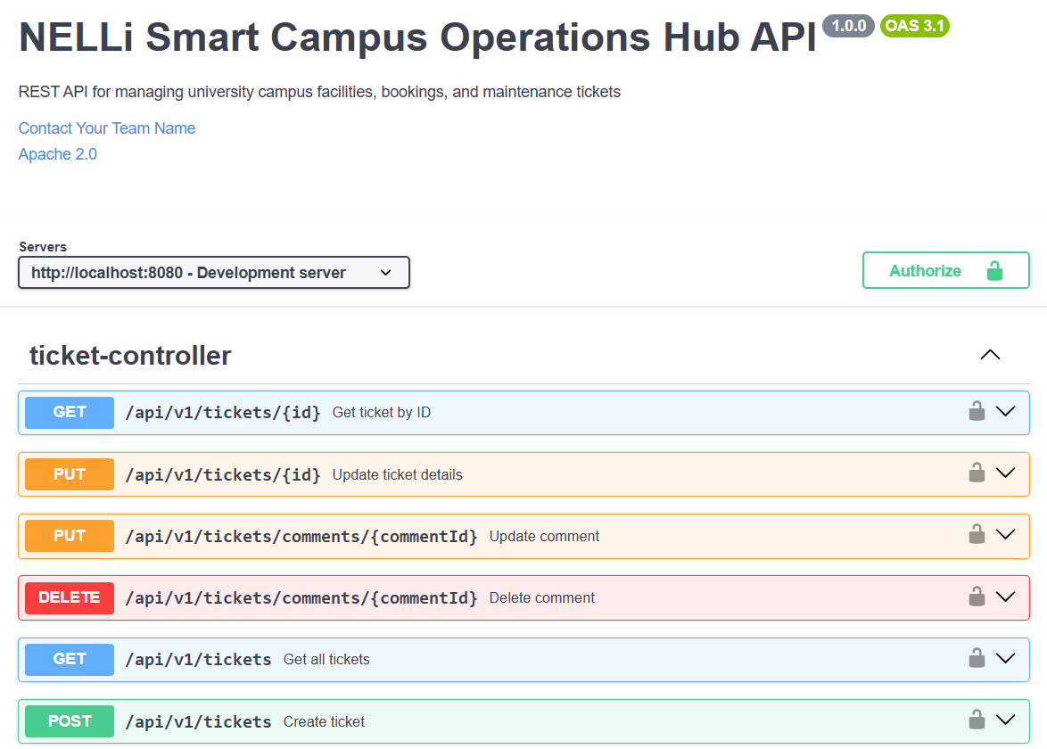
The backend exposes a Swagger UI at http://localhost:8080/swagger-ui.html, auto-generated by SpringDoc OpenAPI. All endpoints are documented with request/response schemas, example payloads, authentication requirements, and possible error codes. The OpenAPI specification is available in JSON format at /v3/api-docs.
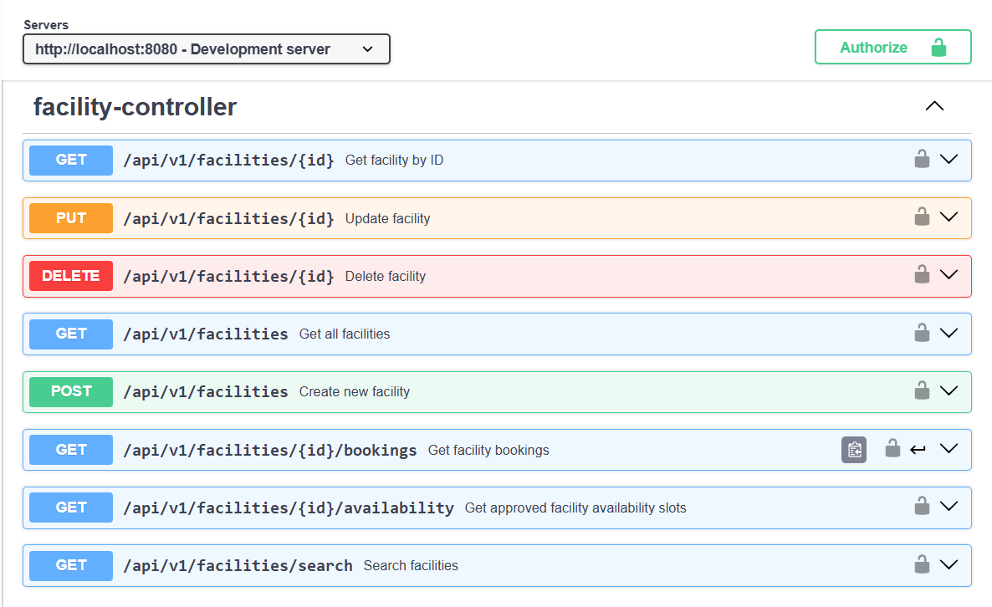
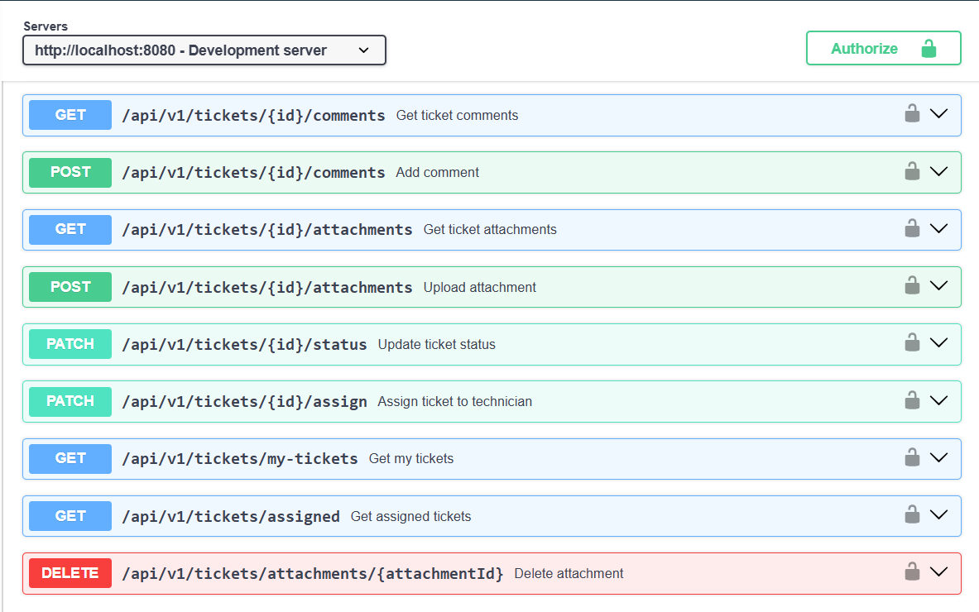

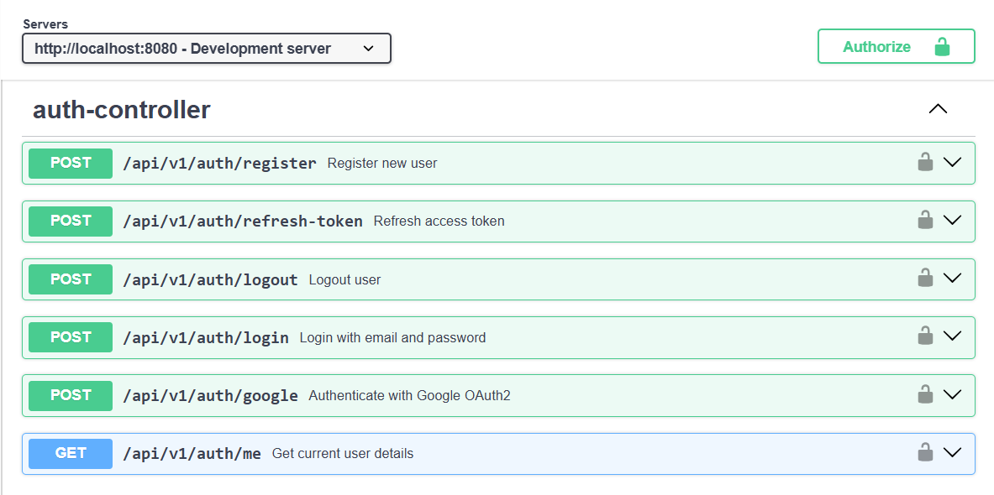
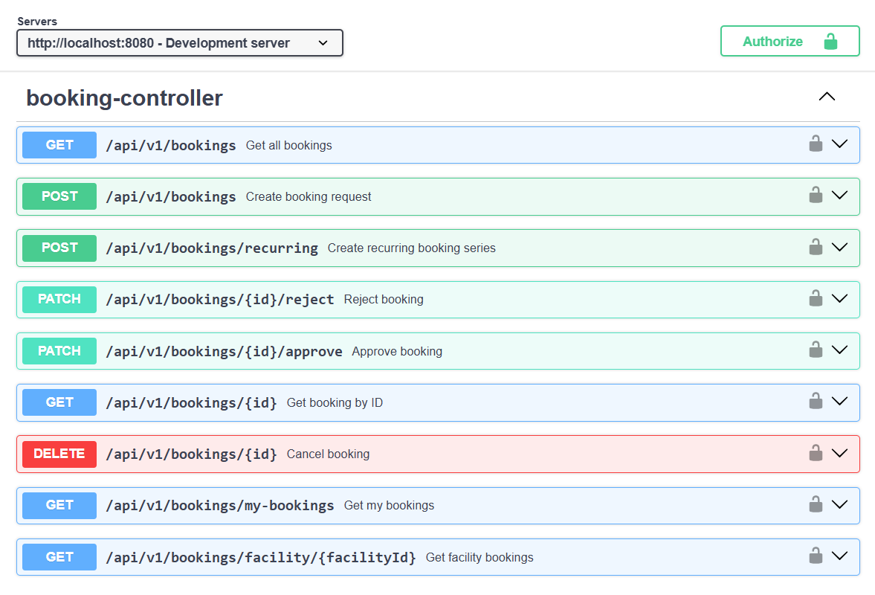

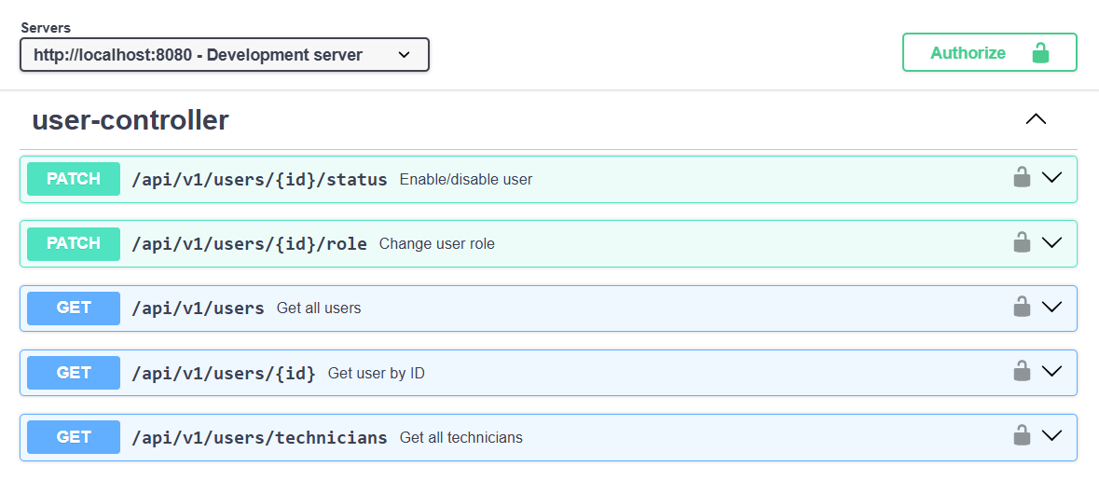
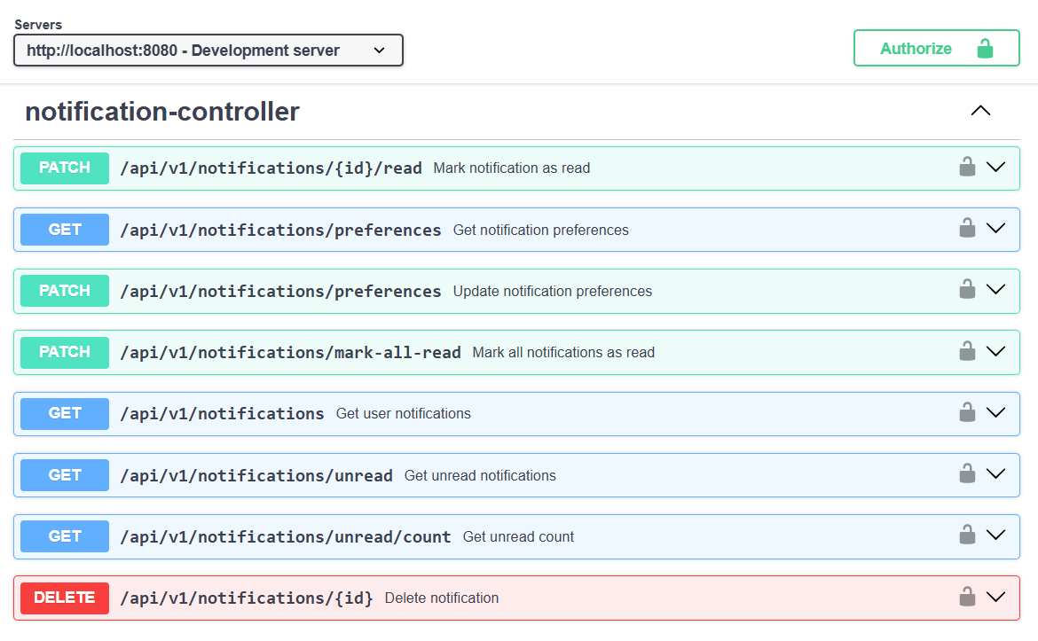

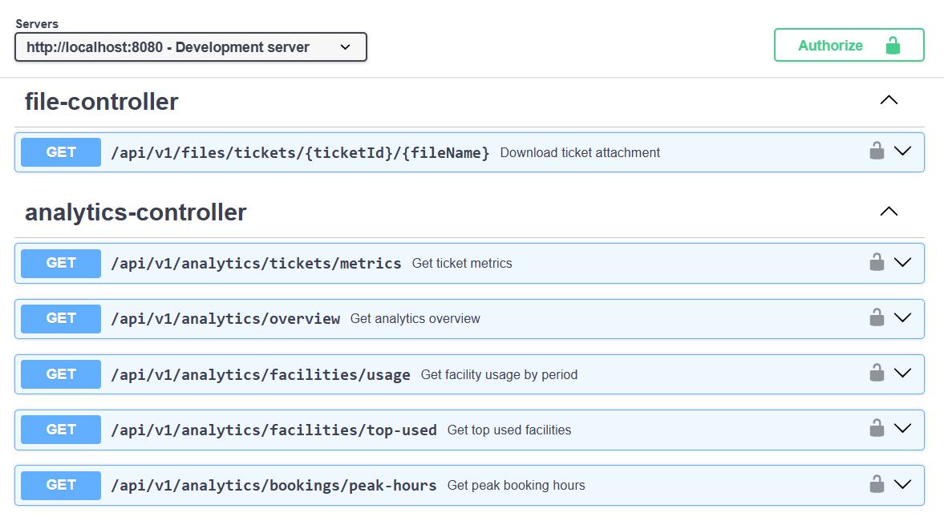

- Testing & Quality Management w/ Postman

  - Testing Strategy

NELLi's quality management approach covers three distinct testing layers: automated unit and integration tests in the Spring Boot backend, manual API testing via Postman collections, and frontend component validation through manual workflow testing.

  - Backend Unit & Integration Tests

    - Service Layer Unit Tests

- BookingServiceTest.java - Tests conflict detection logic with mocked BookingRepository. Scenarios: no conflict (creates booking), same facility different time (no conflict), overlapping APPROVED booking (throws BookingConflictException), overlapping PENDING booking (throws exception), REJECTED booking in slot (no conflict - should succeed).
- FacilityServiceTest.java - Tests CRUD operations, search filtering, and availability calculation. Uses Mockito for repository mocking.

- TicketServiceTest.java - Tests ticket creation with number generation, status transition validation, attachment count enforcement (rejects 4th attachment), and comment ownership rules.

- NotificationServiceTest.java - Tests notification creation triggers and unread count queries.

    - Controller Integration Tests

- BookingControllerIntegrationTest.java - Uses @SpringBootTest and @AutoConfigureMockMvc. Tests full request/response cycle for booking creation (with JWT token), approval workflow, and conflict response (expecting 409).

- FacilityControllerIntegrationTest.java - Tests CRUD endpoints, search filtering, and role-based access (expects 403 for USER attempting to POST /facilities).

- AuthControllerIntegrationTest.java - Tests registration, login, and token refresh flows.

  - Postman Testing

    - Collection Structure

A comprehensive Postman collection is organised as follows:
- NELLi API v1 - Root collection with environment variables: baseUrl, adminToken, userToken, techToken.

- Auth - All authentication endpoint tests (register, login, OAuth exchange, token refresh, /me).

- Facilities - CRUD tests including search with various filter combinations, availability check.
- Bookings - Full booking lifecycle: create → admin approve → user view QR → cancel. Conflict scenario tests.

- Tickets - Create ticket, upload attachment, add comment, update status, assign technician, resolve.

- Notifications - Fetch, mark read, bulk mark read, preference update.

- Analytics - All dashboard and analytics endpoints (admin token required).

- QR Verification - Verify valid token, verify expired token, verify invalid token.

    - Test Scripts

Each Postman request includes Tests tab scripts for automated responses validation:
// Example: POST /api/v1/bookings test script
pm.test("Status is 201 Created", () => {
pm.response.to.have.status(201);
});
pm.test("Response has booking ID", () => {
const body = pm.response.json();
pm.expect(body).to.have.property("id");
pm.environment.set("bookingId", body.id);
});
pm.test("Status is PENDING", () => {
pm.expect(pm.response.json().status).to.equal("PENDING");
});
pm.test("HATEOAS links present", () => {
pm.expect(pm.response.json()._links).to.have.property("self");
pm.expect(pm.response.json()._links).to.have.property("approve");
});

    - Test Coverage Summary

Module | # Requests | # Test Assertions | Edge Cases Covered
Authentication | 8 | 24 | Invalid credentials, expired token, duplicate email
Facilities | 10 | 35 | Search filter combos, soft delete, role enforcement
Bookings | 12 | 48 | Conflict detection, workflow transitions, role checks
Tickets | 15 | 52 | Attachment limit, comment ownership, status transitions
Notifications | 8 | 20 | Unread count accuracy, bulk read, preference persistence
Analytics | 6 | 18 | Admin-only access, date range validation
QR / Verify | 4 | 12 | Valid scan, expired, already used, invalid token
TOTAL | 63 | 209 | Full happy-path + error scenarios

9.4. Input Validation & Error Handling

- All request DTOs use Jakarta Bean Validation annotations. @NotBlank, @NotNull, @Email, @Size, @Min, @Max, @Future (for booking dates) are applied at the DTO level.

- @Valid annotation on all @RequestBody parameters activates validation; MethodArgumentNotValidException is caught by GlobalExceptionHandler and returns structured 400 responses.

- Custom validators: @ValidTimeRange checks that endDateTime > startDateTime; @ValidBookingWindow checks that the requested time fits within facility availability windows.

- Business rule violations (e.g., booking a resource with OUT_OF_SERVICE status) throw custom exception classes (ResourceUnavailableException) with meaningful HTTP status codes.

Safe file handling: attachment uploads validate MIME type from file header bytes (not just extension), enforce size limits (5MB), and sanitize file names before storage.

- Version Control w/ Github

  - Repository Structure (Source Code Links)
Detail | Value
Repository Name | Project-NELLi-SmartCampusOperationsHub
Source Code Link (One Drive) | Nelli-Project-Source-Code-in_OneDrive
Primary Branch | main (production-ready releases)
Development Branch | dev (integration branch for feature merges)
Feature Branches | 28 feature branches (numbered 001-028)
Total Merged Pull Requests | 40 Merged Pull Requests
Branch Naming Convention | feature/{number}/{member}/{feature-name}
Total Commits | ~150+ commits across all branches
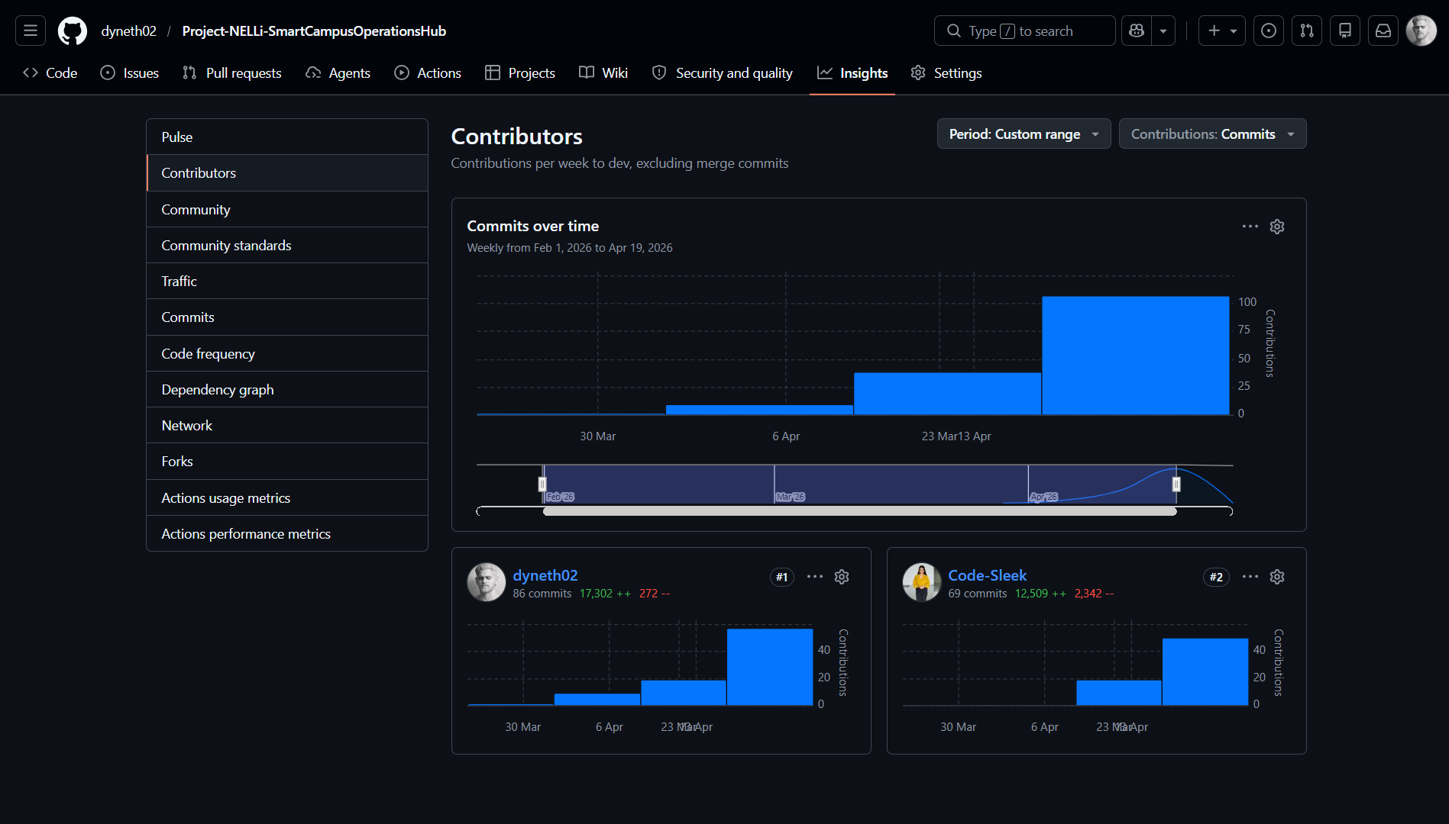

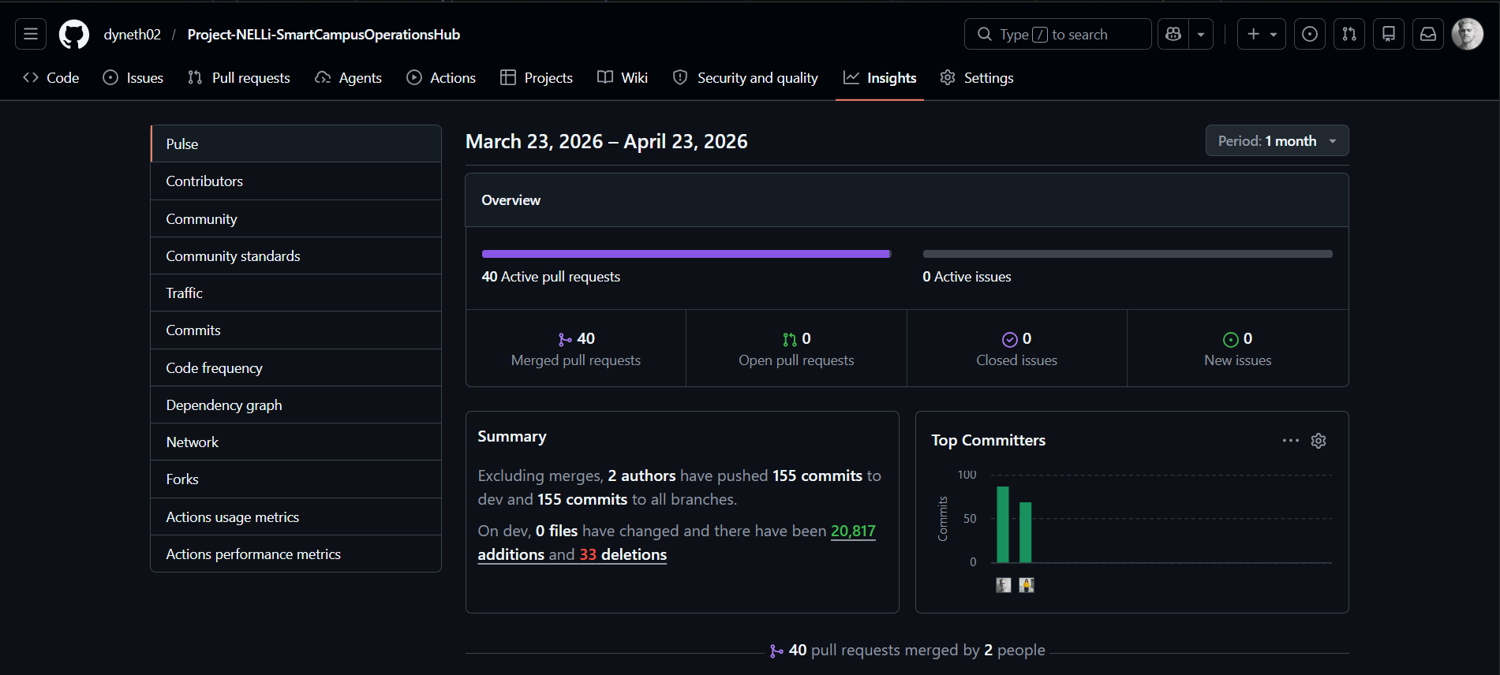

  - Branching Strategy

The project adopts a structured GitFlow-inspired branching model adapted for a two-member team:
- main - Contains only release-ready, tested code. Merged from develop after milestone completion.
- develop - Integration branch. All feature branches are merged here via Pull Request after self-review.
- feature/* - Individual feature branches, one per task unit, named with developer identity and sequential numbering for traceability.

  - Complete Branch Registery

Branch ID | Branch Name | Owner | Scope
001 | feature/001/dineth/oauth2-implementation | Dineth | Google OAuth2 + Spring Security setup
002 | feature/002/yashodha/jwt-authentication-implementation | Yashodha | JWT provider, filter, config classes
003 | feature/003/dineth/user-implementation | Dineth | User entity, repository, user service
004 | feature/004/dineth/notifications-implementation | Dineth | Notification entity & early triggers
005 | feature/005/dineth/base-entities-and-enums | Dineth | All enums and base entity classes
006 | feature/006/yashodha/facility-entity-implementation | Yashodha | Facility entity, repo, DTOs
007 | feature/007/dineth/booking-entity-implementation | Dineth | Booking entity, repository, DTOs
008 | feature/008/yashodha/ticket-entity-implementation | Yashodha | Ticket, Comment, Attachment entities
009 | feature/009/dineth/notification-entity-implementation | Dineth | Notification entity refinement
010 | feature/010/yashodha/facility-service-implementation | Yashodha | FacilityService + FacilityController
011 | feature/011/dineth/booking-service-implementation | Dineth | BookingService with conflict detection
012 | feature/012/yashodha/ticket-service-implementation | Yashodha | TicketService, CommentService, AttachmentService
013 | feature/013/dineth/notification-and-email-services | Dineth | NotificationService + EmailService (SMTP)
014 | feature/014/dineth/auth-and-security-implementation | Dineth | AuthController, SecurityConfig, CORS
015 | feature/015/yashodha/analytics-and-common-dtos | Yashodha | AnalyticsService, DTOs, QR endpoints
016 | feature/016/yashodha/frontend-setup-and-configuration | Yashodha | Vite + React project init, Tailwind, Axios config
017 | feature/017/dineth/frontend-common-components | Dineth | Button, Input, Modal, Card, Badge, Spinner
018 | feature/018/yashodha/frontend-layout-components | Yashodha | Navbar, Sidebar, Footer, MainLayout, AdminLayout
019 | feature/019/dineth/frontend-api-services | Dineth | All API service modules (facilityApi, bookingApi, etc.)
020 | feature/020/dineth/frontend-auth-pages | Dineth | Login, Register, OAuthCallback, NotFound pages
021 | feature/021/dineth/frontend-home-and-dashboard | Dineth | Home, Dashboard, Profile pages
022 | feature/022/yashodha/frontend-facility-pages | Yashodha | Facilities, FacilityDetails pages
023 | feature/023/dineth/frontend-booking-pages | Dineth | MyBookings, CreateBooking pages
024 | feature/024/yashodha/frontend-ticket-pages | Yashodha | MyTickets, TicketDetails, CreateTicket pages
025 | feature/025/dineth/frontend-notification-page | Dineth | Notifications page + preference management
026 | feature/026/Dineth/qr-pass-implementation | Dineth | BookingVerify.jsx, bookingApi.js, QrCodeService.java, QrVerificationController.java
027 | feature/027/yashodha/frontend-admin-pages | Yashodha | AdminDashboard, AdminFacilities, AdminBookings, AdminTickets, AdminUsers, AdminAnalytics
028 | feature/028/dineth/backend-configuration-files | Dineth | pom.xml, application.properties, README.md

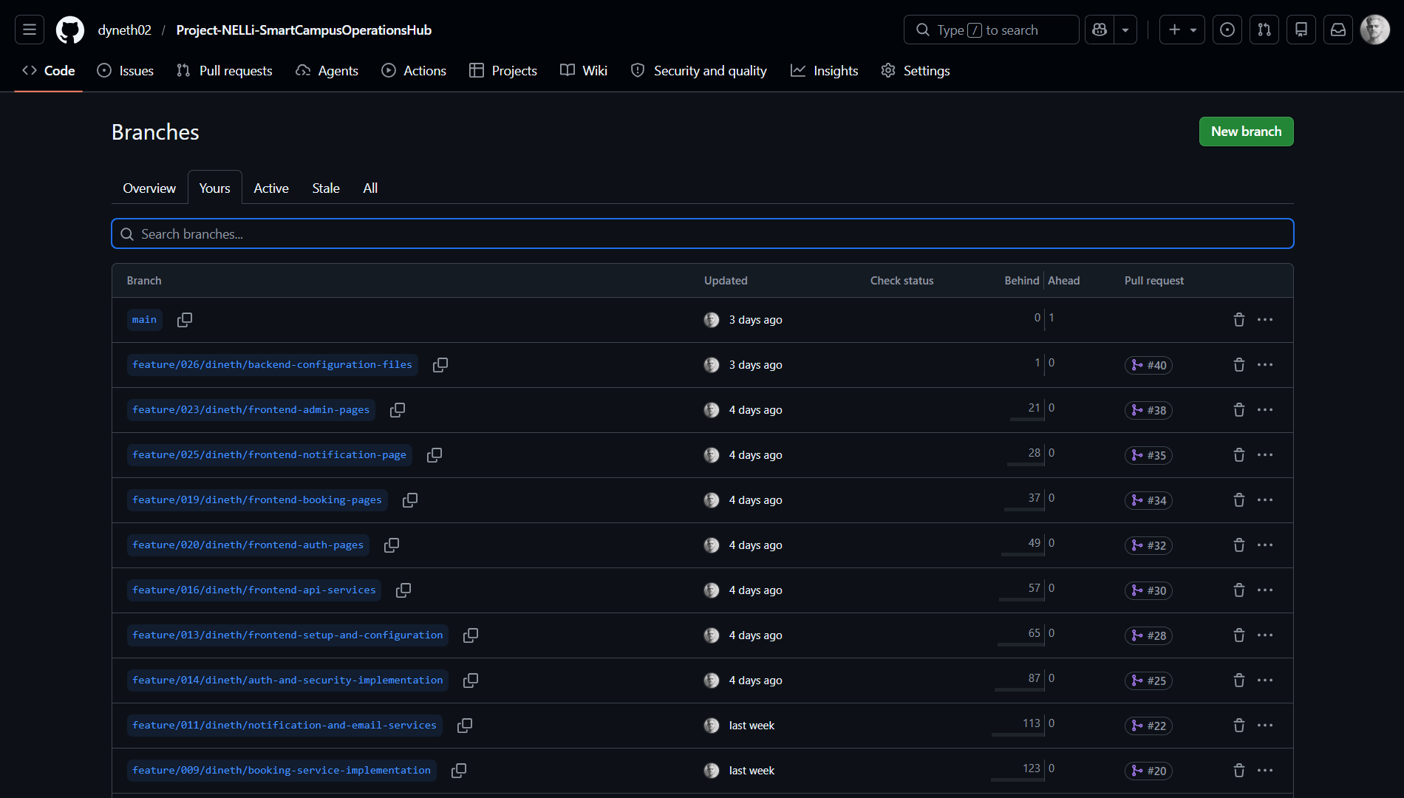

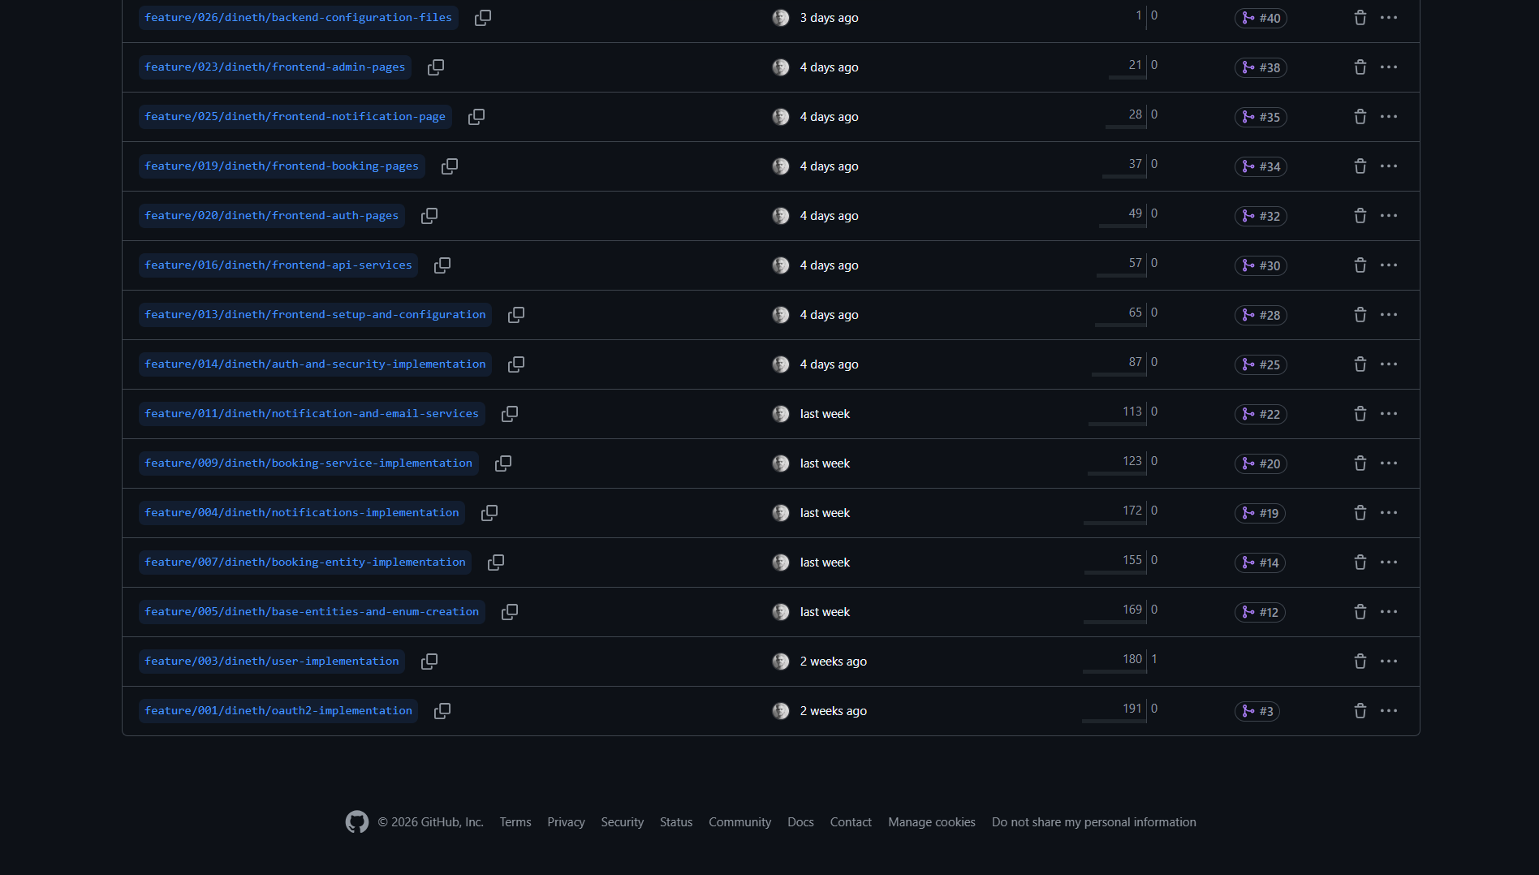

  - Commit Message Convention

All commits follow a standardized convention to ensure traceability and clear history:

Format: prefix(type): Descriptive message

Prefixes:
impl – New feature implementation
upd – Update to existing feature
fix – Bug fix
refactor – Code restructure without behavior change
config – Configuration changes
docs – Documentation updates
test – Test additions or changes
style – Formatting / style only

Types (in parentheses):
(model) – JPA entity
(service) – Service layer
(controller) – REST controller
(dto) – Data Transfer Object
(security) – Security component
(config) – Configuration class
(component) – React component
(page) – React page component
(api) – API service module
(hooks) – Custom React hooks

Examples:
  - impl(model): Created Booking entity with status enum and FK relationships
  - impl(service): Added conflict detection logic in BookingService
  - impl(controller): Created BookingController with PATCH approve endpoint
  - config(backend): Created application.properties with Neon DB and SMTP settings
  - impl(page): Created MyBookings page with status filter tabs

  - GitFlow WorkFlow

# 1. Create feature branch from develop
git checkout develop
git pull origin develop
git checkout -b feature/011/dineth/booking-service-implementation

# 2. Implement feature with incremental commits
git add src/main/java/com/smartcampus/service/BookingService.java
git commit -m "impl(service): Added createBooking with conflict detection"
git add src/main/java/com/smartcampus/service/BookingService.java
git commit -m "impl(service): Added approveBooking with QR token generation"

# 3. Push branch to remote
git push origin feature/011/dineth/booking-service-implementation

# 4. Create Pull Request to develop on GitHub

# 5. After review, merge to develop
git checkout develop
git merge feature/011/dineth/booking-service-implementation
git push origin develop

# 6. Release merge: develop → main
git checkout main
git merge develop
git tag -a v1.0.0 -m "Release: Feature-complete NELLi v1.0.0"
git push origin main --tags

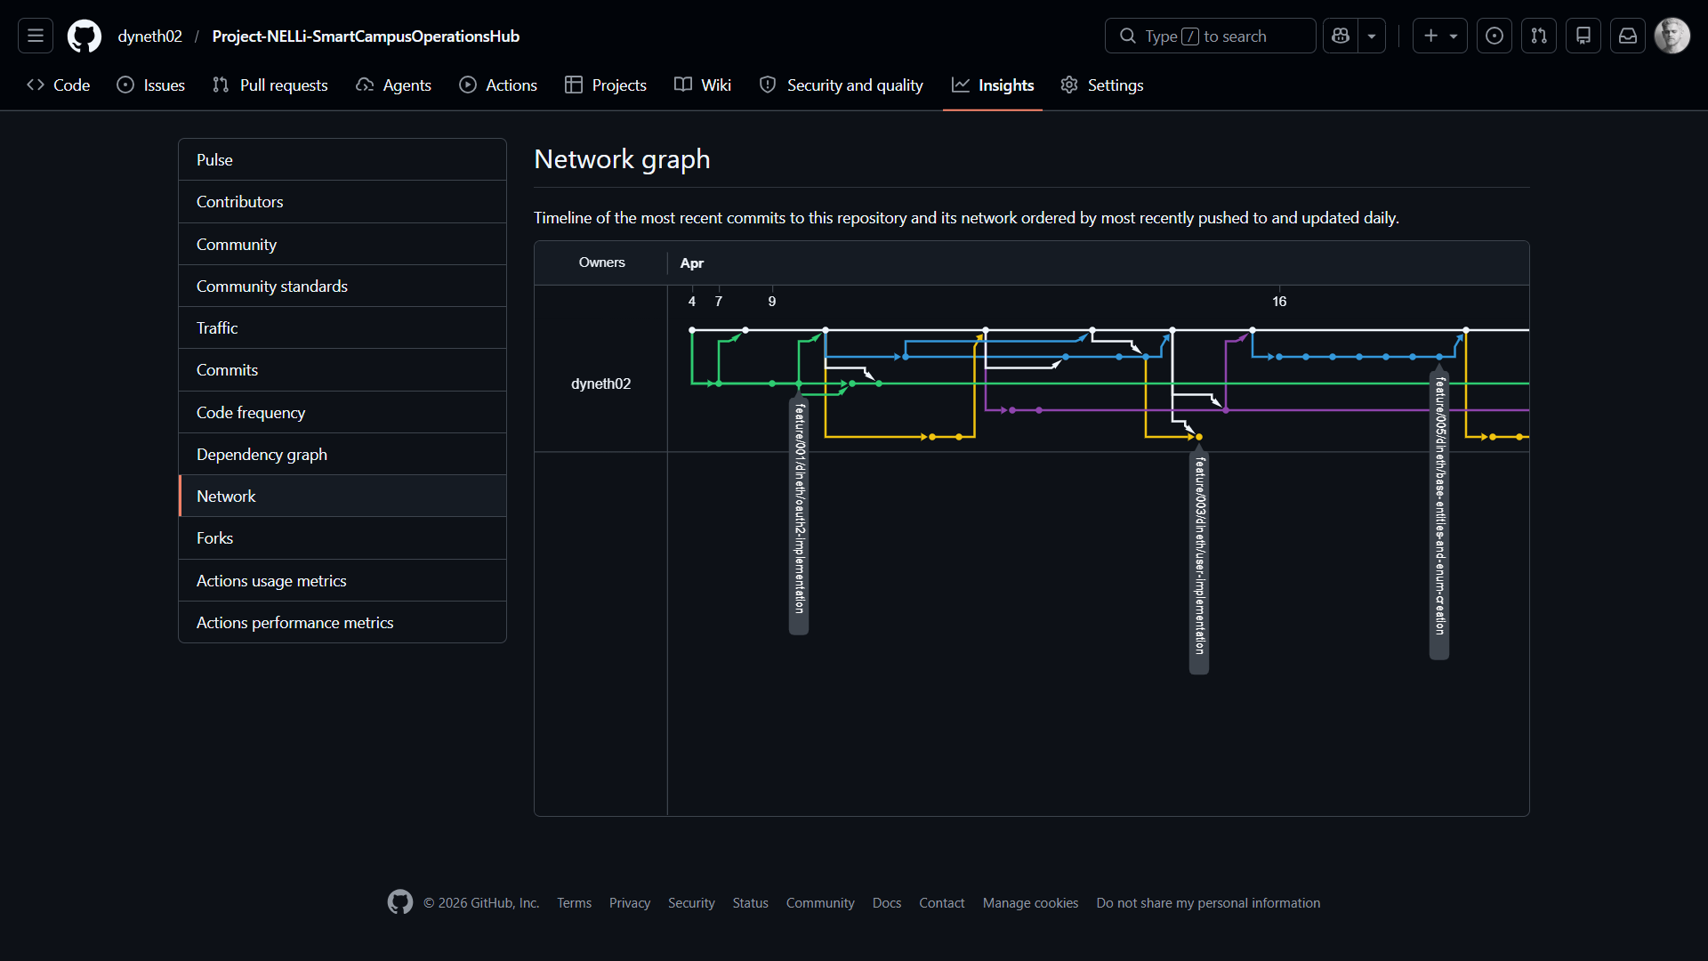

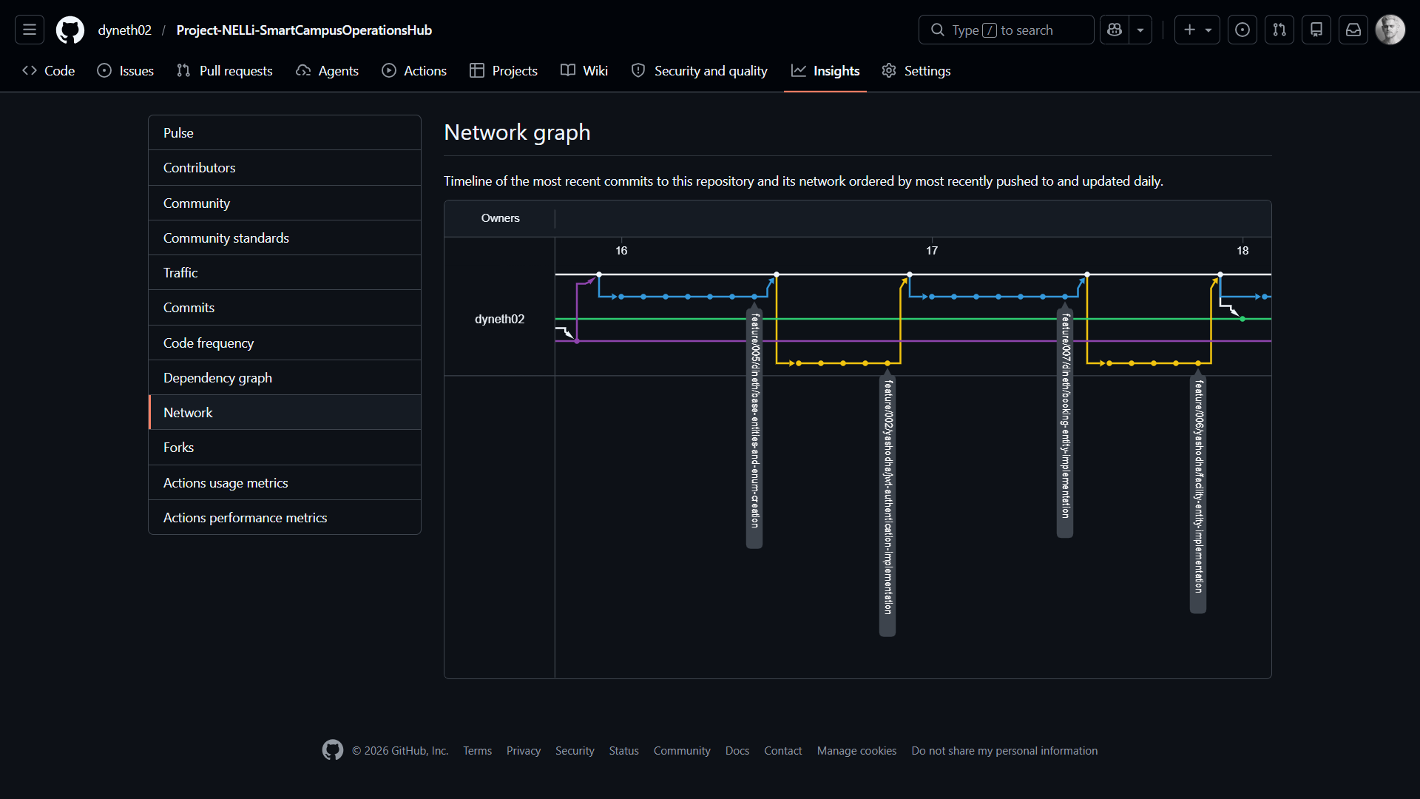
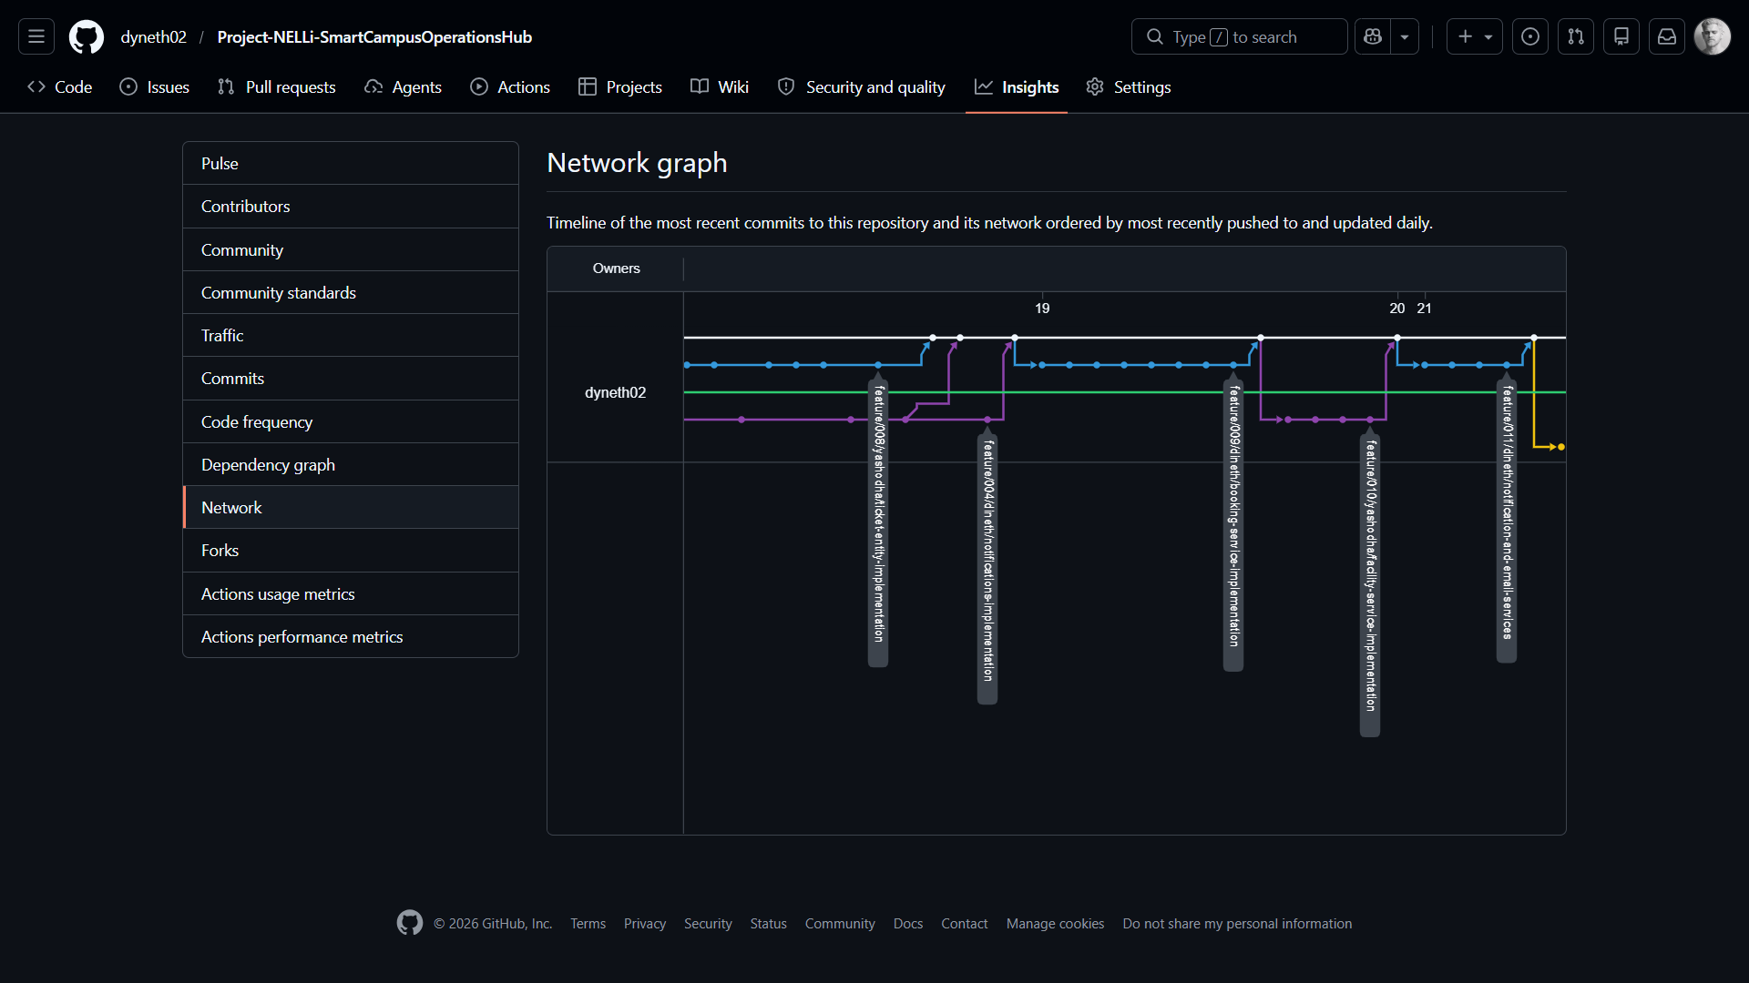

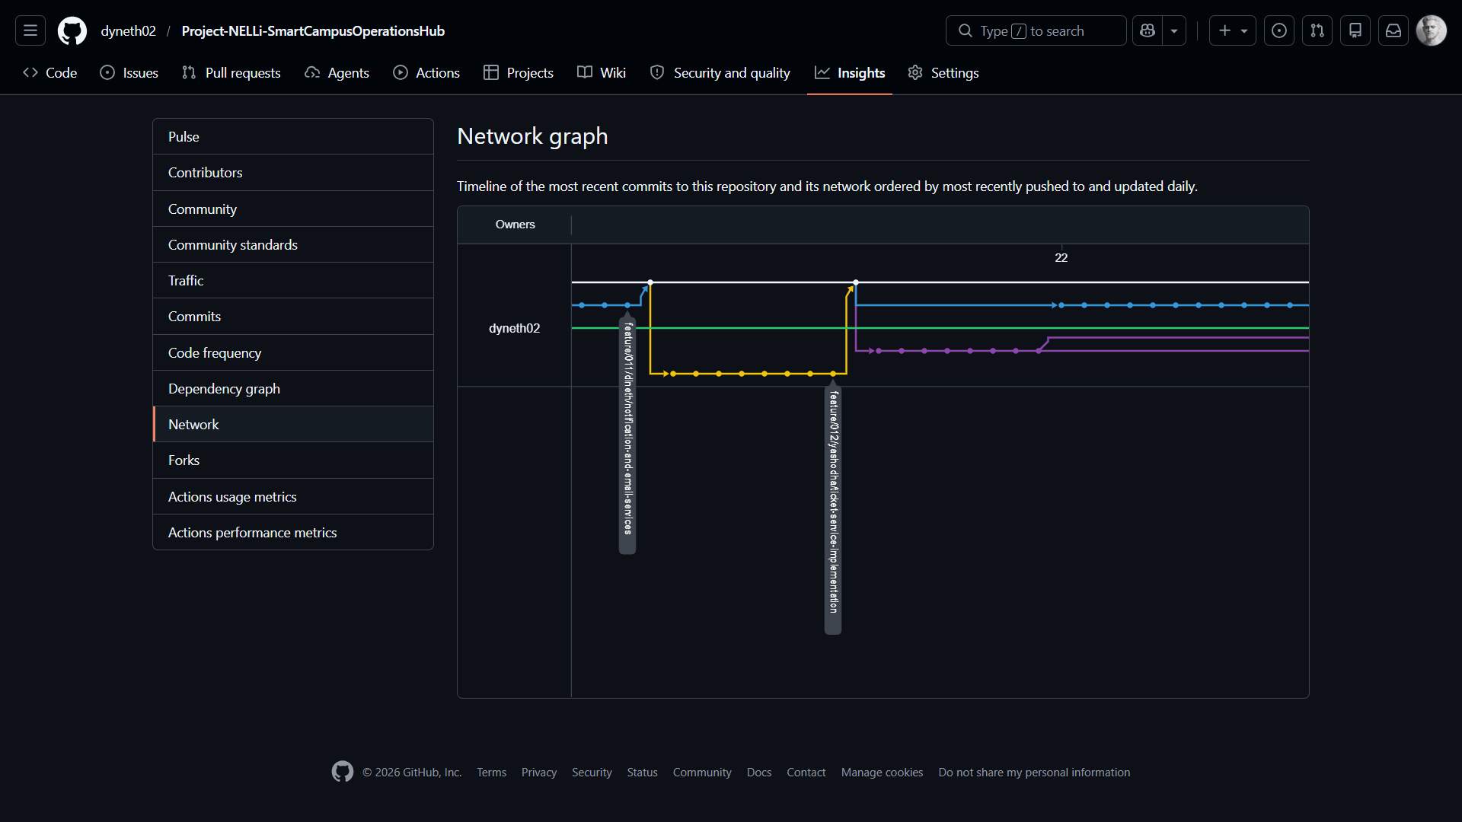

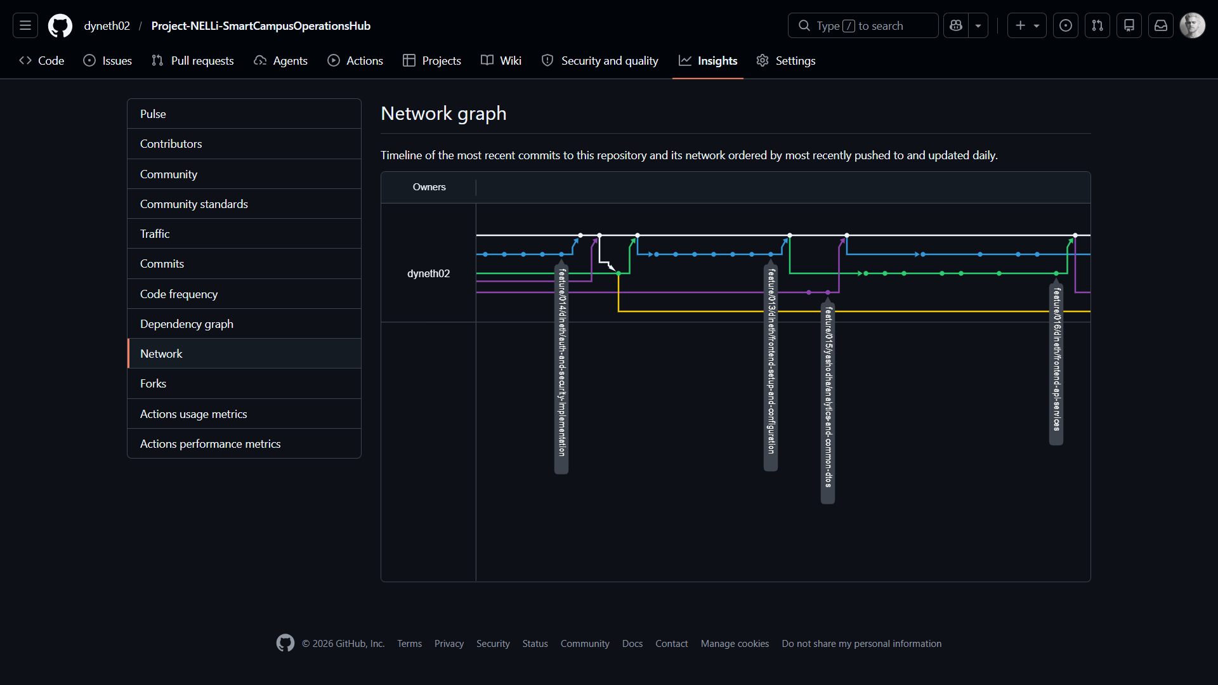

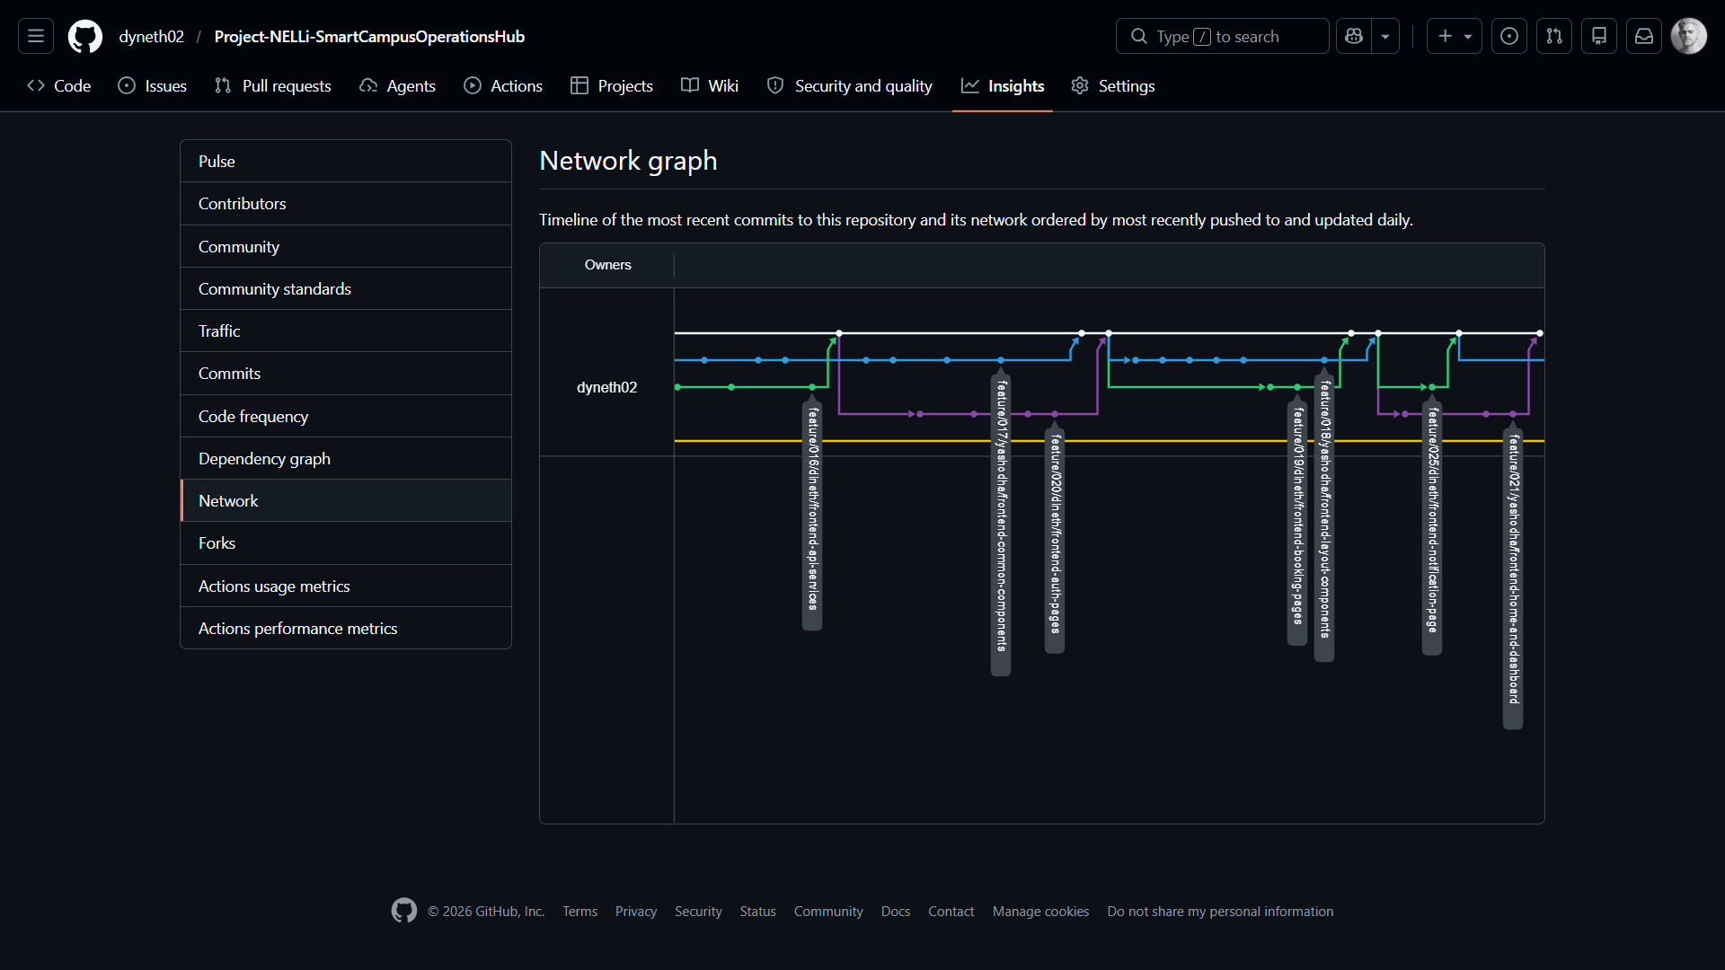

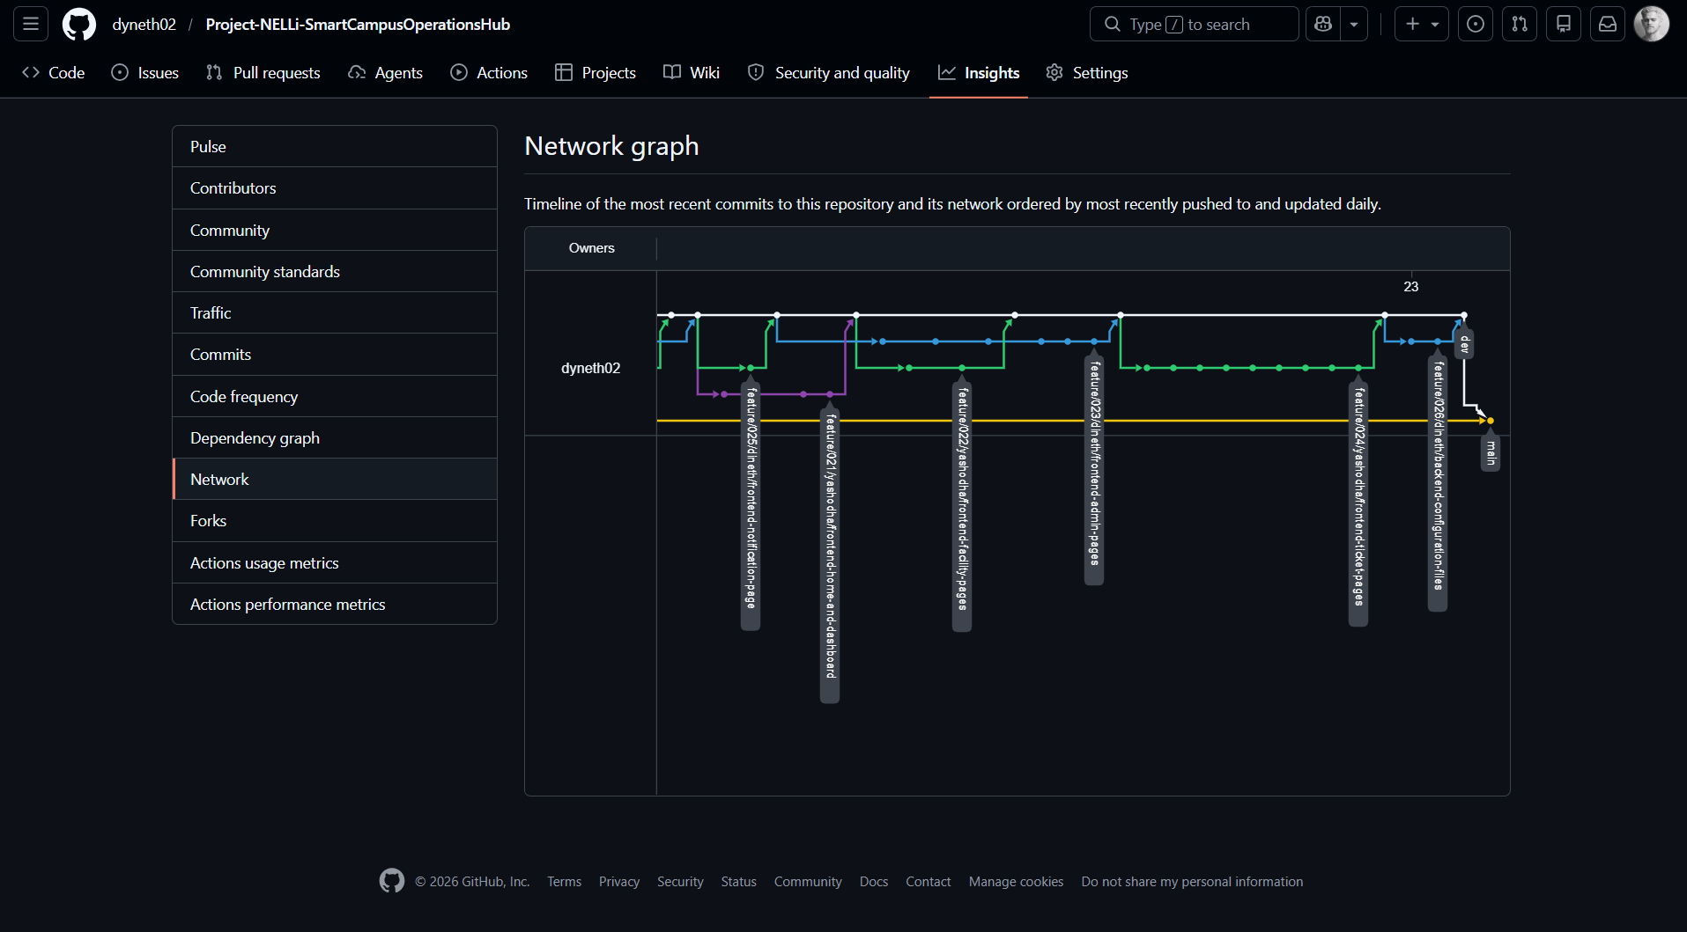

  - Continuous Integration Pipeline

    - Github Actions Workflow

A GitHub Actions CI workflow (ci-cd.yml) is configured in .github/workflows/ to automatically build and test both the backend and frontend on every push to any branch and on every Pull Request targeting develop or main.

    - Workflow Configuration

name: NELLi CI Pipeline

on:
push:
branches: [ '**' ]
pull_request:
branches: [ develop, main ]

jobs:
backend-build-test:
name: Backend – Build & Test
runs-on: ubuntu-latest

services:
postgres:
image: postgres:15
env:
POSTGRES_USER: testuser
POSTGRES_PASSWORD: testpass
POSTGRES_DB: nelli_test
options: >-
--health-cmd pg_isready
--health-interval 10s
--health-timeout 5s
--health-retries 5

steps:
- name: Checkout code
uses: actions/checkout@v4

- name: Set up JDK 17
uses: actions/setup-java@v4
with:
java-version: '17'
distribution: 'temurin'
cache: maven

- name: Build and test with Maven
working-directory: ./backend
env:
SPRING_DATASOURCE_URL: jdbc:postgresql://localhost:5432/nelli_test
SPRING_DATASOURCE_USERNAME: testuser
SPRING_DATASOURCE_PASSWORD: testpass
JWT_SECRET: $[[ secrets.JWT_SECRET_TEST ]]
GOOGLE_CLIENT_ID: $[[ secrets.GOOGLE_CLIENT_ID ]]
GOOGLE_CLIENT_SECRET: $[[ secrets.GOOGLE_CLIENT_SECRET ]]
run: mvn clean verify --no-transfer-progress

- name: Publish test results
uses: EnricoMi/publish-unit-test-result-action@v2
if: always()
with:
files: backend/target/surefire-reports/*.xml

frontend-build:
name: Frontend – Build & Lint
runs-on: ubuntu-latest

steps:
- name: Checkout code
uses: actions/checkout@v4

- name: Set up Node.js 20
uses: actions/setup-node@v4
with:
node-version: '20'
cache: 'npm'
cache-dependency-path: frontend/package-lock.json

- name: Install dependencies
working-directory: ./frontend
run: npm ci

- name: Run ESLint
working-directory: ./frontend
run: npm run lint

- name: Build production bundle
working-directory: ./frontend
env:
VITE_API_BASE_URL: http://localhost:8080/api/v1
run: npm run build

- name: Upload build artifacts
uses: actions/upload-artifact@v4
with:
name: frontend-dist
path: frontend/dist/

11.3. CI Pipeline Stages

Stage | Description
Trigger | On every push (all branches) and Pull Request to develop/main
Backend: Checkout | Clone repository to ubuntu-latest runner
Backend: JDK Setup | Java 21 (Temurin) with Maven dependency cache
Backend: PostgreSQL Service | Ephemeral PostgreSQL 15 container for integration tests
Backend: mvn clean verify | Compile, run unit tests (Surefire), run integration tests (Failsafe), package JAR
Backend: Test Reports | Publishes JUnit XML reports as PR check annotations
Frontend: Node Setup | Node.js 22.19.0 with npm cache
Frontend: npm ci | Clean install from package-lock.json (deterministic)
Frontend: ESLint | Static analysis - fails build on lint errors
Frontend: npm run build | Vite production build - fails on TypeScript/JSX errors
Frontend: Artifact Upload | dist/ folder uploaded as workflow artifact for review

11.4. Secrets Management

- Sensitive values (JWT_SECRET, GOOGLE_CLIENT_ID, GOOGLE_CLIENT_SECRET) are stored as GitHub Repository Secrets, never committed to the codebase.

- Test-specific variants of secrets use _TEST suffix (JWT_SECRET_TEST) to prevent accidental production credential use in CI.

- The Neon production database is NOT used in CI; an ephemeral PostgreSQL service container is spun up for each CI run and torn down after.

- application.properties uses ${ENV_VAR} placeholders; actual values are injected via environment variables in CI and via .env file locally.

- Individual Contribution

NELLi was developed by a two-member team (HIRUSHA D G A D and COORAY Y H) delivering the full scope of a four-member group assignment. This section provides a detailed, transparent account of each member's technical contributions, mapped to specific GitHub feature branches, files, and module responsibilities.

  - HIRUSHA D G A D - Contribution Summary

Dineth took primary ownership of the application's security architecture, authentication flows, booking business logic (including the conflict detection engine), notification and email services, and several key frontend modules.

    - Backend Contributions

Branch | Feature | Key Files Created | LOC Est.
feature/001 | OAuth2 Implementation | SecurityConfig.java, OAuth2SuccessHandler.java, CorsConfig.java | ~320
feature/003 | User Implementation | User.java, UserRepository.java, UserService.java, UserController.java | ~280
feature/004 | Notification Entity (initial) | Notification.java, NotificationRepository.java | ~120
feature/005 | Base Entities & Enums | All enum classes (FacilityType, BookingStatus, TicketStatus, etc.), BaseEntity.java | ~240
feature/007 | Booking Entity | Booking.java, BookingRepository.java, BookingRequest.java, BookingResponse.java | ~350
feature/009 | Notification Entity (refined) | Notification.java (updated), NotificationPreferences.java | ~160
feature/011 | Booking Service | BookingService.java (conflict detection, approval, QR trigger), BookingController.java, AvailabilityWindowDTO.java | ~520
feature/013 | Notification & Email Services | NotificationService.java, EmailService.java, email HTML templates | ~480
feature/014 | Auth & Security | AuthController.java, AuthService.java, CustomUserDetailsService.java | ~460
feature/026 | QR Validation | QrCodeService.java, QrVerificationController.java | ~220
feature/028 | Backend Config Files | pom.xml, application.properties, application-dev.properties, .gitignore, backend README | ~200

    - Frontend Contributions

Branch | Feature | Key Files Created | LOC Est.
feature/017 | Common UI Components | Button.jsx, Input.jsx, TextArea.jsx, Card.jsx, Badge.jsx, LoadingSpinner.jsx, Modal.jsx, Dropdown.jsx, Select.jsx, useAnimations.js | ~680
feature/019 | API Service Modules | authApi.js, facilityApi.js, bookingApi.js, ticketApi.js, notificationApi.js, analyticsApi.js | ~380
feature/020 | Auth Pages | Login.jsx, Register.jsx, OAuthCallback.jsx, NotFound.jsx | ~520
feature/021 | Home & Dashboard | Home.jsx, Dashboard.jsx, Profile.jsx | ~420
feature/023 | Booking Pages | MyBookings.jsx, CreateBooking.jsx | ~440
feature/025 | Notification Page | Notifications.jsx (full page with preferences) | ~280
Feature/026 | QR Code Validation Page | BookingVerify.jsx | ~220

    - Key Technical Achievements

- Implemented the booking conflict detection engine using JPQL overlap query and custom BookingConflictException, correctly handling PENDING and APPROVED bookings as blocking states while ignoring REJECTED and CANCELLED records.

- Built the full OAuth2 → JWT pipeline: Google OAuth2 callback → OAuth2SuccessHandler account linking → JWT issuance → frontend token storage → protected API access.

- Developed the Email Service with HTML email templates for all six notification types, ensuring email failures do not propagate as HTTP errors through the service chain.

- Created the common UI component library (Button, Modal, Card, Input, etc.) with Tailwind CSS styling, loading states, and GSAP animation integration, establishing the design system used throughout the entire frontend.
  - COORAY Y H - Contribution Summary

Yashodha was the primary contributor to the frontend architecture, having initiated the React/Vite project and established the project-wide design system. On the backend, Yashodha owned the Facility and Ticket domains, the Analytics module with supporting HIRUSHA D G A D. Yashodha also implemented the largest volume of frontend pages.

    - Backend Contributions

Branch | Feature | Key Files Created | LOC Est.
feature/002 | JWT Authentication | JwtTokenProvider.java, JwtConfig.java, JwtAuthenticationFilter.java (initial), TokenRefreshService.java | ~340
feature/006 | Facility Entity | Facility.java, FacilityRepository.java, FacilityRequest.java, FacilityResponse.java | ~380
feature/008 | Ticket Entity | Ticket.java, Comment.java, Attachment.java, TicketRepository.java, CommentRepository.java, AttachmentRepository.java, all Ticket DTOs | ~560
feature/010 | Facility Service | FacilityService.java, FacilityController.java (all 8 endpoints) | ~480
feature/012 | Ticket Service | TicketService.java, CommentService.java, AttachmentService.java, TicketController.java (all 12 endpoints) | ~640
feature/015 | Analytics | AnalyticsService.java, AnalyticsController.java, all Analytics DTOs | ~520

    - Frontend Contributions

Branch | Feature | Key Files Created | LOC Est.
feature/016 | Frontend Setup | package.json, vite.config.js, tailwind.config.js, index.html, App.jsx, main.jsx, index.css, ThemeContext.jsx, AuthContext.jsx, axiosConfig.js, animations.js | ~480
feature/018 | Layout Components | Navbar.jsx, Sidebar.jsx, Footer.jsx, MainLayout.jsx, AdminLayout.jsx, AppRoutes.jsx | ~560
feature/022 | Facility Pages | Facilities.jsx, FacilityDetails.jsx | ~380
feature/024 | Ticket Pages | MyTickets.jsx, TicketDetails.jsx, CreateTicket.jsx | ~560
feature/026 | Admin Pages | AdminDashboard.jsx, AdminFacilities.jsx, AdminBookings.jsx, AdminTickets.jsx, AdminUsers.jsx, AdminAnalytics.jsx | ~840

    - Key Technical Achievements

- Designed and implemented the complete Ticket domain including three related entities (Ticket, Comment, Attachment) with careful cascade rules and referential integrity, supporting all business workflows (lifecycle transitions, ownership enforcement, SLA tracking fields).

- Built the full analytics backend with aggregation JPQL queries for facility utilization, peak booking hours, ticket KPIs, and user growth all results cached with Spring Cache to reduce database load.

- Established the entire React/Vite frontend project from scratch including Tailwind CSS design system with custom dark/light theme tokens, GSAP animation utilities, and Axios instance with automatic JWT refresh interceptors.

- Implemented the Admin section (6 admin pages) covering the complete administrative workflow from facility management through booking approvals, ticket assignment, user role management, and the analytics dashboard with Recharts visualizations.

- Conclusion

The NELLi Smart Campus Operations Hub successfully delivers a production-quality, full-stack web system that fulfils and significantly exceeds the minimum requirements of the IT3030 PAF Assignment. All five core modules are fully implemented Facilities Catalogue, Booking Management, Incident Ticketing, Notifications & Email, and Authentication & Authorization alongside both optional innovation features: the QR Code Check-In system and the Admin Analytics Dashboard.

Technically, the system demonstrates mastery of the required stack (Spring Boot REST API + React) and applies industry best practices throughout: layered backend architecture with clean separation of concerns, RESTful API design with HATEOAS links, JWT + OAuth 2.0 security, server-side conflict detection, role-based access control at both the API and frontend routing layers, structured Git branching with 27 feature branches, and automated CI via GitHub Actions.

The two-member team delivered the full scope planned for a four-member group, with clearly delineated and individually traceable contributions evident in the Git commit history. Dineth owned the security, authentication, booking logic, and notification pipelines, while Yashodha owned the facility and ticket domains, analytics, and the majority of the frontend page implementations. Both members contributed to shared architecture decisions, the CI pipeline, integration testing, and documentation.

The 27-branch repository structure, standardized commit message conventions, and CI pipeline ensure full auditability of individual contributions and demonstrate professional version control practices. The comprehensive Postman test collection with 63 requests and 209 assertions validates both the happy-path workflows and critical edge cases across all seven modules.

NELLi demonstrates that with disciplined project planning, clear technical architecture, and effective collaboration, a two-member team can deliver a feature-complete, production-inspired campus management system within a four-week sprint.

- Appendix

  - The Landing Page

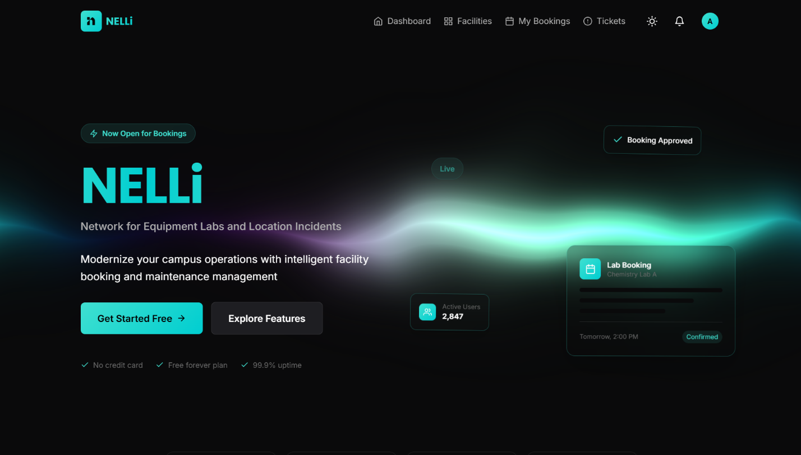

[ Hero Section ]

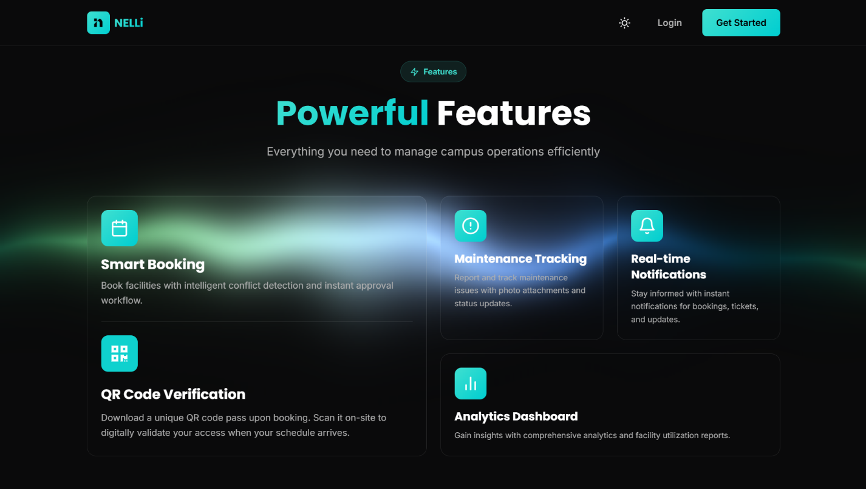
[ Features Section ]

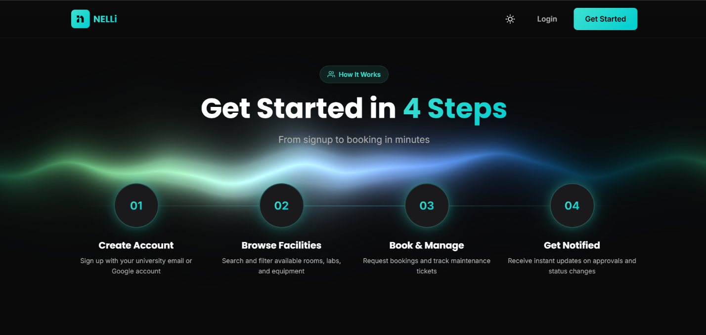

[ Site-flow Showcase ]

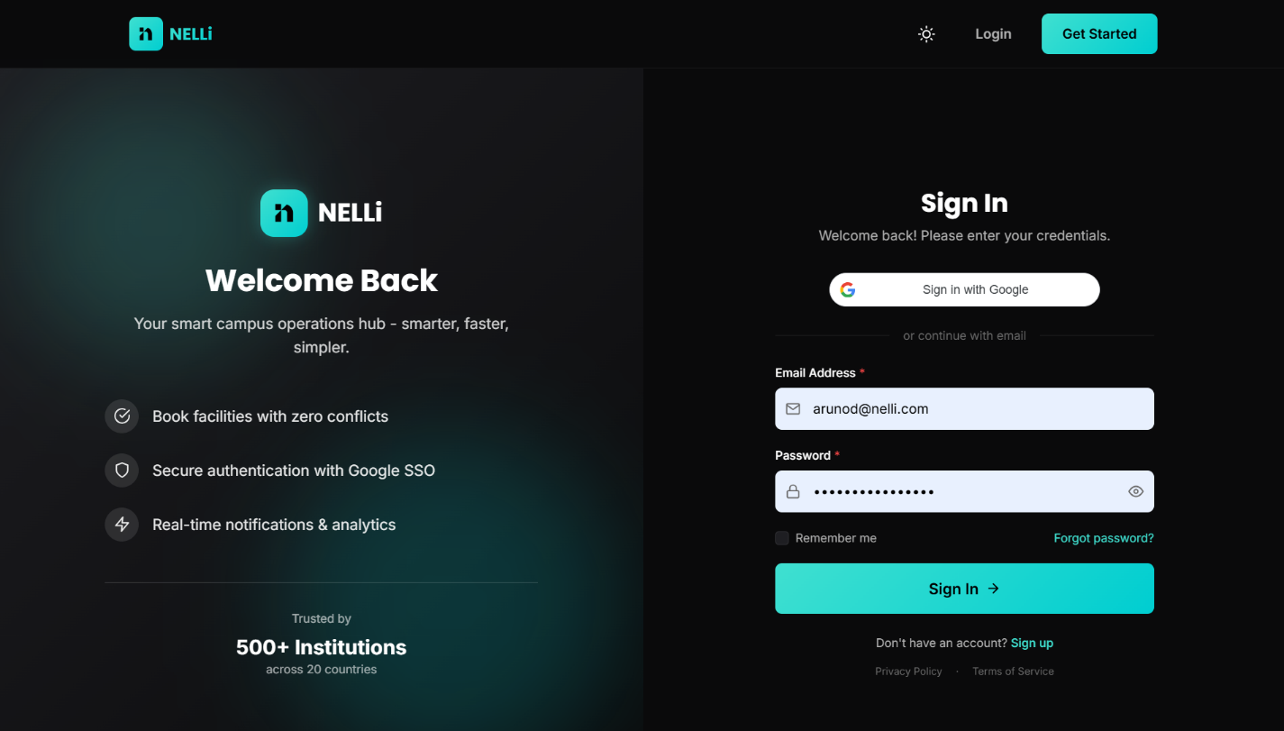
  - Login & Register Pages

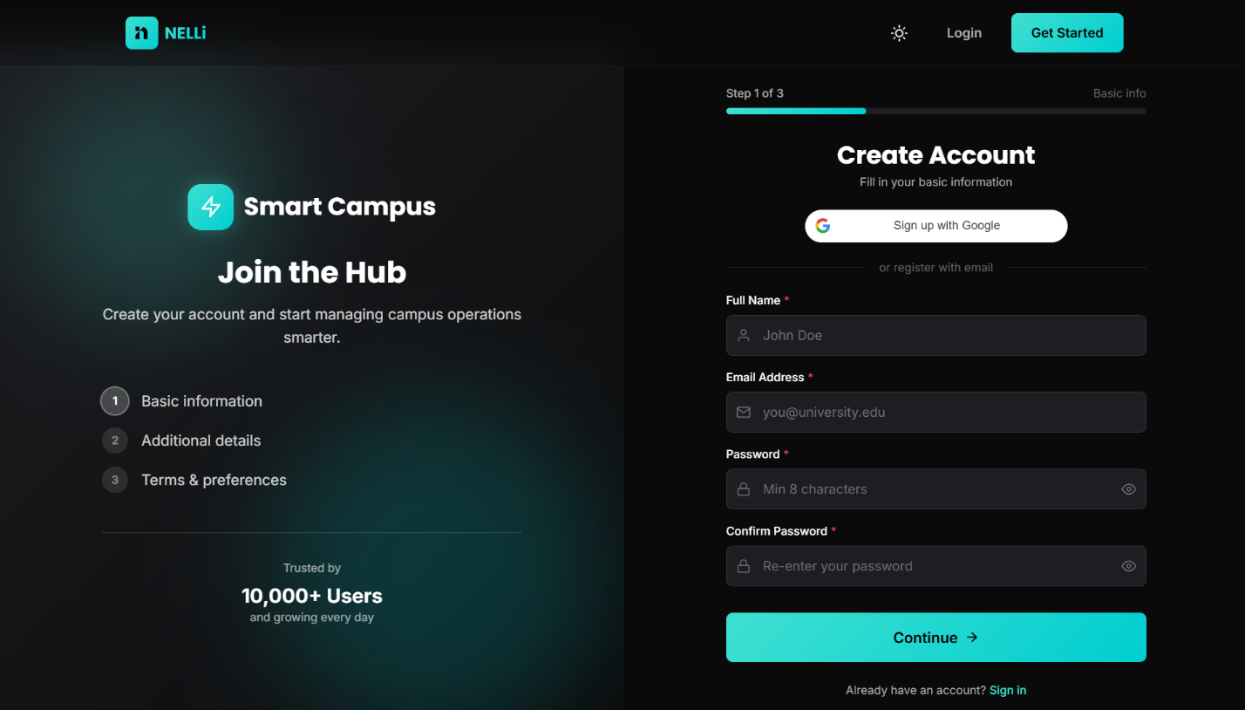
[ Login Page ]

[ Register Page ]
  - User Dashboard
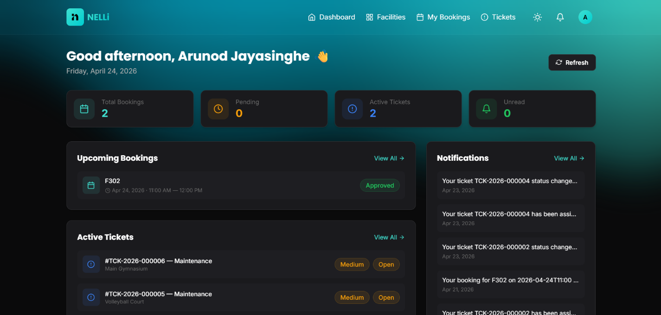

  - Facilities Component

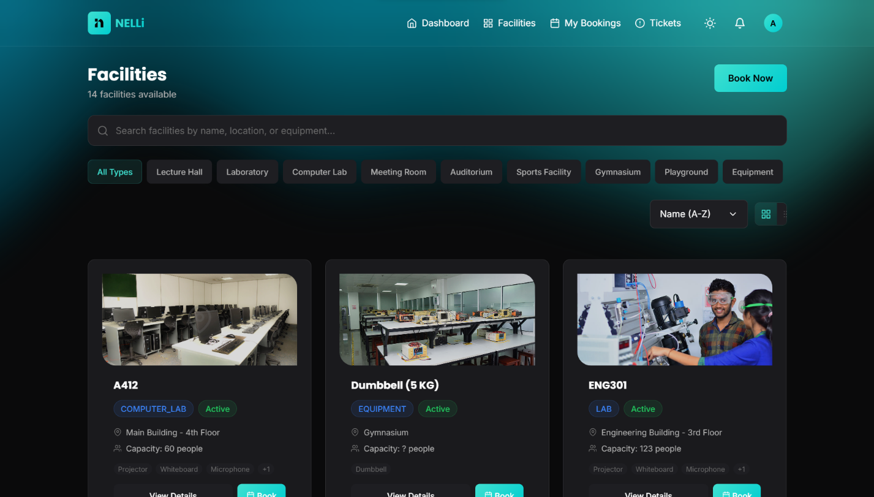
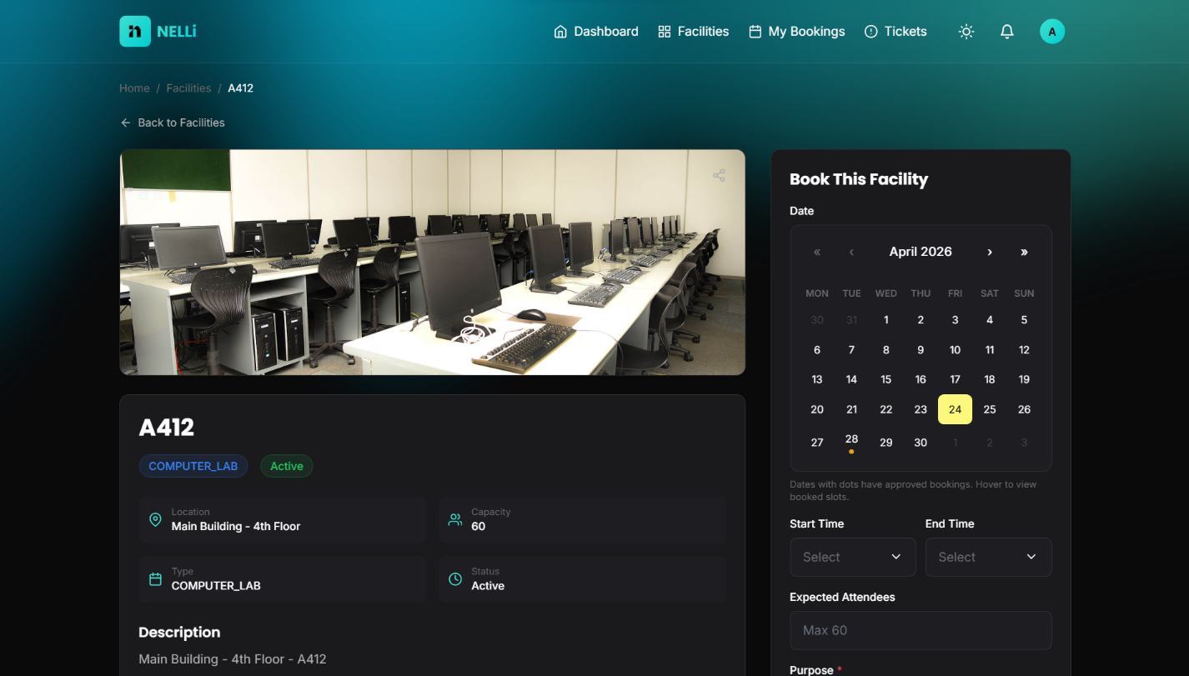

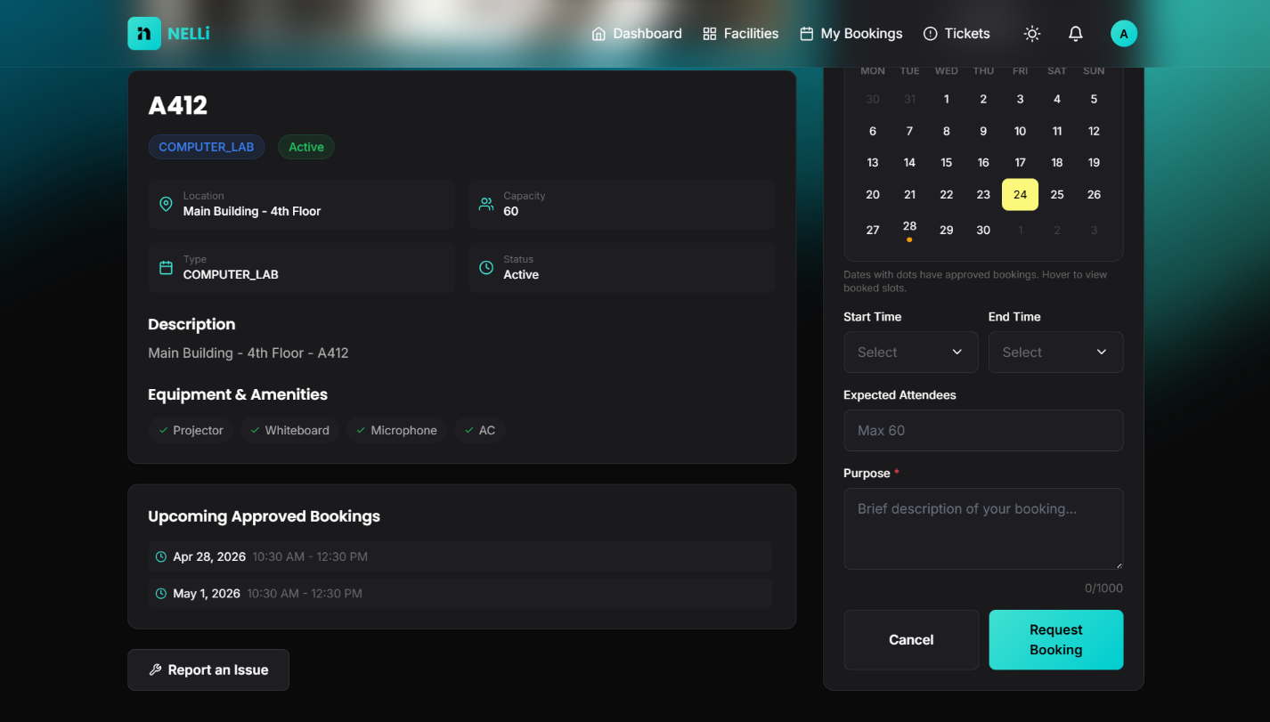

  - Booking Component

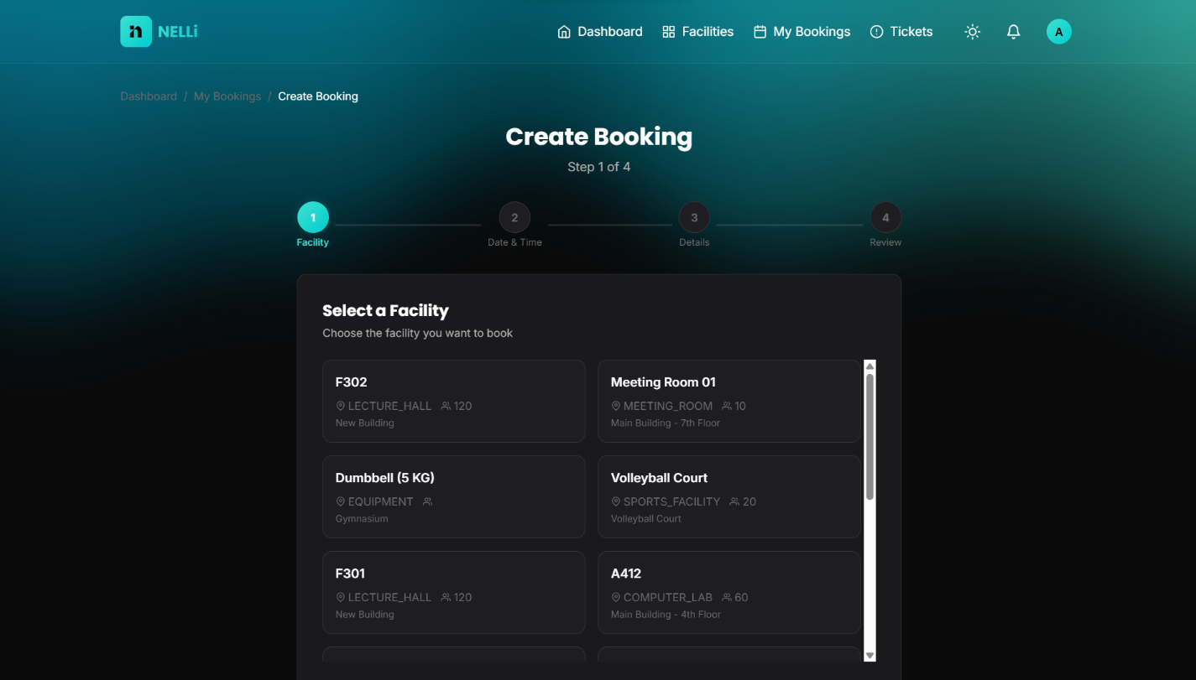
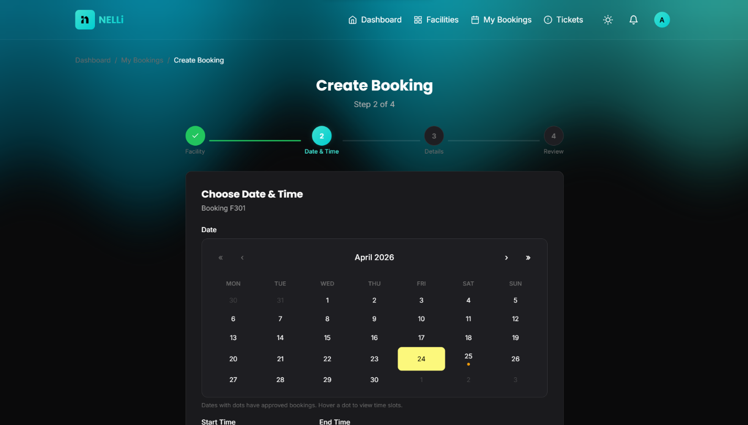

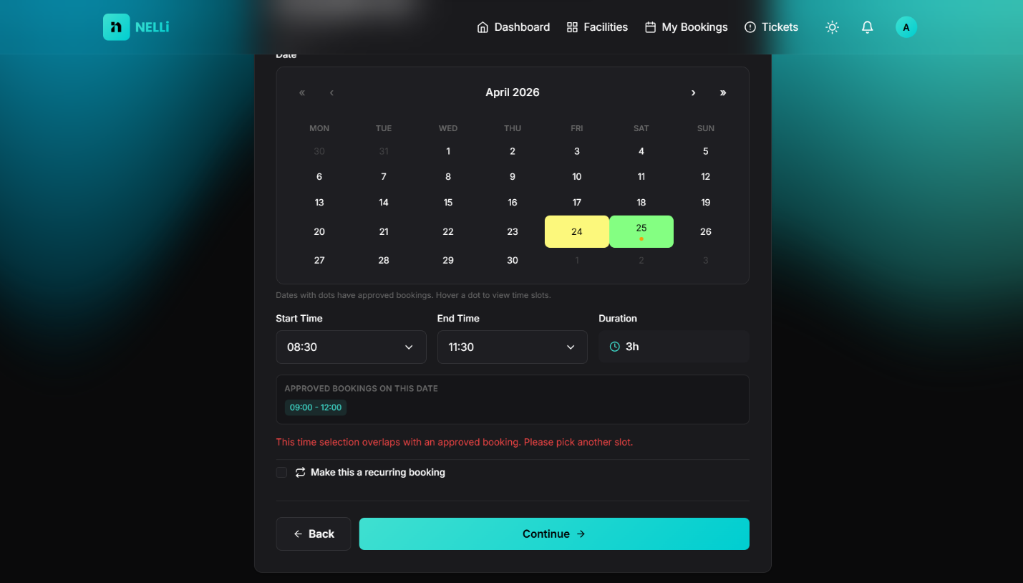
[ Resolved Booking Conflicts ]
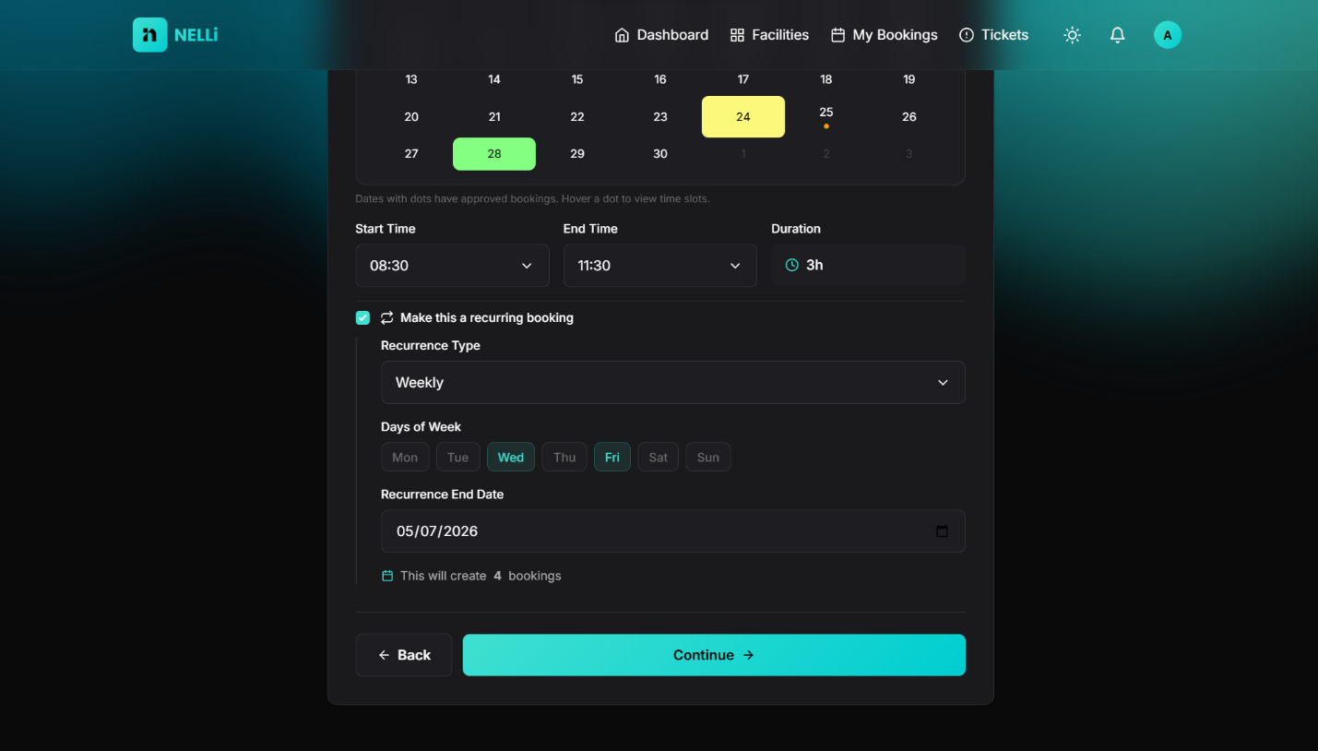

[ Recurring Bookings ]
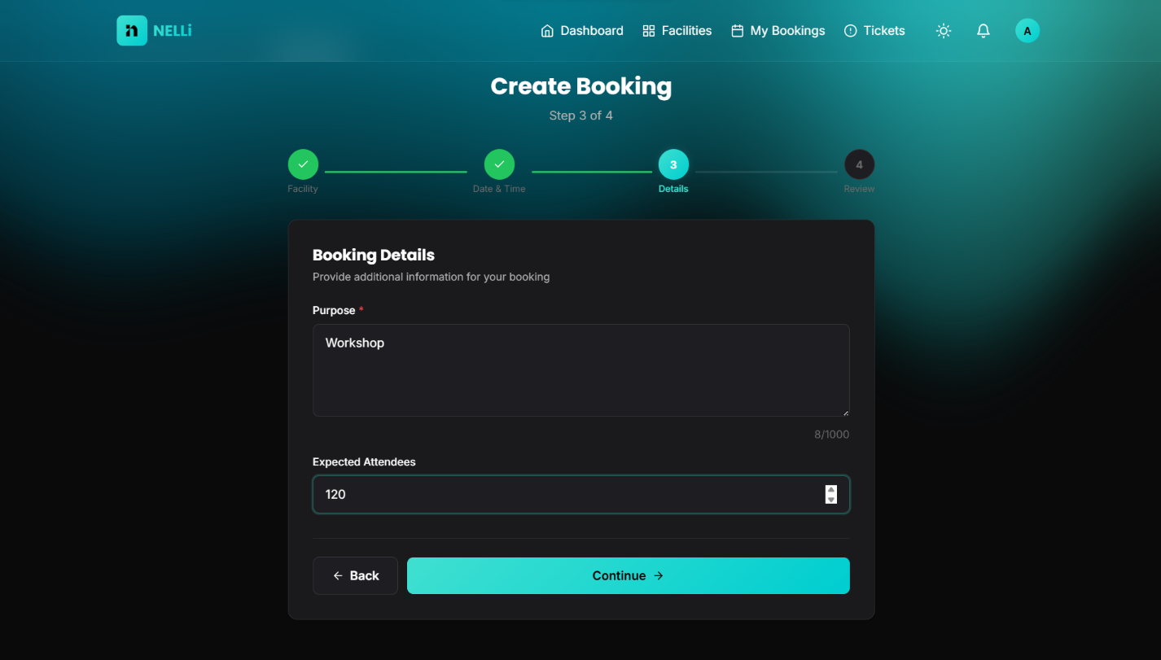

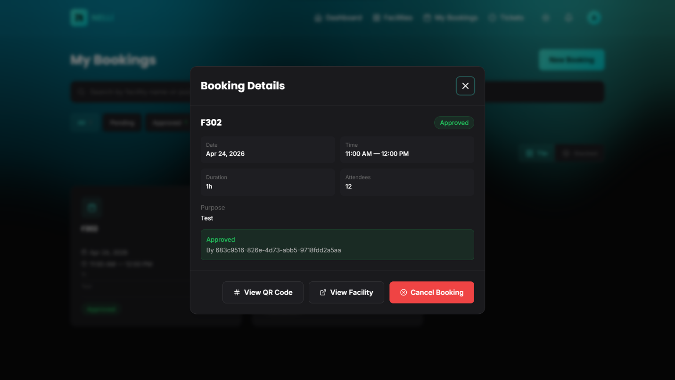

  - Ticketing Component

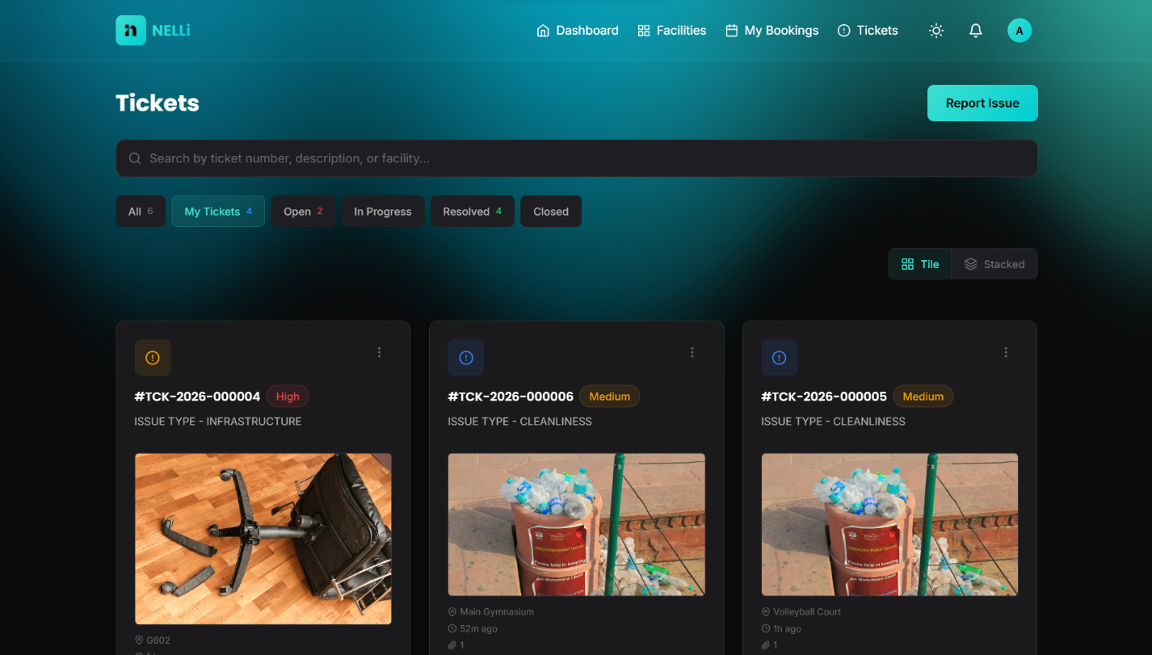
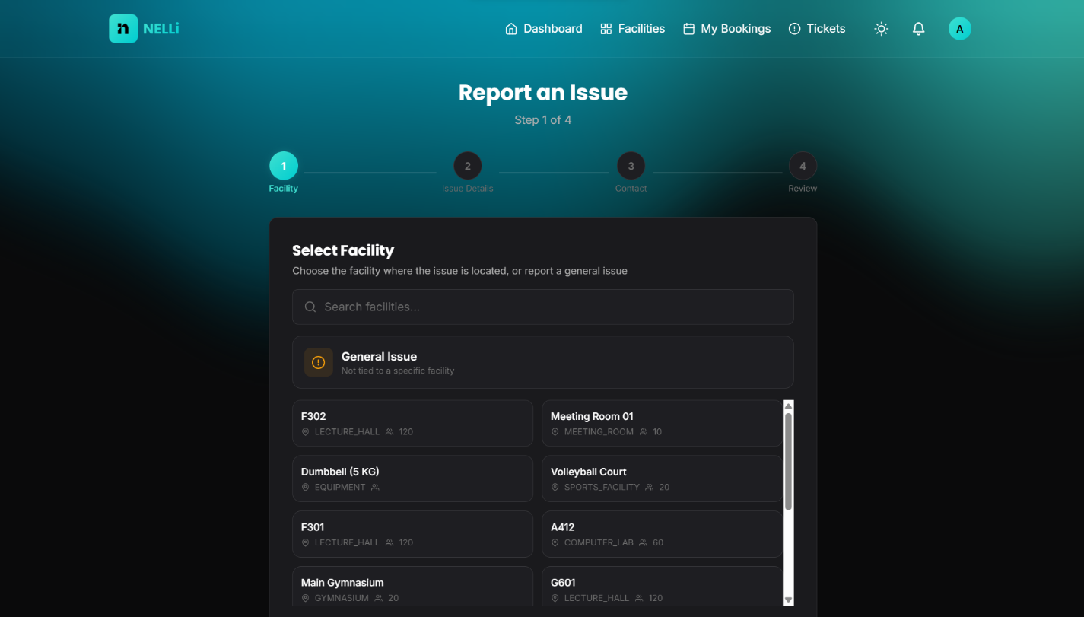

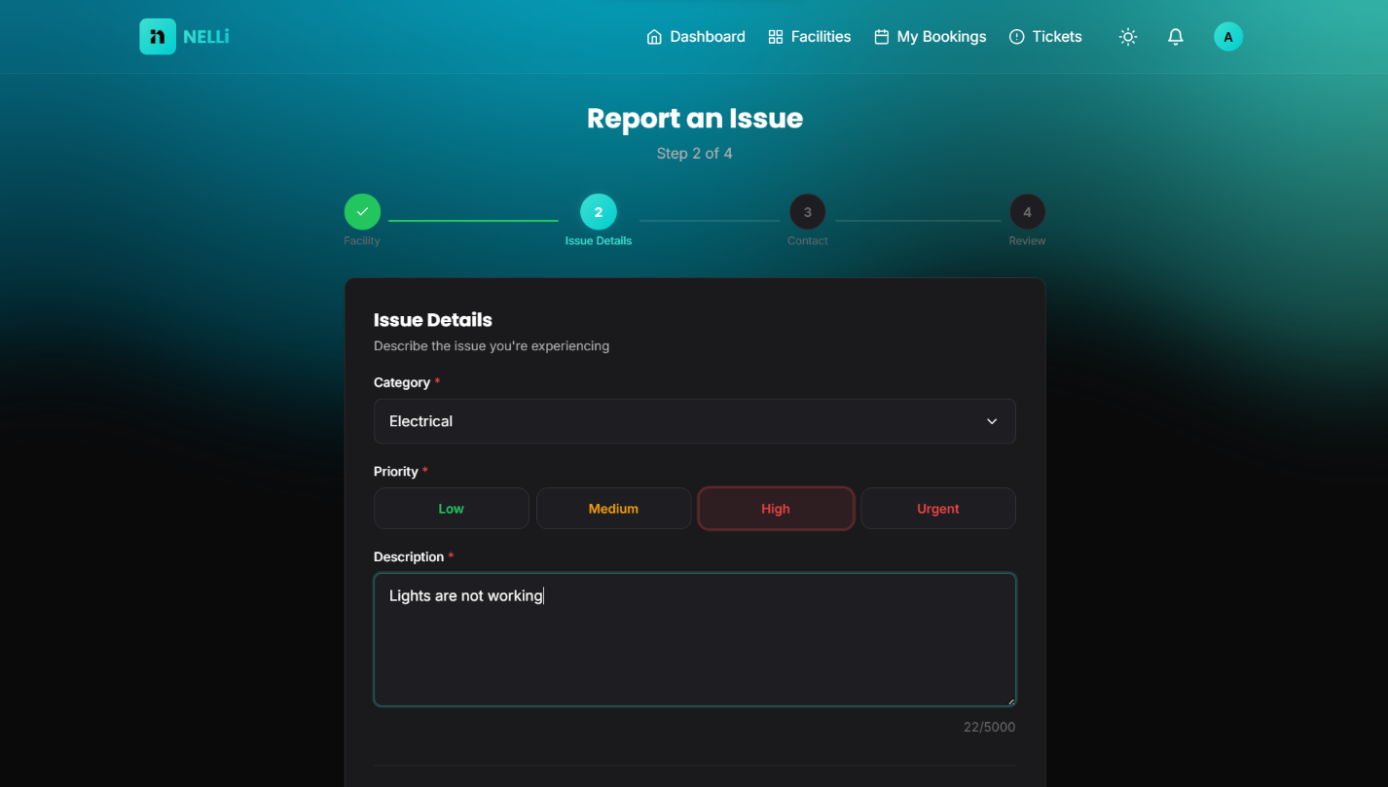
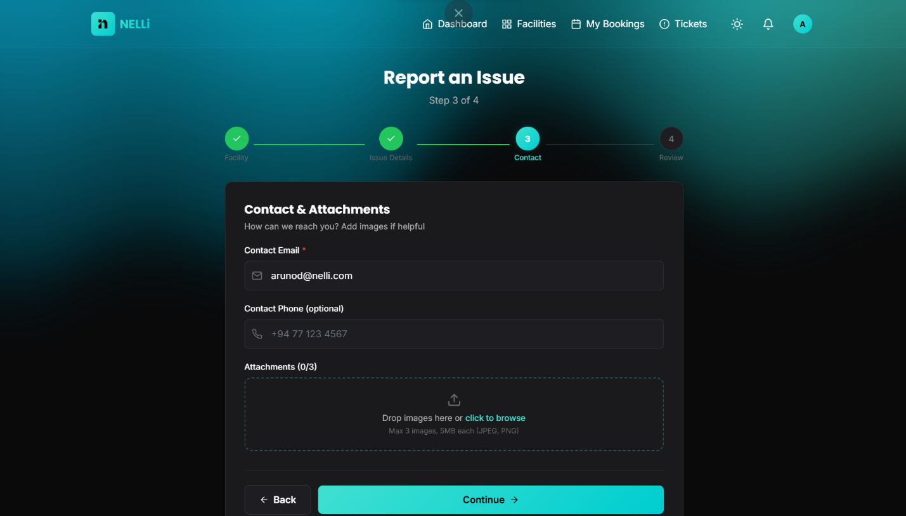

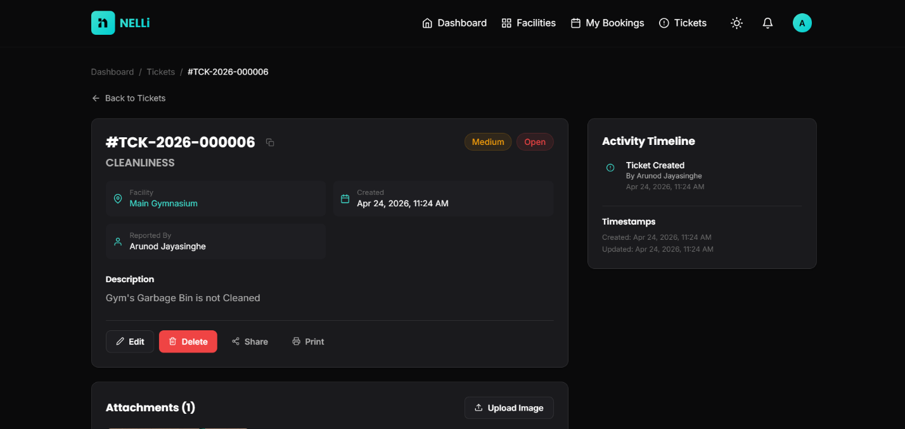

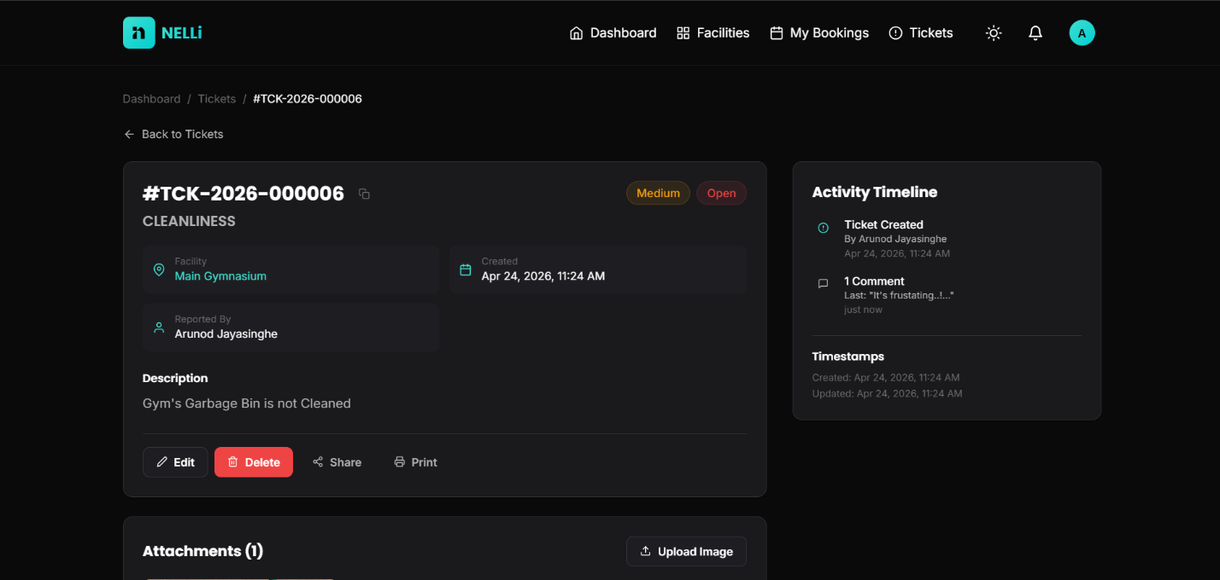

  - QR Code Verification Component

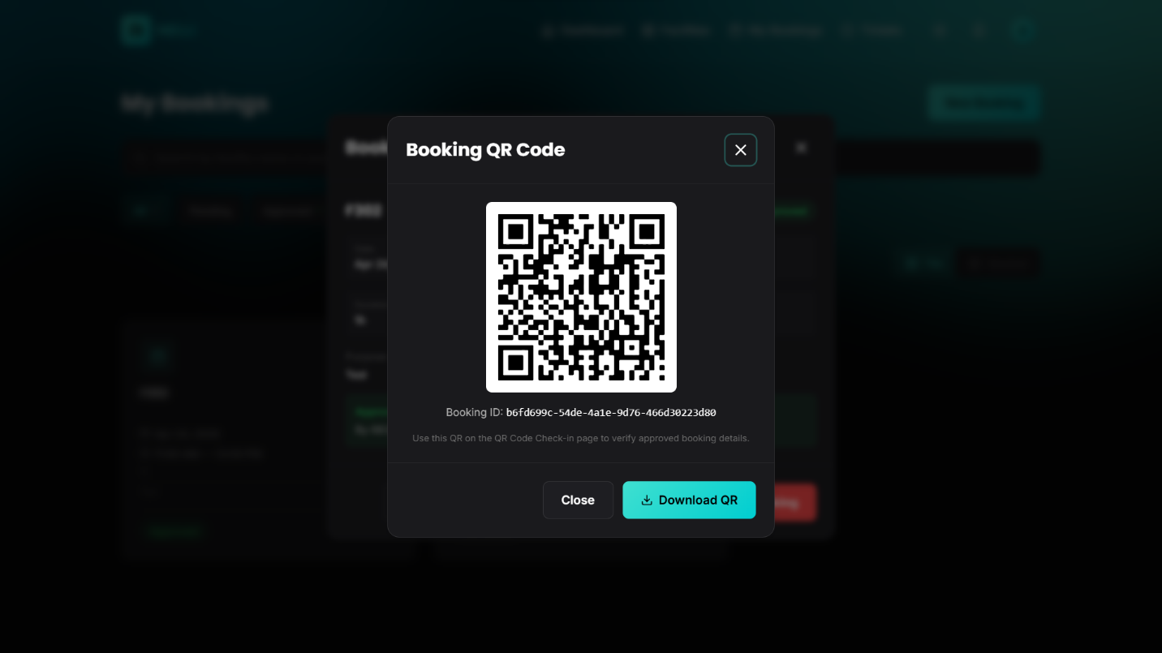

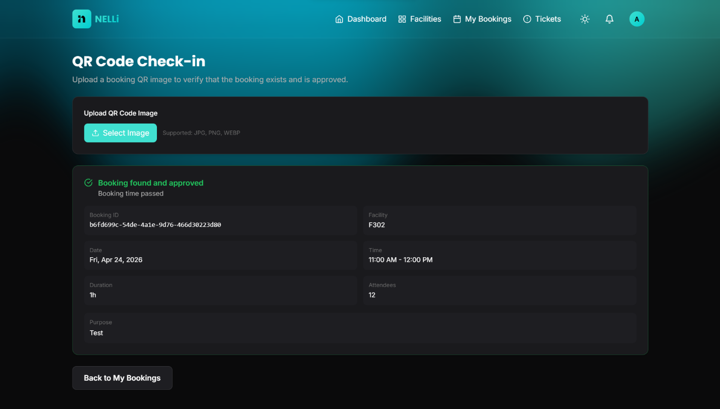

  - Admin Management Components

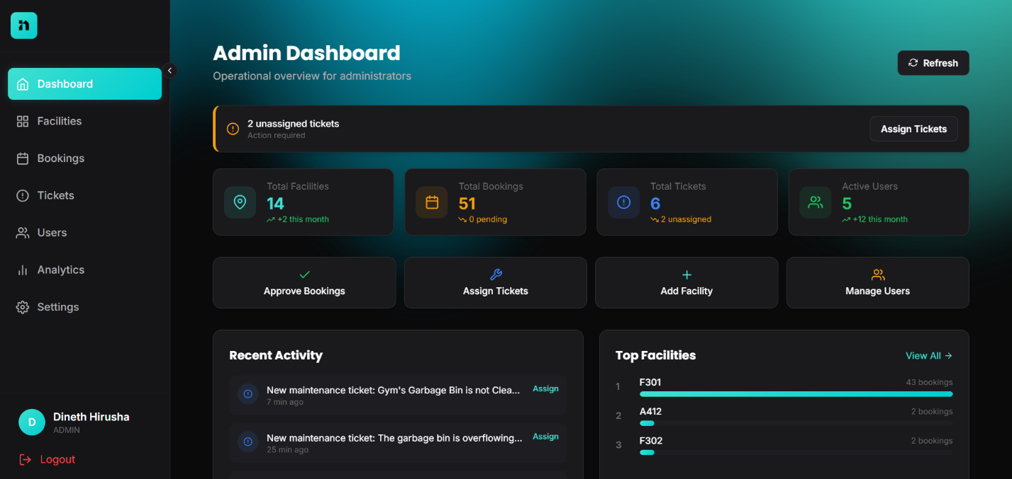

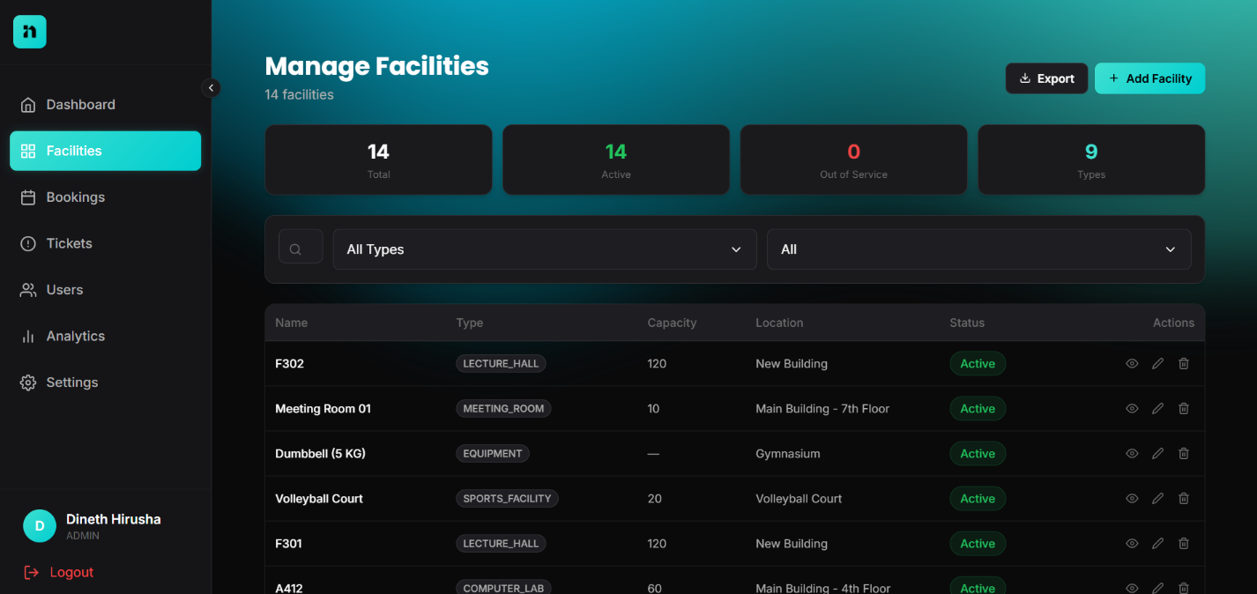

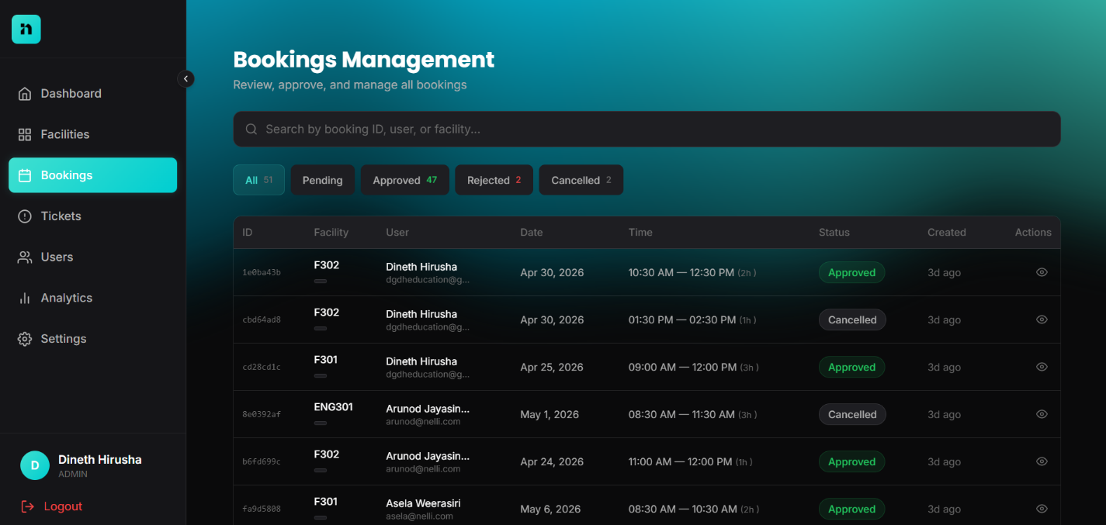

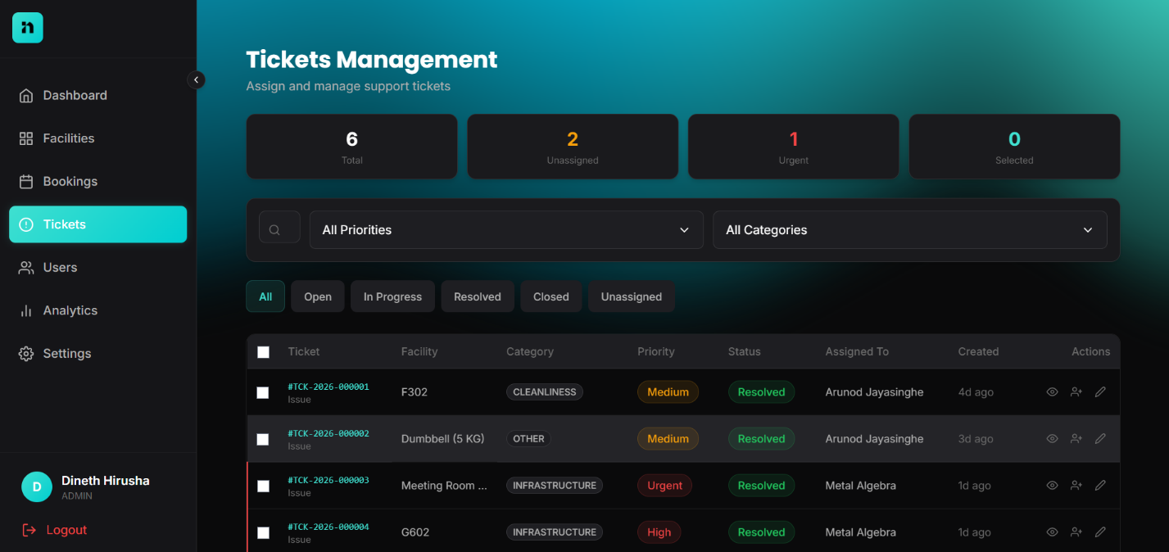

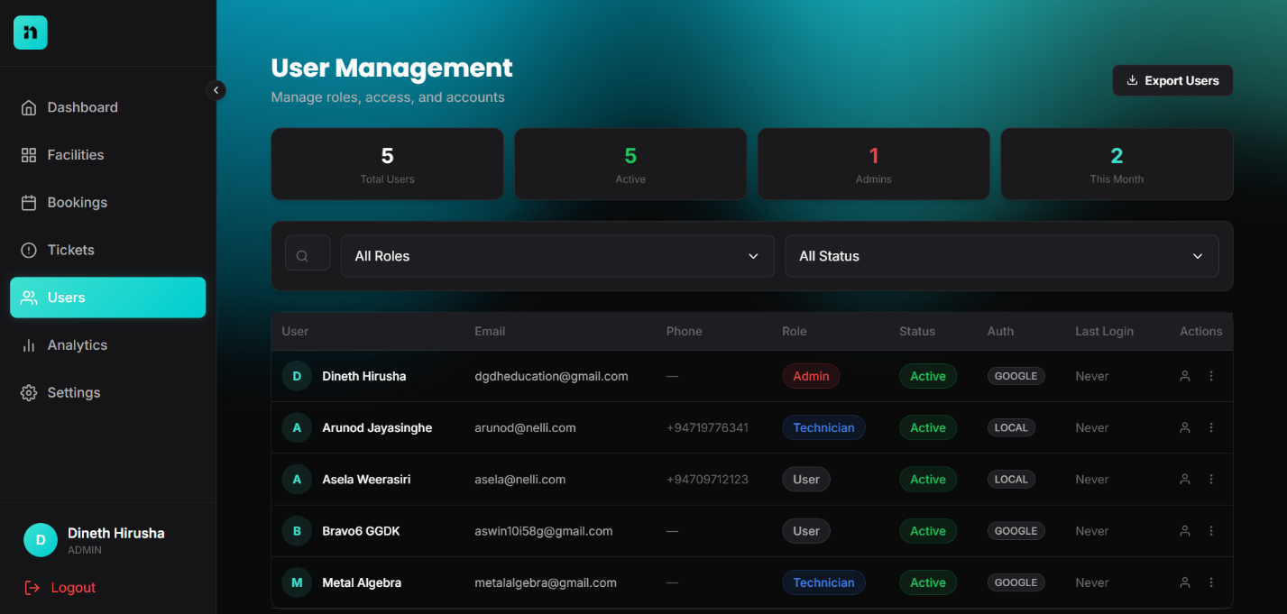

  - Admin Analytics Components

