Experiment 6
KNN-Decision Tree

Objectives
After completing this experiment, you will be able to:
- Getting start with Python
- Solving fundamental math problems
- Plotting data with many graphics

Materials Needed
- Introduction to Python Tutorial: Anaconda: [https://www.youtube.com/watch?v=YJC6ldI3hWk] for window [https://www.youtube.com/watch?v=6LXwdjdACWM]
- Practice Matplotlib: Lab6-Matplotlib.html

Submission
- Each exercise is saved in one file
- Make a zip file and upload the file to blackboard

Procedures

Machine Learning
- Machine Learning is a concept which allows the machine to learn from examples and experience, and that too without being explicitly programmed. So instead of you writing the code, what you do is you feed data to the generic algorithm, and the algorithm/ machine builds the logic based on the given data.
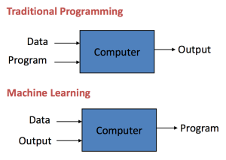
How does Machine Learning Work?
Figure 1 Machine Learning Model
- Machine Learning algorithm is trained using a training data set to create a model. When new input data is introduced to the ML algorithm, it makes a prediction on the basis of the model.
- The prediction is evaluated for accuracy and if the accuracy is acceptable, the Machine Learning algorithm is deployed. If the accuracy is not acceptable, the Machine Learning algorithm is trained again and again with an augmented training data set.
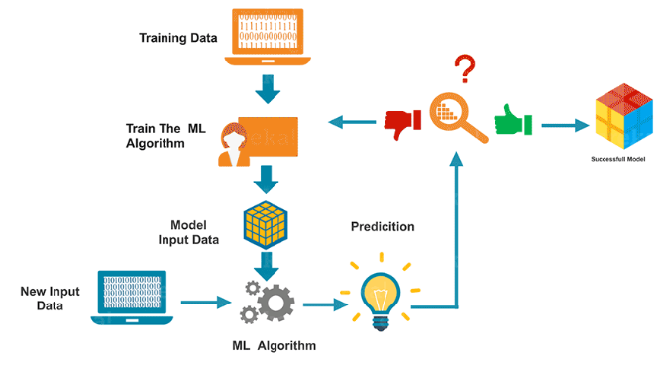
Figure 2 How does ML work?
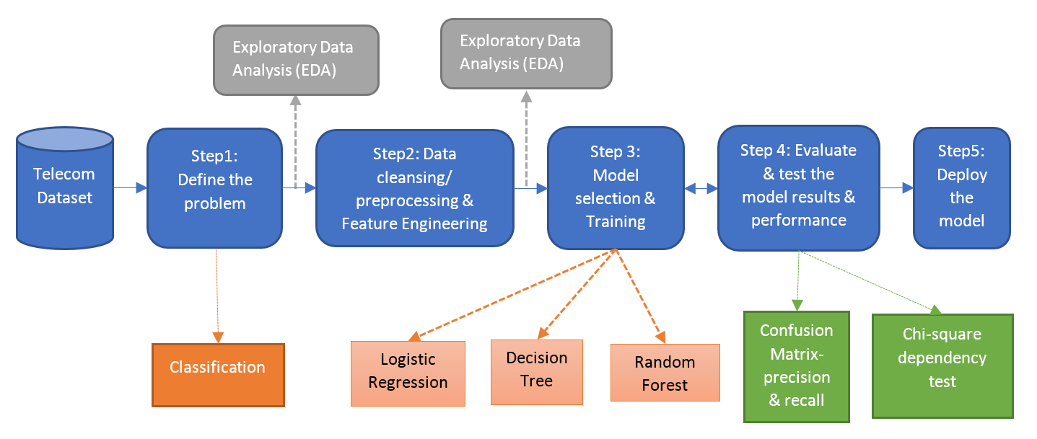
Figure 3 The process of training models

Types of Machine Learning
- What is Supervised Learning?
  - Supervised Learning is the one, where you can consider the learning is guided by a teacher. We have a dataset which acts as a teacher and its role is to train the model or the machine. Once the model gets trained it can start making a prediction or decision when new data is given to it.
- What is Unsupervised Learning?
  - The model learns through observation and finds structures in the data. Once the model is given a dataset, it automatically finds patterns and relationships in the dataset by creating clusters in it.
- What is Reinforcement Learning?
  - It is the ability of an agent to interact with the environment and find out what is the best outcome. It follows the concept of hit and trial method. The agent is rewarded or penalized with a point for a correct or a wrong answer, and on the basis of the positive reward points gained the model trains itself. And again once trained it gets ready to predict the new data presented to it.

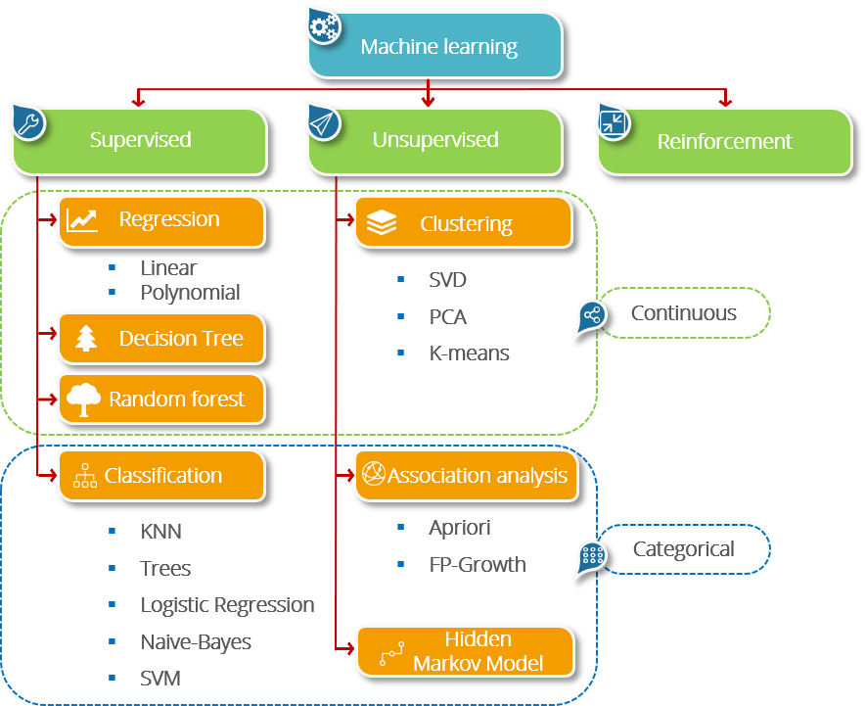
Figure 4 Types of ML

P1. KNN

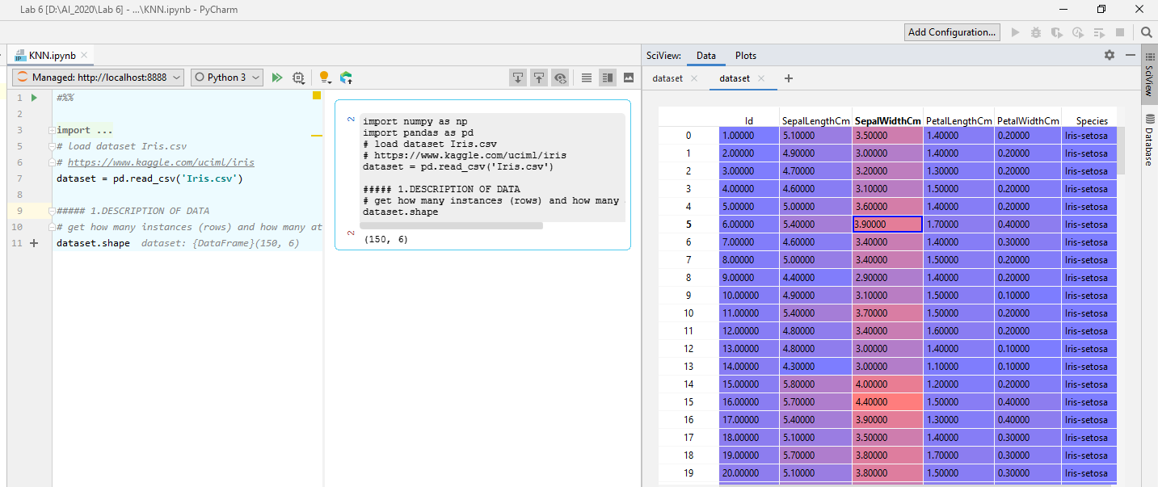

Practice
Solve exercise

P2. DT
Practice 1,2,3
Solve exercise

