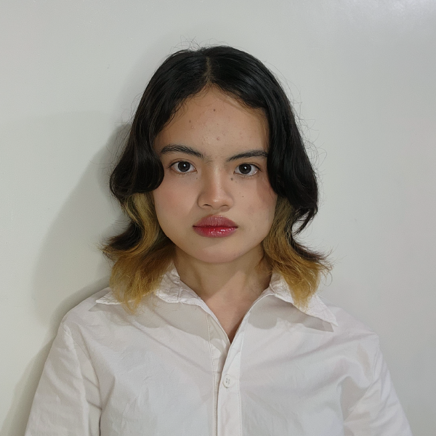
DIANA AMORA PANUGA
Atimonan, Quezon
09151789234
20230084@cstc.edu.ph

CAREER OBJECTIVE
To secure a challenging position in a reputable organization to expand and utilize my learning, knowledge, and skills while making a significant contribution to the success of the company.
PERSONAL DATA

:20
: March 11,2005
: Atimonan
: Filipino
: Single
: Female
: Roman Catholic
: Filipino & English

Age
Date of Birth
Place of Birth
Nationality
Civil Status
Sex
Religion
Language Spoken

EDUCATIONAL ATTAINMENT
2023 – PRESENT
TERTIARY EDUCATION
College of Science, Technology and Communication Inc.
Sariaya, Quezon

2021 – 2023
SECONDARY EDUCATION
Atimonan National Comprehensive High School
Atimonan, Quezon

2012 – 2021
PRIMARY EDUCATION
Malinao Ilaya Integrated National High School
Atimonan, Quezon

SKILLS

Technical Skills:
Proficient in programming languages: C++, C#
Web Development: HTML,CSS,UI/UX design using Figma
Graphic Design: Adobe Illustrator
Database Management: experience with SQL Server Management Studio
Software Proficiency:
Microsoft Excel, Word, and PowerPoint
Soft Skills:
Attention to detail
Collaborative team player
Quick learner, adaptable to new technologies

WORK EXPERIENCE
On-the-Job Training
PHILIPPINE HEALTH INSURANCE
CORPORATION (2017)
Lucena City

Graphic Designer
TEODY REYES STUDIO (2018)
Tayabas City, Quezon

SHS Teacher
COLLEGE OF SCIENCES, TECHNOLOGY AND
COMMUNICATIONS, INC.,
(May 2019 – up to present)
Sariaya, Quezon

REFERENCES

NINO JOSEPH A. BALLARES
SHS Principal
CSTC Sariaya
09*********

Jeorge T. Jader, MIT
Acting Dean, School of Information Technology
Sariaya, Quezon
09*********

TEODY REYES
Professional Photographer
Tayabas, City
09*********

SEMINARS AND TRAININGS ATTENDED
National Service Training Program General Orientation
CSTC Inc. Sariaya, Quezon – September 8,2023
National Service Training Program Seminar and Workshop 2023
CSTC Inc. Sariaya, Quezon – October 16, 2023

Diana A. Panuga
Brgy. Malinao Ilaya
Atimonan, Quezon, 4331
20230084@cstc.edu.ph
I hereby certify that all the information above is true and correct to the best of my knowledge and belief.
09151789234
DIANA A. PANUGA
November 26,2024

Mr. John Smith
Hiring Manager
Tech Innovations Inc.
5th Floor, Pioneer Building
123 Innovation Avenue
Makati City, Metro Manila, 1226

Dear Mr. Smith,
I am writing to express my interest in the Web Developer position at Tech Innovations Inc., as advertised. I am a recent graduate from College of Sciences, Technology and Communications, Inc., holding a Bachelor of Science in Information Technology. My academic background and technical skills make me a strong candidate for this role.

Throughout my studies, I developed a solid foundation in programming and design. I have experience using Adobe Illustrator, Microsoft Excel, and Word, and am proficient in Figma for creating user-friendly interface designs. My knowledge of C++ and C# programming languages, combined with my enthusiasm for learning, enables me to develop efficient and reliable solutions.

I have attached my curriculum vitae for your review, which provides additional details about my educational background, technical skills, and relevant projects.
I am particularly excited about the opportunity to contribute to Tech Innovations Inc. because of your company’s commitment to cutting-edge web technologies. I am confident that my skills and passion for web development align well with the requirements of this position.

I am eager to bring my creativity, technical expertise, and dedication to your team. I would appreciate the opportunity to discuss how I can contribute to the success of Tech Innovations Inc. at your earliest convenience.
Thank you for considering my application. I look forward to the possibility of working with you.

Sincerely,

Diana A. Panuga

