Objective:

To set up your DNS settings through Dyn's Dynect/Dynect SMB for your front-ends and back-end database servers so that they will function properly on Amazon EC2.

Prerequisites:

A registered domain (or you can register with Dyn at: http://www.dyndns.com/services/domains/ )

Overview:

Because instances can be launched and terminated on EC2 depending on a site's need at any given time, it's important that a framework is in place that will allow the DNS settings to point to the proper instances at all times. It is important to use a DNS framework including an API that enables registration of IPaddresses of Servers dynamically. Our MySQL database ServerTemplates contain RightScripts that are designed to use Dyn's Dynect/Dynect SMB API to properly update A Records. This way, the application servers will always be able to connect to the "master" database server at all times.
This tutorial will show you how to use Dyn's Dynect/Dynect SMB to create A Records for your databases and frontends.

Background:

Just to provide a reminder or a bit more context on where setting up your Dyn Dynect/Dynect SMB sits in a typical Deployment building process:
- Create your Elastic IPs
- Setup your Servers using ServerTemplates (for example, Master/Slave Database Servers and front end Servers for your load balancing pool)
- Create and/or configure your Dyn Dynect/Dynext SMB account (you are here!)
- ... Continue configuring your Deployment to suit your needs ...

Steps:

Create a Dyn Dynect or Dynect SMB Account
If you already have a Dyn Dynect or Dynect SMB account you can skip to the next step. If not:
Go to http://dyn.com/why-dyn/solutions and sign up for either the Dynect or Dynect SMB based on your business needs:

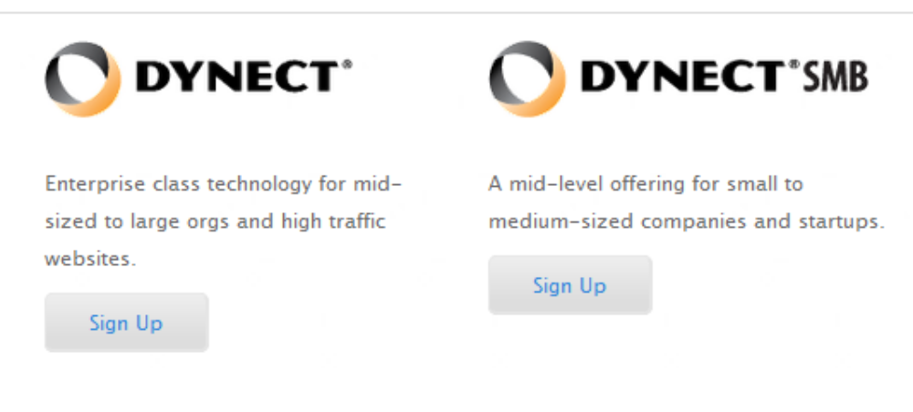

After completing the sign up process your request will be verified with a representative from Dyn and your login credentials will be emailed to you.

If you are just looking to try out the Dyn Dynect/Dynect SMB services before making your final DNS decision you can request a demo account here: http://dyn.com/enterprise-dynect-platform/contact-dynect-sales

Configure your DNS Settings

Once you have your login credentials go to http://www.dyn.com/ and click on the customer login at the top of the page:
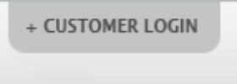
The enter your credentials on the next page:
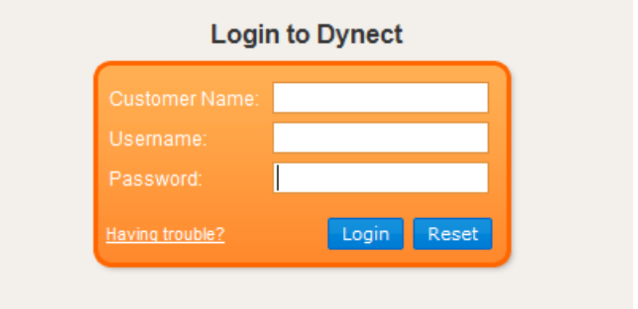
You will be presented with your “Account at a Glance” page. The first thing you have to do is set up a zone for your domain ( if you still have not registered for a domain you may do so through Dyn at http://www.dyndns.com/services/domains/ or any other domain registrar). To set up your new zone, click the “Create Zone” button:
This will bring you to the zone creation page, all that is required to be filled out is the zone name (which is going to be your domain name) and the mailbox which is your email address then click “Create Zone”:

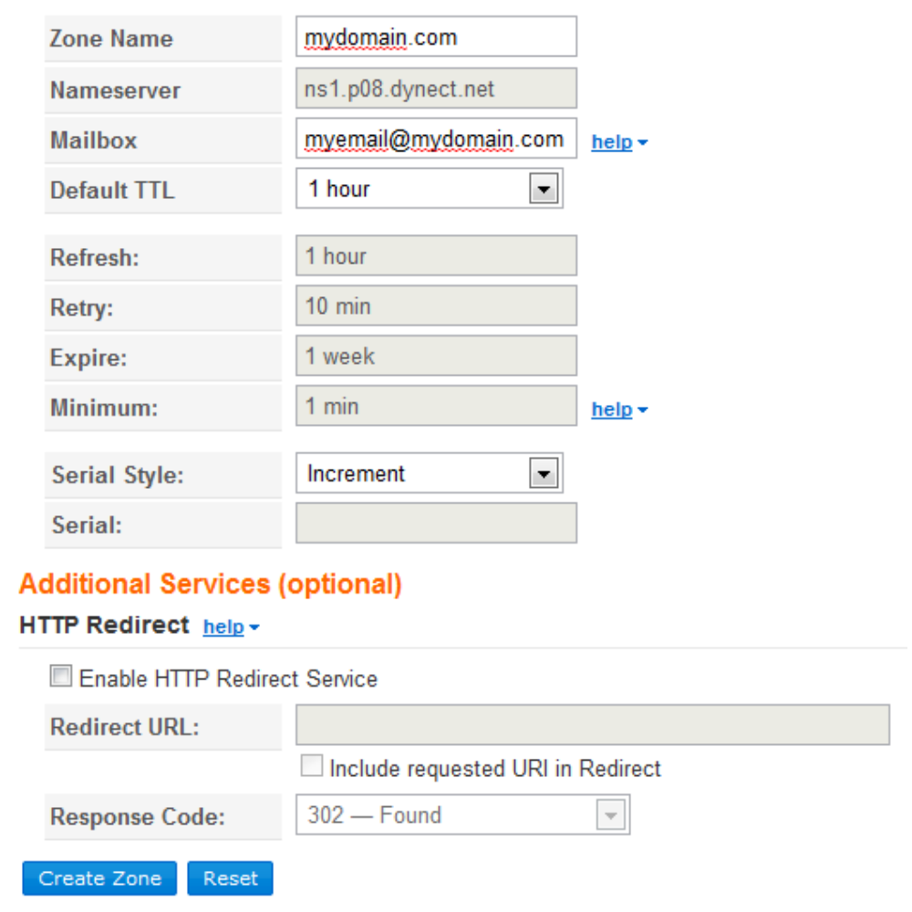

Before your zone is live you must publish it, so on the next page click “Publish Zone”:

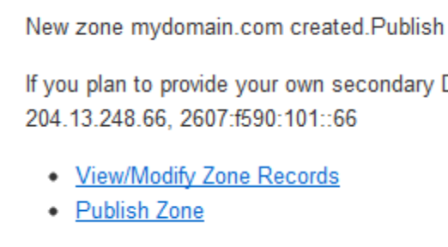
The confirm the publish which will send it live:

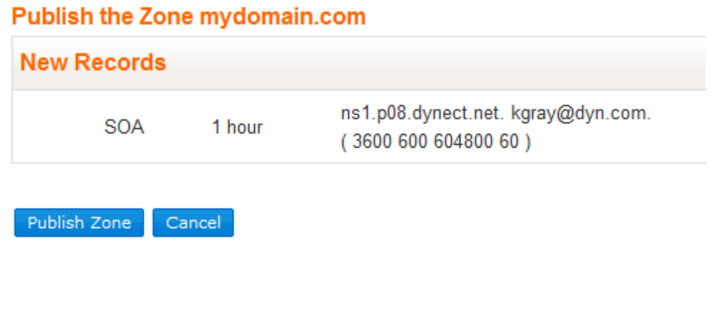
Now the process of setting up your zone is complete!

The next thing you will want to do is select “Simple Editer” from the Dyn Dynect/Dynect SMB zone editor:

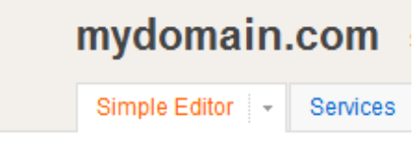
This will show you a list of all records in the zone, currently it will only have an SOA (Start of Authority) and several NS (Name Server) records in the list, these are standard and should be left as is.

*** Make note of the NS records, these are what you will provide to your domain name registrar in order for the look ups to work correctly (if you have questions on how to do this for your registrar you can contact them directly or Dyn support would be happy to help you get set up). ****

Add A Records

The final step to the process is to add your A Records into the zone. The A record is what is used to connect the ip address of your RightScale created EC2 instance to your domain name (which is also the zone name). To do this, from the “Simple Editer” page click the “Add a New Record” drop down and select “(A) – Ipv4 Address”:
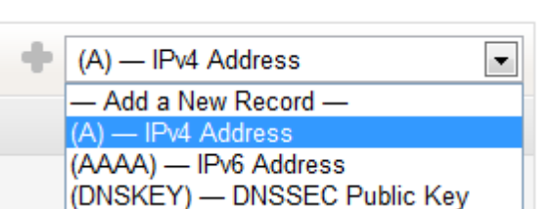

This will bring up the edit box for Add A Record, add in whatever the public ip address of your EC2 instance is (elastic or dynamically created) found on the RightScale dashboard on the “Deployments” tab under “Instances”. Once you have filled this in, click “Add”:

RightScale Instance list:
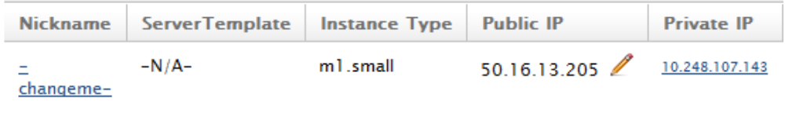
Dyn Dynect/Dynect SMB Add Box:
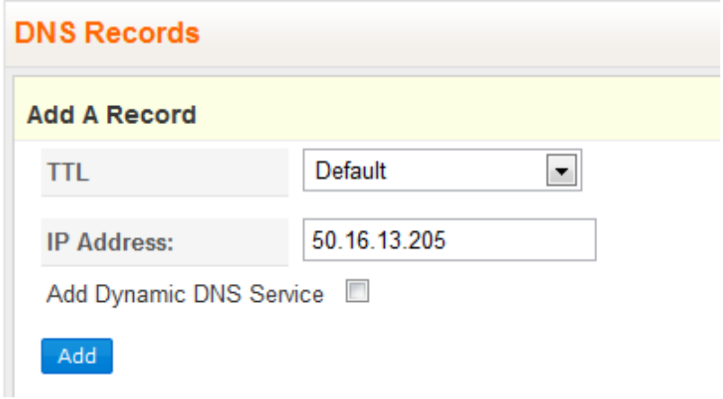
Next click the “Publish Now!” Link at the top of the page to update the live zone:
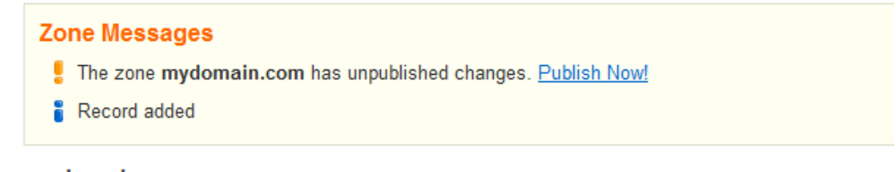
And finally confirm the publish by clicking “Publish Zone”:
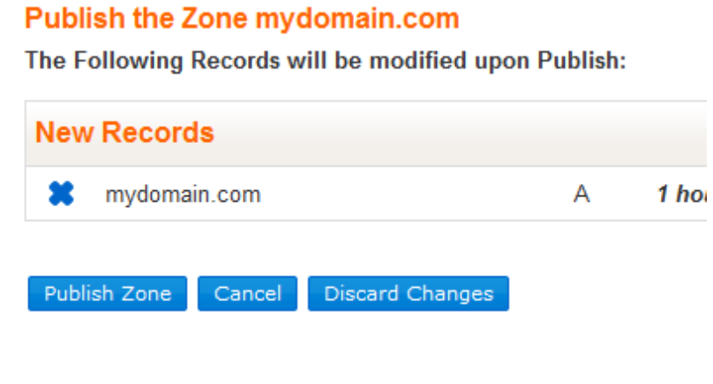
Now your new A Record is in and users will be able to go to your domain and be directed to your EC2 instance setup through RightScale. You can follow the same “Add A Record” procedure for any further server's you create. This is a very simple getting started with Dyn's Dynect/Dynect SMB, for more of the advanced features available there is a users guide on the Support tab within the interface:

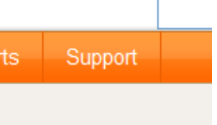
and for questions you can contact Dyn support to help you out!

See Also:

http://www.dyn.com

Dyn RightScale Scripts

