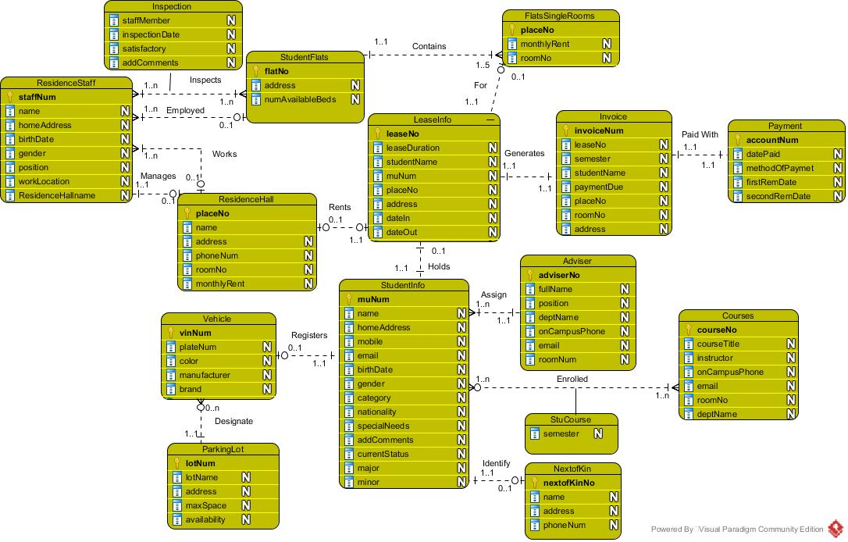

Figure 1 MUHousing--ER Diagram, A Conceptual Model

Note. The ER model needs to be validated against the given queries. Validation will be completed in the next assignment.