VIETNAM GENERAL CONFEDERATION OF LABOR
TON DUC THANG UNIVERSITY
FACULTY OF INFORMATION TECHNOLOGY



Pham Duy Phat – 524H0178
Nguyen Huu Nghia – 524H0171

GROUP ASSIGNMENT 1

SOFTWARE ENGINEERING

HO CHI MINH CITY, 2026
VIETNAM GENERAL CONFEDERATION OF LABOR
TON DUC THANG UNIVERSITY
FACULTY OF INFORMATION TECHNOLOGY



Pham Duy Phat – 524H0178
Nguyen Huu Nghia – 524H0171

GROUP ASSIGNMENT 1

SOFTWARE ENGINEERING

Advised by
Msc. Pham Thai Ky Trung

HO CHI MINH CITY, 2026
ACKNOWLEDGEMENT

We would like to express our sincere gratitude to Mr. Pham Thai Ky Trung, our instructor and mentor, for his valuable guidance and support throughout the mid-term report of our project on Building a book management and ordering system on the MERN stack platform. He has been very helpful and patient in providing us with constructive feedback and suggestions to improve our work. He has also encouraged us to explore new technologies and techniques to enhance our system's functionality and performance. We have learned a lot from his expertise and experience in web development and software engineering. We are honored and privileged to have him as our teacher and supervisor.

Ho Chi Minh city, 3rd April 2026.
Author
(Signature and full name)

Phat
Pham Duy Phat

Nghia
Nguyen Huu Nghia

DECLARATION OF AUTHORSHIP
We hereby declare that this is our own project and is guided by Mr. Trinh Hung Cuong; The content research and results contained herein are central and have not been published in any form before. The data in the tables for analysis, comments and evaluation are collected by the main author from different sources, which are clearly stated in the reference section.
In addition, the project also uses some comments, assessments as well as data of other authors, other organizations with citations and annotated sources.
If something wrong happens, We’ll take full responsibility for the content of my project. Ton Duc Thang University is not related to the infringing rights, the copyrights that We give during the implementation process (if any).
Ho Chi Minh city, 3rd April 2026
Author
(Signature and full name)

Phat
Pham Duy Phat

Nghia
Nguyen Huu Nghia

BUILDING A SELF-SERVICE METRO TICKET VENDING SYSTEM FOR BEN THANH LINE 1
ABSTRACT
With the rapid urbanization of Ho Chi Minh City and the upcoming full-scale operation of the Metro Line 1, managing passenger flow efficiently is a critical challenge. Traditional manual ticketing counters are prone to congestion during peak hours. This project aims to design and implement a "Self-Service Metro Ticket Vending System," a digital Kiosk application that allows passengers to purchase tickets autonomously. Utilizing the ASP.NET MVC framework, Entity Framework, and Microsoft SQL Server, the system provides a robust and secure backend for transaction processing. The frontend is heavily optimized for touch-screen interactions, ensuring a seamless user experience (UX) with support for modern payment methods, including credit cards (NFC/Insert) and digital wallets (MoMo, VNPay, ZaloPay). The outcome is a fully functional prototype that successfully demonstrates end-to-end data processing, from user input to the generation of a scannable barcode ticket and comprehensive revenue reports for administrators.

TABLE OF CONTENT
LIST OF FIGURES 3
CHAPTER 1. INTRODUCTION 4
1.1 Context and Motivation 4
1.2 Project Objectives 4
CHAPTER 2. THEORETICAL BASIS 5
2.1 Backend Architecture and Technologies 5
2.2 Frontend and Database Management 5
CHAPTER 3. DESIGNING AND IMPLEMENTING 6
3.1 System Architecture 6
3.2 System Design (Use Case Modeling) 8
3.3 Database Design (Class Modeling) 8
3.4 Process Flow 9
3.5 System States 11
CHAPTER 4. RESULT 13
4.1 User Interface 13
4.2 System Output 14
REFERENCES 16

LIST OF FIGURES
Figure 3.1 Deployment Diagram 7
Figure 3.2 Use Case Diagram 8
Figure 3.3 Class Diagram 9
Figure 3.4 User Activity Diagram 10
Figure 3.5 Machine Activity Diagram 10
Figure 3.6 Sequence Diagram 11
Figure 3.7 State-Chart Diagram 12
Figure 4.1 Welcome screen 13
Figure 4.2 Database 13
Figure 4.3 Payment Method screen 14
Figure 4.4 Success Transaction sceen 14
Figure 4.5 Report of Transaction and Revenue 15

INTRODUCTION

Context and Motivation
In modern smart cities, public transportation heavily relies on automated systems to ensure efficiency and convenience. As Ho Chi Minh City prepares to launch the Ben Thanh Metro Line, the sheer volume of daily commuters will easily overwhelm traditional manual ticket booths. Prolonged waiting times not only degrade the passenger experience but also pose safety risks in crowded stations. To address this bottleneck, automated Ticket Vending Machines (TVMs) or Kiosks are globally recognized as the standard solution. These self-service terminals distribute the workload, accelerate the purchasing process, and integrate seamlessly with modern cashless payment ecosystems.

Project Objectives
The primary objective of this project is to apply Software Engineering principles to build a reliable, user-friendly ticketing kiosk. The specific goals are:
- Intuitive User Interface (UI): Develop a touch-optimized frontend that requires zero learning curve for passengers of all demographics.
- Payment Flexibility: Simulate a modern payment gateway that accepts both physical cards and QR-based digital wallets.
- Data Integrity: Ensure that all transactions are securely logged into a relational database using strict transaction management to prevent data loss.
- Administrative Management: Provide a secure backend portal for authorized staff to manage station pricing, monitor kiosk hardware status, and generate real-time financial reports.

THEORETICAL BASIS

Backend Architecture and Technologies
The core logic of the system is built upon the ASP.NET MVC (.NET Framework). The Model-View-Controller architectural pattern was selected because it strictly separates the application's concerns, making the code more modular, testable, and maintainable.
To interact with the database, we utilized Entity Framework (Database-First Approach). This Object-Relational Mapper (ORM) allows us to manipulate database records using strongly typed C# objects rather than writing raw, error-prone SQL queries. We also implemented database transaction mechanisms (SqlTransaction) to guarantee the ACID (Atomicity, Consistency, Isolation, Durability) properties during ticket issuance and payment processing.

Frontend and Database Management
For the user interface, we combined HTML5, CSS3, and JavaScript, significantly enhanced by the Bootstrap framework to create responsive, card-based layouts suitable for large touch screens. Custom CSS was applied to implement kiosk-specific constraints, such as disabling text selection and right-click menus, to prevent unintended user errors.
Data persistence is handled by Microsoft SQL Server (MSSQL). The database is designed with high normalization to eliminate redundancy, ensuring that relationships between ticket machines, destinations, and payments are strictly maintained via foreign keys.

DESIGNING AND IMPLEMENTING

System Architecture
This section describes the physical deployment structure and the interactions between the hardware and software components of the Ben Thanh Metro ticket vending system. The architecture is designed based on a distributed model to ensure operational stability and transaction security.
The system consists of three main functional zones:
- Ticket Vendor Machine (Kiosk Hardware): This is the direct point of interaction for passengers, where the TVM Application (a C# Executable) runs. The integrated hardware includes:
- Touch Screen: Receives user interactions and displays the GUI.
- Thermal Ticket Printer: Dispenses paper tickets upon successful transactions.
- Card Reader: Accepts physical bank cards for credit/debit payments.
- Local Server / Cloud: Serves as the central data management hub for the entire system. A Microsoft SQL Server (MSSQL Database) is hosted here to store the list of available routes and all transaction history. The connection between the TVM application and the server is established via TCP/IP within the Local Network using a direct SQL Connection.
- External Payment Gateways: To process cashless transactions, the system connects to external financial partners such as the VNPay API, MoMo API, and standard Banking Systems via a secure internet connection (HTTPS). Authentication requests and payment data are transmitted using REST APIs and Secure APIs to guarantee the safety of customers' financial information.
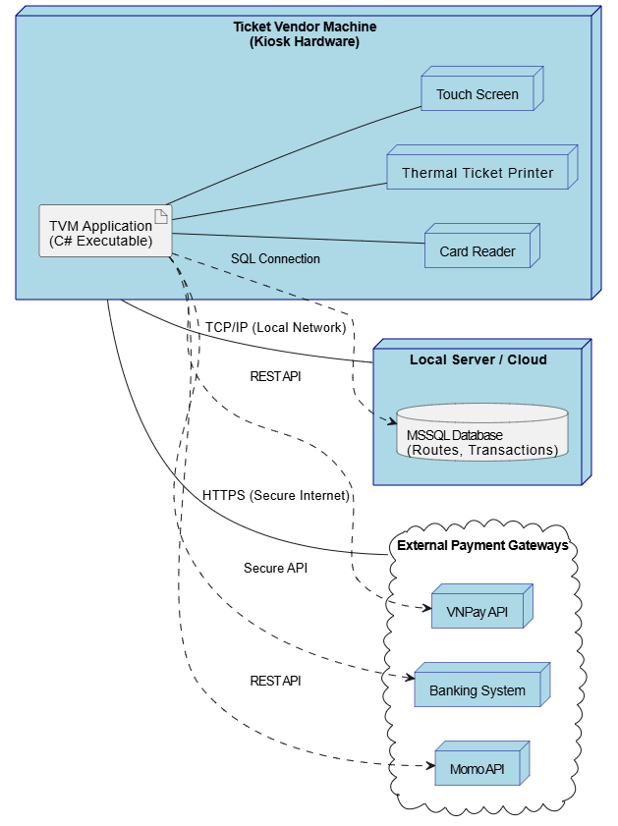
Figure 3.1 Deployment Diagram

System Design (Use Case Modeling)
To capture the functional requirements, a Use Case Diagram was constructed. The system identifies two primary actors:
- Passenger: Can interact with the kiosk to view available destinations, view fares, select payment methods, and receive a printed ticket.
- Administrator: Must authenticate via a secure login to access the backend. Once authorized, they can perform CRUD (Create, Read, Update, Delete) operations on Metro Stations, manage Kiosk Devices, and view Transaction Reports.
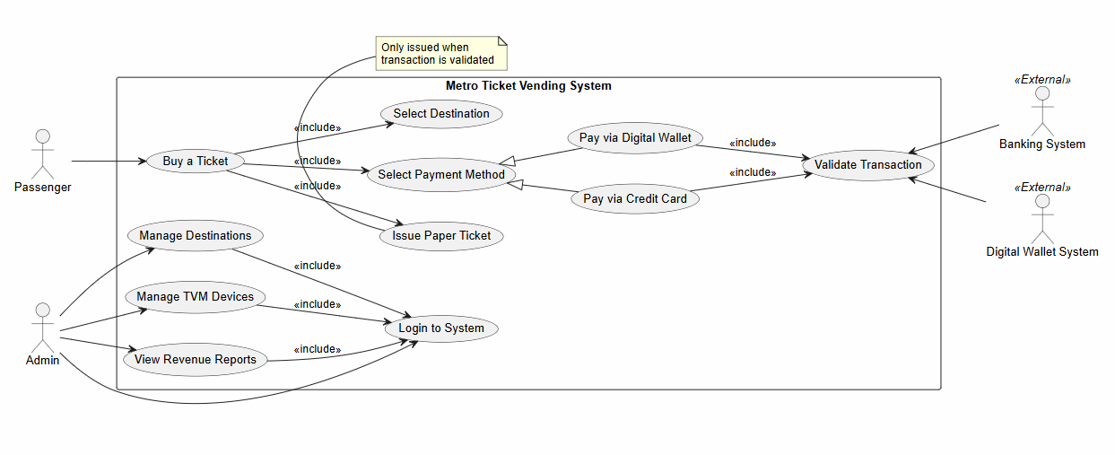
Figure 3.2 Use Case Diagram

Database Design (Class Modeling)
The system's database schema is designed to track the entire lifecycle of a ticket. The core entities include:
- Destination: Stores station names and base fare amounts.
- TicketVendorMachine: Tracks the physical location and operational status of each kiosk.
- Ticket: Generates and stores the unique Barcode and the validity expiration time.
- Payment: Links to the Ticket, recording the exact amount paid, the chosen method (e.g., VNPay, Credit Card), and the transaction status.
- tblUser: Manages administrator credentials and authorization roles.
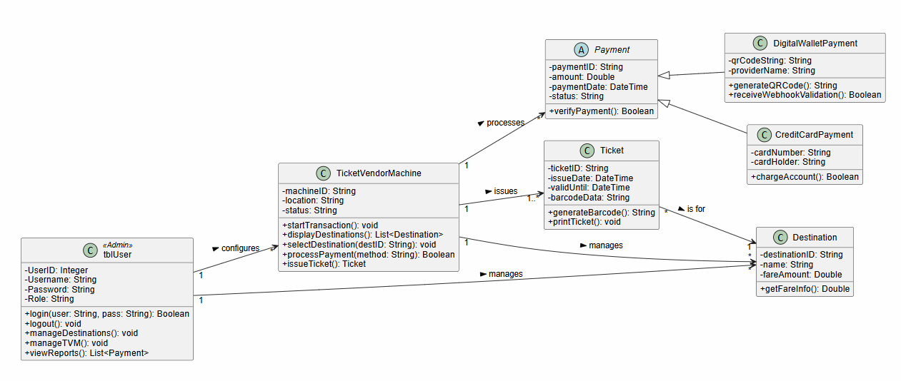
Figure 3.3 Class Diagram

Process Flow
The operational logic is mapped out using Activity and Sequence Diagrams. The passenger journey begins at an idle "Welcome" screen. Upon interacting, the system queries the database for available stations. After selecting a destination, the system temporarily stores the choice and prompts for payment. A simulated processing delay (Loading screen) mimics real-world banking API communication. Upon success, the system simultaneously inserts records into the Ticket and Payment tables before rendering the final barcode interface.
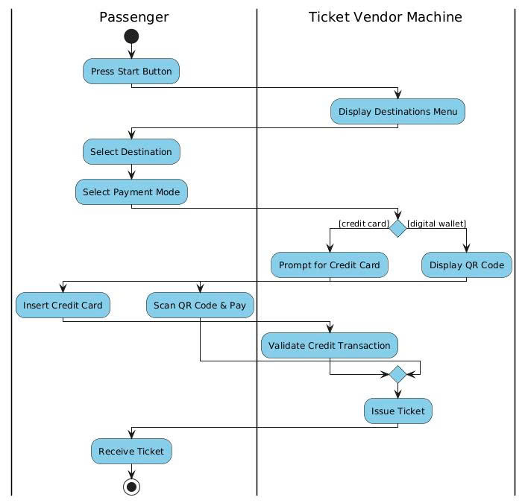
Figure 3.4 User Activity Diagram
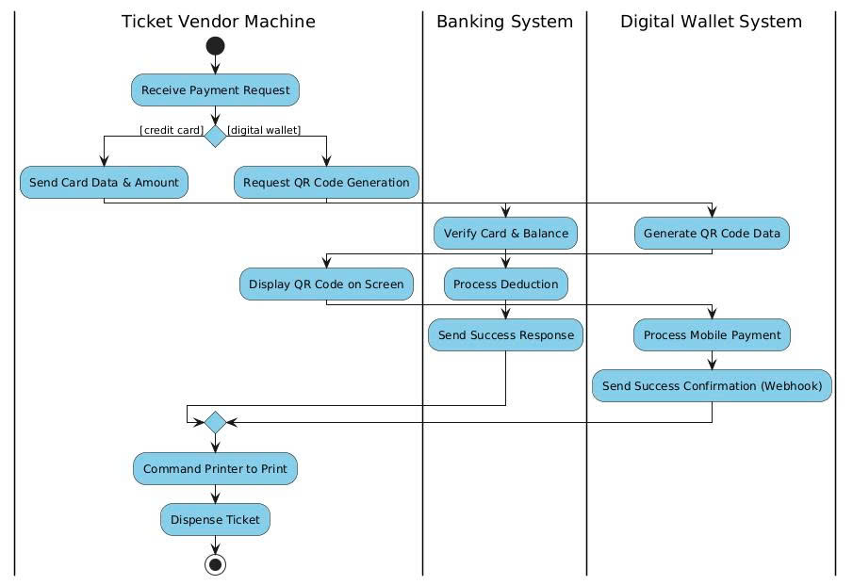
Figure 3.5 Machine Activity Diagram
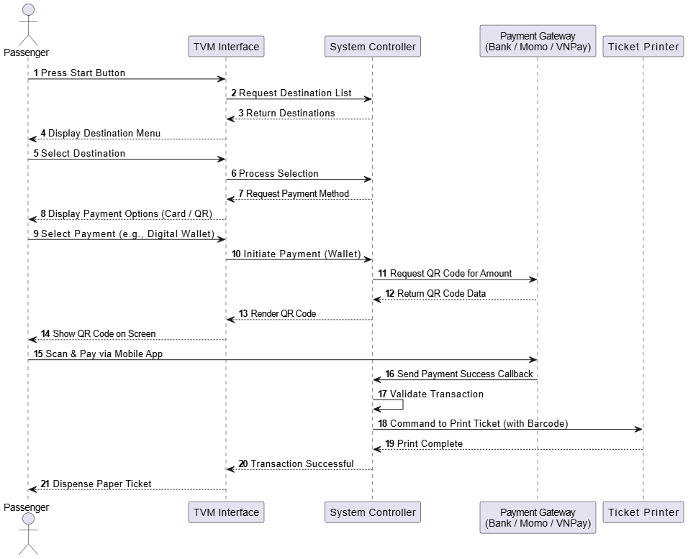
Figure 3.6 Sequence Diagram

System States
The state machine diagram illustrates the operational lifecycle of a Kiosk machine and how the system responds to user events or payment processing outcomes.
The transition process between states is established as follows:
- Idle State: This is the default standby state. When a passenger triggers the "Start button pressed" event on the screen, the system transitions to the DestinationSelection state to display the available stations.
- Transaction Progress: Once a destination is chosen, the system moves to the PaymentMethodSelection state. At this point, depending on the chosen payment method (Card inserted or QR generated), the system enters the ProcessingPayment state to authorize the transaction.
- Processing and Completion:
- If the payment is validated successfully, the machine shifts to the PrintingTicket state to generate the physical ticket, and then to the TicketDispensed state when the ticket is successfully printed. Once the ticket is taken by the passenger, the system automatically returns to the Idle state.
- In the event of a payment failure or an invalid card, the system loops back to the PaymentMethodSelection state, allowing the passenger to try again or choose an alternative method rather than restarting the entire process.
- Cancellation and Timeout Mechanism: To optimize service efficiency, during the destination or payment selection phases, if the passenger explicitly cancels the transaction or if no interaction occurs for a specified period (Timeout / Cancel), the system aborts the current session and immediately resets to the Idle state.
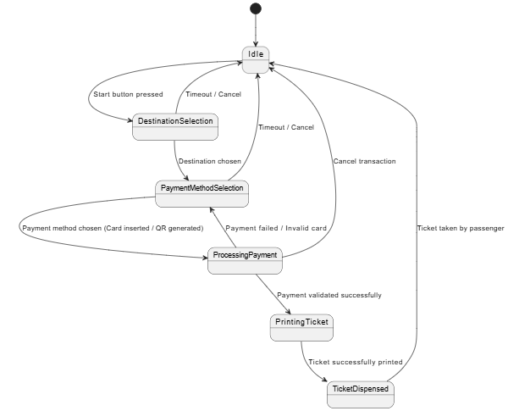
Figure 3.7 State-Chart Diagram

RESULT

User Interface
The user interface was successfully transformed into a touch-friendly kiosk format.
Step 1: The passenger is greeted by an engaging Welcome screen.
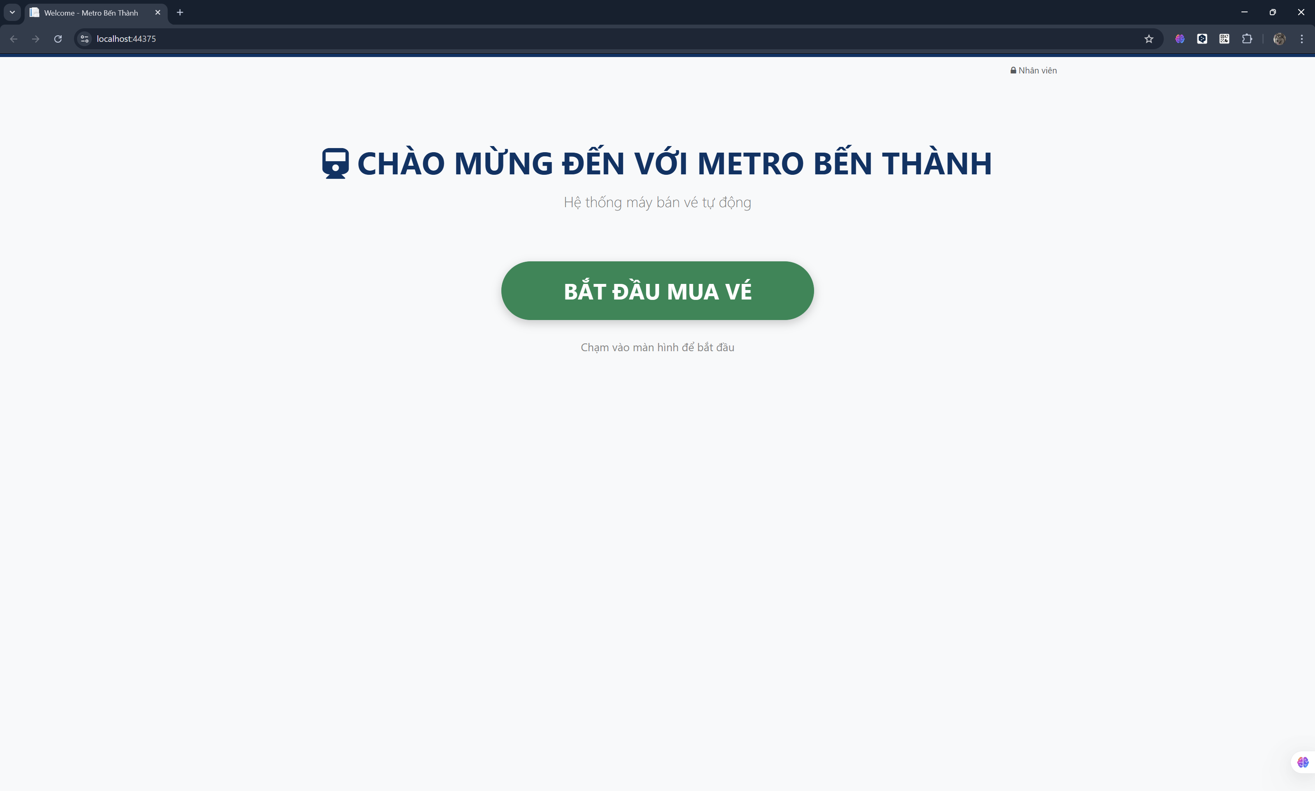
Figure 4.1 Welcome screen
Step 2: The Destination Selection screen dynamically renders available stations and fares retrieved directly from the MSSQL database.
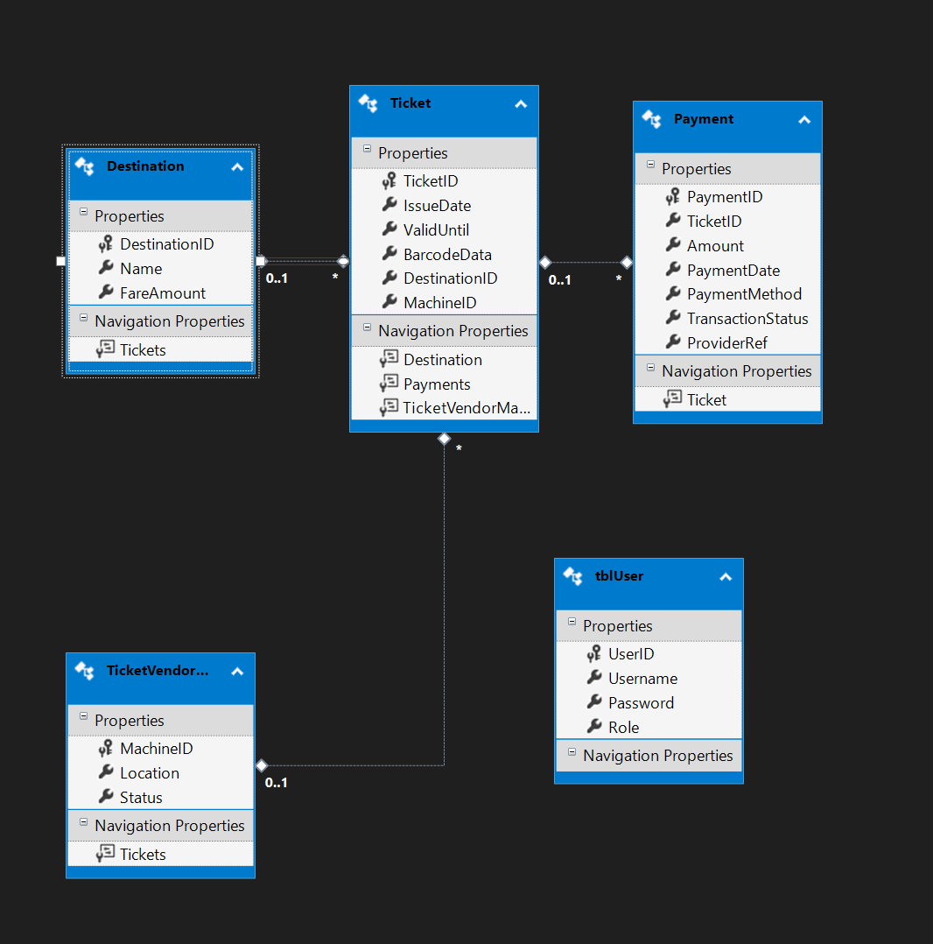
Figure 4.2 Database
Step 3: The Payment Method screen offers large, easily tappable options for modern payment methods.
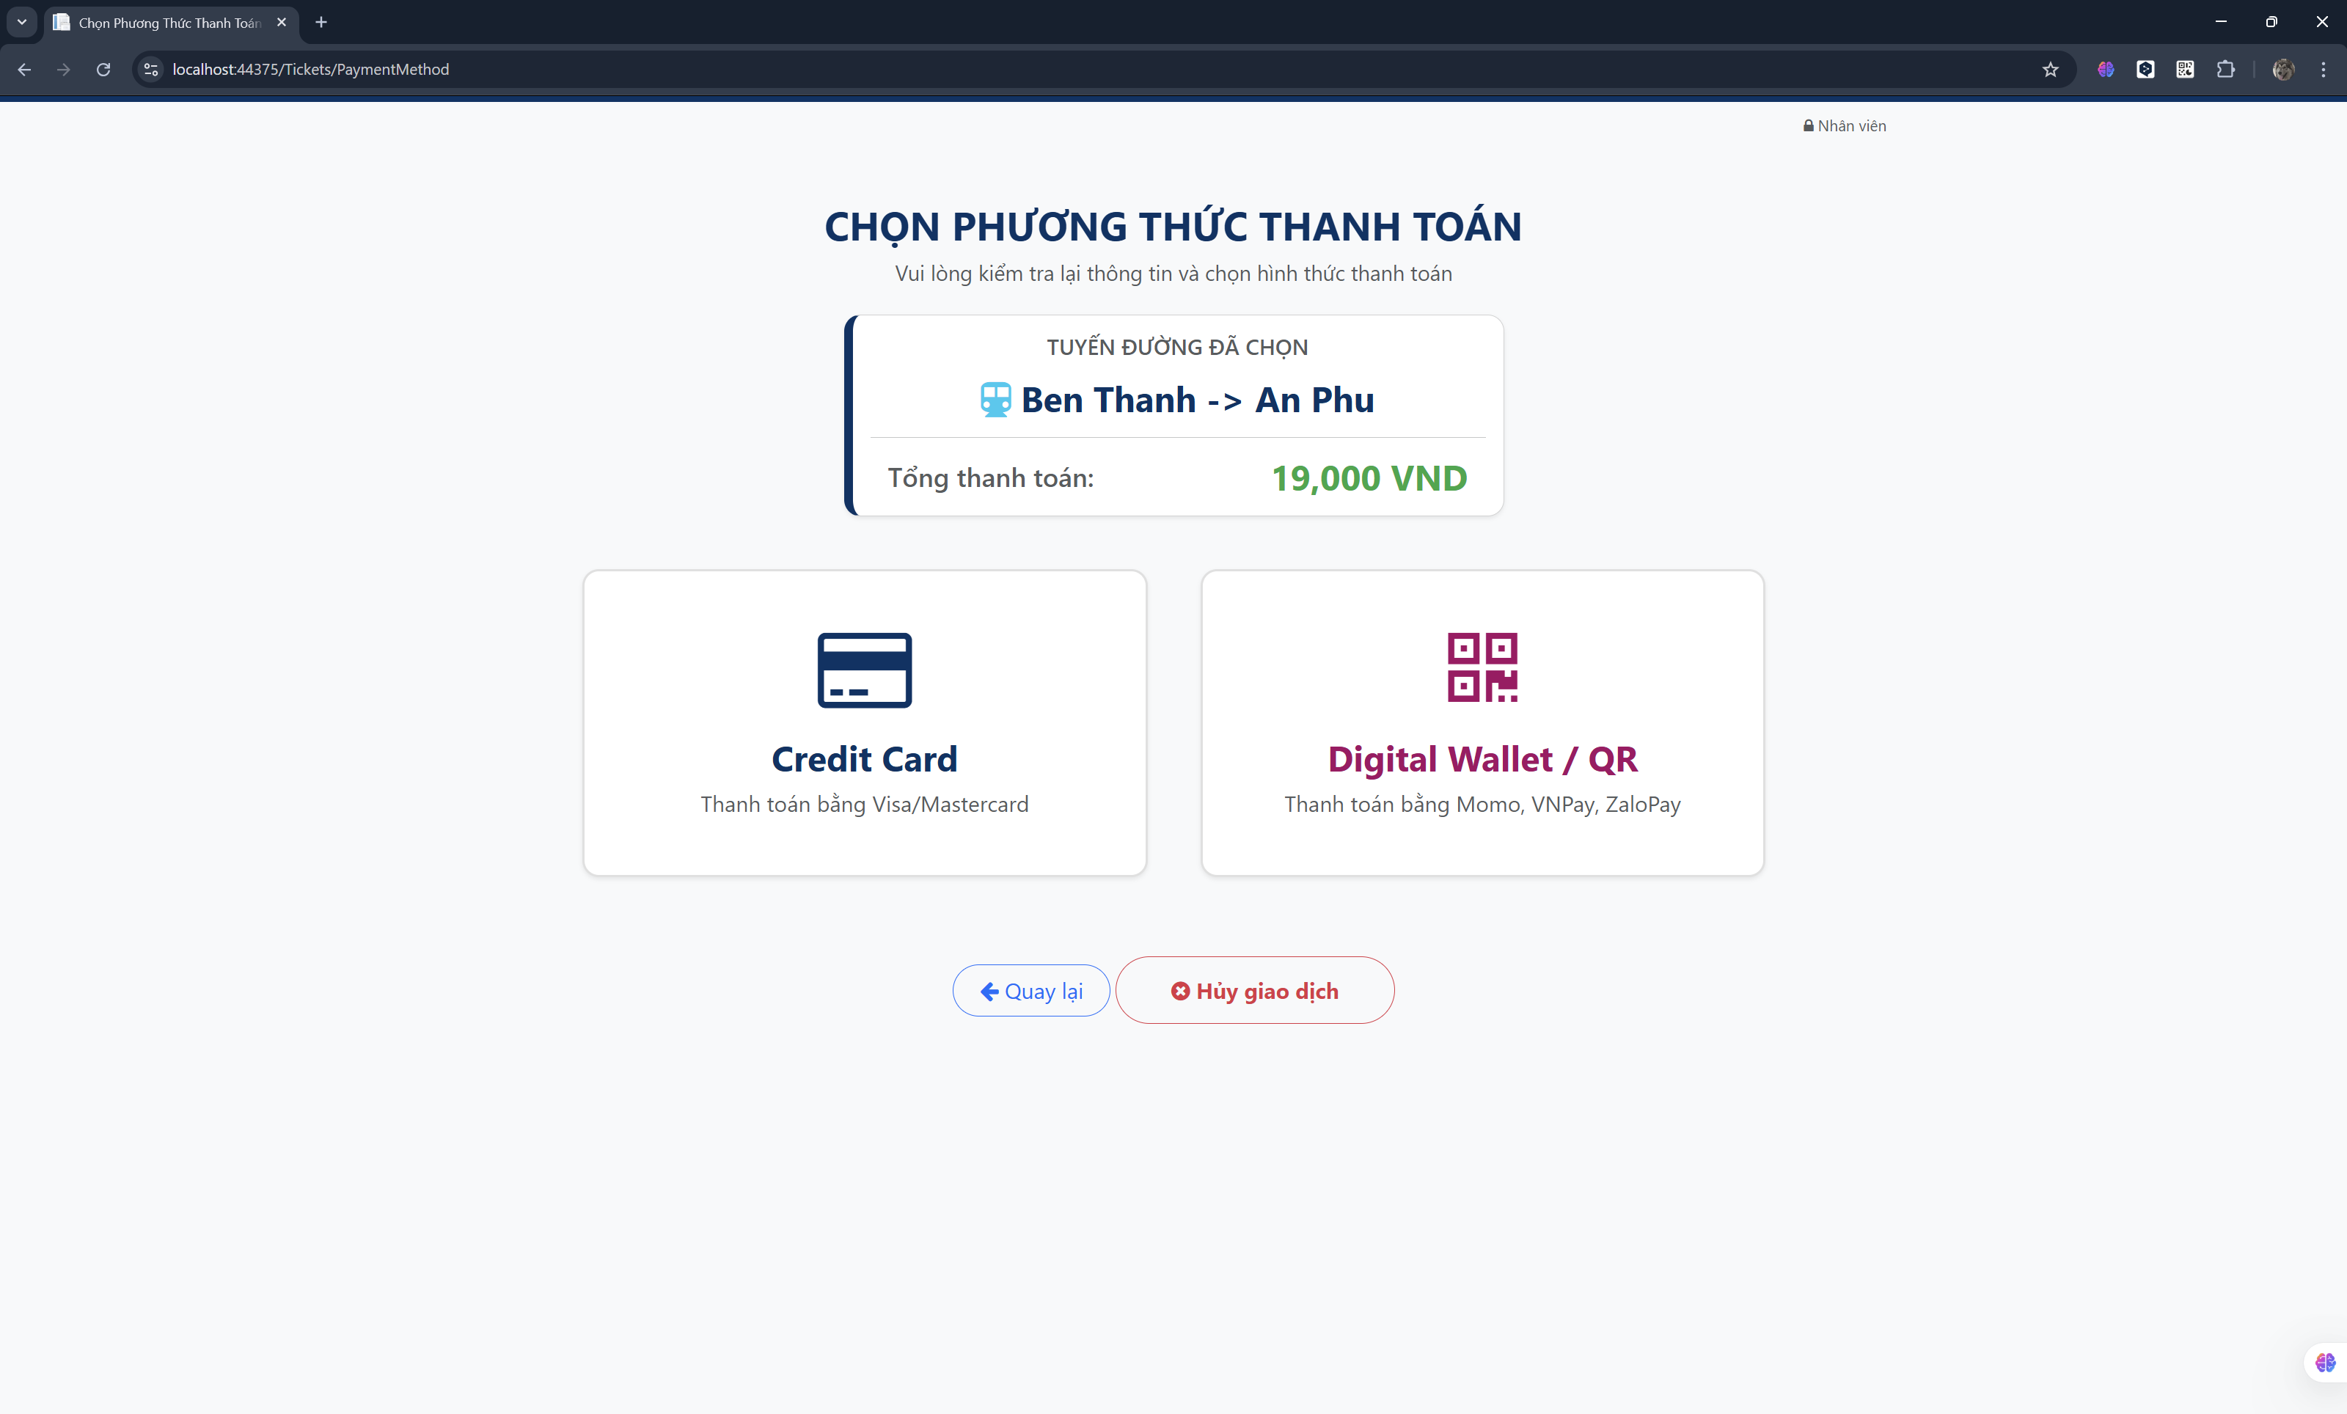
Figure 4.3 Payment Method screen

System Output
After processing the input, the system successfully generates the required outputs:
Passenger Output:
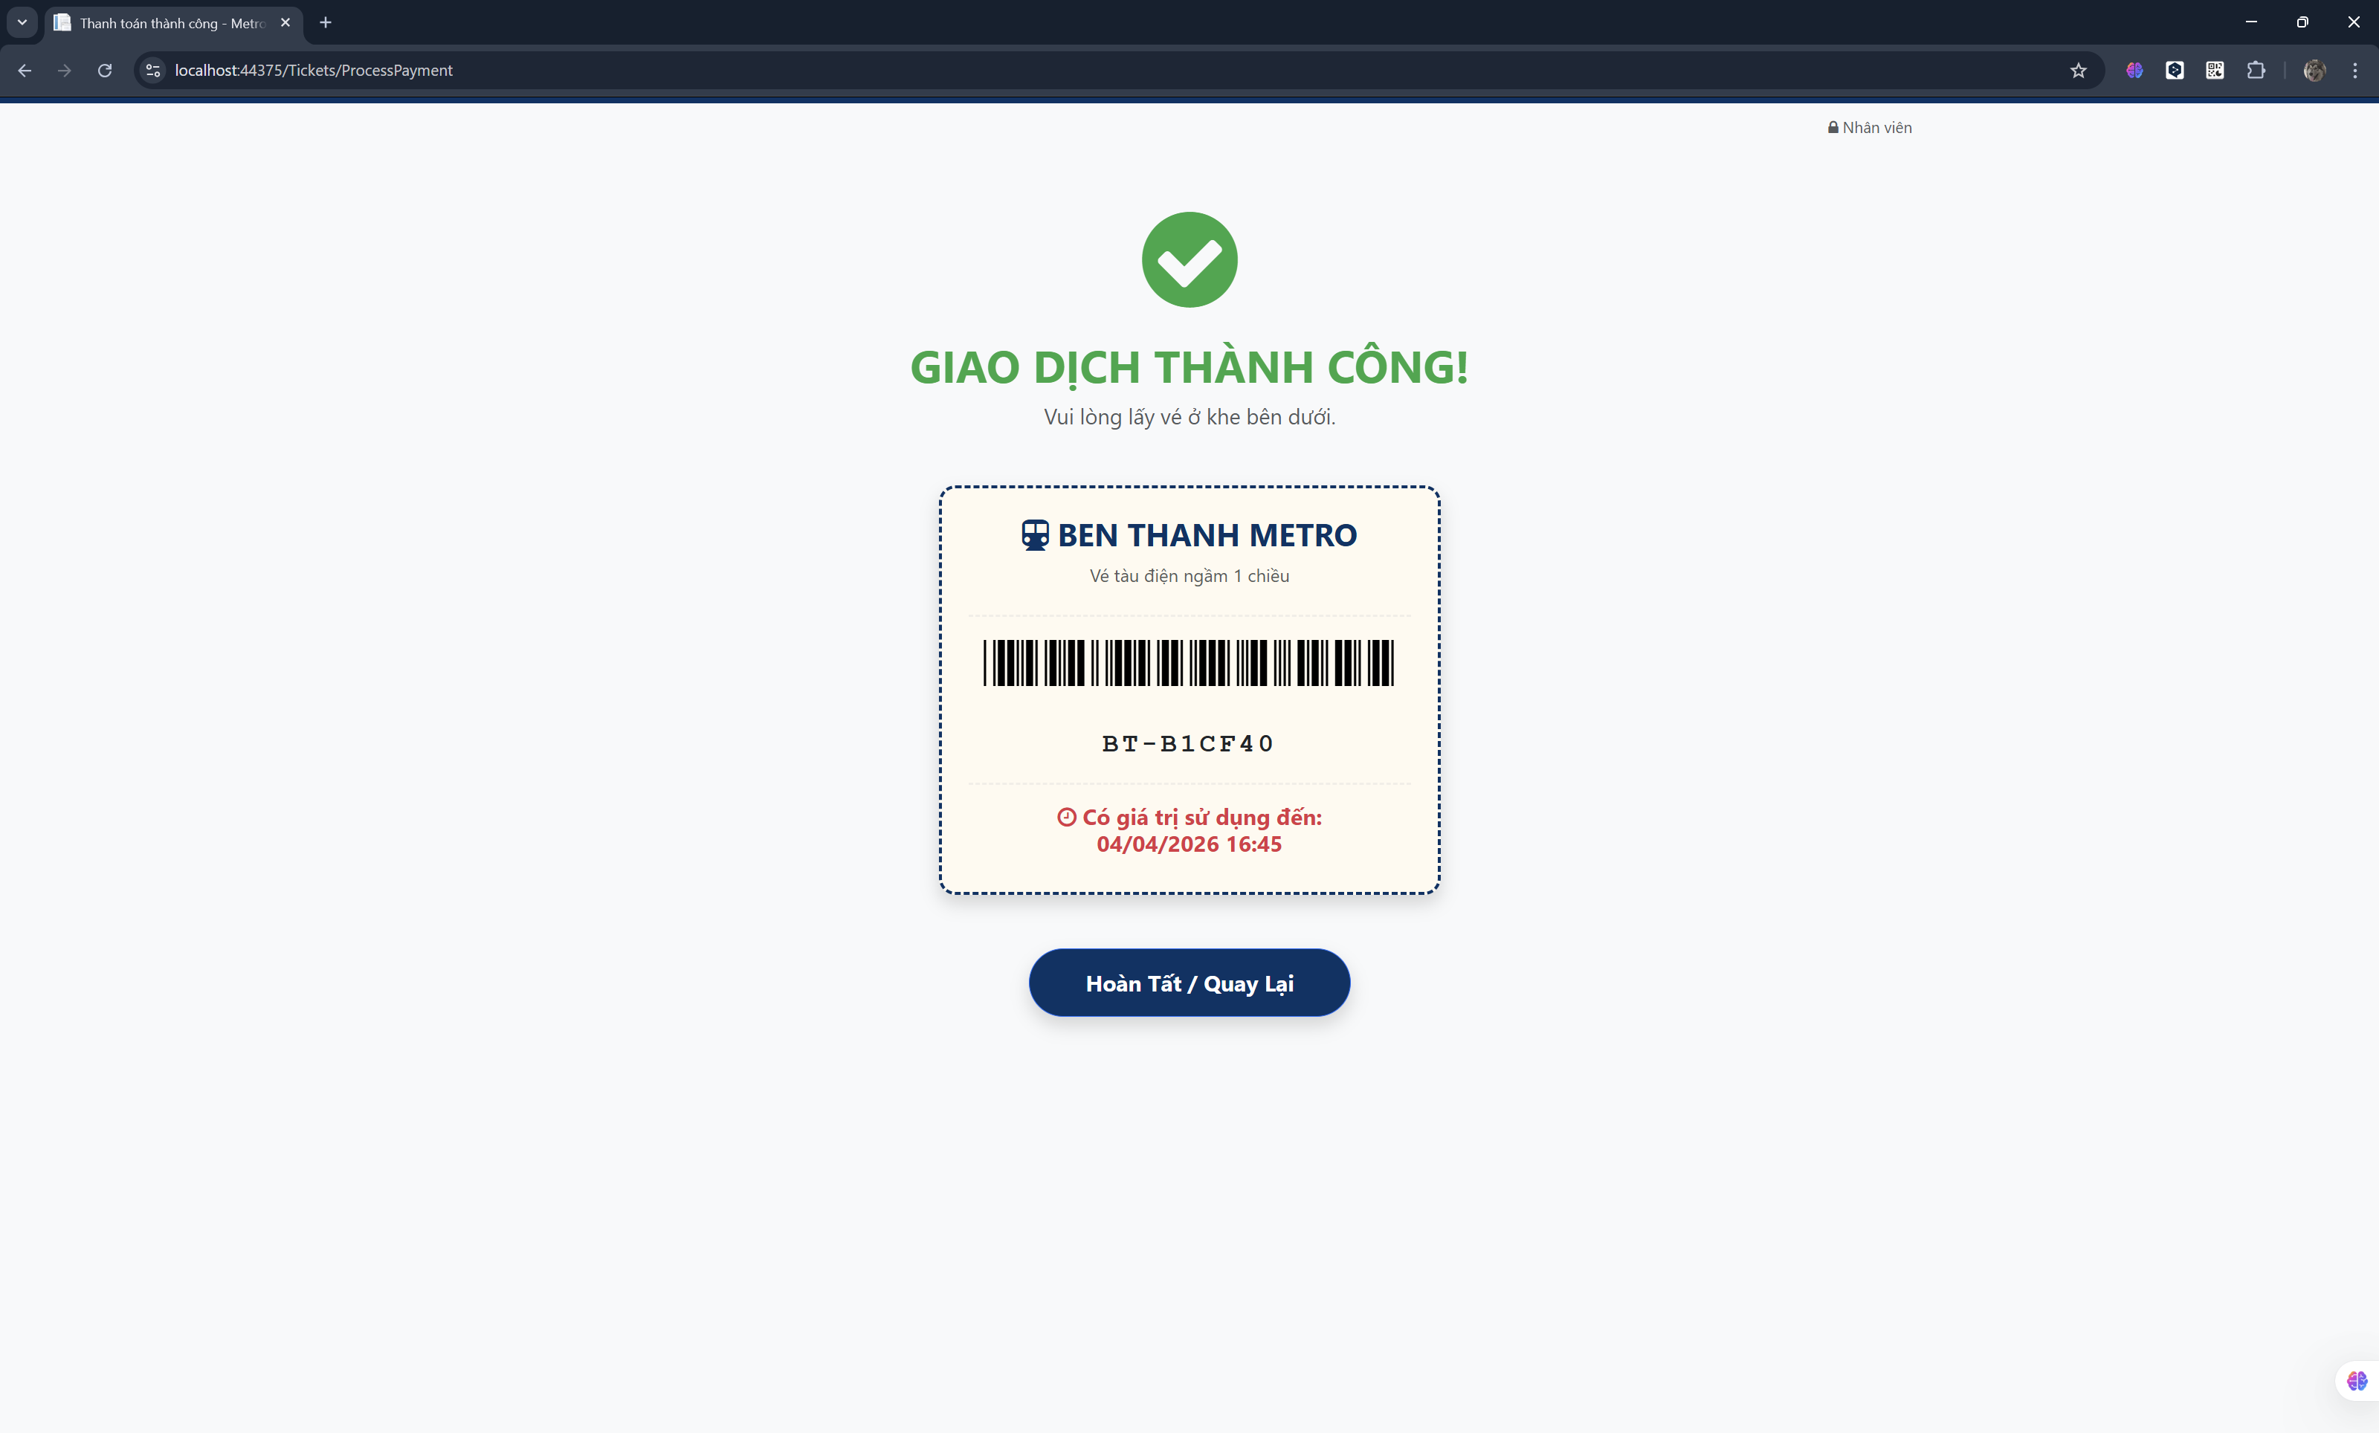
Figure 4.4 Success Transaction sceen
Administrator’s Output (Report):
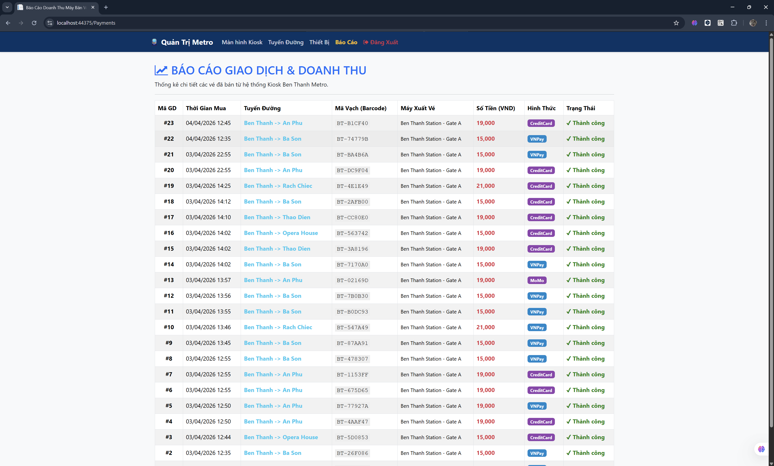
Figure 4.5 Report of Transaction and Revenue

Link github repo: https://github.com/dyphat0711/Ticket-Vendor-Machine.git

REFERENCES

(n.d.). Retrieved from Microsoft Corporation. (2023). ASP.NET MVC Overview. Retrieved from Microsoft Learn:: https://learn.microsoft.com/en-us/aspnet/mvc/
(n.d.). Retrieved from Microsoft Corporation. (2023). Entity Framework Documentation. Retrieved from Microsoft Learn:: https://learn.microsoft.com/en-us/ef/
Faculty of Information Technology, T. D. (n.d.). Retrieved from Software Engineering - Lab 6 Guidelines: ASP.NET MVC and Database Connectivity.

