**Name: Srushti Haridas Patil  
Class: SE (A)  
Roll No: SEAD22516  
Subject: IOTL**

**Lab Practical 5**

**Problem Statement:**Write a program using Raspberry-pi to control LED (One or more ON/OFF) or Blinking

//Code:

import time  
from gpiozero import LED  
led1 =LED(7)  
led2 =LED(22)  
led3 =LED(23)  
led4 =LED(25)  
while True:  
 try:  
 led1.off()  
 time.sleep(0.5)  
 led1.on()  
 led2.off()  
 time.sleep(0.5)  
 led2.on()  
 led3.off()  
 time.sleep(0.5)  
 led3.on()  
 led4.off()  
 time.sleep(0.5)  
 led4.on()  
 time.sleep(0.5)  
 except KeyboardInterrupt:  
 print(“Closing”)  
 exit()

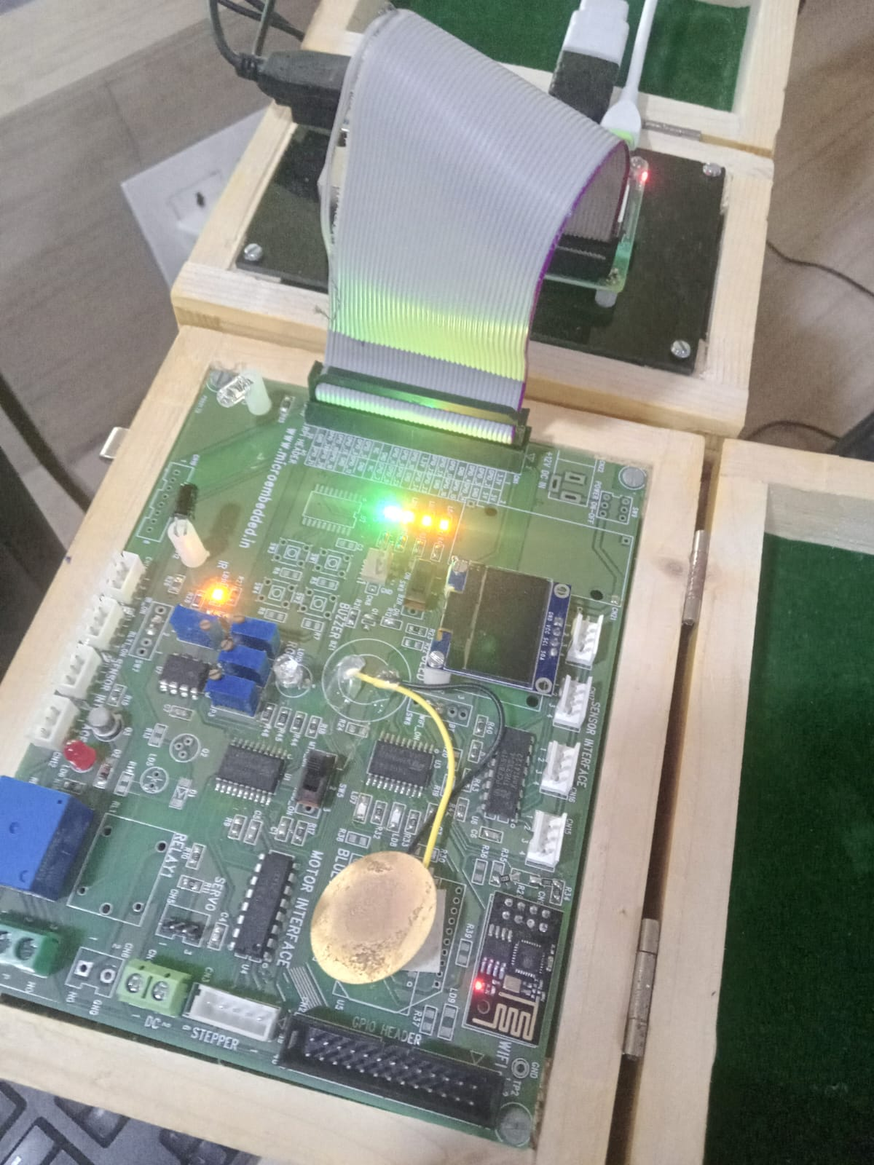OUTPUT: