# 

# 

# 

# Case Study

# Database Design & Development

# for

# E-commerce Platform

# Primenest

# Diya Patel

# 000966657

**Table of Contents**

1. Introduction ..................................................................................................................................3

* + 1. Introduction
    2. Scope
    3. Mission
    4. Objectives

1. List of data table.........................................................................................................................6
   * 1. User & order Management Table
     2. Product & Supplier Management Tables
     3. Transaction & Shipping Tables
2. Entity Relationship Diagram.................................................................................................12
3. Possible Relationship Between Tables
4. ER Diagram
5. Views................................................................................................................................................15
6. TopSellingProductByRevenue
7. CustomerPurchaseHistory
8. Conclusion.....................................................................................................................................22
   1. **INTRODUCTION**
      * **INTRODUCTION**
      * **SCOPE**
      * **MISSION**
      * **OBJECTIVES**
   2. **Introduction**

PrimeNest is a global e-commerce leader, known for its customer-first approach, vast product selection, and competitive prices. By leveraging technology and innovation, PrimeNest ensures fast delivery, efficient logistics, and a seamless shopping experience. With a strong marketplace and global reach, it empowers businesses and connects millions of customers worldwide.

## Scope

##### Current Scope

PrimeNest is more than just an e-commerce platform—it’s a growing digital marketplace that connects businesses and customers with ease. By leveraging technology and innovation, PrimeNest ensures fast delivery, efficient logistics, and a seamless shopping experience. Its smart recommendation system helps customers find what they need quickly, while a strong seller network empowers businesses to grow. PrimeNest also explores AI-powered solutions, digital payments, and customer-first services to enhance the shopping journey. With a focus on convenience, affordability, and sustainability, PrimeNest is building the future of online shopping, making it easier and more rewarding for everyone.

##### Mission

"To provide a seamless, user-friendly e-commerce platform connecting buyers with a wide range of products globally."

* 1. **Objectives**
* **Customer-Centric Excellence** :- To be the most customer-focused company in the world, offering a seamless, personalized shopping experience with the widest selection of products at competitive prices.
* **Operational Efficiency and Innovation :-**To continually improve operational efficiency by leveraging technology and innovation, ensuring fast delivery, streamlined logistics, and superior user experiences.
* **Global Market Leadership :-** To expand its global presence, making products and services accessible worldwide while supporting sellers and empowering businesses through platforms like Amazon Marketplace and AWS.

# LIST OF DATA TABLE

# User & Order Management Table

# Sellers

# Customers

# Orders

# Reviews

# Product & Supplier Management Tables

# Products

# Transaction & Shipping Tables

# Payments

# Shipping

#### Sellers Table

1. **SellerID** (Primary Key) – Unique identifier for each seller.
2. **SellerName** – Name of the seller or business.
3. **Email** – Contact email for the seller.
4. **Phone** – Contact number.
5. **StoreName** – Name of the seller's store.
6. **RegistrationDate** – Date when the seller joined the platform.
7. **Rating** – Average rating from customer reviews.

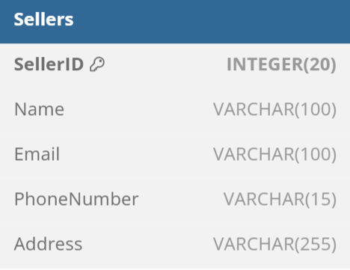

#### Products Table

* + - 1. **ProductID** (Primary Key) – Unique identifier for each product.
      2. **ProductName** – Name of the product.
      3. **Description** – Brief product details.
      4. **Price** – Selling price.
      5. **StockQuantity** – Available inventory.
      6. **Category** – Product category.

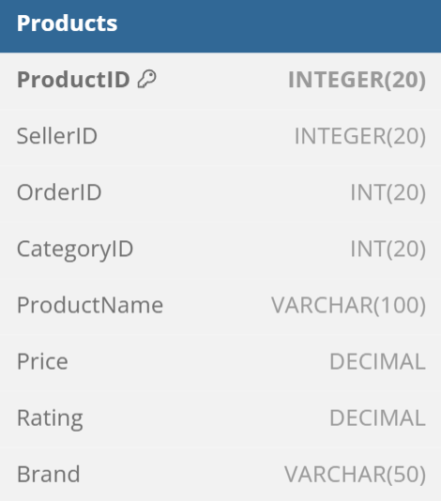

#### Customers Table

1. **CustomerID** (Primary Key) – Unique identifier for each customer.
2. **FullName** – Customer’s full name.
3. **Email** – Contact email.
4. **Phone** – Contact number.
5. **Address** – Default shipping address.
6. **RegistrationDate** – Date of account creation.

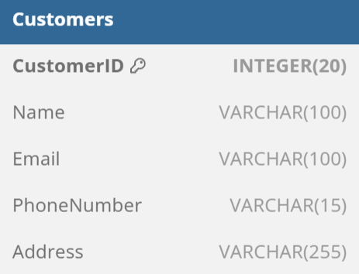

#### Orders Table

1. **OrderID** (Primary Key) – Unique identifier for each order.
2. **CustomerID** (Foreign Key) – Links to the Customers table.
3. **SellerID** (Foreign Key) – Links to the Sellers table.
4. **OrderDate** – Date when the order was placed.
5. **TotalAmount** – Total price of the order.
6. **OrderStatus** – Status of the order (Pending, Shipped, Delivered, etc.).

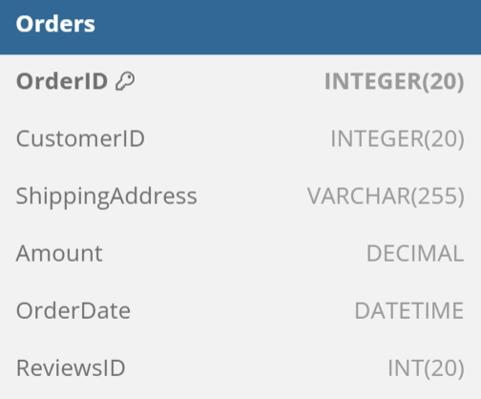

#### Payments Table

1. **PaymentID** (Primary Key) – Unique identifier for each payment.
2. **OrderID** (Foreign Key) – Links to the Orders table.
3. **CustomerID** (Foreign Key) – Links to the Customers table.
4. **PaymentMethod** – Payment type (Credit Card, PayPal, etc.).
5. **AmountPaid** – Total payment amount.
6. **PaymentStatus** – Status (Pending, Completed, Failed).
7. **PaymentDate** – Date of transaction.

#### 

#### Shipping Table

1. **ShipmentID** (Primary Key) – Unique identifier for each shipment.
2. **OrderID** (Foreign Key) – Links to the Orders table.
3. **Carrier** – Shipping service (DHL, FedEx, etc.).
4. **TrackingNumber** – Unique tracking number.
5. **ShippingStatus** – Status (In Transit, Delivered, etc.).
6. **EstimatedDelivery** – Expected delivery date.

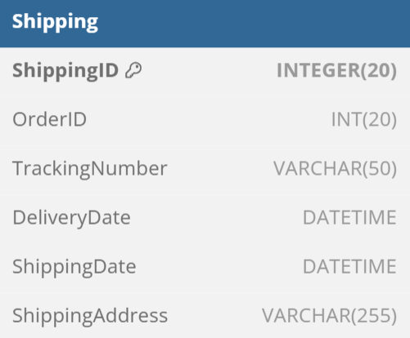

#### Review Table

#### ReviewID (Primary Key) – Unique identifier for each review.

#### CustomerID (Foreign Key) – Links to the Customers table.

#### ProductID (Foreign Key) – Links to the Products table.

#### Rating – Star rating (1-5).

#### Comment – Customer feedback.

#### ReviewDate – Date of submission

#### 

# Entity Relationship Diagram

## Possible Relationship Between Tables

## ER Diagram

## ER Diagram

#### Possible Relationship

**1. Customers & Orders (One-to-Many)**

* **One customer can place multiple orders**, but each order belongs to **only one customer**.
* **Foreign Key:** Orders.CustomerID → Customers.CustomerID.

**2. Sellers & Products (One-to-Many)**

* **One seller can list multiple products**, but each product belongs to **only one seller**.
* **Foreign Key:** Products.SellerID → Sellers.SellerID

**3. Orders & Products (Many-to-Many)**

* **One order can contain multiple products, and a product can be part of multiple orders.**
* **This requires a junction table (OrderDetails or LineItems), which is not shown in the diagram.**

**4. Orders & Payments (One-to-One)**

* **Each order has only one payment, and each payment is linked to only one order.**
* **Foreign Key:** Payments.OrderID → Orders.OrderID

**5. Orders & Shipping (One-to-One)**

* **Each order has only one shipping entry**, meaning each order is shipped once.
* **Foreign Key:** Shipping.OrderID → Orders.OrderID

**6. Orders & Reviews (One-to-Many)**

* **One order can have multiple reviews if it contains multiple products.**
* **Foreign Key:** Reviews.ReviewID → Orders.ReviewID

**7. Products & Reviews (One-to-Many)**

* **One product can have multiple reviews, but each review is for a single product.**
* **Foreign Key:** Reviews.ProductID → Products.ProductID

#### ER Diagram

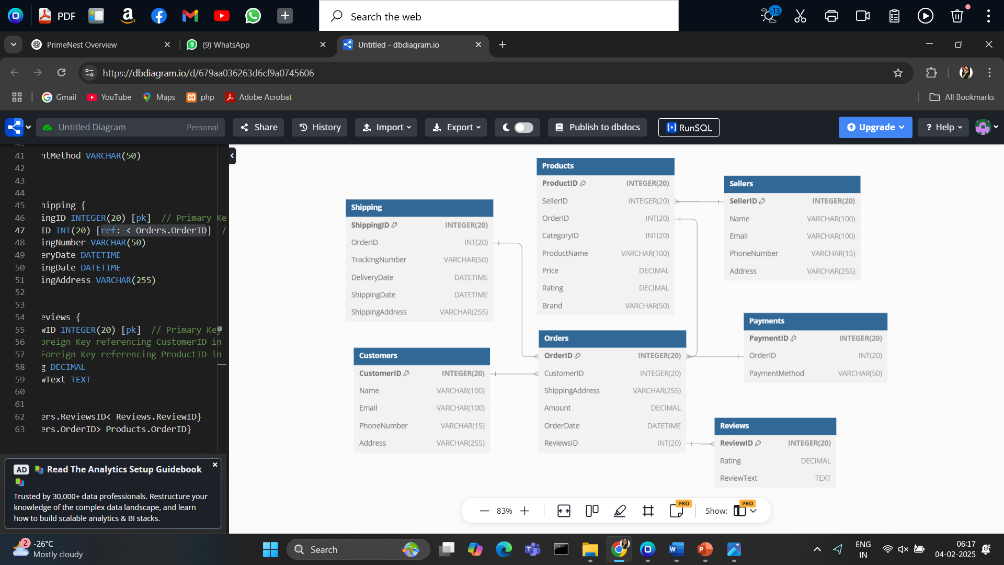

# Views

## TopSellingProductsByRevenue

## CustomerPurchaseHistory

## ProductRatings

#### TopSellingProductsByRevenue

#### Purpose:

#### This view identifies the top 10 best-selling products based on total revenue, helping sellers and administrators track high-performing products.

#### 

**Key Components:**

1. **JOIN Orders o ON p.OrderID = o.OrderID**
   * Uses an **INNER JOIN** to link Products and Orders, ensuring only **sold products** are included.
2. **SUM(o.Amount) AS TotalRevenue**
   * Calculates total revenue per product by summing up the order amounts.
3. **COUNT(o.OrderID) AS TotalOrders**
   * Counts how many times each product has been ordered.
4. **GROUP BY p.ProductID, p.ProductName, p.Brand**
   * Groups data by product, ensuring revenue and order count are calculated per product.
5. **ORDER BY TotalRevenue DESC**
   * Sorts products from **highest to lowest revenue**, ensuring the best-selling products appear first.
6. **LIMIT 10**
   * Restricts the results to the **top 10** products based on revenue.

**OUTPUT :**

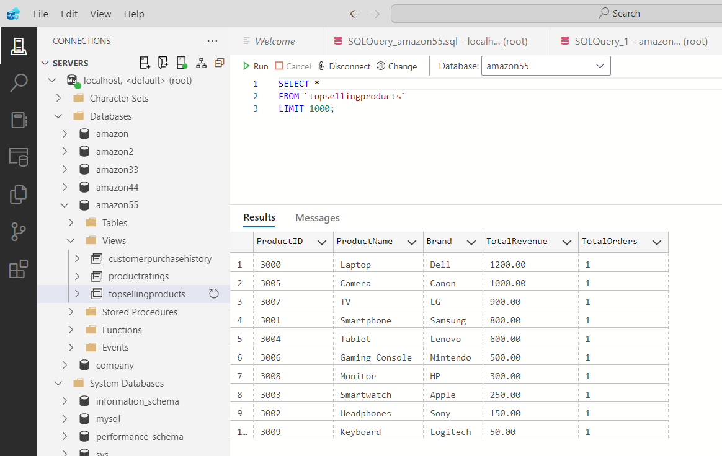

**BENEFITS :**

* Helps sellers identify **high-revenue products**.
* Assists in **inventory planning** by focusing on fast-moving items.
* Supports **marketing efforts** for top-selling products.

#### CustomerPurchaseHistory

#### 

#### Purpose:

#### This view tracks each customer's total orders and total spending, helping businesses identify high-value customers and analyze buying behavior.

#### 

#### Key Components:

#### JOIN Orders o ON c.CustomerID = o.CustomerID

#### Uses an INNER JOIN to link Customers with Orders, ensuring only customers who have made at least one purchase are included.

#### COUNT(o.OrderID) AS TotalOrders

#### Counts the total number of orders each customer has placed.

#### SUM(o.Amount) AS TotalSpent

#### Sums up the total spending per customer from all their orders.

#### GROUP BY c.CustomerID, c.Name

#### Groups data by customer to ensure total orders and spending are aggregated per customer.

#### ORDER BY TotalSpent DESC

#### Sorts customers by total spending, with the highest spenders appearing first.

#### OUTPUT :

#### 

BENEFITS :

* **Identifies Top-Spending Customers** – Helps target high-value customers for loyalty programs.
* **Enhances Marketing Strategies** – Enables personalized promotions based on purchase history.
* **Improves Sales Analysis** – Provides insights into customer buying behavior.

#### ProductRatings

#### Purpose:

#### This view helps track the average rating and total number of reviews for each product, providing insights into customer satisfaction and product performance.

#### 

#### Key Components:

#### JOIN Orders o ON p.OrderID = o.OrderID

#### Links the Products table to the Orders table, ensuring only ordered products are included.

#### JOIN Reviews r ON o.ReviewsID = r.ReviewID

#### Connects Orders with Reviews, ensuring only products that have been reviewed appear in the results.

#### AVG(r.Rating) AS AvgRating

#### Calculates the average rating per product from customer reviews.

#### COUNT(r.ReviewID) AS TotalReviews

#### Counts the total number of reviews each product has received.

#### GROUP BY p.ProductID, p.ProductName, p.Brand

#### Ensures the calculations are done per product.

#### ORDER BY AvgRating DESC

#### Sorts products from highest to lowest average rating, prioritizing top-rated products.

#### OUTPUT :

#### 

#### BENEFITS :

#### dentifies Best-Rated Products – Helps highlight top-quality products based on customer feedback.

#### Improves Customer Trust – Encourages potential buyers by showing well-rated products.

#### Supports Product Improvement – Helps sellers analyze products with low ratings for necessary improvements

#### Boosts Marketing & Sales – High-rated products can be promoted to attract more buyers.

1. **CONCLUSION**

PrimeNest is a global leader in e-commerce, known for fast delivery, a wide range of products, and focusing on customer satisfaction. Its success is driven by smart use of technology, strong logistics, and a marketplace that connects buyers and sellers. While it faces challenges like competition and regulations, PrimeNest keeps growing by innovating and enhancing the shopping experience, ensuring it remains a top player in the industry**.**