Semi-Annual Narrative Report (SNR)

1. Project Details
GUIDELINES: Please complete the following table with details of the project.
Project Number | P 3589
Project Title | BCH/CBM Ear, Nose and Throat (ENT) Project
City/ Country/ Region | Lusaka/Zambia/Southern Africa
Name of Contractual Partner | Beit CURE Hospital
Other Implementing Partners | None
Duration of Project | 3 Years
Project Start Date | January, 2018
Project End Date | December, 2021
Project Cycle | January-December
Report Submitted by;
Name | Stephen Chishimba
Designation | Project Manager
Email Address | steven.chishimba@cureinternational.org
Date of Submission | 11th January, 2021

2. Summary of Results Achievements
GUIDELINES: Insert a qualitative ‘summary’ of the overall progress of the project towards its Result areas. Please focus on the changes (intentional or unintentional) that has come about as a result of implementation of activities. Limit your response to 1 paragraph per result area.
P 3589 Finance Report for the year ending 2020.
Result/  Activity / Item | Description | CBM Yearly Budget | Project Expenditure | Balance at the project | Budget Implementation Rate (%)
Result/  Activity / Item | Description | CBM Yearly Budget | Total Expenditure | by end of current  reporting period | Budget Implementation Rate (%)
Result Area 1 | ENT (diagnostic and surgery) and rehabilitative services (audiology and audio-verbal therapy) provided to a larger number of patients | 2,707,182.55 | 2,697,147.59 | 10,034.96 | 99.63
Activity 01.01 | Conduct ENT Consultations at ENT Clinic | 454,672.38 | 454,596.29 | 76.09 | 99.98
Activity 01.02 | Perform ENT Surgeries at Beit CURE Hospital (salaries, equipment, and supplies) | 1,757,923.66 | 1,742,163.53 | 15,760.13 | 99.10
Activity 01.03 | Conduct ENT mobile outreaches within Lusaka | 181,112.89 | 143,879.25 | 37,233.64 | 79.44
Activity 01.04 | Conduct Audiology Consultations | 217,069.93 | 268,308.52 | -51,238.59 | 123.60
Activity 01.05 | Continue the 2016 initiated speech therapy program | 96,403.69 | 88,200.00 | 8,203.69 | 91.49
Result 02 | Strengthen the Zambian Health system through support to implement the National ENT Plan and meetings amongst relevant stakeholders | 17,050.29 | 0.00 | 17,050.29 | 0.00
Activity 02.01 | Biannual meetings of a National ENT Technical Committee | 17,050.29 | 0.00 | 17,050.29 | 0.00
Result 03 | Provide operational management and financial sustainability in ENT Clinic | 445,011.90 | 442,686.45 | 2,325.45 | 99.48
Activity 03.01 | Provide dedicated project manager to oversee business operations of ENT Clinic | 209,952.26 | 209,952.28 | -0.02 | 100.00
Activity 03.02 | Infrastructure support for ENT clinic | 142,676.98 | 142,676.98 | 0.00 | 100.00
Activity 03.03 | Support for Dr. Froeschl's vehicle | 46,775.58 | 64,537.19 | -17,761.61 | 137.97
Activity 03.04 | Perform annual audit on p.2740 | 45,607.08 | 25,520.00 | 20,087.08 | 55.96
 | Total amounts current year | 3,169,244.74 | 3,139,834.04 | 29,410.70 | 99.07

Result Area 1: ENT and rehabilitation services
During the period under review, the hospital was able to resume its field-based activities such as outreaches and school screenings whilst also stably increasing the patient inflow to provide more services to children and adults with ENT, Audiology and Speech services.
- With the recruitment of 2 more speech therapist, the hospital is now able to serve more clients (with a 107% achievement rate on speech consultations.
- Speech and Language therapy unit’s focus has been to focus on strengthen the home therapy strategy and language and articulation strategy to empower the caregivers to aid their children’s communication abilities within the home set up.
- This period also enabled us to launch our COVID 19 response initiative focused on promoting disability inclusiveness in the way that the public responds to pandemic.
- As a hospital we managed our patients with the best care and ensured that we continued to provide surgical treatment to patients despite challenges with the pandemic (133% achievement rate on this activity).
- As public health restrictions began to be eased, we gradually begin to conduct field-based activities but struggled with school screenings to assemble large crowds of pupils due to reluctance by most school administrations amid the pandemic. This affected our ability to conduct adequate the targeted number of outreaches to aid us in meeting our target on outreach and school screening consultations.

3. Narrative Reporting on Activity Implementation
3.1 GUIDELINES: Which activities were planned to be implemented in the first six months (Q1 and Q2)? Please list down the Activity Name and Number only.

Result Area 1: ENT and rehabilitation services
Activity 01.01 Conduct ENT Consultations at ENT Clinic
Activity 01.02 Perform ENT Surgeries at Beit CURE Hospital
Activity 01.03 Conduct ENT mobile outreaches within Lusaka
Activity 01.04 Conduct Audiology Consultations
Activity 01.05 Continue the 2016 initiated speech therapy program.

3.2 GUIDELINES: Using the list above, please report on the activities implemented during the last 6 months. Describe if any targets were achieved or explain any variance in achieved versus planned activities in the reporting period. Explain who the main beneficiaries/ participants were.

Result Area 1: ENT and rehabilitation Services
The table below illustrates the progress made during the last 6 months (Q 3 and Q 4, 2020) under review as well as the overall cumulative progress made on each activity area under this result area.
Table 1: Summary of Result Area 1 achievements
Activity Area | Quarter 3 Target | Quarter 3 Achievement | Quarter 3 % Progress | Quarter 4 Target | Quarter 4 Achievement | Quarter 4 % Progress | Q3 & Q 4 Semi-Annual Target | Q3 & Q 4 Semi-Annual Achievement | Q3 & Q 4 Semi-Annual % Progress
ENT Consultations at BCH Clinic | 1175 | 876 | 75% | 1175 | 2000 | 170% | 2350 | 2876 | 122%
ENT Surgeries Conducted at BCH | 90 | 108 | 120% | 90 | 131 | 146% | 180 | 239 | 133%
ENT Mobile Outreach screenings | 1950 | 72 | 4% | 1950 | 685 | 35% | 3900 | 757 | 19%
Audiology Consultations Conducted | 1000 | 560 | 56% | 1000 | 972 | 97% | 2000 | 1532 | 77%
Speech Therapy Consultations | 102 | 49 | 48% | 104 | 171 | 164% | 206 | 220 | 107%
Total ENT, Audiology and Speech Therapy Services provided | 4317 | 1665 | 52% (% Progress achieved) | 4319 | 3959 | 92% (%progress achieved) | 8636 | 5624 | 65% (Semi-annual % progress achieved)

During the semi-annual period under review, the project successfully managed to conduct outreaches and school screenings activities in Central, Lusaka and Southern Province particularly in Quarter 4. This was made possible by the reduction in the incidence of COVID 19 cases within the country. As quarter 4 progressed we gradually began to steady the increase in the patient inflow at the hospital and managed to re-open the ENT and Audiology department after having closed it for 3 weeks in the previous quarter for the month of September. With all 3 speech therapists fully settled in during quarter 4, the ENT department successfully scaled up on the number of speech therapy consultations as each day during the week has been provided for speech therapy consultations and treatment.
3.1 Activity 01.01 Conduct ENT Consultations at BCH ENT Clinic
During the period under review, the hospital successfully achieved 122% achievement on ENT consultations as observed in graph 1 below. We re-opened the ENT department in Q 4 after a short closure in Q 3 due as a precautionary measure to a short spike during that period. We have since successfully scaled up on the patient inflow resulting in increased ENT consultations.

Graph 1: Summary of ENT Consultations during the period under review.
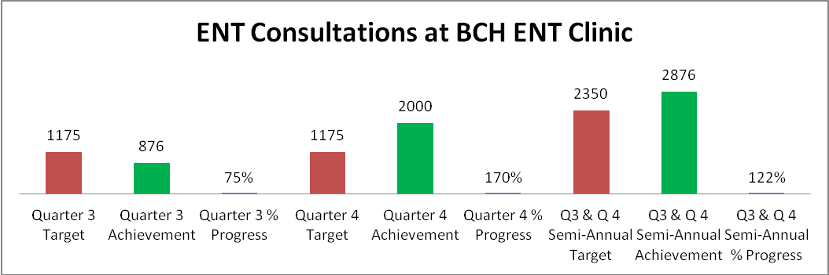
3.2 Activity 01.02 Perform ENT Surgeries at Beit CURE Hospital
Despite the ongoing pandemic Beit Cure has successfully managed patient surgeries without any challenges related to re-scheduling pre-arranged surgery days. We have leveraged on the extension of the Operation theatre that was supported by CBM with great efficiency to ensure that we continue to serve our patients with the best surgical treatment possible. We have hit a remarkable achievement of 122% during this period and we do anticipate that this shall steadily commence in subsequent years to come.
Our priority as a hospital has always been children with ear and hearing disabilities as well as those with throat and nose related conditions and during this period, we have continued to serve them diligently. Most of the surgeries performed during this period were minor surgeries mainly due to the types of conditions we have been treating. Out of a total of 239 ENT related surgeries we successfully treated 234 children with 5 surgeries being directed towards serving adults. We continue to provide adult services at a fee for all ENT and Audiology services and we do recognize that it is an area we need to strengthen to aid resource mobilization to sustain this service. Below is table 2 which illustrates the disaggregation of surgeries by sex.
Table 2: Successful Surgeries Performed on Children during Q3 & Q 4, 2020.
Successful Surgeries Performed | Children |  | Total by Surgery Type
Quarter 3, 2020 | Boys | Girls | Boys + Girls
Major Surgeries | 15 | 11 | 26
Minor Surgeries | 46 | 34 | 80
Total Surgeries | 61 | 45 | 106
Quarter 4, 2020 | Boys | Girls | Boys + Girls
Major Surgeries | 6 | 10 | 16
Minor Surgeries | 56 | 56 | 112
Total Surgeries | 62 | 66 | 128
Semi Annual Achievement on successful surgeries performed on Children | 123 | 111 | 234

3.3 Activity 01.03 Conduct ENT mobile outreaches within Lusaka
During the period under review, the hospital successfully conducted 8 outreach activities in (5 community-based outreaches & 3 school screenings mobile clinics). We achieved 16% achievement on this activity area which is still below the target, but we continue facing challenges with regards to gathering crowds in the wake of the pandemic. When we have conducted outreaches and school screenings, we have been inclined to limit the number of consultations. We continue to follow laid out public health guidelines in line with the Public Health Act Cap 295 of the Laws of Zambia prohibiting mass gatherings to avoid the spread of COVID 19 which contributes to our inability to conduct targeted community-based outreaches and school screenings.
Table 3: Summary of ENT Mobile Outreach Screenings during Q3 & Q4, 2020.

District | # of mobile outreaches and school screenings conducted | Adults |  | Children
District | # of mobile outreaches and school screenings conducted | Male | Female | Boy | Girl | Total # consultations
Outreaches | 5 | 103 | 126 | 67 | 63 | 359
School Screening | 3 | 11 | 14 | 166 | 207 | 398
Total | 8 | 114 | 140 | 233 | 270 | 757

3.4 Activity 01.04 Conduct Audiology Consultations
The ENT department experienced a short closure at the beginning of quarter 3 to help curb the spread of the COVID 19 virus but later opened the department to the public towards the end of Q 3 and fully operational in quarter 4.
- Increase our patient inflow trickled down towards a higher number of patients seen by the audiology unit.
- During quarter 4, the hospital was privileged to participate in child health week related activities such as radio media programs prior to its commencement. This enabled us generate a high demand for ENT services during the commemoration week.
- Child Health week also enabled us raise awareness to mothers and caregivers on importance child growth milestones that relate to speech therapy.
- To raise more awareness on speech therapy we endeavored to conduct more audiology consultations to help us identify children that had delayed speech especially amongst children under the age of five years (5).
With respect to that activity, we focused on conducting more tympanograms and audiograms (see graph 2 below) to determine levels on sound transmission within the children. The radio programmes also gave us an opportunity to express to patients that have received hearing aids from Beit CURE either through an outreach event or at the hospital, the opportunity to make follow ups on the state of the hearing aids if rehabilitation is required.
Graph 2: Summary of Audiology Consultations during Q3 & Q 4, 2020.
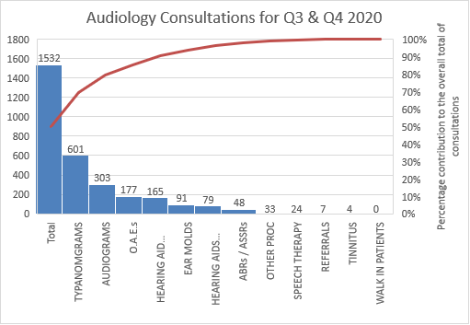

3.5 Activity 01.05 Provide Speech therapy sessions for children.
During the period under review, the hospital successfully recruited two (2) new speech therapists to join the already existing 1 into the speech therapy unit. The two (2) new therapists are Petronella Bhemba and Jessica Cramer who bring with them solid experience in providing speech and communication therapy for children with Ear and hearing disorders, autism, language disorders etc. The 3 speech therapists have contributed to 107% completion on speech therapy consultations with the ENT department.
Graph 3: Summary of Speech therapy consultations for Q3 & Q 4, 2020.
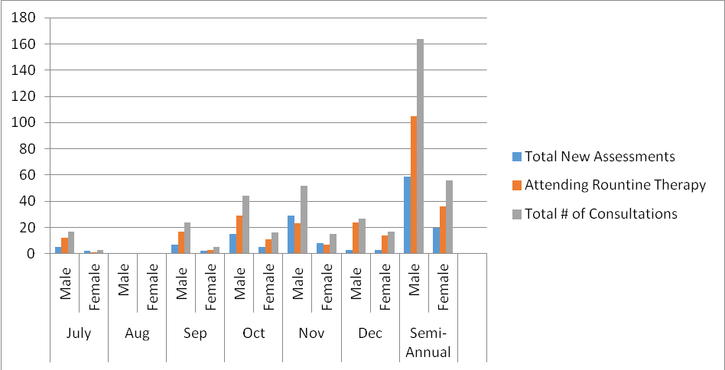
From the graph above, we observe that the number of consultations started to increase during the month of October and the introduction of the two (2) new speech therapists. In the month of August, no consultations had been conducted due to the closure of the department when Lusaka district had experienced a spike in the number of COVID 19 cases. We did however commence to open the clinic within the month of September.
During the period under review the speech therapy unit has since developed standardized policies and procedures that harmonize with international guidelines and standards of speech and language therapy (therefore strengthening the already existing Beit Cure Standards) and has created a more elaborate inclusion and exclusion criteria to ensure that the hospital enhances its efficiency better in the selection process of the children that will require their assistance.

4. Challenges and Lessons Learned
GUIDELINES: Please complete the table below with challenges that were encountered during the reporting period and the lessons learned. Include any solution that you plan to implement in the next reporting period. (If you have used the Status Column in the Indicator Tracking Sheet (Column K) to report Challenges against specific indicators, make sure you elaborate on the challenge in the table below)

5. Changes in Implementation Plan and Personnel (if applicable)
GUIDELINES: Please use the space below to specify any changes to (I) the implementation plan (strategies, timelines, targets or key results; also specify if any approval for changes has been sought from CBM), (II) any changes in personnel at the organization’s senior management level, (III) key positions related to the project implementation.
There have been no changes in the implementation plan and personnel during quarter 4, but we did experience changes during quarter 3 as already reported in Q 3 report. Find below the changes that occurred:
Change 1: Newly Appointed Executive Director Fridah Kabaso Phiri
Fridah has now settled into her new role as Executive Director for CURE Zambia since her appointment in August of 2020.Frida joins CURE-Zambia from Lesotho where she served as Country Director for mothers2mothers for close to 7 years, she brings to Beit-CURE a rich experience in intentional leadership that includes maintaining overall accountability for the operational, financial, spiritual, and networking for an organization. Fridah’s wealth of experience is gleaned from the strategic leadership roles she has held and the partnership and relationships she has built over the years both in the health sector and other socio-economic development areas. She holds an MSC in Development Management from Open University (UK) and a Bachelor of Arts degree in Public Administration from the University of Zambia. She has over 25 years’ experience in International Development, 18 years of which is at Senior Strategic Leadership level. Previously, she has spent much of her career at International NGOs both in Zambia and other African countries. She has served as Country Director for various international NGOs including Voluntary Services Overseas (VSO), Action Aid, and mothers2mothers.

Change 2: Newly Recruited Speech Therapist called Jessica L. Cramer
Jessica is an American national (USA) experienced speech-language pathologist with over 3 years of experience and expertise in students/children with complex communication needs. She has specialized training and experience with Augmentative and Alternative Communication (AAC), Language and Literacy intervention with Special Populations, and Autism Spectrum Disorder. Her special interests include equal access of evidence-based practice services in populations who may have limited access to quality care, due to low socioeconomic status. Jessica holds a Bachelor of Arts in Communication Sciences and Disorders and a Master of Arts in Speech-Language Pathology from the University of Iowa in the United States of America.
Change 3: Newly Recruited Speech Therapist called Bhemba, Petronella Katongo
Petronella has over 4 years work experience, 2 years with non-governmental organizations (NGOs) working with vulnerable populations (special needs, learning and mental health challenges), 2years as Certified Accelerated Christian Education (A.C.E) Supervisor and working as a counselor therapist in Private practice. She is a holder of a Bachelor of Arts Degree in Psychology and Master of Education in Speech, Language and Communication Disorders from the University of Zambia. She is also member of the Zambia Counseling Council (ZCC and Psychology Association Zambia (PAZ).

6. Risk Update (If applicable)
GUIDELINES: Have any of the risks identified during the project design materialized or changed?

Risk 1: Ongoing Global Pandemic (COVID 19 Virus)

The corona virus continues to have a great impact on our daily lives more so on the project. Public health guidelines and restrictions entail that certain actives especially those that involve mass gatherings pose a threat a risk to people’s lives. As such we have been operating very cautiously to ensure that we remain safe and free from the pandemic. A spike in the number of cases has a ripple effect to the number of patients we see and a greater impact on our ability to reach out to children especially outside of Lusaka province. During the end of the month of September, public restrictions have slowly been eased to allow to free flow economic activity which we hope will not lead to a spike in cases and allow us implement the project to attain impact.

Risk 2: Devaluation of the Zambian Currency / Exchange Rate Effect

The Zambian kwacha’s exchange rate performance against foreign currencies namely the United States dollar (USD), the British Pound and the Euro remain a serious threat to our currency. As a country that is a net importer of the majority of goods and services we access, a devalued kwacha entails weakened purchasing power parity which is directly proportional to high inflation. These possess a great threat on our ability to appreciate the same monetary value of the project funds.

Risk 3: Political Environment and Upcoming 2021 General Presidential and Parliamentary Elections in Zambia.

With nationwide voter registration having been successfully conducted and finalized on the 20th December, 2020 the country is set to engage into a series of campaign related activities by various political parties projected to commence after the month of April. Historically the country has experienced some level of violence over this period which has posed a threat to the public. The project anticipates a huge slowdown in the implementation of field based related activities as well as a slowdown in the patient inflow thereby affecting implementation. The country has most recently in quarter 4 of 2020 in the month of December faced political violence between rival political parties that has threatened the level of peace particularly within Lusaka Province with in which the project is primarily being implemented. The link provides more information on the upcoming general elections (https://www.elections.org.zm)

7. Activity Forecast
GUIDELINES: Which activities are planned to be implemented in the next 6 months (Q3 and Q4)? Please list down the Activity Name and Number only.

Activity 01.01 Conduct ENT Consultations at ENT Clinic
Activity 01.02 Perform ENT Surgeries at Beit CURE Hospital
Activity 01.03 Conduct ENT mobile outreaches within Lusaka
Activity 01.04 Conduct Audiology Consultations
Activity 01.05 Continue the 2016 initiated speech therapy program.
Activity 03.04 Perform Annual Audit on the Project

8. Photos
GUIDELINES: Please use the space below to paste any photos, with captions, news items etc. related to the project. Please ensure that written consent has been obtained from all identifiable people in the photos.
Photo’s shall be attached in an Annex document.

9. Comments from CBM Country Office
GUIDELINES: (Only to be filled by the Country Office) Please use the space below to briefly comment on the quality of project implementation and reporting, and describe whether the project is on track and on schedule. If a monitoring visit was conducted during the last 6 months, what were the main findings and recommendations?

Initially, this project was to run from 2018 – 2020. However, the partner presented a request to extend it to 2021 in order to complete some critical ENT statistic services at their hospital. The request was granted, and it shall run for an additional year.
Overall, the project achieved most of its planned activities despite the Covid19 pandemic which led to delays in some cases. Other notable aspects are
- Despite covid19 pandemic the project still scored very well with ENT consultations, exceeding the target by 20%
- that this is the same project which was funding Dr Harrison Phiri’s salary before he left BCH this year; and that the project continues to support a substantial number of ENT staff to keep the ENT clinic running.
- There is need to report on quality of ENT surgeries at the hospital. This will be taken up in the next reporting period
- (Paul Kasoka)

If there is no Country Office, then the Regional Office/IAA/TU is invited to share their comments as per the arrangement regarding the supervision of the project.

