PROJECT REPORT
Smart Campus Management &
Student Services Platform
One platform for attendance, notices, assignments, events, complaints, leave requests and results
Built with MongoDB · Express · Node.js · React
Submitted by
[Student Name] — [Roll Number]
[Student Name] — [Roll Number]
Submitted to
[Faculty Name]
[Department], [College Name]
September 2026

Acknowledgement
We would like to thank [Faculty Name] for teaching us Node.js, Express, MongoDB and middleware step by step in the MEN stack sessions. The Railway Management example from class was the starting point for the structure of this project.
We also thank our department and our classmates for their help while testing the application.

Abstract
Colleges usually keep attendance, notices, assignments, events, complaints, leave requests and results in separate places. This project, Smart Campus, joins all of them into a single web application used by four roles — Admin, HOD, Faculty and Student.
The backend is a REST API built with Node.js and Express 5, storing data in MongoDB through Mongoose across 9 collections. Passwords are stored as salted HMAC-SHA-256 hashes. Users log in with email and password and receive a JSON Web Token; an application-level middleware verifies the token on every protected request, and a route-level allowRoles middleware enforces role-based permissions. The API supports search (regular expressions), pagination (skip/limit), input validation, and an aggregation pipeline ($match, $group, $lookup, $project, $sort) that calculates each student's attendance percentage and highlights at-risk students below 75% on the faculty dashboard.
The frontend is a React single-page application with a tab-based dashboard for each role. Its three special features are an at-risk attendance dashboard, role-based security with department limits, and salted password hashing, and the API documents itself on a live docs page. The system was tested with 22 API and browser test cases, all of which passed.
Keywords: MongoDB, Express, Node.js, React, JWT, middleware, role-based access control, aggregation, $lookup, attendance analytics.

Table of Contents

(If the table of contents is empty, right-click it in Word and choose "Update Field".)

1. Introduction

1.1 The Problem
In most colleges, every job uses a different system. Attendance is written in a register, notices are pinned on a board or sent on WhatsApp, assignments are collected by email, complaints go on paper forms and leave applications are signed by hand. Nobody can see the full picture, and a lot of information gets lost.

In simple words
Imagine your school bag has five different notebooks — one for attendance, one for homework, one for notices, one for complaints and one for marks. Every time you want to know something, you have to search through all five. That is slow and messy.
Our project puts everything in one notebook that everybody can open, but everyone only sees the pages they are allowed to see.

1.2 Our Solution
Smart Campus is one web application where the Admin, HOD, Faculty and Students all log in to the same website. After login, each person sees only the tools that belong to their role. The backend is written with Node.js + Express, the data is saved in MongoDB, and the screens are made with React.

1.3 Objectives
- Give every user one login and one place for all college services.
- Let faculty mark attendance in a few clicks and instantly see who is at risk (below 75%).
- Let students check attendance, submit assignments, see results, read notices, raise complaints and apply for leave.
- Let HODs and Admins manage people, courses, complaints and leave requests.
- Keep the data safe using hashed passwords, JWT login tokens and role-based permissions.
- Show backend skills: middleware, aggregation with $lookup, pagination, search and API validation.

1.4 Modules Covered
# | Module | What it does
1 | Student management | Add, list, search and delete students (with pages of 5)
2 | Faculty management | Add, list and search faculty members
3 | Courses | Create courses and assign a faculty member to each one
4 | Attendance | Mark present/absent per day, see % and at-risk students
5 | Assignments | Faculty creates, students submit a link/answer
6 | Notices | College-wide or department notices with search and pages
7 | Events | Upcoming college events with date and venue
8 | Complaints | Students raise complaints, HOD/Admin mark them resolved
9 | Leave requests | Students/faculty apply, HOD/Admin approve or reject
10 | Results | Faculty enters marks, each student sees only their own
Table 1: The ten modules of the platform

2. Who Uses the System (Roles)
There are four kinds of users. They all log in on the same page, but the server checks their role before letting them do anything.
Role | Real-life person | What they can do
Admin | College office / principal's office | Add and delete any user, add courses, see all reports, post notices and events, handle all complaints and leaves
HOD | Head of a department (e.g. CSE) | Everything for their own department only: attendance report, students, faculty, courses, complaints, leave approval
Faculty | A teacher | See their courses, mark attendance, view the at-risk dashboard, create assignments, enter marks, post notices, apply for leave
Student | A student | See own attendance %, submit assignments, see own results, read notices and events, raise complaints, apply for leave
Table 2: The four roles

In simple words
Think of a school building. Everybody enters through the same main gate (the login page). But the principal has keys to every room, the head of science has keys to the science block, a teacher has keys to their classrooms and a student can only go to their own class. The role is like the set of keys you are given.

3. Special Features
Besides the ten normal modules, three features make this project stand out. These are the best things to show in a demo or viva.

3.1 At-Risk Attendance Dashboard
This is the Advanced requirement from our project brief: a faculty dashboard showing attendance percentage and at-risk students.
- The moment a faculty member logs in, they see how many students are in the course, the class average, and how many students are at risk (below 75%).
- A red banner names the at-risk students, and the table puts the lowest percentage on top, with a red progress bar.
- It is calculated by MongoDB itself using an aggregation pipeline: $match (one course) → $group (count per student) → $lookup (fetch names from users) → $project (calculate %) → $sort (lowest first).
- Students get the same warning on their own screen: Kabir sees 50% (below 75%!) in red.
- The HOD sees the same report for every course in their department, and the admin for every course in the college.
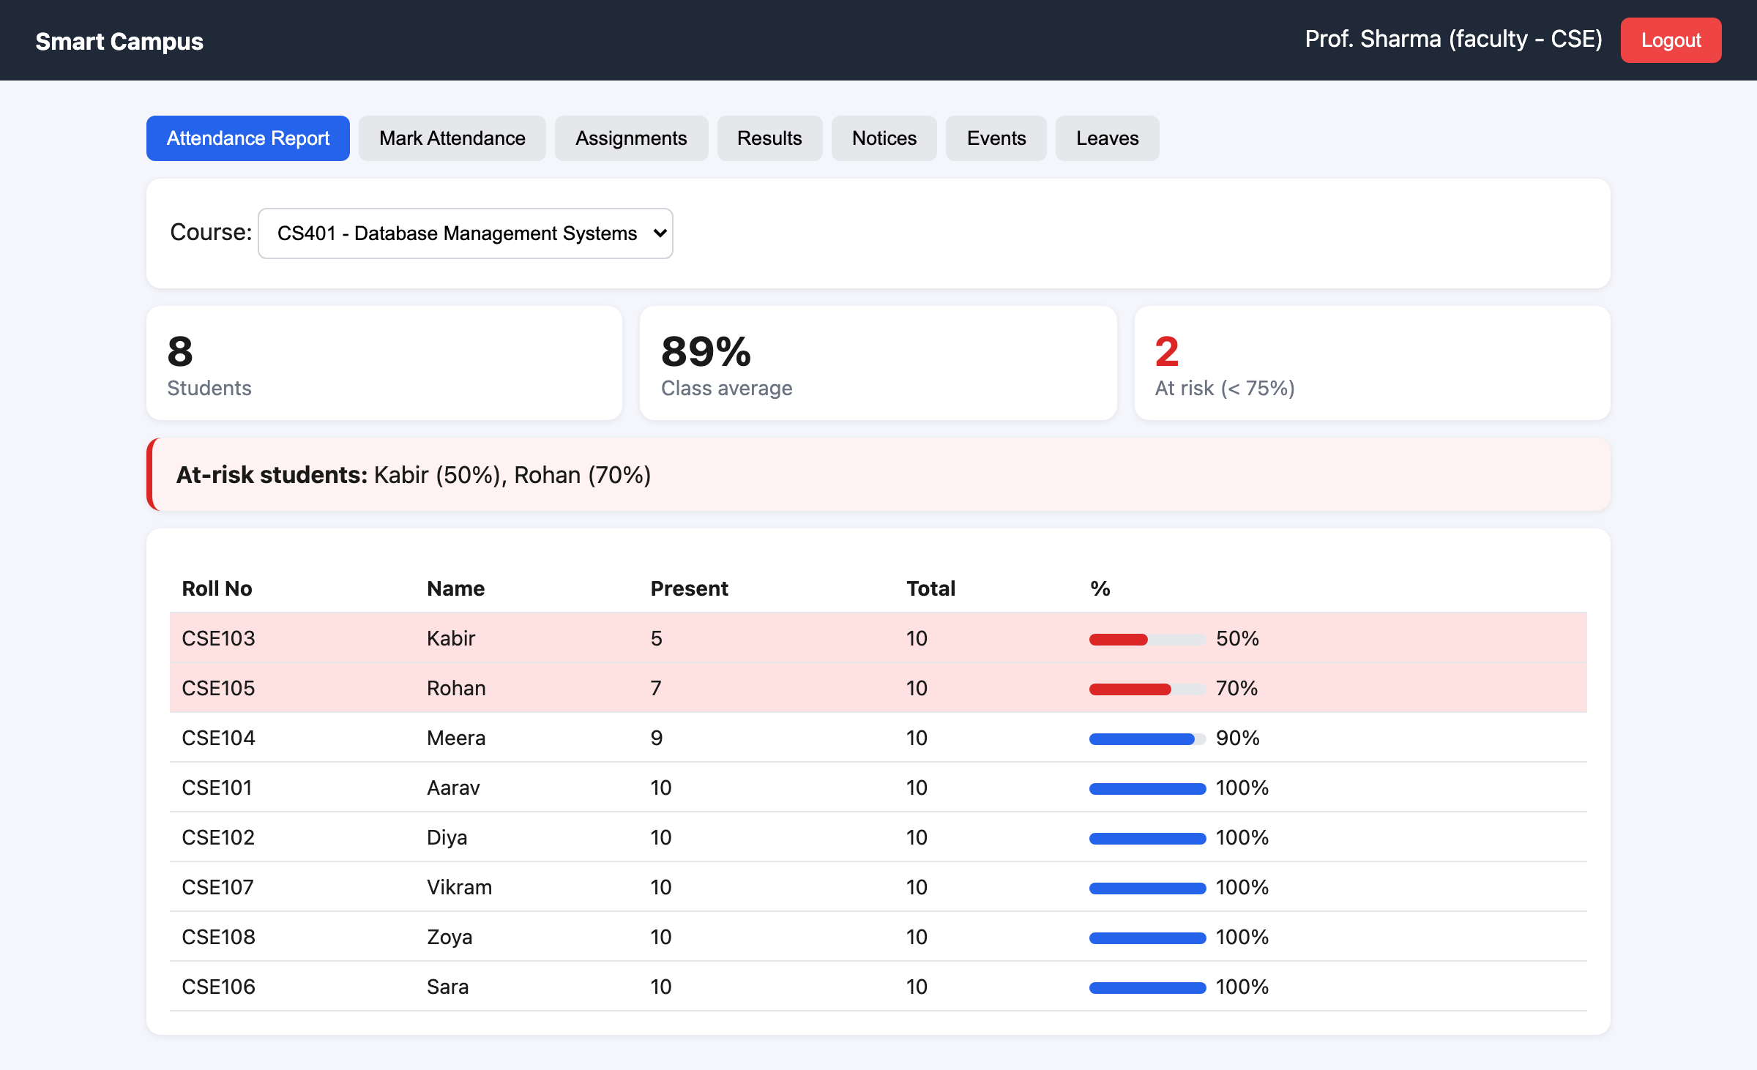
Figure 1: Special feature 1: faculty dashboard with at-risk students
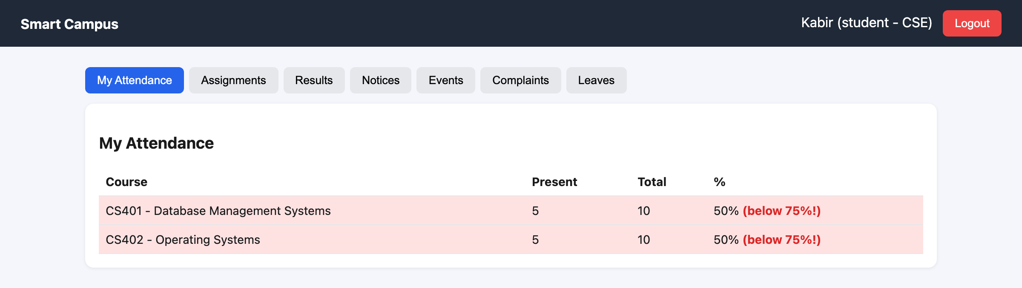
Figure 2: The student's side: Kabir sees his warning

In simple words
Instead of a teacher counting ticks in a register at the end of the term (when it's too late), the app counts for them every day and shouts "these two students need help!" in red.

3.2 Role-Based Security with Department Limits
All four roles use the same website and the same URLs, but each person only gets the data that belongs to them. This is checked on the server, so it can't be bypassed by changing the page.
- At login the server gives a JWT token that carries the user's id, role and department, sealed with a secret key.
- authMiddleware checks the token on every request (401 if missing or fake).
- allowRoles(...) checks the role on every route (403 if not allowed).
- The route then limits the data using values from the token, not from the user: an HOD is always locked to their own department, a student only ever gets their own marks, complaints and leaves, and a faculty member can only mark attendance for their own courses.
Who calls | GET /users?role=student&department=ECE | Why
Admin | ECE students | Admin may choose any department
HOD (CSE) | CSE students only | Department is forced from the token; "ECE" in the URL is ignored
Faculty | Students | Faculty can only list students
Student | 403 Access denied for role: student | Students can't list users at all
Table 3: Same request, different answers depending on who asks
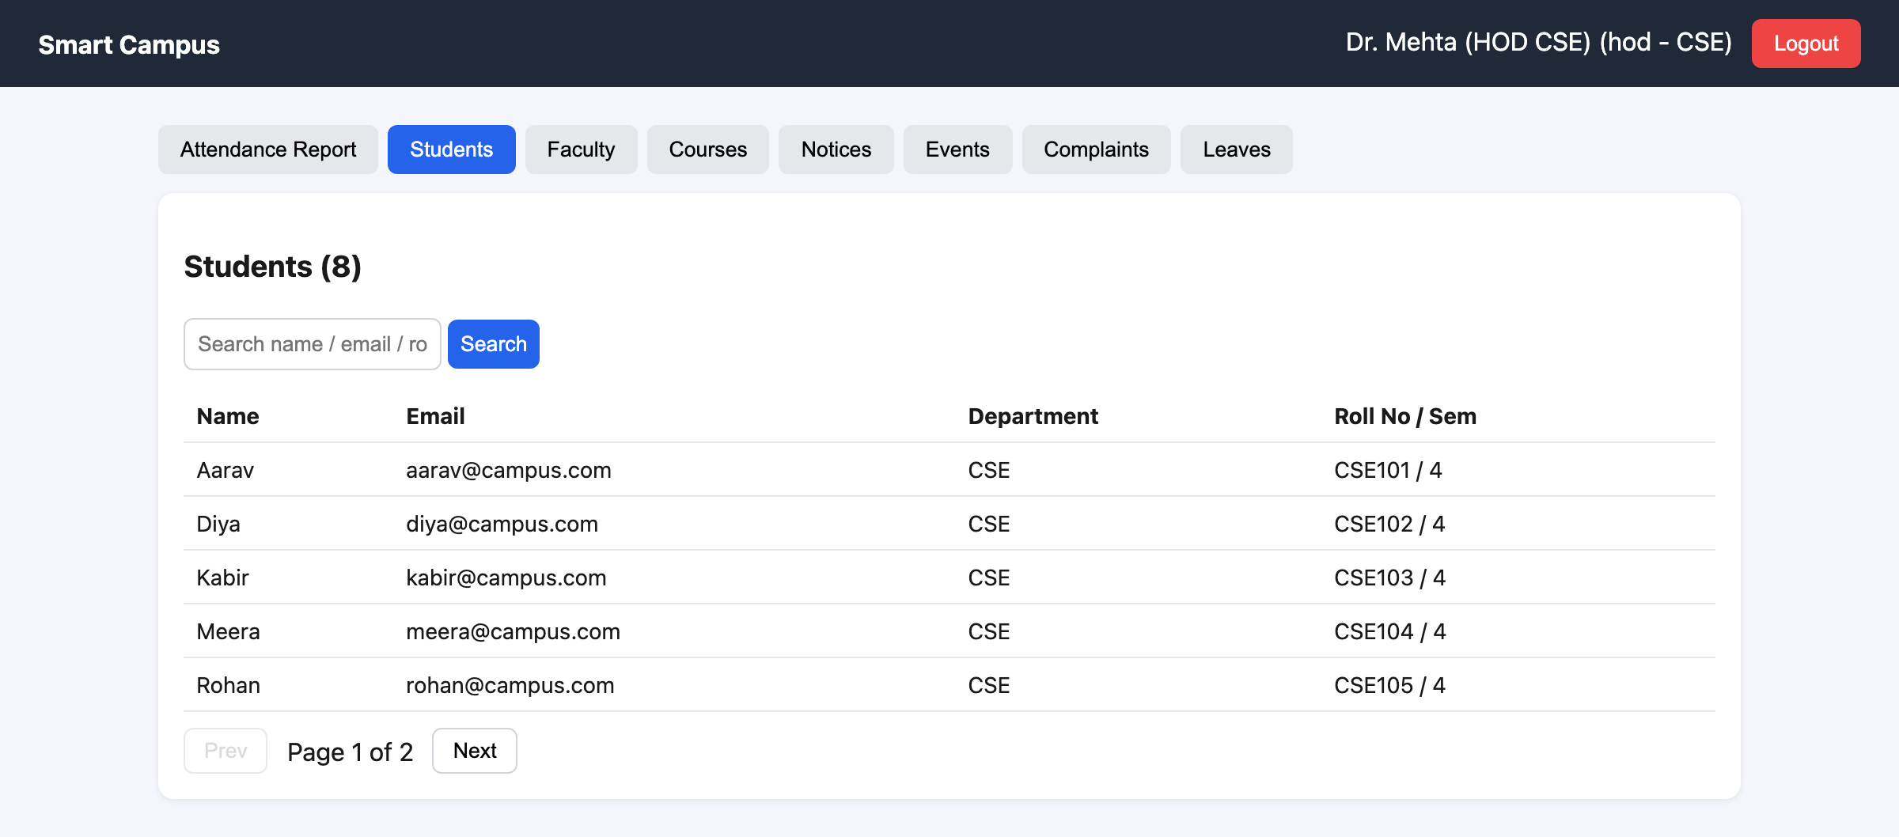
Figure 3: The HOD only ever sees their own department

In simple words
Everyone walks through the same school gate, but the guard reads your ID card. A class teacher's card opens only their classrooms, the head of CSE's card opens only the CSE block, and a student's card only opens their own locker. Writing "ECE" on your hand doesn't help, because the guard only trusts the ID card.

3.3 Secure Password Hashing
Passwords are never stored as typed. Each password is turned into a hash using HMAC-SHA-256 (SHA-256 mixed with a secret key that only the server knows) plus a random salt for every user. It is built with Node's built-in crypto module, so no extra library is needed.
- What is saved looks like salt:hash, for example 1518ddb2...:db5790e3... — the real password is nowhere in the database.
- Admin, HOD and faculty all use the password password123, but their stored values are completely different, because each has its own salt.
- At login the server hashes the typed password again with the same salt and key and compares the two hashes using crypto.timingSafeEqual().
- A wrong password and an unknown email give the same 401 message, so nobody can find out which emails exist.

In simple words
It's like a blender: easy to turn fruit into a smoothie, impossible to turn the smoothie back into fruit. We only keep the smoothie. The secret key is our secret ingredient and the salt is a random sprinkle for each person, so two people with the same fruit still get different-looking smoothies.

3.4 More Highlights
- Correct, don't duplicate: saving attendance for the same day again updates the old records (upsert) instead of adding duplicates, so a teacher can fix a mistake.
- Search and pages: user and notice lists can be searched (by name, email or roll number) and are split into pages of 5 with Prev/Next.
- Live API documentation: opening the API's address (http://localhost:8000) in a browser shows a full docs page listing all 28 endpoints, who can call each one, example requests and responses, and errors.
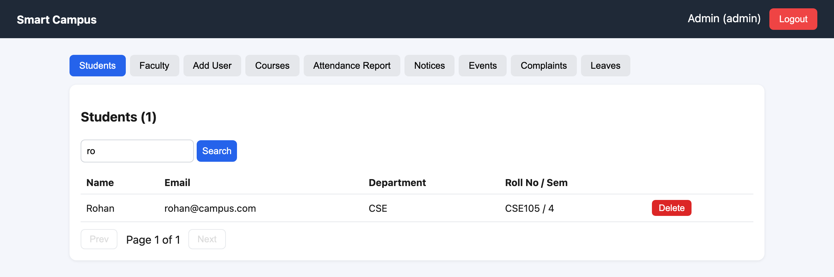
Figure 4: Search and pagination on the student list
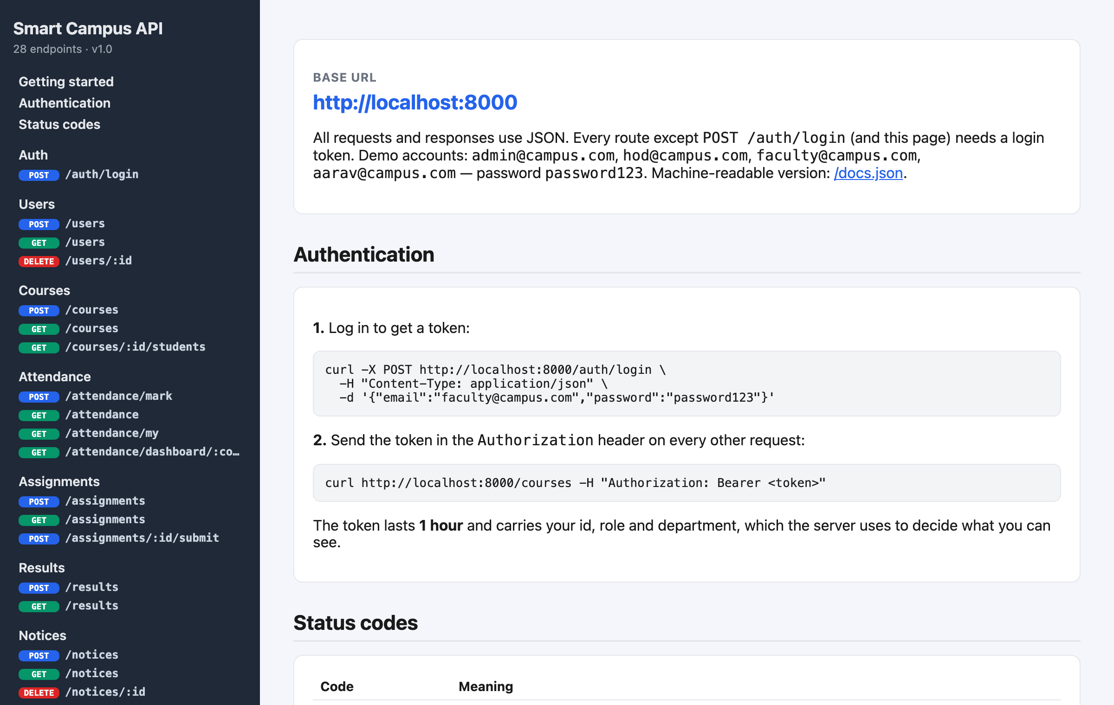
Figure 5: Live API docs page at http://localhost:8000

4. Technologies Used
We used the MEN stack (MongoDB, Express, Node.js) for the backend, which is what we learned in class, plus React for the screens.
Technology | Version | What it is (simple words) | Where we used it
Node.js | 26 | Lets JavaScript run on a computer instead of only inside a browser | Runs our whole backend server
Express | 5.2 | A small library that makes it easy to create URLs (routes) like /login | server.js and all routes/*.js files
MongoDB | 7 | A database that stores data as documents (like JSON objects) | Stores users, courses, attendance, etc.
Mongoose | 9 | A helper that lets Node talk to MongoDB using models/schemas | models/*.js, all find/create calls
jsonwebtoken (JWT) | 9 | Creates and checks a signed login pass (token) | authRoutes.js and authMiddleware.js
crypto | built-in | Node's own toolbox for hashing and random numbers | utils/password.js (HMAC-SHA-256 + salt)
cors | 2.8 | Allows the React website (port 5173) to call our API (port 8000) | server.js
React | 18 | A library for building screens out of small reusable pieces (components) | client/src
Vite | 5 | A tool that runs the React app during development | client folder (npm run dev)
fetch() | built-in | The browser's way to send a request to a server | client/src/api.js and Login.jsx
localStorage | built-in | A small storage box inside the browser that remembers things after refresh | Saves the token and user after login
Table 4: Technology stack

5. System Architecture
The project has three parts that talk to each other: the Frontend (what you see), the Backend (the brain) and the Database (the memory).
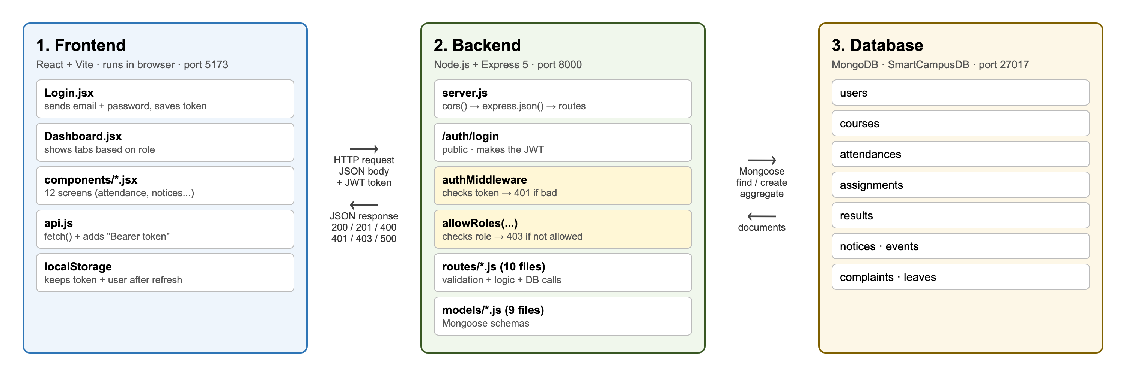
Figure 6: Three-tier architecture of Smart Campus

In simple words
It works like a restaurant.
The frontend (React) is the menu and the waiter. You look at it and tell it what you want.
The backend (Express) is the kitchen. It checks your order is allowed, cooks it, and sends the plate back.
The database (MongoDB) is the fridge. The kitchen takes things out of it and puts things back in.
You never walk into the kitchen yourself — you always go through the waiter. In the same way, the React screens never touch MongoDB directly; they always ask the Express server.

Part | Runs on | Started with
Frontend (React + Vite) | http://localhost:5173 | cd client → npm run dev
Backend (Express) | http://localhost:8000 | npm start
Database (MongoDB) | mongodb://127.0.0.1:27017/SmartCampusDB | MongoDB service / Docker
Table 5: Where each part runs

6. Data Flow: Frontend ↔ API ↔ Backend ↔ Database
This chapter follows the data on its trip there and back: from a click on the screen, through the API to the backend and database, and back to the screen. The browser never talks to MongoDB directly — every piece of data goes through the Express API, which first checks who you are and what you're allowed to do.

The big picture
React (port 5173) HTTP request: JSON + token Express API (port 8000) Mongoose query MongoDB
components/*.jsx ───────────────────────────────────────▶ server.js → middleware ─────────────────────▶ SmartCampusDB
api.js → fetch() ◀─────────────────────────────────────── → routes/*.js → models ◀─────────────────────
HTTP response: JSON + status code documents

6.1 Going There: the Request
# | Where | What happens
1 | Component (e.g. MarkAttendance.jsx) | The user clicks a button. The component takes the values in its useState (course, date, absent students) and calls request("/attendance/mark", "POST", { courseId, date, records }).
2 | client/src/api.js | Builds the fetch call: adds Content-Type: application/json and Authorization: Bearer <token> (saved in localStorage at login), turns the body into JSON text and sends it to http://localhost:8000/attendance/mark.
3 | server.js → cors() | Lets a page on port 5173 call a server on port 8000 (the browser blocks this otherwise).
4 | server.js → express.json() | Turns the JSON text back into a JavaScript object in req.body.
5 | authMiddleware | Checks the token with jwt.verify(). Missing or fake → 401, stop. Valid → puts { userId, name, role, department, semester } into req.user.
6 | app.use("/attendance", …) | Express matches the URL and hands the request to routes/attendanceRoutes.js.
7 | allowRoles("faculty","admin") | Checks req.user.role. A student gets 403 and stops here.
8 | Route handler | Validation: missing fields → 400, course not found → 404, not your course → 403.
9 | Model (models/Attendance.js) | Attendance.findOneAndUpdate(…, { upsert: true }). Mongoose checks the schema rules (required, enum) and sends the query to MongoDB.
10 | MongoDB | Updates or inserts the documents in the attendances collection.
Table 6: The request, step by step

6.2 Coming Back: the Response
# | Where | What happens
11 | MongoDB → Mongoose | Returns the saved or found documents as JavaScript objects (populate() swaps ids for names where needed).
12 | Route handler | Sends the answer with a status code: res.status(201).json({ message: "Attendance saved for 8 students" }). If anything throws, the catch sends 500.
13 | api.js | await res.json() reads the answer. If res.ok is false (400/401/403/404/500) it throws an Error with the server's message, otherwise it returns the data.
14 | Component | Puts the data into state: setMsg(data.message), setStudents(list), …
15 | React | Sees the state changed and re-draws the screen, so the user sees the new list or message.
Table 7: The response, step by step
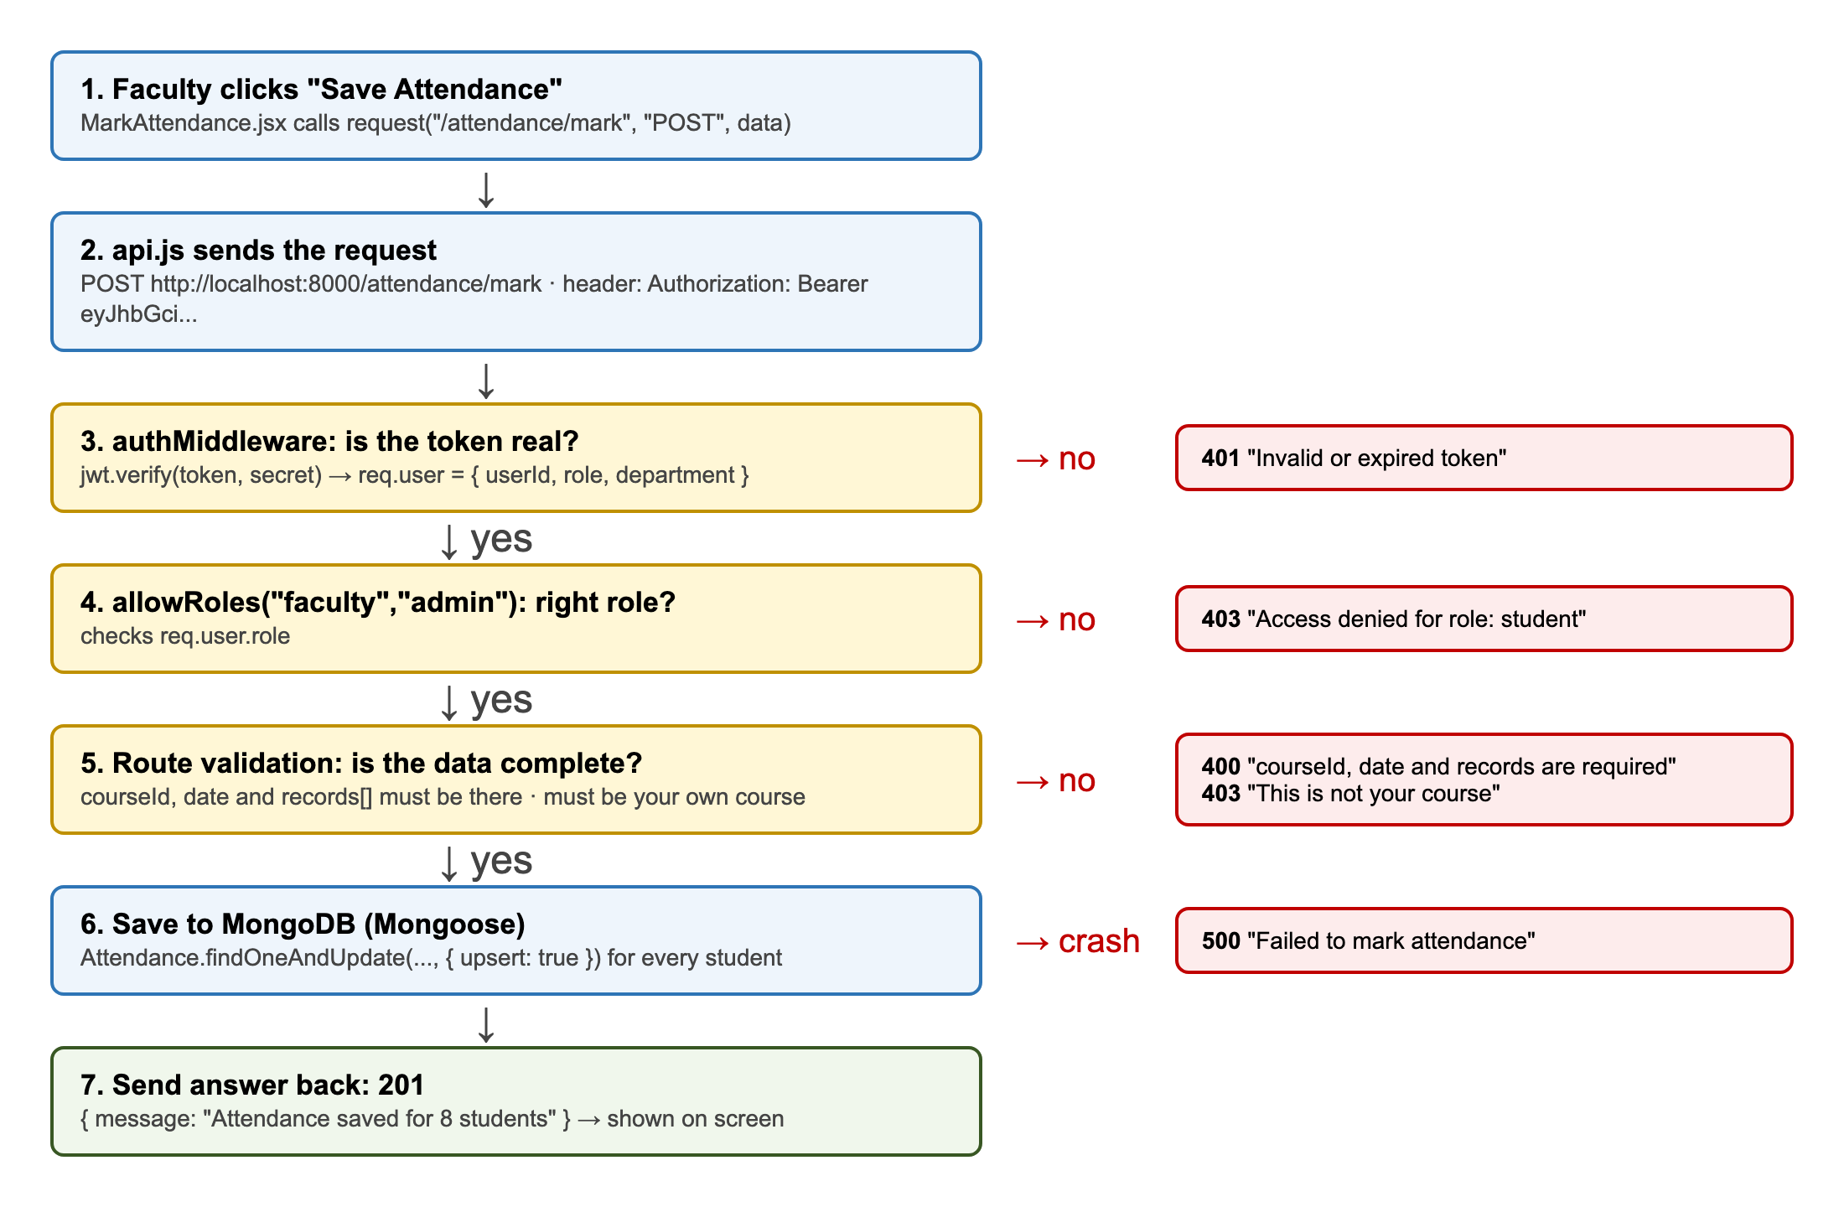
Figure 7: The checkpoints a request passes when faculty clicks "Save Attendance"

6.3 Example 1: Login (the only request without a token)

Login.jsx ── POST /auth/login { email, password } ──▶ authRoutes.js
User.findOne({ email }) ──▶ MongoDB users
checkPassword(typed, saved hash)
jwt.sign({ userId, role, department, ... }, secret, 1h)
Login.jsx ◀── 200 { token, user: { name, role, department } }
localStorage.setItem("token", ...) + setUser(user) → App.jsx shows the Dashboard

From now on, api.js attaches this token to every request, and that's how the backend knows who is calling.

6.4 Example 2: Faculty Dashboard (reading with aggregation)

AttendanceReport.jsx useEffect → request("/attendance/dashboard/<courseId>")
→ authMiddleware (token ok) → allowRoles("faculty","hod","admin") ok
→ Attendance.aggregate([ $match → $group → $lookup users → $unwind → $project → $sort ])
→ MongoDB returns one row per student
→ route adds atRisk (percent < 75) + classAverage
◀ 200 { students: [...], atRisk: [...], classAverage: 89 }
→ setReport(data) → React draws the cards, the red at-risk banner and the % bars

6.5 Example 3: When Something Is Wrong

Student calls POST /attendance/mark
→ authMiddleware ok → allowRoles("faculty","admin") ✗
◀ 403 { message: "Access denied for role: student" }
→ api.js: res.ok is false → throw new Error("Access denied for role: student")
→ the component's catch shows the message on screen (nothing was saved)

Status | Sent by | Meaning
200 / 201 | route handler | OK / created
400 | route validation | missing or wrong data
401 | authMiddleware / login | no token, bad token, or wrong password
403 | allowRoles / route | logged in but not allowed
404 | route / catch-all | item or route not found
500 | route catch | something crashed on the server
Table 8: Which part of the backend sends which status code

In simple words
Sending a request is like posting a letter with a return address. The component writes the letter, api.js puts it in an envelope and sticks your ID card (token) on it, the security guard checks the ID, the right department (route) reads it, fetches what you asked for from the storeroom (MongoDB), and posts the answer back to the same address. When the answer arrives, React opens it and updates the screen.

7. Database Design

7.1 Why MongoDB?
MongoDB stores data as documents. A document looks just like a JavaScript object: { name: "Aarav", role: "student" }. Documents of the same kind are kept together in a collection (like a table in SQL). We have 9 collections.

In simple words
A collection is like a box of index cards. Every card (document) in the "users" box has a name, an email and a role written on it. Every card automatically gets a unique number called _id, so we can always find exactly that card again.
When one card needs to talk about another card, it just writes down the other card's _id. For example an attendance card says "student: 6ab4d65a..." instead of copying the whole student.

7.2 Entity Relationship Diagram (ERD)
The ERD on the next page shows all 9 collections, their fields, and how they are connected. PK = primary key (_id), FK = a field that stores another document's _id, UQ = must be unique. The line ending with two bars means one, and the line ending with a crow's foot (three lines) means many.

ERD — Smart Campus (SmartCampusDB)
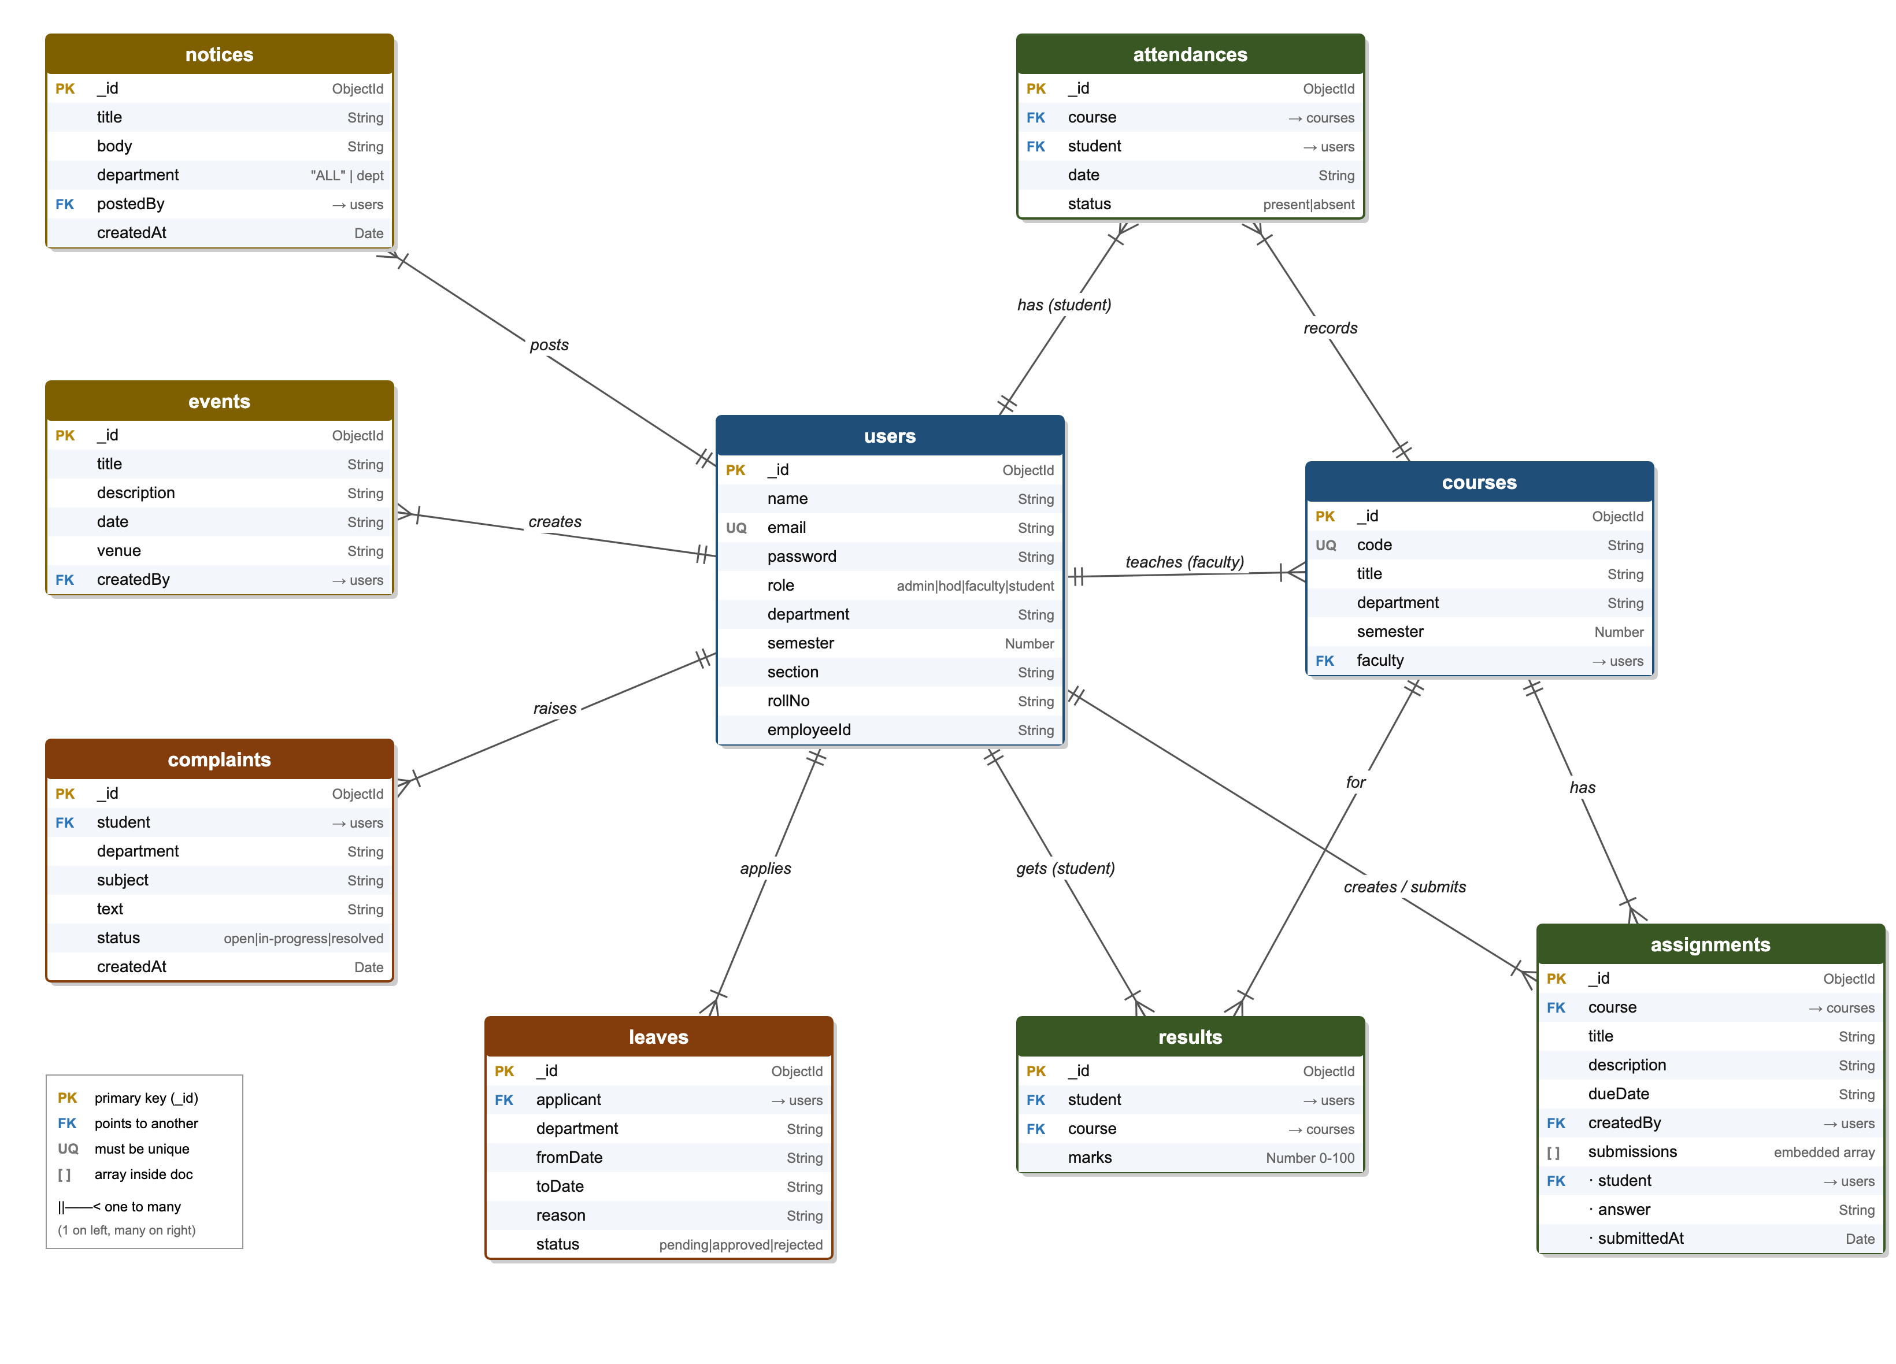
Figure 8: Entity Relationship Diagram of all 9 collections

7.3 Relationships Explained
From (one) | To (many) | Stored as | Meaning
users (faculty) | courses | courses.faculty | One teacher can teach many courses
users (student) | attendances | attendances.student | One student has many attendance records
courses | attendances | attendances.course | One course has many attendance records
courses | assignments | assignments.course | One course has many assignments
users (faculty) | assignments | assignments.createdBy | One teacher creates many assignments
users (student) | assignments.submissions[] | submissions[].student (embedded) | One student can submit to many assignments
users (student) | results | results.student | One student has many results
courses | results | results.course | One course has many results
users | notices / events | postedBy / createdBy | One user can post many notices/events
users (student) | complaints | complaints.student | One student can raise many complaints
users | leaves | leaves.applicant | One student/faculty can apply for many leaves
Table 9: One-to-many relationships

7.4 Collections and Fields

users
One collection for all four roles. The role field decides what the person can do.
Field | Type | Rules | Meaning
_id | ObjectId | auto | Unique id of the user
name | String | required | Full name
email | String | required, unique | Used to log in; no two users can share it
password | String | required | Salted HMAC-SHA-256 hash saved as "salt:hash" (never the real password)
role | String | required, enum | admin / hod / faculty / student
department | String | — | e.g. CSE, ECE
semester | Number | students | e.g. 4
section | String | students | e.g. A
rollNo | String | students | e.g. CSE101
employeeId | String | faculty/HOD | e.g. FAC01
Table 10: users collection

courses
A course belongs to a department and a semester. All students with the same department and semester are in that course.
Field | Type | Rules | Meaning
_id | ObjectId | auto | Unique id
code | String | required, unique | e.g. CS401
title | String | required | e.g. Database Management Systems
department | String | required | Which department runs it
semester | Number | required | Which semester's students take it
faculty | ObjectId → users | — | The teacher of this course
Table 11: courses collection

attendances
One document = one student, in one course, on one day. 8 students × 2 courses × 10 days = 160 documents in our demo data.
Field | Type | Rules | Meaning
_id | ObjectId | auto | Unique id
course | ObjectId → courses | required | Which course
student | ObjectId → users | required | Which student
date | String | required | Day as text, e.g. 2026-09-24
status | String | required, enum | present / absent
Table 12: attendances collection

assignments
Submissions are stored inside the assignment document as an array, so one read gives the assignment and all its answers.
Field | Type | Rules | Meaning
_id | ObjectId | auto | Unique id
course | ObjectId → courses | required | Which course
title | String | required | Assignment name
description | String | — | What to do
dueDate | String | — | Last date
createdBy | ObjectId → users | — | Faculty who created it
submissions[] | Array (embedded) | — | List of { student, answer, submittedAt }
Table 13: assignments collection

results
Saving marks again for the same student + course updates the old value instead of adding a new one.
Field | Type | Rules | Meaning
_id | ObjectId | auto | Unique id
student | ObjectId → users | required | Whose marks
course | ObjectId → courses | required | Which course
marks | Number | required, 0–100 | Marks out of 100
Table 14: results collection

notices
Students only see notices marked "ALL" or their own department.
Field | Type | Rules | Meaning
_id | ObjectId | auto | Unique id
title | String | required | Heading
body | String | required | Message
department | String | default "ALL" | "ALL" = whole college, or one department
postedBy | ObjectId → users | — | Who posted it
createdAt | Date | default now | When it was posted
Table 15: notices collection

events
College events shown to everyone, sorted by date.
Field | Type | Rules | Meaning
_id | ObjectId | auto | Unique id
title | String | required | Event name
description | String | — | Details
date | String | required | Event day
venue | String | — | Place
createdBy | ObjectId → users | — | Who added it
Table 16: events collection

complaints
A complaint moves through three states: open → in-progress → resolved.
Field | Type | Rules | Meaning
_id | ObjectId | auto | Unique id
student | ObjectId → users | required | Who complained
department | String | — | Copied from the student, so the HOD can filter
subject | String | required | Short topic, e.g. WiFi
text | String | required | The problem
status | String | enum, default open | open / in-progress / resolved
createdAt | Date | default now | When it was raised
Table 17: complaints collection

leaves
Leave requests from students and faculty, decided by the HOD or Admin.
Field | Type | Rules | Meaning
_id | ObjectId | auto | Unique id
applicant | ObjectId → users | required | Student or faculty who applied
department | String | — | Copied from applicant, for HOD filtering
fromDate | String | required | Start day
toDate | String | required | End day (cannot be before fromDate)
reason | String | required | Why
status | String | enum, default pending | pending / approved / rejected
Table 18: leaves collection

7.5 Design Decisions
- One users collection for everybody. Students, faculty, HOD and admin all have a name, email and password, so we keep them together and use a role field. "Students" and "faculty" lists are just User.find({ role: "student" }).
- Department as plain text (like "CSE") instead of a separate departments collection, to keep things simple.
- Dates saved as text like "2026-09-24". This matches what the HTML date picker gives us, and avoids time-zone confusion.
- Submissions embedded inside assignments, because we always look at them together.
- References with `ref`, so Mongoose's populate() can swap an _id for the real name when we need it.

8. Project Folder Structure
The backend follows the same pattern as the Day 8 Railway Management project from class: server.js → routes/ → models/, with config/db.js and middleware/. All the logic is written directly inside the routes — there is no separate controllers folder.

Folder tree
cooked-campus/
├── server.js starts the app, connects routes
├── seed.js fills the database with demo data
├── package.json backend libraries + npm scripts
├── config/
│ └── db.js connects to MongoDB
├── middleware/
│ ├── authMiddleware.js checks the JWT token (401 if bad)
│ └── roleMiddleware.js allowRoles(...) (403 if wrong role)
├── utils/
│ ├── password.js hashPassword() / checkPassword()
│ └── apiDocs.js API docs page served at GET /
├── models/ 9 Mongoose schemas
│ ├── User.js Course.js Attendance.js Assignment.js
│ └── Notice.js Event.js Complaint.js Leave.js Result.js
├── routes/ 10 route files (logic lives here)
│ ├── authRoutes.js userRoutes.js courseRoutes.js
│ ├── attendanceRoutes.js assignmentRoutes.js resultRoutes.js
│ └── noticeRoutes.js eventRoutes.js complaintRoutes.js leaveRoutes.js
└── client/ React frontend
└── src/
├── main.jsx puts <App/> on the page
├── App.jsx login page OR dashboard
├── Login.jsx login form
├── Dashboard.jsx tabs for each role
├── api.js fetch helper that adds the token
├── styles.css all the styling
└── components/ 12 screens (one per module)

9. Backend Handbook — How the Code Works
This chapter walks through the important backend files one by one. Every code box below is copied exactly from our project (the line numbers are the real ones).

9.1 server.js — The Starting Point

server.js (lines 1–66)
// bring in express, cors n our db connect func
const express = require("express");
const cors = require("cors");
const {connectDB} = require("./config/db");
// import all route files (each one handles one module)
const authRoutes = require("./routes/authRoutes");
const userRoutes = require("./routes/userRoutes");
const courseRoutes = require("./routes/courseRoutes");
const attendanceRoutes = require("./routes/attendanceRoutes");
const assignmentRoutes = require("./routes/assignmentRoutes");
const noticeRoutes = require("./routes/noticeRoutes");
const eventRoutes = require("./routes/eventRoutes");
const complaintRoutes = require("./routes/complaintRoutes");
const leaveRoutes = require("./routes/leaveRoutes");
const resultRoutes = require("./routes/resultRoutes");
// the jwt checker middleware
const authMiddleware = require("./middleware/authMiddleware");
// api docs page data
const { apiDocs, apiDocsPage } = require("./utils/apiDocs");

// make the app, connect mongo
const app = express();
connectDB();
// cors so react (diff port) can call us, express.json so req.body works
app.use(cors());
app.use(express.json());

// api docs are public -> open http://localhost:8000 in the browser
// (has to be above authMiddleware or u'd need a token just to read the docs)
app.get("/", (req,res)=>{
res.send(apiDocsPage());
})
// same docs as json (for postman / other tools)
app.get("/docs.json", (req,res)=>{
res.json(apiDocs);
})

// login route is open, no token needed (bcoz u dont have one yet lol)
app.use("/auth",authRoutes);

// order matters!! everything BELOW this line goes thru authMiddleware first
// so no token -> 401, never reaches the routes
app.use(authMiddleware);
// all the protected routes
app.use("/users",userRoutes);
app.use("/courses",courseRoutes);
app.use("/attendance",attendanceRoutes);
app.use("/assignments",assignmentRoutes);
app.use("/notices",noticeRoutes);
app.use("/events",eventRoutes);
app.use("/complaints",complaintRoutes);
app.use("/leaves",leaveRoutes);
app.use("/results",resultRoutes);

// catch all, if nothing above matched -> 404 route not found
app.use('/',(req,res)=>{
res.status(404).json({
message:"Route not found: " + req.method + " " + req.originalUrl
});
})

// start server on port 8000
app.listen(8000,()=>{
console.log(`server is running on port 8000`);
})

What happens, line by line:
- Lines 2–19 load Express, CORS, the database function, all 10 route files, the auth middleware and the API docs.
- Line 22 creates the app and line 23 connects to MongoDB.
- Line 25 cors() lets our React site on port 5173 talk to this server on port 8000 (browsers block this by default).
- Line 26 express.json() reads JSON sent by the frontend and puts it in req.body.
- Lines 30–36 serve the API docs page at / and the same docs as JSON at /docs.json. They come before the auth middleware, so anyone can read them.
- Line 39 mounts /auth before the auth middleware, so login works without a token.
- Line 43 app.use(authMiddleware) — from here down, every request must carry a valid token.
- Lines 45–53 mount the protected route files.
- Lines 57–61 are the catch-all: if no route matched, answer 404 Route not found.
- Line 64 starts listening on port 8000.

In simple words
The order of app.use lines is like a queue at a school gate. The first door (/auth) is open to everybody so you can get your ID card. Right after it stands a security guard (authMiddleware). Anyone who wants to go further inside must show the ID card. If you don't have one, the guard sends you back with a 401.

9.2 config/db.js — Connecting to MongoDB

config/db.js (lines 1–12)
const mongoose = require("mongoose");
// connect to mongo (local, db name SmartCampusDB), if it fails just log the error
const connectDB = async()=>{
try{
await mongoose.connect("mongodb://127.0.0.1:27017/SmartCampusDB");
console.log("MongoDB Connected");
}catch(error){
console.log("Database connection failed "+error.message);
}
};
// export as object so we do const {connectDB} = require(...)
module.exports={connectDB};

mongoose.connect() opens a connection to the database called SmartCampusDB on our own computer. If MongoDB is switched off, the error is caught and printed instead of crashing the app.

9.3 Models — Describing the Data
A schema is a list of fields and rules. A model is the tool we use to read and write that collection (User.find(), User.create(), etc.).

models/User.js (lines 1–17)
const mongoose = require("mongoose");

// one collection for everyone, role field decides admin / hod / faculty / student
const userSchema = new mongoose.Schema({
name:{type:String, required:true},
email:{type:String, required:true, unique:true}, // unique = no 2 users w/ same email
password:{type:String, required:true},
role:{type:String, required:true, enum:["admin","hod","faculty","student"]}, // enum = only these 4 allowed
department:String, // like "CSE"
semester:Number, // students only
section:String, // students only
rollNo:String, // students only
employeeId:String, // faculty / hod only
});

// make model, mongo will save it in "users" collection
module.exports=mongoose.model("User",userSchema);

- required: true — the document will not be saved without this field.
- unique: true — MongoDB refuses a second user with the same email.
- enum: [...] — only these exact values are allowed. role: "king" would be rejected.
- mongoose.model("User", ...) — Mongoose automatically names the collection users (lower-case, plural).

models/Attendance.js (lines 1–12)
const mongoose = require("mongoose");

// 1 doc = 1 student, 1 course, 1 day
const attendanceSchema = new mongoose.Schema({
course:{type:mongoose.Schema.Types.ObjectId, ref:"Course", required:true}, // which course (its _id)
student:{type:mongoose.Schema.Types.ObjectId, ref:"User", required:true}, // which student (its _id)
date:{type:String, required:true}, // saved as text like "2026-09-24"
status:{type:String, enum:["present","absent"], required:true}, // only present or absent
});

const Attendance = mongoose.model("Attendance",attendanceSchema);
module.exports = Attendance;

type: mongoose.Schema.Types.ObjectId, ref: "Course" means this field stores the _id of a course. Later, .populate("course") can replace that id with the actual course code and title.

models/Assignment.js (lines 3–18)
const assignmentSchema = new mongoose.Schema({
course:{type:mongoose.Schema.Types.ObjectId, ref:"Course", required:true},
title:{type:String, required:true},
description:String,
dueDate:String,
createdBy:{type:mongoose.Schema.Types.ObjectId, ref:"User"}, // faculty who made it
// submissions are kept inside the assignment itself as an array
// each one = which student + their answer + when
submissions:[
{
student:{type:mongoose.Schema.Types.ObjectId, ref:"User"},
answer:String, // link or text
submittedAt:{type:Date, default:Date.now}, // auto fills current time
}
],
});

submissions is an array of small objects inside the assignment. When a student submits, we push a new object into this array.

In simple words
A schema is like a form with boxes at the post office. It says which boxes must be filled (required), which boxes can only have certain answers (enum, like ticking Male/Female), and which ones must be different for everybody (unique, like your roll number).

9.4 Login and JWT (JSON Web Token)

routes/authRoutes.js (lines 10–64)
// POST /auth/login -> anyone can login (no token needed)
// no register route bcoz admin makes accounts (POST /users)
router.post("/login", async (req, res) => {
try {
// get email n password from body
const { email, password } = req.body;
// if any one is missing -> 400
if (!email || !password) {
return res.status(400).json({
message: "Email and password are required",
});
}
// find user by email only (password in db is hashed, cant search by it)
const user = await User.findOne({ email: email });
// no user OR password doesnt match the saved hash -> wrong login, send 401
// (same msg for both so nobody can guess which emails exist)
if (!user || !checkPassword(password, user.password)) {
return res.status(401).json({
message: "Invalid email or password",
});
}
// make token w/ user info inside, expires in 1hr
// role n dept are inside so middleware can chk them later
const token = jwt.sign(
{
userId: user._id,
name: user.name,
role: user.role,
department: user.department,
semester: user.semester,
},
JWT_SECRET,
{
expiresIn: "1h",
},
);
// send token + basic user info back (no password!)
res.json({
message: "Login successful",
token,
user: {
id: user._id,
name: user.name,
email: user.email,
role: user.role,
department: user.department,
},
});
} catch (error) {
// something broke on server side
res.status(500).json({
message: error.message,
});
}
});

- Take email and password from the request body. If either is missing, answer 400.
- Find the user by email only. Then checkPassword() hashes the typed password with that user's saved salt and compares it with the saved hash. No user, or no match → 401 Invalid email or password (the same message both times, so nobody can find out which emails exist).
- jwt.sign() creates a token that contains userId, name, role, department and semester, signed with our secret key and valid for 1 hour.
- Send the token and some basic user info back. The password is never sent back.

In simple words
A JWT is like a wristband at an amusement park. At the entrance (login) you show your ticket once, and they give you a wristband with your name and pass type printed on it. After that, every ride just looks at your wristband — they don't ask for your ticket again.
The wristband is stamped with a secret seal (the secret key). If someone draws their own wristband at home, the seal won't match and they'll be stopped. It also expires after 1 hour, just like a day pass.

9.5 Password Hashing (HMAC-SHA-256 with a Secret Key and Salt)
We never store the real password. Before a user is saved, the password is turned into a hash using HMAC-SHA-256 from Node's built-in crypto module, so no extra library is needed. HMAC means SHA-256 is mixed with our own secret key. We also add a random salt for every user.

utils/password.js (lines 1–35)
// password hashing w/ node's built in crypto module (no npm install needed)
const crypto = require("crypto");

// secret key mixed into every hash, keep it private (just like JWT_SECRET)
const PASSWORD_SECRET = "campus_password_secret_key";

// makes the HMAC-SHA256 hash of salt + password using our secret key
const makeHash = (salt, password) => {
return crypto.createHmac("sha256", PASSWORD_SECRET).update(salt + password).digest("hex");
};

// plain password -> "salt:hash" (this is what we save in db)
// salt = random text, so 2 users w/ same password still get diff hashes
const hashPassword = (password) => {
const salt = crypto.randomBytes(16).toString("hex");
return salt + ":" + makeHash(salt, password);
};

// chk a typed password against the saved "salt:hash" -> true / false
const checkPassword = (password, saved) => {
// split saved value back into salt n hash, bad format -> false
const [salt, hash] = String(saved).split(":");
if (!salt || !hash) {
return false;
}
// hash the typed password w/ the SAME salt, then compare
const newHash = makeHash(salt, password);
if (newHash.length !== hash.length) {
return false;
}
// timingSafeEqual = compare w/o leaking how many chars matched
return crypto.timingSafeEqual(Buffer.from(newHash), Buffer.from(hash));
};

module.exports = { hashPassword, checkPassword };

- hashPassword() makes 16 random bytes (the salt), then calculates HMAC-SHA256(secretKey, salt + password).
- It saves salt:hash in the database, for example 1518ddb2...:db5790e3....
- At login, checkPassword() splits the saved value, hashes the typed password again with the same salt and key, and compares the two hashes.
- crypto.timingSafeEqual() compares them in constant time, so an attacker can't guess the hash one character at a time by measuring response time.

routes/userRoutes.js (lines 22–27) — admin adds a user
return res.status(400).json({ message:"Email already exists" });
}
// never save the real password -> swap it w/ the salted hash
req.body.password = hashPassword(password);
// save user in db n send back basic info (not the password)
const user = await User.create(req.body);

Email | Typed password | What is actually saved in MongoDB
admin@campus.com | password123 | 1518ddb23957ba003594b424d4f6edf8:db5790e3e7f9…
hod@campus.com | password123 | 23f74eb4368b260bb1cd304e92992ac5:b231ac84b3b8…
faculty@campus.com | password123 | bf412448d24173f2e925d84f32874082:d014c45952fa…
Table 19: Same password, different stored values (thanks to the salt)

In simple words
Hashing is like putting fruit in a blender. It's easy to turn a banana into a smoothie, but impossible to turn the smoothie back into a banana. We only keep the smoothie. At login we blend the password you type again, and if the smoothie tastes exactly the same, you typed the right password.
The secret key is our secret ingredient that only the server knows, so even someone who steals the database can't make matching smoothies at home.
The salt is a random sprinkle added for each person. Three teachers can all have the password "password123", but their smoothies look completely different, so a thief can't tell they're the same.

9.6 authMiddleware — The Security Guard

middleware/authMiddleware.js (lines 1–31)
const jwt = require("jsonwebtoken");
// same secret used in authRoutes when making the token
const JWT_SECRET = "campus_secret_key";
const authMiddleware = (req, res, next) => {
try {
// grab the authorization header, no header = not logged in -> 401
const authHeader = req.headers.authorization;
if (!authHeader) {
return res.status(401).json({
message: "Authorization token is required",
});
}
// token comes like "Bearer abc123" so split n take 2nd part
const token = authHeader.split(" ")[1];
if (!token) {
return res.status(401).json({
message: "Invalid authorization format",
});
}
// verify token w/ same secret, if fake/expired it throws -> catch sends 401
const decoded = jwt.verify(token, JWT_SECRET);
// save user info on req so every route can use req.user.role etc
req.user = decoded; // { userId, name, role, department, semester }
next();
} catch (error) {
return res.status(401).json({
message: "Invalid or expired token",
});
}
};
module.exports = authMiddleware;

A middleware is a function that runs between the request arriving and the route running. It gets req, res and next. Calling next() means "you may go on"; sending a response means "stop here".
- Read the Authorization header. Nothing there → 401.
- The header looks like Bearer eyJhbGci..., so split(" ")[1] takes the token part.
- jwt.verify() checks the seal and expiry. If the token is fake or old it throws an error, and the catch sends 401.
- If it's good, the decoded info is saved in req.user, so every route can use req.user.role, req.user.userId and req.user.department.

9.7 allowRoles — Role-Based Authorization

middleware/roleMiddleware.js (lines 1–16)
// role check middleware, use it like: router.post('/', allowRoles("admin","hod"), async(req,res)=>{ ... })
// runs after authMiddleware so req.user is already there
const allowRoles = (...roles) => {
// returns the actual middleware func
return (req, res, next) => {
// if user's role isnt in the allowed list -> 403 (logged in but not allowed)
if (!roles.includes(req.user.role)) {
return res.status(403).json({
message: "Access denied for role: " + req.user.role,
});
}
// role is ok, go to the route
next();
};
};
module.exports = allowRoles;

allowRoles("admin","hod") returns a middleware function (a function that makes a function — a higher-order function). The returned function checks whether req.user.role is in the allowed list. If not, it answers 403 Access denied.

How we use it inside a route file
router.post('/', allowRoles("admin","hod"), async(req,res)=>{ ... })
// ^ runs first ^ runs only if the role is allowed

In simple words
401 means "I don't know who you are" (no wristband). 403 means "I know who you are, but you're not allowed in here" — like a student trying to walk into the staff room.

9.8 Anatomy of a Route (the pattern every route follows)
Every route in the project is written the same way, just like trainRoutes.js from Day 8. Here is the "raise a complaint" route:

routes/complaintRoutes.js (lines 8–30)
// POST /complaints -> student raises a complaint
router.post('/', allowRoles("student"), async(req,res)=>{
try{
// subject n text r must
const { subject, text } = req.body;
if(!subject || !text){
return res.status(400).json({ message:"subject and text are required" });
}
// save it w/ student id + dept from the token (so hod can see it)
const complaint = await Complaint.create({
student: req.user.userId,
department: req.user.department,
subject: subject,
text: text,
});
res.status(201).json(complaint);
}catch(error){
res.status(500).json({
message:"Failed to add complaint",
error:error.message
});
}
})

Step | Code | Why
1. Who is allowed? | allowRoles("student") | Only students can raise complaints
2. Safety net | try { ... } catch | If anything crashes, send 500 instead of killing the server
3. Validation | if(!subject || !text) → 400 | Stop bad or empty data before it reaches the database
4. Database work | Complaint.create({...}) | Save it. Student id and department come from the token, not from the user, so nobody can fake them
5. Answer | res.status(201).json(...) | 201 = "created", and we send the new complaint back
Table 20: The five steps inside every route

9.9 Search and Pagination

routes/userRoutes.js (lines 40–94)
// GET /users -> admin, hod, faculty see list of users w/ search + pages
// eg: /users?role=student&search=rahul&department=CSE&page=1&limit=5
router.get("/", allowRoles("admin","hod","faculty"), async (req, res) => {
try {
// build the filter step by step, default role = student
const filter = {};
filter.role = req.query.role || "student";

// faculty can only see students, nothing else
if (req.user.role === "faculty") {
filter.role = "student";
}

// hod can only see their own dept, so force it
// others can pick a dept from the url if they want
if (req.user.role === "hod") {
filter.department = req.user.department;
} else if (req.query.department) {
filter.department = req.query.department;
}

// search -> match name OR email OR roll no ("i" = ignore caps)
if (req.query.search) {
filter.$or = [
{ name: { $regex: req.query.search, $options: "i" } },
{ email: { $regex: req.query.search, $options: "i" } },
{ rollNo: { $regex: req.query.search, $options: "i" } },
];
}

// page no n how many per page (defaults 1 n 5)
const page = Number(req.query.page) || 1;
const limit = Number(req.query.limit) || 5;

// count all matches, then skip old pages n grab only 'limit' items
// select("-password") = dont send password
const total = await User.countDocuments(filter);
const users = await User.find(filter)
.select("-password")
.skip((page - 1) * limit)
.limit(limit);

// send the list + page info so frontend can show prev/next
res.json({
data: users,
total: total,
page: page,
pages: Math.ceil(total / limit),
});
} catch (error) {
res.status(500).json({
message: "Failed to fetch users",
});
}
});

Search: $regex finds text that contains the search word, and $options: "i" ignores capital letters. $or means "match name OR email OR roll number". For example, searching "ro" finds Rohan, because his name contains those letters.
Pagination: if there are 8 students and limit is 5, page 1 shows students 1–5 and page 2 shows 6–8. The formula is skip = (page − 1) × limit. For page 2: skip (2−1)×5 = 5 students, then take the next 5. pages = Math.ceil(total / limit) = ceil(8/5) = 2.
HOD rule: if the logged-in user is an HOD, the department filter is forced to their own department from the token. Even if an HOD types ?department=ECE in the URL, they still only get CSE.

In simple words
Pagination is like a book. Instead of printing all 1,000 students on one giant page, we show 5 per page and give you Prev/Next buttons. skip is "how many pages of students to jump over" and limit is "how many fit on one page".
Search is like using Ctrl+F — it finds every student whose name, email or roll number has those letters in it.

9.10 Marking Attendance (with Upsert)

routes/attendanceRoutes.js (lines 10–47)
// POST /attendance/mark -> faculty (or admin) marks attendance for 1 course on 1 date
// body looks like: { courseId, date, records: [ { studentId, status } ] }
router.post('/mark', allowRoles("faculty","admin"), async(req,res)=>{
try{
// chk everything is sent n records isnt empty
const { courseId, date, records } = req.body;
if(!courseId || !date || !records || records.length === 0){
return res.status(400).json({
message:"courseId, date and records are required"
});
}
// find the course, not there -> 404
const course = await Course.findById(courseId);
if(!course){
return res.status(404).json({ message:"Course not found" });
}
// faculty can only mark their own course, else 403
if(req.user.role === "faculty" && String(course.faculty) !== req.user.userId){
return res.status(403).json({ message:"This is not your course" });
}

// go thru each student one by one
for (const r of records) {
// already marked for that day -> update it, else make new one (upsert)
await Attendance.findOneAndUpdate(
{ course: courseId, student: r.studentId, date: date },
{ status: r.status },
{ upsert: true }
);
}
res.status(201).json({ message:"Attendance saved for " + records.length + " students" });
}catch(error){
res.status(500).json({
message:"Failed to mark attendance",
error:error.message
});
}
})

- The body contains one courseId, one date and a list of records (one per student).
- A faculty member can only mark their own course — otherwise 403 This is not your course.
- findOneAndUpdate(filter, update, { upsert: true }) — update if a record for that student+course+date exists, otherwise insert a new one. So if the teacher saves the same day twice, there are no duplicates; the old record is just corrected.

9.11 Attendance Analytics — Aggregation with $lookup
This is the most advanced part of the project and powers the Faculty Dashboard. An aggregation pipeline is a list of steps. The data goes into step 1, the result goes into step 2, and so on — like water through a series of filters.

routes/attendanceRoutes.js (lines 99–162)
// GET /attendance/dashboard/:courseId -> faculty, hod, admin
// faculty dashboard: % of every student in a course + at-risk list
// uses aggregation: $match -> $group -> $lookup -> $project
router.get("/dashboard/:courseId", allowRoles("faculty","hod","admin"), async (req, res) => {
try {
const data = await Attendance.aggregate([
// $match = only keep records of this course (id must be ObjectId here)
{ $match: { course: new mongoose.Types.ObjectId(req.params.courseId) } },
// $group = one row per student, count total classes n present ones
// $cond -> if status is present add 1 else add 0
{
$group: {
_id: "$student",
total: { $sum: 1 },
present: { $sum: { $cond: [{ $eq: ["$status", "present"] }, 1, 0] } },
},
},
// $lookup = join w/ users collection to get the student's details
{
$lookup: {
from: "users",
localField: "_id",
foreignField: "_id",
as: "student",
},
},
// $lookup gives an array, $unwind makes it a single object
{ $unwind: "$student" },
// $project = pick fields to send + calc percent (present/total*100)
{
$project: {
name: "$student.name",
rollNo: "$student.rollNo",
total: 1,
present: 1,
percent: { $round: [{ $multiply: [{ $divide: ["$present", "$total"] }, 100] }, 0] },
},
},
// $sort = lowest % first so at-risk ppl show on top
{ $sort: { percent: 1 } },
]);

// at risk = below 75%
const atRisk = data.filter((s) => s.percent < 75);
// class average = add all % n divide by no. of students
let classAverage = 0;
if (data.length > 0) {
let sum = 0;
data.forEach((s) => (sum += s.percent));
classAverage = Math.round(sum / data.length);
}

// send everything to the dashboard
res.json({
students: data,
atRisk: atRisk,
classAverage: classAverage,
});
} catch (error) {
res.status(500).json({
message: "Failed to load dashboard",
});
}
});

Let's follow Kabir's data through the pipeline:
Stage | What it does | Kabir's data after this stage
Start | All attendance documents (160) | 20 cards for Kabir (10 days × 2 courses) + everyone else's
$match | Keep only the chosen course (CS401) | 10 cards: { student: Kabir, status: present/absent, ... }
$group | Squash all cards of one student into one row and count | { _id: KabirId, total: 10, present: 5 }
$lookup | Go to the users collection and fetch the student whose _id matches (a JOIN) | { _id, total: 10, present: 5, student: [ { name: "Kabir", rollNo: "CSE103", ... } ] }
$unwind | Turn that one-item array into a plain object | { ..., student: { name: "Kabir", ... } }
$project | Pick the fields to send and calculate percent = present ÷ total × 100 | { name: "Kabir", rollNo: "CSE103", present: 5, total: 10, percent: 50 }
$sort | Lowest percent first | Kabir (50%) comes first, then Rohan (70%)...
JavaScript | filter(percent < 75) and average | atRisk = [Kabir, Rohan], classAverage = 89
Table 21: Aggregation pipeline, stage by stage

In simple words
Imagine a big pile of attendance slips on a teacher's desk, for every student in every subject.
$match: throw away every slip that isn't for DBMS.
$group: make one pile per student and count — "Kabir has 10 slips, 5 of them say present".
$lookup: each pile only has a student number on it, so run to the office register (users collection) and write the student's real name and roll number on the pile.
$project: write the final result card: name, roll no, and percentage (5 ÷ 10 × 100 = 50%).
$sort: put the lowest percentages on top so the teacher notices the students in trouble first. Anyone below 75% is marked at risk (red).

The result of this pipeline is the Faculty Dashboard shown in the Special Features chapter.

9.12 API Validation — All the Checks
Where | Check | Error sent
Login | email and password present | 400
Login | user with that email+password exists | 401
Every protected route | valid, unexpired JWT | 401
Every route with allowRoles | role is in the allowed list | 403
Add user | name, email, password, role present; email not already used | 400
Add course | code, title, department, semester present | 400
Mark attendance | courseId, date, non-empty records; course exists; it's your course | 400 / 404 / 403
Assignment | course + title (create), answer (submit), assignment exists | 400 / 404
Notice / Event | title + body / title + date | 400
Complaint | subject + text; status must be open / in-progress / resolved | 400
Leave | fromDate, toDate, reason; fromDate not after toDate; status approved/rejected | 400
Result | student, course, marks; marks between 0 and 100 | 400
Schemas | required, unique, enum, min/max rules in Mongoose | 500 with message
Table 22: Validation rules
Code | Name | Simple meaning
200 | OK | All good, here is your data
201 | Created | All good, I saved the new thing
400 | Bad Request | You forgot something or sent something wrong
401 | Unauthorized | I don't know who you are — please log in
403 | Forbidden | I know who you are, but you're not allowed
404 | Not Found | That thing (or that URL) doesn't exist
500 | Server Error | Something broke on our side
Table 23: HTTP status codes used

10. API Reference
Base URL: `http://localhost:8000`. Every URL below starts with it. All routes except /auth/login (and the docs page) need the header Authorization: Bearer <token>.

10.1 Live API Docs Page
Opening the base URL in a browser shows our API documentation page. It lists all 28 endpoints grouped by module, with a colour for each method (GET, POST, PUT, DELETE), whether a token is needed, which roles can call it, query parameters, an example request body, an example response and the possible errors. The left menu jumps to any endpoint.
Figure 9: API docs page: base URL, authentication and status codes
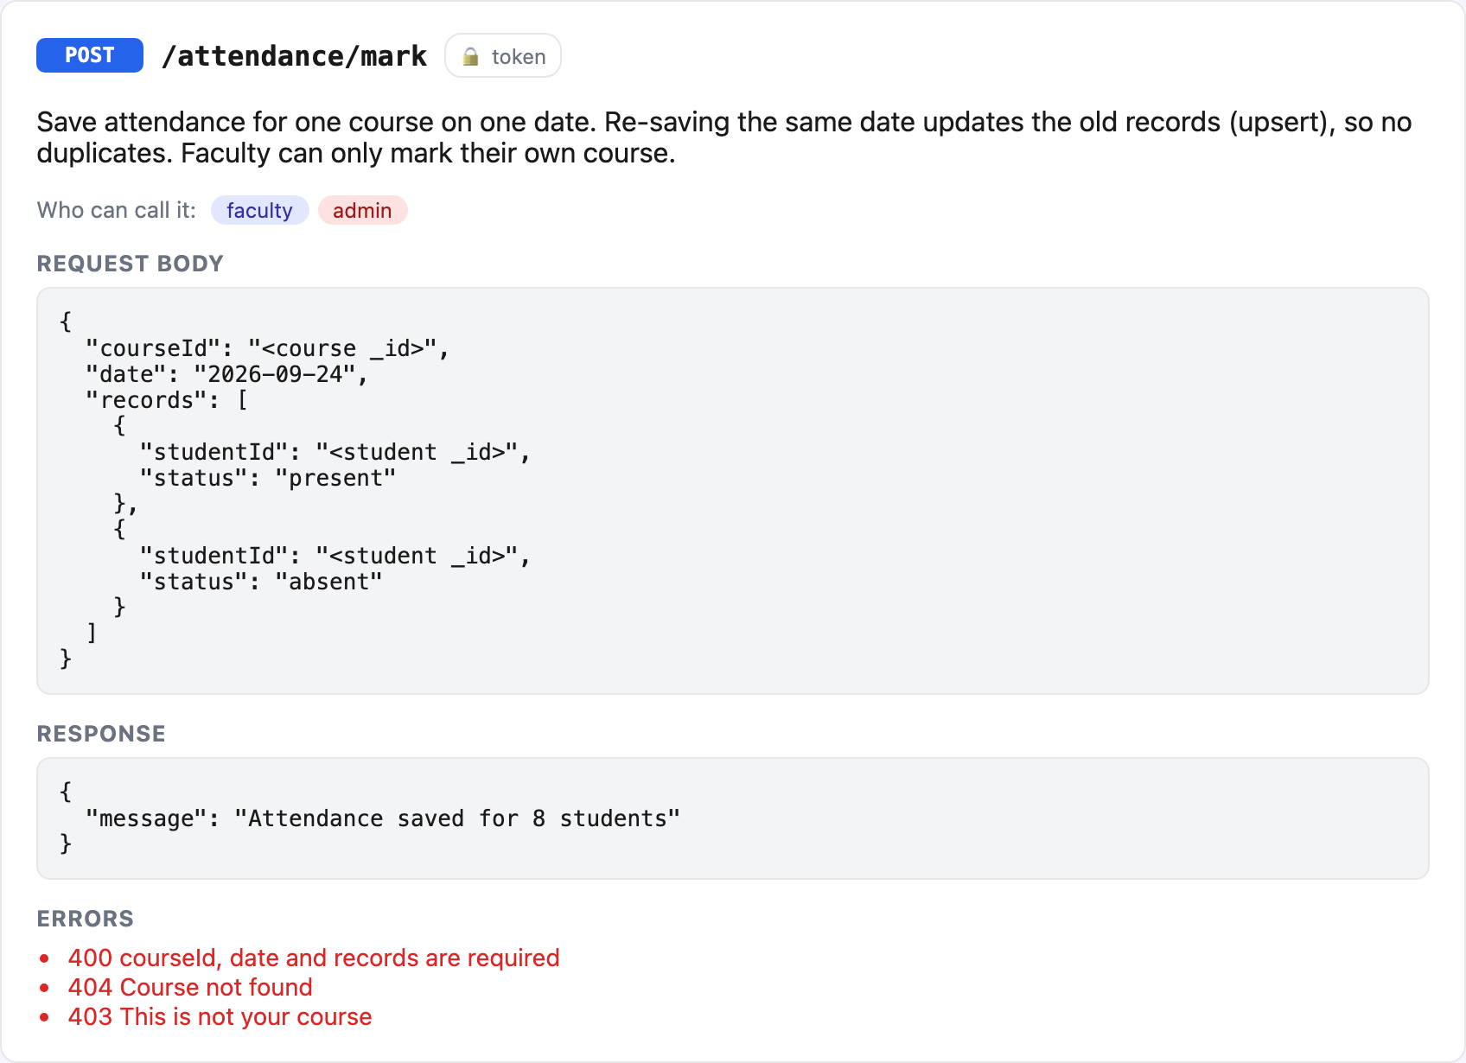
Figure 10: One endpoint card: POST /attendance/mark
- The docs are built from one list in utils/apiDocs.js. To document a new route, we just add one object to that list and the page updates itself.
- The same data is available as JSON at http://localhost:8000/docs.json for tools like Postman.
- Any URL that doesn't exist now returns 404 { "message": "Route not found: GET /something" }.

10.2 All Endpoints
Method | URL | Who | What it does
POST | /auth/login | Anyone | Log in, get a token
POST | /users | Admin | Add a user
GET | /users?role=&search=&page=&limit= | Admin, HOD, Faculty | List users with search + pages (HOD: own dept, Faculty: students only)
DELETE | /users/:id | Admin | Delete a user
POST | /courses | Admin, HOD | Add a course
GET | /courses | All | Courses for you (faculty: yours, student: your dept+sem, HOD: your dept)
GET | /courses/:id/students | Admin, HOD, Faculty | Students in that course
POST | /attendance/mark | Faculty, Admin | Save attendance for a day (upsert)
GET | /attendance?courseId=&date= | Faculty, HOD, Admin | What was marked that day
GET | /attendance/my | Student | My % per course
GET | /attendance/dashboard/:courseId | Faculty, HOD, Admin | Aggregation: % per student + at-risk list + average
POST | /assignments | Faculty | Create assignment
GET | /assignments | All | Faculty: mine; Student: my courses'
POST | /assignments/:id/submit | Student | Submit or re-submit an answer
GET / POST | /notices?search=&page= | All / Staff | Read (search + pages) / post
DELETE | /notices/:id | Admin, HOD | Delete notice
GET / POST | /events | All / Staff | Read / add event
DELETE | /events/:id | Admin, HOD | Delete event
GET / POST | /complaints | Student, HOD, Admin / Student | List (own / dept / all) / raise
PUT | /complaints/:id | HOD, Admin | Change status
GET / POST | /leaves | All / Student, Faculty | List (own / dept / all) / apply
PUT | /leaves/:id | HOD, Admin | Approve or reject
GET / POST | /results | All / Faculty, Admin | Student: own only; faculty: ?course= / save marks
Table 24: Complete list of API endpoints

Example request and response
POST /auth/login
{ "email": "faculty@campus.com", "password": "password123" }

→ 200
{ "message": "Login successful",
"token": "eyJhbGciOiJIUzI1NiIs...",
"user": { "name": "Prof. Sharma", "role": "faculty", "department": "CSE" } }

GET /attendance/dashboard/<courseId> (with Bearer token)
→ 200
{ "students": [ { "name": "Kabir", "rollNo": "CSE103", "present": 5, "total": 10, "percent": 50 }, ... ],
"atRisk": [ { "name": "Kabir", "percent": 50 }, { "name": "Rohan", "percent": 70 } ],
"classAverage": 89 }

11. Frontend Handbook — How the Screens Work
The frontend uses the same React ideas as the Plant Inventory app from class: components, useState, useEffect and fetch. There is no router — the page decides what to show using simple if checks.

In simple words
Component = a LEGO block. Each screen (Notices, Leaves...) is one block, and we snap them together to make the app.
useState = a little memory box inside a component. When you put something new in the box, React redraws the screen automatically.
useEffect = "do this when the screen opens" (or when something changes), for example "load the notices from the server".
props = information a parent block hands to a child block, like handing a note to a friend.

11.1 App.jsx — Login Page or Dashboard?

client/src/App.jsx (lines 5–39)
// main component -> decides login page or dashboard
function App() {
// user from localStorage so after refresh we're still logged in (null = not logged in)
const [user, setUser] = useState(JSON.parse(localStorage.getItem("user")));

// logout -> wipe token n user, set user null so login page shows
const logout = () => {
localStorage.removeItem("token");
localStorage.removeItem("user");
setUser(null);
};

// not logged in? -> show login page. login calls setUser once it works
if (!user) {
return <Login onLogin={setUser} />;
}

// logged in -> top bar + dashboard
return (
<div>
{/* top bar w/ name, role n logout btn */}
<nav className="topbar">
<b>Smart Campus</b>
<span>
{user.name} ({user.role}{user.department ? " - " + user.department : ""})
<button onClick={logout}>Logout</button>
</span>
</nav>
{/* dashboard shows tabs based on user.role */}
<div className="layout">
<Dashboard user={user} />
</div>
</div>
);
}

When the page loads, it reads the user from localStorage. If there is no user, it shows <Login/>. After a successful login, Login calls setUser, the state changes and React shows the dashboard instead. Logout clears localStorage and sets the user back to null.

11.2 api.js — One Function for Every Request

client/src/api.js (lines 1–27)
// every backend call goes thru this one fn
// it sticks the login token on each request so the server knows who we are
const API_URL = "http://localhost:8000";

export async function request(path, method = "GET", body) {
// build fetch settings -> method + headers (json + token)
const options = {
method: method,
headers: {
"Content-Type": "application/json",
Authorization: "Bearer " + localStorage.getItem("token"),
},
};
// if we got data to send, turn it into json text
if (body) {
options.body = JSON.stringify(body);
}
// call the server n read the json it sends back
const res = await fetch(API_URL + path, options);
const data = await res.json();
// server said error (400/401/403/500) -> throw it so the component can show the msg
if (!res.ok) {
throw new Error(data.message);
}
// all good, give back the data
return data;
}

Instead of writing fetch with headers again and again in every component, all components call request(path, method, body). It adds the saved token as Authorization: Bearer ..., converts the body to JSON and throws an error with the server's message if the answer is not OK.

11.3 Dashboard.jsx — Tabs for Each Role

client/src/Dashboard.jsx (lines 16–57)
// which tabs each role gets. first one opens by default
const tabsByRole = {
admin: ["Students", "Faculty", "Add User", "Courses", "Attendance Report", "Notices", "Events", "Complaints", "Leaves"],
hod: ["Attendance Report", "Students", "Faculty", "Courses", "Notices", "Events", "Complaints", "Leaves"],
faculty: ["Attendance Report", "Mark Attendance", "Assignments", "Results", "Notices", "Events", "Leaves"],
student: ["My Attendance", "Assignments", "Results", "Notices", "Events", "Complaints", "Leaves"],
};

// shows tab btns + whichever tab is picked
function Dashboard({ user }) {
// pick tabs for this user's role, start on the first one
const tabs = tabsByRole[user.role];
const [tab, setTab] = useState(tabs[0]);

return (
<div>
{/* one btn per tab, the clicked one gets 'active' class (blue) */}
<div className="tabs">
{tabs.map((t) => (
<button key={t} className={tab === t ? "active" : ""} onClick={() => setTab(t)}>
{t}
</button>
))}
</div>

{/* show only the picked tab's component (&& = if true then show it) */}
{tab === "Students" && <UserList role="student" user={user} />}
{tab === "Faculty" && <UserList role="faculty" user={user} />}
{tab === "Add User" && <AddUser />}
{tab === "Courses" && <Courses user={user} />}
{tab === "Attendance Report" && <AttendanceReport />}
{tab === "Mark Attendance" && <MarkAttendance />}
{tab === "My Attendance" && <MyAttendance />}
{tab === "Assignments" && <Assignments user={user} />}
{tab === "Results" && <Results user={user} />}
{tab === "Notices" && <Notices user={user} />}
{tab === "Events" && <Events user={user} />}
{tab === "Complaints" && <Complaints user={user} />}
{tab === "Leaves" && <Leaves user={user} />}
</div>
);
}

tabsByRole is a plain object that lists the tabs each role gets. tabs.map() draws one button per tab, and tab === "Notices" && <Notices/> shows a component only when that tab is selected. Hiding a tab is only for convenience — the real protection is on the server (allowRoles), so even if someone calls the API directly they are still blocked.

11.4 Components
Component | Used by | What it shows / does | API calls
Login.jsx | Everyone | Email/password form + demo quick-fill buttons | POST /auth/login
UserList.jsx | Admin, HOD | Table with search box and Prev/Next pages; admin gets Delete | GET /users, DELETE /users/:id
AddUser.jsx | Admin | Form that changes fields based on role | POST /users
Courses.jsx | Admin, HOD | Add-course form + course table | GET/POST /courses, GET /users
AttendanceReport.jsx | Faculty, HOD, Admin | Stat cards, at-risk banner, % bars (red below 75%) | GET /attendance/dashboard/:id
MarkAttendance.jsx | Faculty | Pick course + date, tick absent students, save | GET /courses/:id/students, GET/POST /attendance
MyAttendance.jsx | Student | My % per course with warning below 75% | GET /attendance/my
Assignments.jsx | Faculty, Student | Faculty: create + see submissions. Student: submit | GET/POST /assignments, POST /:id/submit
Results.jsx | Faculty, Student | Faculty: marks entry table. Student: my marks | GET/POST /results
Notices.jsx | Everyone | Post form (staff), search, pages, delete (admin/HOD) | GET/POST/DELETE /notices
Events.jsx | Everyone | Add form (staff) + event list | GET/POST/DELETE /events
Complaints.jsx | Student, HOD, Admin | Student: raise + track. HOD/Admin: Start / Resolve | GET/POST/PUT /complaints
Leaves.jsx | Everyone | Student/Faculty: apply. HOD/Admin: Approve / Reject | GET/POST/PUT /leaves
Table 25: React components

12. User Flows with Screenshots
All screenshots below were taken from the running application with the demo data.

12.1 Logging In
- Open http://localhost:5173.
- Type email and password (or click a demo button).
- Click Login. The token is saved and the dashboard for your role opens.
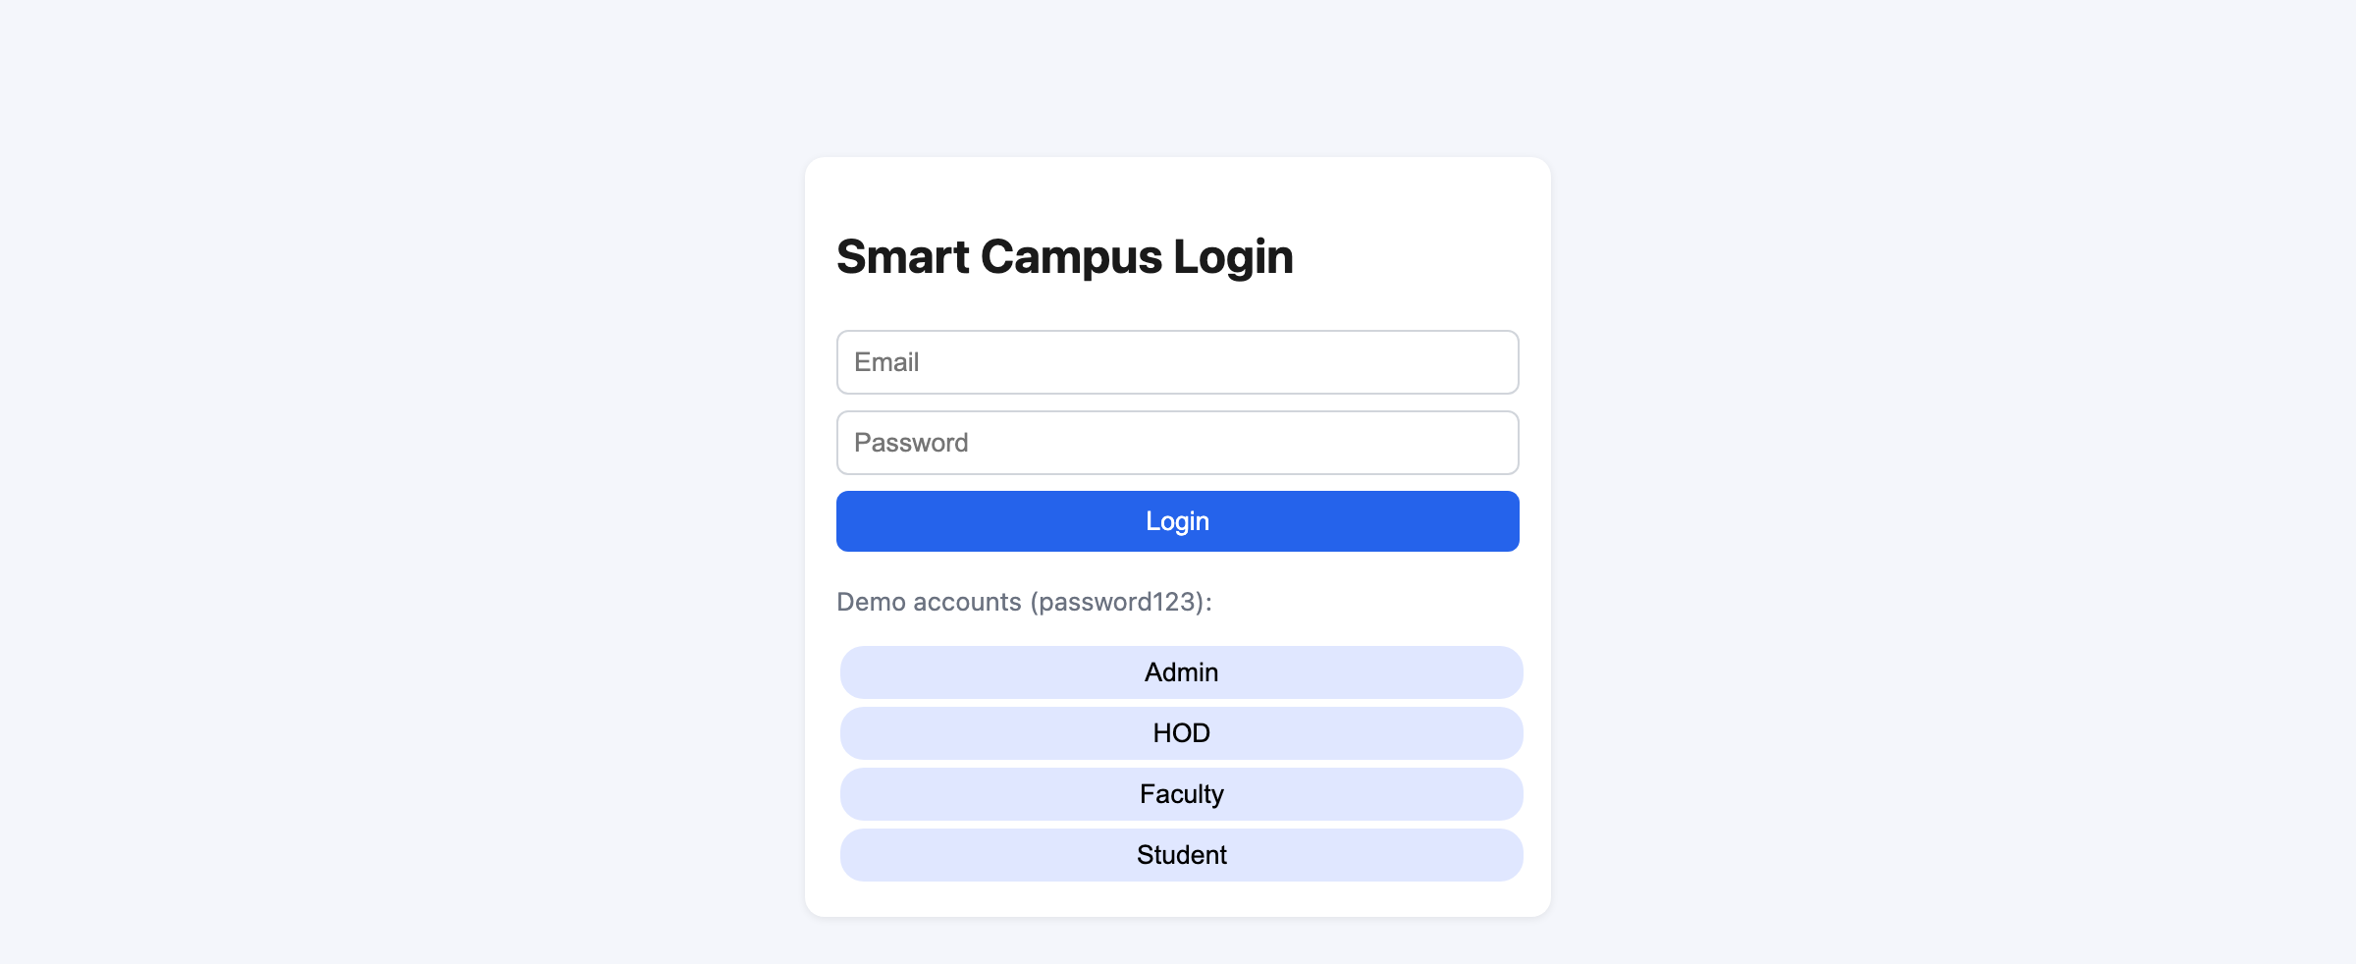
Figure 11: Login page with demo account buttons
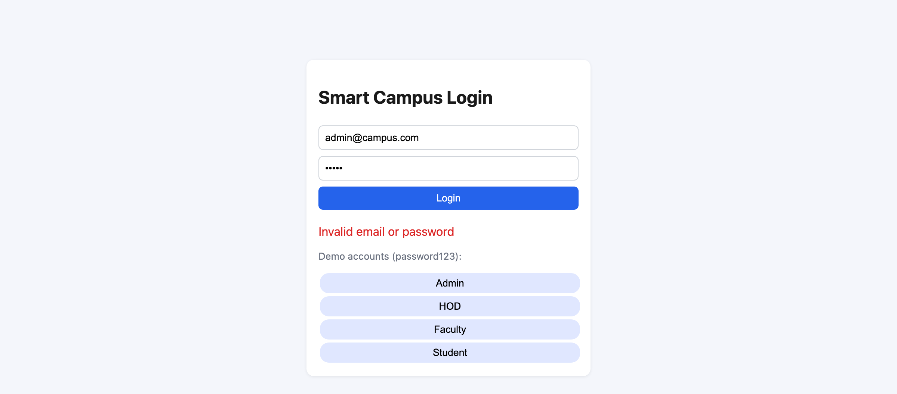
Figure 12: Wrong password — the server's 401 message is shown

12.2 Admin Flow
- Admin logs in and lands on Students — 5 per page with Prev/Next.
- Types in the search box to find a student by name, email or roll number.
- Opens Add User, picks a role (the form changes for student vs faculty) and saves.
- Opens Courses to add a course and assign a teacher.
- Can also post notices/events and handle complaints and leaves for the whole college.
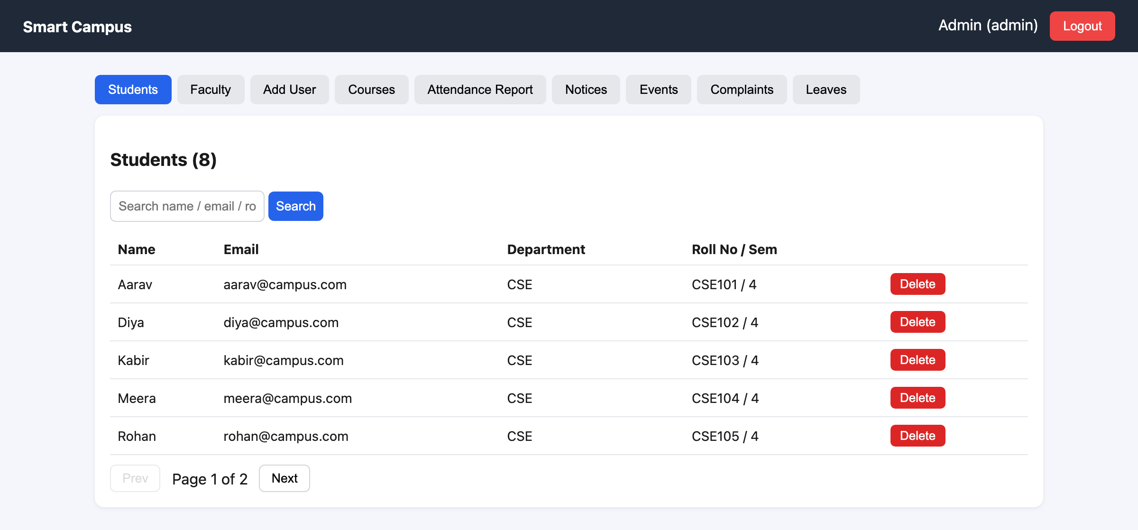
Figure 13: Admin — student list, page 1 of 2
Figure 14: Admin — searching "ro" (regex search)
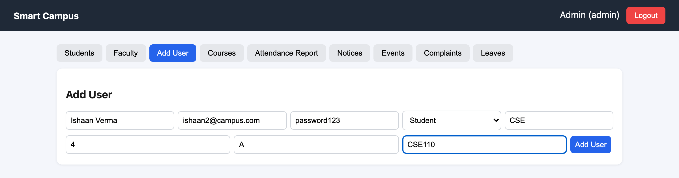
Figure 15: Admin — adding a new student
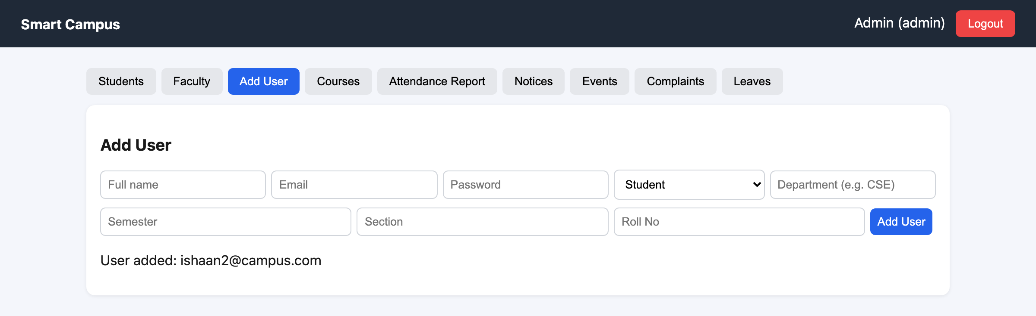
Figure 16: Admin — user added successfully
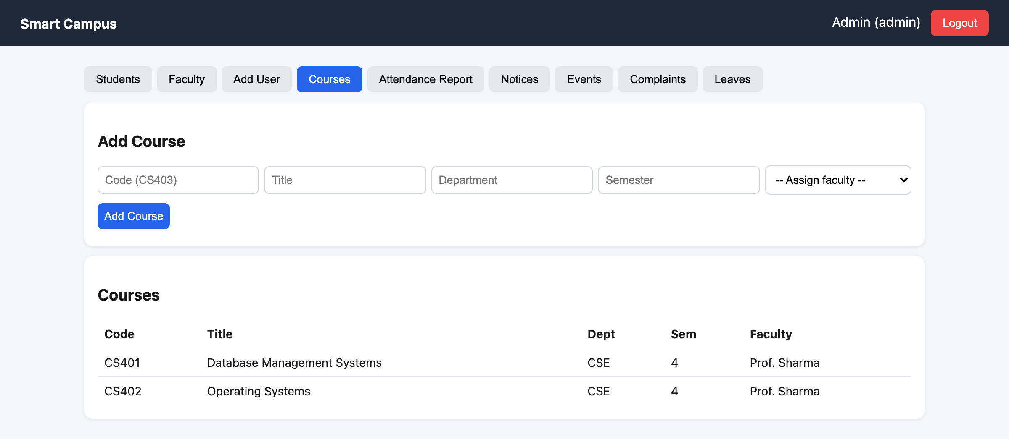
Figure 17: Admin — add course and course list
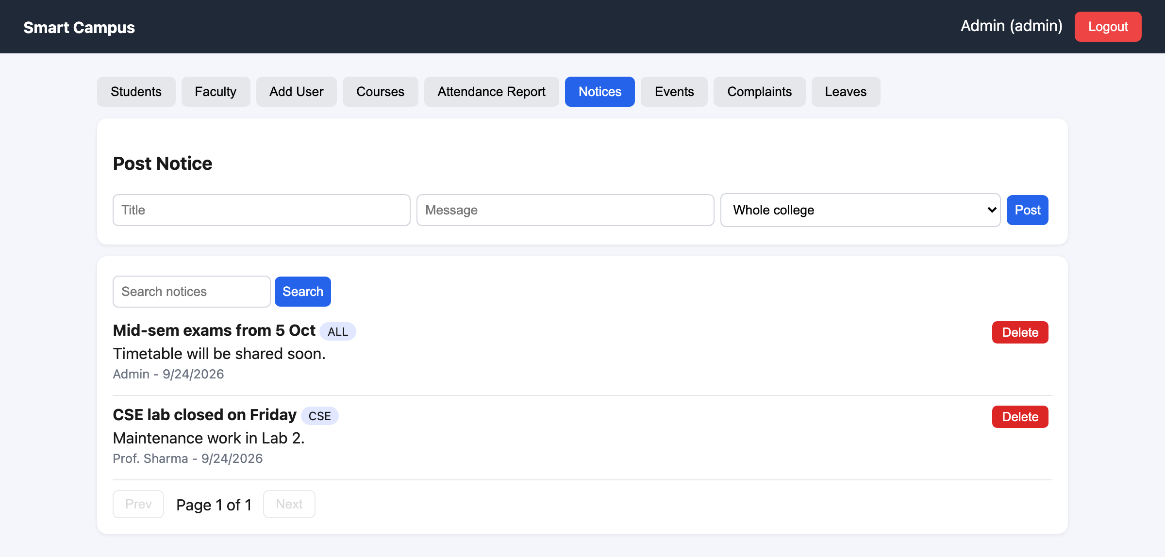
Figure 18: Admin — posting and managing notices

12.3 HOD Flow
- HOD logs in and lands on the Attendance Report for their department's courses.
- Checks Students — only CSE students appear, because the server forces the department.
- Opens Complaints, clicks Start (in-progress) and later Resolve.
- Opens Leaves and approves or rejects requests from students and faculty of the department.
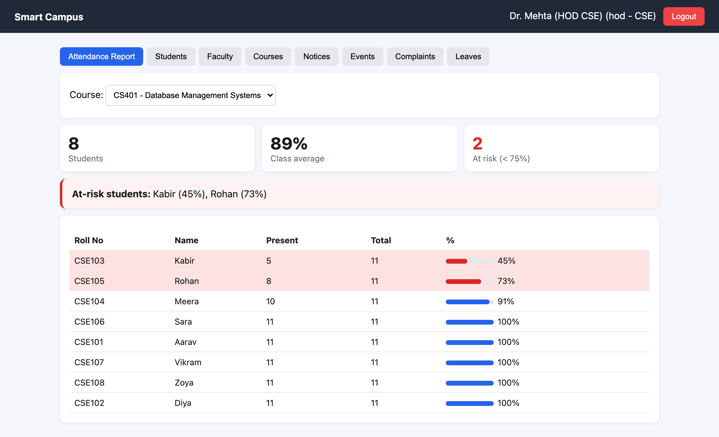
Figure 19: HOD — department attendance report
Figure 20: HOD — only own department's students
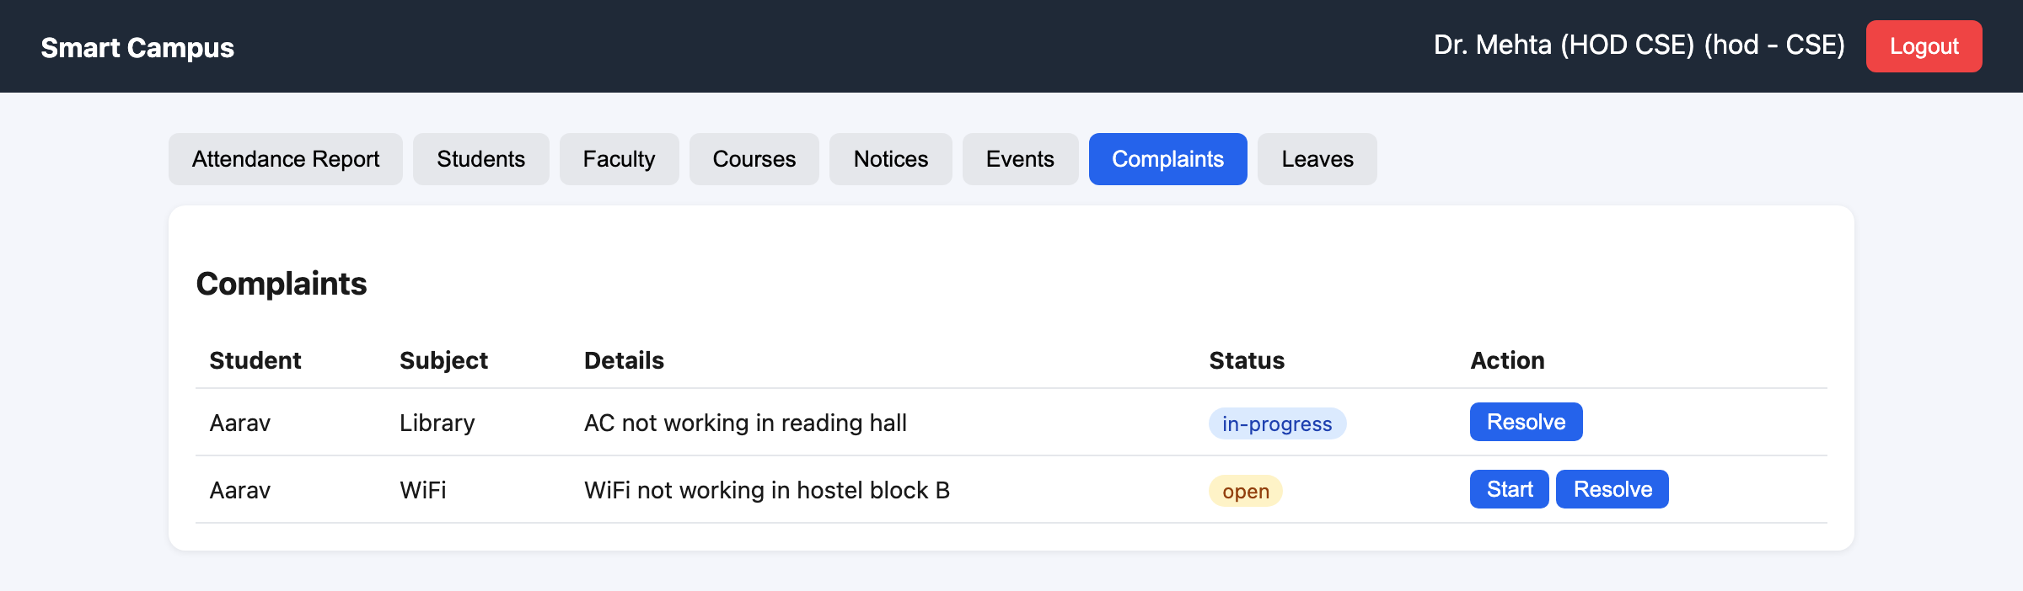
Figure 21: HOD — complaint moved to in-progress
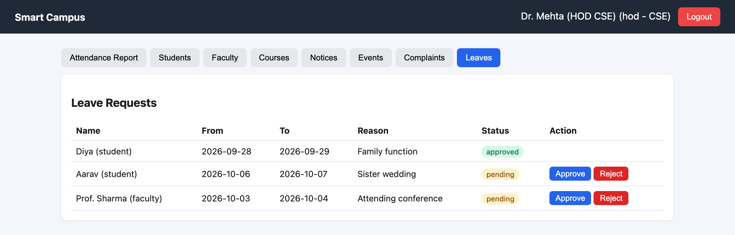
Figure 22: HOD — approving a leave request

12.4 Faculty Flow
- Faculty logs in to the Dashboard: total students, class average, at-risk count and a red list of students below 75%.
- Opens Mark Attendance, chooses the course and date, ticks absent students and clicks Save. Opening the same date later shows the saved ticks.
- Opens Assignments to create one and to see who submitted.
- Opens Results to type marks for each student.
- Can apply for leave and post notices/events.
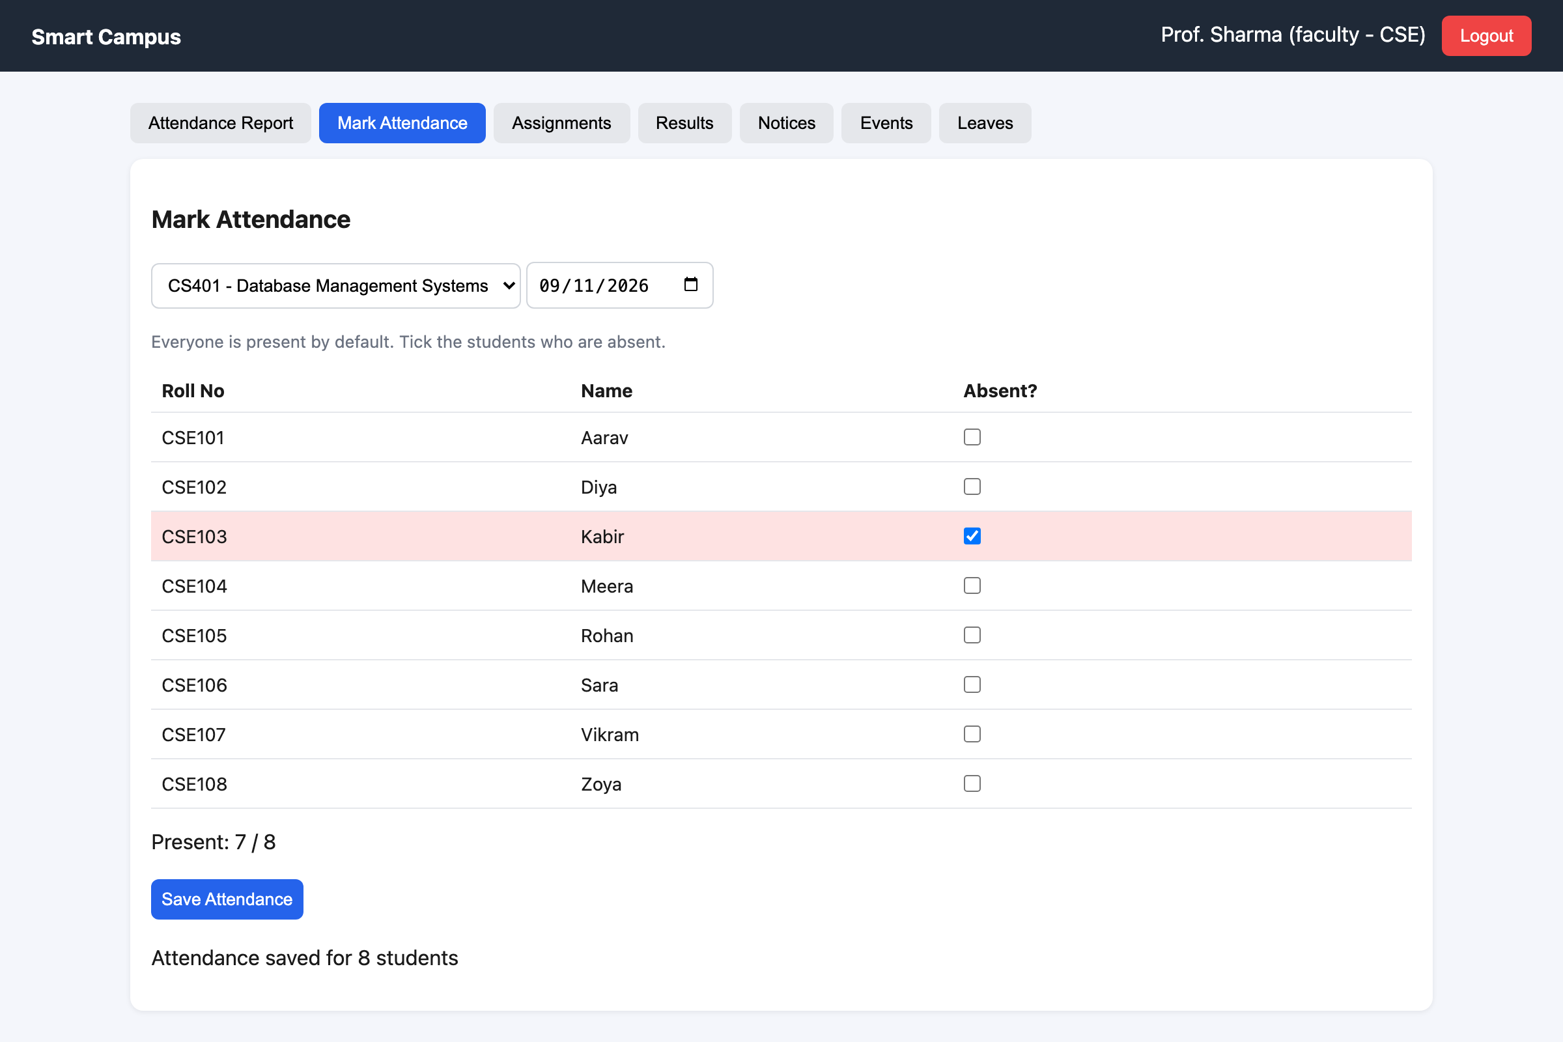
Figure 23: Faculty — marking attendance (one student absent)
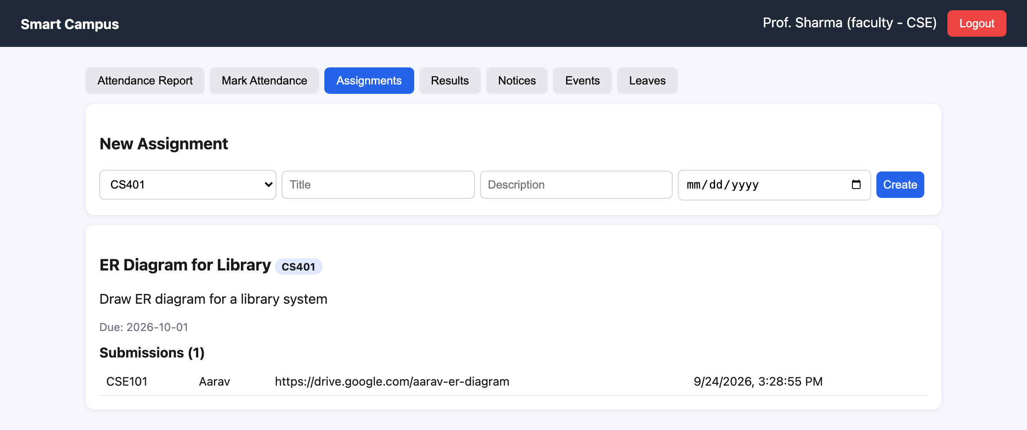
Figure 24: Faculty — assignment with a student's submission
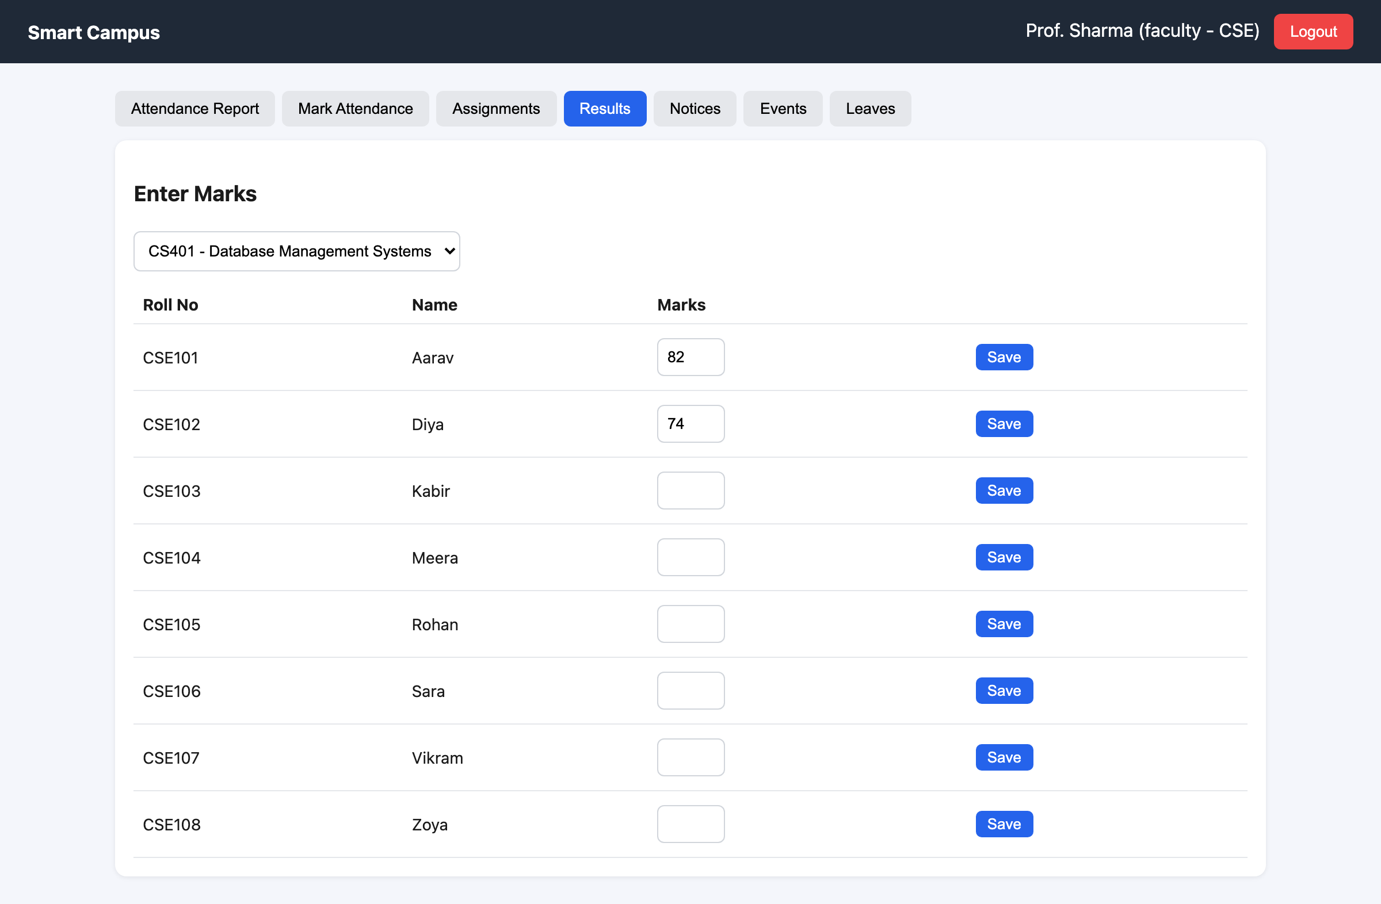
Figure 25: Faculty — entering marks

12.5 Student Flow
- Student logs in to My Attendance — percentage per course, red if below 75%.
- Opens Assignments, pastes a link and clicks Submit (can re-submit).
- Checks Results, Notices and Events.
- Raises a Complaint and watches its status change.
- Applies for Leave and sees whether it is pending, approved or rejected.
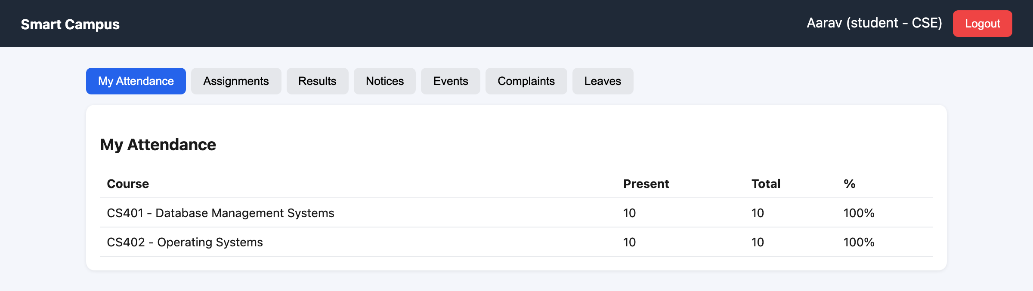
Figure 26: Student (Aarav) — good attendance
Figure 27: Student (Kabir) — below 75%, shown in red
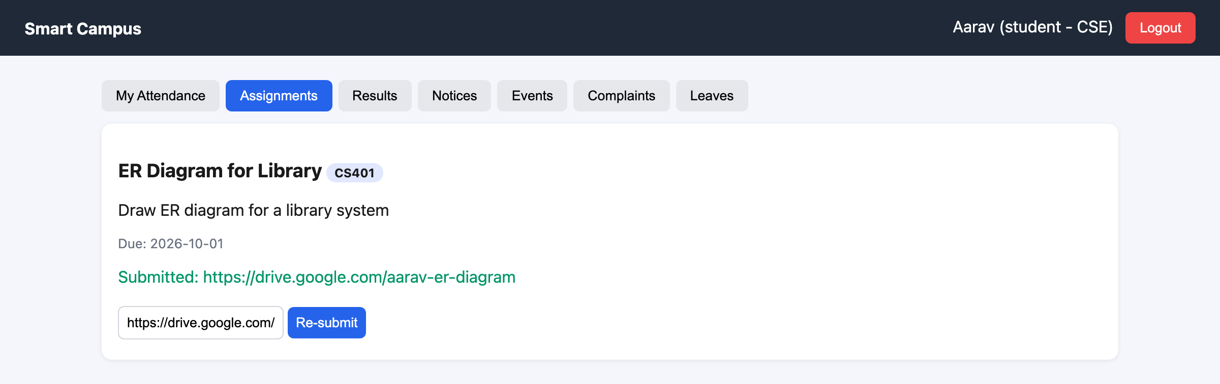
Figure 28: Student — assignment submitted
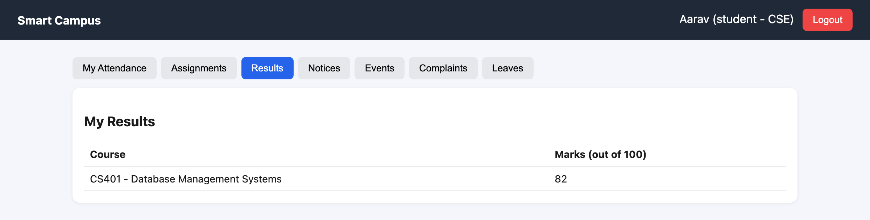
Figure 29: Student — sees only their own marks
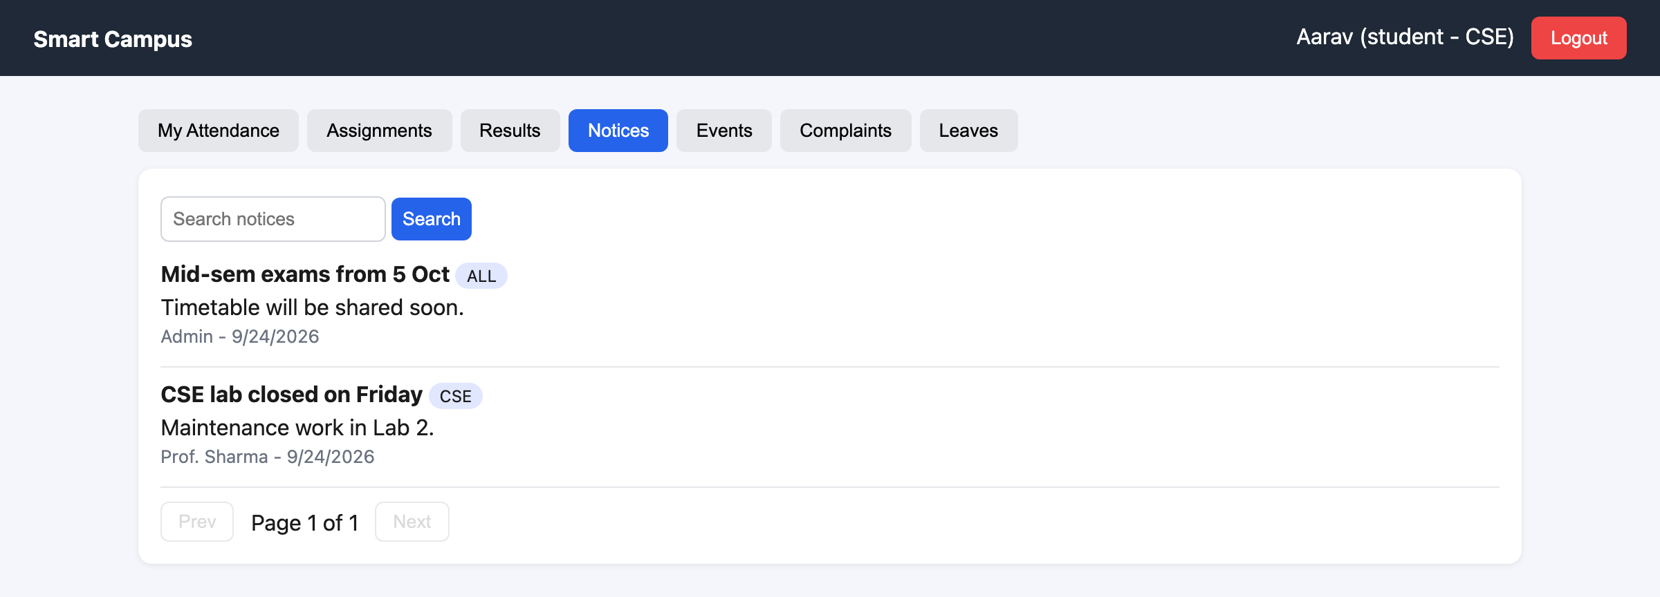
Figure 30: Student — notices (college-wide + own department)
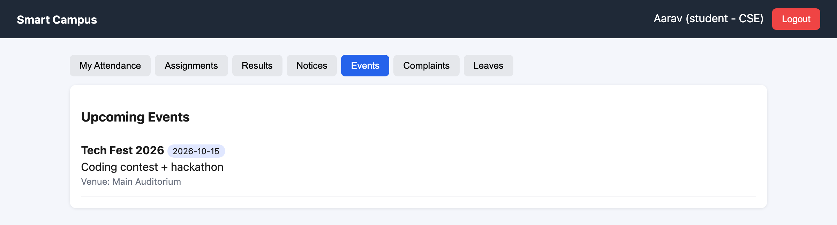
Figure 31: Student — upcoming events
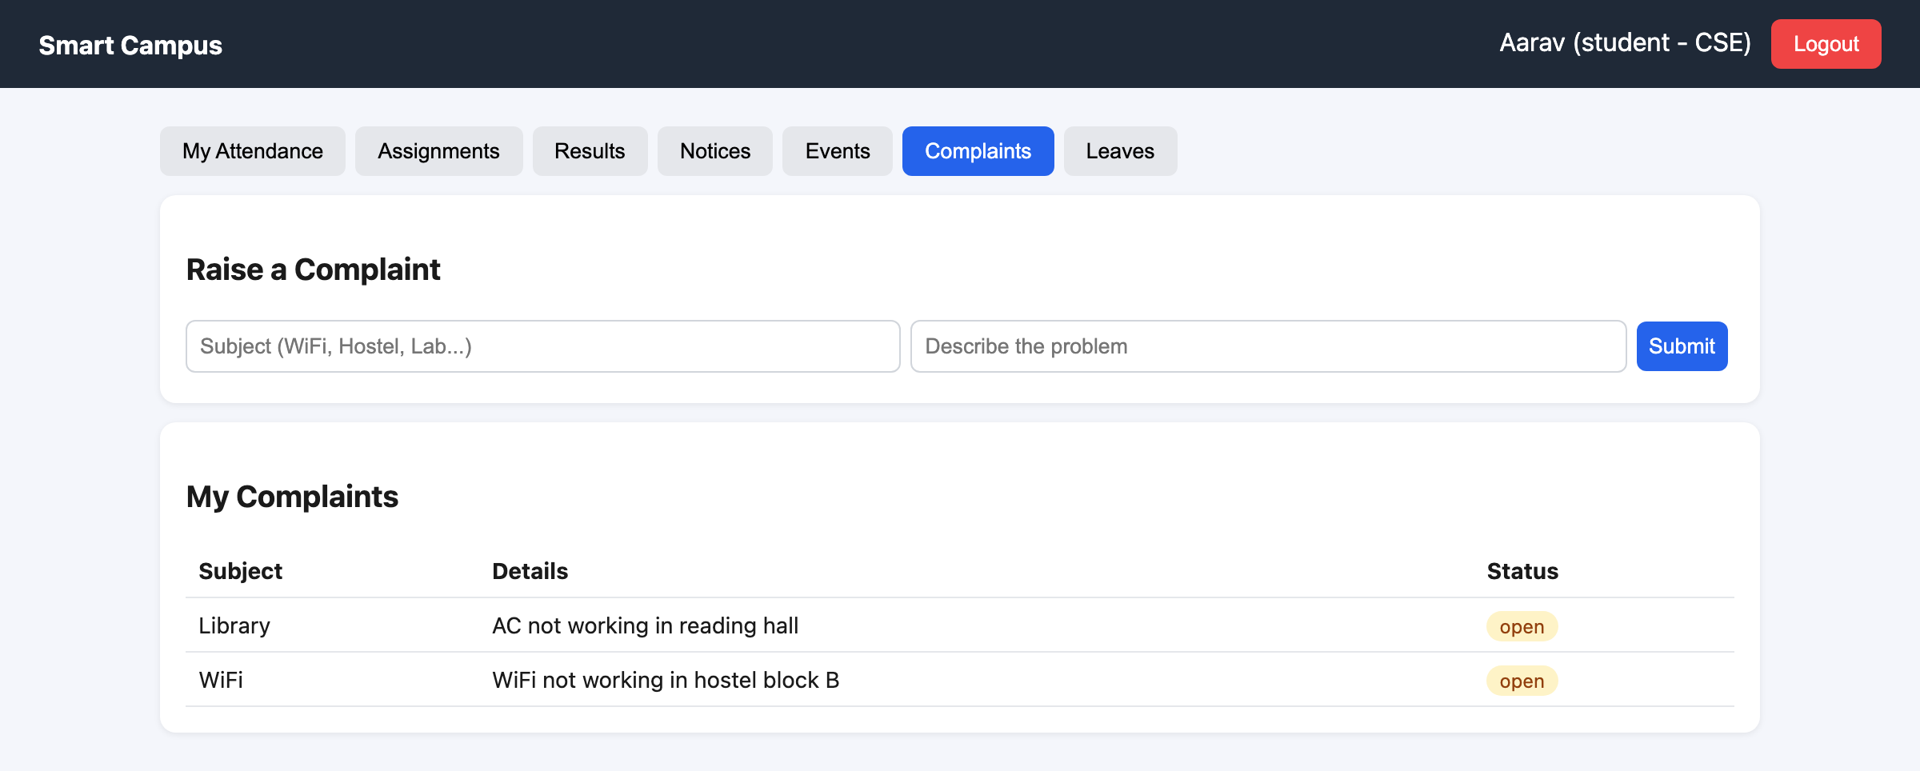
Figure 32: Student — raising and tracking complaints
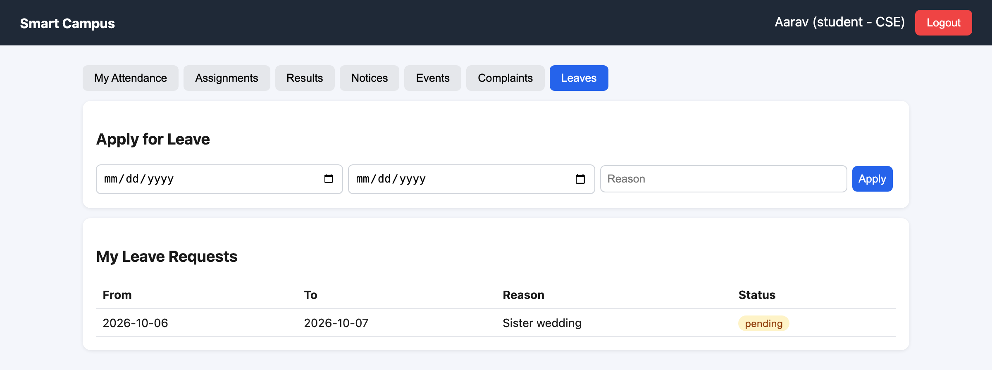
Figure 33: Student — leave requests and their status

12.6 End-to-End Story
- Admin adds a new student and a course, and assigns Prof. Sharma.
- Faculty marks attendance every day. The dashboard shows Kabir (50%) and Rohan (70%) in red as at-risk.
- Faculty creates an assignment → Student submits a link → faculty sees it under Submissions.
- Student raises a WiFi complaint → HOD clicks Start → Resolve → the student sees "resolved".
- Faculty applies for leave → HOD approves it.
- Faculty enters marks → Student sees them in Results.

13. Security and Permissions
Module | Admin | HOD | Faculty | Student
Add / delete users | Yes | No | No | No
View students | All | Own dept | Yes | No
View faculty | All | Own dept | No | No
Add courses | Yes | Own dept | No | No
Mark attendance | Yes | No | Own courses | No
Attendance dashboard | Yes | Yes | Yes | Own % only
Create assignment | No | No | Yes | No
Submit assignment | No | No | No | Yes
Enter marks | Yes | No | Yes | No
See results | All | All | By course | Own only
Post notice / event | Yes | Yes | Yes | No
Delete notice / event | Yes | Yes | No | No
Raise complaint | No | No | No | Yes
Resolve complaint | All | Own dept | No | No
Apply leave | No | No | Yes | Yes
Approve leave | All | Own dept | No | No
Table 26: Permission matrix (enforced on the server by allowRoles and filters)
- Authentication (who are you?) — JWT token, checked by authMiddleware on every protected route.
- Authorization (what may you do?) — allowRoles(...) on each route.
- Data scoping — the server, not the user, decides the filter: students get student = my id, HODs get department = my department. These values come from the signed token, so they can't be faked.
- Passwords are hashed — salted HMAC-SHA-256 with a secret key; the real password is never stored.
- Passwords are never sent back — not even the hash; .select("-password") removes it from user lists.

Honest note
The JWT secret and the password secret key are written directly in the code, like the Day 8 example project. In a real deployment they would go in a .env file. Also, SHA-256 is very fast; for a real college, a deliberately slow password hash like bcrypt or scrypt makes guessing attacks much harder. Both are listed under Future Scope.

14. Testing
We tested every API with real requests (curl) against the running server and database, and then clicked through every screen for all four roles in a browser. All tests passed.
# | Test | Input | Expected | Result
1 | Wrong password | admin@campus.com / x | 401 Invalid email or password | Pass
2 | No token | GET /users | 401 Authorization token is required | Pass
3 | Student opens user list | GET /users as student | 403 Access denied for role: student | Pass
4 | Search + pagination | ?search=a&page=2&limit=3 | Page 2 of matching students | Pass
5 | HOD asks for another dept | ?role=faculty&department=ECE | Only CSE faculty returned | Pass
6 | Add user with missing fields | { name: "X" } | 400 name, email, password and role are required | Pass
7 | Duplicate email | same email twice | 400 Email already exists | Pass
8 | Mark attendance | 1 student absent | 201 Attendance saved | Pass
9 | Re-mark same day | same student → present | Record updated, no duplicate | Pass
10 | Faculty marks someone else's course | faculty2 → CS401 | 403 This is not your course | Pass
11 | Dashboard analytics | GET /attendance/dashboard/CS401 | Kabir 50%, Rohan 70% at risk | Pass
12 | Student attendance % | GET /attendance/my | % per course | Pass
13 | Submit assignment | answer = link | Submitted; faculty sees it | Pass
14 | Complaint flow | raise → resolve | Status becomes resolved | Pass
15 | Leave with wrong dates | from after to | 400 fromDate cannot be after toDate | Pass
16 | Marks out of range | marks = 150 | 400 marks must be between 0 and 100 | Pass
17 | Student sees results | GET /results | Only own marks | Pass
18 | Passwords stored hashed | look inside MongoDB users | salt:hash values, no real passwords | Pass
19 | Same password, 3 users | admin, hod, faculty = password123 | 3 different stored hashes | Pass
20 | API docs page | open http://localhost:8000 without a token | Docs page with all 28 endpoints | Pass
21 | Unknown route | GET /nope (with token) | 404 Route not found: GET /nope | Pass
22 | Browser run-through | all 4 roles, every tab | No console errors | Pass
Table 27: Test cases

15. Team and Work Division
This project was built by a team of 5 members. Each member owned a full slice of the app — the model, the routes and the React screens — so everybody worked on both the backend and the frontend.
Member | Area | Backend files | Frontend files | Also did
Member 1 – [Name] (Team lead) | Project setup, login, security, users | server.js, config/db.js, middleware/authMiddleware.js, middleware/roleMiddleware.js, utils/password.js, utils/apiDocs.js, models/User.js, routes/authRoutes.js, routes/userRoutes.js | main.jsx, App.jsx, Login.jsx, Dashboard.jsx, api.js, UserList.jsx, AddUser.jsx | Folder structure, JWT + password hashing, role rules, API docs page, merging code
Member 2 – [Name] | Courses and attendance marking | models/Course.js, models/Attendance.js, routes/courseRoutes.js, routes/attendanceRoutes.js (mark, day view, /my) | Courses.jsx, MarkAttendance.jsx, MyAttendance.jsx | Upsert so re-marking a day doesn't duplicate
Member 3 – [Name] | Attendance analytics and results | GET /attendance/dashboard (aggregation + $lookup), models/Result.js, routes/resultRoutes.js, seed.js | AttendanceReport.jsx, Results.jsx | At-risk dashboard, demo data
Member 4 – [Name] | Assignments, notices, events | models/Assignment.js, Notice.js, Event.js, routes/assignmentRoutes.js, noticeRoutes.js, eventRoutes.js | Assignments.jsx, Notices.jsx, Events.jsx, styles.css | Search + pagination on notices, UI styling
Member 5 – [Name] | Complaints, leaves, testing and docs | models/Complaint.js, models/Leave.js, routes/complaintRoutes.js, routes/leaveRoutes.js | Complaints.jsx, Leaves.jsx | API + browser testing, ERD, user flows, this report
Table 28: Who built what
Shared work: every member tested their own module with all four roles, and the whole team reviewed the final demo flow together.

16. How to Run the Project
- Install Node.js and MongoDB, and start MongoDB (port 27017).
- Open the project folder in a terminal and install backend libraries: npm install.
- Fill the database with demo data: npm run seed (this deletes old data first).
- Start the backend: npm start → "server is running on port 8000" and "MongoDB Connected".
- In a second terminal: cd client, then npm install, then npm run dev.
- Open http://localhost:5173 in the browser and log in.

Commands
# terminal 1 (backend)
npm install
npm run seed
npm start

# terminal 2 (frontend)
cd client
npm install
npm run dev

Role | Email | Password
Admin | admin@campus.com | password123
HOD (CSE) | hod@campus.com | password123
Faculty (CSE) | faculty@campus.com | password123
Faculty (ECE) | faculty2@campus.com | password123
Student | aarav@campus.com (also diya, kabir, meera, rohan, sara, vikram, zoya) | password123
Table 29: Demo accounts

17. Limitations and Future Scope

17.1 Current Limitations
- The JWT secret, password secret key and MongoDB address are written directly in the code.
- SHA-256 is fast, so a slow hash (bcrypt/scrypt) would resist password guessing better.
- Assignment submissions are links/text; there is no file upload.
- Only notices and users have pagination; other lists are short enough to show fully.
- No email or SMS notifications.

17.2 Future Scope
- Move secret keys into a .env file and switch to a slow password hash such as bcrypt or scrypt.
- Move route logic into controllers once we learn them, to keep route files short.
- File uploads for assignments (e.g. with Multer).
- Automatic email to students when attendance falls below 75%.
- Charts on the dashboard (attendance trend over the semester).
- Timetable module and a mobile app.
- Deploy online (e.g. MongoDB Atlas + a cloud server).

18. Conclusion
Smart Campus brings attendance, assignments, notices, events, complaints, leave requests and results into one web application with four roles. The backend is built with Node.js, Express and MongoDB following the same structure we learned in class — server, routes, models, config and middleware — with hashed passwords, JWT login, role-based authorization, search, pagination, validation and an aggregation pipeline with $lookup that powers the faculty's at-risk dashboard. The React frontend gives every role a simple tab-based screen.
Most importantly, the project taught us how the three layers talk to each other: the browser asks, the server checks and decides, and the database remembers.

In one sentence
We turned five messy notebooks into one smart notebook. Everybody writes in it, everybody reads from it, and a strict but friendly security guard makes sure each person only sees the pages that belong to them.

Appendix A: Glossary
Word | Simple meaning
API | A list of URLs the frontend can call to ask the backend for something
Route | One URL + method (like POST /complaints) and the code that runs for it
Middleware | A checkpoint function that runs before the route (can stop the request or let it continue)
Hash | A one-way scramble of text; you can't turn it back into the original
Salt | Random text added before hashing so equal passwords get different hashes
HMAC-SHA-256 | SHA-256 hashing mixed with a secret key only the server knows
JWT / Token | A signed digital pass that proves who you are after login
Schema | The rules for what a document must look like
Model | The tool (made from a schema) used to read/write a collection
Collection | A group of documents of the same kind (like a table)
Document | One record, stored like a JSON object
ObjectId | The unique id MongoDB gives every document
populate() | Replaces an ObjectId with the real document it points to
Aggregation | A pipeline of steps that filters, groups and calculates data inside MongoDB
$lookup | A join: fetch matching documents from another collection
Upsert | Update if it exists, otherwise insert
Pagination | Showing results a few at a time with pages
Regex | A pattern used to search text ("contains these letters")
CORS | Permission for a website on one port to call a server on another port
Component | A reusable piece of the React screen
useState / useEffect | React's memory box / "do this when the screen opens or changes"
localStorage | Small storage in the browser that survives page refresh
Table 30: Glossary

