User Manual
- Save the zip file at any location
- Go to the Location, right click on the zip file and click on extract all option:

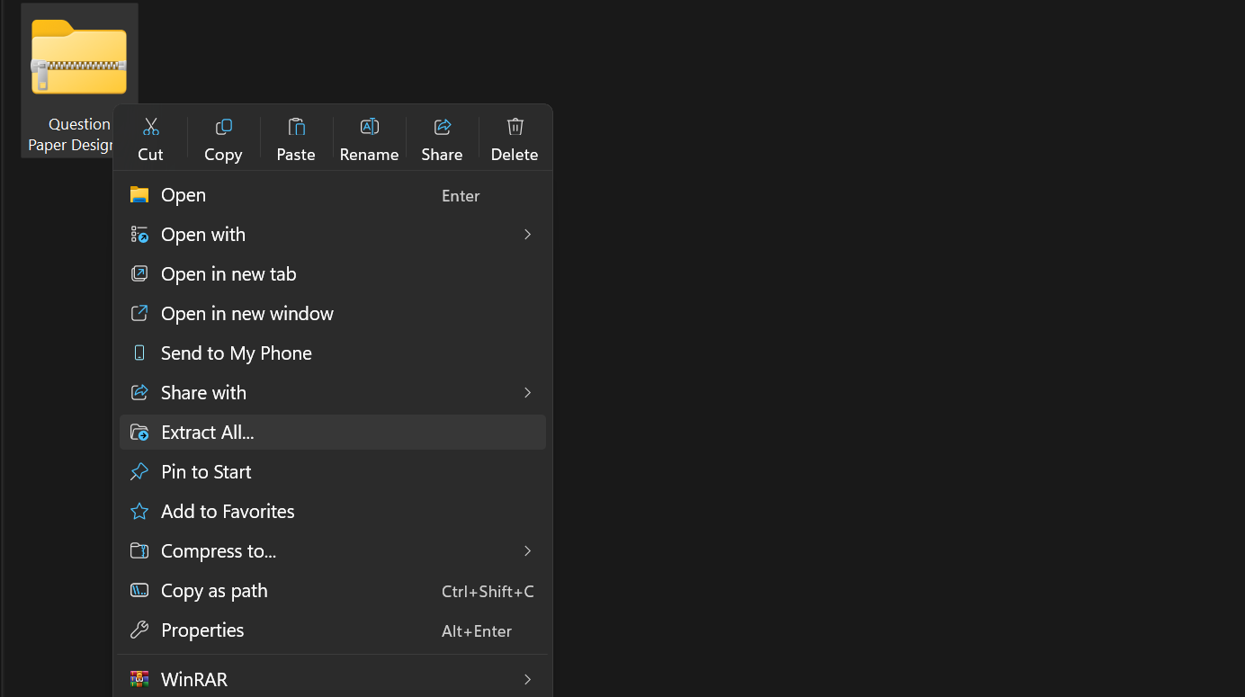

- Choose the location where you want to save and click on extract.
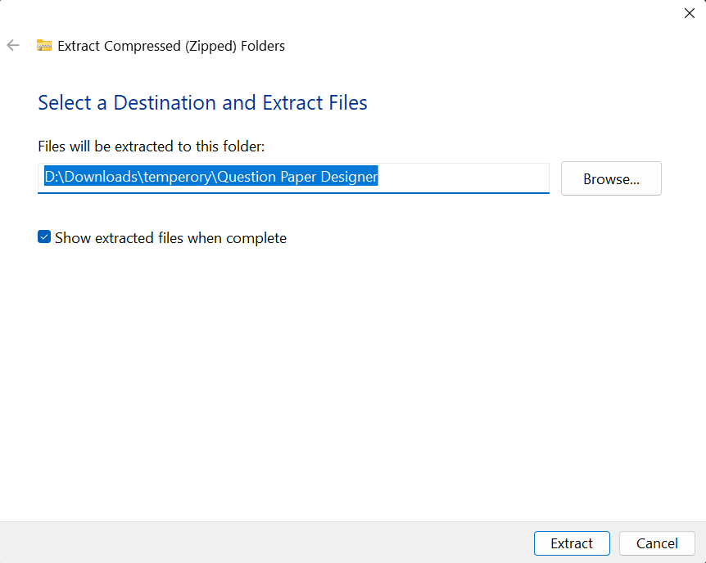
- Go to the location you gave (if not opened automatically) and run the .exe file (Question Paper Designer)
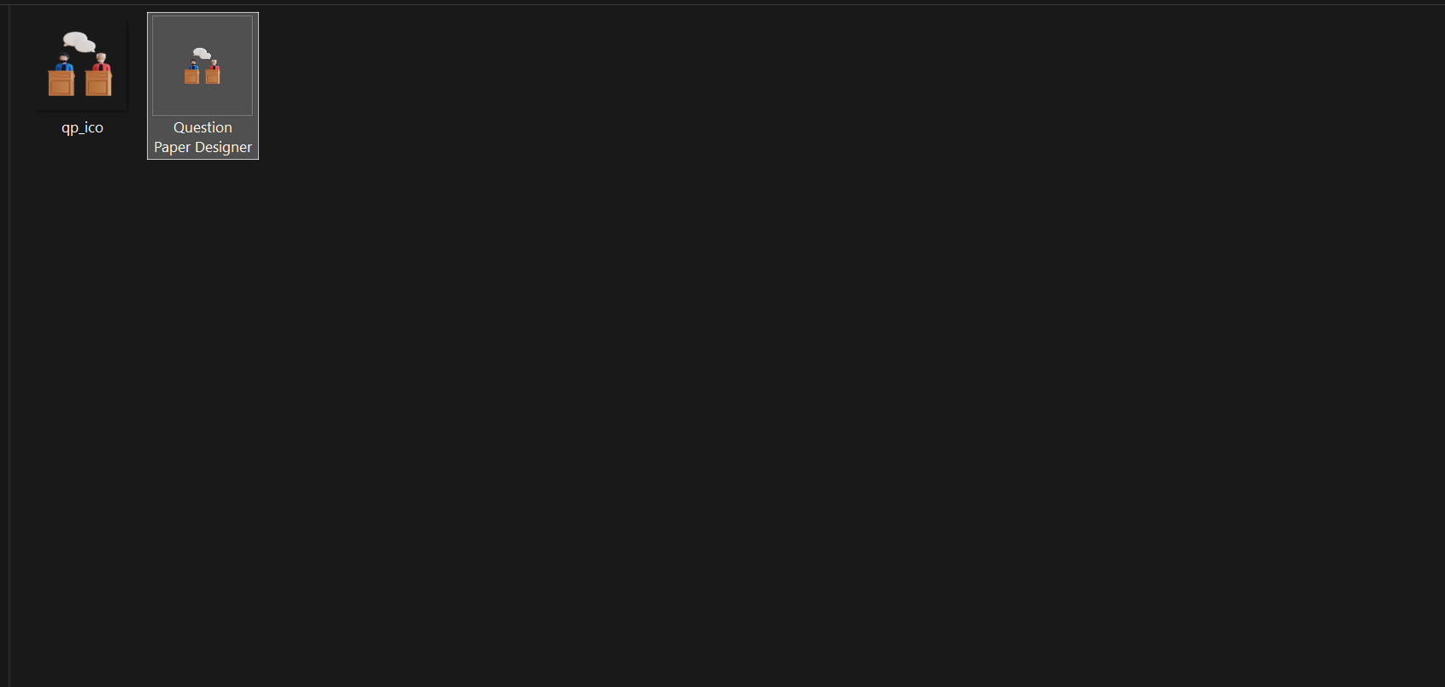

- Allow to your system if windows block it (only happens in first time).
- A window will open (maximize it for better experience)
- Enter the number of websites will be adding for importing questions and click to the next button
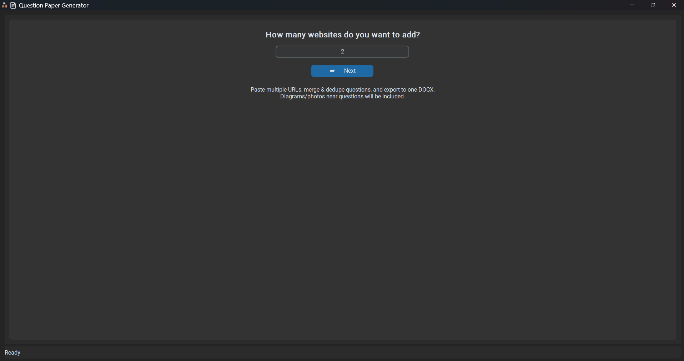
Let we want to add 2 URLS
- A new interface will appear, now go to your search engine, search for questions, and copy the URLs of webpages which are matching your vibes.

Note: Questions in the websites should be in simple text not in PDF format

- Paste the URL(s) in different Entry Boxes
- After all set click on Load Questions It will take some time… keep your eye on progress bar (Bottom)
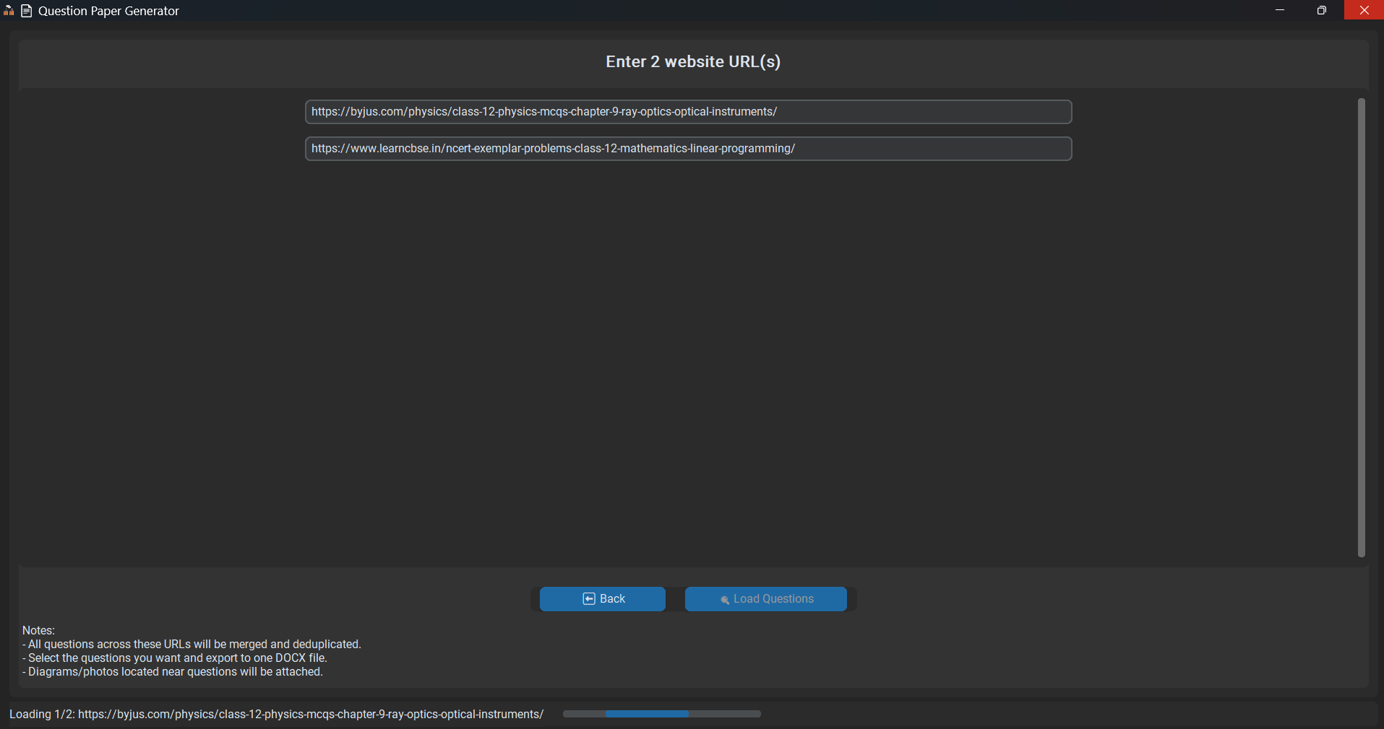
Paste URL(s) Here
Progress Bar
- All extractable questions from that website will be extracted. Click on the checkbox for the question which you want to add in Question Bank.
- You can Use “Select All” and “Deselect All” Button for their respective tasks.
- Click on the preview tab and scroll to the bottom to see them. (if the question has any diagram and our algorithm catches it then only this option will be visible to us).

Note: If the question has any diagram, we added the algorithm for including it but some websites are not designed properly so their frames can exchange the images or can add garbage images in the final output. Please check it manually and revise it if needed.

Note: If any Question is of MCQ type and arranged properly in webpage then our tool will catch it, will arrange all the content in one question and add it properly to the final output.
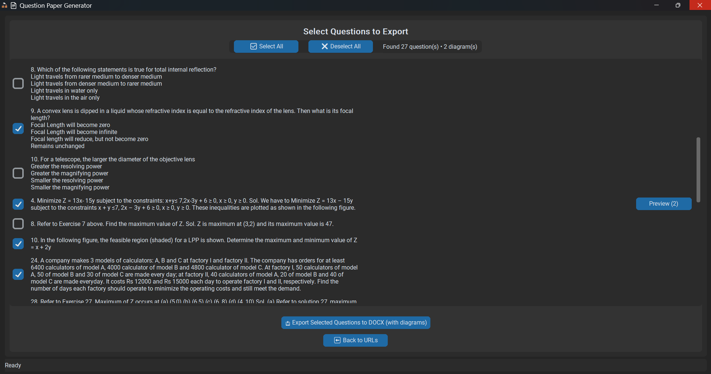
- Click on “Export selected Questions to Docx (with diagrams)” to export it.
- Browse your path and save the docx file. 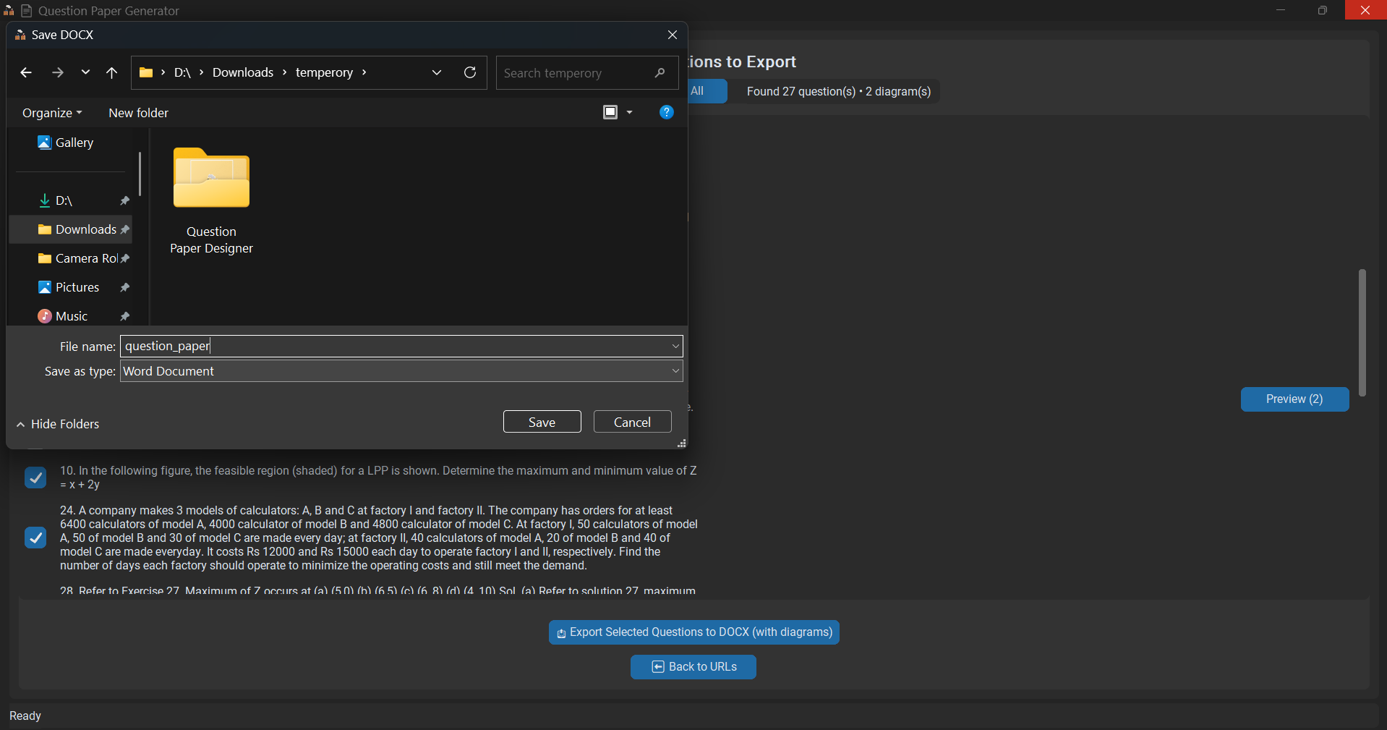
- Once the file is saved you will get a positive messagebox from the software.
- Use back buttons to regenerate other question bank or simply close the software for exit.
- Create a shortcut (manually) to for easy access of the software.

THANK YOU…...!

