SRINIVAS UNIVERSITY
INSTITUTE OF ENGINEERING AND TECHNOLOGY
MUKKA, MANGALURU-574146



AN INTERNSHIP REPORT ON

ENERGY CONSUMPTION AND SUSTAINABILITY ANALYSIS

Submitted in the partial fulfilment of the requirements for the fourth semester

BACHELOR OF TECHNOLOGY IN AIML

Submitted by,

Deeksha Y Shettigar - 01SU24AI023

2025-26
SRINIVAS UNIVERSITY
INSTITUTE OF ENGINEERING AND TECHNOLOGY
MUKKA, MANGALURU-574146

Department of Artificial Intelligence and Machine Learning

CERTIFICATE

This is to certify that the case study titled “Energy Consumption and Sustainability Analysis” is a Bonafide work carried out by Deeksha Y Shettigar (01SU24AI023) in partial fulfilment for the award of Bachelor of Technology of Srinivas University, Institute of Engineering and Technology during the year 2025-26.
MARKS AWAREDED

TABLE OF CONTENTS
1. | ABSTRACT
2. | INTRODUCTION
3. | PROBLEM STATEMENT
4. | OBJECTIVES
5. | DATASET DESCRIPTION
6. | SOFTWARE AND TOOLS USED
7. | METHODOLOGY
8. | DATA CLEANING AND PREPROCESSING
9. | EXPLORATORY DATA ANALYSIS (EDA)
10. | SQL ANALYSIS
11. | POWER BI DASHBOARD
12. | RESULTS AND KEY INSIGHTS
13. | CONCLUSION
14. | REFERENCES
ABSTRACT:
Energy consumption analysis plays a vital role in improving operational efficiency and promoting sustainable resource management. This project focuses on analyzing building energy consumption data to identify usage patterns, energy-intensive buildings, and greenhouse gas emissions using data analytics techniques.

The project was carried out using Python for data cleaning and exploratory data analysis, MySQL for querying and extracting meaningful information, and Power BI for creating an interactive dashboard. The dataset was cleaned by handling missing values, removing duplicates, and preparing it for analysis. Various visualizations and SQL queries were used to uncover trends, compare building performance, and evaluate sustainability metrics.

The final Power BI dashboard presents key insights through interactive charts, maps, KPIs, and filters, enabling effective monitoring of energy consumption and environmental impact. This project demonstrates how data analytics can support informed decision-making and contribute to efficient energy management and sustainable practices.

INTRODUCTION:

Energy is one of the most essential resources for the functioning of residential, commercial, and industrial buildings. With the increasing demand for energy and growing environmental concerns, it has become important to monitor and analyze energy consumption to improve efficiency and reduce greenhouse gas emissions. Data analytics plays a significant role in understanding energy usage patterns and supporting sustainable decision-making.

This project, titled "Energy Consumption and Sustainability Analysis Using Python, SQL, and Power BI," focuses on analyzing a building energy consumption dataset to identify trends, evaluate energy performance, and generate meaningful insights. The project involves collecting and understanding the dataset, cleaning and preprocessing the data, performing exploratory data analysis (EDA), executing SQL queries for deeper analysis, and developing an interactive dashboard using Power BI.

Python libraries such as Pandas, NumPy, Matplotlib, and Seaborn were used for data preprocessing and visualization. MySQL was utilized to perform data queries and summarize important information, while Power BI was used to create an interactive dashboard for presenting the findings in a clear and user-friendly manner.

The insights obtained from this project help identify high energy-consuming buildings, analyze greenhouse gas emissions, compare building performance, and support data-driven decisions for effective energy management. The project demonstrates how modern data analytics tools can be applied to transform raw data into valuable information for promoting sustainability and efficient resource utilization.

PROBLEM STATEMENT:

The rapid growth of urbanization and industrialization has led to a significant increase in energy consumption across residential, commercial, and institutional buildings. As energy demand continues to rise, organizations face challenges in monitoring consumption, reducing operational costs, and minimizing environmental impact. Inefficient energy usage not only increases expenses but also contributes to higher greenhouse gas (GHG) emissions, making sustainable energy management an important global concern.

Large volumes of energy-related data are generated regularly, but extracting meaningful information from this data can be difficult without proper analytical tools and techniques. Traditional methods of analyzing energy consumption are often time-consuming and may fail to identify hidden patterns, trends, or inefficiencies. As a result, organizations require data-driven approaches to better understand energy usage and support informed decision-making.

This project addresses these challenges by analyzing a building energy consumption dataset using Python, MySQL, and Power BI. The data is cleaned, processed, and explored to identify patterns in energy usage, compare building performance, and examine greenhouse gas emissions. SQL queries are used to retrieve valuable information from the dataset, while Power BI is utilized to create interactive dashboards that effectively communicate the results.

The primary aim of this project is to transform raw energy data into meaningful insights that help identify high energy-consuming buildings, evaluate sustainability metrics, and support strategies for improving energy efficiency. By leveraging modern data analytics techniques, the project demonstrates how organizations can make informed decisions that contribute to cost savings, efficient resource utilization, and environmental sustainability.

OBJECTIVES:

The primary objective of this project is to analyze building energy consumption data and generate meaningful insights that can support efficient energy management and sustainable decision-making. By applying data analytics techniques using Python, MySQL, and Power BI, the project aims to transform raw data into useful information through data cleaning, exploration, querying, and visualization. The objectives of the project are outlined below:
- To collect and understand the building energy consumption dataset and identify the important variables required for analysis.
- To clean and preprocess the dataset by handling missing values, removing duplicate records, correcting data types, and preparing the data for further analysis.
- To perform Exploratory Data Analysis (EDA) using Python libraries such as Pandas, NumPy, Matplotlib, and Seaborn in order to identify trends, patterns, and relationships within the data.
- To use SQL for querying the dataset, performing aggregations, filtering records, and extracting meaningful information that supports analytical decision-making.
- To identify buildings with high energy consumption and analyze their energy usage patterns using statistical and visual analysis techniques.
- To examine greenhouse gas (GHG) emissions and study their relationship with energy consumption, thereby evaluating the environmental impact of different buildings.
- To develop an interactive and user-friendly dashboard in Power BI that effectively presents key performance indicators (KPIs), charts, maps, and other visualizations for better interpretation of the results.
- To generate actionable insights that can help organizations monitor energy usage, improve operational efficiency, reduce unnecessary energy consumption, and promote sustainable practices.
- To apply the knowledge and skills acquired during the internship by integrating Python, SQL, and Power BI into a complete end-to-end data analytics project.
DATASET DESCRIPTION:

The dataset used for this project focuses on building energy consumption and sustainability and was obtained from a publicly available open-data source. It contains information related to the energy performance of various buildings, including energy usage, greenhouse gas (GHG) emissions, property characteristics, and other sustainability-related parameters. The dataset was selected because it provides sufficient information to analyze energy consumption patterns and evaluate the environmental performance of buildings.

Before analysis, the dataset was carefully examined to understand its structure, attributes, and quality. The data consisted of multiple records representing different buildings and included both numerical and categorical variables. Some of the important attributes in the dataset include the building name, property type, primary property use, floor area, site energy use intensity (EUI), total greenhouse gas emissions, energy star score, and reporting year. These attributes provide valuable information for identifying energy-intensive buildings and comparing their performance.

Since real-world datasets often contain inconsistencies, the collected data required preprocessing before analysis. The dataset was inspected for missing values, duplicate records, incorrect data types, and unnecessary columns. Appropriate data cleaning techniques were applied to improve data quality and ensure reliable analysis. The cleaned dataset was then used for exploratory data analysis, SQL querying, and dashboard development.

The dataset serves as the foundation of this project by providing meaningful information required to study energy consumption trends and sustainability indicators. Through effective analysis of the available data, it becomes possible to identify patterns, evaluate building performance, and generate insights that support better energy management and environmentally sustainable practices.

SOFTWARE AND TOOLS USED:

The successful completion of this project involved the use of various software applications, programming languages, libraries, and visualization tools. Each tool played an important role in different stages of the data analytics workflow, from data preprocessing and analysis to visualization and dashboard development.
- Python was used as the primary programming language for performing data cleaning, preprocessing, and exploratory data analysis (EDA). Its simplicity and extensive library support made it suitable for handling large datasets efficiently.
- Jupyter Notebook, included with the Anaconda distribution, served as the development environment for writing and executing Python code. It allowed step-by-step execution of code, visualization of outputs, and easy documentation of the analysis process.
- The Pandas library was extensively used for importing the dataset, handling missing values, removing duplicate records, filtering data, and performing data manipulation. It formed the foundation of the data preprocessing stage.
- NumPy was utilized for performing numerical computations and working with arrays and mathematical operations required during data analysis.
- Matplotlib and Seaborn were used to create various visualizations, including histograms, box plots, scatter plots, bar charts, and heatmaps. These visualizations helped identify trends, outliers, and relationships between different variables in the dataset.
- MySQL was used to store the cleaned dataset and execute SQL queries. Different SQL operations such as filtering, grouping, aggregation, sorting, and ranking were performed to extract meaningful insights from the data.
- Power BI was used to design an interactive dashboard that effectively presented the analytical findings. Various visual elements such as KPI cards, bar charts, treemaps, pie charts, line charts, scatter plots, maps, slicers, and gauges were incorporated to make the dashboard informative and user-friendly.

METHODOLOGY:
The project was carried out using a systematic data analytics approach to ensure accurate analysis and meaningful results. The methodology consisted of several stages, beginning with data collection and ending with the visualization of insights through an interactive dashboard. Each stage played an important role in transforming raw data into valuable information for decision-making.
The first stage involved collecting the building energy consumption dataset from a publicly available source. The dataset was then imported into Jupyter Notebook for further analysis. During the preprocessing stage, the data was cleaned by handling missing values, removing duplicate records, correcting data types, and eliminating unnecessary columns to improve data quality.
After preprocessing, Exploratory Data Analysis (EDA) was performed using Python libraries such as Pandas, Matplotlib, and Seaborn. Various statistical summaries and visualizations were created to understand the distribution of data, identify trends, detect outliers, and examine relationships between different variables.
The cleaned dataset was then imported into MySQL, where SQL queries were executed to retrieve meaningful information through filtering, aggregation, grouping, and ranking operations. This helped in answering important analytical questions related to energy consumption and sustainability.
Finally, the processed data was imported into Power BI to develop an interactive dashboard. Different visualizations, KPI cards, maps, charts, and filters were incorporated to present the findings in an easy-to-understand format. The dashboard enabled users to explore energy consumption patterns, compare building performance, and identify areas for improving energy efficiency.

DATA CLEANING AND PREPROCESSING:
Data cleaning and preprocessing is one of the most important steps in any data analytics project, as the quality of the analysis depends on the quality of the data. The building energy consumption dataset was imported into Jupyter Notebook and examined to understand its structure, data types, and overall quality before performing any analysis.
Initially, the dataset was inspected using basic Pandas functions such as head(), info(), describe(), and shape() to obtain an overview of the data. This helped in identifying the number of records, available attributes, and the data types of each column.
The dataset was then checked for missing values and duplicate records. Appropriate cleaning techniques were applied to handle missing data and remove duplicate entries wherever necessary. Unnecessary columns that were not relevant to the analysis were removed to improve the efficiency of the dataset. Data types were verified and corrected to ensure consistency during analysis.
After cleaning, the dataset was validated to confirm that it was free from inconsistencies and suitable for further analysis. The processed dataset provided a reliable foundation for performing Exploratory Data Analysis (EDA), SQL queries, and dashboard development in Power BI.
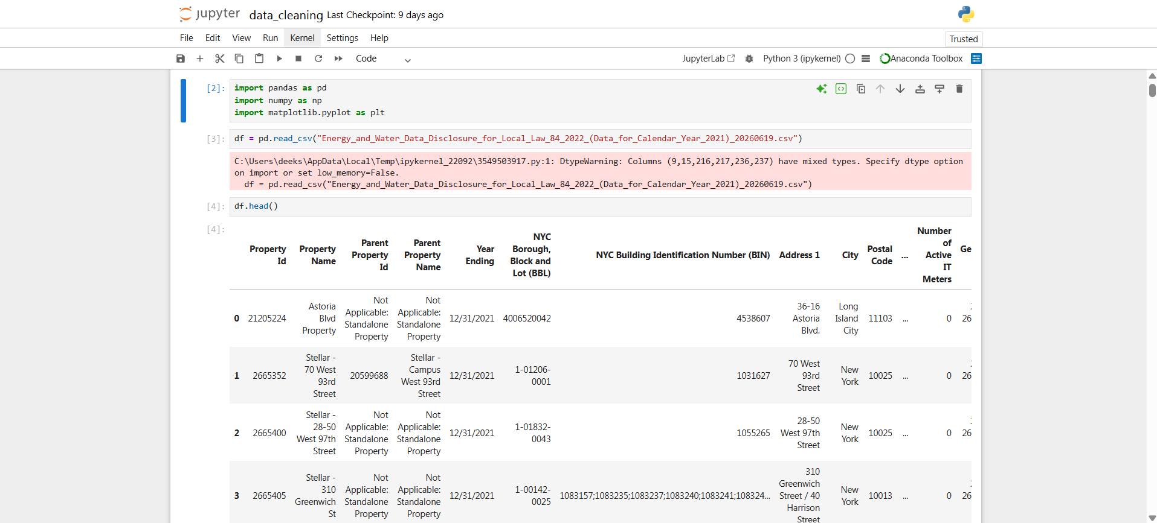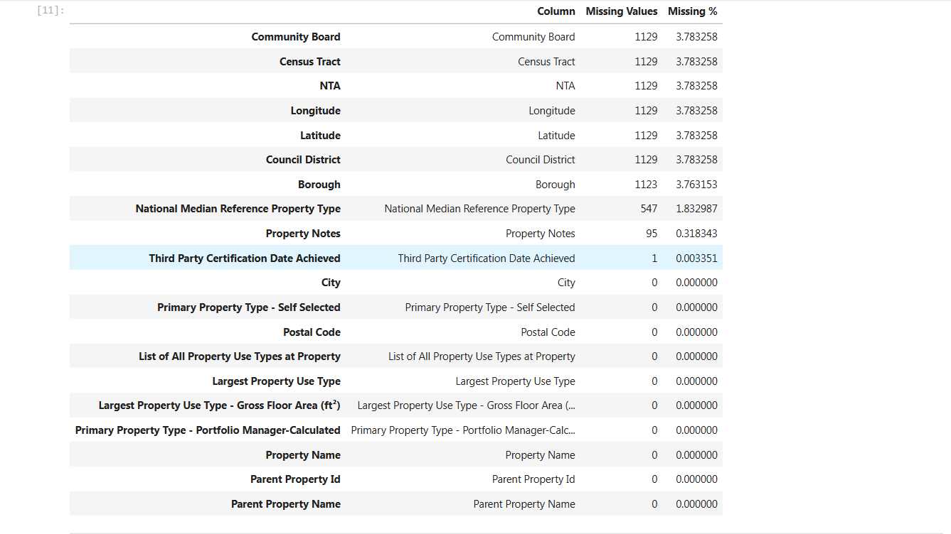
Figure 8.1: Original dataset imported into Jupyter Notebook. Figure 8.2: Output of df.info() showing column names and data types.

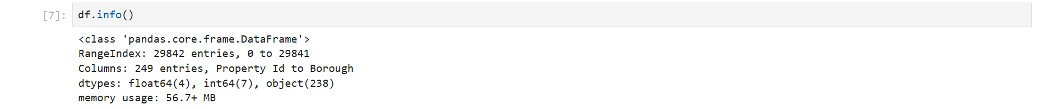
Figure 8.3: Checking for missing values (df.isnull().sum()).

EXPLORATORY DATA ANALYSIS (EDA):

Exploratory Data Analysis (EDA) was performed to understand the characteristics of the cleaned dataset and identify meaningful patterns, trends, and relationships among different variables. Python libraries such as Pandas, Matplotlib, and Seaborn were used to summarize the data and create visualizations that aided in interpreting the dataset effectively.
The analysis began by generating descriptive statistics to understand the distribution of numerical attributes, including measures such as mean, median, minimum, maximum, and standard deviation. This provided a general overview of the dataset and helped identify variations in energy consumption across different buildings.
Various visualizations were created to examine the distribution of energy usage and greenhouse gas (GHG) emissions. Histograms and box plots were used to identify the spread of data and detect potential outliers, while bar charts were used to compare energy consumption across different building categories. Scatter plots were generated to study the relationship between Site Energy Use Intensity (EUI) and GHG emissions, helping to understand how energy usage influences environmental impact.
A correlation heatmap was also developed to analyze the relationships between numerical variables. This visualization helped identify positively and negatively correlated attributes, providing valuable insights into the factors affecting energy consumption. Additional analyses, including the identification of the top energy-consuming buildings and comparisons based on building type, further enhanced the understanding of the dataset.
The findings obtained through EDA served as the foundation for the SQL analysis and the Power BI dashboard. By exploring the data visually and statistically, important trends and patterns were identified, enabling more effective decision-making and supporting the overall objective of analyzing energy consumption and sustainability.

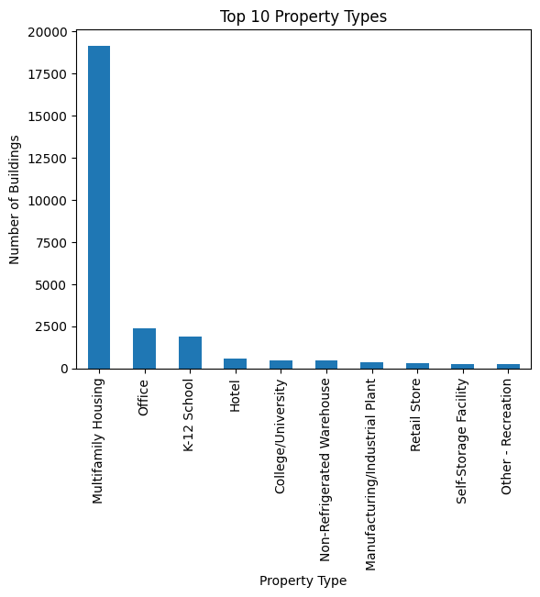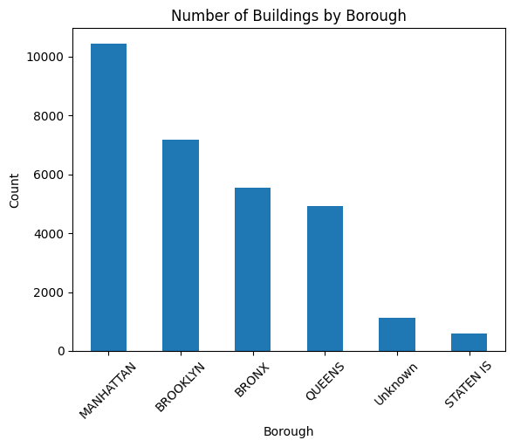
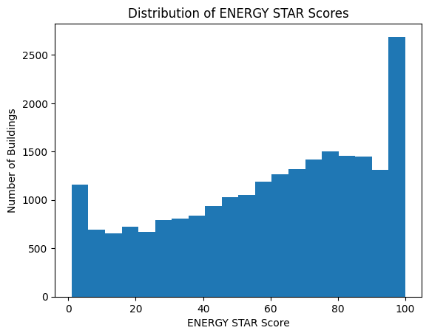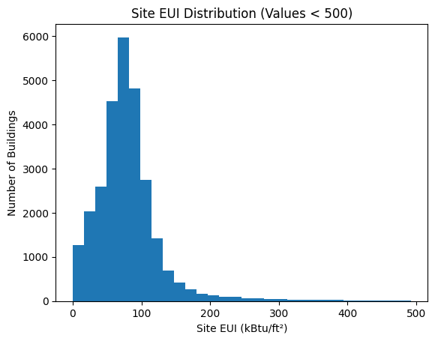

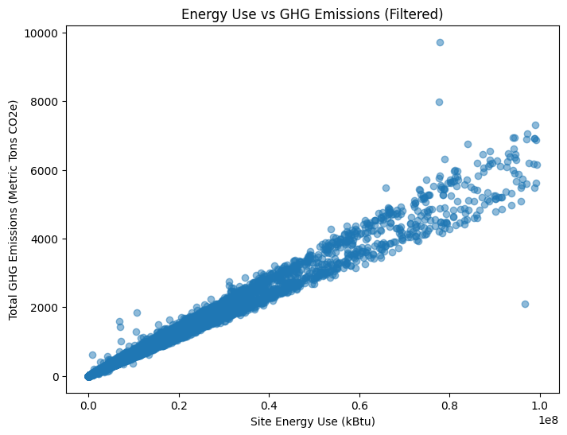

SQL ANALYSIS:

After completing the Exploratory Data Analysis (EDA), the cleaned dataset was imported into MySQL to perform structured data analysis using SQL. SQL was used to retrieve, filter, summarize, and analyze the data efficiently. By executing different queries, meaningful insights were extracted that complemented the findings obtained during the Python analysis.
Various SQL operations such as SELECT, WHERE, GROUP BY, ORDER BY, aggregate functions (SUM, AVG, COUNT, MAX, and MIN), and LIMIT were used to analyze the dataset. These operations helped in organizing the data, identifying trends, and generating summaries based on different building characteristics.
The SQL queries were designed to answer important analytical questions related to energy consumption and sustainability. The analysis included identifying the top energy-consuming buildings, calculating average energy usage, examining greenhouse gas (GHG) emissions, comparing different property types, and analyzing year-wise energy consumption. These queries provided a structured approach to understanding the dataset and validating the results obtained during Exploratory Data Analysis.
The results obtained through SQL formed an important part of the project and were later incorporated into the Power BI dashboard for effective visualization and reporting.
Summary of SQL Analysis
SQL Operation | Purpose
SELECT | Retrieve required data from the dataset
WHERE | Filter records based on specified conditions
GROUP BY | Group data for category-wise analysis
ORDER BY | Sort records in ascending or descending order
Aggregate Functions | Calculate totals, averages, maximums, minimums, and counts
LIMIT | Display the required number of records

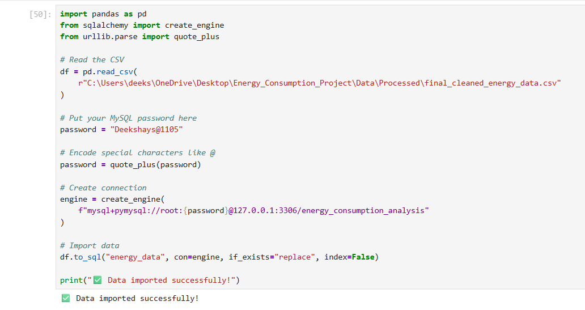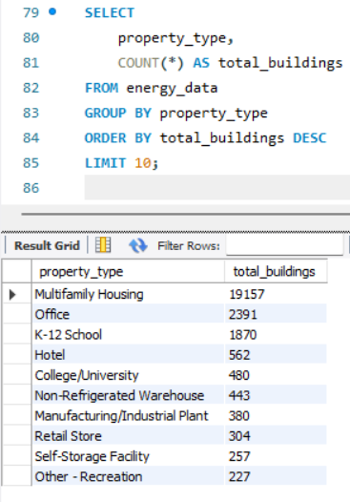
Figure 10.1: Importing the cleaned dataset into MySQL Figure 10.2: Query showing the Top 10 Energy-Consuming Buildings.

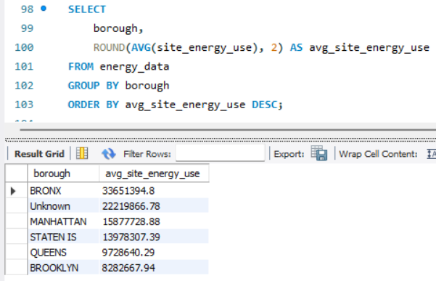
Figure 10.3: Query calculating average Site Energy Use Intensity (EUI).

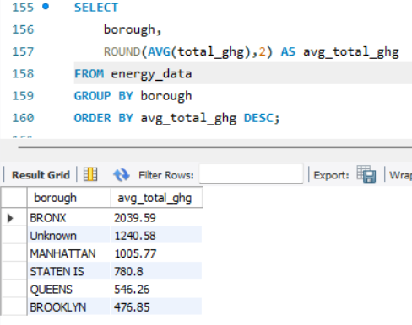
Figure 10.4: Query analyzing greenhouse gas (GHG) emissions by building type.

POWER BI DASHBOARD:

The final stage of the project involved developing an interactive dashboard using Microsoft Power BI to effectively present the insights obtained from Python analysis and SQL queries. The cleaned dataset was imported into Power BI, where data modeling and visualization techniques were applied to create a comprehensive and user-friendly dashboard.
A variety of visual elements were incorporated to represent different aspects of the dataset. KPI cards were used to display important metrics such as total energy consumption, average Site Energy Use Intensity (EUI), total greenhouse gas emissions, and the total number of buildings analyzed. Bar charts and treemaps were used to compare energy consumption across different building types and identify the highest energy-consuming buildings.
Additional visualizations, including a scatter plot, pie chart, map, and gauge chart, were used to analyze the relationship between energy usage and greenhouse gas emissions, display the geographical distribution of buildings, and monitor key performance indicators. Slicers and filters were also added to allow users to interact with the dashboard by selecting specific years, building types, or other relevant categories.
The Power BI dashboard transformed complex analytical results into clear and meaningful visual representations. It enables users to quickly identify trends, compare building performance, and gain valuable insights into energy consumption and sustainability. The dashboard serves as an effective decision-support tool by presenting information in an interactive and easily understandable format.
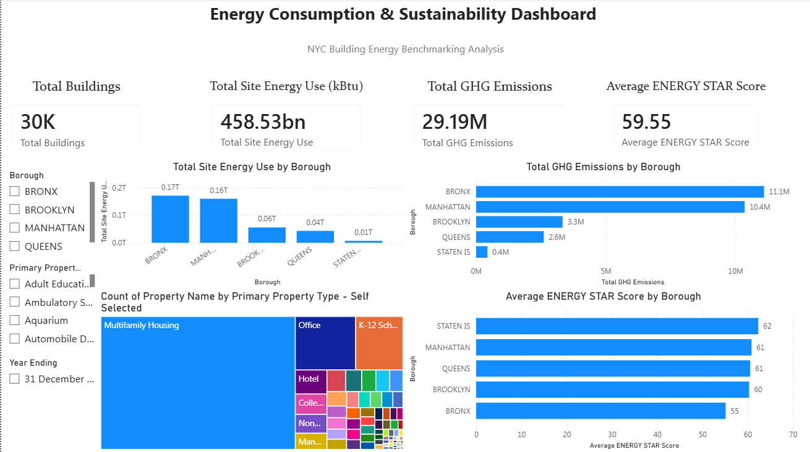

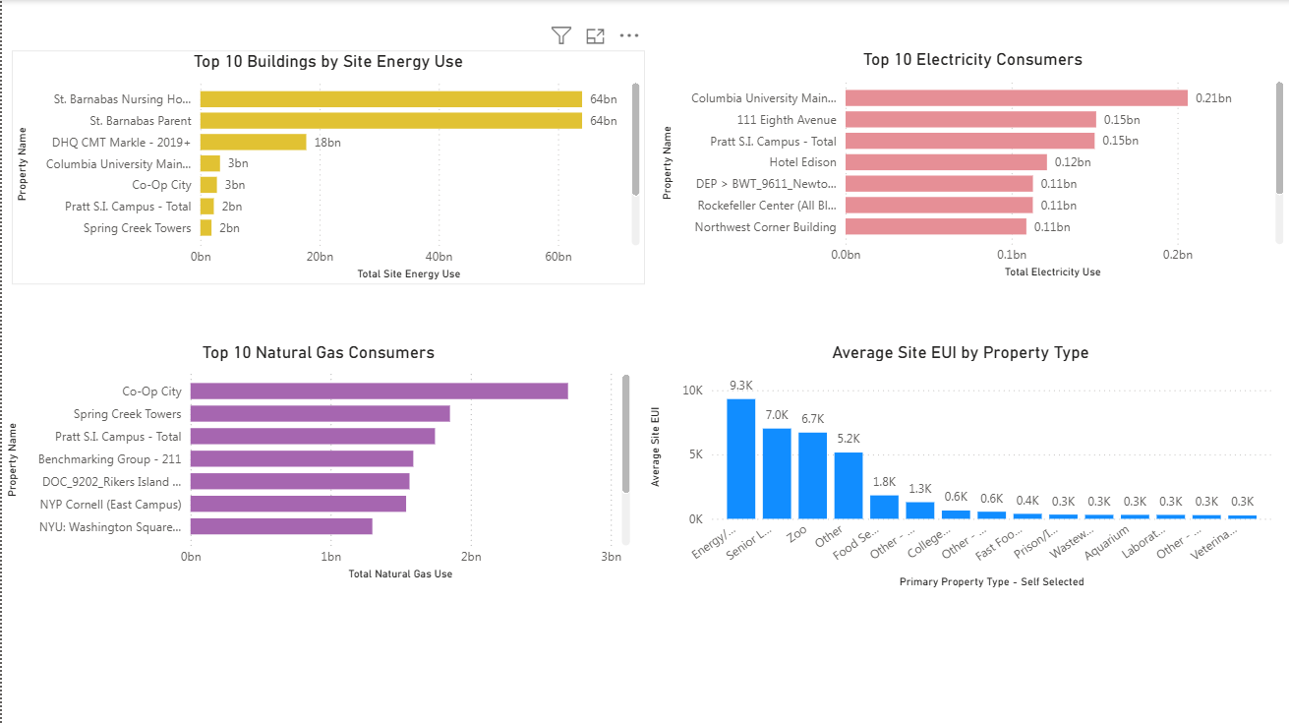

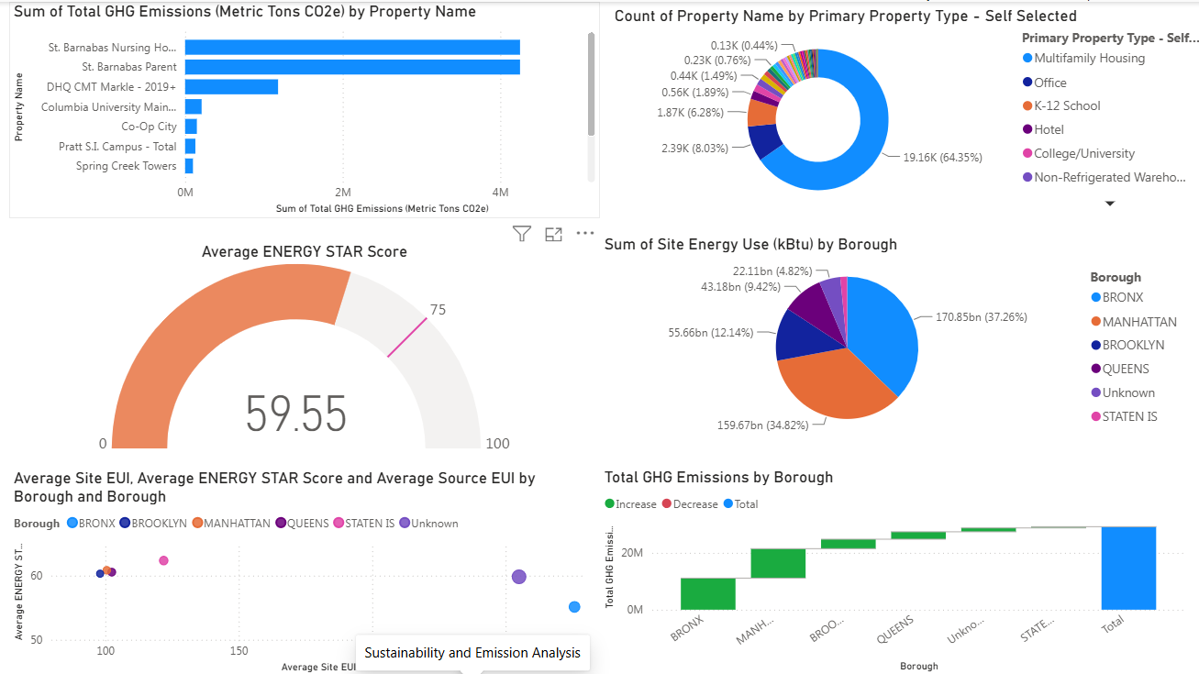

RESULT AND KEY INSIGHTS:

The analysis of the building energy consumption dataset provided several valuable insights into energy usage patterns and sustainability performance. The combined use of Python, MySQL, and Power BI enabled effective analysis and visualization of the data, making it easier to identify trends and support data-driven decision-making.
The Power BI dashboard highlighted the buildings with the highest energy consumption, allowing easy identification of properties that require greater attention for improving energy efficiency. A positive relationship was observed between Site Energy Use Intensity (EUI) and greenhouse gas (GHG) emissions, indicating that buildings with higher energy usage generally produced higher carbon emissions.
The analysis also showed variations in energy consumption among different building types, suggesting that certain categories consume significantly more energy than others. Year-wise comparisons revealed changes in energy usage over time, helping to identify trends and monitor building performance across different reporting years.
Interactive visualizations such as KPI cards, treemaps, scatter plots, maps, and slicers improved the overall interpretation of the data by allowing users to explore the information from multiple perspectives. The dashboard provides an effective platform for monitoring energy performance and identifying opportunities to improve operational efficiency.
Overall, the project demonstrated that data analytics techniques can successfully transform raw energy data into meaningful insights. The findings can assist organizations in optimizing energy consumption, reducing greenhouse gas emissions, and supporting sustainable building management through informed decision-making.

CONCLUSION:

The Energy Consumption and Sustainability Analysis Using Python, SQL, and Power BI project successfully demonstrated the complete data analytics workflow, from data collection and preprocessing to visualization and insight generation. Throughout the project, various analytical techniques were applied to transform raw building energy consumption data into meaningful and actionable information.
Python was used for data cleaning, preprocessing, and exploratory data analysis, enabling a clear understanding of the dataset and its characteristics. MySQL facilitated efficient querying and analysis of the cleaned data, while Power BI was utilized to develop an interactive dashboard that effectively presented the key findings through various visualizations.
The analysis helped identify energy consumption patterns, compare building performance, examine greenhouse gas emissions, and highlight areas where energy efficiency can be improved. The interactive dashboard further enhanced the interpretation of the data by providing users with an intuitive platform for exploring different aspects of the dataset.
Overall, this project strengthened practical knowledge of Python, SQL, and Power BI while providing valuable experience in handling real-world datasets and developing data-driven solutions. The skills and techniques acquired during this project can be applied to future data analytics and business intelligence applications, contributing to informed decision-making and sustainable energy management.

REFERENCE:

- Kaggle. Building Energy Benchmarking Dataset. Retrieved from: https://www.kaggle.com/

- Pandas Documentation: https://pandas.pydata.org/docs/

- NumPy Documentation: https://numpy.org/doc/

- Matplotlib Documentation:https://matplotlib.org/stable/

- Seaborn Documentation: https://seaborn.pydata.org/

- MySQL Documentation: https://dev.mysql.com/doc/

- Microsoft Power BI Documentation: https://learn.microsoft.com/power-bi/

- Python Software Foundation: https://docs.python.org/3/

