

**期末项目设计报告**

|  |  |  |  |
| --- | --- | --- | --- |
| 题 目 | 基于Oracle的汽车博客的数据库设计 | | |
| 课程 | Oracle数据库应用 | | |
| 学 院 | 计算机学院 | | |
| 专 业 | 软件工程 | 年级 | 2018级 |
| 学生姓名 | 邓永霜 | 学号 | 201810112302 |
| 指导教师 | 赵卫东 | 职称 | 副教授 |

|  |  |  |  |
| --- | --- | --- | --- |
| **评分项** | **评分标准** | **满分** | **得分** |
| 文档整体 | 文档内容详实、规范，美观大方 | 10 |  |
| 表设计 | 表，表空间设计合理，数据合理 | 20 |  |
| 用户管理 | 权限及用户分配方案设计正确 | 10 |  |
| PL/SQL设计 | 存储过程和函数设计正确 | 25 |  |
| 备份方案 | 备份方案设计正确 | 25 |  |
| 容灾方案 | DataGuard设计正确 | 10 |  |
| **得分合计** | | |  |

2021 年 6 月 1 日

目录

一.背景 3

二． 创建表空间 3

三． 创建角色 4

四． 创建用户 6

五．创建表及插入数据 10

六．PL/SQL语言设计存储过程和函数 20

七．备份方案 22

一.背景

伴随经济的飞速发展，国内的汽车保有量不断增加，仅成都一城的汽车保有量就超过了一千万。不断增加的汽车用户自然对于一个讨论汽车问题的地方，所以便有了各大汽车论坛的诞生，本项目也因此设计了一个基于Oracle 的汽车论坛数据库。

1. 创建表空间

1.创建space01

CREATE TABLESPACE space01 DATAFILE

'/home/oracle/app/oracle/oradata/orcl/cars/space01_1.dbf'

SIZE 100M AUTOEXTEND ON NEXT 10M MAXSIZE UNLIMITED,

'/home/oracle/app/oracle/oradata/orcl/cars/space01_2.dbf'

SIZE 100M AUTOEXTEND ON NEXT 10M MAXSIZE UNLIMITED

EXTENT MANAGEMENT LOCAL SEGMENT SPACE MANAGEMENT AUTO;

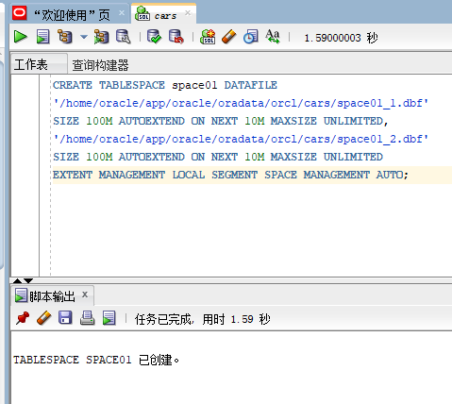

1. 创建表空间sapce02

CREATE TABLESPACE space02 DATAFILE

'/home/oracle/app/oracle/oradata/orcl/cars/space02_1.dbf'

SIZE 100M AUTOEXTEND ON NEXT 10M MAXSIZE UNLIMITED,

'/home/oracle/app/oracle/oradata/orcl/cars/space02_2.dbf'

SIZE 100M AUTOEXTEND ON NEXT 10M MAXSIZE UNLIMITED

EXTENT MANAGEMENT LOCAL SEGMENT SPACE MANAGEMENT AUTO;

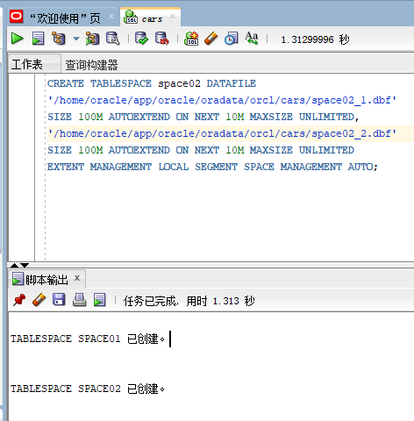

1. 创建角色
2. 创建管理员角色

CREATE ROLE admins;

GRANT create any table, alter any table, create tablespace, alter tablespace, create user, alter user,

create any procedure, alter any procedure, create session, alter session

to admins with admin option;

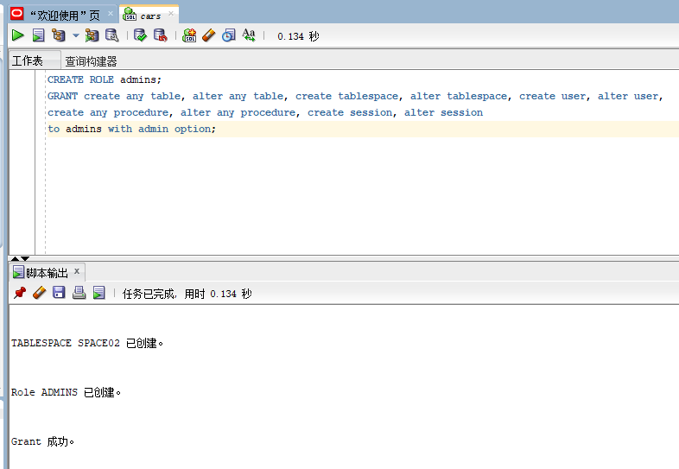

1. 创建用户角色

CREATE ROLE users;

GRANT create session to users with admin option;

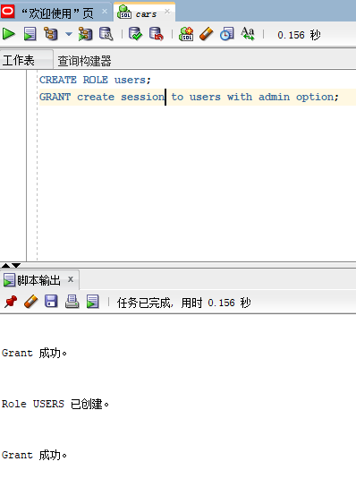

1. 创建用户
2. 创建管理员用户

创建管理员用户admin_01,并赋予它所有权限

GRANT "DBA" TO "admin_01" WITH admin_01 OPTION;

GRANT "C##CON_RES" TO "admin_01" WITH admin_01 OPTION;

GRANT "DV_MONITOR" TO "admin_01" WITH admin_01 OPTION;

GRANT "CTXAPP" TO "admin_01" WITH admin_01 OPTION;

GRANT "DV_AUDIT_CLEANUP" TO "admin_01" WITH admin_01 OPTION;

GRANT "SPATIAL_CSW_admin_01" TO "admin_01" WITH admin_01 OPTION;

GRANT "APEX_GRANTS_FOR_NEW_USERS_ROLE" TO "admin_01" WITH admin_01 OPTION;

GRANT "WFS_USR_ROLE" TO "admin_01" WITH admin_01 OPTION;

GRANT "EM_EXPRESS_ALL" TO "admin_01" WITH admin_01 OPTION;

GRANT "WM_admin_01_ROLE" TO "admin_01" WITH admin_01 OPTION;

GRANT "OLAP_USER" TO "admin_01" WITH admin_01 OPTION;

GRANT "OLAP_XS_admin_01" TO "admin_01" WITH admin_01 OPTION;

GRANT "DV_SECANALYST" TO "admin_01" WITH admin_01 OPTION;

GRANT "CSW_USR_ROLE" TO "admin_01" WITH admin_01 OPTION;

GRANT "XS_CACHE_admin_01" TO "admin_01" WITH admin_01 OPTION;

GRANT "GDS_CATALOG_SELECT" TO "admin_01" WITH admin_01 OPTION;

GRANT "SCHEDULER_admin_01" TO "admin_01" WITH admin_01 OPTION;

GRANT "PROVISIONER" TO "admin_01" WITH admin_01 OPTION;

GRANT "AUDIT_admin_01" TO "admin_01" WITH admin_01 OPTION;

GRANT "XDB_WEBSERVICES_OVER_HTTP" TO "admin_01" WITH admin_01 OPTION;

GRANT "DV_REALM_RESOURCE" TO "admin_01" WITH admin_01 OPTION;

GRANT "AQ_admin_01ISTRATOR_ROLE" TO "admin_01" WITH admin_01 OPTION;

GRANT "DELETE_CATALOG_ROLE" TO "admin_01" WITH admin_01 OPTION;

GRANT "CON_RES" TO "admin_01" WITH admin_01 OPTION;

GRANT "XDB_WEBSERVICES" TO "admin_01" WITH admin_01 OPTION;

GRANT "DV_PUBLIC" TO "admin_01" WITH admin_01 OPTION;

GRANT "LBAC_DBA" TO "admin_01" WITH admin_01 OPTION;

GRANT "OPTIMIZER_PROCESSING_RATE" TO "admin_01" WITH admin_01 OPTION;

GRANT "RECOVERY_CATALOG_USER" TO "admin_01" WITH admin_01 OPTION;

GRANT "DV_DATAPUMP_NETWORK_LINK" TO "admin_01" WITH admin_01 OPTION;

GRANT "GSMUSER_ROLE" TO "admin_01" WITH admin_01 OPTION;

GRANT "GATHER_SYSTEM_STATISTICS" TO "admin_01" WITH admin_01 OPTION;

GRANT "LOGSTDBY_admin_01ISTRATOR" TO "admin_01" WITH admin_01 OPTION;

GRANT "GSM_POOLadmin_01_ROLE" TO "admin_01" WITH admin_01 OPTION;

GRANT "DV_admin_01" TO "admin_01" WITH admin_01 OPTION;

GRANT "HS_admin_01_ROLE" TO "admin_01" WITH admin_01 OPTION;

GRANT "XS_SESSION_admin_01" TO "admin_01" WITH admin_01 OPTION;

GRANT "DV_GOLDENGATE_admin_01" TO "admin_01" WITH admin_01 OPTION;

GRANT "IMP_FULL_DATABASE" TO "admin_01" WITH admin_01 OPTION;

GRANT "DV_XSTREAM_admin_01" TO "admin_01" WITH admin_01 OPTION;

GRANT "DV_PATCH_admin_01" TO "admin_01" WITH admin_01 OPTION;

GRANT "DATAPUMP_EXP_FULL_DATABASE" TO "admin_01" WITH admin_01 OPTION;

GRANT "EJBCLIENT" TO "admin_01" WITH admin_01 OPTION;

GRANT "HS_admin_01_EXECUTE_ROLE" TO "admin_01" WITH admin_01 OPTION;

GRANT "JMXSERVER" TO "admin_01" WITH admin_01 OPTION;

GRANT "OLAP_DBA" TO "admin_01" WITH admin_01 OPTION;

GRANT "ADM_PARALLEL_EXECUTE_TASK" TO "admin_01" WITH admin_01 OPTION;

GRANT "JAVAIDPRIV" TO "admin_01" WITH admin_01 OPTION;

GRANT "SELECT_CATALOG_ROLE" TO "admin_01" WITH admin_01 OPTION;

GRANT "JAVADEBUGPRIV" TO "admin_01" WITH admin_01 OPTION;

GRANT "CONNECT" TO "admin_01" WITH admin_01 OPTION;

GRANT "DATAPUMP_IMP_FULL_DATABASE" TO "admin_01" WITH admin_01 OPTION;

GRANT "OEM_MONITOR" TO "admin_01" WITH admin_01 OPTION;

GRANT "APEX_admin_01ISTRATOR_ROLE" TO "admin_01" WITH admin_01 OPTION;

GRANT "GSMadmin_01_ROLE" TO "admin_01" WITH admin_01 OPTION;

GRANT "AQ_USER_ROLE" TO "admin_01" WITH admin_01 OPTION;

GRANT "JAVAUSERPRIV" TO "admin_01" WITH admin_01 OPTION;

GRANT "XDB_SET_INVOKER" TO "admin_01" WITH admin_01 OPTION;

GRANT "RECOVERY_CATALOG_OWNER" TO "admin_01" WITH admin_01 OPTION;

GRANT "JAVA_admin_01" TO "admin_01" WITH admin_01 OPTION;

GRANT "DBFS_ROLE" TO "admin_01" WITH admin_01 OPTION;

GRANT "PDB_DBA" TO "admin_01" WITH admin_01 OPTION;

GRANT "DV_GOLDENGATE_REDO_ACCESS" TO "admin_01" WITH admin_01 OPTION;

GRANT "CDB_DBA" TO "admin_01" WITH admin_01 OPTION;

GRANT "JAVASYSPRIV" TO "admin_01" WITH admin_01 OPTION;

GRANT "HS_admin_01_SELECT_ROLE" TO "admin_01" WITH admin_01 OPTION;

GRANT "AUDIT_VIEWER" TO "admin_01" WITH admin_01 OPTION;

GRANT "RESOURCE" TO "admin_01" WITH admin_01 OPTION;

GRANT "DV_OWNER" TO "admin_01" WITH admin_01 OPTION;

GRANT "XDB_WEBSERVICES_WITH_PUBLIC" TO "admin_01" WITH admin_01 OPTION;

GRANT "EXECUTE_CATALOG_ROLE" TO "admin_01" WITH admin_01 OPTION;

GRANT "DV_ACCTMGR" TO "admin_01" WITH admin_01 OPTION;

GRANT "DV_REALM_OWNER" TO "admin_01" WITH admin_01 OPTION;

GRANT "EXP_FULL_DATABASE" TO "admin_01" WITH admin_01 OPTION;

GRANT "DV_STREAMS_admin_01" TO "admin_01" WITH admin_01 OPTION;

GRANT "JAVA_DEPLOY" TO "admin_01" WITH admin_01 OPTION;

GRANT "SPATIAL_WFS_admin_01" TO "admin_01" WITH admin_01 OPTION;

GRANT "XS_NAMESPACE_admin_01" TO "admin_01" WITH admin_01 OPTION;

GRANT "DEV" TO "admin_01" WITH admin_01 OPTION;

GRANT "XS_RESOURCE" TO "admin_01" WITH admin_01 OPTION;

GRANT "ORDadmin_01" TO "admin_01" WITH admin_01 OPTION;

GRANT "AUTHENTICATEDUSER" TO "admin_01" WITH admin_01 OPTION;

GRANT "CAPTURE_admin_01" TO "admin_01" WITH admin_01 OPTION;

GRANT "OEM_ADVISOR" TO "admin_01" WITH admin_01 OPTION;

GRANT "XDBadmin_01" TO "admin_01" WITH admin_01 OPTION;

GRANT "EM_EXPRESS_BASIC" TO "admin_01" WITH admin_01 OPTION;

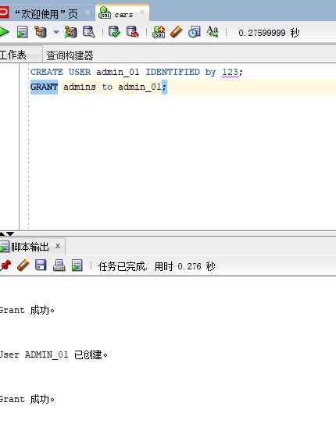

1. 创建普通用户的用户

CREATE USER user_02 IDENTIFIED by 123;

GRANT users to user_02;

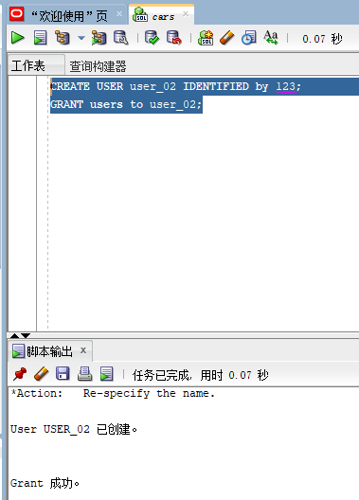

五．创建表及插入数据

1.板块表

DROP TABLE Bankuai;

CREATE TABLE Bankuai (

"name" VARCHAR2(255 BYTE) VISIBLE NOT NULL ,

"introduction" VARCHAR2(255 BYTE) VISIBLE NOT NULL

)

TABLESPACE "SPACE01"

LOGGING

NOCOMPRESS

PCTFREE 10

INITRANS 1

STORAGE (

BUFFER_POOL DEFAULT

)

PARALLEL 1

NOCACHE

DISABLE ROW MOVEMENT

;

COMMENT ON COLUMN Bankuai."name" IS '板块名';

COMMENT ON COLUMN Bankuai."introduction" IS '板块的描述';

ALTER TABLE Bankuai ADD CONSTRAINT "SYS_C0038651" PRIMARY KEY ("name");

-- ----------------------------

-- Checks structure for table Bankuai

-- ----------------------------

ALTER TABLE Bankuai ADD CONSTRAINT "SYS_C0038649" CHECK ("name" IS NOT NULL) NOT DEFERRABLE INITIALLY IMMEDIATE NORELY VALIDATE;

ALTER TABLE Bankuai ADD CONSTRAINT "SYS_C0038650" CHECK ("introduction" IS NOT NULL) NOT DEFERRABLE INITIALLY IMMEDIATE NORELY VALIDATE;

|  |  |  |  |  |  |  |
| --- | --- | --- | --- | --- | --- | --- |
| 表名 | Bankuai | | | | | |
| 字段编号 | 物理字段 | 逻辑字段 | 字段类型 | 是否主键 | 是否非空 | 备注 |
| 1 | 版块名 | name | VARCHAR2 | Y | 非空 |  |
| 2 | 板块描述 | instruction | VARCHAR2 |  | 非空 |  |

插入数据

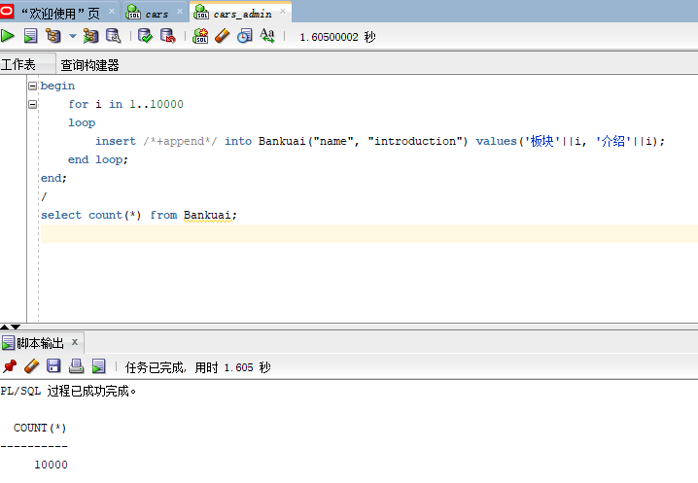

1. 话题表

DROP TABLE post;

CREATE TABLE post (

"id" NUMBER VISIBLE NOT NULL ,

"name" VARCHAR2(255 BYTE) VISIBLE NOT NULL ,

"user_id" NUMBER VISIBLE NOT NULL ,

"title" VARCHAR2(255 BYTE) VISIBLE NOT NULL ,

"details" VARCHAR2(255 BYTE) VISIBLE NOT NULL ,

"time" DATE VISIBLE NOT NULL

)

TABLESPACE "SPACE01"

LOGGING

NOCOMPRESS

PCTFREE 10

INITRANS 1

STORAGE (

BUFFER_POOL DEFAULT

)

PARALLEL 1

NOCACHE

DISABLE ROW MOVEMENT

;

COMMENT ON COLUMN post."id" IS '话题id';

COMMENT ON COLUMN post."name" IS '所属板块名';

COMMENT ON COLUMN post."user_id" IS '发帖人id';

COMMENT ON COLUMN post."title" IS '话题标题';

COMMENT ON COLUMN post."details" IS '话题细节';

COMMENT ON COLUMN post."time" IS '提起时间';

ALTER TABLE post ADD CONSTRAINT "SYS_C0038667" PRIMARY KEY ("id");

-- ----------------------------

-- Checks structure for table post

-- ----------------------------

ALTER TABLE post ADD CONSTRAINT "SYS_C0038661" CHECK ("id" IS NOT NULL) NOT DEFERRABLE INITIALLY IMMEDIATE NORELY VALIDATE;

ALTER TABLE post ADD CONSTRAINT "SYS_C0038662" CHECK ("name" IS NOT NULL) NOT DEFERRABLE INITIALLY IMMEDIATE NORELY VALIDATE;

ALTER TABLE post ADD CONSTRAINT "SYS_C0038663" CHECK ("user_id" IS NOT NULL) NOT DEFERRABLE INITIALLY IMMEDIATE NORELY VALIDATE;

ALTER TABLE post ADD CONSTRAINT "SYS_C0038664" CHECK ("title" IS NOT NULL) NOT DEFERRABLE INITIALLY IMMEDIATE NORELY VALIDATE;

ALTER TABLE post ADD CONSTRAINT "SYS_C0038665" CHECK ("details" IS NOT NULL) NOT DEFERRABLE INITIALLY IMMEDIATE NORELY VALIDATE;

ALTER TABLE post ADD CONSTRAINT "SYS_C0038666" CHECK ("time" IS NOT NULL) NOT DEFERRABLE INITIALLY IMMEDIATE NORELY VALIDATE;

|  |  |  |  |  |  |  |
| --- | --- | --- | --- | --- | --- | --- |
| 表名 | post | | | | | |
| 字段编号 | 物理字段 | 逻辑字段 | 字段类型 | 是否主键 | 是否非空 | 备注 |
| 1 | 话题id | id | NUMBER | Y | 非空 |  |
| 2 | 所属板块名 | name | VARCHAR2 |  | 非空 |  |
| 3 | 发帖人id | User_id | NUMBER |  | 非空 |  |
| 4 | 话题标题 | title | VARCHAR2 |  | 非空 |  |
| 5 | 话题细节 | details | VARCHAR2 |  | 非空 |  |
| 6 | 提起时间 | time | DATE |  | 非空 |  |

插入数据

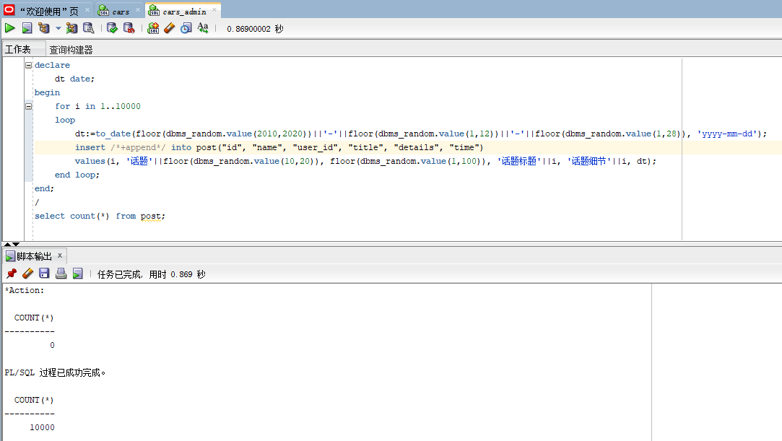

1. 回复表1

DROP TABLE reply_one;

CREATE TABLE reply_one (

"id" NUMBER VISIBLE NOT NULL ,

"post_id" NUMBER VISIBLE NOT NULL ,

"user_id" NUMBER VISIBLE NOT NULL ,

"details" VARCHAR2(255 BYTE) VISIBLE NOT NULL ,

"time" DATE VISIBLE NOT NULL

)

TABLESPACE "SPACE01"

LOGGING

NOCOMPRESS

PCTFREE 10

INITRANS 1

STORAGE (

BUFFER_POOL DEFAULT

)

PARALLEL 1

NOCACHE

DISABLE ROW MOVEMENT

;

COMMENT ON COLUMN reply_one."id" IS '回复id';

COMMENT ON COLUMN reply_one."post_id" IS '话题id';

COMMENT ON COLUMN reply_one."user_id" IS '回复用户id';

COMMENT ON COLUMN reply_one."details" IS '回复内容';

COMMENT ON COLUMN reply_one."time" IS '回复时间';

ALTER TABLE reply_one ADD CONSTRAINT "SYS_C0038673" PRIMARY KEY ("id", "post_id");

-- ----------------------------

-- Checks structure for table reply_one

-- ----------------------------

ALTER TABLE reply_one ADD CONSTRAINT "SYS_C0038668" CHECK ("id" IS NOT NULL) NOT DEFERRABLE INITIALLY IMMEDIATE NORELY VALIDATE;

ALTER TABLE reply_one ADD CONSTRAINT "SYS_C0038669" CHECK ("post_id" IS NOT NULL) NOT DEFERRABLE INITIALLY IMMEDIATE NORELY VALIDATE;

ALTER TABLE reply_one ADD CONSTRAINT "SYS_C0038670" CHECK ("user_id" IS NOT NULL) NOT DEFERRABLE INITIALLY IMMEDIATE NORELY VALIDATE;

ALTER TABLE reply_one ADD CONSTRAINT "SYS_C0038671" CHECK ("details" IS NOT NULL) NOT DEFERRABLE INITIALLY IMMEDIATE NORELY VALIDATE;

ALTER TABLE reply_one ADD CONSTRAINT "SYS_C0038672" CHECK ("time" IS NOT NULL) NOT DEFERRABLE INITIALLY IMMEDIATE NORELY VALIDATE;

|  |  |  |  |  |  |  |
| --- | --- | --- | --- | --- | --- | --- |
| 表名 | reply_one | | | | | |
| 字段编号 | 物理字段 | 逻辑字段 | 字段类型 | 是否主键 | 是否非空 | 备注 |
| 1 | 回复id | id | NUMBER | Y | 非空 |  |
| 2 | 话题id | post_id | NUMBER | Y | 非空 |  |
| 3 | 回复用户id | User_id | NUMBER |  | 非空 |  |
| 4 | 回复内容 | details | VARCHAR2 |  | 非空 |  |
| 5 | 回复时间 | time | DATE |  | 非空 |  |

插入数据

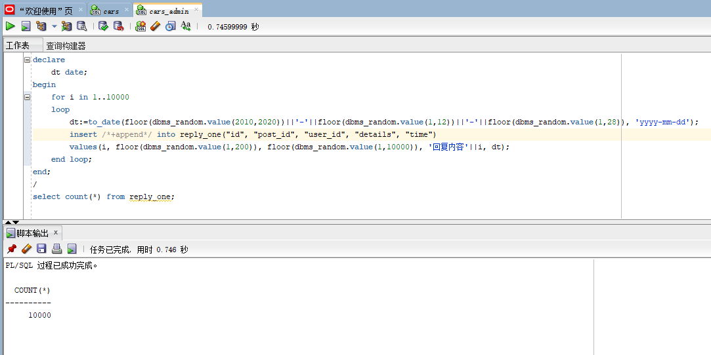

4.回复表2

DROP TABLE reply_two;

CREATE TABLE reply_two (

"id" NUMBER VISIBLE NOT NULL ,

"post_id" NUMBER VISIBLE NOT NULL ,

"reply_id" NUMBER VISIBLE NOT NULL ,

"user_id" NUMBER VISIBLE NOT NULL ,

"details" VARCHAR2(255 BYTE) VISIBLE NOT NULL ,

"time" DATE VISIBLE NOT NULL

)

TABLESPACE "SPACE01"

LOGGING

NOCOMPRESS

PCTFREE 10

INITRANS 1

STORAGE (

BUFFER_POOL DEFAULT

)

PARALLEL 1

NOCACHE

DISABLE ROW MOVEMENT

;

COMMENT ON COLUMN reply_two."id" IS '再次回复的id';

COMMENT ON COLUMN reply_two."post_id" IS '话题id';

COMMENT ON COLUMN reply_two."reply_id" IS '回复的id';

COMMENT ON COLUMN reply_two."user_id" IS '用户id';

COMMENT ON COLUMN reply_two."details" IS '回复内容';

COMMENT ON COLUMN reply_two."time" IS '回复时间';

ALTER TABLE reply_two ADD CONSTRAINT "SYS_C0038680" PRIMARY KEY ("id", "post_id", "reply_id");

-- ----------------------------

-- Checks structure for table reply_two

-- ----------------------------

ALTER TABLE reply_two ADD CONSTRAINT "SYS_C0038674" CHECK ("id" IS NOT NULL) NOT DEFERRABLE INITIALLY IMMEDIATE NORELY VALIDATE;

ALTER TABLE reply_two ADD CONSTRAINT "SYS_C0038675" CHECK ("post_id" IS NOT NULL) NOT DEFERRABLE INITIALLY IMMEDIATE NORELY VALIDATE;

ALTER TABLE reply_two ADD CONSTRAINT "SYS_C0038676" CHECK ("reply_id" IS NOT NULL) NOT DEFERRABLE INITIALLY IMMEDIATE NORELY VALIDATE;

ALTER TABLE reply_two ADD CONSTRAINT "SYS_C0038677" CHECK ("user_id" IS NOT NULL) NOT DEFERRABLE INITIALLY IMMEDIATE NORELY VALIDATE;

ALTER TABLE reply_two ADD CONSTRAINT "SYS_C0038678" CHECK ("details" IS NOT NULL) NOT DEFERRABLE INITIALLY IMMEDIATE NORELY VALIDATE;

ALTER TABLE reply_two ADD CONSTRAINT "SYS_C0038679" CHECK ("time" IS NOT NULL) NOT DEFERRABLE INITIALLY IMMEDIATE NORELY VALIDATE;

|  |  |  |  |  |  |  |
| --- | --- | --- | --- | --- | --- | --- |
| 表名 | reply_two | | | | | |
| 字段编号 | 物理字段 | 逻辑字段 | 字段类型 | 是否主键 | 是否非空 | 备注 |
| 1 | 再次回复的id | id | NUMBER | Y | 非空 |  |
| 2 | 话题id | post_id | NUMBER | Y | 非空 |  |
| 3 | 回复的id | reply_id | NUMBER | Y | 非空 |  |
| 4 | 回复用户id | user_id | NUMBER |  | 非空 |  |
| 5 | 回复内容 | details | VARCHAR2 |  | 非空 |  |
| 6 | 回复时间 | time | DATE |  |  |  |

插入数据

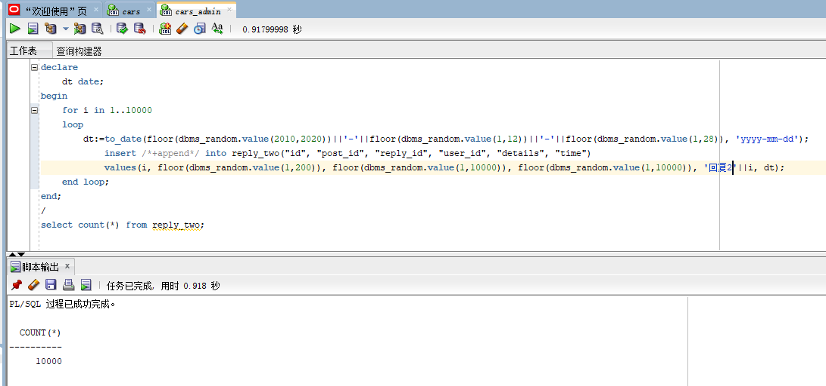

5.用户表

DROP TABLE user_table;

CREATE TABLE user_table (

"id" NUMBER VISIBLE NOT NULL ,

"user_name" VARCHAR2(255 BYTE) VISIBLE NOT NULL ,

"sex" VARCHAR2(255 BYTE) VISIBLE

)

TABLESPACE "SPACE01"

LOGGING

NOCOMPRESS

PCTFREE 10

INITRANS 1

STORAGE (

BUFFER_POOL DEFAULT

)

PARALLEL 1

NOCACHE

DISABLE ROW MOVEMENT

;

COMMENT ON COLUMN user_table."id" IS '用户id';

COMMENT ON COLUMN user_table."user_name" IS '用户名';

COMMENT ON COLUMN user_table."sex" IS '用户性别';

ALTER TABLE user_table ADD CONSTRAINT "SYS_C0038687" PRIMARY KEY ("id");

-- ----------------------------

-- Checks structure for table user_table

-- ----------------------------

ALTER TABLE user_table ADD CONSTRAINT "SYS_C0038685" CHECK ("id" IS NOT NULL) NOT DEFERRABLE INITIALLY IMMEDIATE NORELY VALIDATE;

ALTER TABLE user_table ADD CONSTRAINT "SYS_C0038686" CHECK ("user_name" IS NOT NULL) NOT DEFERRABLE INITIALLY IMMEDIATE NORELY VALIDATE;

|  |  |  |  |  |  |  |
| --- | --- | --- | --- | --- | --- | --- |
| 表名 | user_table | | | | | |
| 字段编号 | 物理字段 | 逻辑字段 | 字段类型 | 是否主键 | 是否非空 | 备注 |
| 1 | 用户id | id | NUMBER | Y | 非空 |  |
| 2 | 用户名 | user_name | VARCHAR2 |  | 非空 |  |
| 3 | 用户性别 | sex | VARCHAR2 |  |  |  |

插入数据

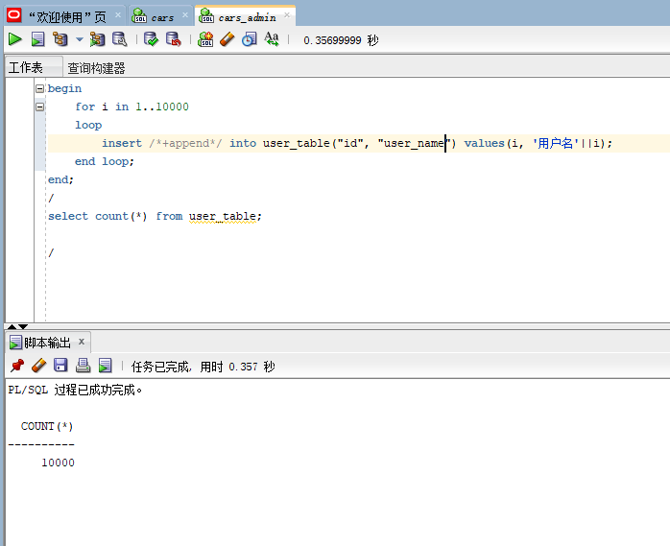

六．PL/SQL语言设计存储过程和函数

1. 函数

create or replace PACKAGE MyPack IS

--获取一个用户的发起的话题、回复、再回复总数

FUNCTION get_posts_num_of_users(user_id int) RETURN int;

--按照结构显示一个话题

PROCEDURE show_post(post_id int);

END MyPack;

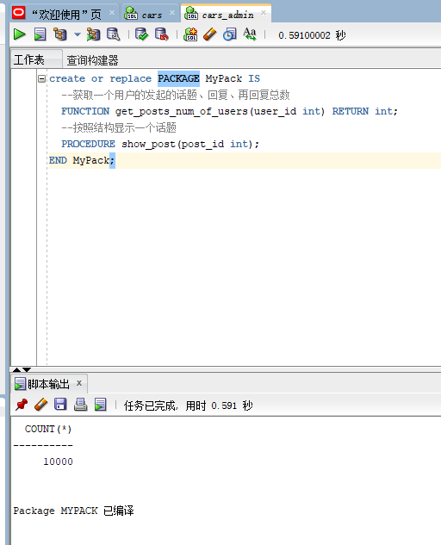

1. 存储过程

create or replace PACKAGE BODY MyPack IS

FUNCTION get_posts_num_of_users(user_id int) RETURN int

AS

posts int;

reply_one int;

reply_two int;

begin

select count(*) into posts from post where "user_id" = user_id;

select count(*) into reply_one from post where "user_id" = user_id;

select count(*) into reply_two from post where "user_id" = user_id;

return posts+reply_one+reply_two;

end;

PROCEDURE show_post(post_id int)

AS

temp varchar2(255);

leftspace varchar2(255);

begin

leftspace:=' ';

select "title" into temp from post where "id"=post_id;

DBMS_OUTPUT.PUT_LINE('标题：'||temp);

select "details" into temp from post where "id"=post_id;

DBMS_OUTPUT.PUT_LINE('细节：'||temp);

for v in (select * from reply_one where "post_id"=post_id)

loop

DBMS_OUTPUT.PUT_LINE(leftspace||'用户'||v."user_id"||'回复：'||v."details");

end loop;

END;

END MyPack;

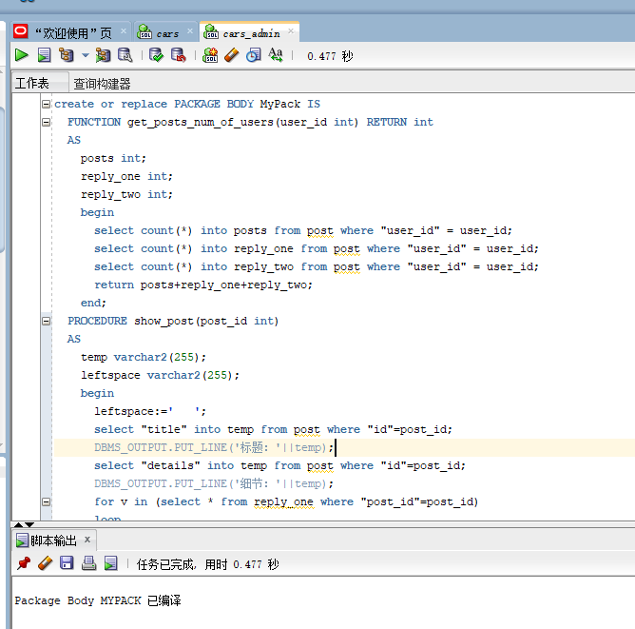

七．备份方案

数据库备份采取每月一次进行数据库全备份，并且在每日凌晨十二点自动开始增量备份的方式进行备份。

1. 开始全备份

[oracle@oracle-pc ~]$ cat rman_level0.sh

[oracle@oracle-pc ~]$ ./rman_level0.sh

每天定时开始增量备份

[oracle@oracle-pc ~]$ cat rman_level1.sh

[oracle@oracle-pc ~]$ ./rman_level1.sh

查看备份文件

•*.log是日志文件

•dblv0*.bak是数据库的备份文件

•arclv0*.bak是归档日期的备份文件

•c-1392946895-20210610-01是控制文件和参数的备份

[oracle@oracle-pc ~]$ cd rman_backup

[oracle@oracle-pc rman_backup]$ ls

arclv0_ORCL_20210610_dauhb2fm_1_1.bak

c-1392946895-20210610-01

dblv0_ORCL_20210610_d7uhb2ap_1_1.bak

dblv0_ORCL_20210610_d8uhb2c6_1_1.bak

dblv0_ORCL_20210610_d9uhb2ei_1_1.bak

lv0_20210610-083949_L0.log

•

查看备份文件的内容

[oracle@oracle-pc ~]$ rman target /

RMAN> list backup;

List of Backup Sets

===================

BS Key Type LV Size Device Type Elapsed Time Completion Time

------- ---- -- ---------- ----------- ------------ ---------------275 Incr 0 215.21M DISK 00:00:36 21-06月-10

BP Key: 275 Status: AVAILABLE Compressed: YES Tag: TAG20210610T083953

Piece Name: /home/oracle/rman_backup/dblv0_ORCL_20210610_d7uhb2ap_1_1.bak

List of Datafiles in backup set 275

Container ID: 3, PDB Name: PDBORCL

File LV Type Ckp SCN Ckp Time Name

---- -- ---- ---------- ---------- ----

8 0 Incr 48162290 21-06月-10 /home/oracle/app/oracle/oradata/orcl/cars/system01.dbf

9 0 Incr 48162290 21-06月-10 /home/oracle/app/oracle/oradata/orcl/cars/sysaux01.dbf

10 0 Incr 48162290 21-06月-10 /home/oracle/app/oracle/oradata/orcl/cars/SAMPLE_SCHEMA_users01.dbf

11 0 Incr 48162290 21-06月-10 /home/oracle/app/oracle/oradata/orcl/cars/example01.dbf

12 0 Incr 48162290 21-06月-10 /home/oracle/app/oracle/oradata/orcl/cars/space01_1.dbf

13 0 Incr 48162290 21-06月-10 /home/oracle/app/oracle/oradata/orcl/cars/space01_2.dbf

16 0 Incr 48162290 21-06月-10 /home/oracle/app/oracle/oradata/orcl/cars/space01_3.dbf

17 0 Incr 48162290 21-06月-10 /home/oracle/app/oracle/oradata/orcl/cars/space01_4.dbf

77 0 Incr 48162290 21-06月-10 /home/oracle/app/oracle/oradata/orcl/cars/space02_1.dbf

78 0 Incr 48162290 21-06月-10 /home/oracle/app/oracle/oradata/orcl/cars/space02_2.dbf

BS Key Type LV Size Device Type Elapsed Time Completion Time

------- ---- -- ---------- ----------- ------------ ---------------276 Incr 0 368.46M DISK 00:01:12 21-06月-10

BP Key: 276 Status: AVAILABLE Compressed: YES Tag: TAG20210610T083953

Piece Name: /home/oracle/rman_backup/dblv0_ORCL_20210610_d8uhb2c6_1_1.bak

List of Datafiles in backup set 276

File LV Type Ckp SCN Ckp Time Name

---- -- ---- ---------- ---------- ----

1 0 Incr 48162395 21-06月-10 /home/oracle/app/oracle/oradata/orcl/system01.dbf

3 0 Incr 48162395 21-06月-10 /home/oracle/app/oracle/oradata/orcl/sysaux01.dbf

4 0 Incr 48162395 21-06月-10 /home/oracle/app/oracle/oradata/orcl/undotbs01.dbf

6 0 Incr 48162395 21-06月-10 /home/oracle/app/oracle/oradata/orcl/users01.dbf

BS Key Type LV Size Device Type Elapsed Time Completion Time

------- ---- -- ---------- ----------- ------------ ---------------277 Incr 0 157.08M DISK 00:00:26 21-06月-10

BP Key: 277 Status: AVAILABLE Compressed: YES Tag: TAG20210610T083953

Piece Name: /home/oracle/rman_backup/dblv0_ORCL_20210610_d9uhb2ei_1_1.bak

List of Datafiles in backup set 277

Container ID: 2, PDB Name: PDB$SEED

File LV Type Ckp SCN Ckp Time Name

---- -- ---- ---------- ---------- ----

5 0 Incr 1819408 01-12月-14 /home/oracle/app/oracle/oradata/orcl/pdbseed/system01.dbf

7 0 Incr 1819408 01-12月-14 /home/oracle/app/oracle/oradata/orcl/pdbseed/sysaux01.dbf

BS Key Size Device Type Elapsed Time Completion Time

------- ---------- ----------- ------------ ---------------278 103.50K DISK 00:00:00 21-06月-10

BP Key: 278 Status: AVAILABLE Compressed: YES Tag: TAG20210610T084230

Piece Name: /home/oracle/rman_backup/arclv0_ORCL_20210610_dauhb2fm_1_1.bak

List of Archived Logs in backup set 278

Thrd Seq Low SCN Low Time Next SCN Next Time

---- ------- ---------- ---------- ---------- ---------

1 1679 48162279 21-06月-10 48162608 21-06月-10

BS Key Type LV Size Device Type Elapsed Time Completion Time

------- ---- -- ---------- ----------- ------------ ---------------279 Full 17.77M DISK 00:00:01 21-06月-10

BP Key: 279 Status: AVAILABLE Compressed: NO Tag: TAG20210610T084231

Piece Name: /home/oracle/rman_backup/c-1392946895-20210610-01

SPFILE Included: Modification time: 21-06月-10

SPFILE db_unique_name: ORCL

Control File Included: Ckp SCN: 48162622 Ckp time: 21-06月-10

由上面的"list backup;" 输出可以看出，备份集中的文件内容是：

•/home/oracle/rman_backup/dblv0_ORCL_20210610_d7uhb2ap_1_1.bak 是插接数据库PDBORCL的备份集

•/home/oracle/rman_backup/dblv0_ORCL_20210610_d8uhb2c6_1_1.bak 是ORCL的备份集

•/home/oracle/rman_backup/dblv0_ORCL_20210610_d9uhb2ei_1_1.bak是PDB$SEED的备份集

•/home/oracle/rman_backup/arclv0_ORCL_20210610_dauhb2fm_1_1.bak是归档文件的备份集

•/home/oracle/rman_backup/c-1392946895-20210610-01是参数文件(SPFILE)和控制文件(Control File)的备份集

2. 备份后修改数据

[oracle@oracle-pc ~]$ sqlplus study/123@pdborcl

SQL> create table t1 (id number,name varchar2(50));

Table created.

SQL> insert into t1 values(1,'zhang');1 row created.

SQL> commit;

Commit complete.

SQL> select * from t1;

ID NAME

---------- --------------------------------------------------

1 zhang

SQL> exit

3. 删除数据库文件，模拟数据库文件损坏

[oracle@oracle-pc ~]$ rm /home/oracle/app/oracle/oradata/orcl/cars/SAMPLE_SCHEMA_users01.dbf

删除数据库文件后修改数据

删除数据文件后，仍然可以增加一条数据。这是因为增加的数据并没有写入数据文件，而是写到了日志文件中。如果增加的数据较多的时候，就会出问题了。

[oracle@oracle-pc ~]$ sqlplus study/123@pdborcl

SQL> insert into t1 values(2,'wang');1 row created.

SQL> commit;

Commit complete.

SQL> select * from t1;

ID NAME

---------- --------------------------------------------------

1 zhang

2 wang

SQL>

SQL> declare

2 n number;

3 begin

4 for n in 1..10000 loop

5 insert into t1 values(n,'name'||n);

6 end loop;

7 end;

8 /

declare

*

ERROR at line 1:

ORA-01116: 打开数据库文件 10 时出错 ORA-01110:

数据文件 10: '/home/oracle/app/oracle/oradata/orcl/cars/SAMPLE_SCHEMA_users01.dbf'

ORA-27041: 无法打开文件

Linux-x86_64 Error: 2: No such file or directory

Additional information: 3

ORA-06512: 在 line 5

SQL> select * from t1;

ID NAME

---------- --------------------------------------------------

1 zhang

2 wang

SQL> exit

4. 数据库完全恢复

4.1 重启损坏的数据库到mount状态

通过shutdown immediate无法正常关闭数据库，只能通过shutdown abort强制关闭。然后将数据库启动到mount状态。

[oracle@oracle-pc ~]$ sqlplus / as sysdba

SQL> shutdown immediate

ORA-01116: 打开数据库文件 10 时出错

ORA-01110: 数据文件 10: '/home/oracle/app/oracle/oradata/orcl/cars/SAMPLE_SCHEMA_users01.dbf'

ORA-27041: 无法打开文件

Linux-x86_64 Error: 2: No such file or directory

Additional information: 3

SQL> shutdown abort

ORACLE instance shut down.

SQL> startup mount

ORACLE instance started.

Total System Global Area 1577058304 bytes

Fixed Size 2924832 bytes

Variable Size 738201312 bytes

Database Buffers 654311424 bytes

Redo Buffers 13848576 bytes

In-Memory Area 167772160 bytes

Database mounted.

SQL> exit

4.2 开始恢复数据库

[oracle@oracle-pc ~]$ rman target /

RMAN> restore database ;

Starting restore at 221-06月-10using target database control file instead of recovery catalog

allocated channel: ORA_DISK_1

channel ORA_DISK_1: SID=243 device type=DISK

skipping datafile 5; already restored to file /home/oracle/app/oracle/oradata/orcl/pdbseed/system01.dbf

skipping datafile 7; already restored to file /home/oracle/app/oracle/oradata/orcl/pdbseed/sysaux01.dbf

channel ORA_DISK_1: starting datafile backup set restore

channel ORA_DISK_1: specifying datafile(s) to restore from backup set

channel ORA_DISK_1: restoring datafile 00008 to /home/oracle/app/oracle/oradata/orcl/cars/system01.dbf

channel ORA_DISK_1: restoring datafile 00009 to /home/oracle/app/oracle/oradata/orcl/cars/sysaux01.dbf

channel ORA_DISK_1: restoring datafile 00010 to /home/oracle/app/oracle/oradata/orcl/cars/SAMPLE_SCHEMA_users01.dbf

channel ORA_DISK_1: restoring datafile 00011 to /home/oracle/app/oracle/oradata/orcl/cars/example01.dbf

channel ORA_DISK_1: restoring datafile 00012 to /home/oracle/app/oracle/oradata/orcl/cars/space01_1.dbf

channel ORA_DISK_1: restoring datafile 00013 to /home/oracle/app/oracle/oradata/orcl/cars/space01_2.dbf

channel ORA_DISK_1: restoring datafile 00016 to /home/oracle/app/oracle/oradata/orcl/cars/space01_3.dbf

channel ORA_DISK_1: restoring datafile 00017 to /home/oracle/app/oracle/oradata/orcl/cars/space01_4.dbf

channel ORA_DISK_1: restoring datafile 00077 to /home/oracle/app/oracle/oradata/orcl/cars/space02_1.dbf

channel ORA_DISK_1: restoring datafile 00078 to /home/oracle/app/oracle/oradata/orcl/cars/space02_2.dbf

channel ORA_DISK_1: reading from backup piece /home/oracle/rman_backup/dblv0_ORCL_20210610_d7uhb2ap_1_1.bak

channel ORA_DISK_1: piece handle=/home/oracle/rman_backup/dblv0_ORCL_20210610_d7uhb2ap_1_1.bak tag=TAG20210610T083953

channel ORA_DISK_1: restored backup piece 1

channel ORA_DISK_1: restore complete, elapsed time: 00:01:41

channel ORA_DISK_1: starting datafile backup set restore

channel ORA_DISK_1: specifying datafile(s) to restore from backup set

channel ORA_DISK_1: restoring datafile 00001 to /home/oracle/app/oracle/oradata/orcl/system01.dbf

channel ORA_DISK_1: restoring datafile 00003 to /home/oracle/app/oracle/oradata/orcl/sysaux01.dbf

channel ORA_DISK_1: restoring datafile 00004 to /home/oracle/app/oracle/oradata/orcl/undotbs01.dbf

channel ORA_DISK_1: restoring datafile 00006 to /home/oracle/app/oracle/oradata/orcl/users01.dbf

channel ORA_DISK_1: reading from backup piece /home/oracle/rman_backup/dblv0_ORCL_20210610_d8uhb2c6_1_1.bak

channel ORA_DISK_1: piece handle=/home/oracle/rman_backup/dblv0_ORCL_20210610_d8uhb2c6_1_1.bak tag=TAG20210610T083953

channel ORA_DISK_1: restored backup piece 1

channel ORA_DISK_1: restore complete, elapsed time: 00:01:55

Finished restore at 21-06月-10

RMAN> recover database;

RMAN> alter database open;

Statement processed

RMAN> exit

5 查询数据是否恢复

[oracle@oracle-pc ~]$ sqlplus study/123@pdborcl

SQL> select * from t1;

ID NAME

---------- --------------------------------------------------

1 zhang

2 wang

SQL>

由以上查询结果可见，数据100%恢复了!

6 删除备份集

[oracle@oracle-pc ~]$ rman target /

RMAN> delete backup;

using target database control file instead of recovery catalog

allocated channel: ORA_DISK_1

channel ORA_DISK_1: SID=366 device type=DISK

List of Backup PiecesBP Key BS Key Pc# Cp# Status Device Type Piece Name

------- ------- --- --- ----------- ----------- ----------275 275 1 1 AVAILABLE DISK /home/oracle/rman_backup/dblv0_ORCL_20210610_d7uhb2ap_1_1.bak276 276 1 1 AVAILABLE DISK /home/oracle/rman_backup/dblv0_ORCL_20210610_d8uhb2c6_1_1.bak277 277 1 1 AVAILABLE DISK /home/oracle/rman_backup/dblv0_ORCL_20210610_d9uhb2ei_1_1.bak278 278 1 1 AVAILABLE DISK /home/oracle/rman_backup/arclv0_ORCL_20210610_dauhb2fm_1_1.bak279 279 1 1 AVAILABLE DISK /home/oracle/rman_backup/c-1392946895-20210610-01

Do you really want to delete the above objects (enter YES or NO)? yes

deleted backup piece

backup piece handle=/home/oracle/rman_backup/dblv0_ORCL_20210610_d7uhb2ap_1_1.bak RECID=275 STAMP=1024821593

deleted backup piece

backup piece handle=/home/oracle/rman_backup/dblv0_ORCL_20210610_d8uhb2c6_1_1.bak RECID=276 STAMP=1024821638

deleted backup piece

backup piece handle=/home/oracle/rman_backup/dblv0_ORCL_20210610_d9uhb2ei_1_1.bak RECID=277 STAMP=1024821715

deleted backup piece

backup piece handle=/home/oracle/rman_backup/arclv0_ORCL_20210610_dauhb2fm_1_1.bak RECID=278 STAMP=1024821750

deleted backup piece

backup piece handle=/home/oracle/rman_backup/c-1392946895-20210610-01 RECID=279 STAMP=1024821752Deleted 5 objectsRMAN> exit

[oracle@oracle-pc ~]$ cd rman_backup

[oracle@oracle-pc rman_backup]$ ls

lv0_20210610-083949_L0.log

由此可知，删除备份集之后，备份文件也删除了。只留下了日志文件。