Problem Chosen
D
2024
MCM/ICM
Summary Sheet
Team Control Number
9390

Summary
This paper presents an all-encompassing framework for autonomous sanitation of educational campuses, with a particular emphasis on enhancing the allocation of cleaning tasks and the nav- igational efficiency of autonomous cleaning vehicles (ACV). The proposed model addresses the intricacies that arise from various topographic features, variable human traffic, and shifting weather patterns, all of which exert a substantial influence on the productivity and efficacy of ACV oper- ations. Our methodology harnesses a synergistic blend of regional segmentation informed by the analytical hierarchy process (AHP) and genetic algorithms (GA) to achieve superior path planning. The structure of the paper is outlined as follows:
The initial section delves into the campus regional division model, which employs the analytical hierarchy process to classify campus zones according to the intricacy of the terrain and the density of pedestrian movement. This model serves as a foundation for grasping the diverse cleaning demands in the campus landscape.
Following this, we develop a task allocation model that assimilates real-time meteorological data and parameters indicative of the ACV’s status, culminating in a dynamic decision function that assigns priority to cleaning tasks. We consider a multitude of practical factors, such as topography, human traffic, and meteorological conditions, to adaptively fine-tune the cleaning strategy. The model employs a fusion of AHP and GA to confront the challenges inherent in dynamic settings.
The paper’s principal contribution is the path optimization model, which integrates a genetic Algorithm for planning cleaning routes within each predefined regional category. This algorithm iteratively improves the cleaning routes, striving for optimal efficiency while accounting for the constraints delineated by the decision function. We elaborate on the processes of the genetic algo- rithm, which encompasses the generation of an initial population, selection, crossover, mutation, and iterative refinement, underscoring how these stages collectively contribute to the discovery of the most effective solution.
In conclusion, the model proposed in this study improves the operational efficiency of Au- tonomous Cleaning Vehicles and provides a valuable decision-making tool for campus admin- istrators. In general, it aspires to facilitate intelligent management of campus environments, transforming campuses into cleaner, more agreeable, and conducive spaces for learning and living for both students and academic staff.
Keywords: Autonomous Cleaning Vehicles (ACVs); Campus Environmental Management; Path Optimization; Rasterization; Analytic Hierarchy Process; Genetic Algorithms; Decision Function; Greedy Algorithm; Uniform crossing; Dynamic Priority Scheduling

Contents

- Introduction 4
  - Problem Background 4
  - Problem Restatement 5
  - Our Work 5
- Preparation of the Models 5
  - Assumptions on Data Completeness and Quality 5
  - Notations 6
- Assumptions 6
  - Regional Division Assumptions 7
  - Task Assignment Model Assumptions 7
  - Algorithm Assumptions 7
- Campus Area Division Model 7
  - Problem Analysis 7
  - Hierarchical Analysis Method Modeling 8
- Cleaning Vehicle Task Allocation and Path Planning Model 10
  - Task Allocation Model 10
  - Path Planning Model 11
  - Integration Model of Two Algorithms 12
  - Operational Efficiency Evaluation Model 12
- Sensitivity Analysis 13
  - Overview 13
    - Purpose and Significance 13
    - Basis for Analysis Method Selection 14
  - Identification of Analysis Factors 14
    - Regional Division Factors 14
    - Task Allocation and Route Planning Factors 14
  - Univariate Method Analysis 14
    - Regional Division Variation Model 14
    - Task allocation and Route Planning Model 18
  - Conclusion 19
- Strengths and weaknesses 19
  - Strengths 19
  - Weakness 19
  - Future Work 20
- Conclusion 20

Introduction

Problem Background
In recent years, with the remarkable expansion of higher education around the world, campuses have witnessed unprecedented growth in both acreage and infrastructure. This has led to a sharp increase in the complexity of environmental sanitation management. As the old saying goes, ’Change is the only constant’. Traditional manual cleaning methods, which have long been the staple of campus maintenance, are now proving to be woefully inadequate.
Autonomous cleaning vehicles have emerged as a game changer, steadily carving out a niche for themselves in the campus cleaning landscape. However, effectively scheduling multiple au- tonomous cleaning vehicles and reasonably planning their cleaning paths to meet the cleanliness needs of different campus areas at various times remains a pressing challenge.
The establishment of a robust mathematical model to optimize the scheduling and path planning of autonomous cleaning vehicles becomes not only important, but absolutely crucial. Using scien- tific algorithms and data analytics, precise scheduling and path optimization can be achieved. This, in turn, will maximize the operational efficiency of cleaning vehicles, reducing operational costs and equipping campus management with the agility to respond to unforeseen events. Ultimately, the overarching goal is to realize intelligent management of the campus environment, turning campuses into cleaner, more comfortable, and conducive learning and living spaces for students and faculty alike.

Figure 1: A cleaner campus needs these vehicles smarter

Problem Restatement
Considering the background information and the restricted conditions identified in the problem statement, we need to solve the following problems:
Q1: Campus cleaning area division: Develop a model to help divide the campus into multiple cleaning areas. This model should consider both environmental and human factors and the degree of their influence on the efficiency of autonomous cleaning.
Q2: Task allocation and scheduling: Develop a task allocation model based on the division of cleaning areas. The model should contain a dynamic scheduling algorithm that addresses the impact of unforeseen events, such as activities and weather changes.
Q3: Path optimization: Design algorithm to plan efficient routes for autonomous cleaning vehicles to cover all designated cleaning areas, and develop a model that optimizes the paths for these vehicles. The model should consider all the influence factors analyzed above and, ultimately, maximize the overall economic benefit for the entire campus.

Our Work
- Comprehensive Autonomous Cleaning Model: We introduce an advanced model for au- tonomous cleaning in campus environments, designed to optimize the tasks and routing of autonomous cleaning vehicles (ACV). This model addresses the challenges of varying ter- rain, fluctuating pedestrian flow, and dynamic weather conditions to enhance the efficiency of ACV operations.
- Integrative Approach to Regional Division and Path Optimization: Utilizing a hybrid approach, we integrate regional division through the Analytic Hierarchy Process (AHP) with Genetic Algorithms (GA) for superior path planning. This synergy allows for a nuanced understanding of campus cleaning demands and the strategic allocation of cleaning tasks.
- Dynamic Decision-Making and Operational Efficiency: We develop a dynamic decision function that incorporates real-time weather data and ACV status, prioritizing cleaning tasks in response to environmental changes. The integration of a genetic algorithm refines the cleaning routes, optimizes efficiency, and provides a valuable decision-making tool for campus management, thus improving the overall operational efficiency of ACVs and contributing to intelligent campus environmental management.

Preparation of the Models

Assumptions on Data Completeness and Quality
The official dataset of the company that owns the autonomous cleaning vehicles contains all necessary information required for the research, eliminating the need for supplementary data. This data set covers the required variables comprehensively and is of high quality, ensuring the reliability of the analysis. The following are our assumptions on the part of the data we need.
- Slope and vegetation data: topographic data can be obtained from the campus’s geographic information system (GIS).

- Pedestrian flow data: video footage of pedestrian flow in different areas at different times can be obtained using the installed surveillance cameras on campus. Using video analysis software, we can statistically analyze changes in pedestrian flow in key time periods such as before class, during class, after class, and during mealtimes.
- Weather data: historical weather records can be obtained from the campus’s weather station, including wind speed and rainfall.
- Cleaning vehicle status data: from the official dataset, actual data on the remaining vehicle battery power, maintenance records, and the frequency of replacement of parts after the vehicle has been in operation for a period of time.
We will process the data as follows: remove noisy data and outliers to obtain valid data; integrate and standardize data from different sources to ensure that data for each area can be matched; for qualitative vegetation data (such as vegetation types), quantify the weighting based on its impact on cleaning tasks; extract features from the time-series pedestrian flow data and weather data.

Notations
In this work, we use the nomenclature in Table below in the model construction. Other symbols that are not used frequently will be introduced once they are used.
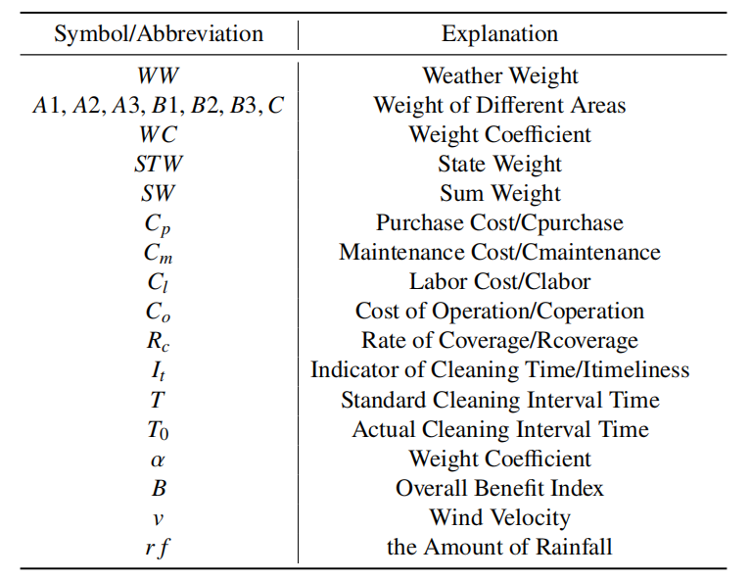

Assumptions
In order to establish our model, we first made some assumptions based on the given problems, considering many factors that influence the performance of autonomous cleaning vehicles. Our assumptions and the reasons behind them are as follows:

Regional Division Assumptions
Regarding the assumptions for regional division, we consider various practical factors, mainly including topography and pedestrian flow. Topography primarily affects the wear and energy consumption of the cleaning vehicle, and generally speaking, the more complex the terrain, the greater the cleaning difficulty for the vehicle and thus the greater the cleaning demand.
As for pedestrian flow, we believed that the higher the pedestrian flow, the greater the cleaning difficulty for the vehicle. The application scenario for the cleaning vehicle is a school, so when pedestrian flow exceeds a critical value, we need to avoid the corresponding areas to prevent student congestion and safety accidents.

Task Assignment Model Assumptions
Regarding the impact of weather, we introduce a time parameter in the decision function to obtain real-time data from weather websites. We believed that when it is windy and rainy, the difficulty in cleaning increases and so does the demand for cleaning. At the same time, when the weather deteriorates to some extent, we consider stopping the vehicle to work to avoid excessive wear and tear.
The assumptions about the vehicle’s status are also factors that determine whether the vehicle can continue working, generally involving battery life and daily wear and tear, which we can integrate into subsequent decision functions.

Algorithm Assumptions
Rasterization is a common method in robot route planning, which formats the specific scene, while genetic algorithms are responsible for iteratively generating the best path.
Genetic algorithms simulate the exchange of genes on chromosomes during biological inheri- tance, gradually iterating until the population that best fits the laws of survival is selected, which is the optimal solution.
This mainly includes five processes: generating initial values, selecting parents, generating offspring, gene mutation, and repeated iteration. The advantage of this method is that through iteration and random mutation, it can continuously select the gene composition that best adapts to the natural environment, which means that through biological fitting, the most eligible solution can be selected.

Campus Area Division Model

Problem Analysis
The key factors that influence the path planning for autonomous cleaning vehicles are twofold: the division of regional levels and the selection of vehicle paths, essentially graph traversal.
We assume that each vehicle has been assigned to its own area using common methods such as clustering algorithms. The primary focus here is on the traversal of each gridded area to seek the optimal path.

This paper considers dynamic environments using decision functions that include time param- eters to generate initial traversal paths in real-time, while employing a simple genetic algorithm to solve for the best traversal paths.

Hierarchical Analysis Method Modeling
We categorize campus areas based on terrain (which contributes to the amount of leaves / stiffness of slopes) and pedestrian flow (which contributes to the amount of white trash) into five categories:

- A: The most complex terrain with high pedestrian flow.
- B: The most complex terrain with low pedestrian flow.
- C: Average terrain with high pedestrian flow.
- D: Average terrain with low pedestrian flow.
- E: Minimal environmental and human impact, essentially a constant speed cruising area.

Solution Approach: Analytic Hierarchy Process

- Objective Layer: Campus automatic cleaning vehicle area division.
- Criteria Layer: Primarily considering unchanging terrain (slope and vegetation), pedestrian flow is managed with a Dirac function, where it equals 1 during class change and meal times and 0 otherwise. Weather conditions, which can vary by season and wind speed, are considered in subsequent area allocations.

Alternatives Layer:

- A1: High slope, much vegetation, frequent presence of students near teaching buildings, canteens, and dormitories.
- A2: Low slope, much vegetation, frequent presence of students near teaching buildings, canteens, and dormitories.
- A3: Low slope, little vegetation, frequent presence of students near teaching buildings, canteens, and dormitories.
- B1: High slope, much vegetation, relatively infrequent student presence near surveillance rooms and landscape lakes.
- B2: Low slope, much vegetation, relatively infrequent student presence near surveillance rooms and landscape lakes.
- B3: Low slope, little vegetation, relatively infrequent student presence near surveillance rooms and landscape lakes.

- C: Inaccessible areas such as rubber sports fields and inside teaching buildings that must be avoided.

Judgment Matrix Construction:
Assume vegetation is slightly more important than terrain and pedestrian flow is even more critical.
Comparisons Across Categories:

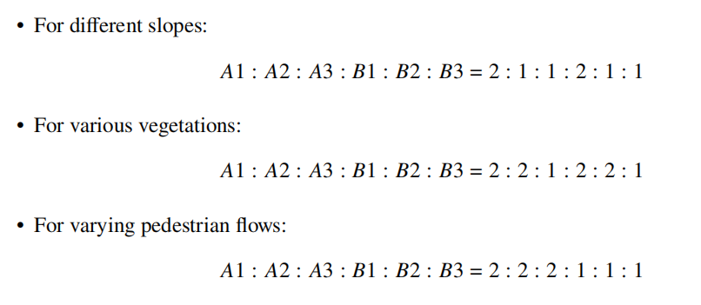
Weight Calculation and Consistency Check:

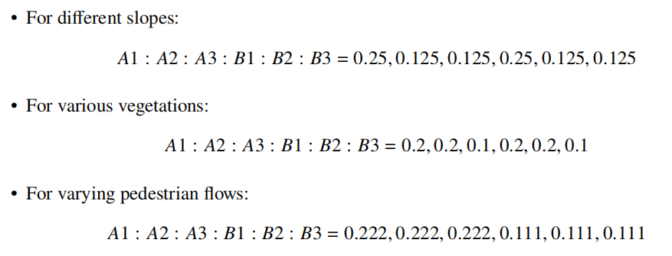
Introduction of Dirac Function:
Assume
𝑓 (𝑡) = 𝑀 · 𝛿(𝑡)

Here 𝑀 represents discrete time periods such as class change and meal times.
Sum Weight (SW) for Each Area:

𝐴1 : 0.25 × 1 + 0.2 × 3 + 0.222 × 5 × 𝑓 (𝑡) = 0.85 + 0.222 × 5 × 𝑓 (𝑡)

𝐴2 : 0.125 × 1 + 0.2 × 3 + 0.222 × 5 × 𝑓 (𝑡) = 0.725 + 0.222 × 5 × 𝑓 (𝑡)

𝐴3 : 0.125 × 1 + 0.1 × 3 + 0.222 × 5 × 𝑓 (𝑡) = 0.425 + 0.222 × 5 × 𝑓 (𝑡)

𝐵1 : 0.25 × 1 + 0.2 × 3 + 0.111 × 5 × 𝑓 (𝑡) = 0.825 + 0.111 × 5 × 𝑓 (𝑡)

𝐵2 : 0.125 × 1 + 0.2 × 3 + 0.111 × 5 × 𝑓 (𝑡) = 0.725 + 0.111 × 5 × 𝑓 (𝑡)

𝐵3 : 0.125 × 1 + 0.1 × 3 + 0.111 × 5 × 𝑓 (𝑡) = 0.425 + 0.111 × 5 × 𝑓 (𝑡)

Conclusion:
The ranking, from highest to lowest priority, is approximately from A1 to B3 This order suggests that Area A1, with its high slope, abundant vegetation, and frequent presence of students, has the highest cleaning demand. In contrast, Area B3, characterized by its low slope, sparse vegetation, and the infrequent presence of students, has the lowest cleaning demand.

Cleaning Vehicle Task Allocation and Path Planning Model

Task Allocation Model
In this section, we construct a model to allocate tasks to cleaning vehicles, considering various factors that influence the assignment process. We introduce a quantification model to assess the impact of weather on vegetation weight, denoted as 𝑊𝑊 = (𝑣 + 𝑟 𝑓 ) × vegetation weight, where 𝑣 signifies wind velocity and 𝑟 𝑓 represents rainfall.
In addition, we incorporate a state variable, STW (State Weight), to evaluate the operational status of the cleaning vehicles, including aspects such as battery level, wear and tear, and fault diagnosis.
We take into account the division of different areas and the fluctuations in pedestrian flow over various time periods, the most critical aspect being the introduction of weather variables. The influence of weather on our decision making is primarily through its effects on vegetation, such as fallen leaves, and on the cleaning vehicles themselves during adverse weather conditions. The Weather Weight (WW) is thus formulated as:

𝑊𝑊 = (𝑣 + 𝑟 𝑓 ) × vegetation weight
Furthermore, before making decisions, we assess the state of cleaning vehicles using the State Weight (SW), a composite variable that represents the operational status. This variable will be

elaborated upon in subsequent algorithmic considerations. Clearly, STW starts as a normal value and decreases gradually during the task execution phase. When STW drops to a critical threshold, the vehicle must stop operations for maintenance or recharging.
We construct the decision function G, which integrates the regional impact, the weather impact, and the current state of the cleaning vehicle to determine the priority of the cleaning areas.
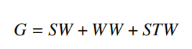

It should be noted that the state of vehicles and extreme weather conditions directly affect operations. Therefore, we introduce a special array Q={q1,q2,q3...}, where each element qn represents a threshold value. For example, if the vehicle battery level is too low, G is directly assigned an iterative critical value. This decision function will be applied as a fundamental component in subsequent algorithms.

Path Planning Model
We begin by gridding the locations to be traversed, treating each area as a point. In this step, we address the issue of "unreachable" areas by treating them as obstacle regions, such as the interiors of teaching buildings and sports facilities. We enclose these areas with complete grids, which, although causing repetition in the traversal area, at least resolve the obstacle issue. The next consideration is to ensure that all grids are traversed, achieving full area coverage.
Next, we utilize algorithms to achieve optimal route planning. Drawing from multi-robot strategies, we divide the grids, assuming that there are K cleaning vehicles and M grids. The preliminary idea is to use dynamic assessment to select the nearest (M/K)+4 grids, with the +4 being for edge handling to avoid edge effects. It is important to note that the divided areas are a complete set, summing up to the entire grid cleaning area.
𝐾
( )
For each cleaning vehicle, the genetic algorithm encodes each global path, iterating continuously to achieve the final optimal solution. The dynamic priority scheduling algorithm generates these iterative paths, that is, "initial values." You can refer to the Multiple Traveling Salesman Problem (MTSP) to understand this algorithm; however, we will tailor it specifically to our problem.
Genetic Algorithm Steps:
- We start with an initial path set X={x1,x2,...xn}, which includes all the grids that the vehicle needs to visit in its area. For ease of iteration, we binary encode it, such as 000001, 000002, etc.
- We use the previously constructed decision function G= SW+WW+STW. Clearly, our decision function is positively correlated with the decision content, which means that the larger the value of the decision function, the greater resistance and the cleaning demand, and the more likely it is to be selected in the genetic algorithm.
However, our decision is based on a greedy algorithm, which chooses the next optimal grid from the current grid. To simplify, we sum the G values between each pair of points on a path as the value of the decision function for the entire path. SW remains constant, WW can be obtained from weather websites without scruples, and STW involves vehicle performance parameters, which are

typically predicted before the vehicle is put into use, such as battery usage curves and wear tests.
- We allow the parent classes to exchange genes, that is, genes that encode recombination. Common methods include single-point crossover, multi-point crossover, and uniform crossover. This step can be self-determined and is not critical; any selection will suffice, as it will produce offspring.
Here, we choose a uniform crossover, which for two parent individuals at each gene position decides whether to exchange genes with a certain probability (usually 0.5).
For example, if parent A = [1, 2, 3, 4, 5] and parent B = [6, 7, 8, 9, 10], and the randomly generated exchange mask is [0, 1, 0, 1, 0] (0 means no exchange, 1 means exchange), then the offspring individuals C and D are [1, 7, 3, 9, 5] and [6, 2, 8, 4, 10], respectively.
- We consider gene mutation and variation. As mentioned, this is not critical as gene exchange is inherently random. We can write a time function to randomize or set a method to change the encoding of the offspring, ultimately obtaining more offspring. Here, we consider a single-gene mutation, where a binary bit changes from 0 to 1. This step is not as inevitable as the previous one, so we introduce the versatile Dirac function or use a constant, such as 0.0005, as the probability of gene mutation.
- Iteration.
- Stop iterating when a threshold is reached and select the best solution, which is the path we desire. This threshold M depends not only on iteration (that is, when the value G reaches the upper critical value MAX, we consider the demand large enough to execute immediately) but also on other factors, such as when STW reaches the lowest critical value, it will also trigger the threshold.
Another scenario is to stop after a limited number of iterations N; the vehicle should not stop working when the demand is small. We can design a constant speed cruising mode, depending primarily on the software designer’s discretion. This is merely a hypothesis.

Integration Model of Two Algorithms
Regarding dynamic priority scheduling, since we know the decision function 𝐺, a simple idea is to use breadth-first search to generate those initial values. It is important to simulate the vehicle’s status and the changing weather factors over time.
However, to ensure universality, we cannot use breadth-first search for every selection, as this would result in only one initial value and no need for iteration. Thus, the consideration of the decision function is random and the generation of initial values is random, meaning that several initial values are generated randomly, and then the decision function is randomly considered among these initial values. This approach ensures that our algorithm remains adaptable and responsive to the dynamic conditions of the campus environment.

Operational Efficiency Evaluation Model
To evaluate the operational efficiency of campus cleaning vehicles, we have constructed an operational efficiency evaluation model. To assess the costs associated with vehicle cleaning, we assume the purchase cost Cp (Cpurchase), maintenance cost Cm(Cmaintenance), labor cost Cl

(Clabor) and operational cost Co (Coperation). The operational cost is the sum of the first three costs:

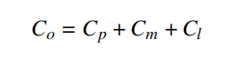
To evaluate the cleaning efficiency of the cleaning vehicles, we have established two indicators: cleaning coverage rate Rc (Rcoverage) and cleaning timeliness It(Itimeliness). The cleaning coverage rate refers to the proportion of the actual cleaned area to the total campus area. Assuming that the campus is divided into N areas and the number of areas actually cleaned per cleaning task is 𝑛, then the cleaning coverage rate is:
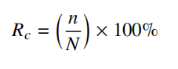
Cleaning timeliness reflects whether the cleaning task can be completed within the desired time frame. Let T be the standard cleaning interval time and 𝑇₀ be the actual cleaning interval time, then the cleaning timeliness is:
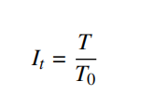

For convenience, we use an overall benefit index B to comprehensively evaluate the benefits of autonomous cleaning vehicles in campus management. The calculation formula is the following.

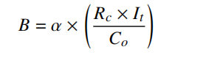
where Alpha is the weight coefficient, and the higher the value of B the better the operational efficiency of autonomous cleaning vehicles. This model provides a quantitative framework to assess the cost-effectiveness and efficiency of autonomous cleaning vehicles, taking into account both the financial and operational aspects of their deployment on campuses.

Sensitivity Analysis

Overview

Purpose and Significance
The purpose of the sensitivity analysis is to evaluate the sensitivity of the model output to changes in input parameters, determining which factors significantly impact the results of the cleaning vehicle scheduling and route optimization model and which have a lesser effect. This helps to focus on key factors in practical applications, enhancing the model’s accuracy and reliability, and providing more valuable information for decision-making. By analyzing the sensitivity of various factors, potential shortcomings within the model can be discovered, providing a basis for adjusting the model structure or parameters to improve its performance.

Basis for Analysis Method Selection
The univariate method is relatively simple and intuitive, clearly demonstrating the impact of each factor when it changes independently on the model results, facilitating analysis and understanding. In this model, which involves multiple factors that influence the analysis (such as regional division factors, task assignment, and route planning factors), the univariate method allows the study of these factors one by one, avoiding interference when multiple factors change simultaneously, thus accurately assessing the sensitivity of each factor.

Identification of Analysis Factors

Regional Division Factors
Areas with steep slopes may require cleaning vehicles to consume more energy, densely vege- tated areas tend to accumulate garbage like leaves, and areas with high pedestrian traffic can affect the passage of cleaning vehicles and require more frequent cleaning services. In modeling, impact factors are mainly reflected by setting weights to reflect their relative importance, with weights for slope, vegetation, and pedestrian traffic set at 1, 3, and 5, respectively.

Task Allocation and Route Planning Factors
High wind conditions can cause significant leaf fall, increasing the cleaning workload; after rainfall, roads can be waterlogged or muddy, requiring cleaning vehicles to adjust their working modes or paths; cleaning vehicles with low battery levels must prioritize heading to charging areas or be assigned shorter cleaning paths.

Univariate Method Analysis

Regional Division Variation Model
      - To explore the impact of the slope weight on the overall weight of each area, the slope weight is increased or decreased within a certain range at a fixed step size while keeping the weights of the vegetation and the traffic of pedestrians constant.

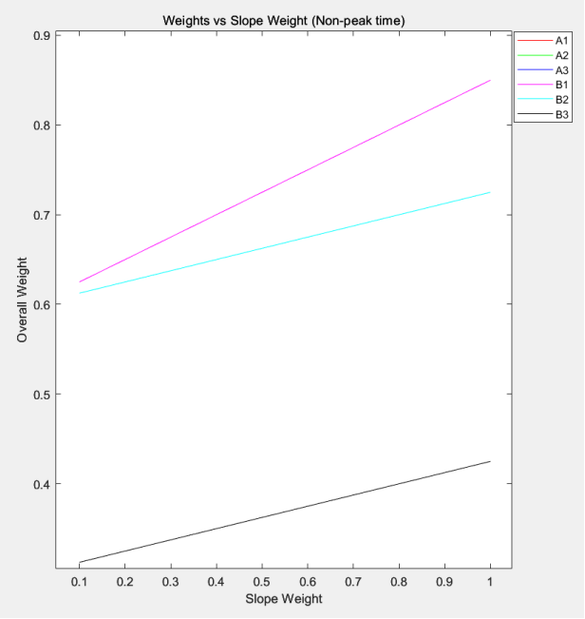

Figure 2: Effect of slope weights on the overall weights of each region during off-peak periods

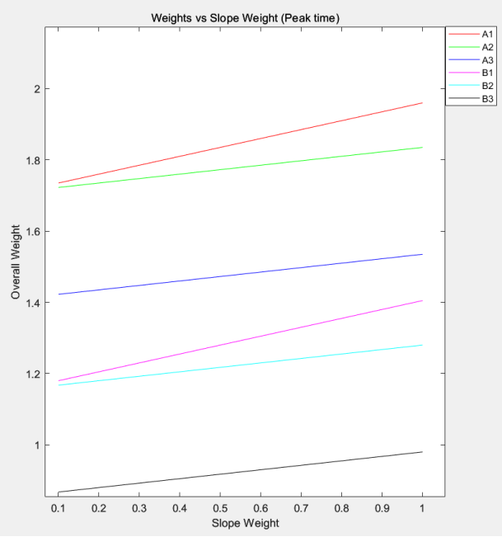

Figure 3: Effect of slope weights on the overall weights of each region during peak periods

According to Figures 2 and 3, as the slope weight increases, the overall weight of each area also increases, but the increase is more significant in areas with higher slopes (A1,B1).
      - To explore the impact of the weight of the vegetation on the overall weight of each area, the weight of the vegetation is increased or decreased within a certain range at a fixed step size while keeping the slope and the weights of the pedestrian traffic constant.

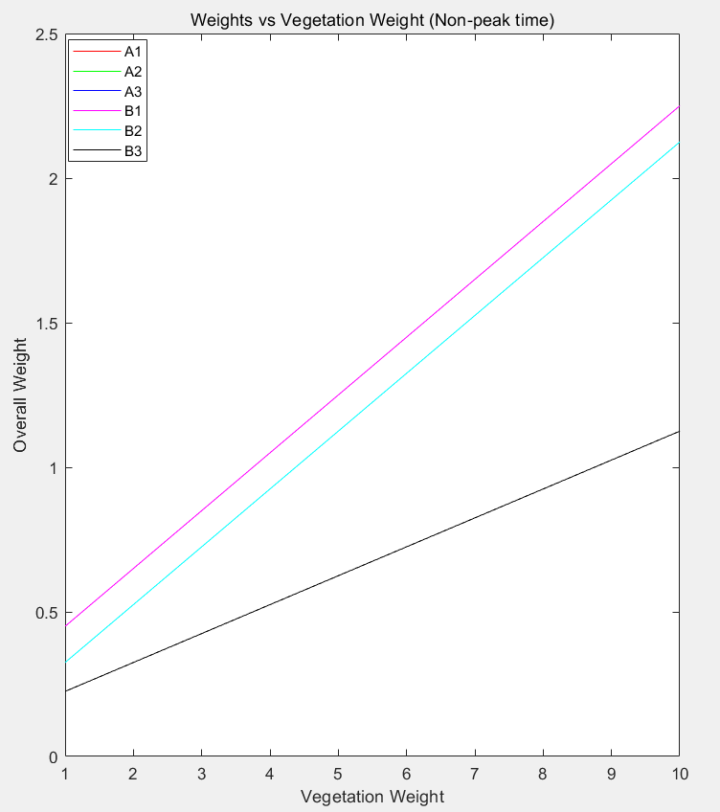

Figure 4: Effect of vegetation weights on the overall weights of each region during off-peak periods

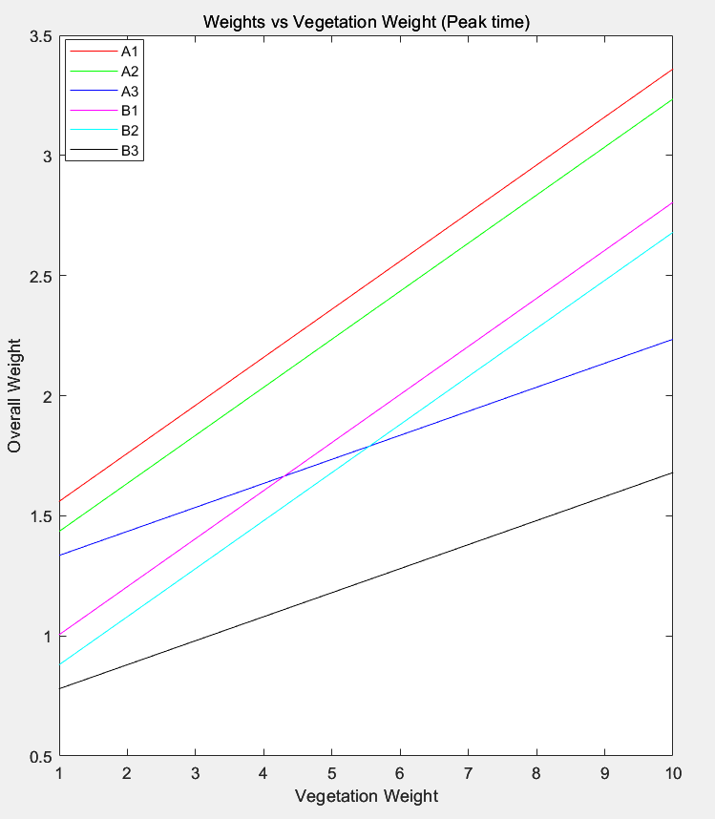

Figure 5: Effect of vegetation weights on the overall weights of each region during peak periods

According to Figures 4 and 5, as the weight of the vegetation increases, the overall weight of each area also increases, but the increase is more significant in areas with more vegetation ( A1,A2,B1,B2 ).
      - To explore the impact of pedestrian traffic weight on the overall weight of each area, the pedestrian traffic weight is increased or decreased within a certain range at a fixed step size while keeping the slope and vegetation weights constant.

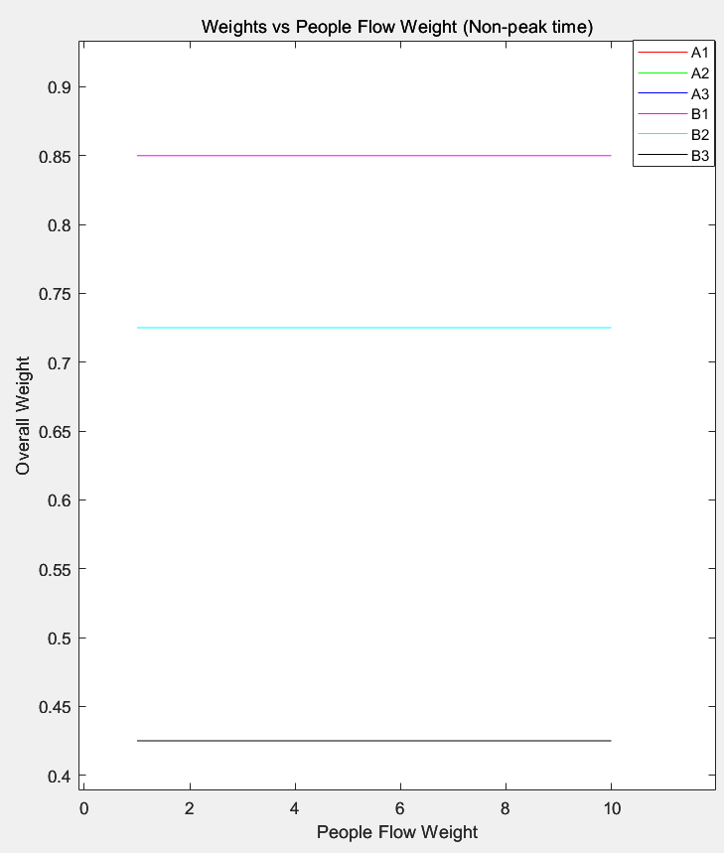

Figure 6: Effect of pedestrian traffic weights on the overall weights of each region during off-peak periods

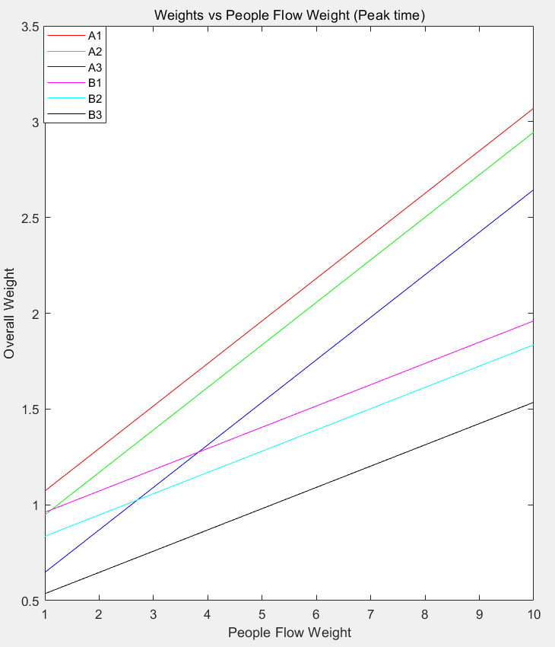

Figure 7: Effect of pedestrian traffic weights on the overall weights of each region during peak periods

According to Figures 6 and 7, during non-peak hours, the overall weight of areas with less pedestrian traffic (B1,B2,B3 ) does not change with increasing pedestrian traffic weight.
According to Figure 7, during peak hours, as the weight of pedestrian traffic increases, the

overall weight of each area also increases, but the increase is more significant in areas with more pedestrian traffic ( A1,A2,A3 ).

Task allocation and Route Planning Model
      - In the task allocation model, the wind speed v has a significant impact on the decision function G Figure 7 shows the variation of the values of the decision function G for each area with changes in wind speed.
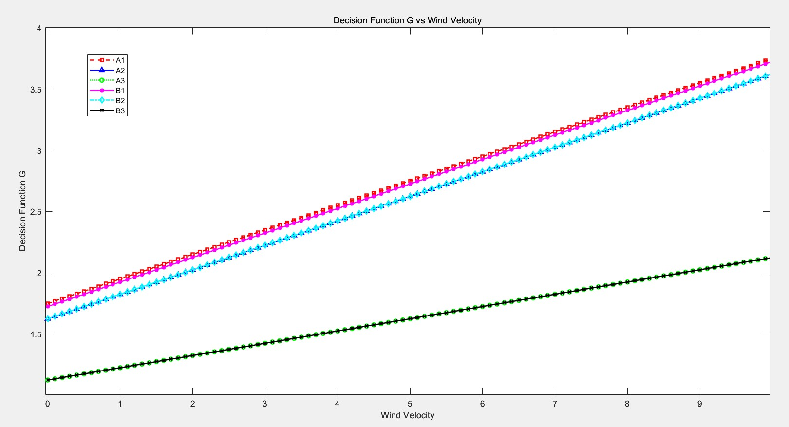

Figure 8: Effect of wind speed on the decision function

Figure 8 shows that as the wind speed increases, the values of the decision function G increase for all areas. The steeper increase in G values for B1 and A1 indicates that the wind speed significantly affects these areas. This means that when the wind speed increases, the areas A1 and
B1 should be prioritized in the allocation of cleaning tasks.
      - In the task allocation model, rainfall rf has a significant impact on the decision function G Figure 8 shows the variation of the values of the decision function G for each area with changes in rainfall.
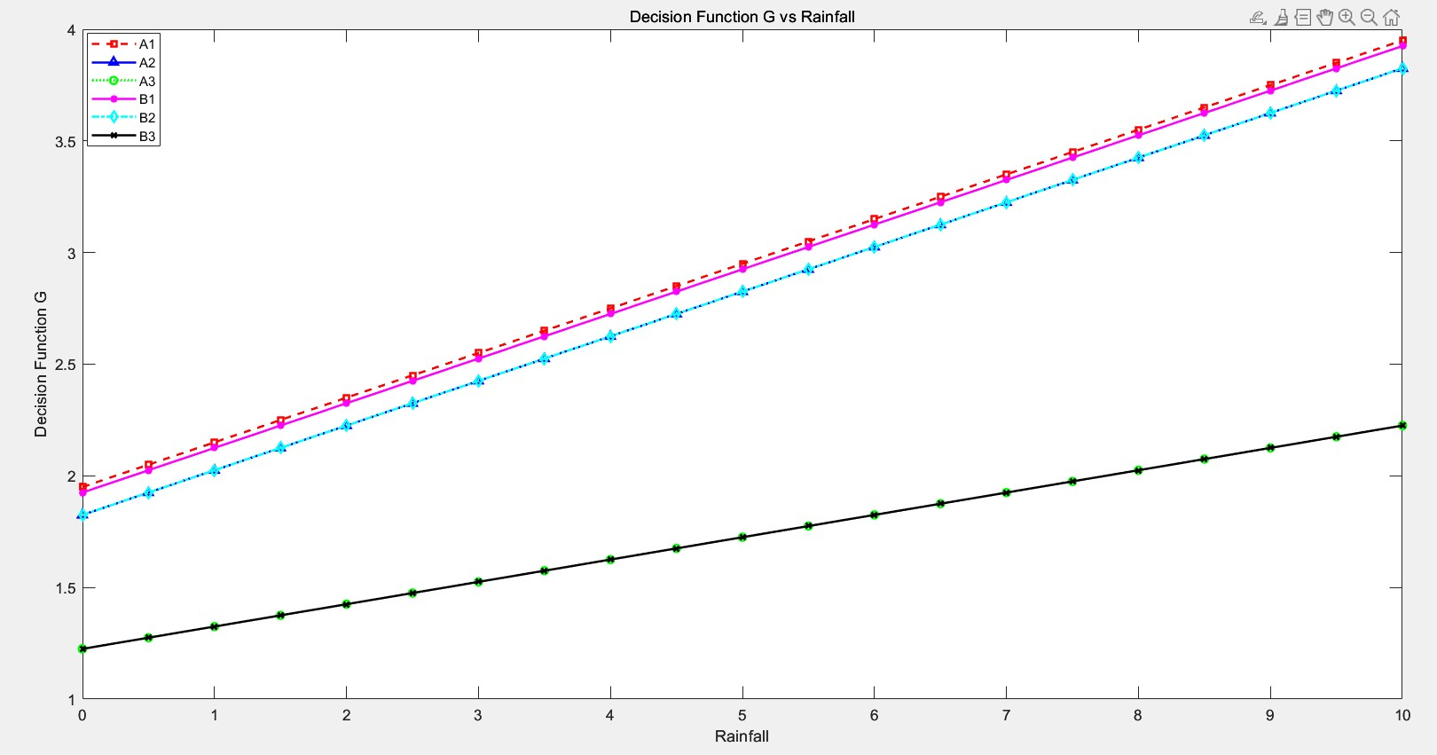

Figure 9: Effect of rainfall on the decision function

Figure 9 shows that as rainfall increases, the values of the decision function 𝐺 increase for all areas ( 𝐴1 − 𝐵3). The steeper increase in 𝐺 values for 𝐴1 and 𝐵1 indicates that rainfall significantly affects these areas. This means that when rainfall increases, areas 𝐴1 and 𝐵1 should be prioritized in the allocation of cleaning tasks.
      - In the task allocation model, the state of the cleaning vehicle STW has a significant impact on the decision function G Figure 10 shows the variation of the values of the decision function G for each area with changes in the state of the cleaning vehicle.

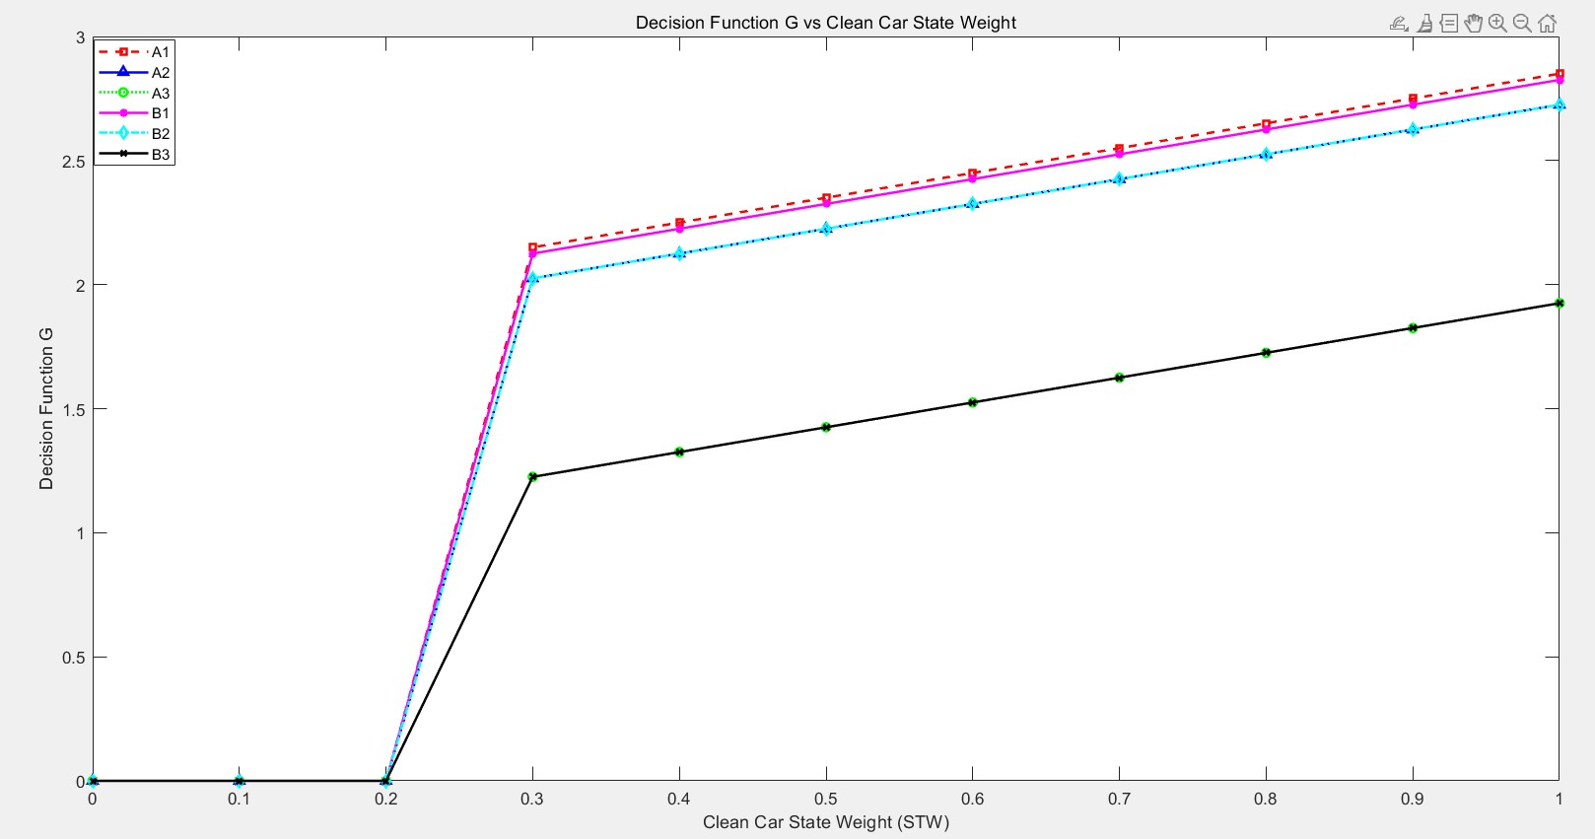

Figure 10: Effect of the state of the cleaning vehicle on the decision function

As the state weight 𝑆𝑇𝑊 increases, the values of the decision function 𝐺 for all areas ( 𝐴1 − 𝐵3) tend mostly upward. When 𝑆𝑇𝑊 is less than or equal to 0.2, the values of 𝐺 for all areas drop to 0, indicating that when the battery level is too low, no area is prioritized for cleaning.

Conclusion
Identifying which factors have a high sensitivity to the model’s results and which are relatively insensitive allows for more focused data monitoring and updating for sensitive factors, ensuring the accuracy of model inputs. For less sensitive factors, the data acquisition process can be simplified, or more conservative parameter settings can be adopted to reduce model complexity and data collection costs. Furthermore, summarizing the implications of sensitivity analysis for model improvement and optimization provides direction for further refinement of subsequent models.

Strengths and weaknesses

Strengths
- Enhanced Efficiency: The integration of hierarchical analysis and genetic algorithms allows a more efficient allocation of cleaning tasks, reducing overall energy consumption and the time required for campus cleaning operations.
- Adaptability: The model’s dynamic decision function responds in real-time to changes in weather and ACV status, making it adaptable to various environmental conditions.
- Safety and Congestion Mitigation: By considering pedestrian flow, the model helps avoid congested areas, improving safety and traffic flow within the campus.
- Data-Driven Decisions: Utilizing real-time data from weather websites and ACV status parameters enables data-driven, informed decisions that enhance the model’s accuracy and reliability.

Weakness
- Complexity: The hybrid model’s complexity may require significant computational re- sources, potentially slowing down the decision-making process in real-time scenarios.

- Data Dependency: The model’s performance is heavily dependent on the accuracy and timeliness of the input data, which may be subject to errors or delays.
- Initial Setup and Calibration: The model requires a thorough initial setup and calibration phase to ensure that the decision thresholds and are set appropriately for the specific campus environment.
- Limited Historical Data: For new campuses or those with limited historical data, the model may not perform optimally until sufficient data have been collected to fine-tune the parameters.
- Resistance to Change: There may be resistance from staff and stakeholders to adopt new technologies and methods, which could slow the implementation of the model.

Future Work
Future research could focus on several areas to build on this study.

- Algorithm Optimization: Further refine the genetic algorithm to handle larger datasets and reduce computational time.
- Machine Learning Integration: Incorporate machine learning techniques to predict and adapt to long-term trends in pedestrian flow and weather patterns.
- Scalability Testing: Test the scalability of the model in different campus sizes and layouts to ensure its applicability in various environments.
- User Interface Development: Develop a user-friendly interface for campus managers to interact with the model, making it more accessible and easier to implement.
- Cost-Benefit Analysis: Conduct a comprehensive cost-benefit analysis to quantify the eco- nomic impact of implementing the model versus traditional cleaning methods.

Conclusion
In conclusion, this paper presents a sophisticated model for autonomous cleaning of campus environments that takes advantage of the strengths of hierarchical analysis and genetic algorithms to optimize ACV task allocation and routing. The model demonstrates significant advantages in terms of efficiency, adaptability, and safety, offering a valuable tool for campus environmental management.
However, challenges remain in terms of complexity, data dependency, and initial setup. Fu- ture work will focus on algorithm optimization, machine learning integration, scalability testing, user interface development, and cost-benefit analysis to further enhance the model’s performance and applicability. This research contributes to the field of autonomous robotics and provides a foundation for the development of more advanced and intelligent cleaning systems.

References
- Z. Luo, S. Feng, X. Liu, J. Chen, and R. Wang, 2020, "Method of area coverage path planning of multi-unmanned cleaning vehicles based on step by step genetic algorithm," Journal of Electronic Measurement and Instrumentation, vol. 34, no. 8, pp. 43-50, doi: 10.13382/j.jemi.B2002917.
- M. Honglin and Y. Lei, 2008, "Simulation and implementation based on dynamic priority scheduling algorithms," Science and Technology Information, no. 25, pp. 4 - 6.
- Y. Guo, 2023,"Research on Path Planning Algorithm of Mobile Robot in Dynamic Environ- ment," Master’s Thesis, North China Electric Power University.
- Y. Zhang, M. L. Zhang, Z. H. Jiang, et al., 2020, "Research on Path Planning of Mobile Robot in Dynamic Environment," Journal of Hefei University of Technology (Natural Science Edition), vol. 43, no. 10, pp. 1297 - 1306.

Report on Use of AI

- Doubao
Query1: What is the purpose and significance of the sensitivity analysis
Output: The purpose of the sensitivity analysis is to evaluate the sensitivity of the model output to changes in input parameters, determining which factors significantly impact the results of the cleaning vehicle scheduling and route optimization model and which have a lesser effect. This helps to focus on key factors in practical applications, improves the accuracy and reliability of the model, and provides more valuable information for decision making. By analyzing the sensitivity of various factors, potential shortcomings within the model can be discovered, providing a basis for adjusting the model structure or parameters to improve its performance.
- Doubao
Query2: What is the basis of the selection of the single-factor change method
Output: The univariate method is relatively simple and intuitive, clearly demonstrating the impact of each factor when it changes independently on the model results, facilitating analysis and understanding. In this model, which involves multiple factors that influence the analysis (such as regional division factors, task assignment, and route planning factors), the univariate method allows the study of these factors one by one, avoiding interference when multiple factors change simultaneously, thus accurately assessing the sensitivity of each factor.

