Ground Truth System
User Guide

Release 0.1.1

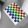

Introduction

This document is intended to guide its reader through the use of the Ground Truth System when executing the IEC robot tests as defined in [1]. This should be used as the primary document to enable the setting up of the GTS system, the execution of the IEC tests and analysis of the results. The IEC tests covered by this document are:
- Autonomous coverage / navigation test;
- Average robot speed test;
- Dust removal – straight line cleaning.

It is anticipated that the execution of these tests will provide a sufficient introduction to the system so as to enable the user to carry out other tests not covered here. The software package provided is still in development - it is released here to enable initial testing of both the application and the IEC tests.

References
- CDV on IEC 60312 – 3 Ed. 1

Setting up the GTS

Installation

The GTS is provided for convenience in the form of an executable (GTS-0.0.1a-win32.exe) which should be run to install the software. This is presented in the form of a step-by-step wizard - in most cases the default settings will be appropriate.

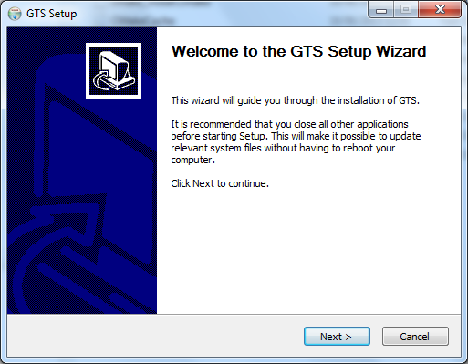 | 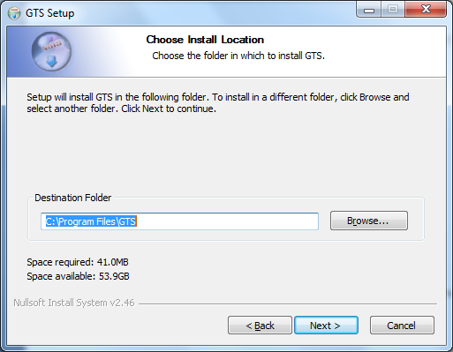 | 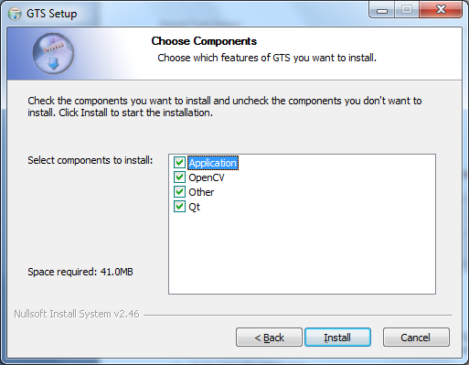

Installers for two additional components are required to use the GTS on Windows. The successful operation of the GTS is dependent upon them so they should be run prior to using it:

- Xvid-1.3.2-20110601.exe
The latest version of the Xvid codec for Windows including GUI frontends (Video for Windows (VfW) and DirectShow filters) packaged as a Windows installer.
- vcredist_x86_2010.exe
The Microsoft Visual C++ 2010 Redistributable Package installs runtime components of Visual C++ Libraries required to run applications developed with Visual C++ on a computer that does not have Visual C++ 2010 installed.

Migration

Users of previous GTS releases (who wish to use their existing workbenches) need to perform a number of steps to “migrate” that data and use it with the latest software:

- Define a target – the latest release allows for “non-standard” targets and therefore requires an additional step (see Defining a Target);
- Recalibrate (cameras and positions) – due to changes in the underlying schema, it is necessary to recalibrate. This is straight-forward and requires no “new” calibration image capture. (See Configuring a Camera and Configuring a Position.)
- Define a room floor plan / mask – this release needs a floor plan / mask to be defined prior to tracking. (This requires additional calibration image capture for multi-camera layouts.) See Create a Floor Plan and Create a Floor Mask.

 Please ensure all changes are saved. It is recommended that whenever possible, changes to a workbench are saved as you proceed. This protects against loss of work in the event of a problem.

Using the GTS

Creating a Workbench

- Open up the GTS by clicking the icon in the Start Menu;
- From Workbench drop down menu, select New Workbench...;
- Create a new folder called ‘MyWorkspace’ and call the file ‘MyWorkbench.xml’.

Defining a Target

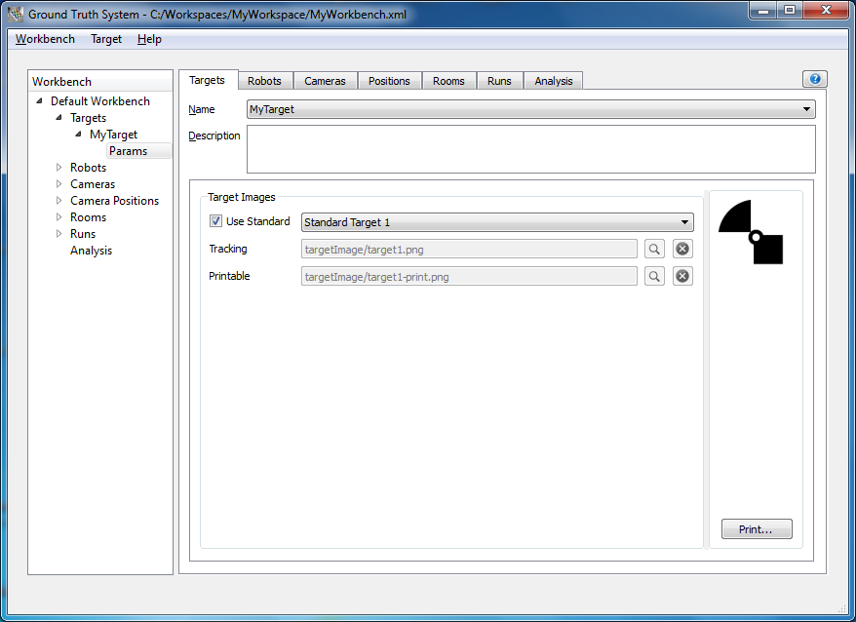

- Go to the Targets tab;
- In the Target drop down menu, select New...;
- Name the target ‘MyTarget’ and press Finish;
- In the Target tab select ‘MyTarget’ from the Name drop-down list. Add a description of your target in the Description field below;
- To create a target based upon a pre-defined one, check the Use Standard box and select the target type from the drop-down list;
- To create a new target, two images should be supplied – a (small) one (128x128 pixels) for the GTS to use when tracking and a (large) hi-resolution one for attaching to the robot;
- The target can be printed by clicking the Print... button.

Configuring a Robot

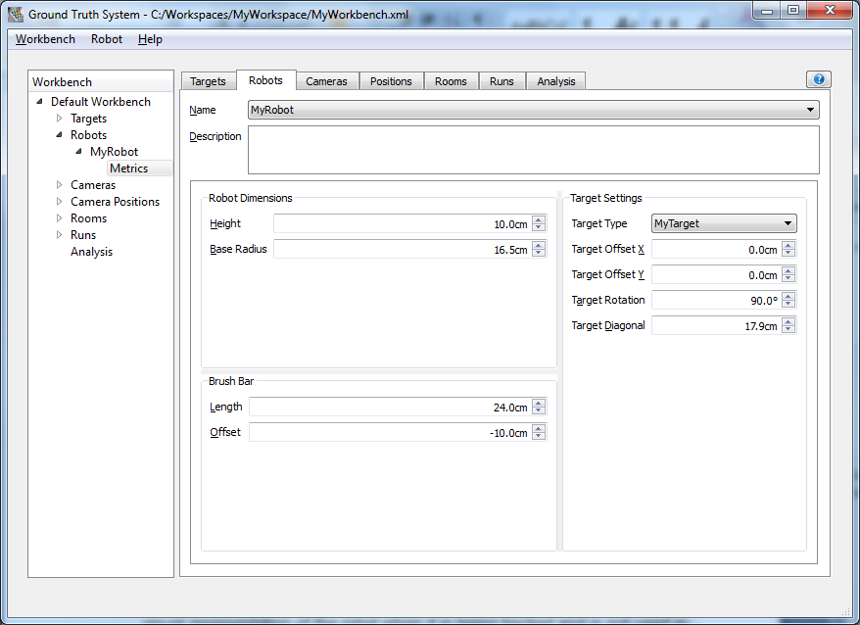 | 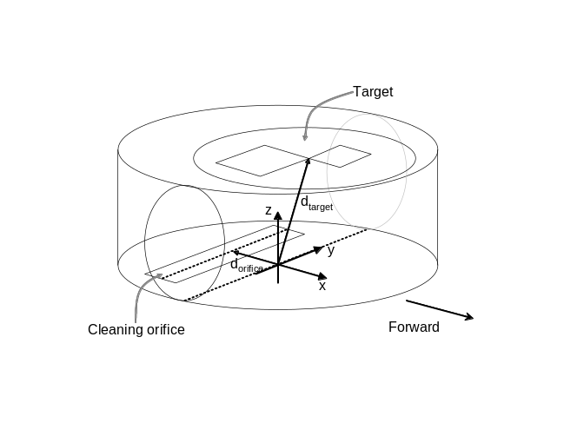

- Go to the Robots tab;
- In the Robot drop down menu, select New...;
- Name the robot ‘MyRobot’ and press Finish;
- In the Robots tab select ‘MyRobot’ from the Name drop-down list. Add a description of the robot in the Description field below;
- First add the Height of the robot, which is the distance from the floor to the surface of the target;
- Now define Base Radius to Robot Dimensions. This is purely used for the visual representation of the robot when it is being tracked and is not used in any analysis. It defines the radius of the circle used to represent the robot;
- Now add the Length of the brush bar and its Offset, which is the distance of the centre of the brush bar from the centre of the robot. (It is assumed that the brush bar is symmetric and centred along the centre line of the robot, so the offset is one dimensional and defines the distance from the brush bar centre point along the centre line of the machine);
- Next you will want to select the correct target type. You should select ‘MyTarget’ from the drop-down list. You will need to be able to attach the target parallel to the ground on top of your robot;
- Lastly, you need to set up the Target Geometry. Target Offset X is how far the centre of the target is from the centre of the robot on the x-axis, going left to right. Target Offset Y is how far the centre of the target is from the centre of the robot on the y-axis, going back to front on the robot. Target Rotation is the rotation of the target compared to the image shown in the GUI, with the robot looking forward and the target on top. Target Diagonal is the length of the target square from one corner to the other;
The target should be mounted on card or any other material that ensures it stays flat and rigid. It should mounted such that it is parallel to the floor plane and is constantly visible from above (i.e. it should not be obscured by any element of the machine). The centre circular section of the target may be removed to allow access to buttons etc. It is possible to verify the correct Target Rotation during tracking (see “Tracking the Robot”) – during this, the tracked target is outlined (in blue) with heading indicators.

Configuring a Camera

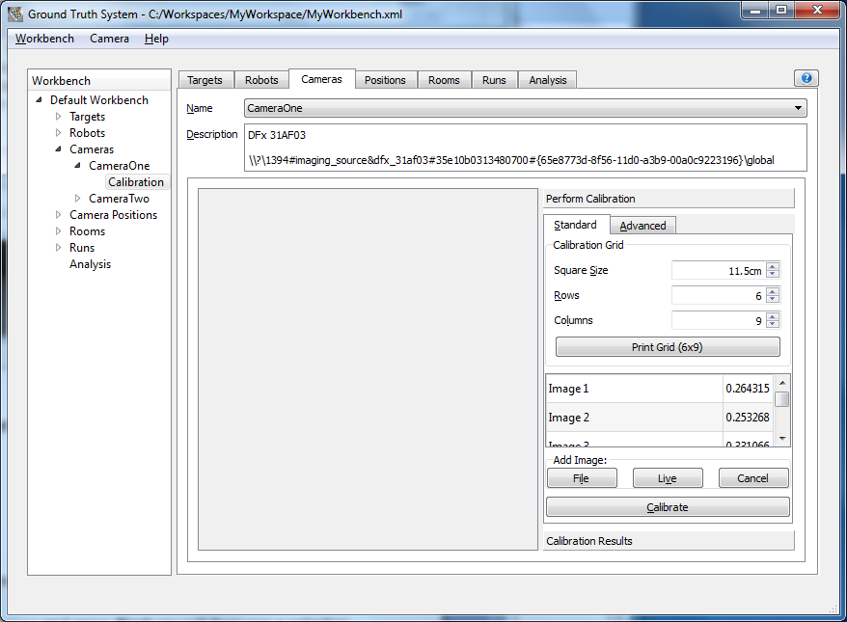

Add a Camera

- Go to the Cameras tab;
- In the Camera drop down menu, select New...;
- Name the camera ‘CameraOne’ and press Next you will then see a selection of all cameras you have connected. Select the one you want and press Finish;
- In the Cameras tab, you should now select the camera you have just created from the Name drop down menu to access the camera calibration.

Calibrate a Camera (Intrinsic)

- On the right hand side you should see a box labelled Calibration Grid. Enter the number of rows and columns into the appropriate boxes. (The numbers represent the lines that make up the grid and should be one less than the number of squares in the corresponding dimension.) Click the Print Grid button and print out the grid. The grid should ideally be mounted on card or similar rigid material to ensure it stays flat;
- Measure that actual size of one of the sides of one square on the gird. Enter the actual square size of your calibration grid into the Square Size box;
- You will now need to place your calibration grid into the room.
- Once your calibration grid is in place select the Live button in the bottom right corner then select Capture. Now move your calibration grid to a new location and repeat this process (at least) 24 times – more images can improve calibration accuracy;
- To calibrate your camera capture the following images:
  - Five images of the grid flat on the floor - one in the centre of the image, and one in each of the four corners, first 5 images;
  - Nine images of the grid approximately one metre off the floor – spaced in a 3x3 grid across the image, last 9 images;
  - Two images approximately two metres off the floor, taking up most of the image and at slightly different heights, middle line of images and last image on previous line;
  - Four images of the grid angled, sloping and spaced evenly around the camera and approximately two metres off the floor, first 4 images on second line. Do not angle these too greatly. The maximum slant from the floor plane should be 45°.
- When you have all your images click the Calibrate button in the bottom right corner. The GTS then start to calibrate - once finished you should get an average projection error of less than 0.7 if it is more than 0.7 check your images to see which ones have the highest average projection error and trying retaking those images one by one until average error falls below 0.7.
If an image needs to be removed and re-captured or an image is accidentally taken then it can be removed easily by right clicking on the appropriate image in the image drop down box and selecting Remove. New images can then be added using the method described above.

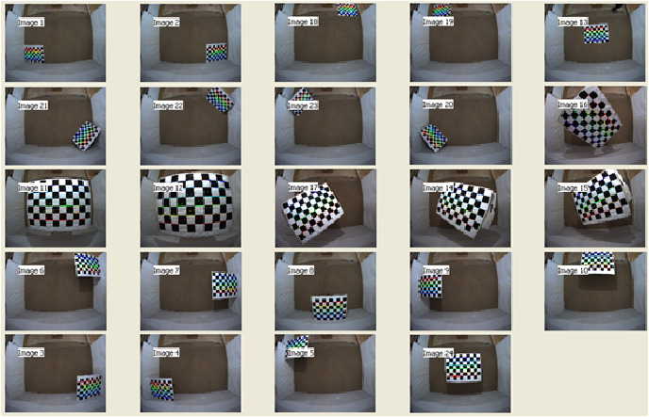

Configuring a Position

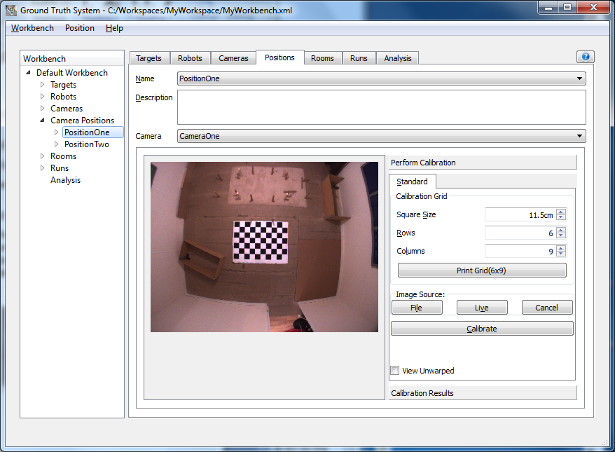

Add a Position

- Go to the Positions tab;
- In Position drop down menu, in top left corner of the application window, select New...;
- Name the position ‘PositionOne’ and press Finish;
- In the Positions tab, you should now select the position you have just created from the Name drop down menu to access the position calibration;
- Below in the Position tab is another drop down menu called Camera select ‘CameraOne’.

Calibrate a Position (Extrinsic)

- On the right hand side you should see a box labelled Calibration Grid. You will need to input the calibration grid size - enter the number of rows and columns into the appropriate boxes. (The numbers represent the lines that make up the grid and should be one less than the number of squares in the corresponding dimension.);
- Now you need to capture an image of the calibration grid on the floor. Click the Live button then Capture. Ensure you have an image from the fixed ceiling camera in the room, with the calibration grid as central and level to the floor plane as possible. Click the Calibrate button.

Creating a Room

- Go to the Rooms tab;
- In Room drop down menu, select New...;
- Name the room ‘MyRoom’ and press Finish.

Define the Layout

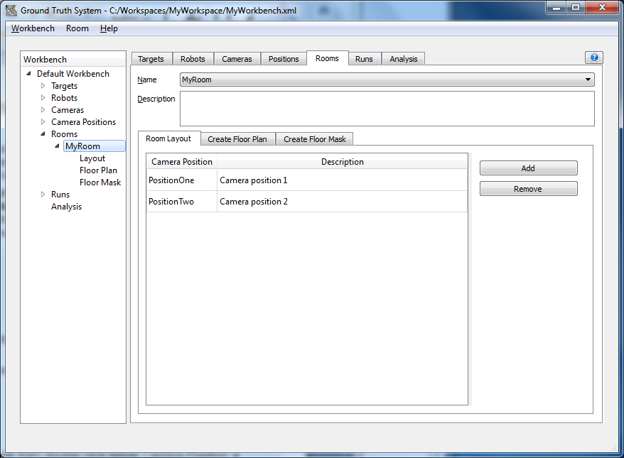

- Press Add on the right hand side then double click below Camera Position, a drop down list should appear. Select ‘PositionOne’.
- Repeat this process until you have all cameras in the room setup.

Create a Floor Plan

If the room has only a single camera, there is no need for further configuration – simply press the Create button and the floor plan is created with the image used during calibration of the camera position. (The resulting floor plan can be viewed by pressing the Show button.)
Where a room has more than one camera, it is necessary to calibrate each of them against another in order that the physical relationship between cameras can be determined and a composite floor plan produced. Relations (mappings) are specified between pairs of cameras – with one being the “base” and the other the “referent”. To aid (visual) configuration, each of these can be loaded into any segment of the display. As with previous calibration steps, a chessboard is used – in this case, an image for each camera is required in which they simultaneously observe the same grid. | 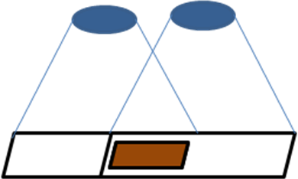
- On the right hand side you should see a box labelled Calibration Grid. You will need to input the calibration grid size - enter the number of rows and columns into the appropriate boxes. (The numbers represent the lines that make up the grid and should be one less than the number of squares in the corresponding dimension.)
- Select the “base” camera and segment then click the  button and locate the appropriate camera image;
- Select the “referent” camera and segment then click the button and locate the appropriate camera image;
- Now you need to capture an image of the calibration grid on the floor. Click the Live button then Capture. Ensure you have an image from each of the fixed ceiling cameras (“base” and “referent”), with the calibration grid as level to the floor plane as possible.
- Rotate the “referent” by pressing the  button until its alignment corresponds as closely as possible with the “base”;
- Match the pair together using the  button and view the result – a dialog pops-up and displays the correspondence between each image;
- Stitch the pair together using the  button and view the result – a dialog pops-up and displays the result of stitching the pair of images;
- Save this mapping pair by pressing the  button (or reset the form using the  button);
- Once all mapping pairs are complete press the Create button and the floor plan is created by combining all of the images used during image used during calibration for each camera position.

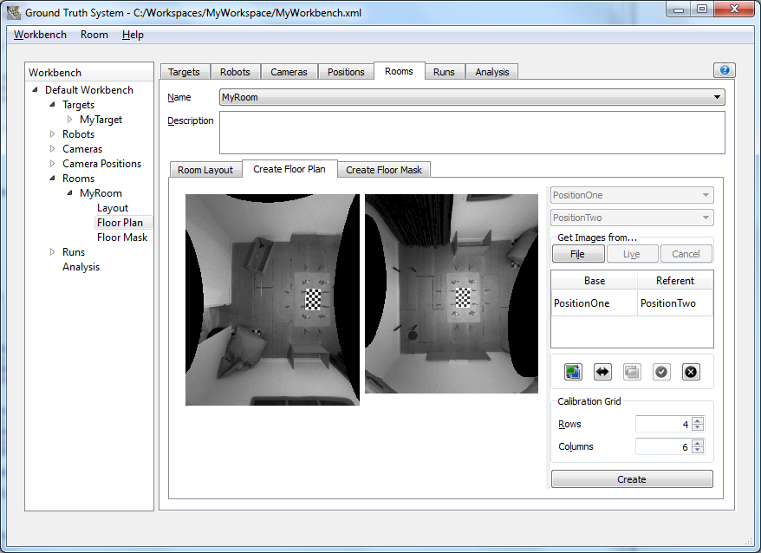

Create a Floor Mask

A floor mask is used to identify the region within which the robot is expected to travel. It needs to be a black and white image (identical in size to the floor plan). Ensure that the accessible floor space using white pixels and black pixels for all other locations.

- Click on the Export Plan button on the right-hand side of the “Room - Floor Mask” tab. Select the location where you wish to save your floor plan image;
- Open the file you just saved in the image editor of your choice;
At present, the easiest way to generate the floor mask is to use an (external) image editor such as Gimp or Photoshop;
- Click on the Import Mask button on the right-hand side of the “Room - Floor Mask” tab. Select the location from which to load your floor mask image.

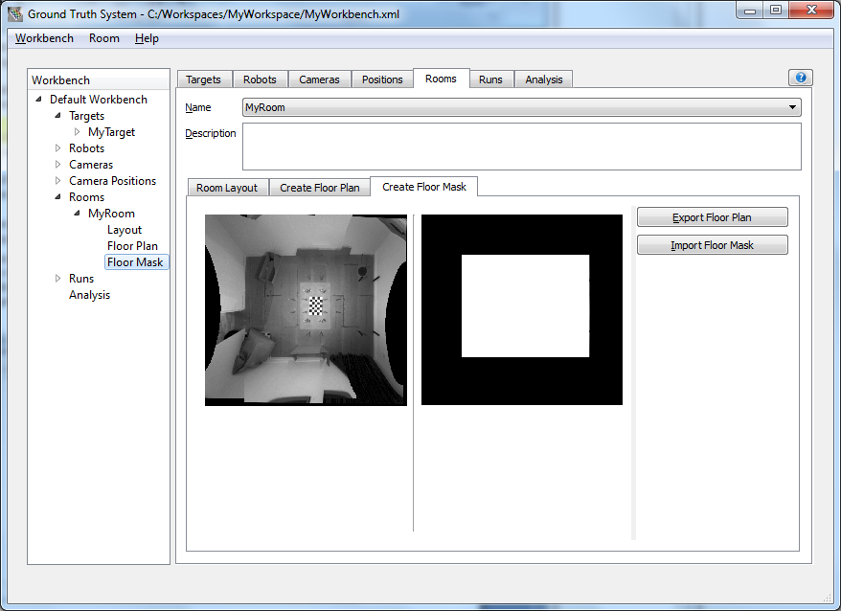

Recording a Run

Creating a Run

- Go to the Runs tab;
- In Run drop down menu, select New...;
- Name the run ‘TestRun’ and press Finish;
- Select ‘MyRoom’ from the Room drop down just below the Description.

Capturing Videos

- Go to the Capture Video tab;
- In Run drop down menu, select New...;
- Name the run ‘TestRun’ and press finish;
- Select ‘MyRoom’ from the Room drop down just below the Description;
- Press Load to populate the table with the room’s cameras.
- Press Connect to open a live feed from each camera connected to the system;
- When the robot is ready press the button to start recording a run;
- When the run is finished press the  button to stop recording.
- Click Disconnect to terminate the live feed.
- Click Clear to wipe the camera’s from the table if you change the room setup.

Robot Tracking

- Click the Track Robot tab;
- Select the appropriate robot from the Robot drop down (automatically selected)
- Set the tracking parameters as desired:
- Tracker (bi-level) threshold (default 128);
- NCC threshold (default 0.3);
- Resolution (default 15).

- The videos will be pre-populated based on your last recording, but this can be changed via the combo-boxes on the right.
- Set the replay rate – this controls the rate at which frames are read from each of the recorded videos. When tracking, this needs to be (For a video recorded at 7.5fps, the rate should be less than 133ms to handle every single frame i.e. 1000/FPS) ;
- Press to start playing the video(s) at the set rate if you need to skip ahead at any time. Pause the video to switch to tracking by pressing .
- Click on the centre of the robot in the track view window of any camera in which it is visible. This will mark it for tracking and provide a visual representation of the robot (on the video);

Button | Action | Track | Description
 | Rewind | N | Rewind at “replay rate” – deleting track history.
 | Step backward | N | Step backward one frame – deleting track history.
 | Play | N | Play video at “replay rate”. Switches to Track when pressed.
 | Track | Y | Play and track video at “replay rate”. Switches to Pause Track when pressed.
 | Step forward | N | Step forward one frame.
 | Track Step Forward | Y | Step forward one frame and track.
 | Pause | - | Suspend video replay – allows robot selection (for subsequent tracking) and modification of “replay rate”. Switches to Play when pressed.
 | Pause Track | - | Suspends video replay, continuing to track when un-pressed. Switches to Track when pressed.
 | Stop | - | Terminate video replay – prior to either a reset (Reset) or saving of data (Save Data).

- With the robot selected in either track view, press to begin tracking.
- If the software loses track of the robot in both videos it will pause. Click on the robot in any videos where it is still visible and then press or to resume tracking the video;
- If the software loses track of the robot due to distortion then reselect the robot to lock the target and continue by pressing .
- Once the robot run has completed then pressing will stop the tracking process. Alternatively the application will stop automatically tracking once the videos have completed;
- The tracking data should be stored by pressing the Save Data button. It will be stored in a folder called results inside the folder associated with the run. This will result in the storage of the following files – these include:

track_result_raw.txt - the path that was tracked (text);
track_result_raw.csv - the path that was tracked (csv);
track_result_img.png - image showing the tracked path.

Post Processing

- Click the Post Process tab;
- Press the Load button. This shows the floor plan and a table of tracked results. It is possible to remove points from the tracked results if desired (typically because of anomalies during tracking);
- Click the Process button. After a period of time a dialog will appear to indicate that the results have been prepared. These include:

coverage_colour.png - the coverage image;
coverage_histogram.txt - the coverage histogram;
coverage_increment.txt - incremental coverage log (over time);
coverage_relative.txt - the path that was tracked (relative to origin);
coverage_missed.png - mask of the floor area not covered;
coverage_overlay.png - the “raw data” for “total coverage” analysis.

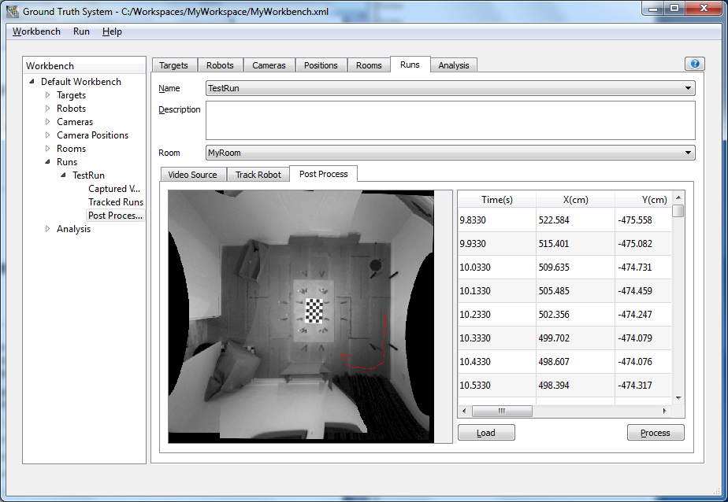

Analysing Results

Create a Result-Set

- Click the Analysis tab;
- In Analysis drop down menu, select New...;
- Name the result-set ‘TestResults’ and press Finish.

Perform Analysis

- In the floor plan selection box click the button and locate the appropriate floor plan image;
- In the floor mask selection box click the button and locate the appropriate floor mask image;
- Press the Load button. This populates the table of runs (within the current workspace). Select those to be included in the analysis by “checking” the appropriate entry;
- Click the Analyse button. After a period of time a dialog will appear to indicate that the results have been prepared. These include:

total_coverage.png - the (total) coverage image;
total_coverage.csv - the (total) coverage histogram.

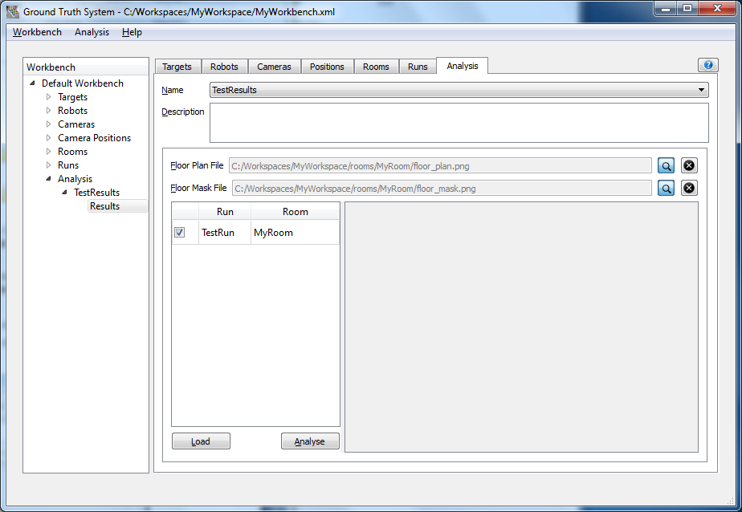

IEC Testing

Coverage / Navigation Test

Setting up the GTS
The navigation / coverage environment contains two cameras which combine to monitor a robot within the test area. This is also where the robot average speed test is carried out.
Setting up the GTS requires five stages:
- Software installation;
- Camera setup;
- Camera calibration;
- Position calibration;
- Room configuration.
Once the camera’s optical parameters and their position in the room have been defined the system is ready to use for tracking. Both camera / position calibration and room configuration can be carried out from within the GTS software package.

Software Installation
The first stage of set up should be to install the GTS onto the computer to which the cameras will attach. Please run the GTS executable installer to install the system onto any required computer.
Next, create a workbench (see “Creating a Workbench”).

Camera Setup
The cameras now need to be installed within the coverage test area. Given the “fixed” nature of this test area it is advised that the cameras in this environment are permanently fixed into the ceiling of the room. They should be focused such that there is sharp definition of the image on the ground plane of the room.
The locations of the GTS cameras within the coverage test environment are defined in Section 9.1 (Autonomous Navigation / Coverage Test – Test Bed) of [1].

Camera Calibration (Intrinsic)
Once the cameras are in place the next stage in the set up process is to understand the distortions caused by the camera and lens assemblies that are to be used. The calibration is specific to the camera, its lens and its focal settings. Each camera will need to be independently calibrated.
Ensure all cameras are connected to the computer and powered before attempting calibration.
For each camera in the test area being set up please follow the “Calibrating a Camera” instructions.

Position Calibration (Extrinsic)
The location of the cameras within the coverage test environment now needs to be calibrated. This calibration defines the relative location of the camera with respect to the 2D floor plane.
The calibration requires a calibration grid to be used. For ease of use it is suggested to re-use the calibration grid created when calibrating the camera. A new grid can be created if required using the calibration grid control box in the “Set Up Camera Positions” tab.
The first stage of room configuration requires each camera position with respect to the floor to be established. Please follow “Setting up Camera Positions” instructions for each camera in the test environment.

Room Configuration
Finally, each camera in the test environment needs to be added into a room record which groups together all cameras in the environment.
Having identified the cameras within a room a “floor plan” can be constructed. This requires a further calibration step during which each camera is related to another. On completion, a composite plan of the room is formed by “stitching” individual camera views together.
Please follow “Creating Rooms” instructions.

Running a Coverage Test
The IEC standard defines how the test should be conducted. This is covered in Section 9 (Autonomous Navigation / Coverage Test) of [1].

Setting up a Robot
For each robot to be run in the coverage test a target needs to be mounted on top of the robot and its parameters need to be stored in the GTS system.
For each robot to be tested please create a robot record as instructed in “Configuring a Robot”. Additional details of the coordinate system to use when specifying robot parameters can be found in Appendix A.1 (Robot Metrics) of [1], if required. Name each robot appropriately.

Recording a Run
For a coverage test, multiple runs of the machine need to be recorded in each of the starting positions.
Care should be taken to ensure that exposure and gain within the videos are good. This often means disabling auto exposure / gain control and setting parameters manually. The black and white target on top of the machine should be clearly visible within the image, with high contrast, otherwise tracking may be compromised.
Follow the instructions for “Recording a Run”. A new run in a new folder will be created for each test location and run.
Care should be taken to ensure that, where possible, any user interaction with the machine does not obscure the cameras view of the machine. If this were to happen the robot will not be able to be tracked for the period of the obscuration.
All runs can be made and recorded separately from, and before, the analysis phase if required.

Tracking the Robot
Firstly the robot track has to be established for each run.
For each run select the “Capture Run” tab and select the appropriate run from the “name” pull down box. The associated run folder will be used to store the test results.
Follow the instructions in “Tracking the Robot” to track the robot during a run.
Now repeat for the remaining tests.
This process establishes the path each robot took during each of the runs.

Creating a Floor Mask
When analysing the coverage of the robot it is necessary to know where the accessible floor space is. This is achieved using a “floor mask”. This is an image which simply defines accessible floor space using white pixels and black pixels for all other locations. Once created, this mask can be used for all coverage tests performed in the test area.
Follow the instructions in “Creating a Floor Mask” to prepare a floor mask.

Performing Coverage Analysis
Now the robot tracks have been established for each run the final stage in the IEC coverage test is to obtain the coverage statistics.
For each run select the “Capture Run” tab and select the appropriate run from the “name” pull down box.
Follow the instruction for “Analysing Results”.
The results are stored within the associated run folder. The key file for the IEC coverage test is the coverage_hist.txt file. This file records the number of passes as a percentage across the area defined in the floor mask. So the first value represents the percentage of area covered by one pass, the second is the percentage of area covered by two passes. To establish the three or more pass percentage all other values need to be summed.

Average Speed Test
To perform the average speed test simply set up a test area within the coverage test area as defined in Section 10 (Average Robot Speed) of [1].
Due to the fact that the cameras and the coverage test room are static a lot of the data created for the coverage test can be reused because no further calibration is required. This includes:
- Workbench creation;
- Camera calibration;
- Room calibration.

For each run simply execute the following steps:
- Open the workbench created during the coverage test.
- Follow the instructions of “Recording a Run”:
- Name the run appropriately;
- Select the room which was created during the coverage test
- Follow the instructions for “Tracking the Robot”.
- Use the appropriate robot as defined during the coverage tests
Upon completion, the track_result.txt file which is now stored within the associated run folder. This data can be used with the algorithms defined in Section 10 (Average Robot Speed) of [1] to establish the robot average speed.

Straight Line Test
The test method for Straight line tests are defined in Section 7 (Dust Removal – Straight Line Cleaning) of [1].
The majority of the usage of the GTS for the straight line test is identical to the coverage test with a few exceptions. These are highlighted in the following sections.

Setting up the GTS
The straight line test environment contains a single camera. This needs to be mounted over the area to be monitored.

Software Set-up
The “IEC workbench” created for the coverage test can also be used for the straight line (and any other) tests.

Camera Installation / Calibration and Room Calibration.
The camera needs to be installed above the test area. This could be done with a permanently fixed camera mounted on the ceiling of the environmental chamber. However, this may not be possible, in which case it is possible to mount a camera on temporary structure as long as it is solid and is not moved in any way once calibrated, for the duration of the test.
In terms of the camera, the field of view requirements for the straight line test are far less challenging than that of the coverage test. In our testing we have used a standard Fire-I camera mounted on a tripod with an arm extending of the test area. The advantage of this is that the camera calibration only needs to be performed once and can be stored in the workbench (as defined in 5.1.1.3). Then we can move the tripod and camera to any area we want to monitor and only have to perform the position calibration as described in 5.1.1.4. This has the advantage of mobility and a quick and easy set up but does require care not to knock the camera once it has been calibrated for the room.
Camera calibration can be carried out in exactly the same way as described in 5.1.1.3. The same calibration grid as created previously can be re-used. Position calibration can be carried out exactly as described in 5.1.1.4.
If the camera is permanently mounted in the chamber then this only needs to be carried out once. If a mobile set up is used then it needs to be re-calculated every time the setup is moved.

Running a Set of Straight Line Tests
Recording of runs is carried out in the same was as performed during the coverage tests. A separate run should be recorded for each pass of a robot over the area of direct
For each run follow the instructions for “Recording a Run”.
Track each run following the instruction “Tracking the Robot”.
On the first run create a floor mask (see 5.1.2.4) which covers only the area of dirt laid.
Perform coverage analysis of the run as described in 5.1.2.
Results are stored within the associated run folder – one (or more) raw_coverage_NNN.png files will be created (each having a unique time-stamped name).
Now repeat for the remaining passes.

Analysing a Set of Straight Line Runs
Now the robot tracks have been established for each run the final stage in the IEC coverage test is to obtain the coverage statistics.
For each run select the “Capture Run” tab and select the appropriate run from the “name” pull down box.
Follow the instruction for “Analysing Results”.
The results are stored within the associated run folder. The key file for the IEC straight line test is the coverage.csv file. This file contains the 1, 2 and 3+ pass data upon completion of each of the passes. Also, a total_coverage.png file will be created which visually represents the combination of all the “raw coverage” images, and corresponds with the coverage.csv data file.

Note, the “height” of the robot is not, in fact, the robots z dimension but is actually the height of the target from the floor plane. The target can be placed anywhere on the robot as long as it is visible from above and not obscured. This does not necessarily mean it has to be on top of the robot.
Note, the default value of 6x9 is usually fine for most uses.
Note, the tracking will pause only if the robot is lost in all videos. It should automatically regain track of the robot as soon as it reaches a similar orientation to the one where it was lost.
Note, all those runs selected for analysis must share the same room.
Note, you do not need to create a robot within the workbench at this stage, so ignore the “Configuring a Robot” step(s).
The GTS assumes that the robot remains on a consistent 2D plane.
Note, it is not possible to perform this process from within the GTS and may need to be achieved through (external) software supplied with the cameras.
The floor mask image must be the same dimensions as the un-warped mosaic image created during the tracking process, floor_plan.png.
Note, the room will now only contain a single camera.
Note, it is important to ensure that only valid raw_coverage_NNN.png files are present in the test result directory.

