- Problem Statement

During active disasters (floods, earthquakes, cyclones), emergency responders are overwhelmed by fragmented, unstructured data from multiple sources—SOS texts, satellite imagery, and audio distress calls. Current systems lack a unified memory, meaning they cannot correlate new information with past updates, leading to delayed responses, misallocated resources, and preventable loss of life.

- Overview of the Solution

This AI-powered system acts as a "Unified Memory" for disaster management. By using Qdrant as a high-performance vector search engine, it retrieves, correlates, and prioritizes multimodal data. The system allows responders to perform evidence-based decision making, ensuring that every recommendation (e.g., "prioritize Area X") is grounded in specific, traceable data like a drone image or a transcribed SOS call.

- Core Features
  - Multimodal Ingestion: Processes text (SOS messages), audio (transcribed calls), and images (drone/satellite) into a single vector space.
  - Long-Term Memory Evolution: Features "Memory beyond a single prompt," where new reports update existing records in a specific geo-fence rather than creating duplicates.
  - Heuristic Severity Scoring: Automatically classifies the urgency of reports (e.g., "flood" + "trapped" = 9/10) to support immediate prioritization.
  - Evidence-Based Response Agent: An LLM-based coordinator that generates evacuation lists with traceable links to the data that influenced the decision.

- Technical Features

  - Vector Database: Qdrant (Primary engine for semantic search, metadata filtering, and storage).
  - Embedding Models: * Text/Audio: all-mpnet-base-v2 via Sentence-Transformers (768-dimensional vectors).
- Computer Vision: CLIP for aligning drone/satellite images into the same vector space.
- Payload Schema: Strict metadata indexing for Geo-coordinates, Timestamps, Severity Scores, and Status (e.g., "pending", "visiting", "assisted").
  - Language Layer: LLM-based Response Agent for grounded, non-hallucinatory reasoning.

- Architecture Diagram
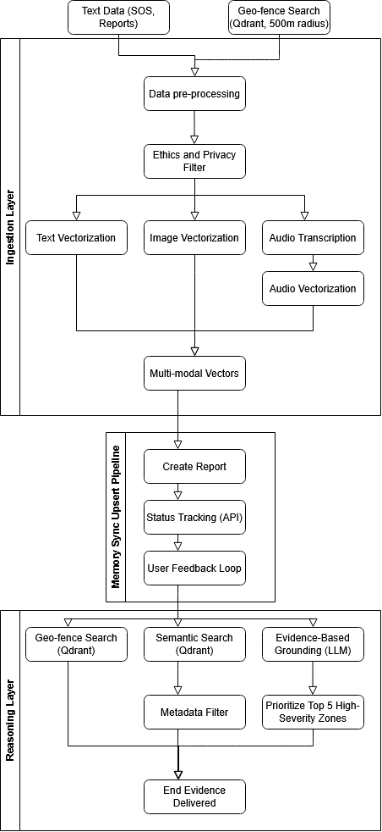
- Impact Assessment
- Societal Relevance: Directly addresses public safety and climate resilience.
- Efficiency: Reduces "information overload" for control room coordinators by filtering for high-severity clusters.
- Accountability: Eliminates AI hallucinations by forcing the system to cite specific "Traceable IDs" (e.g., "Area X needs help because of Audio Call #20").

- Scalability and Feasibility
- Scalability: Qdrant supports horizontal scaling and low-latency retrieval, making it feasible to handle massive datasets during large-scale regional disasters.
- Feasibility: The system uses standard API structures and existing embedding models (like CLIP), allowing it to be deployed without training massive models from scratch.

- Future Scope
- Real-Time Drone Feedback: Integrating live streaming telemetry directly into the Qdrant indexing pipeline.
- Decay Functions: Implementing memory "decay" where older, resolved reports lose relevance over time to keep the database focused on active threats.
- Human-in-the-Loop Refinement: Allowing responders to "thumbs up/down" AI priorities to reinforce the ranking model.

