Introduction

SingapuraAir is a global company providing the highest quality in terms of air transportation. Founded in 2012, SingapuraAir flies one of the youngest aircraft fleets in the world to destinations spanning a network spread over six continents. Today, we internationally recognized as the world's leading airline and operate a modern passenger fleet of more than 20 aircraft.

Achievements

Best Airlines in South East Asia 2012

Airline of the Year 2012 (2nd Consecutive Years)

Most Trusted Airline 2011

Departments and Staffs

**IT Department**

Manager: Joeven Valenzuela

Supervisor: MaimaiMansanades

Team Members: Angel Locsin, Christine Reyes

**Human Resource Department**

Manager: Jason Albores

Supervisor: Isaiah San Jose

Team members: Danica Torres, Cyril Locsin

**Marketing Department**

Manager: Ron Derek De Ramos

Supervisor: Perigrine Rivera

Team members: SolennHuesaff, Isabelle Daza

**Accounting Department**

Manager: Kenneth Manansala

Supervisor: Kalvin James Manansala

Team members: Gerryl Sierra, John Michael Mendez

**Customer Service Department**

Manager: Joey Reyes

Supervisor: ChelaiManansala

Team member: Camille Rivera, Sarah Jean Valenzuela

**Pilots, Flight Attendants and Crews**

Capt. Juan Dela Cruz

Capt. Juan Dela Cruz II

Capt. Juan Dela Cruz III

Paulene So

Akira Hassan

PalomaEsmeria

Objectives

* To provide excellent services between our shareholders and customers.
* To be able to install Linux Operating System to Singapura Air company.
* To be able to create users and groups using Linux.

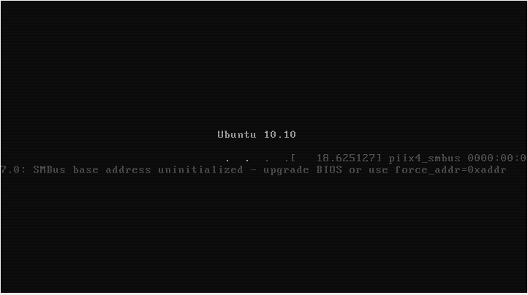Installation of Linux

Installation of Linux will start with this display.

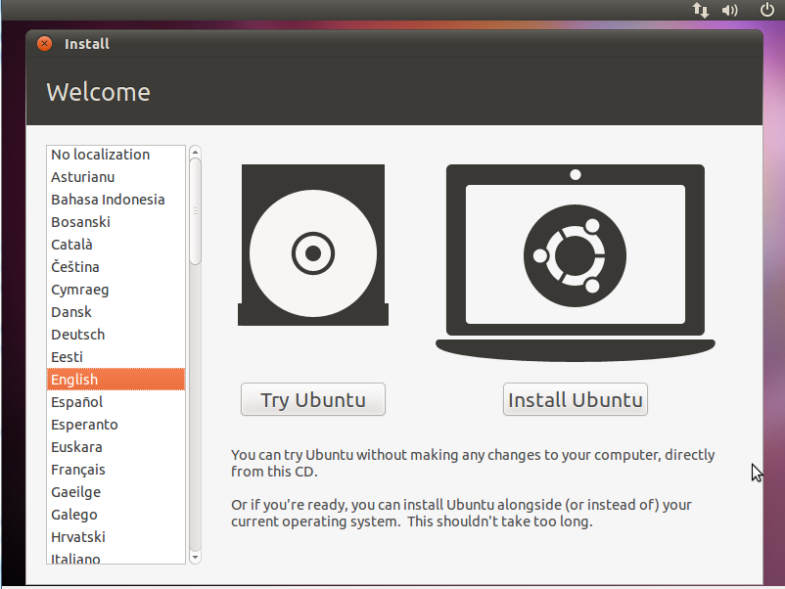

First thing you will do is to choose what language you will pick. Then click “Install Ubuntu”.

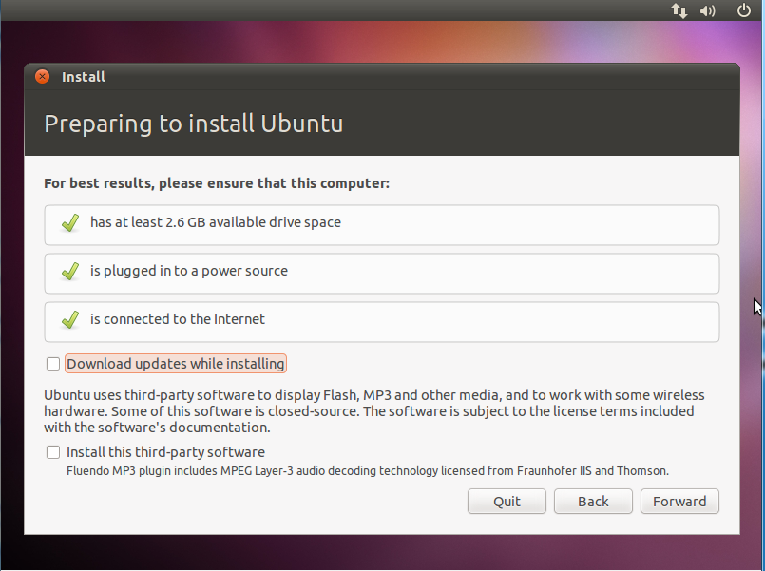

You are now preparing to install Ubuntu, just press “Forward”

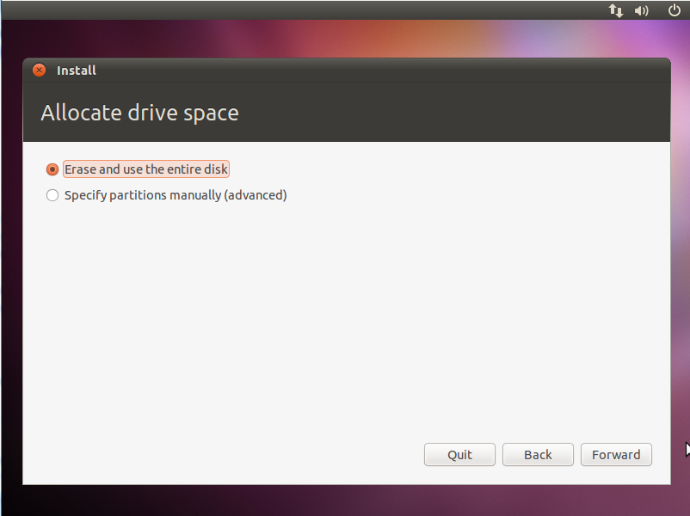

Allocate drive space will now appear, you will need to erase and use the entire disk to reformat then press “Forward”.

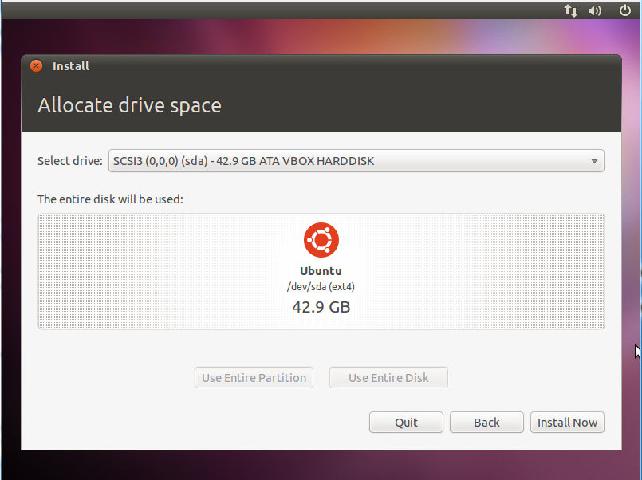

The entire disk will be use to install Linux in your operating system. Click “Install Now”.

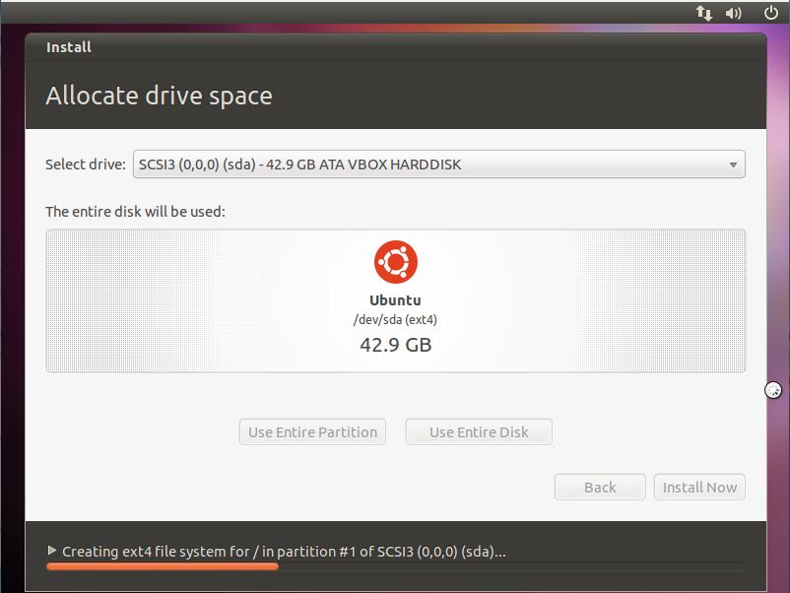

Installation process has now started. It will just take several minutes to install.

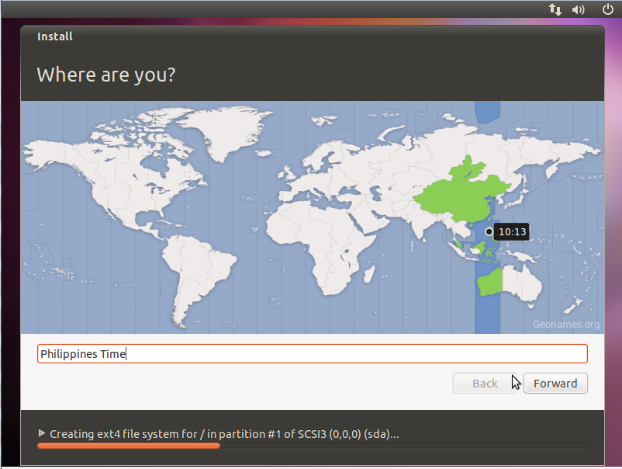

This display will show what GMT you are in right now.

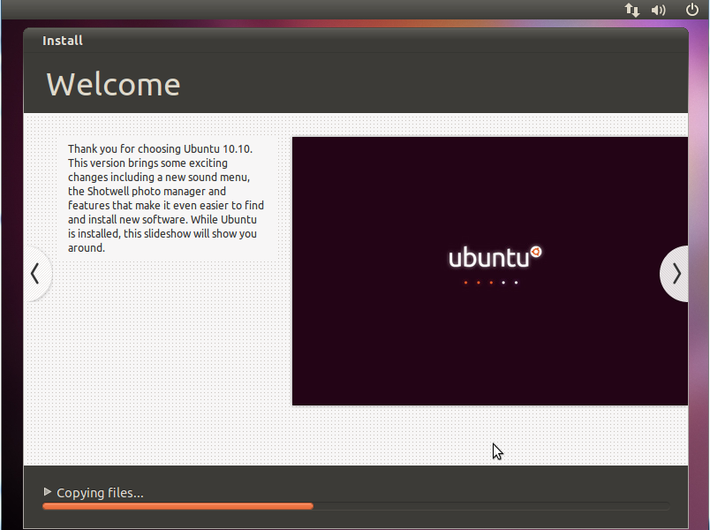

While Ubuntu 10.10 is installed, this slideshow will show you around.

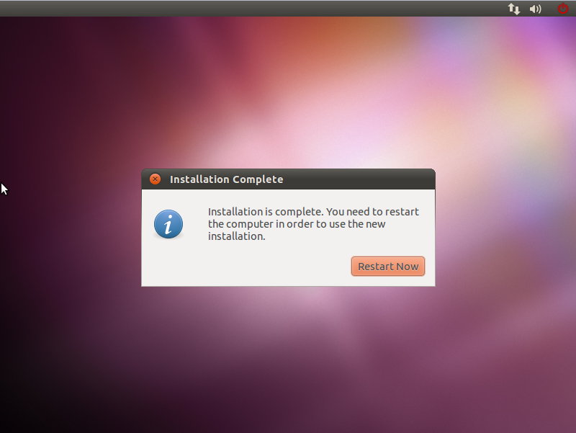

Installation of Ubuntu 10.10 is now complete. The computer will ask you to restart in

order to use the new operating system.

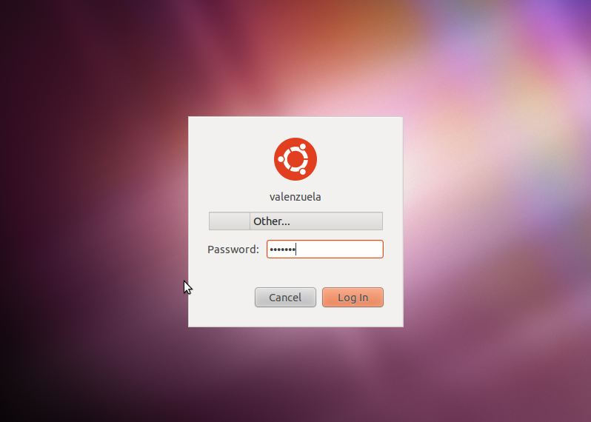

As you preferred to have a password, you will now enter your password to enter your desktop.

Policy Settings

**IT Folder “drwx------”**

Admin: Joeven Valenzuela “rwxrwxrwx”

MaimaiMansanades file “-wx-wx-wx“

Angel Locsin file “------rwx“

Christine Reyes file “------rwx“

**Human Resource Folder “drwx------”**

Admin: Jason Albores “rwx------”

Isaiah San Jose file “-wx-wx-wx“

Danica Torres file “------rwx“

Cyril Locsin file“------rwx“

**Marketing Folder “drwx------”**

Admin: Ron Derek De Ramos “rwx------”

Perigrine Rivera file “-wx-wx-wx“

SolennHuesaf file “------rwx“

Isabelle Daza file “------rwx“

**Accounting Folder “drwx------”**

Admin: Kenneth Manansala “rwx------”

Kalvin James Manansalafile“-wx-wx-wx“

Gerryl Sierra file “------rwx“

John Michael Mendez file “------rwx“

**Customer Service Folder “drwx------”**

Admin: Manager: Joey Reyes “rwxr--r--”

ChelaiManansalafile “-wx-wx-wx“

Camille Rivera file “------rwx“

Sarah Jean Valenzuela file “------rwx

**Pilots, Flight Attendants and Crews Folder “drwx------”**

Admin: Capt. Juan Dela Cruz “rwxr—r—“

Capt. Juan Dela Cruz II “rwxr--r--“

Capt. Juan Dela Cruz III “rwxr--r--“

Paulene So “------r--“

Akira Hassan “------r--“

PalomaEsmeria“------r--“

GRand Unified Bootloader “GRUB”

Is a [boot loader](http://searchenterpriselinux.techtarget.com/definition/boot-loader) package developed to support multiple operating systems and allow the user to select among them during [boot](http://searchwinit.techtarget.com/definition/boot)-up.GRUB was created by Erich Stefan Boleyn and has been further developed under the GNU project as [GNU GRUB](http://searchenterpriselinux.techtarget.com/definition/GNU-GRUB). The original package, sometimes known as GRUB Legacy, is still available for download but no longer being developed.

Adding User

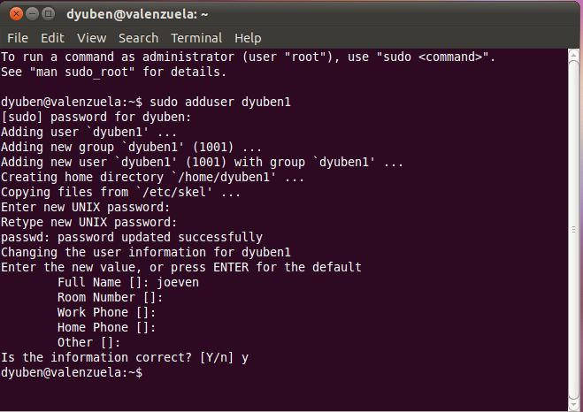

In order to add user, type in sudoadduser “desired username”. It will ask

for password and for some information you can skip the information if you want to then press Y

for yes.

Adding Group

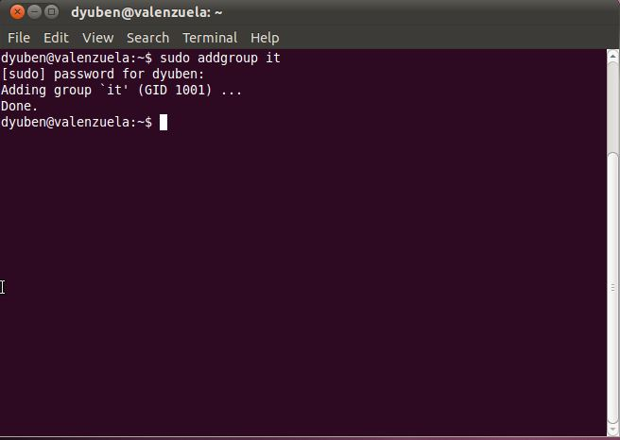

Same procedure for adding user but it will not asks you for password or any information.

Common Linux Commands

|  |  |
| --- | --- |
| Command | Description |
| ls | Show all files and folders. |
| ls -al | Show all files and folders with its description. |
| pwd | Show the present working directory. |
| chmod | Changing the permission of a file or folder to its user, groups, and others. |
| touch | Creates a file. |
| mkdir | Makes a directory/folder. |
| rmdir | Removes a directory/folder. |
| groups | Shows your group. |
| rm | Removes a file. |
| cd | Go to $home directory |
| sudoaddgroup | Adding group to a user. |
| sudoadduser | Adding user. |
| sudo apt-get install | Install new programs. |
| sudo reboot | Restart OS. |
| sudo halt | Shutdown OS. |

Text Editor

|  |  |
| --- | --- |
| Command | Description |
| vim/vi | Command line text editor. |
| Esc: w q! | Save and quit. |
| Esc:q! | Quit without saving. |
| less | To view the file. |
| a | To insert text. |

[Products & Services](http://www.singaporeair.com/en_UK/careers/careers-at-sia/#accord_1_9)

Your role will be to deliver and support a consistently high standard of customer service across the entire Singapore Airlines network. Equally important is the development of new products and services to maintain Singapore Airlines' leadership in the industry through differentiation and innovation.

GNOME is much more than just a desktop environment for Linux. It has emerged as a standard around which many traditional Unix vendors have begun to coalesce and has become a shining example of how the open source community can work together with commercial vendors.



OpenOffice is developed for [Linux](http://en.wikipedia.org/wiki/Linux), [OS X](http://en.wikipedia.org/wiki/OS_X) and [Windows](http://en.wikipedia.org/wiki/Microsoft_Windows), with ports to other [operating systems](http://en.wikipedia.org/wiki/Operating_system). It is distributed under the [Apache License](http://en.wikipedia.org/wiki/Apache_License).

OpenOffice contains a [word processor](http://en.wikipedia.org/wiki/Word_processor) ([Writer](http://en.wikipedia.org/wiki/OpenOffice_Writer)), a [spreadsheet](http://en.wikipedia.org/wiki/Spreadsheet) ([Calc](http://en.wikipedia.org/wiki/OpenOffice_Calc)), a [presentation](http://en.wikipedia.org/wiki/Presentation_program) application ([Impress](http://en.wikipedia.org/wiki/OpenOffice_Impress)), a [drawing](http://en.wikipedia.org/wiki/Graphics_software) application ([Draw](http://en.wikipedia.org/wiki/OpenOffice_Draw)), a [formula editor](http://en.wikipedia.org/wiki/Formula) ([Math](http://en.wikipedia.org/wiki/OpenOffice_Math)), and a [database management](http://en.wikipedia.org/wiki/Relational_database_management_system) application ([Base](http://en.wikipedia.org/wiki/OpenOffice_Base))



<http://www.linux-mag.com/id/668/>

http://en.wikipedia.org/wiki/OpenOffice