

**CHAPTER 9:HANDS_ON**

* Create a COURSE table based on the following table instance chart.

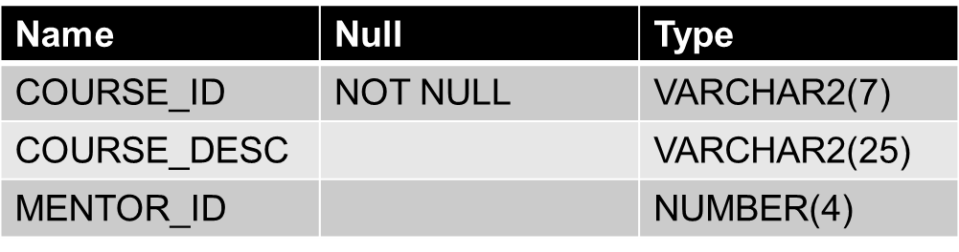

* CREATE a STUDENT table based on the ff. data:

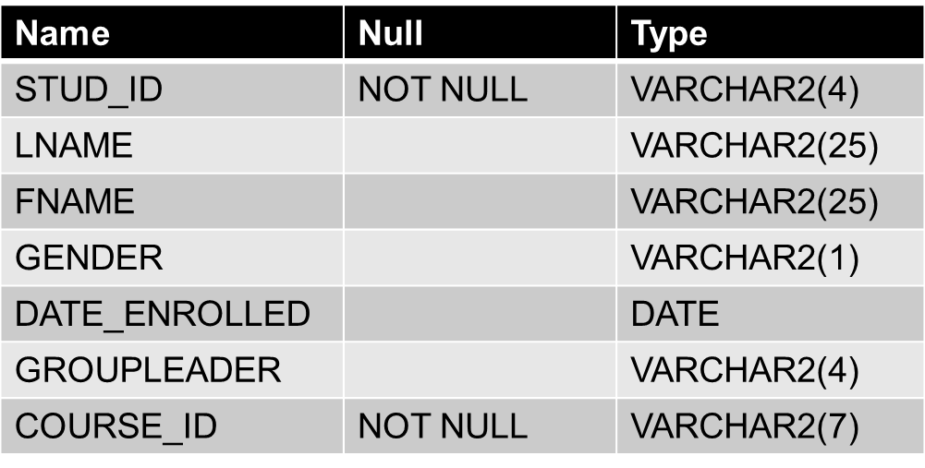

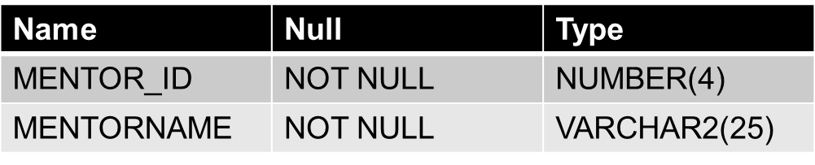

* Create a MENTOR table based on the following field