**Homework**

**ATM system**

**Description**

**Step 1**: Create class in header file (atm.h) and source file (atm.cpp). These two files communicate with each other. The structure of the class is programmed in atm.h file using the constructor, access functions, and variables. The access to the class structure is programmed in atm.cpp file using the methods and their return values.

**Header file atm.h**

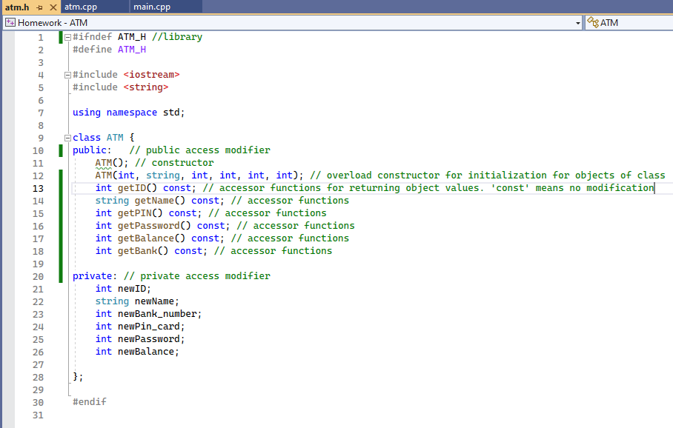

**File atm.cpp**

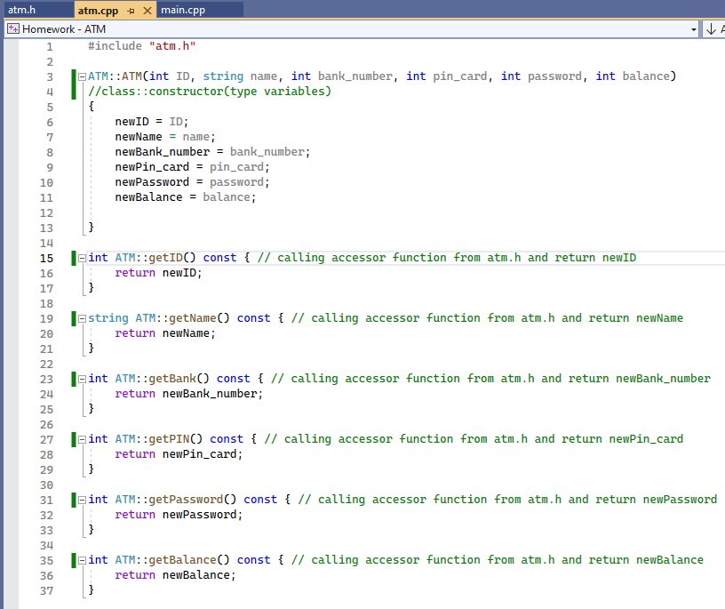

**Step 2**: The program logic of ATM system is programmed in main.cpp file. The OS begins to read the program from int main() function. It created myClient vector of ATM object. Then, it calls insertVector function for filling out the client data to the vector. Next, the ATM system asks the user about the bank name and its pin card number.

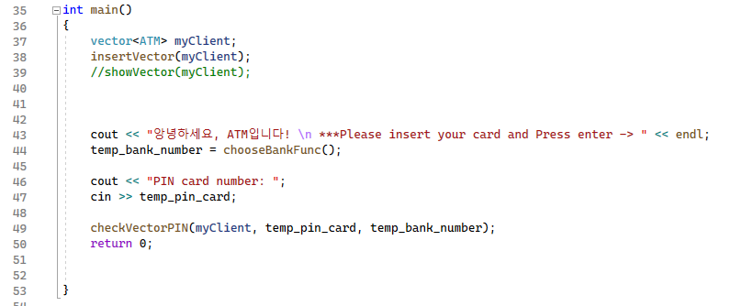

**Step 3**: Create a vector (dynamic array) of ATM object in order to increase the number of clients and to call the data by elements (newClient[**i**].getBalance()). In the beginning, I created objects of class one by one (for example like this: client1.password = 6324; , client2.password = 1999; ) and I figured out that it is not possible to use data in for-loop or if-else condition, because the objects are not an array or list. Then, I searched a solution and decided to save the data in the vector of ATM object.

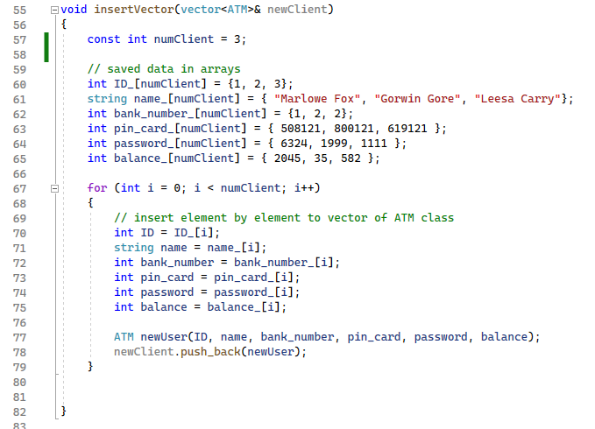

**Step 4:** The ATM system asks the bank number and check the input value is correct or not.

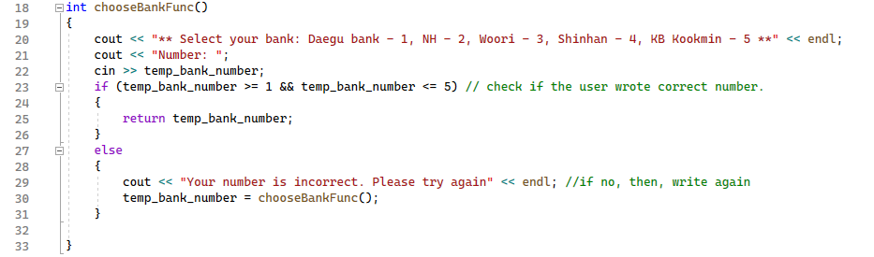

**Step 5**: The ATM system asks the pin card number and password. The checkVectorPIN checks the user input values. If all is correct, it returns the balance of client card.

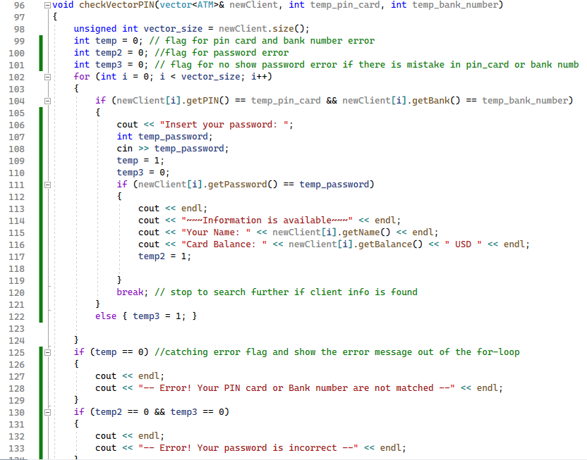

**Full code of main.cpp file**

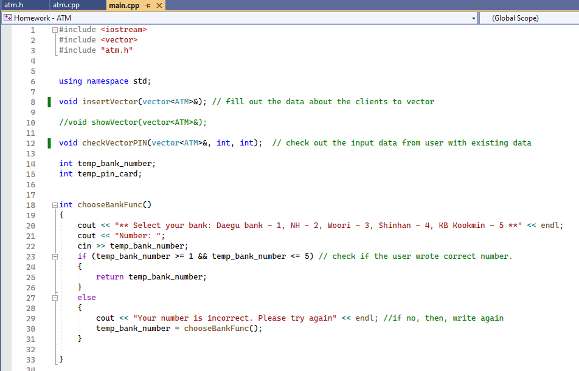

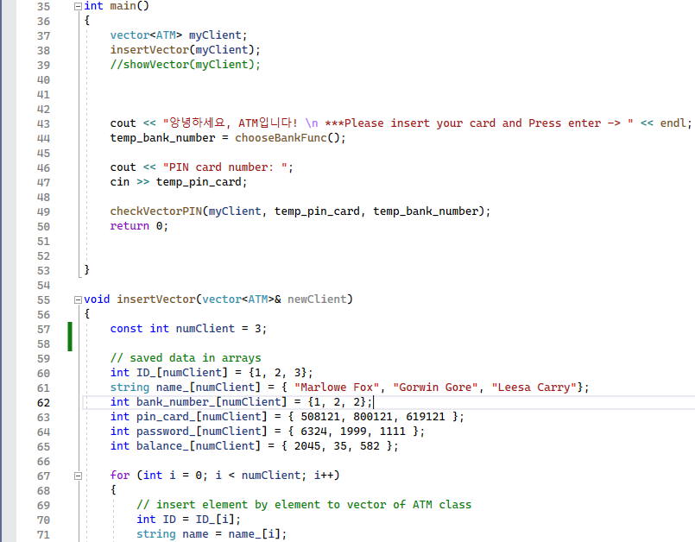

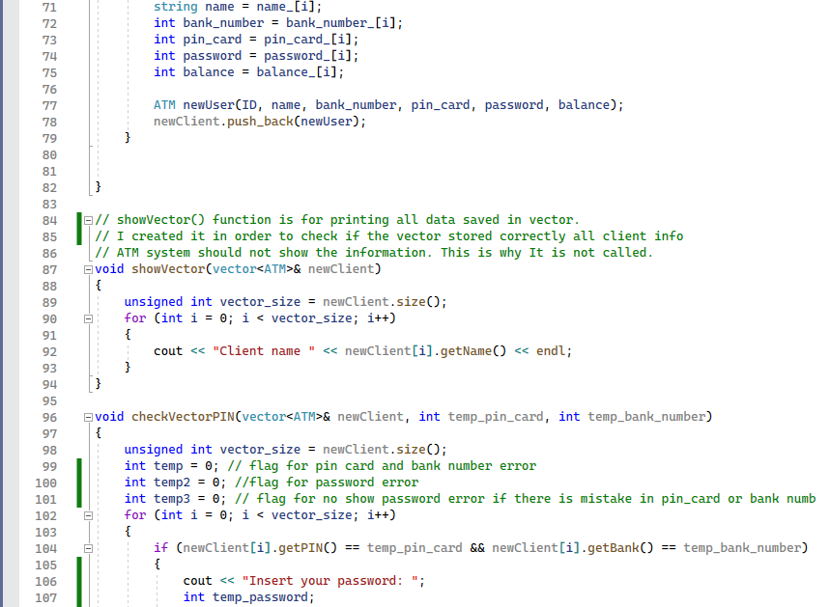

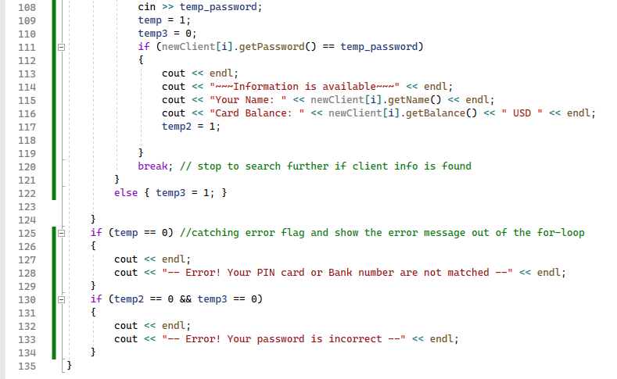

**Results**

Information about the clients. The information can be received from the database using SQL command (SELECT).

|  |  |  |  |  |  |  |
| --- | --- | --- | --- | --- | --- | --- |
|  | **ID** | **Name** | **Bank Number** | **Pin card number** | **Password** | **Balance (USD)** |
| Client 1 | 1 | Marlowe Fox | 1 (Daegu Bank) | 508121 | 6324 | 2045 |
| Client 2 | 2 | Gorwin Gore | 2 (NH bank) | 800121 | 1999 | 35 |
| Client 3 | 3 | Leesa Carry | 2 (NH bank) | 619121 | 1111 | 582 |

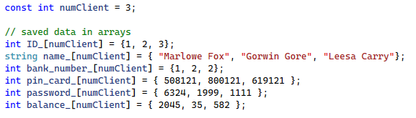

Test 1. Client 1 selected Daegu Bank (number 1) and entered the correct PIN card number and password. The result showed the current balance on the card.

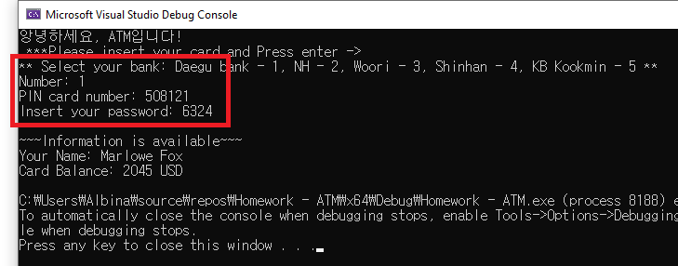

Test 2. Client 3 selected Daegu Bank (number 1), but the PIN card number is incorrect. The ATM system returned the error message.

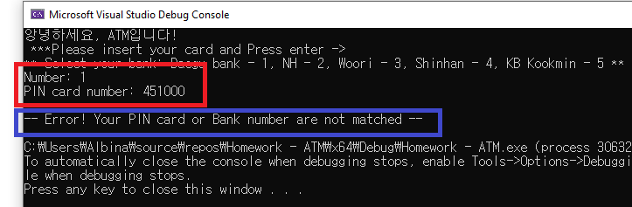

Test 3. Client 2 selected NH bank (number 2) and entered the correct PIN card number. But the password is wrong. The ATM system returned the error message.

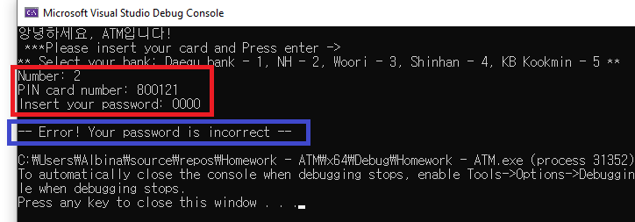

**References**

I used the Internet resources (Google search) widely during my programming googling about creating a class and a vector of a class in C++. But, the design and the logic of the ATM project belong to me. No cheating and support from others.

Time was consumed for programming around 6 hours and for the paper report around 2 hours.

Internet resources:

[1] <https://www.youtube.com/watch?v=iPlW5tSUOUM&t=493s> - How to create a vector of objects

[2] <https://stackoverflow.com/questions/15802006/how-can-i-create-objects-while-adding-them-into-a-vector> - How can I create objects while adding them into a vector

[3] <https://stackoverflow.com/questions/13324431/c-vectors-insert-push-back-difference> - C++ vector’s insert & push_back difference