**Children’s gestures provide a continuous signal of word knowledge**

Before they produce any words, infants gesture to communicate their interests and intentions to their social partners (Tomasello et al., 2007). Individual differences in infants’ gestural development predict their later lexical development (Brooks & Meltzoff, 2008; Rowe & Goldin-Meadow, 2009), and the individual referents that infants gesture about can even predict the words that enter their vocabularies (Iverson & Goldin-Meadow, 2005). However, infants may continue to use gesture to communicate about a referent even after they have learned its spoken label.

Communication is highly time-sensitive, requiring rapid transmission of intended meaning. Studies of infants’ language comprehension show that speed of processing a known word is a graded function of both the child’s age and the familiarity of the individual word (Fernald et al., 1998). We predict that children’s language production should be similarly graded: Children should smoothly increase how often they use gesture to refer to an object as the spoken word for that object becomes less familiar and thus slower to retrieve.

We test this prediction in a corpus study of 10 infant-mother dyads recorded at home at 18- and 22-mo. of age (5 male, 5 female; 5 White, 3 Black, 2 Mixed-Race). Each ~90min recording was transcribed, and all referents produced in either speech or gesture were coded utterance-by-utterance. As it is difficult both to gesture about, and to code, gestures for abstract entities like “weekend,” we analyzed only concrete nouns. Spoken references were counted only if the label for the referent was used (i.e., not pronouns). Gestural references were counted if they were deictic (e.g. pointing, showing). To estimate usage frequency, we computed total frequency for each referent across all dyads. The corpus contained 839 unique referents that varied in their usage frequency [*M*=16 (e.g., ant, brush); range=1 (wrench) – 886 (mom)].

If infants gesture to refer to an object when they cannot recall the spoken word for that object quickly enough, they should gesture particularly often for words that are infrequent, and particularly when they are younger. We fit a mixed-effects logistic regression to children’s productions, asking whether children’s use of speech vs. gesture for a particular referent was related to that referent’s total log frequency in the corpus, the child’s age, and the interaction between the two (Table 1). Both main effects and the interaction were significant, indicating that children are more likely to use speech for frequent referents and gesture for infrequent referents, and that younger children are especially likely to gesture for infrequent referents (Figure 1).

Words are not merely known or not known––children’s comprehension of even familiar words is a function of both their age and the frequency of each word’s use. Here we show that children’s *production* is similarly graded––children are more likely to gesture when they cannot retrieve the label for their intended referent quickly. Gesture thus provides an exciting tool for studying children’s developing lexicons, giving a continuous measure of their knowledge of a word, beyond the simple binary measure of whether or not they produce it.

(500 Words)

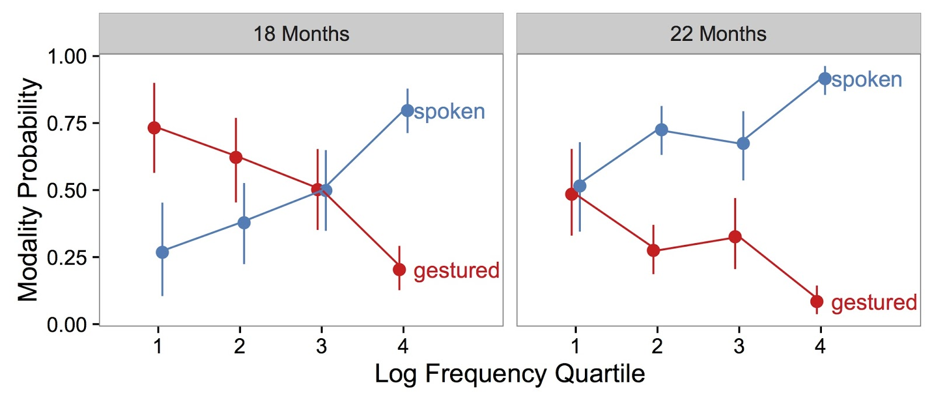

Figure 1: Children’s probability of using speech vs. gesture to communicate about a referent varies with age (18 mos. vs. 22 mos.), and the referent’s word frequency (log frequency quartile). For clarity of presentation, words were binned into quartiles by their total log frequency in the corpus for presentation, but analyses were performed on the continuous frequencies. Error bars show 95% confidence intervals computed by non-parametric bootstrap.

|  |  |  |  |  |
| --- | --- | --- | --- | --- |
| Predictor | *β* | *z* | *p* |  |
| (Intercept) | -15.00 | -5.95 | < .001 | *** |
| age | .68 | 5.81 | < .001 | *** |
| log(freq) | 2.52 | 4.34 | < .001 | *** |
| age * log(freq) | -.10 | -3.64 | < .001 | *** |

Table 1: Coefficient estimates for a mixed effects model predicting children’s use of speech vs. gesture to communicate. The model was specified as (num. spoken, num. gestured) ~ age * log(frequency) + (1|subject) + (1|referent). Log frequency remained a significant predictor when we subset the data to only referents that were produced in both modalities by individual children in individual sessions (*β*=.37; z = 3.54, p < .001).

**References**

Brooks, R., & Meltzoff, A. N. (2008). Infant gaze following and pointing predict accelerated vocabulary growth through two years of age: a longitudinal, growth curve modeling study. *Journal of Child Language*, *35*, 207–220.

Fernald, A., Pinto, J. P., & Swingley, D. (1998). Rapid gains in speed of verbal processing by infants in the 2nd year. *Psychological Science*, *9*, 228–231.

Iverson, J. M., & Goldin-Meadow, S. (2005). Gesture Paves the Way for Language Development. *Psychological Science*, *16*, 367–371.

Rowe, M.L., & Goldin-Meadow, S. (2009). Differences in early gesture explain SES disparities in child vocabulary size at school entry.  *Science*, *323*, 951-953.

Tomasello, M., Carpenter, M., & Liszkowski, U. (2007). A new look at infant pointing. *Child Development*, *78*, 705–722.