Online Food Delivery System

Theme :
The Online Food Delivery System is a database management project developed using MySQL that simulates the operations of an online food ordering platform. The project focuses on managing essential data related to restaurants, customers, menu items, orders, delivery partners, payments, and customer reviews within a centralized database.

ER Diagram :
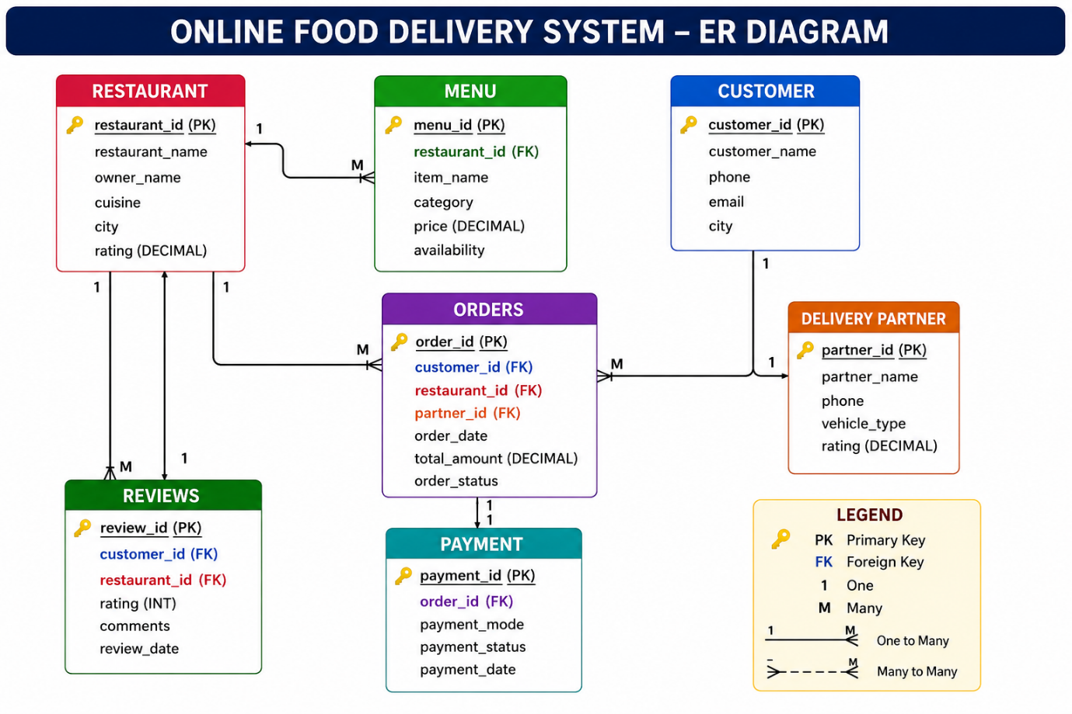

---->Create database :
create database online_food_Delivery_system;
---->Use database :
use online_food_Delivery_system;

Creation of tables :
---->create table Restaurants :
create table restaurant(
restaurant_id int primary key,
restaurant_name varchar(20),
owner_name varchar(20),
cuisine varchar(20),
city varchar(20),
rating decimal(10,2));

---->create table Customers :
create table customer(
customer_id int primary key,
customer_name varchar(20),
phone bigint,
email varchar(20),
city varchar(20));

---->create table Delivery Partners :
create table Delivery_partner(
partner_id int primary key,
partner_name varchar(20),
phone bigint,
vehicle_type varchar(20),
rating decimal(10,2));

---->create table Menu :
create table Menu(
menu_id int primary key auto_increment,
restaurant_id int,
item_name varchar(100) not null,
category varchar(50),
price decimal(10,2),
availability varchar(20),
foreign key(restaurant_id) references restaurant(restaurant_id));

---->create table Orders :
create table orders(
order_id int primary key auto_increment,
customer_id int,
restaurant_id int,
partner_id int,
order_date date not null,
total_amount decimal(10,2),
order_status Enum('Placed','Preparing','Out for Delivery','Delivered','Cancelled'),
foreign key(customer_id) references customer(customer_id),
foreign key(restaurant_id) references restaurant(restaurant_id),
foreign key(partner_id) references delivery_partner(partner_id));

---->create table Payments :
create table payment(
payment_id int primary key auto_increment,
order_id int,
payment_mode enum('UPI','Cash','Card'),
payment_status enum('Success','Failed','cancel'),
payment_date date not null,
foreign key(order_id) references orders(order_id));

---->create table Reviews :
create table reviews(
review_id int primary key auto_increment,
customer_id int,
restaurant_id int,
rating int(10) check(rating between 1 and 10),
comments varchar(20),
review_date date not null,
foreign key(customer_id) references customer(customer_id),
foreign key(restaurant_id) references restaurant(restaurant_id));

Insertion of data into tables :
---->restuarant :
INSERT INTO restaurant (restaurant_id, restaurant_name, owner_name, cuisine, city, rating) VALUES
(1, 'Sri Sai Tiffins', 'Ramesh', 'South Indian', 'Hyderabad', 4.3),
(2, 'Paradise Biryani', 'Srinivas', 'Hyderabadi', 'Hyderabad', 4.6),
(3, 'Udupi Grand', 'Mahesh', 'South Indian', 'Bengaluru', 4.4),
(4, 'Annapurna Restaurant', 'Suresh', 'North Indian', 'Vijayawada', 4.2),
(5, 'Hotel Swagath', 'Prakash', 'Multi Cuisine', 'Visakhapatnam', 4.1),
(6, 'Mehfil Restaurant', 'Imran', 'Mughlai', 'Hyderabad', 4.5),
(7, 'Food Factory', 'Kiran', 'Fast Food', 'Warangal', 4.0),
(8, 'Balaji Restaurant', 'Ravi', 'Chinese', 'Guntur', 4.3),
(9, 'New Andhra Mess', 'Venkatesh', 'Andhra', 'Tirupati', 4.4),
(10, 'Green Leaf', 'Anil', 'Vegetarian', 'Nellore', 4.2),
(11, 'mehfil', 'khan','hyderabadi', 'banglore', null),
(12, 'amruta_restaurant', 'ramesh','south','chennail', null) ;
----> Customer :
INSERT INTO customer (customer_id, customer_name, phone, email, city) VALUES
(1, 'Akhil', 9876543210, 'akhil@gmail.com', 'Hyderabad'),
(2, 'Priya', 9123456780, 'priya@gmail.com', 'Hyderabad'),
(3, 'Rahul', 9012345678, 'rahul@gmail.com', 'Bengaluru'),
(4, 'Sneha', 9988776655, 'sneha@gmail.com', 'Vijayawada'),
(5, 'Karthik', 9090909090, 'karthik@gmail.com', 'Visakhapatnam'),
(6, 'Anjali', 9345678901, 'anjali@gmail.com', 'Hyderabad'),
(7, 'Vamsi', 9871234567, 'vamsi@gmail.com', 'Warangal'),
(8, 'Divya', 9701234567, 'divya@gmail.com', 'Guntur'),
(9, 'Sandeep', 9955667788, 'sandeep@gmail.com', 'Tirupati'),
(10, 'Keerthi', 9888997766, 'keerthi@gmail.com', 'Nellore'),
(11, 'dharna', 9763977669, 'dharna@gmail.com', 'bandra'),
(12, 'rachna', 9762356738, 'rachna@gmail.com', 'vijaywada');

----->delivery_partner :
INSERT INTO delivery_partner (partner_id, partner_name, phone, vehicle_type, rating) VALUES
(1, 'Ravi', 1234567890, 'Bike', 4.8),
(2, 'Suresh', 1234567891, 'Scooter', 4.5),
(3, 'Mahesh', 1234567892, 'Bike', 4.7),
(4, 'Kiran', 1234567893, 'Cycle', 4.2),
(5, 'Vamsi', 1234567894, 'Bike', 4.6),
(6, 'Naresh', 1234567895, 'Scooter', 4.4),
(7, 'Ajay', 1234567896, 'Bike', 4.9),
(8, 'Ramesh', 1234567897, 'Cycle', 4.1),
(9, 'Praveen', 1234567898, 'Bike', 4.3),
(10, 'Arun', 1234567899, 'Scooter', 4.7);

---->menu :
INSERT INTO menu (restaurant_id, item_name, category, price, availability) VALUES
(1, 'Idli', 'Breakfast', 40.00, 'Available'),
(1, 'Masala Dosa', 'Breakfast', 80.00, 'Available'),

(2, 'Chicken Biryani', 'Main Course', 280.00, 'Available'),
(2, 'Mutton Biryani', 'Main Course', 350.00, 'Available'),

(3, 'Plain Dosa', 'Breakfast', 60.00, 'Available'),
(4, 'Butter Naan', 'Bread', 40.00, 'Available'),
(4, 'Paneer Butter Masala', 'Main Course', 220.00, 'Available'),
(5, 'Veg Fried Rice', 'Chinese', 170.00, 'Available'),
(6, 'Chicken Shawarma', 'Snacks', 160.00, 'Available'),
(6, 'Chicken Kebab', 'Main Course', 240.00, 'Available'),
(7, 'Veg Burger', 'Fast Food', 120.00, 'Available'),
(7, 'Cheese Burger', 'Fast Food', 180.00, 'Available'),
(7, 'Veg Sandwich', 'Fast Food', 100.00, 'Available'),
(8, 'Chicken Manchurian', 'Chinese', 210.00, 'Available'),

(9, 'Andhra Meals', 'Lunch', 200.00, 'Available'),

(10, 'Veg Thali', 'Lunch', 180.00, 'Available'),
(10, 'Mushroom Curry', 'Main Course', 220.00, 'Available');

---->orders :
INSERT INTO orders (customer_id, restaurant_id, partner_id, order_date, total_amount, order_status) VALUES
(1, 2, 1, '2026-07-01', 280.00, 'Delivered'),
(2, 1, 2, '2026-07-01', 120.00, 'Delivered'),
(3, 4, 3, '2026-07-02', 260.00, 'Preparing'),
(4, 5, 4, '2026-07-02', 170.00, 'Delivered'),
(5, 6, 5, '2026-07-03', 240.00, 'Out for Delivery'),
(6, 3, 6, '2026-07-03', 150.00, 'Placed'),
(7, 7, 7, '2026-07-04', 210.00, 'Delivered'),
(8, 8, 8, '2026-07-04', 390.00, 'Cancelled'),
(9, 9, 9, '2026-07-05', 200.00, 'Delivered'),
(10, 10, 10, '2026-07-05', 220.00, 'Preparing'),
(1, 5, 2, '2026-07-06', 350.00, 'Delivered'),
(3, 2, 4, '2026-07-06', 560.00, 'Out for Delivery'),
(5, 1, 6, '2026-07-07', 80.00, 'Placed'),
(7, 6, 8, '2026-07-07', 400.00, 'Delivered'),
(10, 3, 10, '2026-07-08', 210.00, 'Preparing');

---->review :
INSERT INTO reviews (customer_id, restaurant_id, rating, comments, review_date) VALUES
(1, 2, 5, 'Excellent Food', '2026-07-02'),
(2, 1, 4, 'Good Service', '2026-07-02'),
(3, 4, 5, 'Very Tasty', '2026-07-03'),
(4, 5, 3, 'Average Food', '2026-07-03'),
(5, 6, 4, 'Nice Ambience', '2026-07-04'),
(6, 3, 5, 'Loved It', '2026-07-04'),
(7, 7, 4, 'Quick Delivery', '2026-07-05'),
(8, 8, 2, 'Too Spicy', '2026-07-05'),
(9, 9, 5, 'Best Meals', '2026-07-06'),
(10, 10, 4, 'Healthy Food', '2026-07-06'),
(1, 5, 5, 'Worth Price', '2026-07-07'),
(3, 2, 4, 'Nice Biryani', '2026-07-07'),
(5, 1, 3, 'Can Improve', '2026-07-08'),
(7, 6, 5, 'Excellent', '2026-07-08'),
(10, 3, 4, 'Good Taste', '2026-07-09');

---->payment :
INSERT INTO payment (order_id, payment_mode, payment_status, payment_date) VALUES
(1, 'UPI', 'Success', '2026-07-01'),
(2, 'Cash', 'Success', '2026-07-01'),
(3, 'Card', 'Success', '2026-07-02'),
(4, 'UPI', 'Success', '2026-07-02'),
(5, 'Cash', 'Success', '2026-07-03'),
(6, 'UPI', 'Success', '2026-07-03'),
(7, 'Card', 'Success', '2026-07-04'),
(8, 'UPI', 'Failed', '2026-07-04'),
(9, 'Cash', 'Success', '2026-07-05'),
(10, 'Card', 'Success', '2026-07-05'),
(11, 'UPI', 'Success', '2026-07-06'),
(12, 'Card', 'Success', '2026-07-06'),
(13, 'Cash', 'Success', '2026-07-07'),
(14, 'UPI', 'Success', '2026-07-07'),
(15, 'Card', 'cancel', '2026-07-08');

Display of tables :

select * from restaurant;
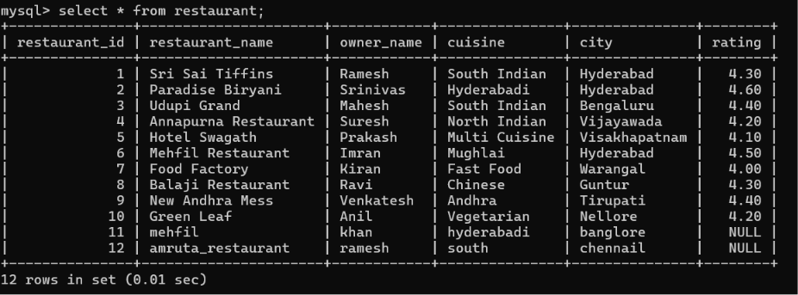

select * from customer;
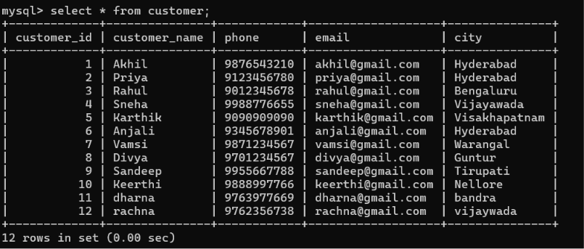
select * from menu;
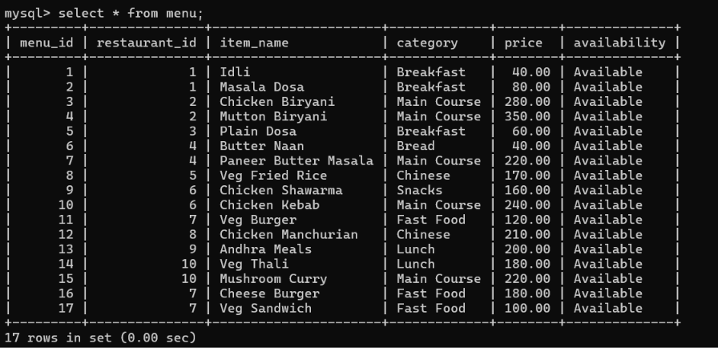

select * from delivery_partner;
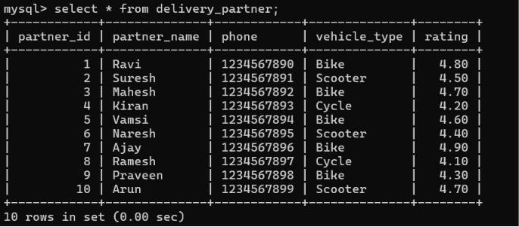
select * from orders;
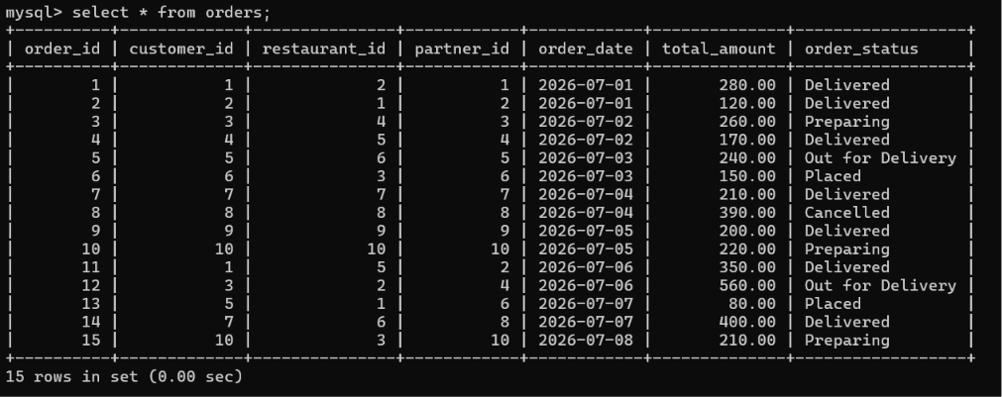
select * from reviews;
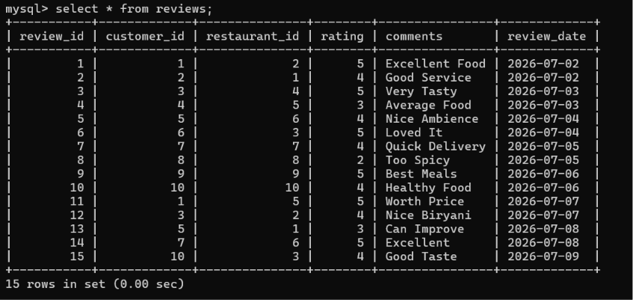
select * from payment;
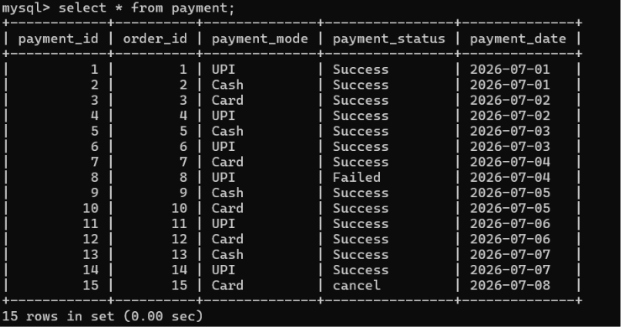

Queries :

1.Display all restaurants.
Select * from restaurant ;

2.Show all customers.
Select * from customer ;

3.List all available food items.
select * from menu where Availability = 'Available';

4.Find restaurants serving Chinese cuisine.
SELECT * FROM RESTAURANT WHERE CUISINE = 'CHINESE';

5.Display menu items costing more than ₹300.
SELECT * FROM MENU WHERE PRICE > 300;

6.Show all delivery partners.
SELECT * FROM DELIVERY_PARTNER;

7.Display completed orders.
SELECT * FROM ORDERS WHERE ORDER_STATUS = 'COMPLETED';
[COMPLETED STATUS NOT THERE SO ITS EMPTY SET]
SELECT * FROM ORDERS;

8.List customers from Hyderabad.
SELECT * FROM CUSTOMER WHERE CITY = 'HYDERABAD';

9.Show all online payments.
SELECT * FROM PAYMENT WHERE PAYMENT_MODE = 'ONLINE';
[ONLINE MODE IS NOT THERE SO ENTER UPI PAYMENT_MODE]
SELECT * FROM PAYMENT WHERE PAYMENT_MODE = 'UPI';
SELECT * FROM PAYMENT;

10.Display restaurants with rating above 4.5.
SELECT * FROM REVIEWS WHERE RATING > 4.5;
11.Count menu items for each restaurant :
select r.restaurant_name,count(m.item_name) as count
from menu m
join restaurant r on
m.restaurant_id=r.restaurant_id
group by m.restaurant_id;

12.Find the average food price :
select avg(price) as average_price from menu;

13.Count total orders placed by each customer :
select c.customer_name,count(o.order_id) as orders_placed
from orders o
join customer c
on o.customer_id=c.customer_id
group by c.customer_id;

14. Find the restaurant with the highest rating :
select re.restaurant_name, r.rating
from reviews r join restaurant re
on r.restaurant_id=re.restaurant_id
where r.rating=(select max(rating) from reviews);

15.Display total revenue generated by each restaurant :
select r.restaurant_name,sum(o.total_amount) as total_revenue
from orders o join restaurant r on
o.restaurant_id=r.restaurant_id
group by r.restaurant_name;
16.Count orders handled by each delivery partner :
select d.partner_name,count(o.order_id) as total_orders
from delivery_partner d join orders o
on o.partner_id=d.partner_id
group by d.partner_name;

17.Find restaurants with more than 20 menu items :
select restaurant_name from restaurant
where restaurant_id in
(select restaurant_id from menu
group by restaurant_id having count(menu_id)>2);

18.Display the top 5 expensive food items :
select item_name from menu order by price desc limit 5;

19.Find the total number of reviews for each restaurant :
select r.restaurant_name,count(o.review_id) as total_no_of_review
from reviews o join restaurant r on
o.restaurant_id=r.restaurant_id
group by r.restaurant_name;

20.Calculate the average review rating for each restaurant.
select r.restaurant_name,avg(o.rating) as average_review
from reviews o join restaurant r on
o.restaurant_id=r.restaurant_id
group by r.restaurant_name;

21.Display customer name with restaurant name for every order.
Select customer_name, restaurant_name
From orders
Join customer
On orders.customer_id = customer.customer_id
Join restaurant
On orders.restaurant_id = restaurant.restaurant_id;

22.Show delivery partner handling each order.
select o.order_id,
d.partner_name
From orders o
Join delivery_partner d
On o.partner_id = d.partner_id;
23.Find customers who have never placed an order.
select c.customer_id, c.customer_name
from customer c
Left join orders o
on c.customer_id = o.customer_id
o.customer_id is null;

24.Find restaurants that never received any review.
Select r.restaurant_name
from restaurant r
left join reviews rv
on r.restaurant_id = rv.restaurant_id
where rv.restaurant_id is null ;

25.Display restaurants with revenue greater than ₹400.
Select r.restaurant_name, sum (o.total_amount) as revenue
From restaurant r
join orders o
on r.restaurant_id = o.restaurant_id
Group by r.restaurant_name
Having sum(o.total_amount) > 400;

26.Find the most ordered restaurant.
Select r.restaurant_name, count(*) AS total_orders
from restaurant r
join orders o
on r.restaurant_id = o.restaurant_id
group by r.restaurant_name
order by total_orders desc
limit 1;

27.Display the delivery partner who delivered the maximum orders.
SELECT d.partner_name, COUNT(o.order_id) AS total_orders
from delivery_partner d
join orders o
on d.partner_id = o.partner_id
Group by d.partner_name
Order by total_orders DESC
limit 1;

28.Find customers who placed more than 2 orders.
Select c.customer_name, count(o.order_id) as total_orders
From customer c
join orders o
On c.customer_id =o.customer_id
Group by c.customer_name
Having count (o.order_id)>2;

29.Display restaurant names along with their average menu price.
Select r.restaurant_name , avg (m.price) as average_price
From restaurant r
Join menu m
On r.restaurant_id=m.restaurant_id
Group by r.restaurant_name;

30.Find the customer who spent the highest amount on food.
Select c.customer_name,sum(o.total_amount) as total_spent
from customer c
join orders o
on c.customer_id = o.customer_id
group by c.customer_name
order by total_spent DESC
limit 1;

