Online Food Delivery System

Theme :
The Online Food Delivery System is a database management project developed using MySQL that simulates the operations of an online food ordering platform. The project focuses on managing essential data related to restaurants, customers, menu items, orders, delivery partners, payments, and customer reviews within a centralized database.

ER Diagram :
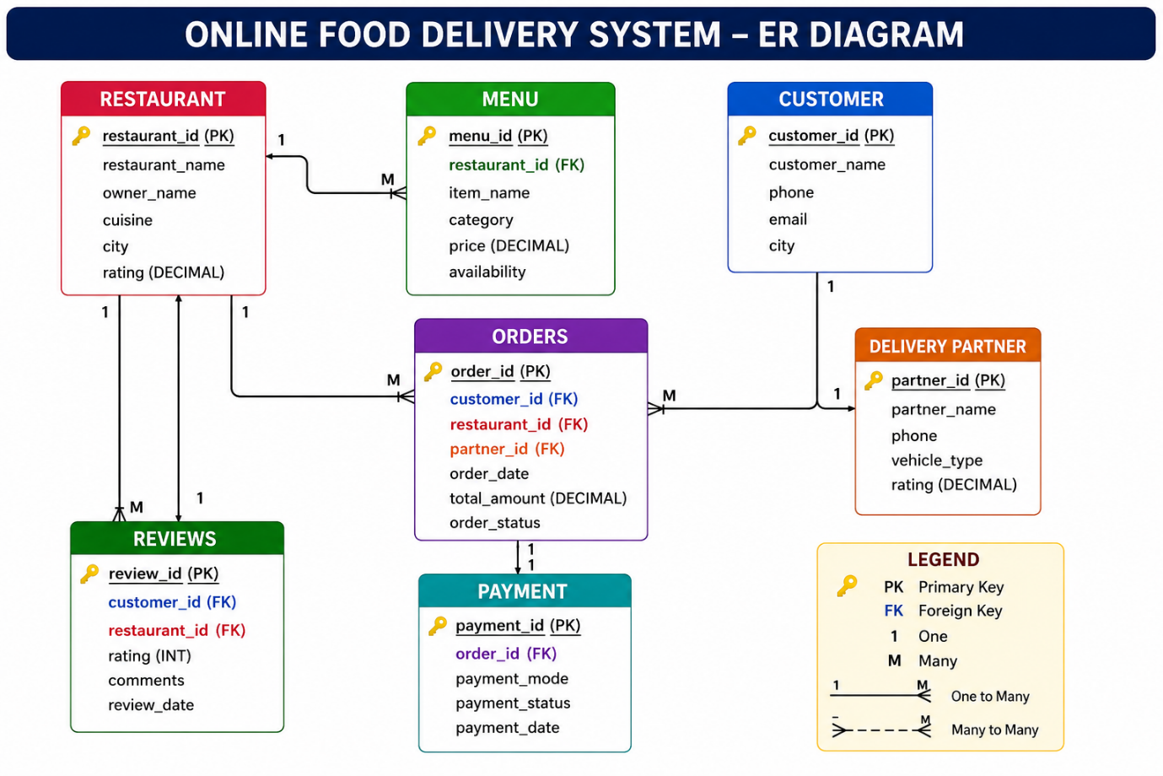

---->Create database :
create database online_food_Delivery_system;
---->Use database :
use online_food_Delivery_system;

