Creation of tables :
---->create table Restaurants :
create table restaurant(
restaurant_id int primary key,
restaurant_name varchar(20),
owner_name varchar(20),
cuisine varchar(20),
city varchar(20),
rating decimal(10,2));

---->create table Customers :
create table customer(
customer_id int primary key,
customer_name varchar(20),
phone bigint,
email varchar(20),
city varchar(20));

---->create table Delivery Partners :
create table Delivery_partner(
partner_id int primary key,
partner_name varchar(20),
phone bigint,
vehicle_type varchar(20),
rating decimal(10,2));

---->create table Menu :
create table Menu(
menu_id int primary key auto_increment,
restaurant_id int,
item_name varchar(100) not null,
category varchar(50),
price decimal(10,2),
availability varchar(20),
foreign key(restaurant_id) references restaurant(restaurant_id));

---->create table Orders :
create table orders(
order_id int primary key auto_increment,
customer_id int,
restaurant_id int,
partner_id int,
order_date date not null,
total_amount decimal(10,2),
order_status Enum('Placed','Preparing','Out for Delivery','Delivered','Cancelled'),
foreign key(customer_id) references customer(customer_id),
foreign key(restaurant_id) references restaurant(restaurant_id),
foreign key(partner_id) references delivery_partner(partner_id));

---->create table Payments :
create table payment(
payment_id int primary key auto_increment,
order_id int,
payment_mode enum('UPI','Cash','Card'),
payment_status enum('Success','Failed','cancel'),
payment_date date not null,
foreign key(order_id) references orders(order_id));

---->create table Reviews :
create table reviews(
review_id int primary key auto_increment,
customer_id int,
restaurant_id int,
rating int(10) check(rating between 1 and 10),
comments varchar(20),
review_date date not null,
foreign key(customer_id) references customer(customer_id),
foreign key(restaurant_id) references restaurant(restaurant_id));

Insertion of data into tables :
---->restuarant :
INSERT INTO restaurant (restaurant_id, restaurant_name, owner_name, cuisine, city, rating) VALUES
(1, 'Sri Sai Tiffins', 'Ramesh', 'South Indian', 'Hyderabad', 4.3),
(2, 'Paradise Biryani', 'Srinivas', 'Hyderabadi', 'Hyderabad', 4.6),
(3, 'Udupi Grand', 'Mahesh', 'South Indian', 'Bengaluru', 4.4),
(4, 'Annapurna Restaurant', 'Suresh', 'North Indian', 'Vijayawada', 4.2),
(5, 'Hotel Swagath', 'Prakash', 'Multi Cuisine', 'Visakhapatnam', 4.1),
(6, 'Mehfil Restaurant', 'Imran', 'Mughlai', 'Hyderabad', 4.5),
(7, 'Food Factory', 'Kiran', 'Fast Food', 'Warangal', 4.0),
(8, 'Balaji Restaurant', 'Ravi', 'Chinese', 'Guntur', 4.3),
(9, 'New Andhra Mess', 'Venkatesh', 'Andhra', 'Tirupati', 4.4),
(10, 'Green Leaf', 'Anil', 'Vegetarian', 'Nellore', 4.2),
(11, 'mehfil', 'khan','hyderabadi', 'banglore', null),
(12, 'amruta_restaurant', 'ramesh','south','chennail', null) ;
----> Customer :
INSERT INTO customer (customer_id, customer_name, phone, email, city) VALUES
(1, 'Akhil', 9876543210, 'akhil@gmail.com', 'Hyderabad'),
(2, 'Priya', 9123456780, 'priya@gmail.com', 'Hyderabad'),
(3, 'Rahul', 9012345678, 'rahul@gmail.com', 'Bengaluru'),
(4, 'Sneha', 9988776655, 'sneha@gmail.com', 'Vijayawada'),
(5, 'Karthik', 9090909090, 'karthik@gmail.com', 'Visakhapatnam'),
(6, 'Anjali', 9345678901, 'anjali@gmail.com', 'Hyderabad'),
(7, 'Vamsi', 9871234567, 'vamsi@gmail.com', 'Warangal'),
(8, 'Divya', 9701234567, 'divya@gmail.com', 'Guntur'),
(9, 'Sandeep', 9955667788, 'sandeep@gmail.com', 'Tirupati'),
(10, 'Keerthi', 9888997766, 'keerthi@gmail.com', 'Nellore'),
(11, 'dharna', 9763977669, 'dharna@gmail.com', 'bandra'),
(12, 'rachna', 9762356738, 'rachna@gmail.com', 'vijaywada');

----->delivery_partner :
INSERT INTO delivery_partner (partner_id, partner_name, phone, vehicle_type, rating) VALUES
(1, 'Ravi', 1234567890, 'Bike', 4.8),
(2, 'Suresh', 1234567891, 'Scooter', 4.5),
(3, 'Mahesh', 1234567892, 'Bike', 4.7),
(4, 'Kiran', 1234567893, 'Cycle', 4.2),
(5, 'Vamsi', 1234567894, 'Bike', 4.6),
(6, 'Naresh', 1234567895, 'Scooter', 4.4),
(7, 'Ajay', 1234567896, 'Bike', 4.9),
(8, 'Ramesh', 1234567897, 'Cycle', 4.1),
(9, 'Praveen', 1234567898, 'Bike', 4.3),
(10, 'Arun', 1234567899, 'Scooter', 4.7);

---->menu :
INSERT INTO menu (restaurant_id, item_name, category, price, availability) VALUES
(1, 'Idli', 'Breakfast', 40.00, 'Available'),
(1, 'Masala Dosa', 'Breakfast', 80.00, 'Available'),

(2, 'Chicken Biryani', 'Main Course', 280.00, 'Available'),
(2, 'Mutton Biryani', 'Main Course', 350.00, 'Available'),

(3, 'Plain Dosa', 'Breakfast', 60.00, 'Available'),
(4, 'Butter Naan', 'Bread', 40.00, 'Available'),
(4, 'Paneer Butter Masala', 'Main Course', 220.00, 'Available'),
(5, 'Veg Fried Rice', 'Chinese', 170.00, 'Available'),
(6, 'Chicken Shawarma', 'Snacks', 160.00, 'Available'),
(6, 'Chicken Kebab', 'Main Course', 240.00, 'Available'),
(7, 'Veg Burger', 'Fast Food', 120.00, 'Available'),
(7, 'Cheese Burger', 'Fast Food', 180.00, 'Available'),
(7, 'Veg Sandwich', 'Fast Food', 100.00, 'Available'),
(8, 'Chicken Manchurian', 'Chinese', 210.00, 'Available'),

(9, 'Andhra Meals', 'Lunch', 200.00, 'Available'),

(10, 'Veg Thali', 'Lunch', 180.00, 'Available'),
(10, 'Mushroom Curry', 'Main Course', 220.00, 'Available');

---->orders :
INSERT INTO orders (customer_id, restaurant_id, partner_id, order_date, total_amount, order_status) VALUES
(1, 2, 1, '2026-07-01', 280.00, 'Delivered'),
(2, 1, 2, '2026-07-01', 120.00, 'Delivered'),
(3, 4, 3, '2026-07-02', 260.00, 'Preparing'),
(4, 5, 4, '2026-07-02', 170.00, 'Delivered'),
(5, 6, 5, '2026-07-03', 240.00, 'Out for Delivery'),
(6, 3, 6, '2026-07-03', 150.00, 'Placed'),
(7, 7, 7, '2026-07-04', 210.00, 'Delivered'),
(8, 8, 8, '2026-07-04', 390.00, 'Cancelled'),
(9, 9, 9, '2026-07-05', 200.00, 'Delivered'),
(10, 10, 10, '2026-07-05', 220.00, 'Preparing'),
(1, 5, 2, '2026-07-06', 350.00, 'Delivered'),
(3, 2, 4, '2026-07-06', 560.00, 'Out for Delivery'),
(5, 1, 6, '2026-07-07', 80.00, 'Placed'),
(7, 6, 8, '2026-07-07', 400.00, 'Delivered'),
(10, 3, 10, '2026-07-08', 210.00, 'Preparing');

---->review :
INSERT INTO reviews (customer_id, restaurant_id, rating, comments, review_date) VALUES
(1, 2, 5, 'Excellent Food', '2026-07-02'),
(2, 1, 4, 'Good Service', '2026-07-02'),
(3, 4, 5, 'Very Tasty', '2026-07-03'),
(4, 5, 3, 'Average Food', '2026-07-03'),
(5, 6, 4, 'Nice Ambience', '2026-07-04'),
(6, 3, 5, 'Loved It', '2026-07-04'),
(7, 7, 4, 'Quick Delivery', '2026-07-05'),
(8, 8, 2, 'Too Spicy', '2026-07-05'),
(9, 9, 5, 'Best Meals', '2026-07-06'),
(10, 10, 4, 'Healthy Food', '2026-07-06'),
(1, 5, 5, 'Worth Price', '2026-07-07'),
(3, 2, 4, 'Nice Biryani', '2026-07-07'),
(5, 1, 3, 'Can Improve', '2026-07-08'),
(7, 6, 5, 'Excellent', '2026-07-08'),
(10, 3, 4, 'Good Taste', '2026-07-09');

---->payment :
INSERT INTO payment (order_id, payment_mode, payment_status, payment_date) VALUES
(1, 'UPI', 'Success', '2026-07-01'),
(2, 'Cash', 'Success', '2026-07-01'),
(3, 'Card', 'Success', '2026-07-02'),
(4, 'UPI', 'Success', '2026-07-02'),
(5, 'Cash', 'Success', '2026-07-03'),
(6, 'UPI', 'Success', '2026-07-03'),
(7, 'Card', 'Success', '2026-07-04'),
(8, 'UPI', 'Failed', '2026-07-04'),
(9, 'Cash', 'Success', '2026-07-05'),
(10, 'Card', 'Success', '2026-07-05'),
(11, 'UPI', 'Success', '2026-07-06'),
(12, 'Card', 'Success', '2026-07-06'),
(13, 'Cash', 'Success', '2026-07-07'),
(14, 'UPI', 'Success', '2026-07-07'),
(15, 'Card', 'cancel', '2026-07-08');

Display of tables :

select * from restaurant;
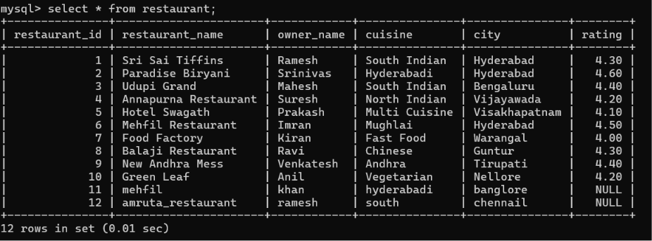

select * from customer;
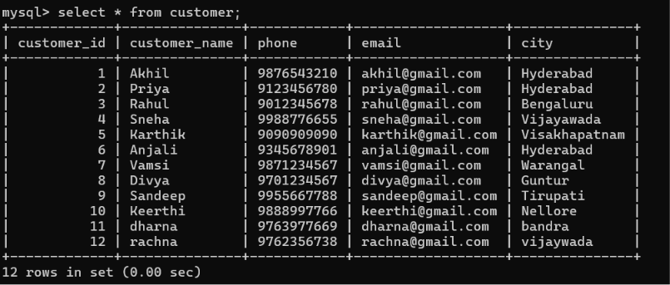
select * from menu;
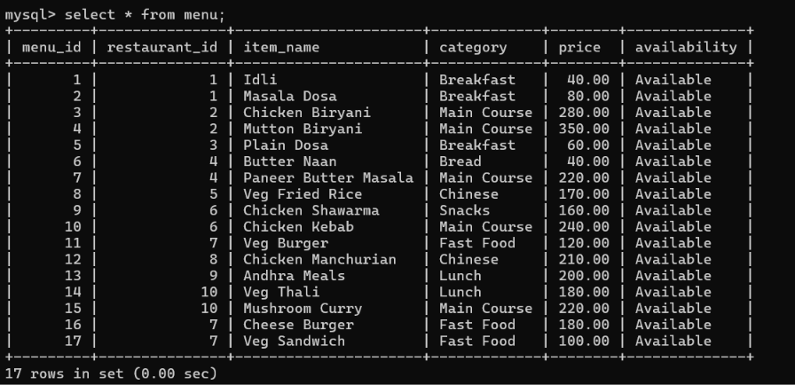

select * from delivery_partner;
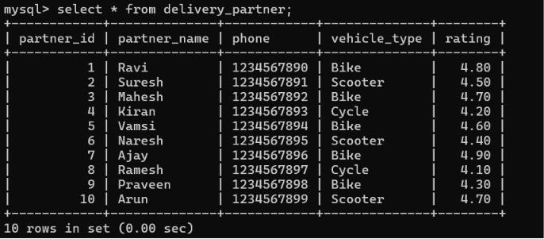
select * from orders;
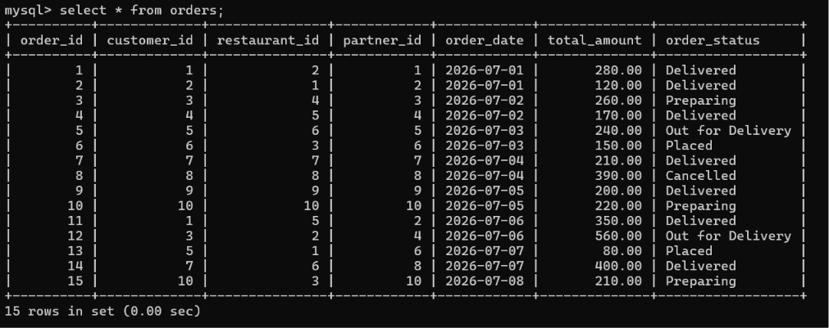
select * from reviews;
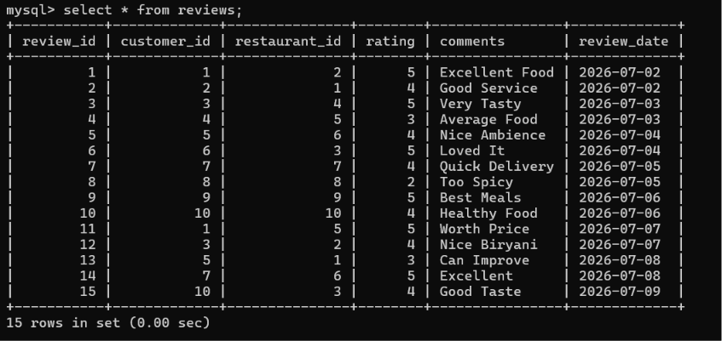

select * from payment;
