E-Commerce Platform with Product & Order Management

Introduction
The E-Commerce Platform is a web-based application designed to allow users to browse products, add them to a cart, and place orders online. It provides a seamless shopping experience with secure authentication and efficient product management.
Traditional shopping systems lack flexibility, real-time updates, and convenience. This platform solves these issues by offering a centralized system where users can easily explore products, manage orders, and track purchases.
Built using modern web technologies, the platform ensures scalability, security, and a smooth user experience for both customers and administrators.

Description
The E-Commerce Platform is a full-stack web application that enables users to interact with products and manage purchases efficiently.
The system allows:
- View products
- Add products to cart
- Place orders
- Manage stock
- Track orders
Users can:
- Register and login
- Browse products
- Add/remove items from cart
- Place orders
- View order history
Admin/Seller can:
- Add products
- Update product details
- Manage stock
- View all orders

Problem Statement
Many users face difficulties in online shopping systems such as:
- Poor product organization
- Lack of real-time stock updates
- Complicated checkout processes
- Limited order tracking
This system provides a structured and efficient solution for managing products and orders while improving user experience.

Scenario
Workflow:
1. User registers and logs in
2. Browses products
3. Adds items to cart
4. Places an order
5. Admin manages stock and orders
6. User tracks order status

Architecture
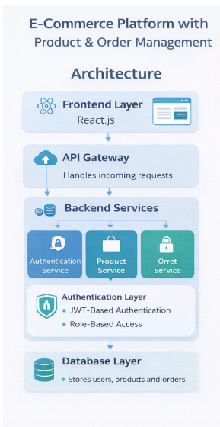
The system follows a client-server architecture:
Frontend Layer:
- Built using React.js
- Provides UI for users
Backend Layer:
- Node.js + Express.js
- Handles APIs and business logic
Database Layer:
- MongoDB stores users, products, orders
Authentication Layer:
- JWT-based authentication
- Secure access control

Project Flow
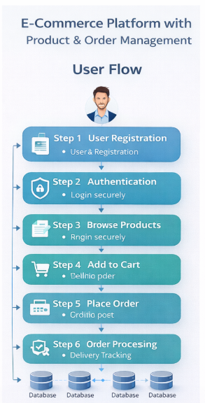
Step 1: User Registration
Step 2: Authentication
Step 3: Browse Products
Step 4: Add to Cart
Step 5: Place Order
Step 6: Order Processing
Step 7: Order Tracking

Pre-Requisites
Frontend:
- React.js
- Hooks
- Routing
- Axios
Backend:
- Node.js
- Express.js
- REST APIs
Database:
- MongoDB
- Mongoose

Required Technologies
Frontend:
- React.js
- TailwindCSS
- Axios
Backend:
- Node.js
- Express.js
- JWT
- Bcrypt
Database:
- MongoDB
- Mongoose
Tools:
- Git
- GitHub
- VS Code
- Postman

Database Collections
Users:
- _id
- name
- email
- password
Products:
- _id
- name
- description
- price
- stock
- category
Orders:
- _id
- userId
- items
- totalAmount
- status
- createdAt

Key Features
- Product Management
- Cart System
- Order Management
- Authentication

Advanced Features
- Payment integration
- Order status updates
- Search & filter products
- Wishlist functionality
- Admin dashboard

Learning Outcomes
- Full-stack development
- API design
- Database schema design
- Authentication & authorization
- E-commerce workflow

