AIFAR OPERATIONS GUIDE

AIFAR Monitoring and
Troubleshooting Manual
  - Monitoring, Evidence Collection, and Escalation Guidance

Scope: Read-only monitoring and troubleshooting after sign-in
Boundary: Status review, evidence collection, impact assessment, and escalation
Product baseline: AIFAR Deployment 0.1.0
Prepared: July 27, 2026
READ-ONLY MONITORING | FACTS FIRST | COMPLETE EVIDENCE | TIMELY ESCALATION

1. Scope and Read-Only Boundary

1.1 Purpose
This manual explains how you can review operating status after signing in to AIFAR, identify abnormalities, collect evidence, and coordinate escalation.
This manual does not provide deployment, configuration, administration, or change instructions. Use only the status, task steps, target logs, and audit records already available in the UI. Any system change must be performed by authorized personnel through the agreed change process.
Important Even when the UI shows controls that can change system state, do not use them under this manual. Preserve the evidence first, then hand off the incident according to the escalation criteria.

1.2 Your Responsibilities
- Review realtime connectivity, the latest snapshot time, alert counts, and core module summaries.
- Identify server, Docker/AIFAR Runtime, database, Nacos, object storage, and task abnormalities.
- Correlate the affected object, occurrence time, task step, failed target, error context, and audit source.
- Determine the impact scope, whether data may be stale, and whether escalation is required.
- Redact screenshots, log excerpts, object identifiers, and environment details before sharing them.

1.3 Responsibility Boundary at a Glance
What you may review | Actions outside this manual | Hand off to
Review status, timestamps, alerts, and trends | Change task, service, container, or configuration state | Implementation or platform operations team
Review task steps, targets, and logs | Modify credentials, servers, policies, or panel settings | Authorized administrator
Review audit records and verify the operation source | Perform terminal operations | Infrastructure or implementation team
Collect redacted evidence and describe the impact | Declare recovery based on one UI status alone | Incident owner

1.4 Operating Principles
- Confirm data freshness before interpreting the operating state.
- Identify the affected object before reviewing tasks, steps, targets, and logs.
- Use Dashboard to detect abnormalities, module pages to confirm the object, Tasks to confirm the process, and Log Audit to confirm the source.
- A control-plane record does not prove field acceptance, and an Available label does not replace business verification.
- Evidence must be minimal, traceable, accurately timestamped, and redacted.

2. Monitoring Overview

2.1 First-Screen Review Order
After opening Dashboard, review the first screen in this order:
- Realtime connectivity: confirm that the page shows a connected realtime channel. Do not rely on a stale view when the channel is disconnected.
- Latest snapshot: record the latest snapshot time and compare it with the current time.
- Alert Center: review critical alerts first, then identify the affected module, object, and time.
- Summary cards: review the counts and running counts for servers, tasks, Docker, databases, and object storage.
- Server metrics: confirm that CPU, memory, disk, Docker status, and probe time are populated.
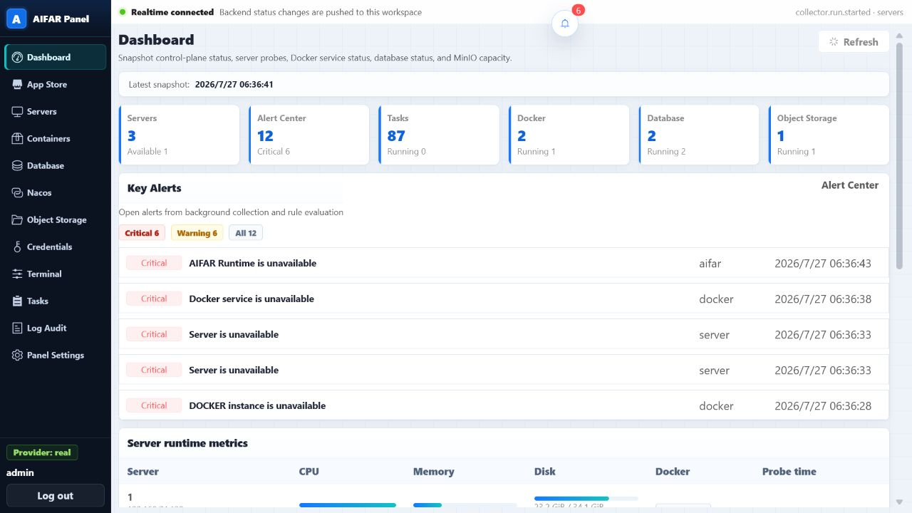
Figure 1. Dashboard monitoring overview: confirm realtime connectivity and the latest snapshot before reviewing alerts and module summaries.
Note The alert shown in this screenshot demonstrates the monitoring entry point. It does not represent the current state of a delivery environment. Always use the timestamp and evidence from your AIFAR environment.

2.2 Monitoring Objects and Evidence Entry Points
Monitoring object | What to review | Additional evidence | Abnormal signals
Servers | Availability, CPU, memory, disk, probe time | Server details and related task logs | Unavailable, Unknown, missing metrics, stale probe time
Docker / Runtime | Instance status, nodes, service or Pod readiness, error summary | Containers, AIFAR Runtime, Tasks | Unavailable, Degraded, insufficient ready count, unchanged status
Databases | Engine, topology, node status, role, latest monitoring time | Database instance details and task logs | Abnormal node, unexpected role, stale monitoring time
Nacos | Instance, topology, node status, latest monitoring time | Nacos instance details and task logs | Unavailable node, Unknown status, stale monitoring time
Object storage | Instance status, nodes, capacity summary, latest monitoring time | Object Storage instance details and task logs | Missing instance, abnormal capacity, abnormal node status
Tasks | Type, target, overall status, steps, target logs | Task details | Failed, no progress, partial target failure
Audit | Time, actor, module, action, target, status, details | Log Audit | Unexpected source, status inconsistent with the task

2.3 Data Freshness
Always interpret UI data together with realtime channel status and the latest collection time.
- Realtime connected and snapshot time continuously updating: continue to the relevant module page.
- Realtime unavailable or snapshot time significantly delayed: record Data may be stale. Do not confirm normal operation or recovery.
- Timestamps differ between pages: record each timestamp and use the collection time closest to the affected object as the primary evidence.
- Counts or status conflict with task records: preserve evidence from both locations and escalate instead of choosing one as correct.

3. Daily Inspection

3.1 Server Inspection
Server inspection focuses on reachability, metric completeness, and collection freshness. It does not include server configuration changes.
- Compare the server count with the current duty roster or environment baseline.
- Review each server's status, CPU, memory, disk, and Docker status.
- Record the affected server identifier, displayed state, latest probe time, and missing metrics.
- Determine whether the issue affects one server, several servers in the same location, or all servers.
- Review Tasks for work associated with the same server and time window.

3.2 Docker and AIFAR Runtime Inspection
Distinguish between Docker runtime unavailability, an abnormal AIFAR Runtime instance, and an individual service or Pod that is not ready.
- Confirm that the Docker summary is present and that the node count matches the environment baseline.
- Review the overall AIFAR Runtime instance state and the latest collection time.
- Compare total, ready, and abnormal service or Pod counts and review the error summary.
- For each affected service, record the service name, node, displayed state, and first observed time.
- Review recent tasks for the same instance and identify failed steps or failed targets.
Note The presence of an instance record in the control plane only means that AIFAR has stored the object. It does not prove that every container, service, or business path has passed acceptance.

3.3 Database Inspection
- Review the number, engine type, and topology of registered MySQL, Redis, and other database instances.
- Confirm node count, node status, role, and latest monitoring time.
- Determine whether one node or the entire topology is affected.
- For a role or status issue, record the instance, node, expected role, displayed role, and timestamp.
- If the instance page conflicts with a recent task result, preserve both the instance-page evidence and the task evidence.

3.4 Nacos Inspection
- Review the number of Nacos instances, topology, node count, and latest monitoring time.
- Confirm that node status is complete and identify Unknown, Unavailable, or long-unchanged records.
- Record the instance, affected node, displayed status, latest monitoring time, and related task.
- Do not modify configuration content. If a business team reports a configuration-related issue, record only the Data ID, namespace, group, and time, and redact the content.

3.5 Object Storage Inspection
- Review registered MinIO instances, node status, and latest monitoring time.
- Review capacity or runtime summaries for unusual changes and record the relevant time window.
- Distinguish instance runtime status from control-plane records for buckets, objects, users, and related items. Control-plane records do not replace storage validation.
- If the page is empty, record No registered instance or No data returned. Do not conclude that no storage service exists in the field.

3.6 Task and Audit Inspection
- Review failed tasks, tasks with no recent progress, and tasks with partial target failures.
- Confirm that every critical alert has corresponding evidence on a module page, in Tasks, or in Log Audit.
- Verify that recent operation sources match the approved change window and authorization plan.
- If an alert or audit entry cannot be correlated, record its time, module, action, target, and status, then escalate.

4. Status Interpretation

4.1 Common Status Meanings
Status | How to interpret it | Additional evidence | Can it confirm normal operation?
Normal / Available | The latest collection did not detect a known issue | Latest snapshot, object details, required business verification | No
Running | A task or process is in progress and has not reached a final result | Start time, current step, target progress, latest log time | No
Unknown | AIFAR does not have enough information to determine status | Realtime connectivity, latest collection, related tasks and logs | No
Degraded | Part of the capability or topology is abnormal while some service may remain available | Affected nodes, ready ratio, impact scope, error summary | No
Abnormal / Failed | A collector detected an error or a task did not complete | First failed step, failed target, error context, logs | No
Unavailable | The latest collection indicates that the object cannot provide the expected capability | Object, time, related modules, impact scope | No
Cancelled | The task did not complete and must not be treated as successful | Cancellation time, completed steps, incomplete targets, audit source | No

4.2 Avoiding False Conclusions
- A cleared alert does not prove recovery. Confirm the object state, latest collection time, and business verification result.
- A successful task record does not prove end-to-end acceptance. The responsible team must complete business verification.
- No instance shown may mean not registered, no data returned, or a different permission scope. It does not prove that no field service exists.
- When status differs between pages, record Evidence conflict and escalate. Do not ignore one source selectively.
- Timestamps are more important than status colors. A green status without a fresh timestamp may still be stale.

4.3 Impact Scope
Scope | How to identify it | How to record it
Single object | One server, node, service, or task target is affected | Identify the object and comparable healthy objects
Single module | Several objects in one module are affected while other modules appear normal | Record module, object count, and common time window
Multiple modules | Server, Runtime, database, Nacos, or storage issues appear together | Use one incident ID and build a shared timeline
Global or business outage | Multiple critical alerts plus confirmed impact to a core business path | Escalate at high priority and continue adding evidence

5. Troubleshooting Workflow

5.1 Fixed Review Sequence
- Identify the affected object: record the module, instance, server, node, service, or task identifier.
- Confirm data time: record realtime connectivity, latest snapshot, latest monitoring time, and latest log time.
- Review the related task: confirm task type, target, start time, end time, and overall status.
- Find the first abnormal step: identify the earliest failed step or the point where progress stopped.
- Identify the failed target: use target groups to distinguish one node, several nodes, or every target.
- Read the error context: preserve the error summary with the necessary log lines before and after it.
- Recheck the module page and audit record: compare the current object state with operation sources in the same time window.
Important Troubleshooting ends with reproducible facts, a defined impact scope, and an escalation package. It does not end with an unauthorized attempt to change system state.

5.2 What to Review in Tasks
Tasks helps convert a page-level symptom into a traceable sequence: which task, which step, which target, and which error at what time.
- Task list: confirm task type, creation time, target module, and overall status.
- Task steps: identify the first abnormal step and record its name and status.
- Target groups: determine whether failure is concentrated on one server or node.
- Task logs: preserve error context, latest log time, and key correlation identifiers.
- Module recheck: return to the relevant module and compare its current status with the task result.
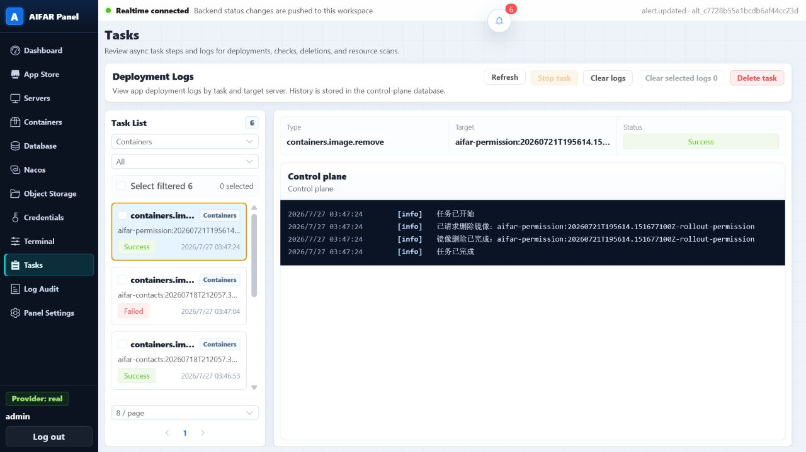
Figure 2. Tasks evidence entry point: use the task list, selected task summary, and log pane for read-only review. Historical log content retains the language used when the task was created.

5.3 Reading Logs
- Record the task ID, target ID, step name, and log time range first.
- Find the first explicit error instead of copying only the final summary line.
- Preserve the necessary context before and after the error so that the trigger is not lost.
- Summarize repeated stack traces as first occurrence, last occurrence, and repetition count or time range.
- Redact accounts, addresses, connection strings, tokens, keys, and business data.

5.4 Correlating Audit Records
Log Audit answers who initiated which action against which object, when it occurred, and what result was recorded. Review time, actor, module, action, target, provider, status, and details.
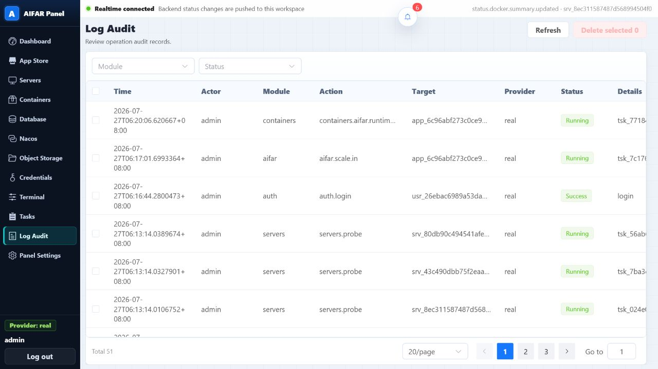
Figure 3. Log Audit evidence entry point: correlate time, actor, module, action, target, status, and details within the incident window.
- Compare audit time with alert, task, and module-page timestamps on one timeline.
- Use the target identifier to correlate tasks and business objects, but redact it as required before external sharing.
- If audit status is successful while the task or module is abnormal, record Control-plane result differs from runtime state.
- If no related audit record is found, preserve the query conditions, time window, and page result, then escalate.

6. Common Troubleshooting Scenarios

6.1 Page Status Is Not Updating or Data May Be Stale
Check | Read-only interpretation | Evidence to preserve
Realtime connectivity | Whether the page is connected and status changes continue | Top-bar connection status and timestamp
Latest snapshot | Whether the timestamp is delayed or unchanged | Current time and snapshot time
Cross-page comparison | Whether Dashboard, module pages, and Tasks are stale together | Timestamp from each page
User scope | Whether the issue affects one browser, one user, or several users | User scope and reproduction time

Record the conclusion as Current page data may be stale; the actual object state is not yet confirmed. Escalate to platform operations or the implementation team to verify the collection path.

6.2 Server Shows Unknown or Unavailable
- Record the server identifier, displayed status, latest probe time, and missing metrics.
- Compare other servers in the same time window.
- Review related tasks, steps, and target logs for the same server.
- Record whether Docker, Runtime, or several module alerts occurred at the same time.
- If several servers are affected, escalate as a multi-module or global issue to infrastructure and implementation teams.

6.3 Docker or AIFAR Runtime Is Abnormal
- Distinguish an unavailable Docker summary, an abnormal Runtime instance, and individual services or Pods that are not ready.
- Record the instance, node, service or Pod, total count, ready count, error summary, and time.
- Review recent tasks for the same instance and determine whether failures are concentrated on one target.
- Compare the Servers page for Docker status or resource-metric abnormalities at the same time.
- Submit Runtime status, task steps, target logs, and server status as one incident evidence set.

6.4 Database, Nacos, or Object Storage Is Abnormal
- Record the module, instance, topology, affected node, displayed status, and latest monitoring time.
- Compare healthy nodes in the same topology and identify whether one node or the whole topology is affected.
- Review related tasks and audit records in the same time window.
- For object storage, distinguish instance runtime status from control-plane records. A stored record does not prove storage availability.
- Do not copy complete connection information or configuration content. Preserve only redacted object identifiers and error summaries.

6.5 Task Failed or Has No Recent Progress
- Record task type, task ID, target, start time, displayed status, and latest log time.
- Identify the first abnormal step and failed target, and state whether the remaining targets are healthy.
- Preserve the error context and necessary surrounding logs instead of sending a single failure line.
- Return to the module page and record the current object state to determine whether runtime status is affected.
- Raise escalation priority when similar tasks fail repeatedly or several targets fail together.

6.6 Terminal Page Cannot Establish a Connection
- Record the selected server, page message, occurrence time, and whether the issue affects only one server.
- Review the server status, latest probe time, and related task records.
- Compare whether other authorized users see the same behavior and record the affected user scope.
- Do not attempt terminal operations under this manual. Hand off the connection issue to infrastructure or the implementation team.

7. Evidence Collection and Escalation

7.1 Minimum Evidence Package
Category | Required content | Redaction requirement
Incident information | Detection time, duration, reporter, environment, incident ID | Exclude personal data
Business impact | Affected function, user scope, duration, reported symptom | Do not attach production data content
UI status | Realtime connection, latest snapshot, module, object, status, alert | Mask addresses according to the agreed rule
Task evidence | Task type, task ID, status, first abnormal step, failed target | Redact identifiers as agreed
Log evidence | Time range, error summary, necessary context, latest log time | Remove passwords, tokens, keys, and complete connection strings
Audit evidence | Time, actor, module, action, target, status | Share actor and target only when necessary
Comparison | Healthy peer, before/after timestamps, other-page status | Do not widen the disclosure scope

7.2 Escalation Criteria
- Critical alerts affect several servers, nodes, or modules.
- AIFAR Runtime, database, Nacos, or object storage is Unavailable or remains Degraded.
- UI data exceeds the agreed freshness threshold and cannot support a reliable conclusion.
- Similar tasks fail repeatedly, several targets fail together, or logs show no new progress.
- Control-plane status, task result, audit record, and business symptom conflict.
- The business team confirms a core-path outage, data-consistency risk, or security risk.
- Further investigation requires any change permission, configuration content, or terminal operation.

7.3 Suggested Escalation Owners
Symptom | Primary owner | Also notify
Several servers unavailable or common resource-metric issue | Your infrastructure team | AIFAR implementation team
Docker, Runtime, task, or collection-path issue | AIFAR implementation or platform operations team | Your incident owner
Database, Nacos, or object-storage node/topology issue | Responsible component team | AIFAR implementation team
Unexpected audit source or security risk | Your security and authorization administrator | Incident owner and AIFAR implementation team
Business outage with multi-module alerts | Your incident owner | All relevant component owners

7.4 Escalation Message Template
Incident ID: [enter]
Detection time and time zone: [enter]
Environment and impact scope: [enter]
Current business symptom: [enter]
Realtime connectivity and latest snapshot: [enter]
Affected module and object: [enter]
Task, first abnormal step, and failed target: [enter]
Error summary and log time range: [enter]
Related audit record: [enter]
Attached redacted evidence: [screenshots, log excerpts, timeline]
Requested assistance: [question for the responsible team]

8. Inspection and Incident Record Templates

8.1 Daily Inspection Checklist
Inspection item | Normal reference | Result | Evidence or notes
Realtime connection and latest snapshot | Connected and timestamps continue updating | [ ] Normal [ ] Abnormal
Critical alerts | No unexplained critical alert | [ ] Normal [ ] Abnormal
Servers | Complete status and metrics, fresh probe time | [ ] Normal [ ] Abnormal
Docker / Runtime | Instance and readiness match the environment baseline | [ ] Normal [ ] Abnormal
Databases | Nodes, roles, and monitoring time match the baseline | [ ] Normal [ ] Abnormal
Nacos | Instances, nodes, and monitoring time match the baseline | [ ] Normal [ ] Abnormal
Object storage | Instance, node, and capacity summary show no abnormality | [ ] Normal [ ] Abnormal
Tasks | No unexplained failed task or task without recent progress | [ ] Normal [ ] Abnormal
Log Audit | Recent operation sources match authorization and window | [ ] Normal [ ] Abnormal

8.2 Incident Timeline
Time | Page or source | Object | Observed fact | Evidence ID
[hh:mm:ss] | [Dashboard/module/task/audit] | [redacted ID] | [facts only] | [screenshot or log ID]
[hh:mm:ss] | [enter] | [enter] | [enter] | [enter]
[hh:mm:ss] | [enter] | [enter] | [enter] | [enter]

8.3 Menu Quick Reference
Menu | Read-only purpose | Common evidence
Dashboard | Detect abnormalities and confirm data freshness | Realtime connection, snapshot, alerts, summaries, metrics
Servers | Confirm the affected server and resource metrics | Status, CPU, memory, disk, probe time
Containers / AIFAR Runtime | Confirm Docker, instance, service, or Pod state | Totals, ready count, nodes, error summary
Database | Confirm instance, topology, node, and role | Status, role, latest monitoring time
Nacos | Confirm instance and node state | Topology, nodes, latest monitoring time
Object Storage | Confirm MinIO instance and runtime summary | Instance, nodes, capacity, monitoring time
Tasks | Locate the abnormal point in a task process | Task, step, target, log
Log Audit | Correlate operation source and result | Time, actor, action, target, status

8.4 Before Shift Handover
- Record every open alert, affected object, and latest status timestamp.
- Add task, log, or audit evidence to every unresolved incident.
- State whether data is fresh and which conclusions still require confirmation.
- Redact every screenshot and log excerpt before sharing.
- Identify the next owner, escalation time, and any pending response.
Note Completion under this manual means that monitoring facts are clear, the evidence chain is complete, the impact scope is defined, and the escalation owner is correct. Authorized owners are responsible for system-state changes and recovery acceptance.

