2026-2027学年第一学期
《高级语言程序设计(C++语言)》
实验报告
实验名称：C++实践课程作业题
实验日期：2026年10月23日 | 实验地点：于刚宋晓楼A237
学 号：2026302192088 | 姓 名：董奕贤
学 院：人工智能学院 | 专 业：人工智能
指导老师：丁建利

一、实验目的

写代码
二、实验环境
Visual studio

- 实验过程及结果
题目1.
#include <iostream>using namespace std;int main() {
double profit, bonus = 0;
cout << "请输入当月利润(万元): ";
cin >> profit;

if (profit <= 10) {
bonus = profit * 0.10;
}
else if (profit <= 20) {
bonus = 10 * 0.10 + (profit - 10) * 0.075;
}
else if (profit <= 40) {
bonus = 10 * 0.10 + 10 * 0.075 + (profit - 20) * 0.05;
}
else if (profit <= 60) {
bonus = 10 * 0.10 + 10 * 0.075 + 20 * 0.05 + (profit - 40) * 0.03;
}
else if (profit <= 100) {
bonus = 10 * 0.10 + 10 * 0.075 + 20 * 0.05 + 20 * 0.03 + (profit - 60) * 0.015;
}
else {
bonus = 10 * 0.10 + 10 * 0.075 + 20 * 0.05 + 20 * 0.03 + 40 * 0.015 + (profit - 100) * 0.01;
}

cout << "应发放奖金总数为: " << bonus << " 万元" << endl;
return 0;
}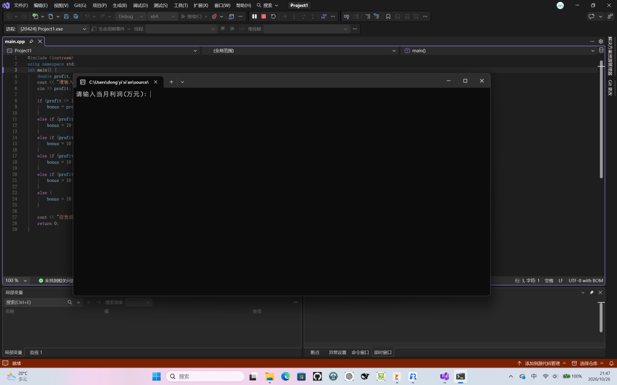
题目2
#include <iostream>using namespace std;
int main() {
int score;
cout << "请输入电影打分(1-10): ";
cin >> score;

if (score >= 9 && score <= 10) {
cout << "经典" << endl;
}
else if (score >= 7 && score <= 8) {
cout << "非常好" << endl;
}
else if (score >= 5 && score <= 6) {
cout << "一般" << endl;
}
else if ( score < 5) {
cout << "烂片" << endl;
}
return 0;
}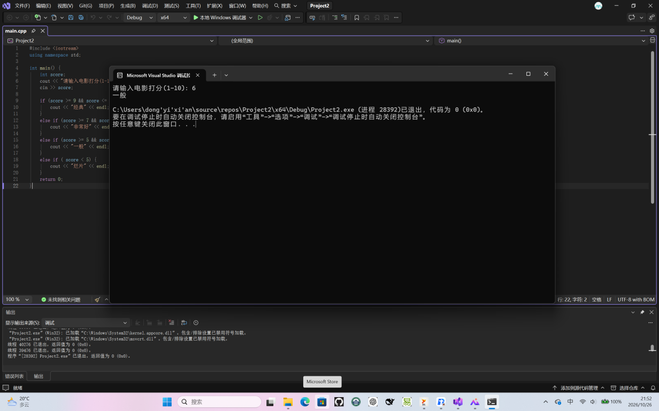
题目3

#include <iostream>using namespace std;
int main() {
long long n;
cin >> n;

if (n < 0) {
cout << "不是回文数" << endl;
return 0;
}

long long original = n;
long long reversed = 0;

while (n > 0) {
int digit = n % 10;
reversed = reversed * 10 + digit;
n = n / 10;
}

if (reversed == original) {
cout << "是回文数" << endl;
}
else {
cout << "不是回文数" << endl;
}

return 0;
}
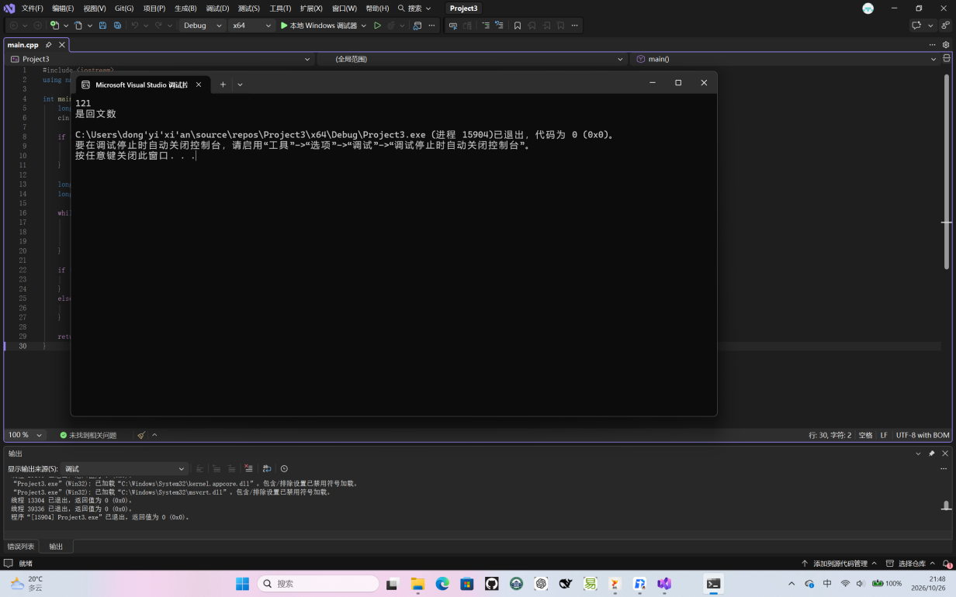
题目4
#include <iostream>using namespace std;int main() {
cout << "所有的三位水仙花数为: ";
for (int i = 100; i <= 999; ++i) {
int hundreds = i / 100;
int tens = (i / 10) % 10;
int units = i % 10;

int sum = (hundreds * hundreds * hundreds) +
(tens * tens * tens) +
(units * units * units);

if (sum == i) {
cout << i << " ";
}
}
cout << endl;
return 0;
}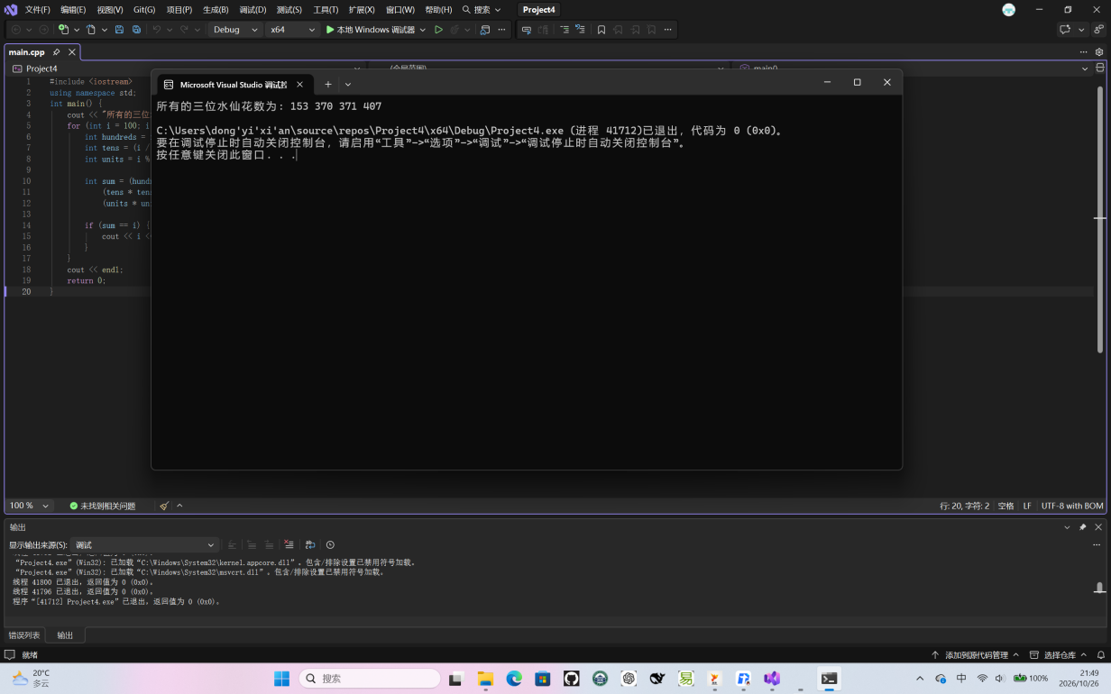
题目5
#include <iostream>using namespace std;int main() {
int a, n;
long long sum = 0;
long long term = 0;

cout << "请输入两个正整数n和a: ";
cin >> n >> a;

for (int i = 0; i < n; ++i) {
term = term * 10 + a;
sum += term;
}

cout << "数列所有项的和为: " << sum << endl;
return 0;
}
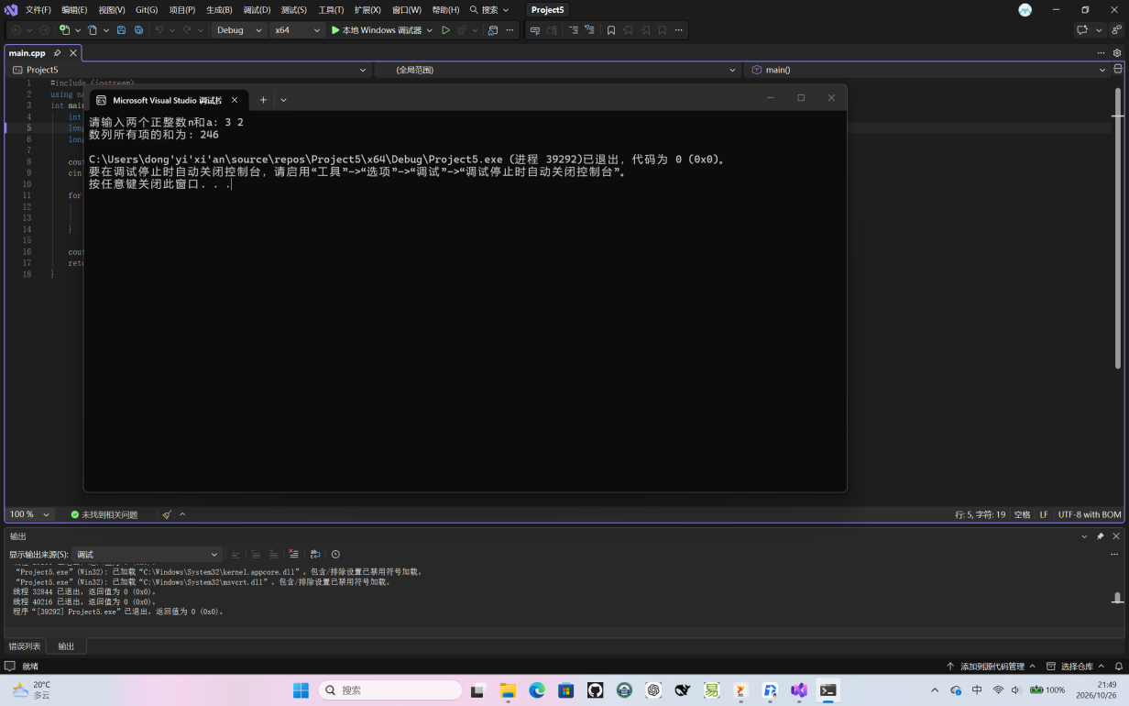
题目6
#include <iostream>using namespace std;int main() {
for (int i = 1; i <= 9; i++) {
for (int j = 1; j <= i; j++) {
cout << j << "*" << i << "=" << i * j << "\t";
}
cout << endl;
}
return 0;
}
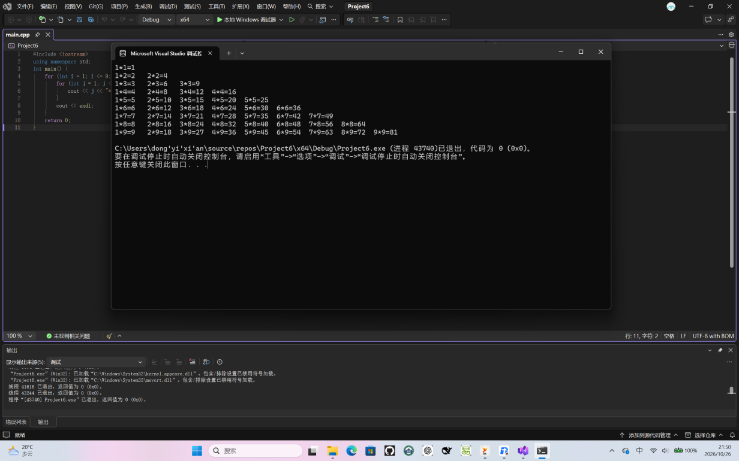
题目7#include <iostream>using namespace std;int main() {
long long f1 = 1, f2 = 1, f3;

cout << "第1个月的兔子总数为: 1 对" << endl;
cout << "第2个月的兔子总数为: 1 对" << endl;

for (int i = 3; i <= 20; ++i) {
f3 = f1 + f2;
cout << "第" << i << "个月的兔子总数为: " << f3 << " 对" << endl;

f1 = f2;
f2 = f3;
}
return 0;
}
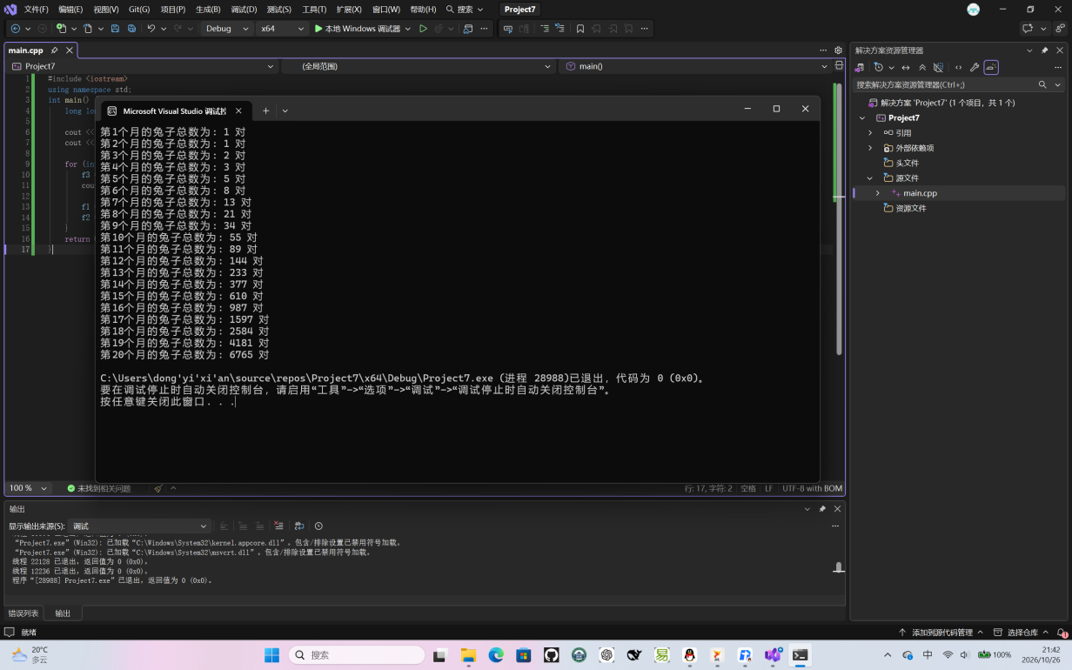
题目8
#include <iostream>using namespace std;int main() {
int peach = 1;

for (int day = 9; day >= 1; --day) {
peach = (peach + 1) * 2;
}

cout << "第一天共摘了 " << peach << " 个桃子" << endl;
return 0;
}
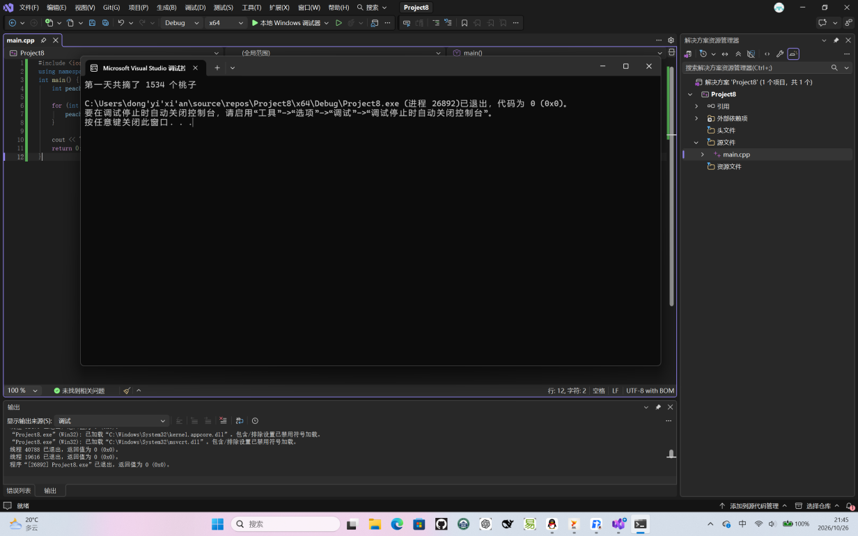

- 实验总结（本次实验的收获、体会、经验和教训）
还是不够熟练，慢慢来吧

