
Making Handling Easier

User
Manual

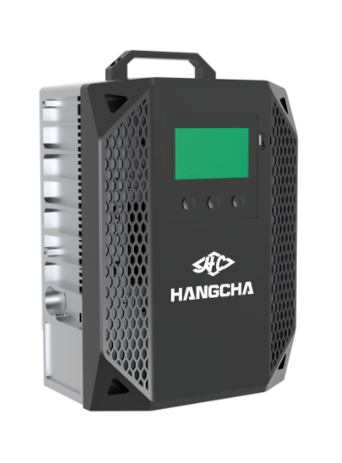

Foreword
By carefully reading the operating instructions, the user can acquire the necessary technical knowledge to safely operate the charger. The operating instructions contain concise and well organized information sections are arranged alphabetically, and page numbers are numbered.
The company will continue to develop chargers therefore, Manufacturing company must
reserve the right to modify the appearance, equipment, and technology. For these reasons, no claims for any device-specific performance may be derived from the contents of these
operating instructions.

Safety notices and text mark-ups

Safety instructions and important explanations are indicated by the following graphics:

⚠ DANGER
Means that failure to comply can cause risk to life and/or major damage to property.

⚠ WARNING
Please strictly adhere to these safety instructions to avoid personal injury or major damage to equipment.

⚠ CAUTION
Please pay attention to the important safety instructions.

 NOTE
Pay attention to Instruction.

ALL RIGHTS RESERVED
2025.10 01st EDITION

Content
Foreword 1
1 General 2
1.1 I ntrod uction 2
1.2 I mportant safety tips 3
1.3 Permissible operating conditions 4
1.4 I ntended use 4
1.5 I mpermissible use 4
1.6 Defin it ion of t he person w ho is used 5
1.6.1 Operator 5
1.6.2 Users 5
1.6.3 Specia list 5
1.6.4 User right,d uties and rules of be haviour 5
1.6.5 Operator Rights, Duties and Code of Conduct 5
2 Charger description 6
2.1 C harger appearance 6
2.2 Feature description 6
2.3 Prod uct Mode l Description 6
2.3.1 Mode l list 6
2.3.2 Mode l Nami ng Rules 7
2.4 Description of how it works 7
2.4.1 C harging flow c hart 7
2.4.2 How it works 8
2.5 Outline d rawi ngs 9
2.6 Tech n ical data s heets 9
2.6.1 E lectrical performance parameter table 9
2.6.2 E lectrical function parameter table 14
2.6.3 Work envi ronment support 14
2.6.4 Safety performance 14
2.7 Nameplates and logotype 15
2.8 Scope of de livery 15
2.9 Enforce t he standard 16
3 Safety 17
3.1 Safety tipsfor i nstallation 17
3.1.1 F i re hazard 17
3.1.2 Water i ngress r is k 17
3.1.3 Stress r is k 17
3.1.4 E lectric s hock r is k 17
3.1.5 I nstallation envi ronmental r is ks 18
3.1.6 Appearance warni ng 19
3.2 Use safety remi nders 20
3.2.1 Pre-use safety remi nders 20

3.2.2 Run and operate safety remi nders 21
3.2.3 Safety remi nder after use 21
3.3 Service Safety Remi nder 22
3.4 Mai ntenance safety tips 22
4 Operation 23
4.1 Installation 23
4.1.1 External Wiring Table 23
4.1.2 Grid safety devices 24
4.1.3 I nstall t he charger 25
4.1.3.1 Pole Mount I nstallation 26
4.1.3.2 Wall Mount I nstallation 28
4.2 Operators Daily C hecklist 30
4.3 Accessibility 31
4.3.1 T he mai n i nterface of t he charger 31
4.3.2 Battery i nformation i nqui ry 32
4.3.3 Functional i nterface 32
4.3.4 Parameter setti ngs 33
4.3.5 C harging record i nterface 34
4.3.6 C harger i nformation i nqui ry 35
4.3.7 Warni ng i nformation query 36
4.3.8 T i med c harging function 37
4.3.9 C harging Protocol Function 38
4.3.10 System T i me Function 39
4.3.11 Download Program Function 40
5 Description of the fault 41
5.1 Fault table 41
5.2 S i mple b reakdown repai rs 41
5.3 Service support 44
6 Waste disposal 44

1 General

1.1 Introduction
This manual must be readily available and kept in a prepared place. This manual is intended for use by all persons who have access to the operating process of the charger, including transportation,
installation and installation, operation, maintenance, and disassembly.

In commercial use, in addition to the operating instructions, the relevant guidelines, regulations, and laws in force in the place of use or the country of use should be followed to ensure safe and
standardized operations.
Information other than this operating manual is provided by a professional on the part of the local distributor or supplier.
All materials are protected by copyright Without express authorization, it is forbidden to retransmit and reproduce the material and its excerpts, to quote and disseminate its contents.
Obligations and Responsibilities of the User of the Equipment: In this Manual, the term "User" refers to any natural or legal person who directly uses or appoints another person to use the Equipment In
special cases such as rental, sale or rental, "Equipment User" represents a party that has specific operational obligations under the terms of the contract concluded between the Owner of the Equipment and the User.
In addition, the user of the equipment must strictly comply with the provisions for the prevention of accidents, other safety technical regulations, and guidelines for the use, maintenance and repair of the equipment The user must ensure that all operators carefully read and fully understand the contents of this manual.
The Company shall not be liable for any damages arising from the improper operation of the
equipment by the customer or the user of the equipment or a third party without the permission of the Company's customer service department.
If additional equipment needs to be installed or added, and if it affects or complements the
functionality of the equipment, prior written consent must be obtained from the local distributor and, depending on the actual situation, approval from the relevant certification body may also be required.

1.2 Important safety tips

The charger is produced in accordance with EU directives and state-of-the-art technology and provides additional safety tips to ensure the absolute safety of personnel.
⚠ DANGER
• The following conditions can result in serious personal and property damage：
• Improper use or incorrect operation.
• Turn on the charger without permission.
• Installation errors or improper maintenance and repairs .
• Replace the input and output wires without permission.
• Charge the damaged battery.

⚠ DANGER
Attention must be paid to and all instructions contained in this operating instruction regarding proper use, residual risks, installation, operation, and maintenance.
⚠ WARNING
Dangerous voltage warning
Chargers are electrical devices in which voltage and current can endanger personal safety:
• The charger should only be operated by a trained and authorized professional.
• Before intervening in the charger or working on the charger, the power supply should be disconnected and if necessary, the battery should be disconnected.
• The charger can only be opened and repaired by local distributor Customer Service.

⚠ WARNING
Damage or other defects in the charger can lead to accidents
If it is determined that there are safety-related changes, damage, or other defects in the charger or in performance, the charger must not be used until repairs have been carried out in accordance with the Regulations:
• Identified deficiencies must be reported to the local distributor immediately.
• Mark the damaged charger and deactivate it.
• The charger should only be reused after the fault has been identified and troubleshooting.

⚠ CAUTION
This charger is not suitable for use by:Persons (including children) with impairments in physical,
sensory, or mental abilities, or lack of electrical experience and knowledge system and battery charging unless someone supervises or instructs them in using the charger Be responsible for their safety
Children should be supervised to ensure they are not playing with the charger.

1.3 Permissable operating conditions
This series of charger should be installed in an environment free from direct sunlight, corrosive gases, flammable gases, oil, mold, etc., and free from sudden temperature changes that could cause
condensation. If installed outdoors, the exterior must be protected from wind, rain, and direct sunlight. Any installation that does not comply with these regulations may result in personal injury, equipment damage, or other property loss.:
• The rated operating input voltage range, frequency range, maximum input current, and input power are all specified in detail on the nameplate .
• The rated working output voltage range, current range, and constant power are all specified in detail on the nameplate.
• Used in industrial environments .
• Keep at least 20 cm of space around all sides.
• The working temperature range is between -40°C and 55°C, >55℃ reduce power .
• The altitude should not exceed 2000 m .
• Input voltage fluctuation range of ± 15% .
• Storage temperature: -40°C~85°C.
Note: When the environmental conditions exceed the above range, you should contact us in advance to negotiate and solve.

1.4 Intended use
• Damage and other defects to the charger or accessories must be reported to the supervisor
immediately. Chargers and accessories that are not safe to operate should not be used until they have been properly serviced.
• Safety installations and switches may not be removed or rendered unusable. Specified settings may only be changed with the approval of the local distributor.
• The charger must not use more than the limit set by the local distributor, and the fluctuation range must not exceed ± 15%.
• Warning signs need to be added to the charger working area.
• In order to maintain LVD compliance with EMC, any replacement of exterior parts requires prior contact with the local distributor.
• When using the utility grid, the regulations must be followed, as well as country-specific restrictions for winter.

1.5 Impermissible use
• If the charger is used in a way that is not permitted, the user, not the local distributor, is responsible. The following list is for informational purposes only and is not intended to be exhaustive:
• Charge commercial batteries.
• Charge non-local distributor brand batteries.
• Modify or destroy safety devices.
• Modification or replacement of unauthorized parts.
• Extend or shorten the AC/DC end cable.
• The usage environment is beyond the scope of Section 1.3.
• Personnel have not undergone safety training or have not consulted the instructions for operation.

1.6 Definition of the person who is used

1.6.1 Operator
The charger should only be operated by a person who is at least 18 years of age, has been trained in electrical safety and operational safety, and who demonstrates their basic electrical skills to the user or an authorized representative. It is also necessary to have a specific understanding of the working logic of the charger to be used.

1.6.2 Users
The user is the natural person or legal entity responsible for pumping the charger. Users can operate the charger themselves or delegate the task of operating the charger to someone else, such as an
operator. In the case of specific cases such as rentals, the liability is borne by the user in accordance with a valid contract between the owner of the car and the operator of the charger.

1.6.3 Specialist
A qualified person is defined as a service engineer or a person who meets the following requirements:
• Full professional qualifications that demonstrate their expertise. The certificate should include a professional qualification or similar document.
• Professional experience shows that the qualified person has gained hands-on experience with the charger during their career During this time, the person has become familiar with the various
symptoms that need to be examined, such as based on the results of hazard assessments or routine inspections.
• Recent professional involvement in the field of relevant charger testing or R&D and appropriate further qualification is essential. Qualified personnel must have experience in conducting relevant tests or conducting similar tests.
• In addition, the person must be aware of the latest technological developments and the risks being assessed for the charger to be made.

1.6.4 User right,duties and rules of behaviour
Everyone operating the charger has read and understood this manual and has been approved with the relevant charger operator training. Operate the charger in a safe manner so as not to endanger the life and health of the operator and/or others. Follow all warnings and instructions in this
manual This manual is available for use by the operator.

1.6.5 Operator Rights, Duties and Code of Conduct
For the purposes of these operating instructions, the operating company is defined as any natural or
legal person who uses the charger on its own or on its behalf. In exceptional cases (e.g. lease or rental). The operating company is considered to be a person who performs specific operational duties under an existing contractual agreement between the charger owner and the operator.
The operating company must ensure that the charger is used only for its intended purpose and to
prevent danger to the health and safety of the operator and third parties. In addition, accident
prevention regulations, safety regulations, and operation, maintenance, and repair guidelines must be complied with. The operating company must ensure that all operators have read and understood
these operating instructions

2 Charger description

2.1 Charger appearance


2.2 Feature description
This portable charger supports wall mounting and boasts advantages such as a compact design, high conversion efficiency, wide input voltage range, and flexible single-phase/three-phase switching.
Equipped with an intelligent touchscreen, it allows users to set voltage and current on the screen, view charging records, and make charging reservations. The charger adopts forced-air cooling and provides comprehensive protection, including input overvoltage/under-voltage, output overvoltage /
undervoltage, overcurrent, short-circuit protection, and fan failure protection etc.

2.3 Product Model Description

2.3.1 Model list

HCF(CE)A-48200-R | HCF(UL)A-48200-R | HCF(UL)C-48200-R
HCF(CE)A-48200-G | HCF(UL)A-48200-G | HCF(UL)C-48200-G
HCF(CE)A-48250-R | HCF(UL)A-48250-R | HCF(UL)C-48250-R
HCF(CE)A-48250-G | HCF(UL)A-48250-G | HCF(UL)C-48250-G
HCF(CE)A-80150-R | HCF(UL)A-80150-R | HCF(UL)C-80150-R
HCF(CE)A-80150-G | HCF(UL)A-80150-G | HCF(UL)C-80150-G
HCF(CE)A-80200-R | HCF(UL)A-80200-R | HCF(UL)C-80200-R
HCF(CE)A-80200-G | HCF(UL)A-80200-G | HCF(UL)C-80200-G
HCF(CE)A-96160-R | HCF(UL)A-96160-R | HCF(UL)C-96160-R
HCF(CE)A-96160-G | HCF(UL)A-96160-G | HCF(UL)C-96160-G

2.3.2 Model Naming Rules

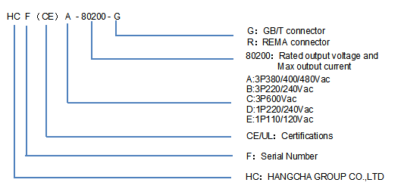

2.4 Description of how it works

2.4.1 Charging flow chart

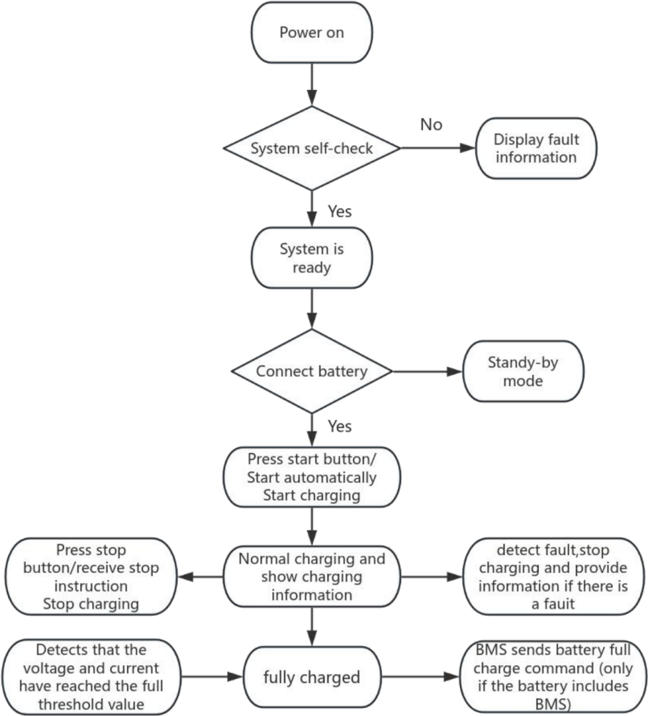

2.4.2 How it works

PFC —>
AC
input
DC
output
Rectification
and filtering
DC DC conversation circuit

PWM control 

MCU
Protection circuit
communication

The implementation principle of the high-frequency PFC (Power Factor Correction) module charger generally follows these steps:
Input current rectification: Firstly, the AC input power is rectified into a DC power source.
High-frequency conversion: The DC power source is converted into a high-frequency AC power source, typically achieved through high-frequency switching power supplies using devices such as MOSFETs.
PFC control: The PFC controller monitors the input current and voltage and controls the high-
frequency switch to minimize the phase difference between the input current and voltage, thereby maximizing the power factor.
DC-DC conversion: The power source, after power factor correction, enters a DC-DC converter to
convert the high-frequency AC power into the desired DC voltage. This typically involves an inductor, a capacitor, a switching element (such as a MOSFET), and control circuitry.
Control and protection: The charger also includes control and protection circuits to ensure that the output voltage and current are within safe ranges and to monitor various conditions during the
charging process, such as overvoltage, overcurrent, overtemperature, etc., and take appropriate measures to protect the charger and battery.

2.5 Outline drawings

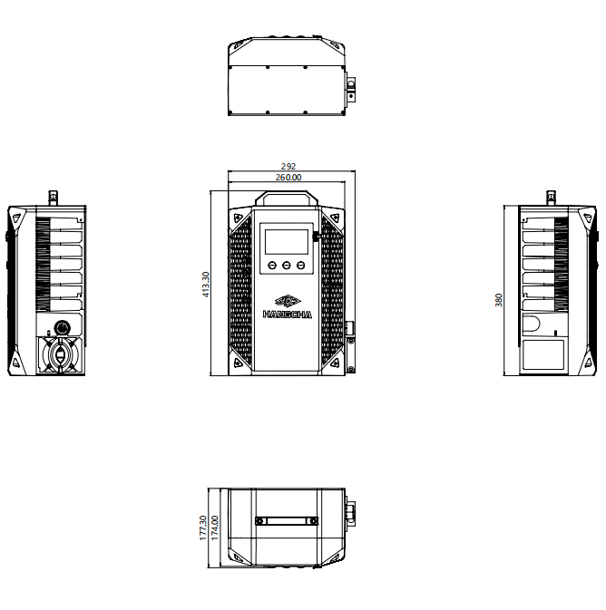

NOTE: ALL STANDARD SIZES ARE IN MM

2.6 Technical data sheets

2.6.1 Electrical performance parameter table

AC input | HCF(CE)A-48200-R | HCF(CE)A-48200-G | HCF(CE)A-48250-R | HCF(CE)A-48250-G | HCF(CE)A-80150-R | HCF(CE)A-80150-G
Input Voltage | 3P 220-480VAC(3P+PE/3P+PE+N）
Max. input current | 30A
Input frequency | 45-65HZ
Max. Input power | 21KW@3P 480VAC  11KW@3P 220VAC
Power factor | >0.99
X capacity | 0.68 µF
Y capacity L1 PE | 15.1nFX3

DC output
Suitable for Lithium Batteries | 48V |  | 48V |  | 80V
Suitable for Lead- Acid Batteries | 48V |  | 48V |  | 84V
Output Voltage range | 20-66VDC |  |  |  | 35-115VDC
Charging voltage accuracy | 0.5%
Charging current accuracy | 0.5%FS
Max. charging current  @3P380/440/480VAC | 200A |  | 250A |  | 150A
Max. charging  power  @3P380/440/480VAC | 14KW |  | 20KW
Max. charging  power  @3P220VAC | 10KW
Efficiency | Up to 95%
Communication | CANBus (Standard)  CCS1/CCS2(Optional)
Weight | 23KG

AC input | HCF(CE)A-80200-R | HCF(CE)A-80200-G | HCF(CE)A-96160-R | HCF(CE)A-96160-G | HCF(UL)A-48200-R | HCF(UL)A-48200-G
Input Voltage | 3P 220-480VAC(3P+PE/3P+PE+N）
Max. input current | 30A
Input frequency | 45-65HZ
Max. Input power | 21KW@3P 480VAC  11KW@3P 220VAC
Power factor | >0.99
X capacity | 0.68 µF
Y capacity L1 PE | 15.1nFX3

DC output
Suitable for Lithium Batteries | 80V |  | 96V |  | 48V
Suitable for Lead- Acid Batteries | 84V |  | 96V |  | 48V
Output Voltage range | 35-115VDC |  | 40-132VDC |  | 20-66VDC
Charging voltage accuracy | 0.5%
Charging current accuracy | 0.5%FS
Max. charging current  @3P380/440/480VAC | 80A |  | 160A |  | 200A
Max. charging  power  @3P380/440/480VAC | 20KW |  |  |  | 14KW
Max. charging  power  @3P220VAC | 10KW
Efficiency | Up to 95%
Communication | CANBus (Standard)  CCS1/CCS2(Optional)
Weight | 23KG

AC input | HCF(UL)A-48250-R | HCF(UL)A-48250-G |  | HCF(UL)A-80150-R | HCF(UL)A-80150-G | HCF(UL)A-80200-R | HCF(UL)A-80200-G
Input Voltage | 3P 220-480VAC(3P+PE/3P+PE+N）
Max. input current | 30A
Input frequency | 45-65HZ
Max. Input power | 21KW@3P 480VAC  11KW@3P 220VAC
Power factor | >0.99
X capacity | 0.68 µF
Y capacity L1 PE | 15.1nFX3

DC output
Suitable for Lithium Batteries | 48V |  | 80V
Suitable for Lead- Acid Batteries | 48V |  | 84V
Output Voltage range | 20-66VDC |  | 35-115VDC
Charging voltage accuracy | 0.5%
Charging current accuracy | 0.5%FS
Max. charging current  @3P380/440/480VAC | 250A |  |  | 150A |  | 200A
Max. charging  power  @3P380/440/480VAC | 20KW
Max. charging  power  @3P220VAC | 10KW
Efficiency | Up to 95%
Communication | CANBus (Standard)  CCS1/CCS2(Optional)
Weight | 23KG

AC input | HCF(UL)A-96160-R | HCF(UL)A-96160-G | HCF(UL)C-48200-R | HCF(UL)C-48200-G | HCF(UL)C-48250-R | HCF(UL)C-48250-G
Input Voltage | 3P 220-480VAC  (3P+PE/3P+PE+N） |  | 3P 600VAC  (3P+PE/3P+PE+N）
Max. input current | 30A |  | 20A
Input frequency | 45-65HZ
Max. Input power | 21KW@3P 480VAC  11KW@3P 220VAC |  | 21KW@3P 600VAC
Power factor | >0.99
X capacity | 0.68 µF |  | 0.47µF
Y capacity L1 PE | 15.1nFX3

DC output
Suitable for Lithium Batteries | 96V |  | 48V
Suitable for Lead- Acid Batteries | 96V |  | 48V
Output Voltage range | 40-132VDC |  | 20-66VDC
Charging voltage accuracy | 0.5%
Charging current accuracy | 0.5%FS
Max. charging current  @3P380/440/480VAC | 160A |  | 200A |  | 250A
Max. charging  power  @3P380/440/480/600VAC | 20KW |  | 14KW |  | 20KW
Max. charging  power  @3P220VAC | 10KW |  | ~
Efficiency | Up to 95%
Communication | CANBus (Standard)  CCS1/CCS2(Optional)
Weight | 23KG

AC input | HCF(UL)C-80150-R | HCF(UL)C-80150-G | HCF(UL)C-80200-R | HCF(UL)C-80200-G | HCF(UL)C-96160-R | HCF(UL)C-96160-G
Input Voltage | 3P 600VAC(3P+PE/3P+PE+N）
Max. input current | 20A
Input frequency | 45-65HZ
Max. Input power | 21KW@3P 600VAC
Power factor | >0.99
X capacity | 0.47 µF
Y capacity L1 PE | 15.1nFX3

DC output
Suitable for Lithium Batteries | 80V |  |  |  | 96V
Suitable for Lead- Acid Batteries | 84V |  |  |  | 96V
Output Voltage range | 35-115VDC |  |  |  | 40-132VDC
Charging voltage accuracy | 0.5%
Charging current accuracy | 0.5%FS
Max. charging current  @3P380/440/480VAC | 150A |  | 200A |  | 160A
Max. charging  power  @3P380/440/480VAC | 20KW
Efficiency | Up to 95%
Communication | CANBus (Standard)  CCS1/CCS2(Optional)
Weight | 23KG

2.6.2 Electrical function parameter table

Name  Model | HCF 20KW
Phase-loss protection | V | V | V
Input undervoltage protection | V | V | V
Input overvoltage protection | V | V | V
Output undervoltage protection | V | V | V
Output overvoltage protection | V | V | V
Input overcurrent protection | V | V | V
Short-circuit protection | V | V | V
Reversepolarity protection | V | V | V

2.6.3 Work environment support

Name  Model | HCF 20KW
Voltage adaptive（%） | ± 15 | ± 15 | ± 15
Work Scenario | indoor | indoor | indoor
Protection Level | IP65 | IP65 | IP65
Operating temperature (℃) | -40-55 | -40-55 | -40-55
elevation（*m） | 4000 | 4000 | 4000

2.6.4 Safety performance

Name  Model | HCF 20KW
Dielectric voltage withstand | Input to chassis 2120 VAC, 1  minute, leakage current <30 mA | No discharge  tube test; no arcing, no  breakdown
Dielectric voltage withstand | Input to output 2120 VAC, 1  minute, leakage current <30 mA
Dielectric voltage withstand | Output to chassis 500 VDC, 1  minute, leakage current <30 mA
Insulation resistance(Ω) | Insulation resistance: Input to output ≥ 10 MΩ; Output to  chassis >5 MΩ | Tested at 500V DC, 25°C

2.7 Nameplates and logotype

Intelligent Charger
Model: HCF-80200-R
Input: 220-480Va.c. , 3P+PE, 50/60Hz, 30A Max.
Output: 60-100V , 200A Max., 20KW Max.
Protective class I
IP rating: IP65
Weight:
Serial Number: | Manufacture Date:

First Power ensures a complete quality proof for all raw materials, manufacturing processes and products by means of suitable label and traceability measures.
Traceability shall be organized in such a way that in the event of a defect the following characteristics can be identified at any time:
• Manufacturer
• Production batch
• Serial Number

2.8 Scope of delivery

Meaning | Pieces | llustration
Mains charger | 1
Manual | 1
TF card/card reader | 1

2.9 Enforce the standard
The charger is designed and manufactured in accordance with the technical specifications that have obtained the following technical certifications Therefore, when used correctly, it does not pose a
threat to the safety and health of operators or third parties.
The charger is CE marked The necessary isolation spacing must be observed All circuits use primary and secondary protection devices, which are protected by a set current intensity and trigger
characteristics.
All live components are supplied with a casing or a cover that can only be loosened with a tool All cables and plugs are shielded and grounded as specified.
All metal parts are grounded by a ground wire system.
The charger is equipped with a CAN safety function that prevents the battery from overcharging by means of information recognition.

Standard table

serial  number | Standard number | Standard name
1 | IEC EN 62477 | Safety requirements for power electronic converter systems and equipment –Part 1: General
2 | IEC 60512-6-4:2002 | Dynamic stress test
3 | IEC 68-2-27 | Impact test
4 | IEC 61000-4-2 | Electromagnetic Compatibility Test & Measurement Technology Electrostatic Discharge Immunity Test
5 | IEC 61000-4-3 | Electromagnetic Compatibility Test & Measurement  Technology RF Electromagnetic Field Radiated Immunity Test
6 | IEC 61000-4-4 | Electromagnetic Compatibility Test and Measurement Technology Electrical Fast Transient Burst Immunity Test
7 | IEC 61000-4-5 | Electromagnetic Compatibility Test & Measurement Technology Surge (Shock) Immunity Test
8 | IEC 61000-4-6 | Electromagnetic Compatibility Test & Measurement Technology RF field-induced immunity to conducted disturbances
9 | IEC 61000-4-11 | Electromagnetic compatibility test and measurement technology voltage
10 | IEC 61000-6-2 | Common Criteria - Immunity to Industrial Environments
11 | IEC 61000-6-4 | General Criteria - Emission standards for industrial environments
12 | IEC 60529:2001 | Enclosure rating
13 | EN 50699 | Recurrent Tests of Electrical Equipment
14 | UL1564 | Industrial battery chargers
15 | CSA-C22.2 no.107.2-01 | battery chargers
17 | CEC-400-2017-002 | 2016 APPLIANCE EFFICIENCY REGULATIONS
18 | FCC part 15 | part15-radio frequency devices

3 Safety

3.1 Safety tips for installation

3.1.1 Fire hazard

⚠ DANGER
• There must be no flammable materials near the charger Included shipping and packaging materials are included:
• There must be no flammable materials within 2.5 m of the charger.
• The horizontal distance between the charger and the combustible material is at least 2.5 m It is forbidden to store flammable materials (e g on shelves) above the charger or to use flammable
building materials The distance from areas with a risk of fire, explosion and explosives must be at least 5 m .

3.1.2 Water ingress risk

⚠ DANGER
There must not be any liquid in the vicinity of the charger. Do not place any liquid on top of the charger.

3.1.3 Stress risk
⚠ DANGER
• Avoid the charger exceeding the stress level and do not place anything on top of the charger.
• Electrical installation according to uniform regulations (wire cross-sections, safety devices, ground connections)Avoid the input and output stress of the charger exceeding the range, and do not
modify any parameters of the cable (including length, wire diameter, voltage carrying range, etc.) without the authorization of the local distributor.Before electrical installation, please check the
parameters on the nameplate (voltage/frequency/current, etc.) and compare them with the
performance parameters of the power connector. Prevent the charger from ultra-high stress ranges (voltage, frequency, and current) by connecting the grid safety device in series.

3.1.4 Electric shock risk
⚠ DANGER
• Missing or improperly designed leakage protection devices can lead to a risk of electric shock and fire .
• Missing or poorly designed residual current protection devices can cause fatal injuries by causing
electric shock or fire in the event of a malfunction necessary, use Type B or B+RCD (Residual Current Device, RCD).
• In order to operate the charger, the location of use must have a grid interface The supply voltage and frequency must match the instructions on the rating plate (see the section "Identification and Labeling on the Charger") As specified, grid interfaces must be properly grounded .
• The charger must be protected from excessive contact voltages according to the regulations of the local power supply unit (EVU) .
• If the power cord of the charger is damaged, it must be replaced by the local distributor or its customer service department or appropriate qualified personnel to avoid danger.

3.1.5 Installation environmental risks
⚠ WARNING
• The side distance to the next charger is at least twice the width of the charger If t he spacing to the next charger cannot be respected, the chargers need to be staggered.
• Please install the charger in a vertical position, and there are no foreign objects around the fan to prevent the fan from getting foreign objects inside the charger when working Do not allow
horizontal installation.
• Maintain a minimum lateral distance of 0,5 m from the next wall.
• Do not install this charger in a commercial environment.
• Fire extinguishing equipment must be prepared around the charger.
• Ensure optimal ventilation of the charger：
• When installing/installing the charger, you should pay attention to:
– No corrosive gases, e g acid gases,
– No conductive dust, such as soot or metal dust,
– No excessive non-conductive dust is deposited,
– No water should enter the inside of the charger
• Pay attention and comply with the regulations set by the battery local distributor.
• In addition to the restrictions on the choice of installation site mentioned in this operating
instruction national regulations must be observed.

3.1.6 Appearance warning

⚠ WARNING

The charger has an IP 65 degree of protection against Moisture Ingress.  This is identified by the character 5957 in accordance with IEC 60417. | 
Please read the operating instructions carefully before use The  work of the battery and charger should only be carried out by  a professional following instructions The operating instructions must be placed in a prominent location and easily accessible. | 
Avoid open flames or open ignition sources near the battery or charger,and do not smoke. | 
Make sure there is adequate ventilation in the chargingarea and do not disconnect.  Note:Dirty batteries or chargers require personal protective equipment (e.g., protective glasses and gloves). | 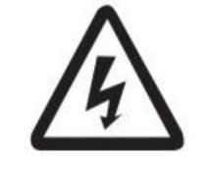
If your charger is not working poperly,you will face many dangers Such as electrical hazards due to mains currents or hazards due to Other causes should be repaired immediately by an authorized Professional.  note: high-performance lithium-ion batteries generate extremely  high short-circuit currents The metal part is always live, so do not place foreign objects or tools on the battery Take care to comply with accident prevention regulations such as D IN EN 62485-3. | 
Pay attention to the correct use of the charger as prescribed  Otherwise it may lead to greater danger Unprofessiona l or  incorrect use will invalidate the product Do not cover the charger in any form during charging In addition, it is necessary to pay attention to the installation instructions | 
Used chargers are hazardous waste and require special disposal Do not dispose of this product in household waste In accordance with the European WEEE Directive 2012/19/EU on waste electrical and electronic equipment (which has been transposed into national law) used power tools must be collected separately and recycled in an environmentally friendly manner Be sure to return your used charger to the dealer or get information about your local authorized collection and disposal system | 

3.2 Use safety reminders

3.2.1 Pre-use safety reminders

⚠ DANGER
• Check before each use of the charger.
• The space for forklift charging should be kept fully ventilated.
• There is no clogging of the fan and no foreign objects around None of the vents were blocked
Within a radius of at least 2,5 m around the forklift that needs to be charged, flammable materials and work equipment that could generate sparks must not be placed.
• There are no flammable, explosive, or combustible materials, chemicals, flammable vapors, and other dangerous items in the vicinity of the charger.
• Ensure that the available space around the battery charger is sufficient to provide adequate ventilation and easy access to the cable socket .
• Make sure the charger is not in the environment where any liquid gets in, and do not pour liquid into the charging case or place it on top of the charger.
• Confirm that nothing has been placed on the output cable and input power cord or place it where you can step on it.
• Confirm that there are no defects, cracks, worn, or exposed copper wires inside the output plug and cable, and that the charging output plug is clean and dry, and that there are no dirt, iron filings and other foreign objects inside, and that the cable is not entangled with any items, and that there are no knots.
• Make sure the input and output cables are not scattered and tangled, people may get entangled or trip over the scattered and surrounded cables.
• Confirm that the input plug and wire are free of defects, cracks, wear, or exposed copper wires inside the cable, and that the charging input plug is clean and dry, and that the metal contacts are free of dirt, iron filings and other foreign objects, and that the metal contacts are in a shiny state.
• Whether the grid interface is intact .
• Whether the enclosure is intact or not .

3.2.2 Run and operate safety reminders

⚠ DANGER
• Before connecting the output, make sure that there is no fault information on the charger display Interface.
• Do not connect batteries that cannot be charged.
• Do not connect any commercial batteries.
• It is forbidden to smoke or use an open flame around the battery.
• Make sure that liquid does not flow into the inside of the charger.
• Before connecting the battery, it is essential to check and follow the instructions on the rating. voltage of the allowable battery voltage (see the "Identification and Labeling on the Charger"
section) Place the battery in front of or next to the charger so that the battery plug is within the operating distance of the charger's charging cable (standard 2,5 m).
• The relevant safety regulations of the local distributor of the battery and the charging station must be strictly followed.
• The charger input and output cables can only be connected or unplugged when the charger and forklift are turned off.
• If the charging process is interrupted by unplugging it, there is a risk of personal injury The resulting spark can ignite the charging gas formed during charging, which can cause a fire or explosion.
• For chargers whose charging procedures can be changed subsequently, the operator is obliged to record the applicable battery type on the housing.
• If it is determined that there are safety-related changes, damage, or other defects in the charger or in performance, the charger must not be used until repairs have been carried out in accordance with the regulations.
• If you find any damage, you can immediately feedback with the local distributor.
• Mark the damaged charger and deactivate it.
• The charger should only be reused after the fault has been identified and troubleshooting.
• Do not unplug the charger input power plug while the charger is working.
• Do not unplug the charger output while the charger is working.
• Do not directly touch the surface of the charger when the charger is working to avoid high temperature burns.

3.2.3 Safety reminder after use

⚠ CAUTION
• Prerequisite.
• The charger is fully charged or standby.
• The charger is paused.
• Procedure.
• Turn off the charger air switch.
• Disconnect the charger input.
• Disconnect the charger output.
• When the charging process is over, roll up the charging cable or place it on the cable holder, and when placing the cable, make sure it doesn't get tangled or trip over people.

3.3 Service Safety Reminder

⚠ DANGER
Dangerous voltage warning.
• Chargers are electrical devices in which voltage and current can endanger personal safety.
• The charger should only be operated by a trained and authorized professional.
• Before intervening in the charger or working on the charger, the power supply should be disconnected,and, if necessary, the battery should be disconnected.
• The inside of the charger can only be opened and repaired by obtaining local distributor authorized service
The charger must be separated from the power supply and battery before maintenance or repair work begins.
• After 5 minutes of separation from the grid and the battery, the charger's housing can be opened from which the installed capacitors can be unloaded.
• No alterations, modifications and additions to the charger that affect safety are allowed without the local distributor's permission! This also applies to the installation and setting of safety devices•
Special care should be taken not to narrow the spacing and air gaps.
• The spare parts used must meet the technical requirements specified by the local distributor This is always ensured by the use of original spare part.

3.4 Maintenance safety tips
⚠ DANGER
Dangerous voltage warning.
• Chargers are electrical devices in which voltage and current can endanger personal safet The charger should only be operated by a trained and authorized professional.
⚠ CAUTION
The wear and tear of the required maintenance parts is highly dependent on the actual operation and conditions of use of the charger. The following must be checked monthly.
• Whether the signal pin inside the output plug-in is firmly linked.
• Clean the dust of the filter screen at the air inlet of the fan, and replace it immediately if it is damaged.
• Use a dry rag to remove any foreign matter from the inside of the plug-in and the signal pin.
• Whether the grid interface is intact.
• Whether the enclosure is intact.
• Whether the insulation of the grid interface cable is intact.
• Whether all bolted joints are fixed or not.
⚠ WARNING
• The following safety tests must be performed every 6 months or after the replacement of repair part. Ground resistance test.
• Insulation resistance test.
• Hipot test.
• Leakage current test.
• Output surge.
• Voltage dip test.
• Leakage protection.
• Protection against electric shock.

4 Operation

4.1 Installation

4.1.1 External Wiring Table

MODEL | Cable Cross-sectional Area（mm）
 | CE Input | UL Input | CE Output | ULOutput
HCF(CE)A-36200  HCF(UL)C-36200 | 4*6mm² | 4*10AWG | 2*50mm² | 2*1/0AWG | 3P 220/380  /440/480/600VAC
HCF(CE)A-36250  HCF(UL)C-36250 | 4*6mm² | 4*10AWG | 2*95mm² | 2*4/0AWG
HCF(CE)A-48200  HCF(UL)C-48200 | 4*6mm² | 4*10AWG | 2*50mm² | 2*1/0AWG
HCF(CE)A-48250  HCF(UL)C-48250 | 4*6mm² | 4*10AWG | 2*95mm² | 2*2/0AWG
HCF(CE)A-80150  HCF(UL)C-80150 | 4*6mm² | 4*10AWG | 2*35mm² | 2*4/0AWG
HCF(CE)A-80200  HCF(UL)C-80200 | 4*6mm² | 4*10AWG | 2*50mm² | 2*1/0AWG
HCF(CE)A-96160  HCF(UL)C-96160 | 4*6mm² | 4*10AWG | 2*50mm² | 2*1/0AWG
HCF(CE)A-150120  HCF(UL)C-150120 | 4*6mm² | 4*10AWG | 2*35mm² | 2*2AWG
HCF(CE)A-20090  HCF(UL)C-20090 | 4*6mm² | 4*10AWG | 2*35mm² | 2*2AWG
HCF(CE)A-31060  HCF(UL)C-31060 | 4*6mm² | 4*10AWG | 2*35mm² | 2*2AWG
HCF(CE)A-62030  HCF(UL)C-62030 | 4*6mm² | 4*10AWG | 2*35mm² | 2*2AWG

4.1.2 Grid safety devices

⚠ DANGER
• The following work should only be performed by trained and authorized professionals.
• Do not install the device with electricity.
⚠ DANGER
• Missing or improperly designed leakage protection devices can lead to a risk of electric shock and fire.
• Missing or poorly designed residual current protection devices can cause fatal injuries by causing.
• Electric shock or fire in the event of a malfunction.
• necessary, use Type B or B+RCD (Residual Current Device, RCD).
• In order to operate the charger, the location of use must have a grid interface The supply voltage and frequency must match the instructions on the rating plate (see the section "Identification and Labeling on the Charger") As specified, grid interfaces must be properly grounded.
• The charger must be protected from excessive contact voltages according to the regulations of the local power supply unit (EVU).
• If the power cord of the charger is damaged, it must be replaced by the local distributor or its Customer.
• service department or appropriate qualified personnel to avoid danger.
• Do not install the device with electricity.
Refer to the following table for the safety device of the series power grid

Current rating | Grid safety devices | remark
> 0 to 6 A | 6 A gL | A gL fuse can be used Or use a circuit autoprotector with K  performance
> 10 to 16 A | 16 A gL
> 16 to 18 A | 20 A gL
> 18 to 23 A | 25 A gL
> 32 to 32 A | 35 A gL
The output current rate of the charger is detailed on the rating plate

charger |  | Fuse data[A]
Output current [A] |  | At an output voltage of 48 V
from | reach | /
0 | 100 | 600
100 | 150 | 600
150 | 200 | 600
charger |  | Fuse data[A]
Output current [A] |  | At an output voltage of 48 V
from | reach | /
0 | 100 | 600
100 | 150 | 600
150 | 200 | 600

4.1.3 Install the charger

⚠ DANGER
• The following work should only be performed by trained and authorized professionals.
• There must be no flammable materials near the charger Included shipping and packaging materials are included.
• There must be no flammable materials within 2.5 m of the charger.
• The horizontal distance between the charger and the combustible material is at least 2.5m It is forbidden to store flammable materials (e g on shelves) above the charger or to use flammable.
• The distance between the material and the area where there is a risk of fire, explosion and explosion
• must be at least 5 meters.
• There must not be any liquid in the vicinity of the charger.
• Do not place any liquid on top of the charge.
⚠ WARNING
• The following work should only be performed by trained and authorized professionals.
• The side distance to the next charger is at least twice the width of the charger If t he spacing to the
• next charger cannot be respected, the chargers need to be staggered.
• Please install the charger in a vertical position, and there are no foreign objects around the fan to prevent the fan from getting foreign objects inside the charger when working Do not allow
horizontal installation.
• Maintain a minimum lateral distance of 0,5 m from the next wall.
• Do not install this charger in a commercial environment.
• Fire extinguishing equipment must be prepared around the charger.
• Ensure optimal ventilation of the charger.
• When installing/installing the charger, you should pay attention to:
– No corrosive gases, e g acid gases,
– No conductive dust, such as soot or metal dust,
– No excessive non-conductive dust is deposited
– No water should enter the inside of the charger
• Pay attention and comply with the regulations set by the battery local distributor.
• In addition to the restrictions on the choice of installation site mentioned in this operating Nstruction national regulations must be observed.
⚠ WARNING
• The rated operating input voltage range, frequency range, maximum input current, and input power are all specified in detail on the nameplate.
• The rated working output voltage range, current range, and constant power are all specified in detail on the nameplate.
• Used in industrial environments.
• The permissible temperature range is between -40°C and 55°C .
• The altitude should not exceed 2000 m .
• Input voltage fluctuation range of ± 15%.
• Storage temperature: -40°C~85°C.

4.1.3.1 Pole Mount Installation

Parts List
Before starting installation, please carefully check the quantity and integrity of parts against the following list to ensure nothing is missing or damaged.

No. | Part Name | Qty. | Unit | Remarks
1 | H-20KW Wall Mount Plate | 1 | set
2 | Pole Assembly | 1 | set
3 | Hook | 1 | pc
4 | Expansion Bolt M8X60 for Pipe | 4 | pc | For fixing pole assembly to ground
5 | Pan Head Cross Screw with 3 Washers M5X20 | 2 | pc | For connecting hook to pole
6 | Pan Head Cross Screw with 3 Washers M5X10 | 4 | pc | For connecting charger to wall mount plate
7 | Hex Washer Head Cross Bolt with 3 Washers M8X25 | 4 | pc | For connecting wall mount plate to pole
8 | H-20KW Lithium Charger | 1 | set
9 | Cable Tightener | 1 | pc
10 | Countersunk Head Screw M5X45 | 1 | pc | For connecting cable tightener to wall mount plate

Installation Preparation
• Tool Preparation: Prepare power drill (fitted with 12mm diameter drill bit), wrench, screwdriver and other common installation tools. Ensure tools are intact and functional to avoid affecting installation progress due to tool issues.
• Parts Inspection: Carefully inspect all parts for defects such as deformation, cracks, or thread damage. Replace any problematic parts promptly to prevent safety hazards or impact on normal equipment operation after installation.
Installation Steps
Pole Assembly Installation
•Marking and Drilling: At the selected installation ground, accurately mark the positions based on the bottom mounting holes of the pole assembly. Use the power drill with a 12mm diameter bit to drill
mounting holes with a diameter of 12mm and depth of 40mm. Keep the drill vertical during drilling to ensure hole accuracy.
•Fixing the Pole: Place the expansion bolts M8X60 into the drilled holes. Align the mounting holes of the pole assembly with the bolts. Sequentially place the flat washer and spring washer (provided with the bolt), then use a wrench to tighten the nuts. Tighten gradually in a diagonal pattern to ensure the pole assembly is firmly connected to the ground. Refer to Figure 1 for installation details.
Charger Installation
•Fixing the Lithium Charger: As shown in Figure 2, use the Pan Head Cross Screws with 3 Washers
M5X10 to connect and secure the lithium charger to the corresponding holes on the wall mount plate. Ensure the charger is installed stably.
Cable Tightener Installation (Optional)
Connecting Parts: Use the Countersunk Head Screw M5X45. Align the mounting hole of the cable tightener with the corresponding hole on the wall mount plate and screw in the screw. Use a
screwdriver to control the tightening force during installation, avoiding over-tightening which may

damage parts or under-tightening which may affect connection strength. Refer to Figure 2 for installation details.
Precautions
•Standard Operation: Strictly follow the installation steps. After completing each step, carefully check the connections to avoid missing or incorrectly installed parts.
•Safety Protection: Installers must take personal safety protection measures to prevent accidental injury during installation.
•Problem Handling: If encountering difficulties or problems during installation, such as parts not fitting properly or loose connections, do not force the operation. Stop installation promptly and contact professionals for consultation and resolution to avoid damaging the equipment.
Figure 1
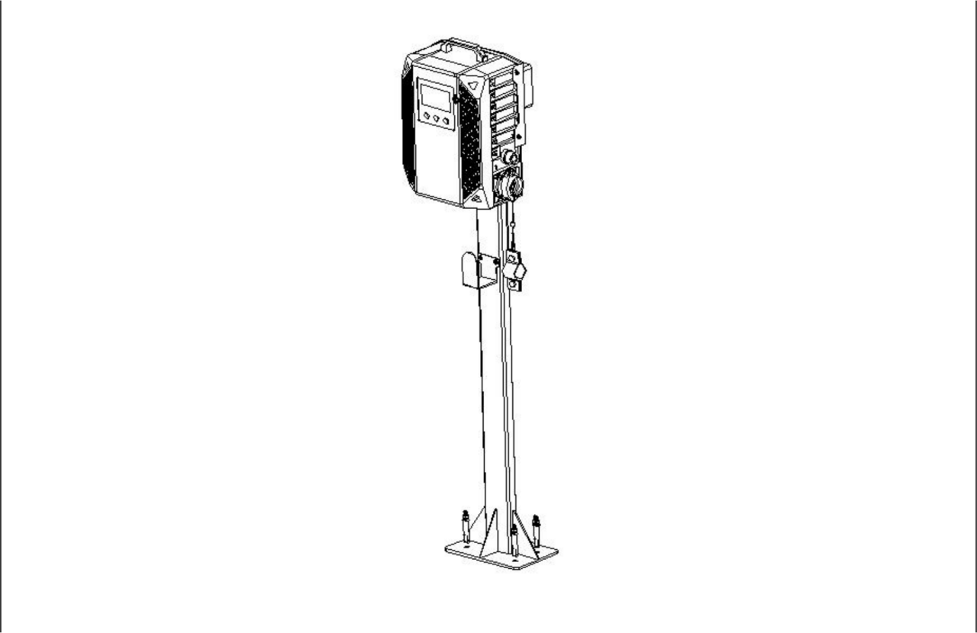

Figure 2
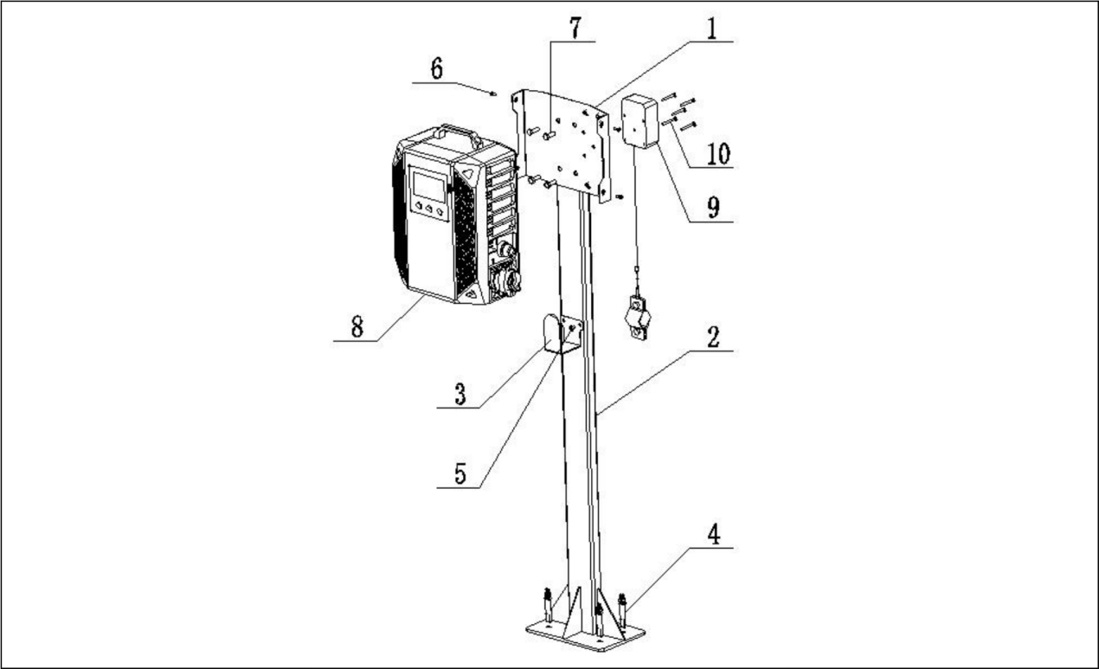

4.1.3.2 Wall Mount Installation
Parts List
Before starting installation, please carefully check the quantity and integrity of parts against the following list to ensure nothing is missing or damaged.

No. | Part Name | Qty. | Unit | Remarks
1 | H-20KW Wall Mount Plate | 1 | set
2 | Expansion Bolt M8X60 for Pipe | 4 | pc | For fixing mount plate to wall
3 | Pan Head Cross Screw with 3 Washers M5X10 | 4 | pc | For connecting charger to mount plate
4 | H-20KW Lithium Charger | 1 | set
5 | Hook (Optional Part) | 1 | pc
6 | 304 Stainless Steel Hex Washer Head Internal Expansion Screw M6*40 (Hole Dia. 8) | 3 | pc

Installation Preparation
•Tool Preparation: Prepare power drill (fitted with 12mm diameter drill bit), wrench, screwdriver and other common installation tools. Ensure tools are intact and functional to avoid affecting installation progress due to tool issues.
•Parts Inspection: Carefully inspect all parts for defects such as deformation, cracks, or thread damage. Replace any problematic parts promptly to prevent safety hazards or impact on normal equipment
operation after installation.

Installation Steps
Installing the Wall Mount Plate
•Marking: On the predetermined installation wall, use a tape measure and level to determine the installation position. Accurately mark the wall based on the fixing holes of the wall mount plate, ensuring multiple hole positions are horizontally aligned.
•Drilling: Use a φ12mm drill bit to drill holes vertically into the wall at the marked positions, with a depth of about 50mm. Keep the drill steady during drilling to avoid deviation. Clean dust from the holes using a blower tool after drilling.
•Installation and Fixing: Insert the M8 expansion sleeves into the holes, making their top flush with the wall surface. Align the holes of the wall mount plate with the sleeves, insert the M8 expansion bolts,
sequentially place the flat washer and spring washer, then use a wrench to tighten the nuts gradually in a diagonal pattern to ensure the plate is level and secure.
Installing the Charger
•Aligning Position: Align the mounting holes on the back of the charger with the corresponding reserved holes on the wall mount plate, ensuring the charger is placed level.
•Tightening Screws: Use Pan Head Cross Screws with 3 Washers M5 × 10. Insert them through the charger's mounting holes and screw into the threaded holes of the wall mount plate. Use a
screwdriver to evenly tighten all screws, ensuring the charger fits snugly against the plate and is securely installed.

Precautions
•Standard Operation: Strictly follow the installation steps. After completing each step, carefully check the connections to avoid missing or incorrectly installed parts.
•Safety Protection: Installers must take personal safety protection measures to prevent accidental injury during installation.
•Problem Handling: If encountering difficulties or problems during installation, such as parts not fitting properly or loose connections, do not force the operation. Stop installation promptly and contact professionals for consultation and resolution to avoid damaging the equipment.

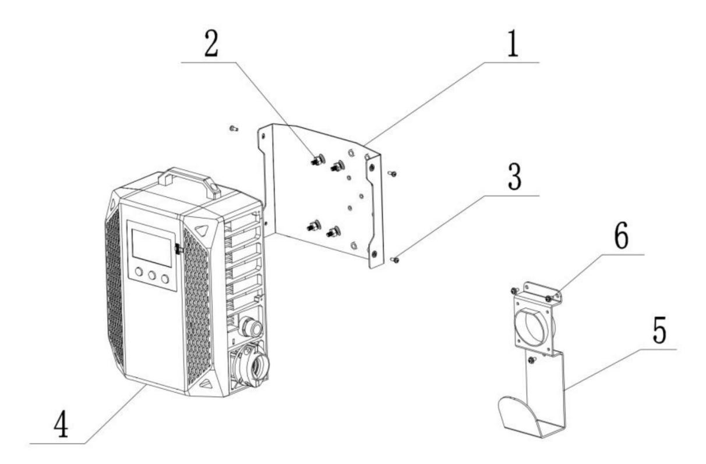
Figure 1

4.2 Operators Daily Checklist

⚠ WARNING
• The forklift charging space is kept fully ventilated.
• The fan is not clogged, there is no foreign object around and not a single vent is clogged.
Within a radius of at least 2,5 m around the forklift that needs to be charged, no flammable materials and work equipment that could generate sparks are placed.
• There are no flammable, explosive, or combustible materials, chemicals, flammable vapors, and other to the cable socket.
• dangerous items in the vicinity of the charger.
• The available space around the charger is sufficient to provide adequate ventilation and easy access to the cable socket.
• The charger is not in an environment where liquid has entered and has some waterproof measures Nothing is placed on the output cable and input power cord, or placed in a place where people
can step on it.
• There are no defects, cracks, worn or exposed copper wires on the surface of the output plug and cable, the charging output plug is clean and dry, there is no dirt, iron filings and other foreign
Objects inside, and the cable is not entangled with any items and is not knotted.
• The input and output cables are not scattered and tangled, and people can get entangled or trip over the scattered and surrounded cables.
• Confirm that there are no defects, cracks, worn, or exposed copper wires inside the input plug and wires and cables, that the charging input plug is clean and dry, that the metal contacts are free of foreign objects such as dirt and iron filings, and that the metal contacts are in a shiny state.
⚠ WARNING
Never start the charger until any damage or malfunction of the charger has been resolved.

4.3 Accessibility

4.3.1 The main interface of the charger

12
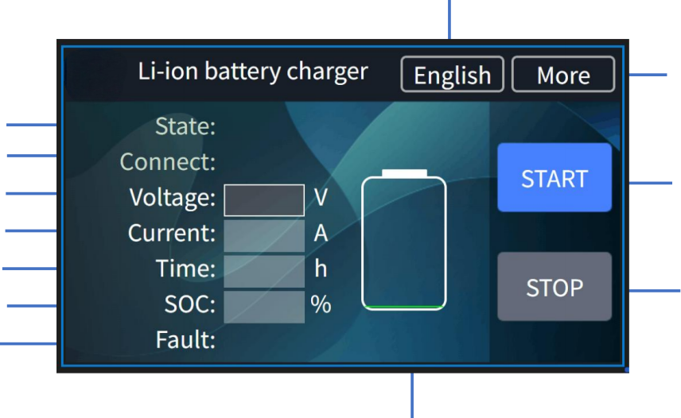
1
2
3
4
5
6
7
10
8

9
11
The main page displays the following charging information:

1、working state | 7、fault info
2、connect state | 8、more info
3、output voltage | 9、start charge
4、output current | 10、stop charge
5、Charging Time | 11、battery BMS info
6、SOC | 12、Language switching
Click the start button and stop button to control the charger to start and stop.
The charger supports English and Chinese. You can change the language of the Charger by clicking the.Chinese and English switch button. This language switch button can be hidden.

4.3.2 Battery information inquiry

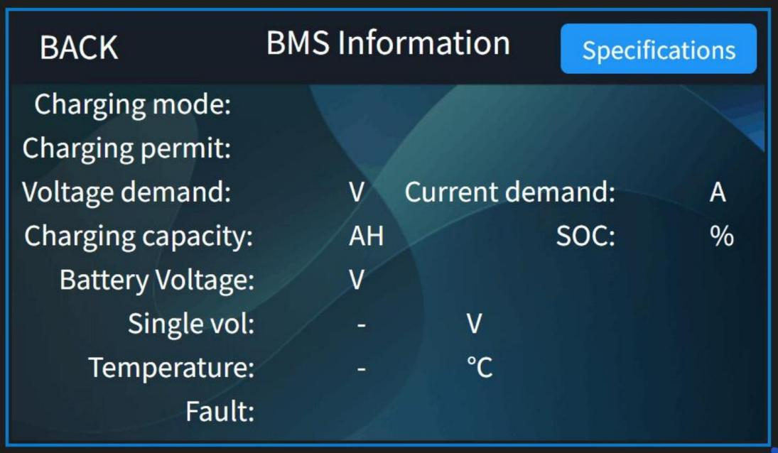
Click battery info icon(11) enter battery BMS info interface:
The battery information interface contains various parameters sent by the.
battery to the charger, such as demand voltage, demand current, control status and other information.

4.3.3 Functional interface

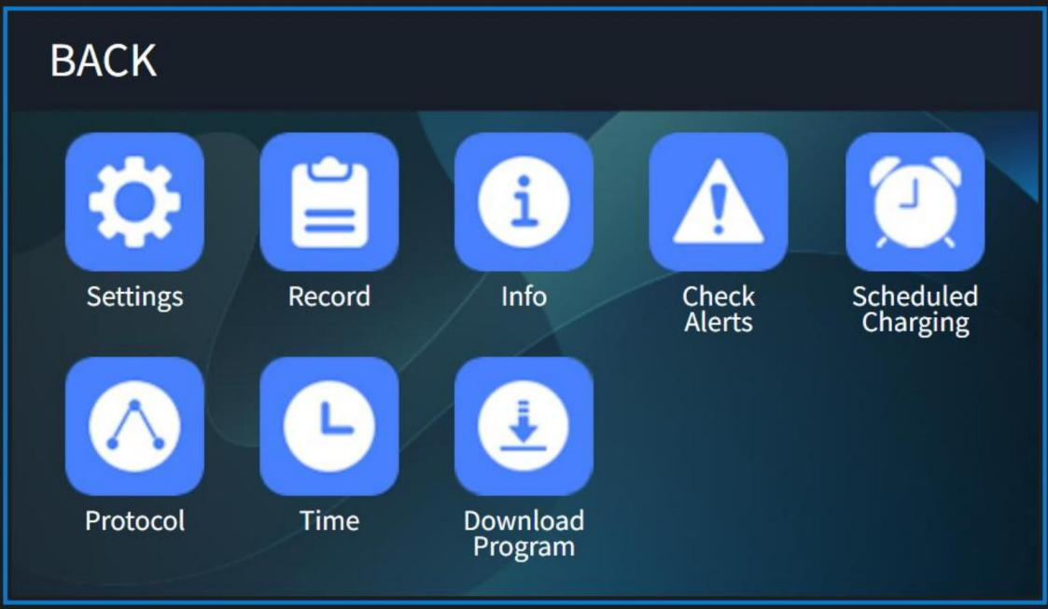
Click more (8) enter function setting interface：

1、Parameter Setting | 5、Charging time appointment
2、Charging Record | 6、Charging protocol
3、Charger specification info | 7、Time
4、Fault and solution | 8、Download Program

4.3.4 Parameter settings

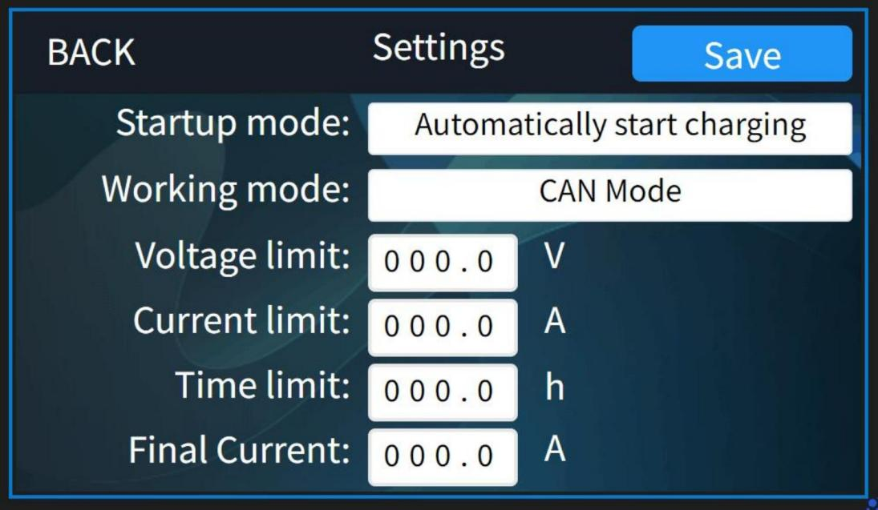
Click setting(1) icon to enter the setting function interface：

1、startup mode options（automatic&Manual） | 5、charging time limit
2、working mode options | 6、final current
3、charger output voltage limit | 7、save the parameter setting
4、charger output current limit
Detail introduction of the parameter setting interface：
• Working mode setting: The charger is divided into two modes: manual charging and automatic charging, which can be adjusted according to needs.
- Start charging manually: After connecting the battery with the charger, you need to press the start button for the charger to start charging.
- Auto-start: When you click this option, when the battery is connected to the charger, the charger can start charging on its own without pressing the Start button.
• Working mode setting: The charger is divided into two modes: CAN mode and No CAN
• Output voltage limit: The voltage output by the charger can be set.
• Output current limit: The current output of the charger can be set.
• Charging time limit: limit the working time of the charger, and it will stop automatically when the set value is reached.
• Final current : cut off current to stop charging
• Parameter setting save.
• Note: Limitations feature explained：
• Output Voltage Limit: The voltage can be set according to the maximum output of the charger, such as HCF-80100-R, this charger can reach 35-115V,
• Output Current limit: The current can be set according to the maximum output of the charger, such As HCF-80100-R, this charger can reach 0-100A,
• Charging time limit: The charger can work at a preset time, if you want the charger to work at night, you can calculate it according to the current time and calculate the value that can be filled.
Note: If you change the above parameters, you need to click Save and return.

4.3.5 Charging record interface

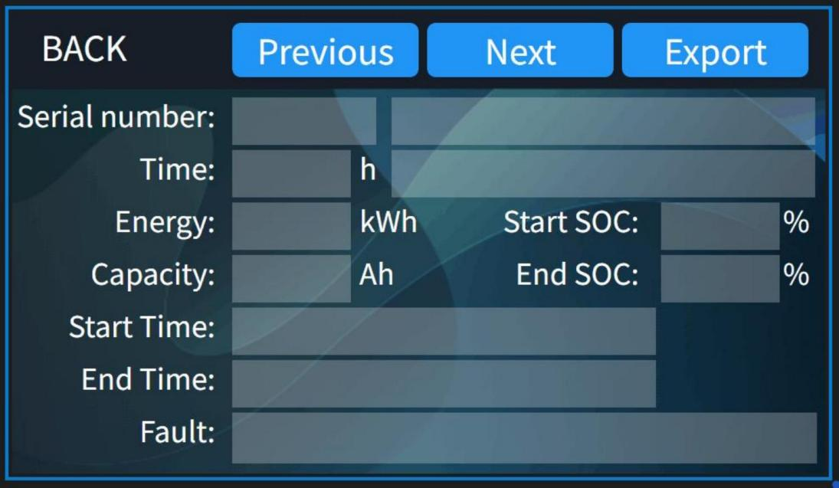
Click record(2) icon to enter the Charging Record interface：

1、charging serial number | 7、charging fault record
2、charging time | 8、start SOC
3、battery Charging kWh Value | 9、end SOC
4、battery charging Ah Value | 10、previous charging record
5、charging start time | 11、next charging record
6、charging end time | 12、export
The charger record query interface allows you to view the charger record. The charger records include : start time , end time , battery SOC at the beginning , battery SOC at the end , each charging time ,
each charging energy and fault information etc.

4.3.6 Charger information inquiry

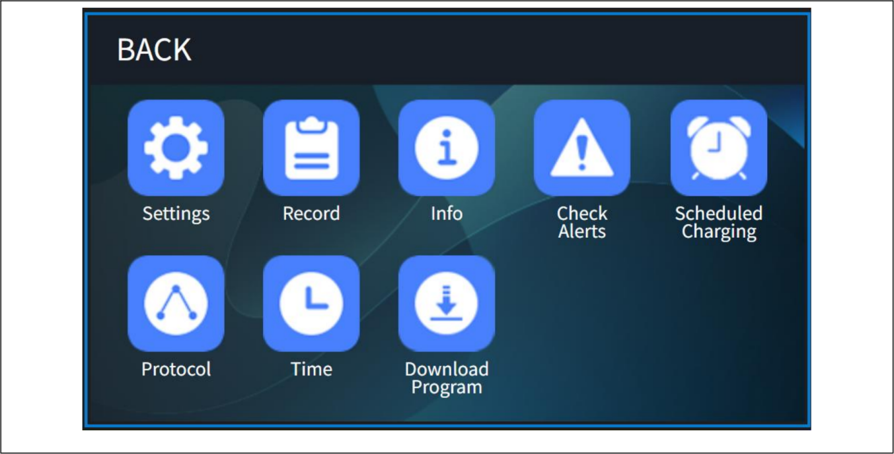
Charger specification information interface： Click the info icon：
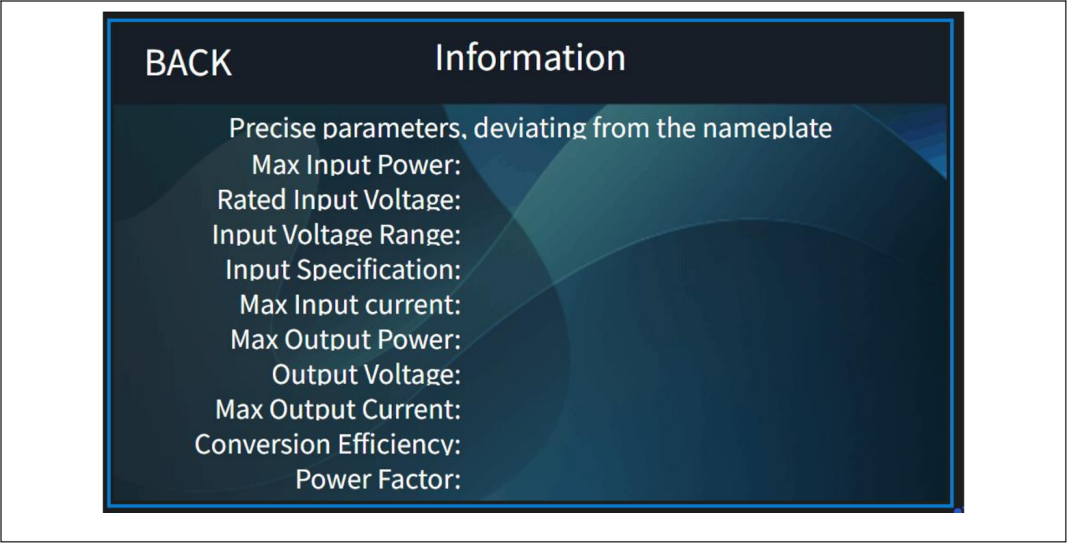
Charger specification information interface：
Enter the charger information interface to view the specific parameters of the charger .
Including information such as the charger's rated input voltage, input voltage range, maximum input current, output voltage, maximum output current and conversion efficiency etc.

4.3.7 Warning information query

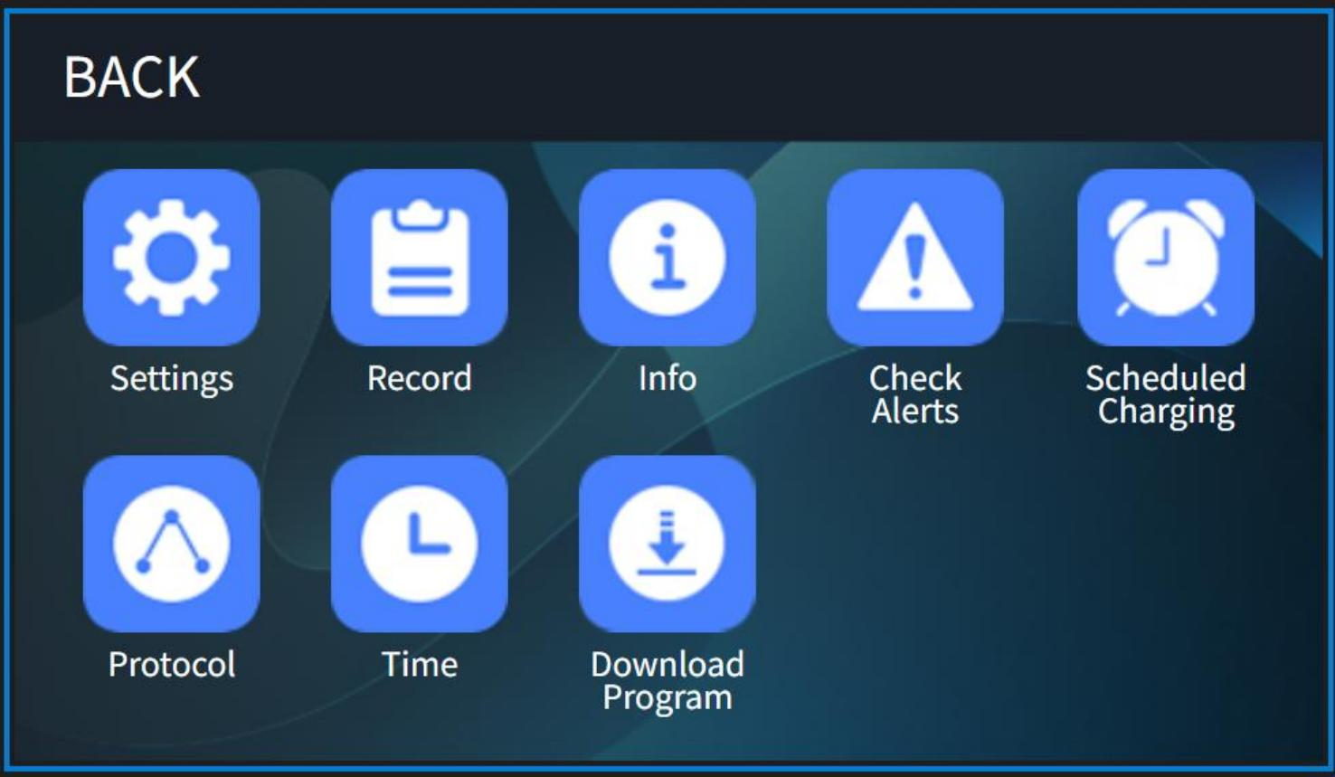
Click the Check Alerts icon：

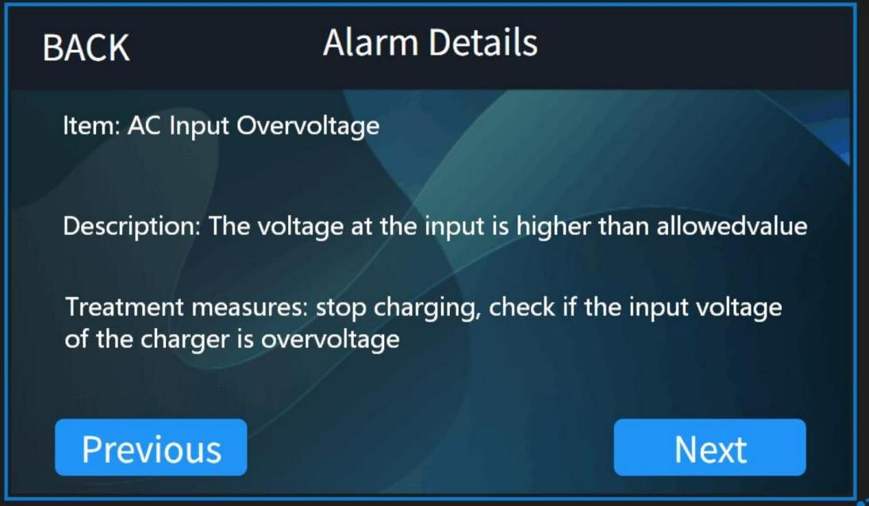
Charger Check Alerts: Click More on the main page and click Check Alerts to view fault items, fault descriptions, and solutions.

4.3.8 Timed charging function


Click Scheduled Charging icon：

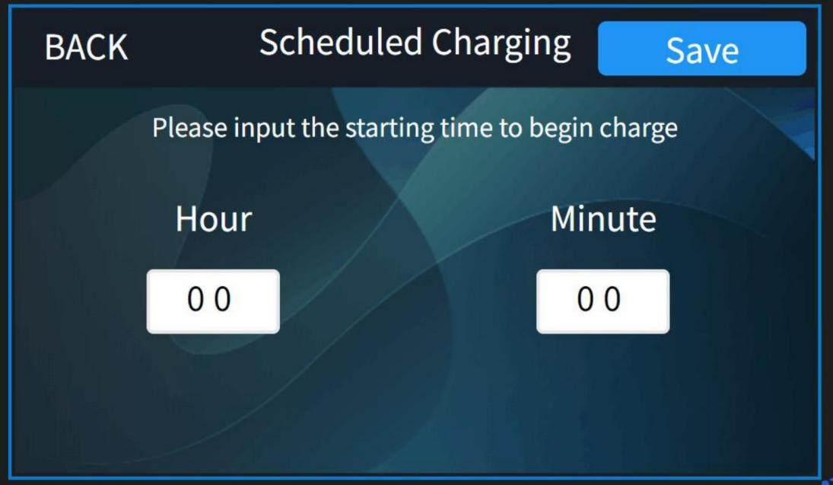
Charger reservation time setting: Click More on the main page, click Scheduled Charging, enter the
scheduled charging interface, fill in the time you want to charge, click Save, the charger will start
counting down, and when the time is up, the charger will automatically start charging without manual labor.

4.3.9 Charging Protocol Function

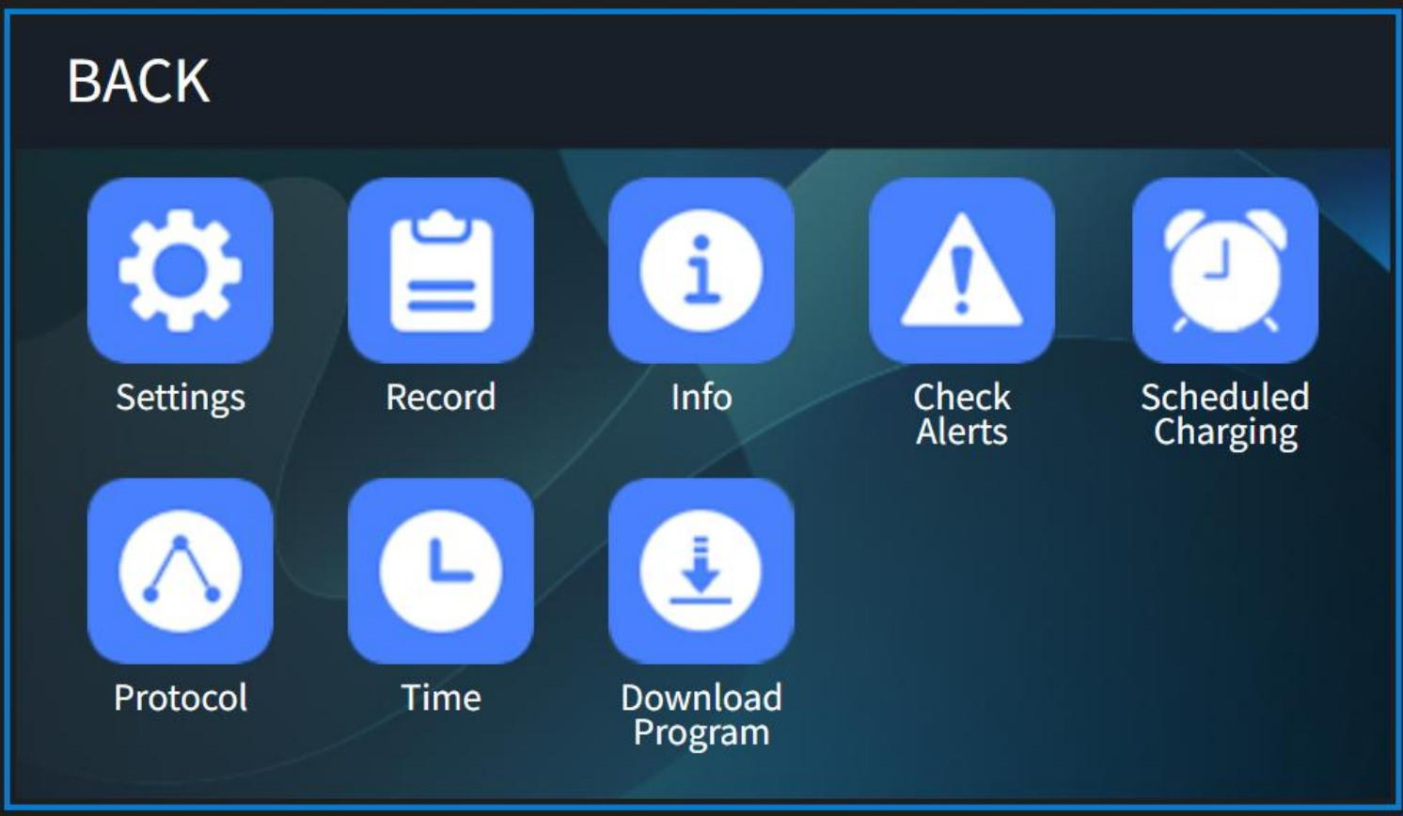

Click Protocol icon：

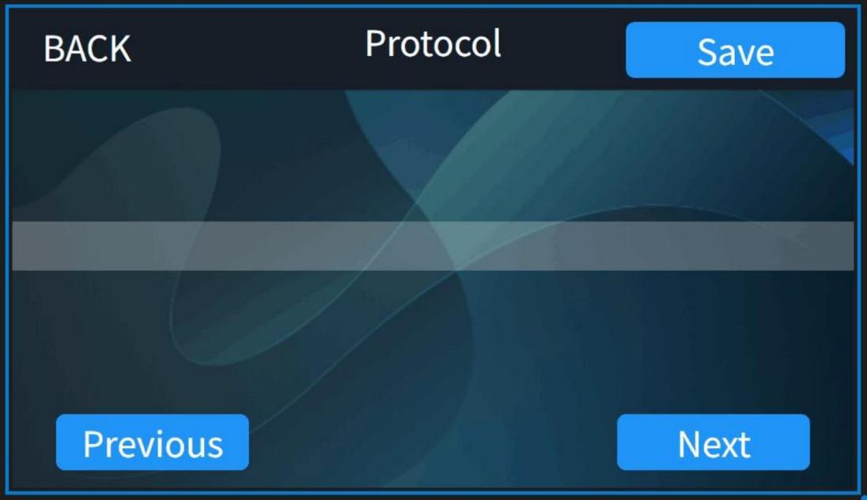

Charging Protocol setting: Click More on the main page, click Protocol icon, enter the protocl interface, you can see the current protocol that you use, and you can choose other protocol you need use, press Save, the charger will work according to that protocol.

4.3.10 System Time Function

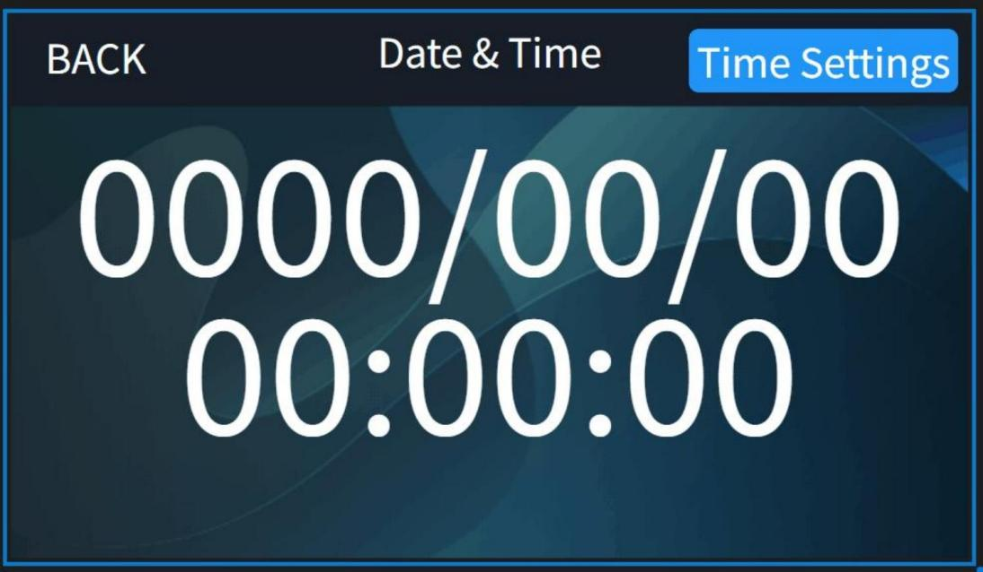
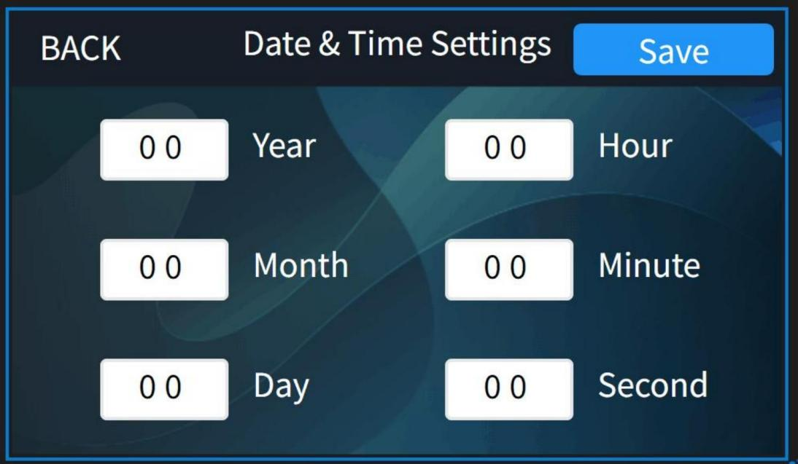

System Time Setting: Click More on the main page, click Time icon, enter the Time setting interface, you can view the system time and change the time manually.

4.3.11 Download Program Function



Click Download Program icon：

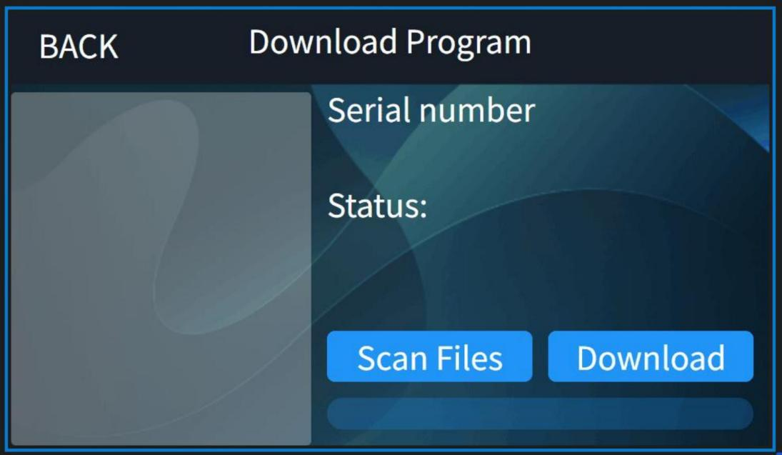

Charging Program Download: Click More on the main page, click Download Program icon, enter the program setting interface. You can update charging protocol here.

5 Description of the fault

5.1 Fault table

Fault Code | Item | Description
1 | BMS hardware failure | BMS Battery failure
2 | BMS Communication Fault | Communication between the charger and BMS is interrupted
3 | Battery Overvoltage | The output voltage is higher than the allowable value
4 | Battery Undervoltage | The output voltage is lower than the allowable value
5 | Battery Overtemperature | The battery temperature is higher than the allowable value.
6 | Battery Low Temperature | The battery temperature is lower than the allowable value.
7 | BMS voltage imbalance | Excessive voltage difference in the battery pack
8 | BMS temperature difference | Excessive temperature difference in the battery pack
9 | BMS other failure | Unknown malfunction in the BMS
10 | AC Input Overvoltage | The input voltage is higher than the allowable value
11 | AC Input Undervoltage | The input voltage is lower than the allowable value
12 | AC input phase loss(Only applicable to three-phase input) | AC input phase loss
13 | Output overcurrent | Charger's output current exceeds the allowed limit
14 | Output short circuit fault | Short circuit at the charger's output terminal
15 | Battery reverse connection fault | Battery's positive and negative terminals are connected in reverse
16 | Charger overheating | Charger overheating
17 | Hardware failure | Charger hardware malfunction
18 | Fan failure | Fan cannot start properly
19 | Relay failure | Relay cannot operate
20 | Other hardware failure | Unknown malfunction in the charger

5.2 Simple breakdown repairs
⚠ DANGER
• The following faults need to be carried out by a professional electrician.
• Before intervening with the charger, disconnect the charger input and output.
• Do not touch the metal surface on the outside of the charger to avoid high temperature burns.
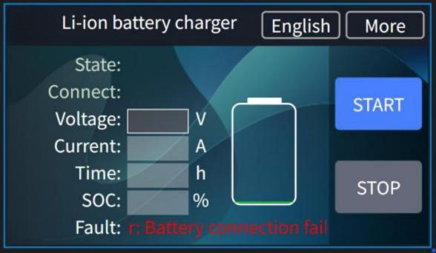
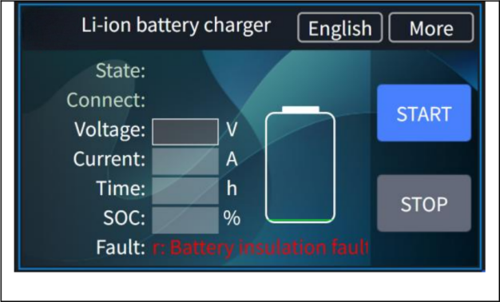
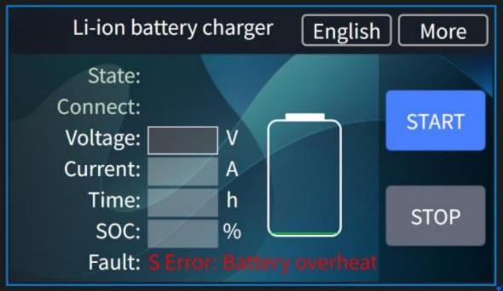
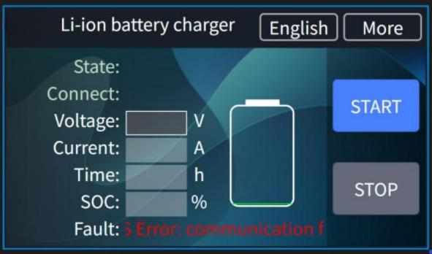







Battery Connection Fault
Solution: Please consult the battery repair manual.

Battery Insulation Fault
Solution: Please consult the battery repair manual.

Battery Overheating Fault
Solution: Please consult the battery repair manual.

Communication Falut
Solution: Please consult the battery repair manual.

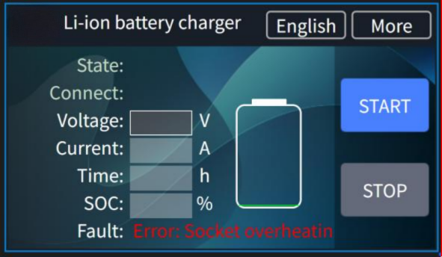

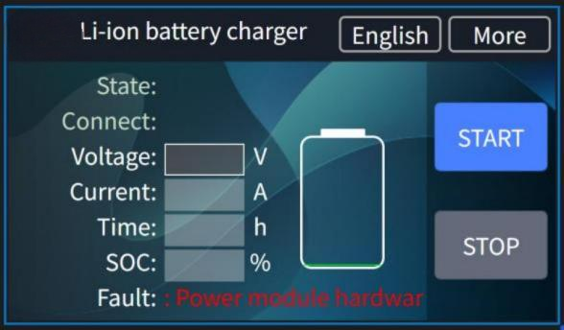

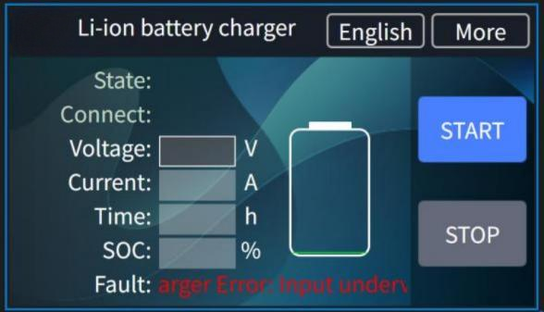

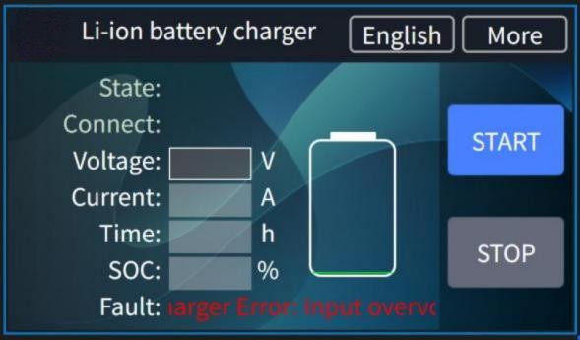

Socket Overheating
Solution: Please consult the battery repair manual.

Power Module Hardware Fault
Cause of failure: incorrect wiring, loose wiring, or module damaged.
Solution: Check whether the power module wiring is loose, whether the wiring is correct, if wiring checks are no problem, replace the power
Module.

Input Undervoltage Fault
Cause of failure: The AC input voltage is lower than the range of the charger Solution: Adjust the power grid.

Input Overvoltage Fault
Cause of failure: The AC input voltage exceeds the allowable range of the
Charger Solution: Adjust the power grid.

5.3 Service support

Most of the above situations can be resolved with simple troubleshooting. If it is determined that the issue does not fall into the above category, it may indicate that the charger's hardware is damaged. Customers who meet the after-sales service conditions are kindly requested to contact local
distributor in time for hardware replacement.

If you are unable to identify the problem, need to replace the hardware, or need to change the
software, please contact local distributor. In this case, remote video communication may be required.

When contacting the local distributor, please provide a detailed description of the problem. For
charger fault repairs, please provide charger nameplate information, battery information, and capture CAN communication information during charging if necessary to identify specific problems.

6 Waste disposal

 NOTE
Chargers should be collected separately from household or commercial waste and properly recycled or disposed of Take the old charger (if any) in-house for disposal and hand it over to a professional company (professional waste disposal company) In principle, it is also possible to return the old
charger to the local distributor. To do so, please contact the local distributor's customer service department. Specific protocols must be adhered to.
According to the European WEEE Directive (2012/19/EU), electrical and electronic equipment must be collected, recycled or professionally disposed of separately from unsorted municipal waste, where
pollutants resulting from improper disposal can cause lasting damage to health and the environment.

Detailed information can be obtained at the Waste Disposal Specialist Plant or the relevant authority The packaging of the charger should be disposed of separately. Paper, cardboard and plastic are
recycled.


Making Handing Easier

If there are any changes to other content of this manual, we reserve the right to interpret it, and no further notice will be given. The final interpretation right belongs to Hangzhou Hangchayunrui Technology Co., Ltd.



HANGCHA GROUP CO.,LTD

Company address:No. 666Xiangfu Road, Lin'an District, Hangzhou City,Zhejiang Province

