WeatherManager Splitup (for Single responsibility in SOLID)
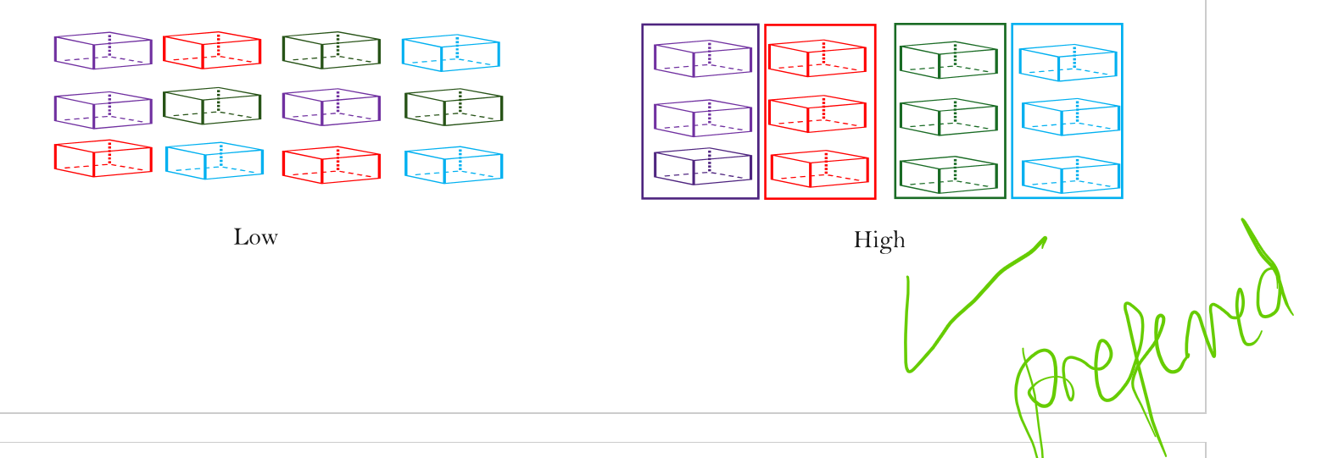
Low cohesion in WeatherManager since it has too many responsibilities
Figure 1. Low Cohesion vs High Cohesion Concept Diagram
Originally, WeatherManager performs too many tasks (hence low cohesion):
- Answers queries on isDamaging, isObscuring
- Applies lightningRod attraction + calculates the radius susceptible to lightning
- Adds weather spawn points (for clouds and lightning)
- Ticks all weather
- Renders all weather
Consequently, it is decided that WeatherManager be split into three classes:
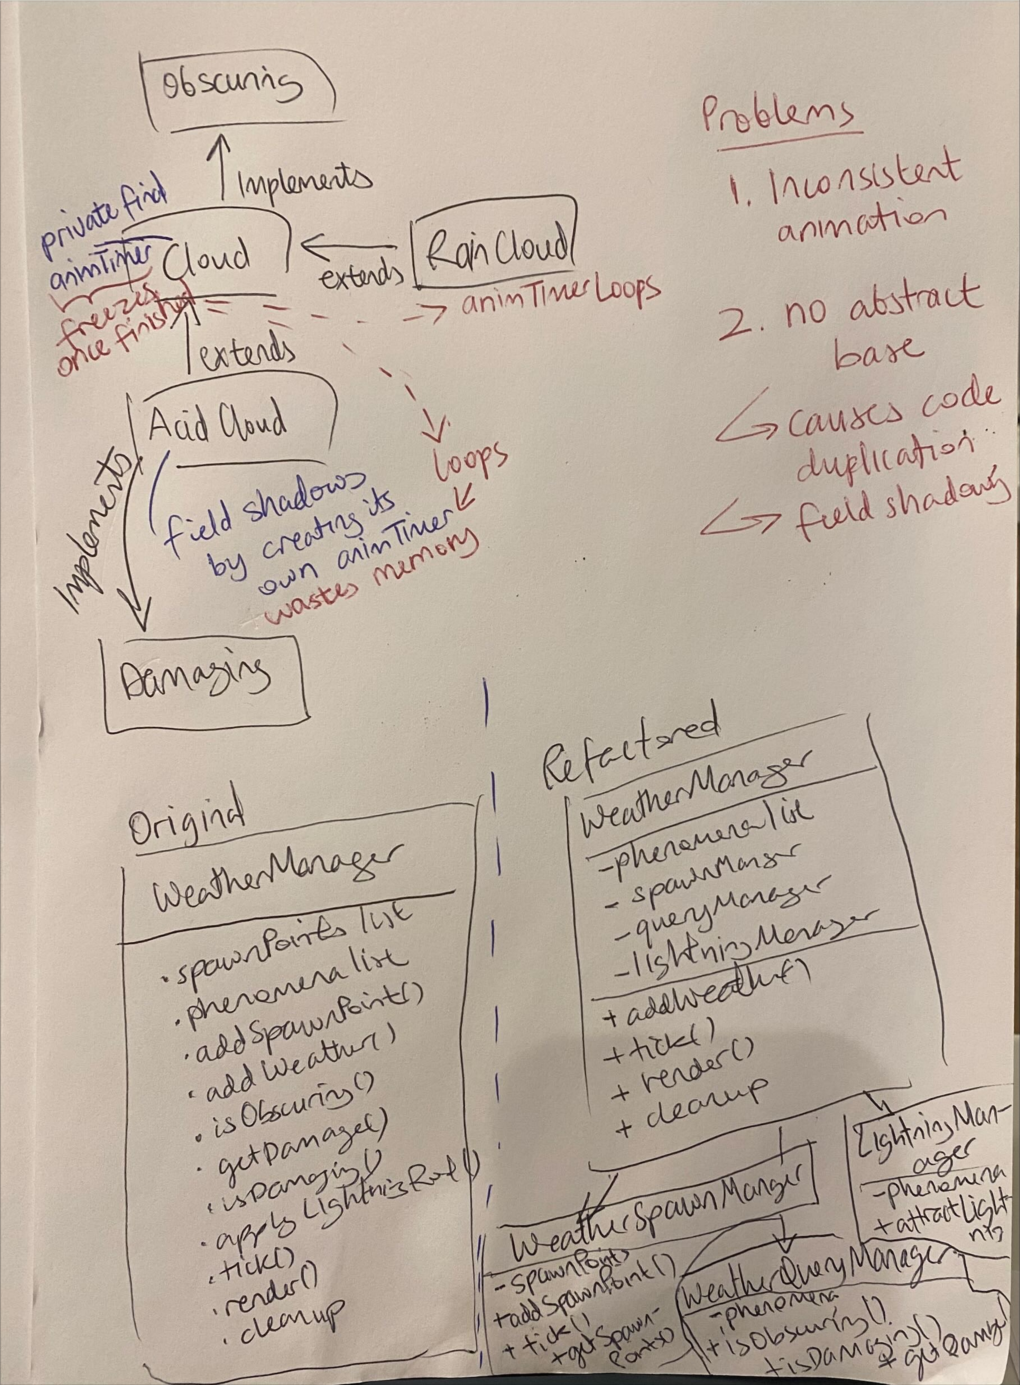
WeatherSpawnManager: only addSpawnPoint and getSpawnPoints (ticked)
LightningManager: only handle attractLightning
WeatherQueryManager: only handle isObscuring and isDamaging
With WeatherManager calling these classes for their modular portion of work in the existing methods.
--
Even after splitting weather, however, there are many other design issues to refactor here.
--

Open/closed principle (O in SOLID)
First, the instanceof Lightning check violates the Open/closed principle. Adding new weather types would require modifying this existing method.
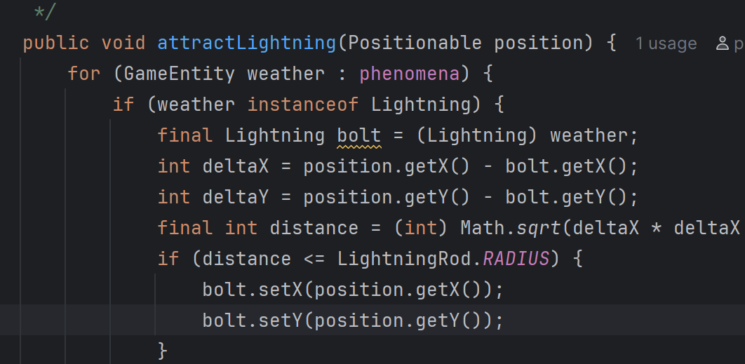
Figure 2. Original method before refactors
To fix, a new class Attractable captures all lightning attracting items in consideration of future machines that could attract lightning. Now, we simply call for all Attractable weather entities, skipping the non-attractables using polymorphism.
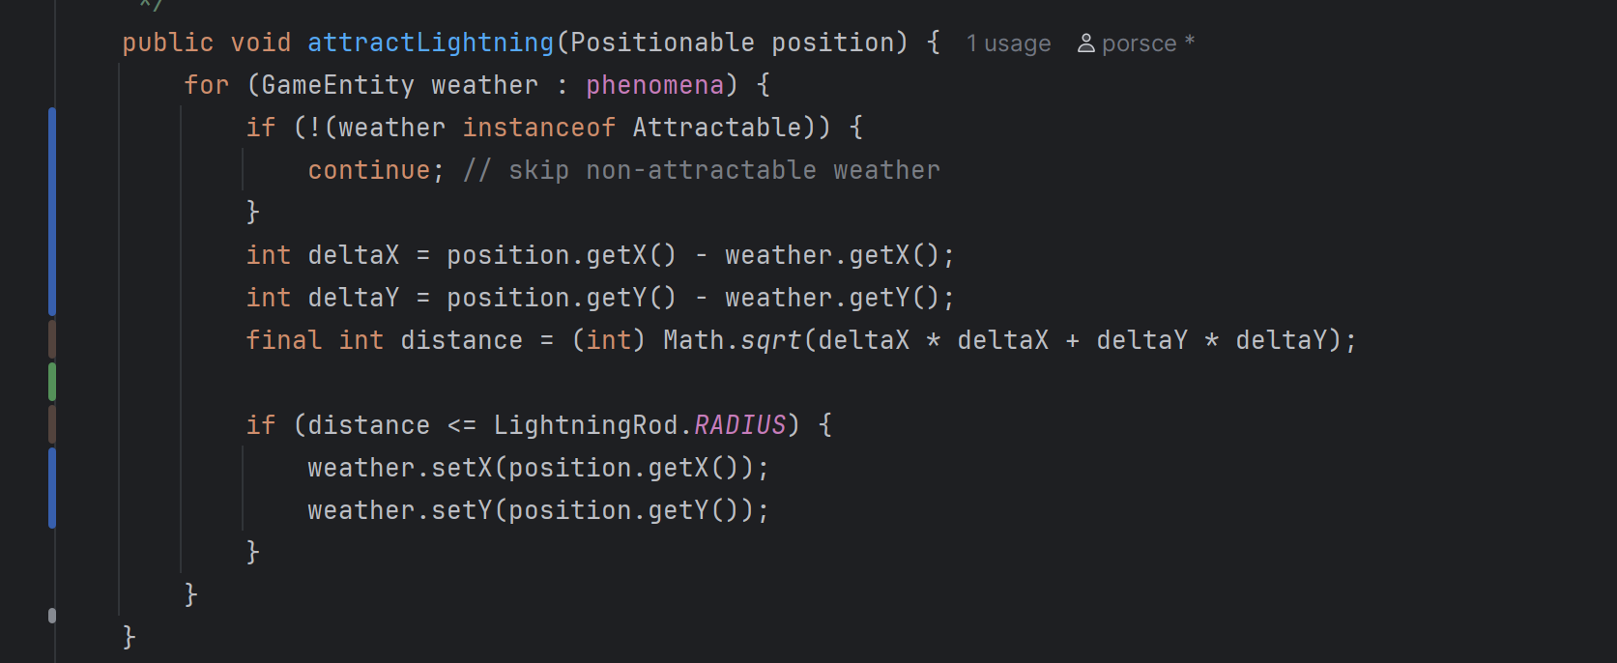
Figure 3. Attractable class created and used
To further improve and completely adhere to the Open/closed principle, I considered passing in int radius to the method so that it can be extendable for new machines with specific radius of attraction; however, this is currently not doable because some of the tests require the current exact method signature (i.e. without radius). Nevertheless, this idea is documented for evidence of thinking.
--

Tight Coupling
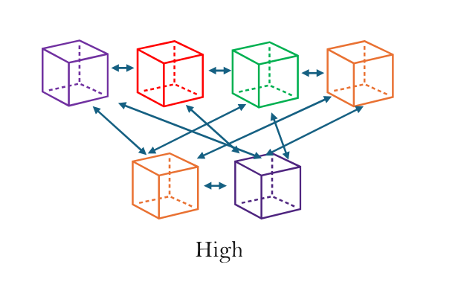
High coupling between LightningManager and Lightning due to strong interconnections where changing one creates issues for the other.
Figure 4. High Coupling Concept Diagram
Second, there is tight coupling between LightningManager and Lightning via the direct position modification of bold.setX and bolt.setY as highlighted yellow below.

Figure 5. identified Feature Envy on Lightning

Feature Envy (Code smell)
This is a code smell too, as LightningManager seems more interested in another class, Lightning’s data than its own here. To fix, the set position task is delegated to Lightning, which is implemented using the interface attractTo method present in Attractable too.
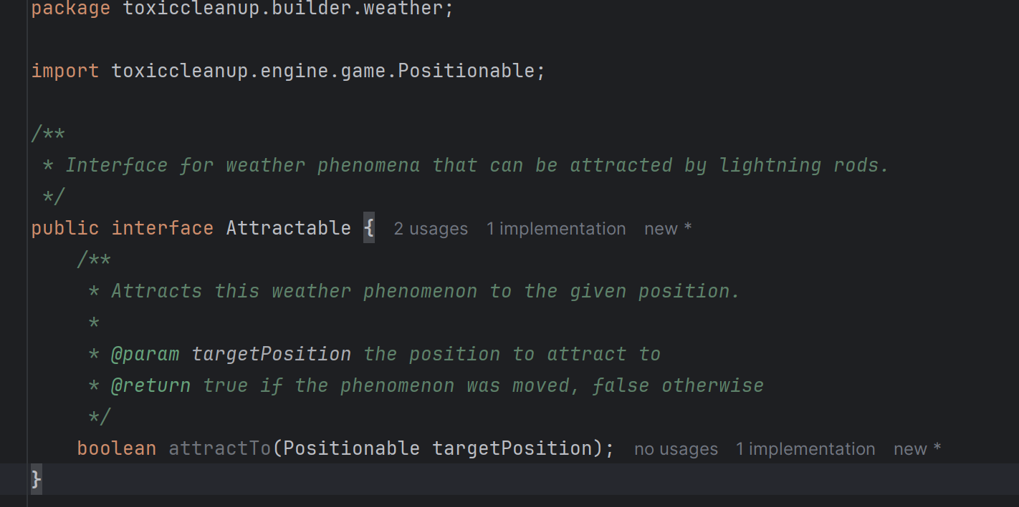
Figure 6. Attractable interface
Implementation moved to Lightning’s attractTo: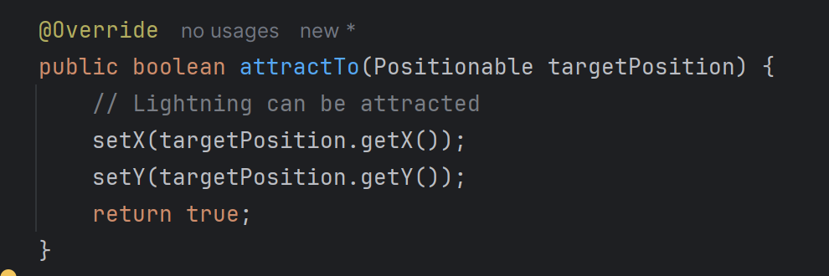
Figure 7. moved Feature Envy part to Lightning itself
Now the LightningManager is adapted to:
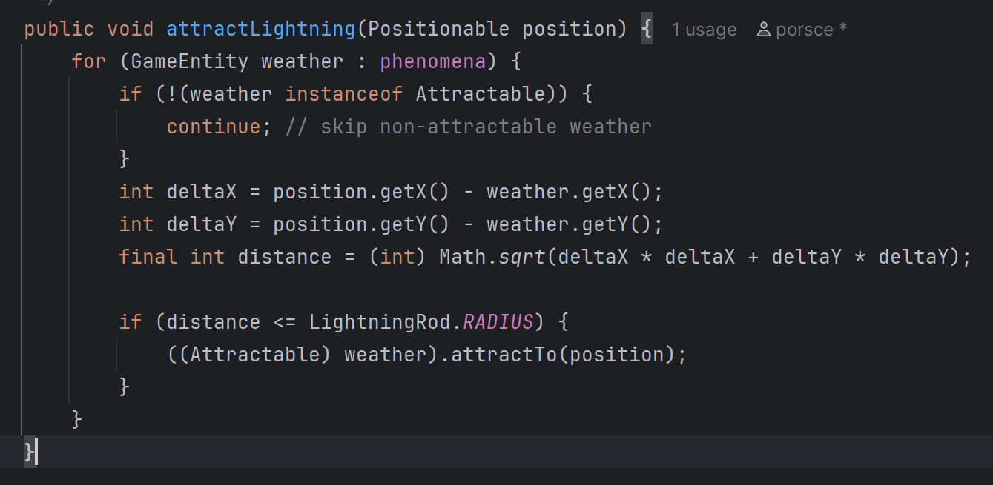
Figure 8. refactored LightningManager
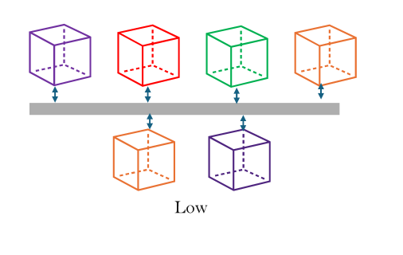
So that coupling is reduced! :)

Figure 9. Low Coupling Concept Diagram

Design Flaw in Weather: Interface Segregation Violation
Weather extends Damaging, forcing all weather to be damaging. This means every class that implements Weather (like WeatherManager) must also implement Damaging, which requires getDamage() methods.
But Cloud (which implements Obscuring) is not damaging. Yet WeatherManager must still provide getDamage() methods that return null. This is awkward and violates the interface segregation violation.
A fix is to create a new interface, Damager, which handles isDamaging and getDamage. Then we make Weather extend Damager so that weather can be a damager, but doesn’t have to be. However, since Weather interface cannot be changed as it will interfere with existing tests to pass, this specific refactor is only documented.

Unused Cleaning Interface - removed
In the provided code, Cleaning interface has no methods or javadocs, with no clear intention on how it’s to be used. There are also no tests running on it, so this class has been removed.

Unused Disableable Interface – removed
Similar to the Cleaning interface, Disableable has no methods or javadocs, with no clear intention on how it’s to be used. There are also no tests running on it, so this class has been removed.

Cloud Inheritance

All cloud classes (Cloud, RainCloud, AcidCloud) share a bit too many things:
- Movement logic (timer, speed, direction)
- Animation logic (timer, frame cycling)
- Boundary detection (remove when x < 0)
- Obscuring interface (obscure solarpanels)
This calls for a refactor!
Hence, two options were considered: abstract class and interface.
Abstract classes are less flexible (if clouds need to extend something else) than interfaces. However, if an interface was chosen, there would be massive code duplication as each cloud would re-implement movement, animation, boundary, etc.
Since interfaces cannot hold shared state (timers would be duplicated), I decided to use an abstract class here called Cloudable.

Code smells

Inconsistent Logic
Cloud.java used to have a fixed implementation that freezes cloud movement once it reaches boundary, which neither RainCloud nor AcidCloud do. Hence, upon refactoring all clouds are removed cleanly once they’ve moved across the screen.

Duplication
Boundary checking before marking for removal is duplicated in every cloud class. This is bad, because fixing one means fixing all. Hence, it was moved to the Cloudable mother class and now occurs just once and for all.
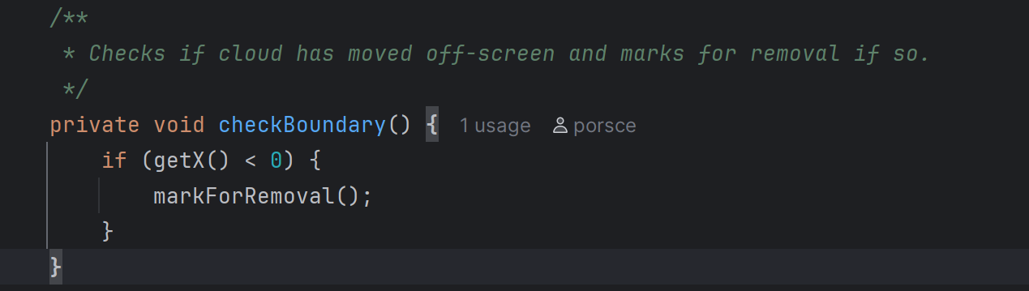
Likewise, Cloud, RainCloud and AcidCloud all had their own animation fields like currentArtFrame and animTimer. This wastes memory, can cause inconsistent behaviour and is difficult to mass-alter if the timer is suddenly changed due to client requests.
private int currentArtFrame = 1;
private final TickTimer animTimer = new RepeatingTimer(12);

Bad Naming
- Changed to: private final TickTimer movementTimer;
instead of: private final TickTimer timer;
Since this is less clear what timer this is (there’s already an animTimer)
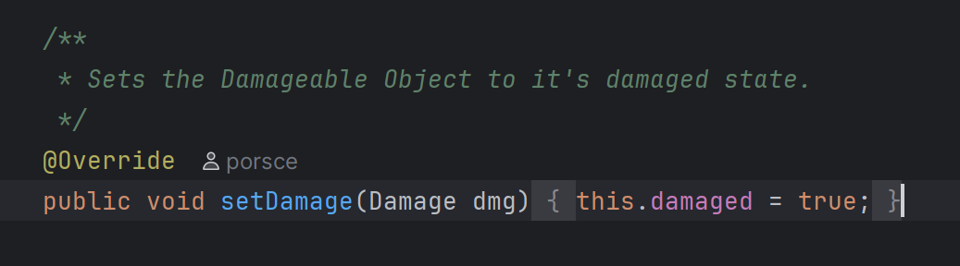
- Misleading method name: setDamage suggets it stores some Damage object, but it only sets a boolean. A better name would be makeDamaged to meaningfully communicate the object getting this method will be damaged. However, this change cannot be done as the provided tests will not pass.

- adjust method is not descriptive enough, many variations of this in different classes.
public void adjust(int amount) {
hp -= amount;
hp = Math.clamp(hp, 0, MAX_HP);
}

Above is playerManager’s adjust, which changes hp. Below is machinesManager’s adjust, which changes power instead.
public void adjust(int amount) {
this.gainPower(amount);
}
A proposal would be to call them adjustHp and adjustPower; however refactoring playerManager is beyond scope of A2.

SpawnFactory

Open/Closed Principle (O from SOLID)
By changing the if statement to a switch, adding a new weather type only requires adding one new case to the switch instead of modifying the existing if-else chain (which added 2 branches when this could be done in 1 in the new implementation).
"Software entities should be open for extension, but closed for modification."

Repetition Removed
Instead of repeating lowercase and uppercase cases for each letter, it was handled in one place using logic:
With finalSpawnTime multiplied to each case’s spawning instead of a statically hardcoded number for each. This simplifies the reading, logic and reduces code duplication.
boolean isUppercase = Character.isUpperCase(symbol);
int finalSpawnTime = isUppercase
? (int)(baseSpawnTime * MULTIPLIER)
: baseSpawnTime;

Information Hiding (to avoid magic numbers)
In SpawnerFactory, a field was created: private static final double SPAWN_MULTIPLIER = 5.5;

WeatherSpawnPoint
Original: private final ArrayList<Positionable> positions = new ArrayList<>();
New: private final Positionable position;
For some reason, the position is stored as an array list when there is only one position for each spawned weather point. This can mislead developers as it suggests positions might exist, but they don't. Further, on a memory usage perspective it is wasteful to do this.
Conveniently, this simplifies some code in WeatherSpawnPoint, e.g. directly access the point in getPosition and WeatherSpawnPoint:
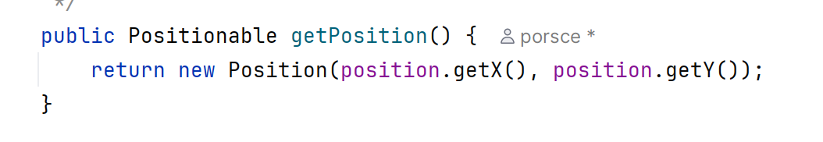
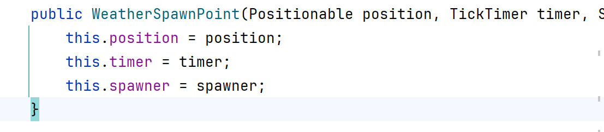

LightningDamage’s Fields Shadowed Parent
Removed:
private int x = 0;
private int y = 0;
Since parent, Damage, already has x and y defined, LightningDamage inherits them via super(position). The child's x and y were shadowing the parent's fields, which can cause bugs.
public class Damage implements Positionable {
private int x = 0;
private int y = 0;
// ...
public Damage(Positionable position) {
this.x = position.getX();
this.y = position.getY();
}
}
Defensive programming: instead of adding it to a final array list,
return new ArrayList<>(phenomena);

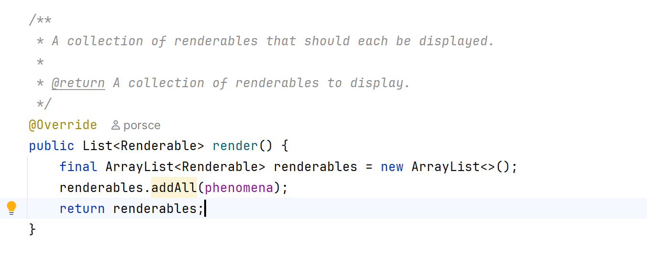

Magic Numbers
- In SpawnerFactory, the 5.5 appeared a catastrophic number of times, usually through the many
new RepeatingTimer((int) (Cloud.SPAWN_TIME * 5.5))
in the massive if statements. This was reduced by adding the field:
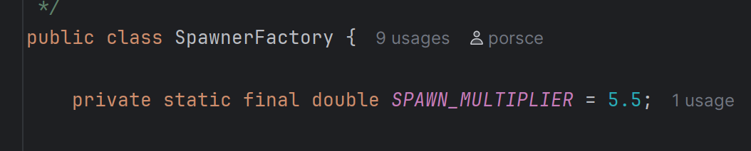

- In Cloud.java, the 12:
private final TickTimer animTimer = new RepeatingTimer(12);
Removed by adding field in Cloudable which got inherited by all clouds:
private static final int ANIMATION_INTERVAL = 12;
- In Lightning.java, the 5:
if (animFrame == 5 || animFrame == 6)
removed by adding
private static final int DAMAGE_FRAME_START = 5;
private static final int DAMAGE_FRAME_END = 6;
so that code becomes:
animFrame == DAMAGE_FRAME_START || animFrame == DAMAGE_FRAME_END;

