Submission Template
You must use this document template to complete the Blackboard submission. A separate PDF of this template will also be available on Blackboard.

Student Details

Full Name | Isabel Lifu
Student Number | 49611610
Assigned Demo Time | 1:15pm – 1:40pm Mon 8th Sept
Practical Demonstration [15 marks]
I have completed and will be demonstrating (please tick one of the three options),
- Only the Input Processing Subsystem (Block A)
- Only the Serial Addition Subsystem (Block B)
- The full system (Blocks A and B)

Design Reasoning [4 marks]
Review the task brief, Fig. 1 and any relevant course content. For each subsystem shown in Fig. 1, mention the combinational/sequential circuit blocks required to implement the given functionality and identify the correspond- ing logic ICs from your lab kit. When mentioning the circuit blocks, your answer must include specific details about input sizes and number of blocks needed. E.g., three 2-input NAND gates, one 2:4 decoder etc.

Input Processing Subsystem [2 marks]
Block A implements the input processing subsystem sequential circuit using a shift register formed by four D flipflops as memory registers that store bits, along with four 2-input multiplexers for mode selection. The mux line for select 0 is wired such that S0-S3 are parallel loaded into corresponding D-flipflops. Conversely a mux line for select 1 enables serial shifting to the right, 1 bit per clock (B0) as indicated on the task sheet’s circuit.

IC components required:
one 74HCT175 (i.e. Quad D Type Flipflop (this contains four D-flipflops))
one 74HCT157 (i.e. Quad 2- input Multiplexer (four 2-input multiplexers))

Serial Addition Subsystem [2 marks]
Block B’s serial addition subsystem sequential circuit is created using a 4-bit counter, one which increments from 0000 to 1111. This is wired in a special way where the 4-bit full adder’s input and thus output depends on the incoming bit from Block A’s serial shift. Consequently the counter only increments when there is an incoming 1, effectively ‘counting’ the number of 1s in the inputted bit stream. The four D-flipflops connect the full adder’s output to one of its two 4-bit inputs, allowing an accumulated sum that is both stored in memory and ready for use when needed.

IC components required:
one 74HCT283 (i.e. one 4-bit full adder)
one 74HCT175 (i.e. one Quad D Type Flipflop (four D-flipflops))

Logic Diagrams [10 marks]
Provide logic diagrams for each of the subsystems using the circuit blocks identified above. Logic diagrams can be either hand-drawn or electronically produced and must fit within the space provided below. Logisim screenshots are not accepted as Logic diagrams. All inputs and outputs must be labeled with the same names as shown in Fig. 1 and the diagrams must adhere to conventions taught in CSSE2010/7201.

Input Processing Subsystem [5 marks]
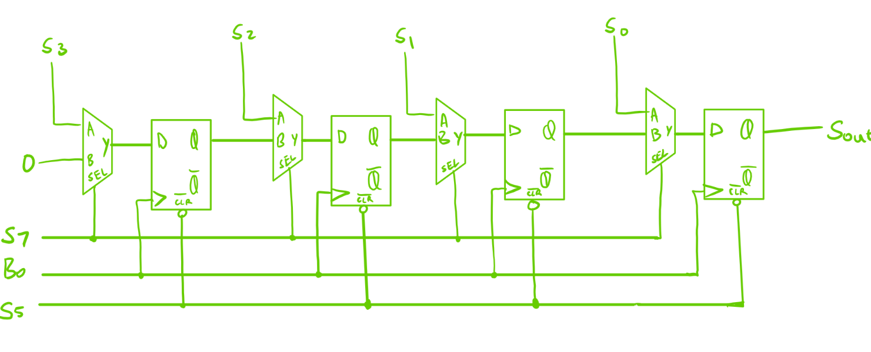

Serial Addition Subsystem [5 marks]

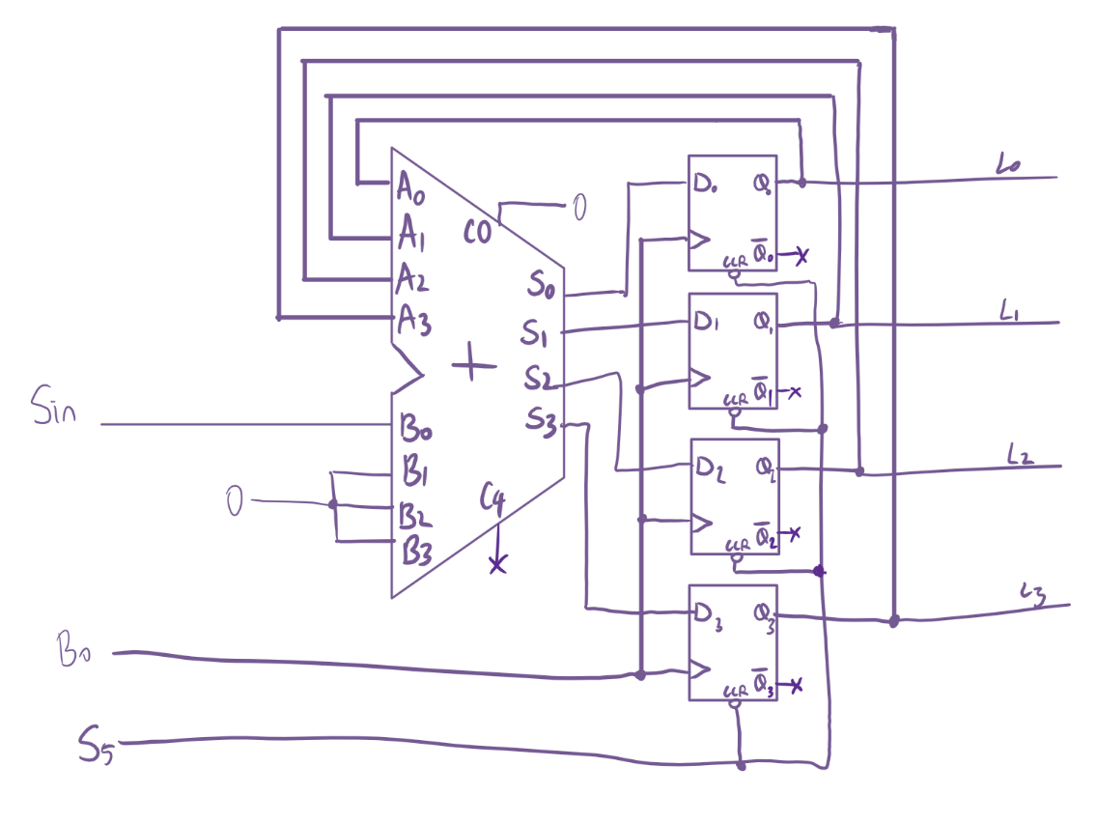

Circuit Schematic [7 marks]
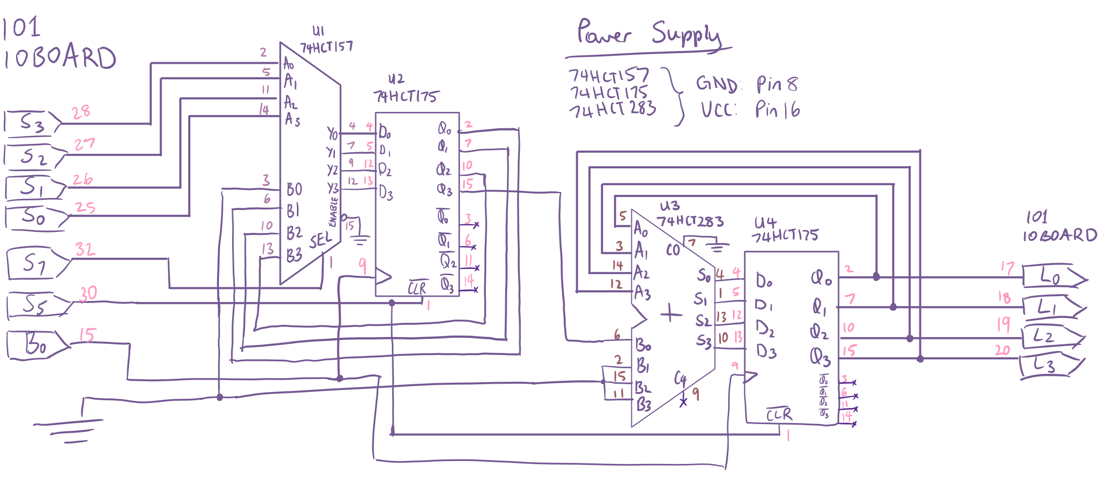
Provide a circuit schematic diagram (either hand-drawn or electronically produced) for the overall system by integrating the two logic diagrams above and mapping the circuit blocks to logic ICs available in your lab kit. Ensure that you are accurately following all conventions of circuit schematics. You may rotate the page.

