CSCI X350: Global (Web) ISs
Spring 2017

Project 2: PHP and State Info
Due: Feb 13 (11:59 pm)

To-Do List
In this project, you will write a web application for an online to-do list. The assignment tests your understanding of user login sessions and cookies, and building a large site with many connected pages.
You will create a web page for a fictional online to-do list site called "Remember the Cow", which is a parody of the real to-do list web site "Remember the Milk". Your site requires the user to log in or create an account first. After logging in, the user can manipulate his/her to-do list by adding or deleting items. Any changes made to the list are saved to the web server, so that if the user leaves the page and returns later, the state of the list is remembered.
You will write and turn in the following files:
- start.php: the initial web page describing the site with a form for the user to log in or register
- login.php: the target where start.php submits its login form data to log the user in
- logout.php: logs the user out and returns them to the front page start.php
- todolist.php: the page that shows the user's to-do list and lets them add/delete items from it
- submit.php: the target where todolist.php submits requests to add/delete items from the list
- common.php: a PHP file containing any shared PHP code or functions used by multiple other files
- cow.css: the style sheet that describes the appearance and presentation of all your pages (optional)
We have provided a skeleton of the HTML output from start.php and todolist.php, to help you get started. The HTML should not necessarily stay in those files exactly as written (e.g., some of it might go into your "common" file), but the skeleton is an indication of what the output should look like. You don't have to produce exactly the same HTML output as in these skeletons, but they can serve as a starting point. Yours style and design can completely differ, but the application needs to provide same functionality. You can also use any framework you prefer. Be creative and make your own unique page appearance
Here is the start.php page's initial appearance:
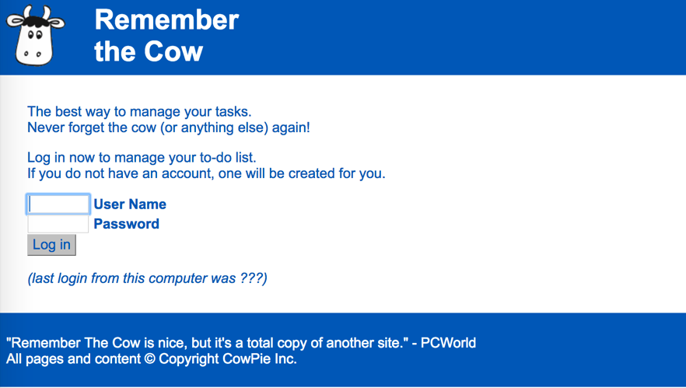

Page Relationships and Behavior:
Various actions cause the user to transition from one page to another, as summarized by the following diagram. Certain pages should only be viewable under certain states. If the user tries to visit start.php or login.php while already logged in, they should be immediately redirected to todolist.php. Similarly, the user tries to visit todolist.php, submit.php, or logout.php while not yet logged in, they should be redirected to start.php. You may assume that the user will not directly try to visit common.php or any of the *.txt files.
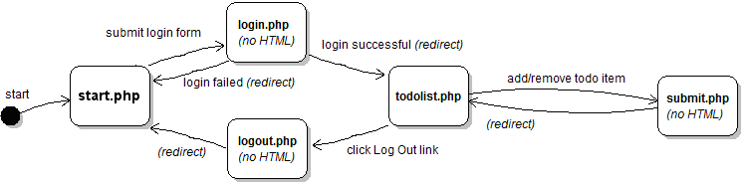
start.php: This is the initial page that the user visits upon entering the site. The page displays a login form with text boxes for a user name and password. The user types a name and password and presses a submit button to log in, which causes the form to submit to login.php as a POST request.
login.php: This file never directly produces any HTML output. Instead, it accepts the user name and password parameters from start.php and based on their values, redirects the user to another page. If either of the required parameters are not passed, display an error message of your choice and exit the page (die). Recall that you can use the PHP header function to redirect from one page to another, such as:
header("Location: foo.php");
die();
Your site will maintain a list of existing user names and passwords, stored in the file users.txt. The file contains one user per line, with the user name and password separated by a colon (:). For example:
aobourn:4ever!
daisy:1PrinceSS@
When the user submits the login form, you should look through this file to see if the user account exists and whether the password given by the user is correct. If the account exists and the user submitted the correct password, start a login session so the site will remember the user's information, and redirect the user to todolist.php. Store session data in PHP's $_SESSION global array. From the user's perspective it may look as though start.php submits directly to todolist.php, since the redirect will happen quickly.
If the user name already exists but the password submitted is incorrect, redirect the user back to start.php. You don't need to display any kind of error message; just put the user back at the start page.
If no such user exists in the file, assume that the user wants to create a new user account. To create an account, first validate the user input based on the following (contrived and arbitrary) rules using regular expressions:
- The user name must be 3-8 characters long, begin with a lowercase letter, and consist entirely of lowercase letters and numbers. Valid examples are "jsmith42", "bradpitt", and "x1234567".
- The password must be 6-12 characters long, begin with a number, and end with any character that is not a letter or number. Valid examples are "4ever!", "123abc$$", "2% milk?", and "01234567891*".
If the user input is valid for the new account, add it to the end of the users.txt file in the format above. Also, start a login session for the newly created user and redirect them to todolist.php. If the input is invalid, redirect the user back to start.php. You don't need to display any kind of error message (no users.txt file is provided, but you can create your own in a text editor or through your PHP code.)
todolist.php: This is the page the user sees after logging in that displays their to-do list and allows them to add/delete from it. If the user visits todolist.php without being logged in, they are redirected to start.php.
The page should have a heading including the user's name (ours says "username's To-Do List"), followed by a bullet list of to-do items. Each item displays its text and a button to Delete that item from the list. After any existing items, there is a text box and a button for the user to Add a new item to the end of the list.
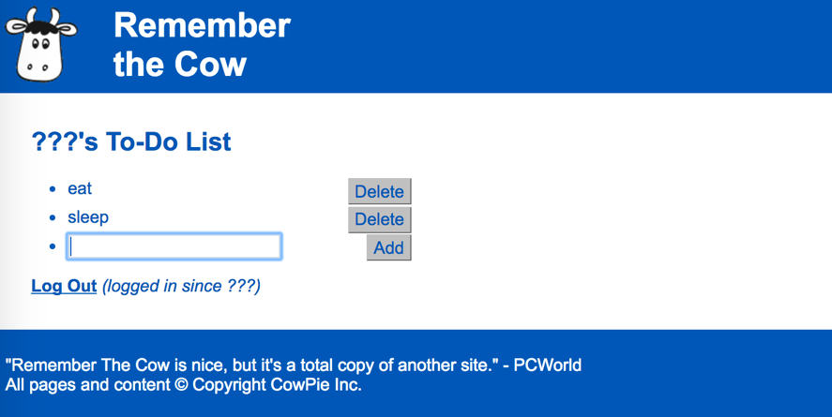
The Add button adds a new item to the end of the list using the text currently in the box. The Delete button next to a given item erases that item from the list.
Each user account maintains a separate to-do list of their own personal items. The list is stored in a file based on the user name; for example, user obourn stores her to-do list in a file todo_obourn.txt. The to-do list files contain each item on its own line without any special formatting or encoding. Your file must follow this format exactly. For example, a list of items would be stored as the following text:
Buy a pet jellyfish!
build a sculpture out of CHEESE
buy Ben & Jerry's ice cream.
The to-do list for any user who has not previously visited the site is initially empty (the to-do list is empty when there is no todo_username.txt file on the server, or when its contents are blank.) If the user has visited the site previously and added items to his/her to-do list, those items are read from the appropriate text file on the server and shown on the page.
Underneath the list of items, the page contains a "Log Out" link. When the user clicks this link, it goes to logout.php. As with the login file, logout.php is not a file that produces any HTML output. Instead, it ends the user's login session and immediately redirects to start.php, which will show the start page and login form. If the user manually directs their browser to logout.php while they are not logged in, just redirect them to start.php.
submit.php: Each Add or Delete action the user takes on the todolist.php page should be implemented as a form POST to the page submit.php, which will modify the user's to-do text file appropriately and then immediately redirect back to todolist.php. Place a small form into each to-do item that POSTs to submit.php to delete the item. Also, place a form into the last item containing the text box for the user to type a new item to add to the list.
To add an item, submit a POST to submit.php with a query parameter of action, set to "add"; and another named item, containing the text of the item to add. If no to-do list file exists for this user, create one. If it exists, the new item should be appended to the end on its own line. Any item text is acceptable, including special characters or an empty string. It is allowed for two items in the list to have exactly the same text; do not assume they are unique.
To delete an item, submit a POST to submit.php with a query parameter of action, set to "delete"; and another named index, set to the 0-based index of the item to delete. For example, if the file contains four to-do items, they should be considered to have the indexes 0-3 from top to bottom. If the user passes an index of 2, they are indicating that they want the third out of four items to be deleted.
Your code can tell whether the user is submitting an Add or Delete based on the value of the action parameter. The submit.php page is used for POSTs only; you do not need to write any code to handle GET requests. The submit code doesn't need to produce any HTML output, but it should redirect back to todolist.php, which will.
Cookie for Last Login Date/Time:
Most of the state that exists between pages should be kept using session variables. For example, when the user logs in, you should create a session to remember who is logged in and maintain that session until the user logs out.
Separately from the session, you should also create a cookie that remembers the last date/time at which the user logged into the site from this particular computer and browser. Set your cookie to expire after 7 days. You can get a string representing the current date/time at the moment the user logs in using PHP's date function:
date("D y M d, g:i:s a") # returns a string such as "Sun 14 Oct 21, 6:49:14 pm"
On the todolist.php page, next to the "Log Out" link, display text indicating how long the user has been logged in during their current session based on the value of this cookie. On the start.php page, if the cookie exists, display the last date/time the user logged in from this computer.
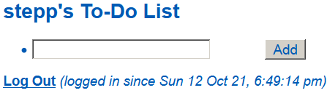
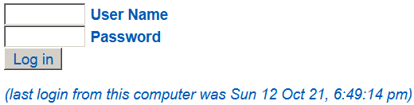
start.php displaying last-login cookie todolist.php displaying last-login cookie
It is important to understand the difference between cookies and session variables. Your cookie will not be lost when the user logs out or closes the browser. But the other user information will, because it is part of the session that is terminated when the user logs out. If the user explicitly clears the cookies in their browser, or uses a different computer or browser, or uses an "Incognito Mode" tab, the cookie will be gone (see PHP's setcookie function.)
How to Submit:
Submit your ".zip" file using ELC. Only team leaders need to make a submission. Every student needs to submit a peer-evaluation form within 24 hours of the project submission deadline.
Do not place your solution on a public web site. Submit your own work and follow the course misconduct policy.

