Photos Storyboard Overview

Select album

User

Move/copy pic

Back

Logout

login

Multi album view

Single album view

Add/delete users

Dest. album selection

Admin

Logout

Photos Storyboard Login

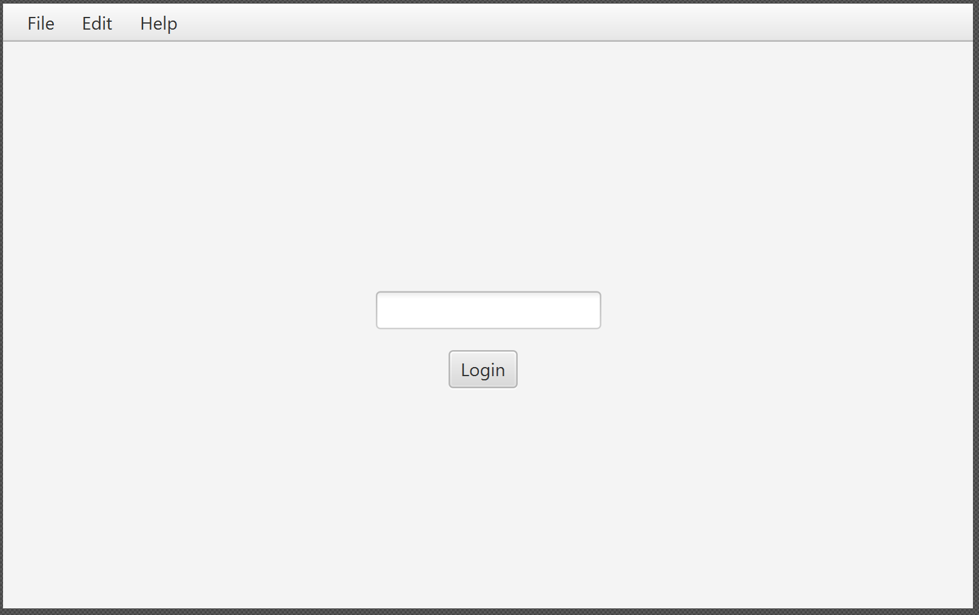

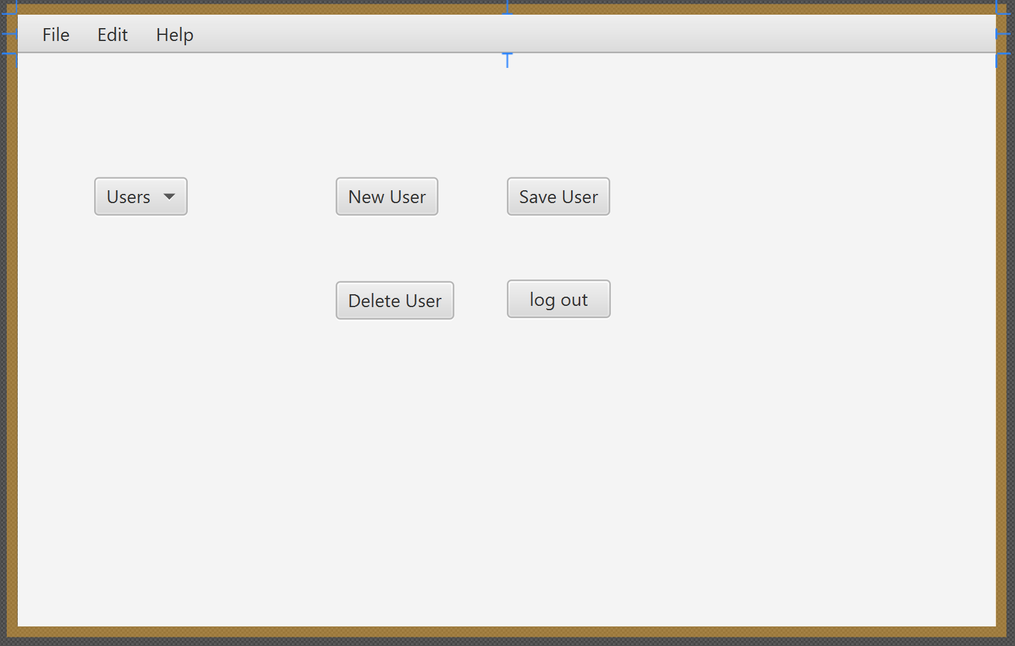Photos Storyboard Add/Delete Users

Users

Photos Storyboard Multi Album View

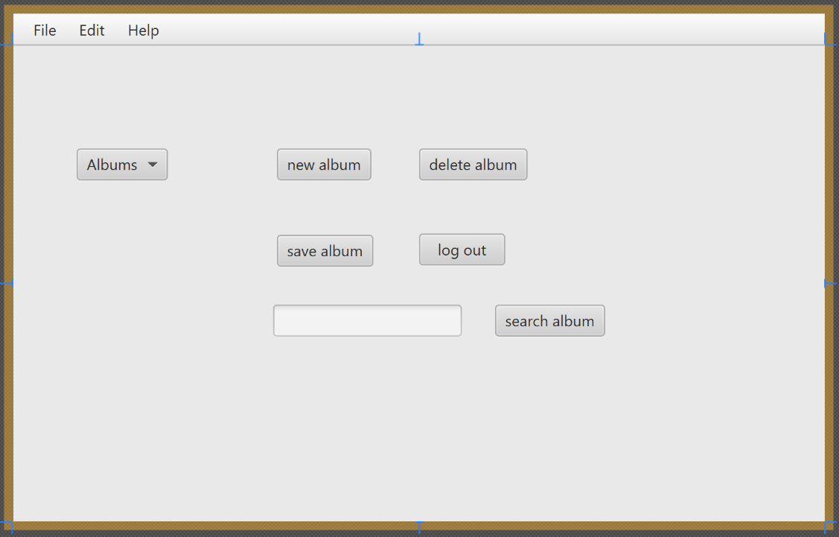

Albums

Photos Storyboard Single Album View

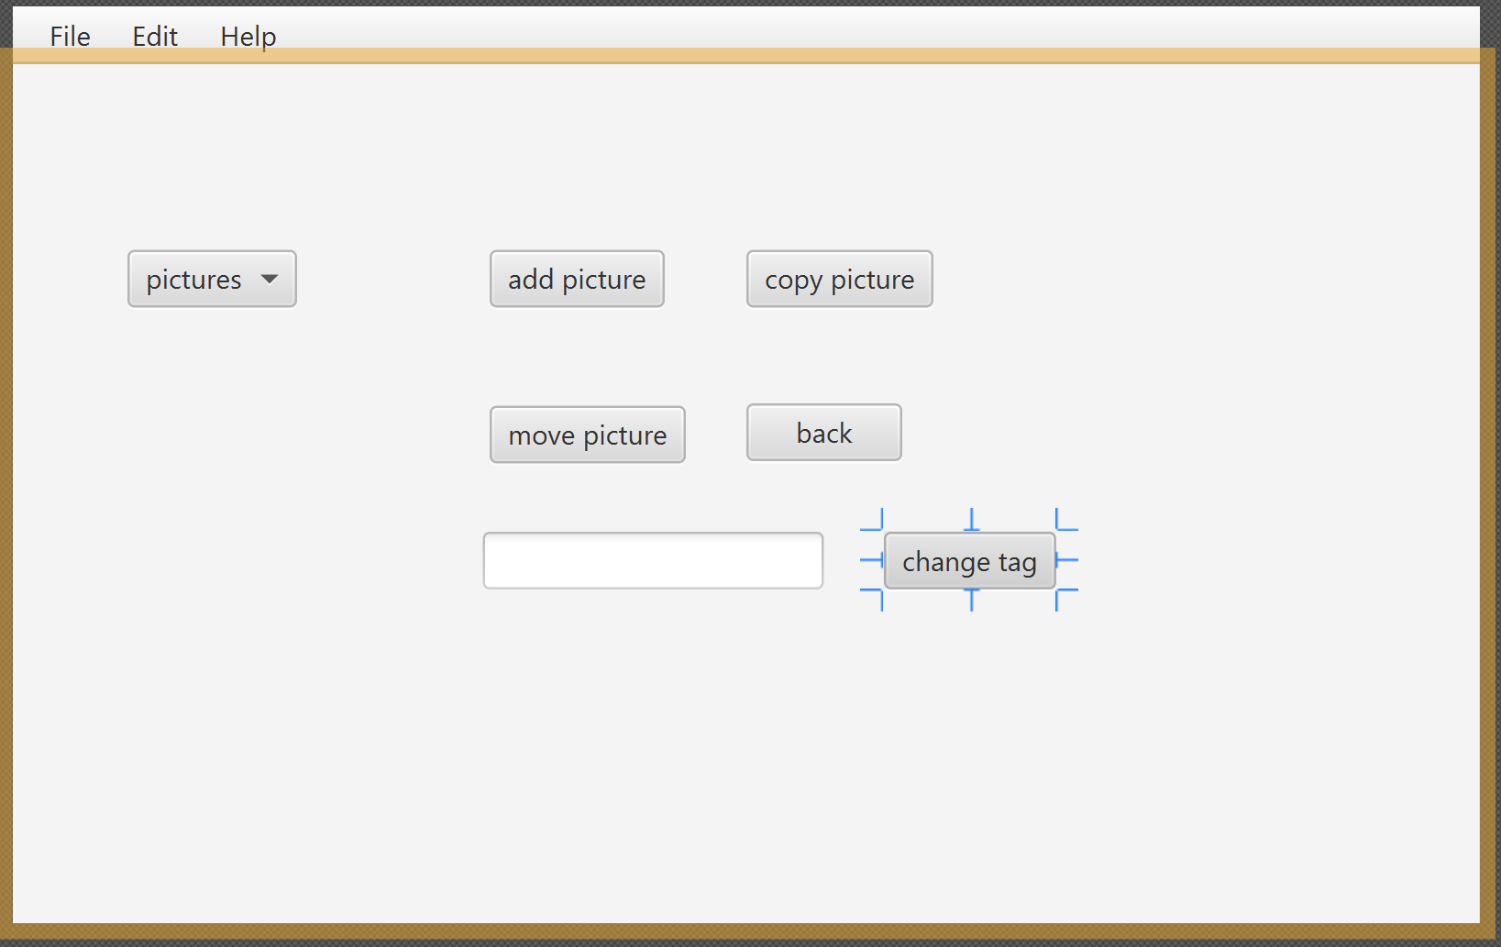

Pictures

Photos Storyboard Dest. Album Selection

