**Group Bacchus**

Brandon Hasty

Stella Kemp

John Smith

Dan Zhu

**Screenshots of tables:**

Owners table

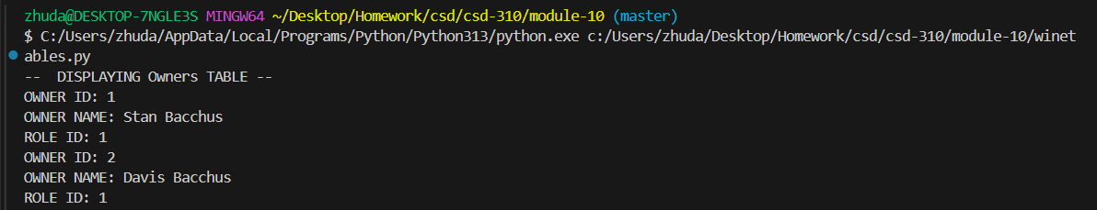

Employee table

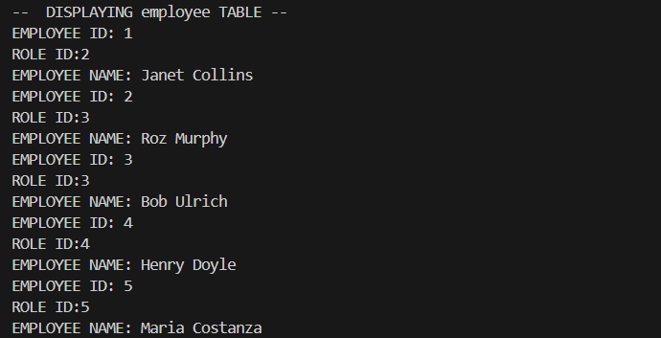

Roles table

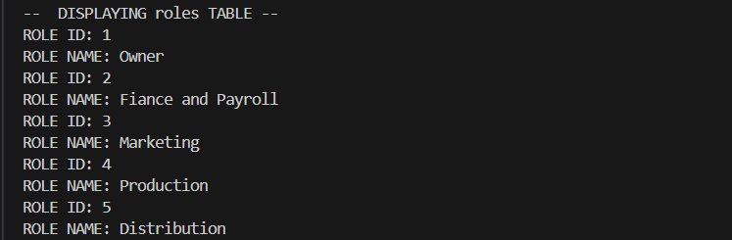

Suppliers table

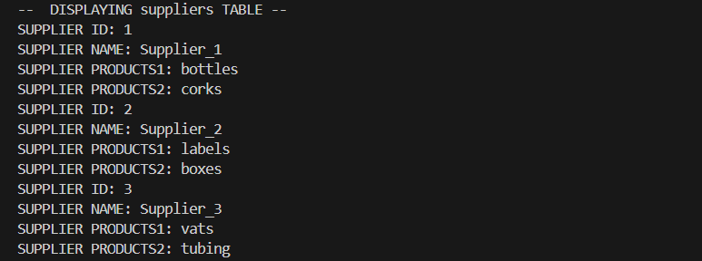

Products table

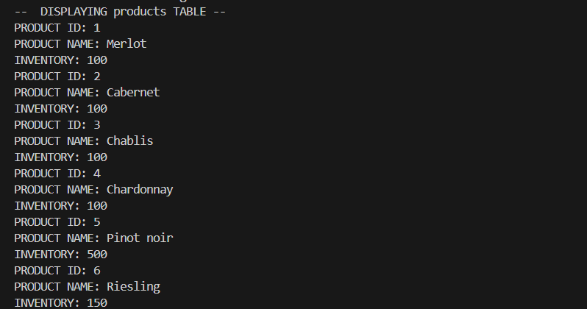

Orders table

