**Group Bacchus**

Brandon Hasty

Stella Kemp

John Smith

Dan Zhu

**Report 1: Supplier Delivery Information**

This report provides detailed information about suppliers, products and delivery information. It includes supplier name, product name, quantity delivered, expected delivery date, and the actual delivery date. It will help owners track suppliers and products.

**Key Information:**

* **Supplier Name:** The name of the supplier responsible for the delivery.
* **Product Name:** The name of the product being delivered.
* **Quantity Delivered:** The quantity of the product delivered.
* **Expected Delivery Date:** The date the supplier expected to deliver the product.
* **Actual Delivery Date:** The actual date on which the delivery was made.

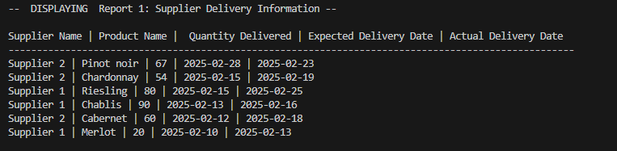

**Report 2: Wine Orders with Distribution Information**

This report provides detailed information about orders with distribution details. It includes the order ID, product name, distributor details (ID and name), quantity ordered, and the order date. It shows orders detail along with distribution information. It will help owner to see which distributor carries which wine and how sales doing.

**Key Information:**

* **Order ID:** The unique identifier for each order.
* **Product Name:** The name of the product ordered (wine).
* **Distributor ID:** The identifier for the distributor fulfilling the order.
* **Distributor Name:** The name of the distributor handling the order.
* **Quantity Ordered:** The quantity of wine ordered.
* **Order Date:** The date the order was placed.

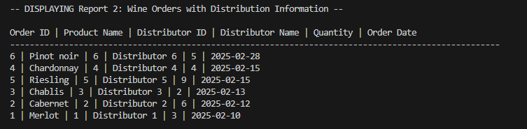

**Report 3: Employee Work Time**

It summarizes total hours of each employee worked. It includes the employee’s ID, their name, and the total hours worked. It helps employer track total hours each employee worked.

**Key Information:**

* **Employee ID:** The unique identifier for the employee.
* **Employee Name:** Employee name
* **Total Hours Worked:** The total number of hours the employee worked

