Dan Zhu

Assignment 5.2

1. CONCAT() function is one of the string function which is used to connect two or more expressions together.

SELECT CONCAT("This", "is", "MySQL") AS Title;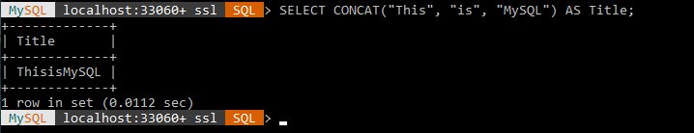

1. LOCATE() function returns the position of the first occurrence of a substring. If the substring is not found, it will return 0. It is case-insensitive as well.

SELECT LOCATE("h", "Hello World!") AS MatchPosition;

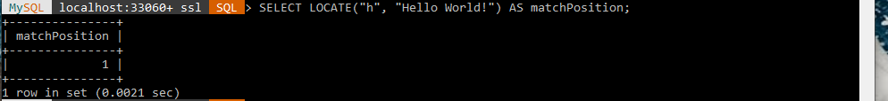

1. MID() function is used to extract substring from a string. It could start from any position and how many characters from the start position. One thing that I want to mention that a position of string in SQL starts from 1.

SELECT MID(“I am so happy!”, 3, 2) AS ExtractString;