Dan Zhu

Assignment 8.2

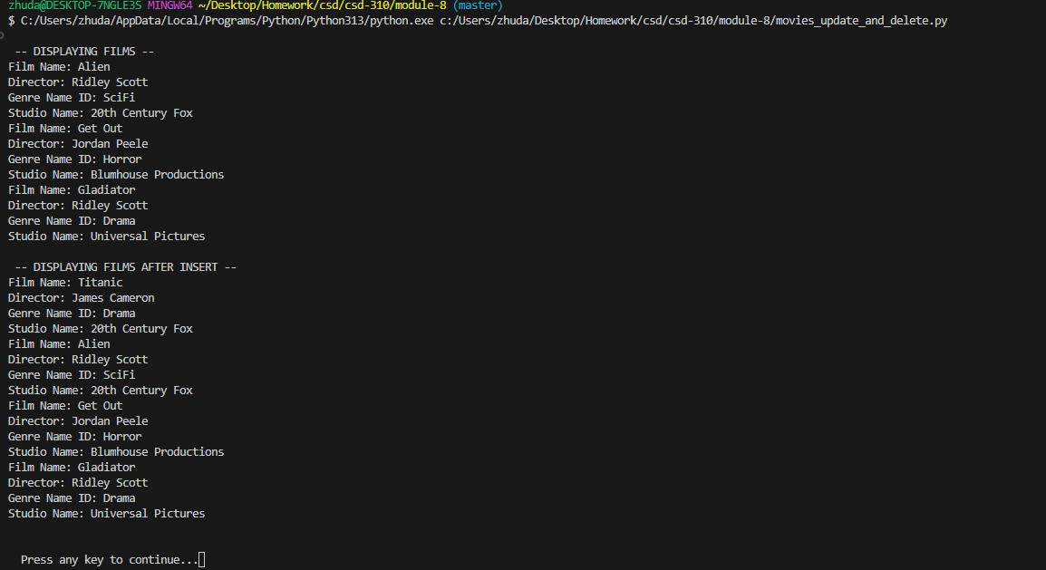

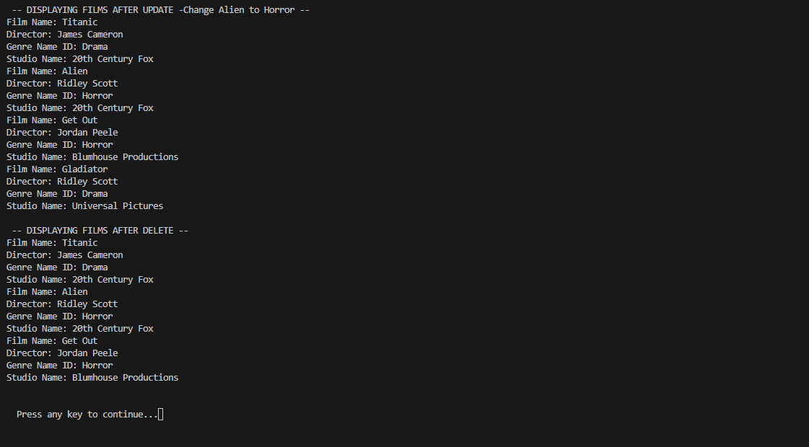

Git hub: https://github.com/dz204625/csd-310/tree/master/module-8