Dan Zhu

Assignment 7.2

City_functions result

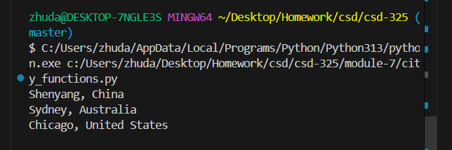

Test

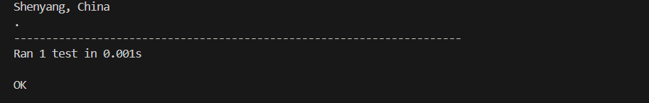

Failed test with population

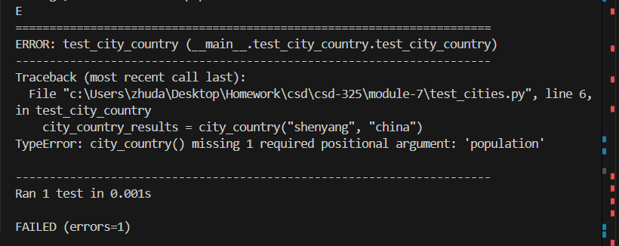

Passed test with optional population

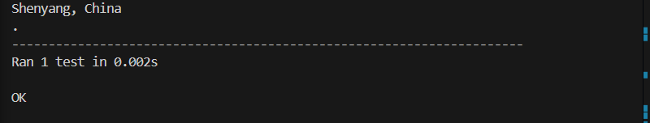

Failed with Language

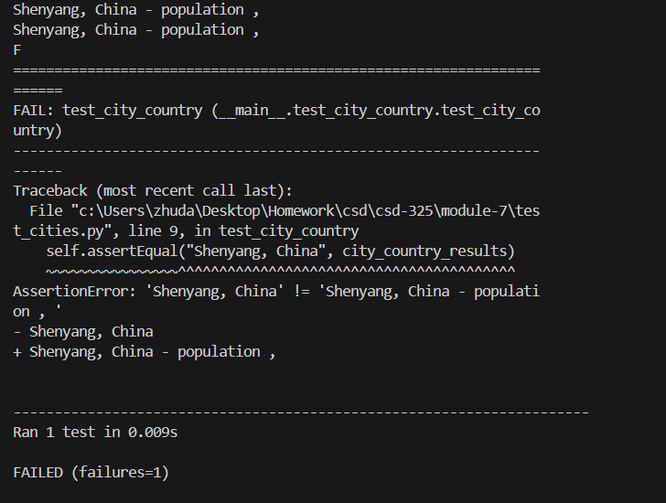

Passed with language optional:

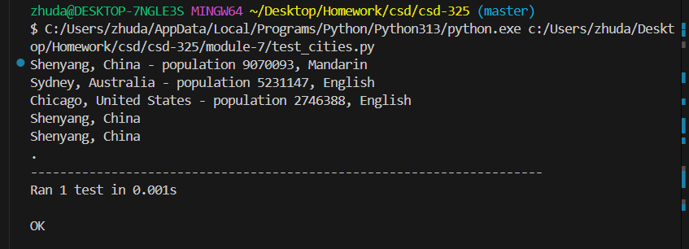

City country; city country population, city country population and language

