Dan Zhu

Assignment 8.2

Flowchart

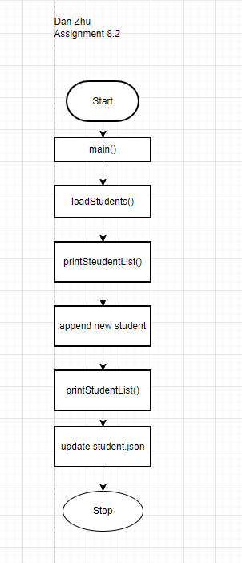

1.

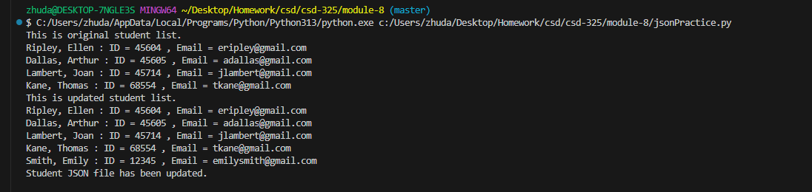

2. I don’t see notification when I run program in VSC.

3. [

    {

        "F_Name": "Ellen",

        "L_Name": "Ripley",

        "Student_ID": 45604,

        "Email": "eripley@gmail.com"

    },

    {

        "F_Name": "Arthur",

        "L_Name": "Dallas",

        "Student_ID": 45605,

        "Email": "adallas@gmail.com"

    },

    {

        "F_Name": "Joan",

        "L_Name": "Lambert",

        "Student_ID": 45714,

        "Email": "jlambert@gmail.com"

    },

    {

        "F_Name": "Thomas",

        "L_Name": "Kane",

        "Student_ID": 68554,

        "Email": "tkane@gmail.com"

    },

    {

        "F_Name": "Emily",

        "L_Name": "Smith",

        "Student_ID": 12345,

        "Email": "emilysmith@gmail.com"

    }

]