Dan Zhu

Assignment 1.2

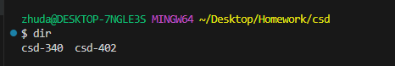

Github link: <https://github.com/dz204625/csd-340>

