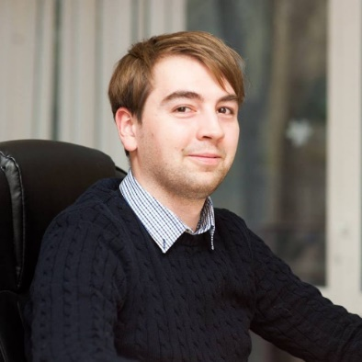

**Zabiaco Dmitri Iuri**

**Personal data**

**Date of birth:** 12.10.1995

**Place of birth:** Chișinău

**Marital status:** Single

**Email:** [dzabiaco@outlook.com](mailto:dzabiaco@outlook.com)

**Address:** 1/1 Dimo str, ap. 154

**Phone:** +37362192233

**Work experience**

**QA Automation Engineer,** January 2021

The project is based on Agile methodology. A team consists of three QA automation testers and three manual testers, product owner, business analyst and project manager. At this project we are testing an application, that implements risk assessments of customers for trading system. We are using such technologies like HTML, CSS, JavaScript, Java, TestNG, Selenium, SQL.

Responsibilities:

* Testing of UI
* Testing of databases

**JavaScript developer**, Allied Testing, January 2020 – January 2021.

The project was based on Agile methodology. A team consisted of seven developers, two QA testers, product owner, business analyst and project manager. At this project we developed a web application for financial analytics and trading. We used such technologies like HTML, CSS, JavaScript, TypeScript, Less, GIT, Tortoise GIT, Jasmine, Karma.

Responsibilities:

* Developed new user-facing features
* Enhance existing features
* Implement bug fixes in existing code
* Continuous build and deployment

**QA Automation Engineer**, Allied Testing, November 2018 – January 2020.

The project was based on Agile methodology. A team consisted of nine QA testers, four developers, product owner, business analyst and project manager. At this project we tested a transaction monitoring application. We used such technologies like Java, Selenium, TestNG, SQL.

Responsibilities:

* Testing of databases
* Testing of UI

**Frontend developer,** Simpals, May 2017 – August 2018;

The project was based on agile methodology. A team consisted of product owner, project manager, five designers, five frontend developers and three backend developers. At this project we developed websites and HTML5 ads. We used such technologies like HTML, CSS, Sass, JavaScript, jQuery, Bootstrap.

Responsibilities:

* Animation of HTML5 ads
* Making websites on WordPress
* Making HTML pages

**Education**

2018 – 2020: Informational technologies in economy at ASEM (Master). Thesis: “Automation testing of web application”

2014 – 2018: Informational security at ASEM. Thesis: “Analysis of security of web application”.

2002 – 2014: Lyceum A. Russo.

**Professional skills**

HTML, CSS, JavaScript, TypeScript, jQuery, Bootstrap, Less, Sass, Photoshop, GIT, OOP, SQL, Java, Selenium, Postman, REST API, Vue (basics).

**Personal skills**

Creativity, punctual, detail – oriented, patience, teamwork, commitment, sociable, aspiration to learn new technologies, teachable, responsible.