LAPORAN PENGERJAAN UJIAN KOMPETENSI

SMK MAHADHIKA BATUJAJAR

TAHUN PELAJARAN 2022-2023



Moch Dzaki Megantara

XII RPL 2

LAPORAN PENGERJAAN UJI KOMPETENSI KEJURUAN SMK MAHARDHIKA BATUJAJAR

TAHUN PELAJARAN 2022-2023

KOMPETENSI KEAHLIAN : Rekayasa Perangkat Lunak KELAS : XII RPL 2

NAMA LENGKAP : Moch Dzaki Megantara

NIS : 2021.10.368

PAKET SOAL : Paket 3 (Aplikasi pengelolaan Laundry)

JENIS APLIKASI : Web

ALOKASI WAKTU : 24 jam

# PENJADWALAN KEGIATAN

|  |  |  |  |  |  |  |  |  |  |  |
| --- | --- | --- | --- | --- | --- | --- | --- | --- | --- | --- |
| Kegiatan | Alokasi waktu | | | | | | | | | |
| Januari | | | | Febuari | | | | Maret | |
| 1-6 | 8-13 | 15-21 | 22-30 | 1-6 | 8-13 | 15-21 | 23-28 | 1-6 | 8-11 |
| Analisis Soal |  |  |  |  |  |  |  |  |  |  |
| Persiapan Perangkat Keras |  |  |  |  |  |  |  |  |  |  |
| Persiapan Perangkat Lunak |  |  |  |  |  |  |  |  |  |  |
| Perancangan Algoritma |  |  |  |  |  |  |  |  |  |  |
| Desain Bisnis Data |  |  |  |  |  |  |  |  |  |  |
| Implementasi Data ke mysql |  |  |  |  |  |  |  |  |  |  |
| Desain UI |  |  |  |  |  |  |  |  |  |  |
| Coding Stuktur HTML |  |  |  |  |  |  |  |  |  |  |
| Coding Style CSS |  |  |  |  |  |  |  |  |  |  |
| Coding PHP |  |  |  |  |  |  |  |  |  |  |
| Uji Coba Aplikasi |  |  |  |  |  |  |  |  |  |  |
| Uji Coba Cetak Struk |  |  |  |  |  |  |  |  |  |  |
| Uji Coba Buat Laporan |  |  |  |  |  |  |  |  |  |  |
| Upload Ke Hosting |  |  |  |  |  |  |  |  |  |  |
| Dokumentasi |  |  |  |  |  |  |  |  |  |  |

# PERSIAPAN PERANGKAT KERAS

|  |  |
| --- | --- |
| 1 | Processor IntelCore Duo CPU E7500 @ 2.93 GHz 2.92 GHz |
| 2 | RAM 6 GB |
| 3 | Monitor |
| 4 | Keyboard |
| 5 | Mouse |
| 6 | Casing CPU |

# PERSIAPAN PERANGKAT LUNAK

*Silahkan isikan perangkat lunak yang terlibat dalam pembuatan project ini*

|  |  |
| --- | --- |
| 1 | Visual Studio Code |
| 2 | Sublime Text |
| 3 | XAMPP Control Panel |
| 4 | Balsamiq |
| 5 | Astah Pro |
| 6 | Chrome |
| 7 | Microsoft Word |
| 8 | Microsoft excel |

# PERANCANGAN ALGORITMA APLIKASI

# 

*Gambar 1.1 Activity Diagram Cetak*

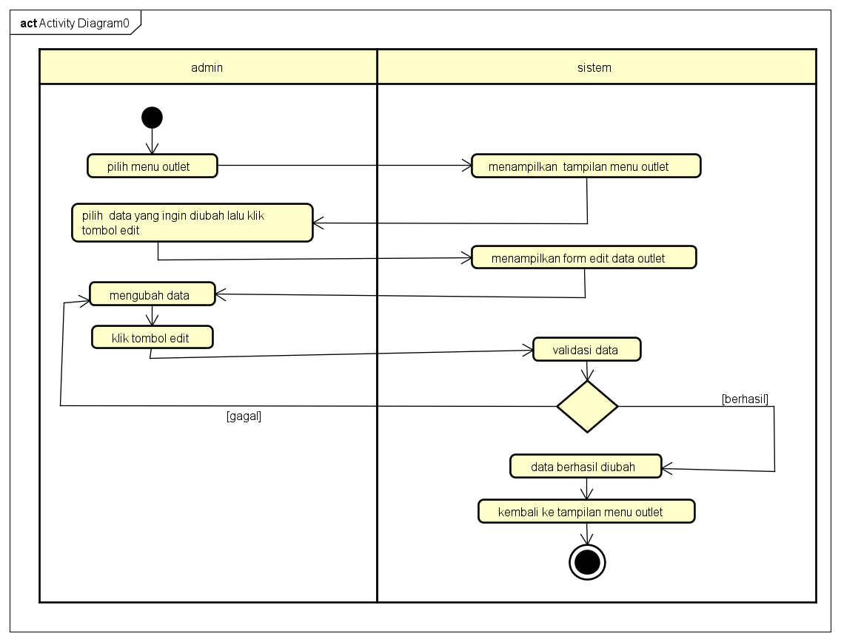

*Gambar 1.2 Activity Diagram Edit_Outlet*

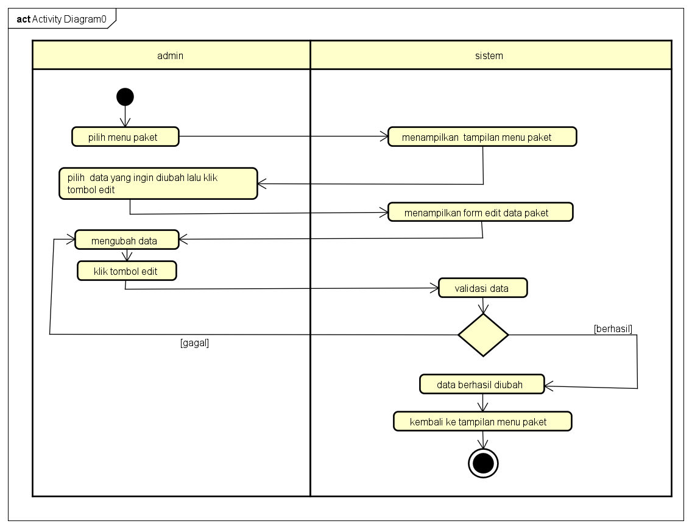

*Gambar 1.3 Activity Diagram Edit_Paket*

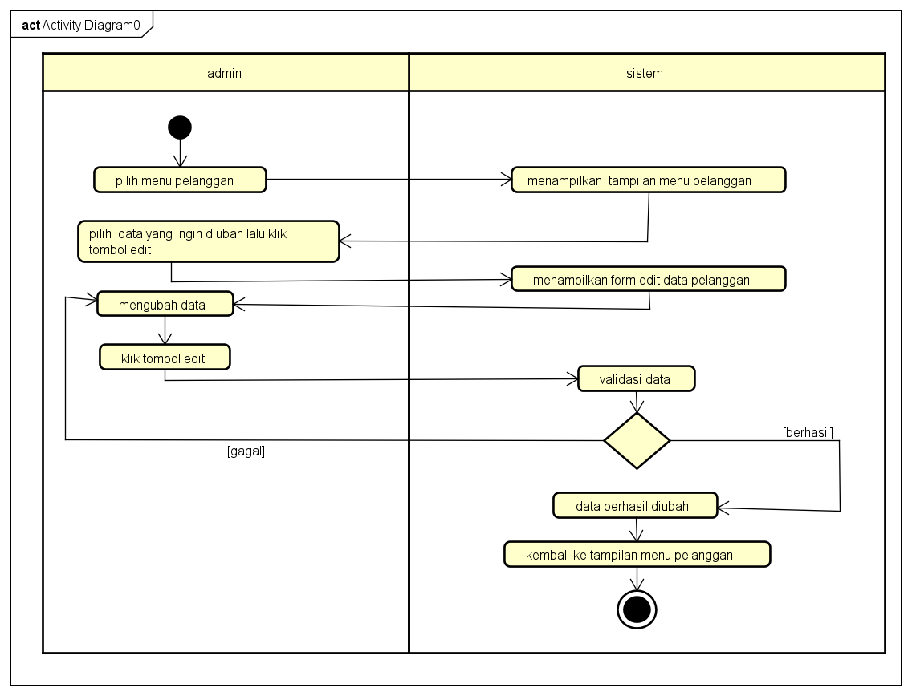

*Gambar 1.4 Activity Diagram Edit_Pelanggan*

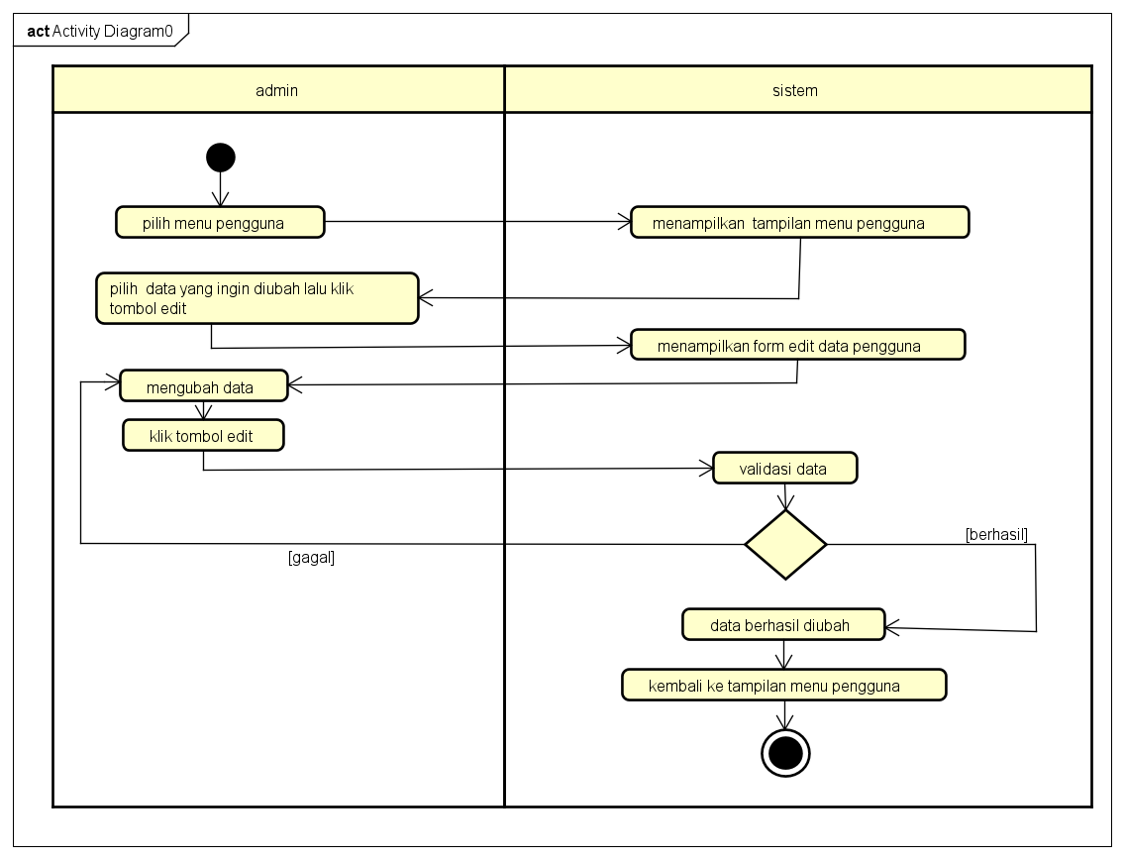

*Gambar 1.5 Activity Diagram Edit_Pengguna*

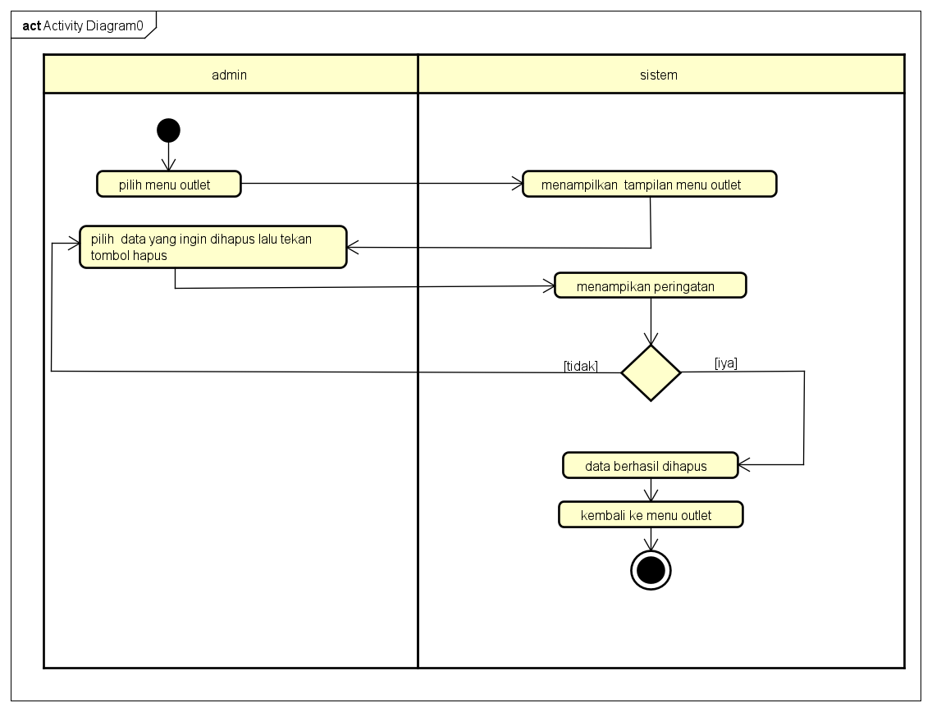

*Gambar 1.6 Activity Diagram Hapus_Outlet*

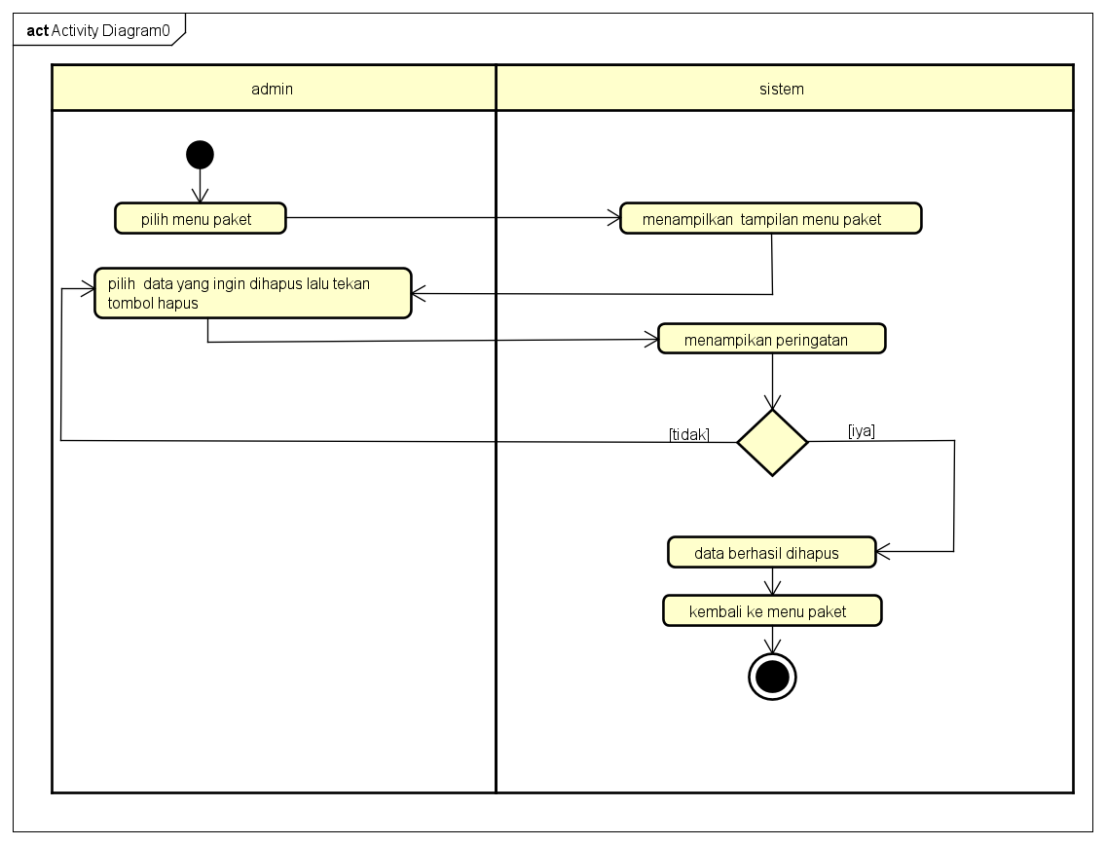

*Gambar 1.7 Activity Diagram Hapus_Paket*

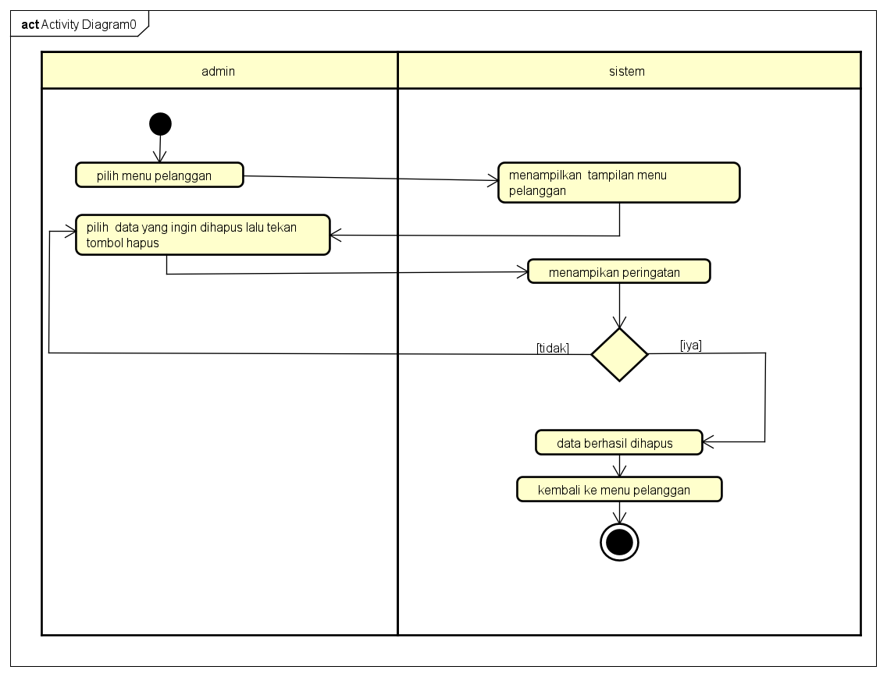

*Gambar 1.8 Activity Diagram Hapus_Pelanggan*

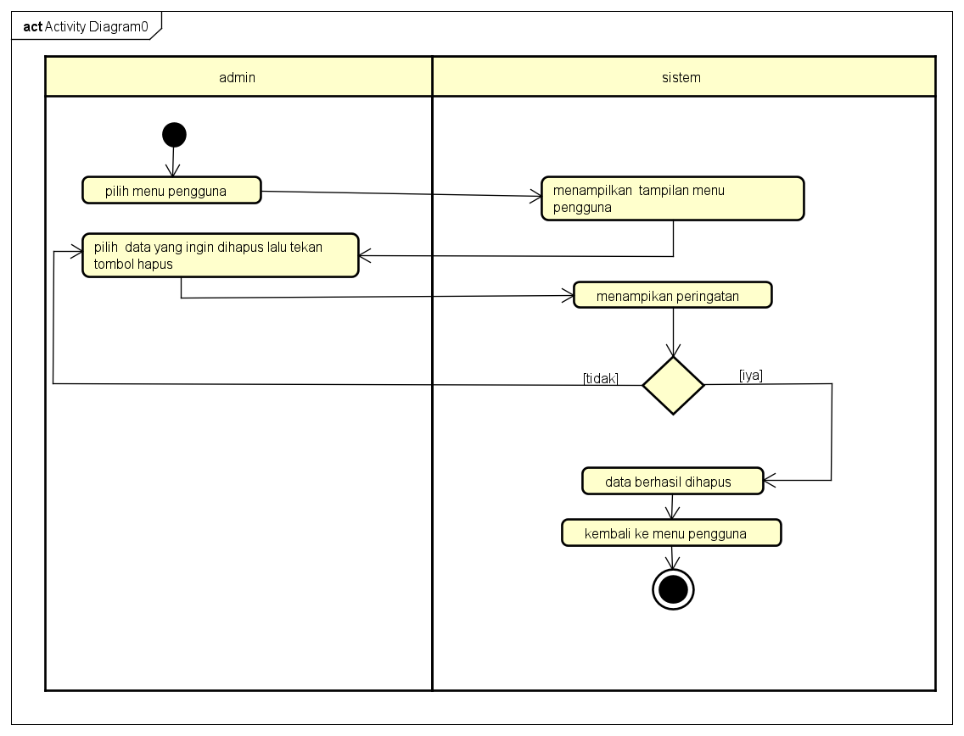

*Gambar 1.9 Activity Diagram Hapus_Pengguna*

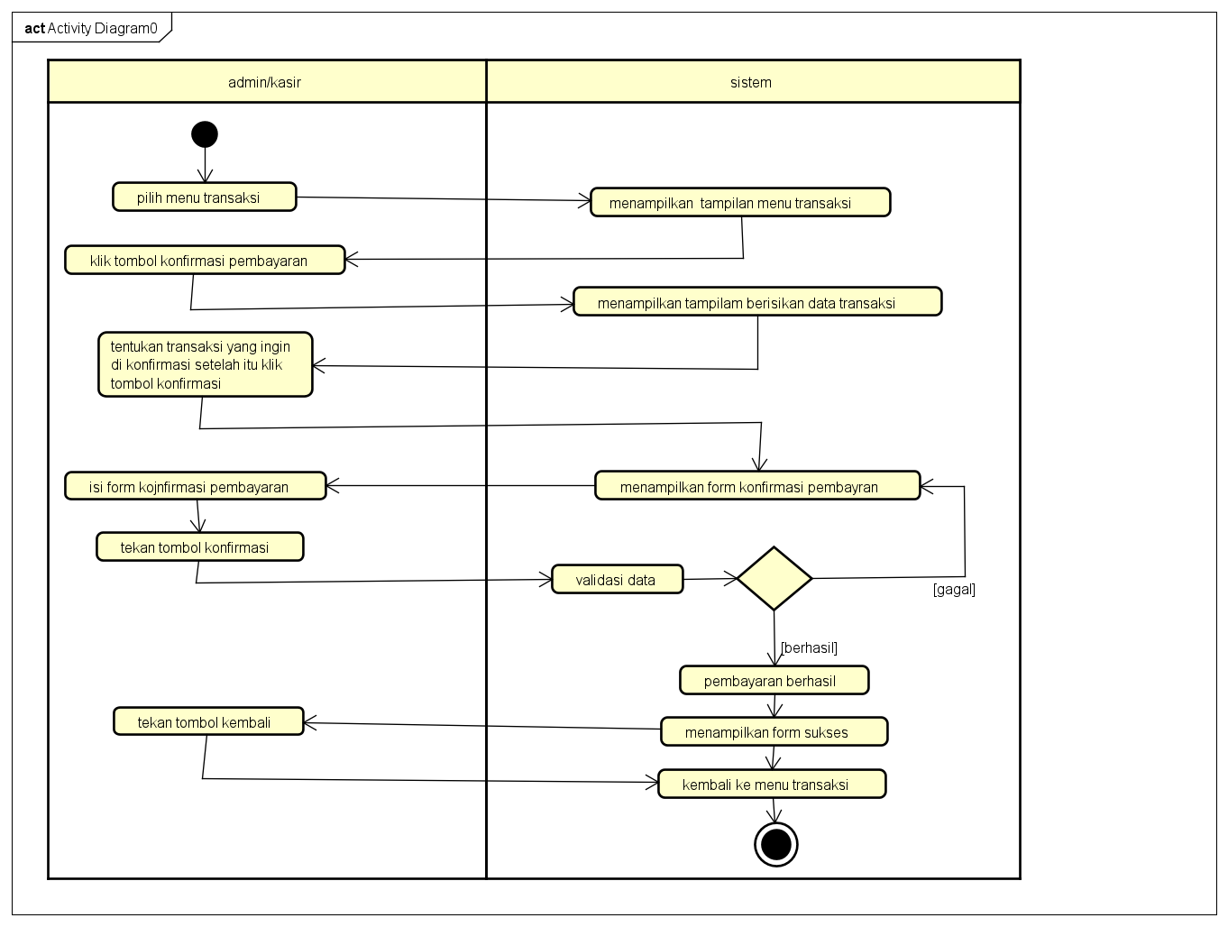

*Gambar 2.0 Activity Diagram Konfirmasi Transaksi*

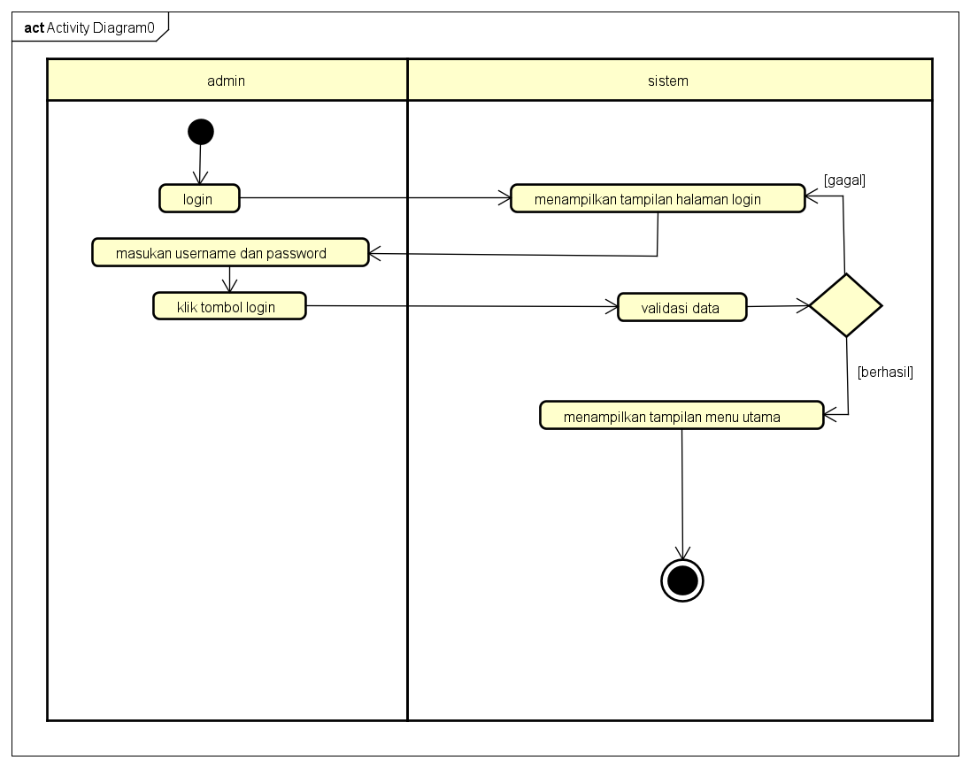

*Gambar 2.1 Activity Diagram Login*

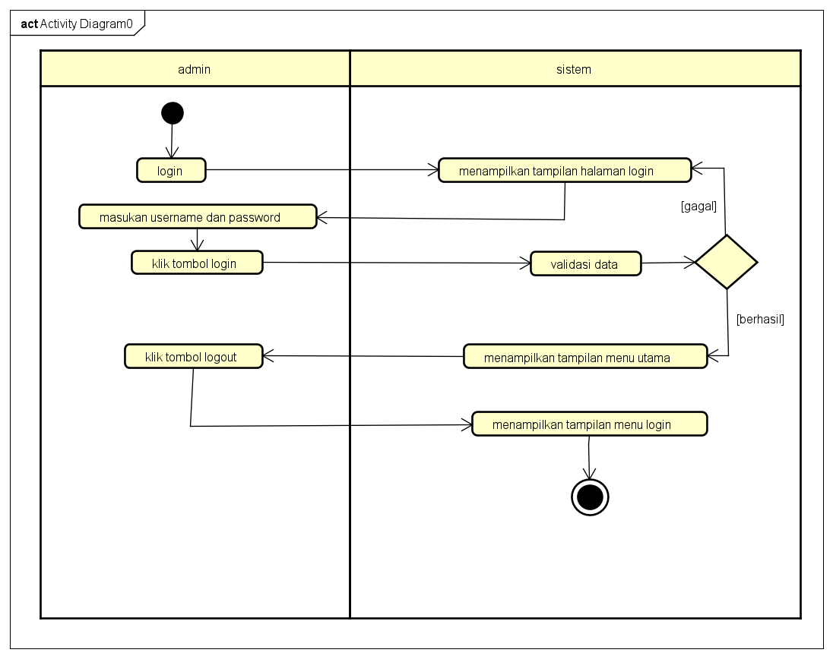

*Gambar 2.2 Activity Diagram Logout*

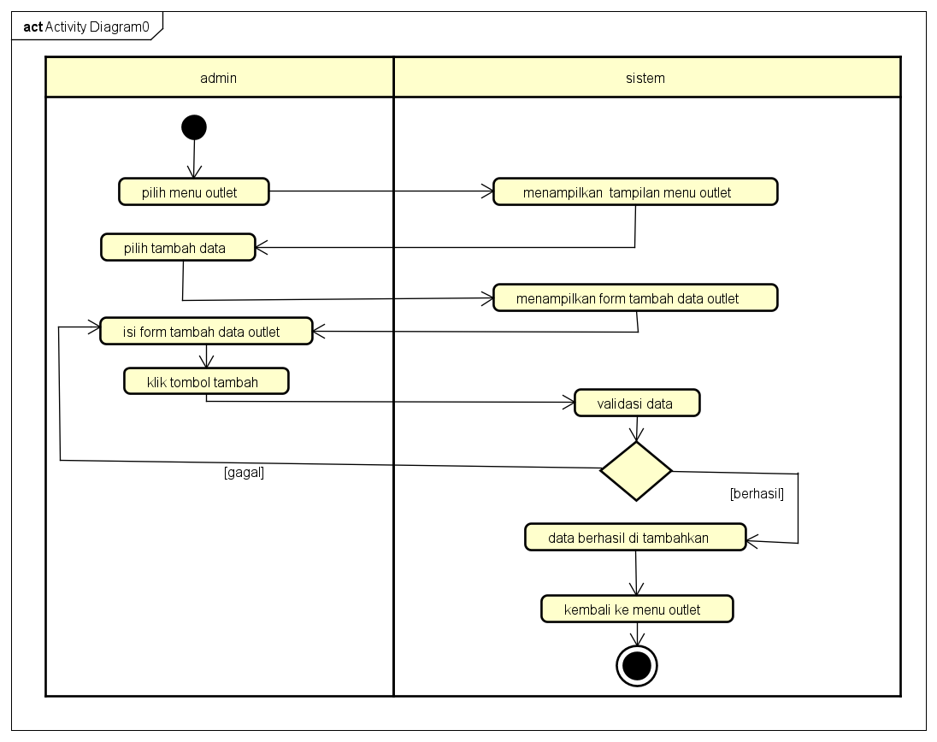

*Gambar 2.3 Activity DiagramTambah Outlet*

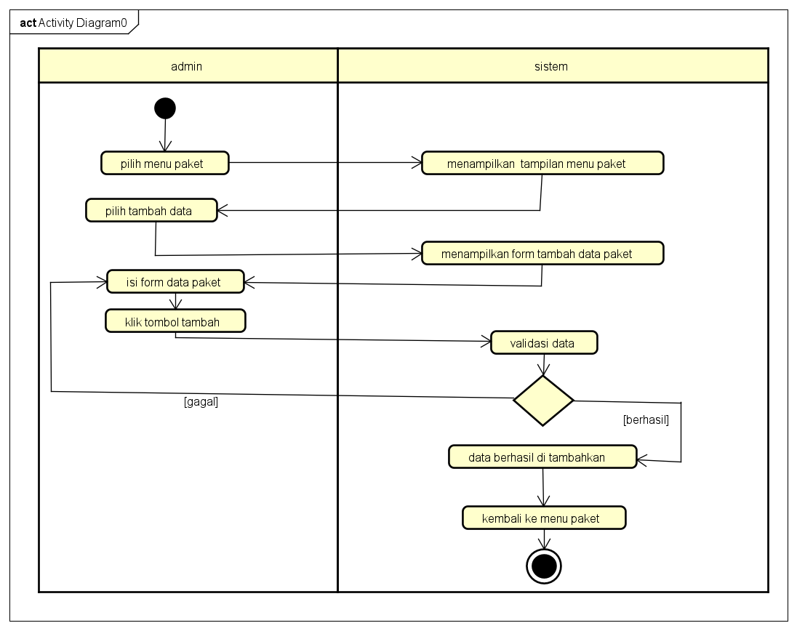

*Gambar 2.4 Activity Diagram Tambah Paket*

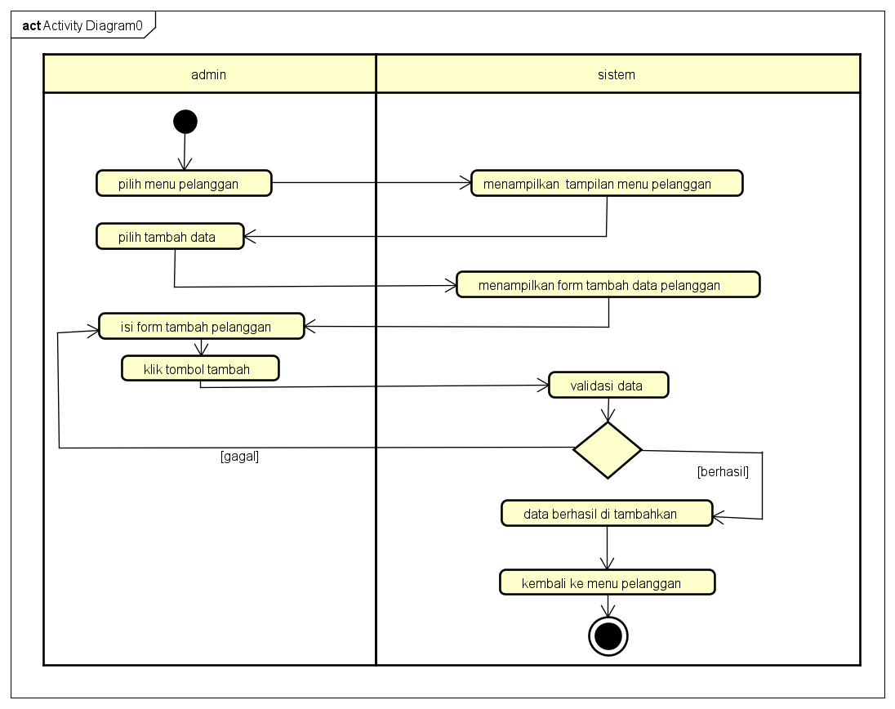

*Gambar 2.5 Activity Diagram Tambah Pelanggan*

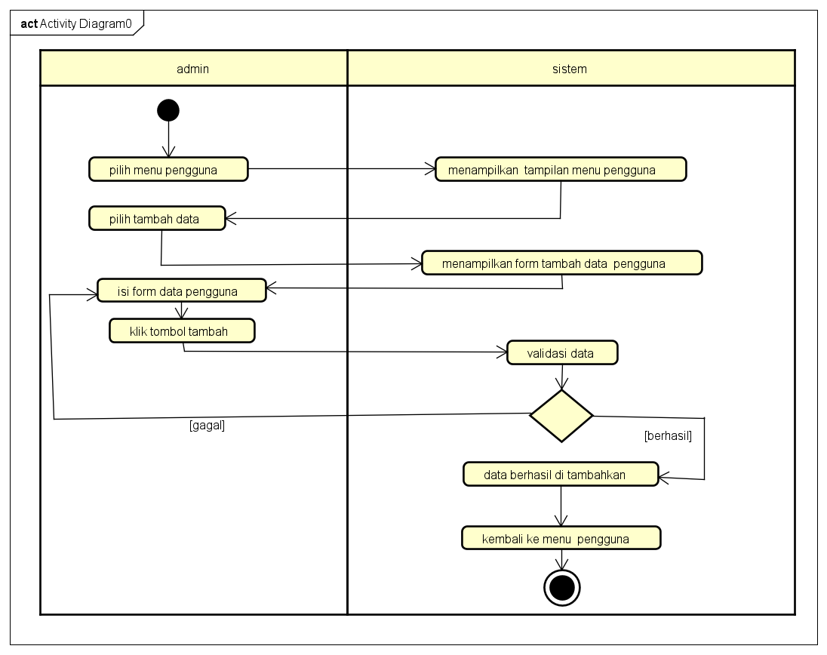

*Gambar 2.6 Activity Diagram Tambah Pengguna*

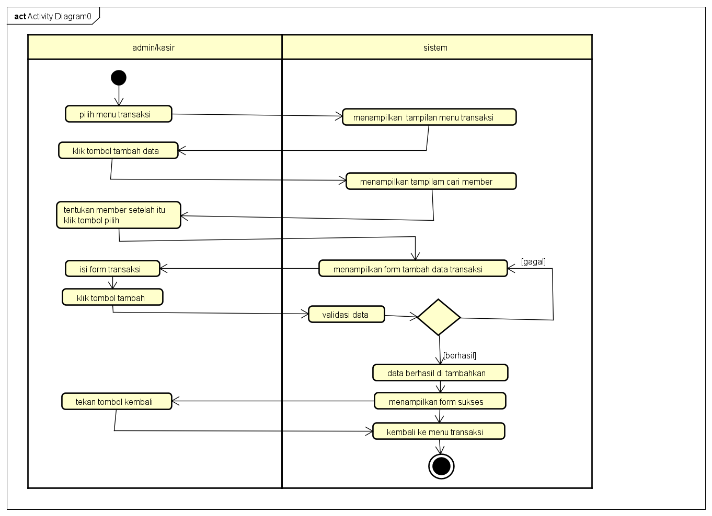

*Gambar 2.7 Activity Diagram Tambah Transaksi*

# PERANCANGAN DESAIN BASIS DATA

*Gambar 2.8 DFD*

# DUMMY DATA

|  |  |  |  |  |  |
| --- | --- | --- | --- | --- | --- |
| Id_member | nama_member | alamat_member | Jenis_kelamin | telp_member | No_ktp |
| 5 | Susi | Cirebon | P | 00000000001 | 00000000001 |
| 6 | Melly | Cirebon | P | 00000000002 | 00000000002 |
| 7 | Neni | Cirebon | P | 00000000003 | 00000000003 |
| 8 | Ako | Cirebon | L | 08998 | 0899332 |
| 9 | Jono | Cirebon | L | 08998444333 | 320939399320023 |
| 10 | Cantika | Kuningan | P | 087772322 | 02332399923 |

*Tabel Dummy Data Dari Member*

|  |  |  |  |  |
| --- | --- | --- | --- | --- |
| id_paket | jenis_paket | Nama_paket | harga | outlet_id |
| 4 | Kiloan | Paket Cuci Kering | 7000 | 26 |
| 5 | Kiloan | Paket Cuci Setrika | 9000 | 26 |
| 6 | Kiloan | Paket Kering | 6000 | 26 |
| 7 | Bedcover | Paket Bedcover | 11000 | 26 |
| 8 | Kiloan | Paket One Day Service (ODS) | 14000 | 26 |
| 9 | Kiloan | Paket Express Service | 21000 | 26 |
| 10 | Kiloan | Bersih 1 hari | 12000 | 26 |
| 11 | Kiloan | Bersih 2 hari | 10000 | 29 |

*Tabel Dummy Data Dari Transaksi*

# PEMBUATAN BASIS DATA (MySQL Code)

1. *Tabel detail_transaksi*

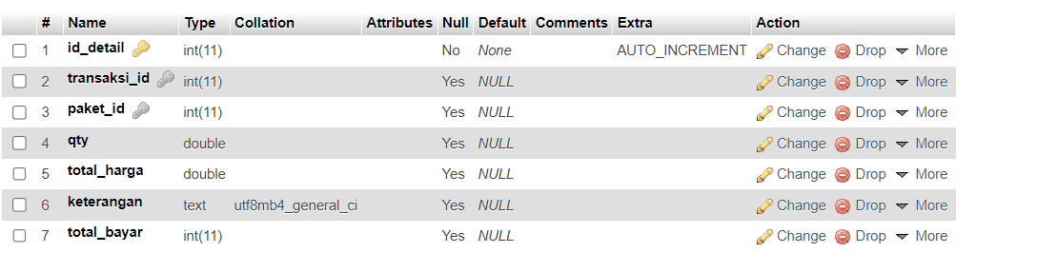

# *Gambar 2.9 Struktur Tabel Detail Transaksi*

# *Tabel member*

# 

# *Gambar 3.0 Struktur Tabel Member*

# *Tabel outlet*

# 

# *Gambar 3.1 Struktur Tabel Outlet*

# *Tabel paket*

# 

# *Gambar 3.2 Struktur Tabel Paket*

# *Tabel Transaksi*

# 

# *Gambar 3.3 Struktur Tabel Transaksi*

# *Tabel user*

# 

# *Gambar 3.4 Struktur Tabel User*

# PERANCANGAN TAMPILAN ANTARMUKA (UI) WEB

# Aplikasi pengelolaan laundry

*1.*

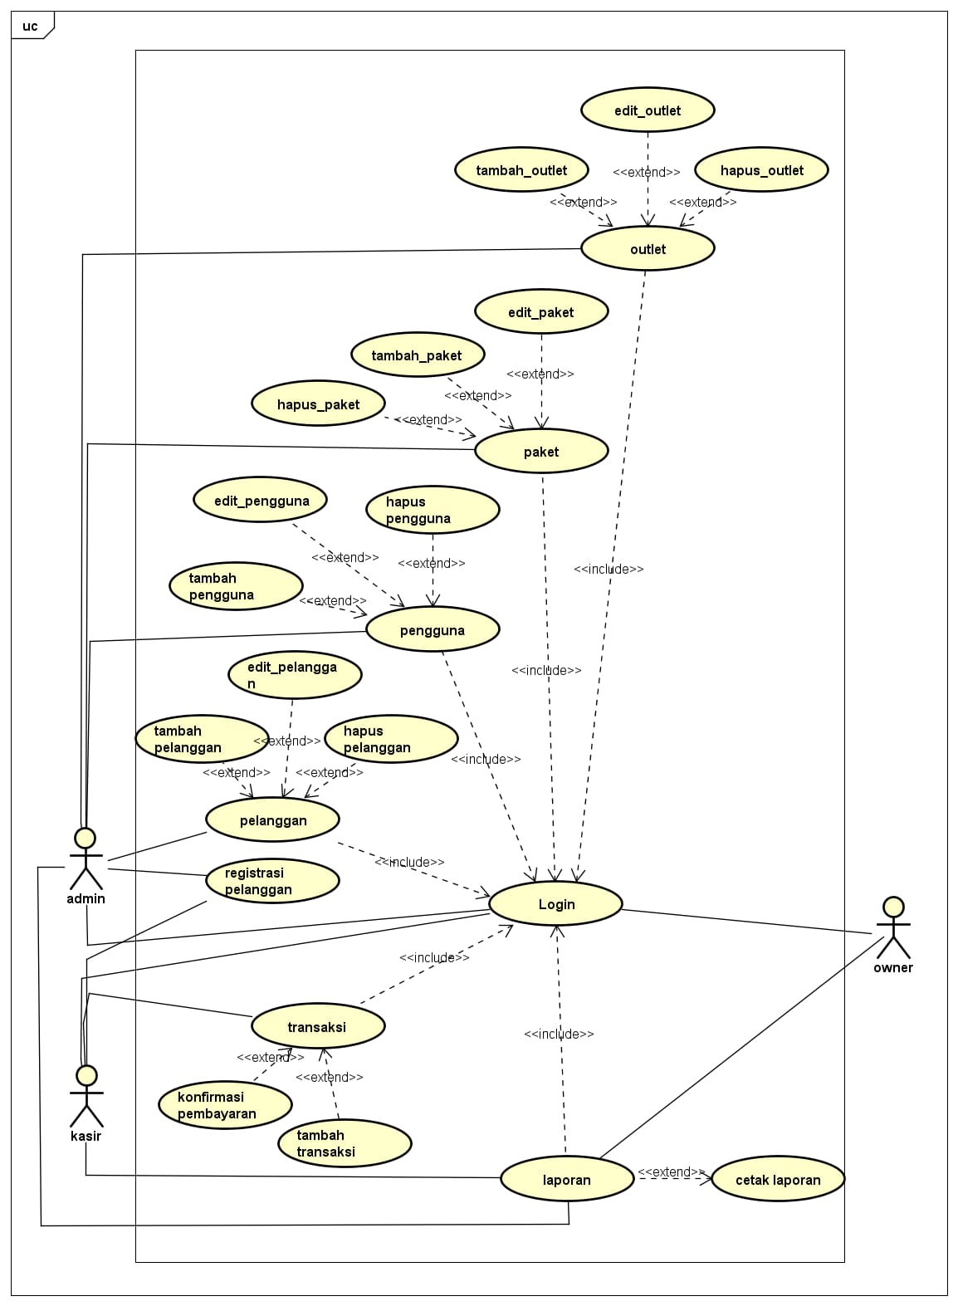

*Gambar 3.9 Usecase Diagram*

1. Admin dashboard

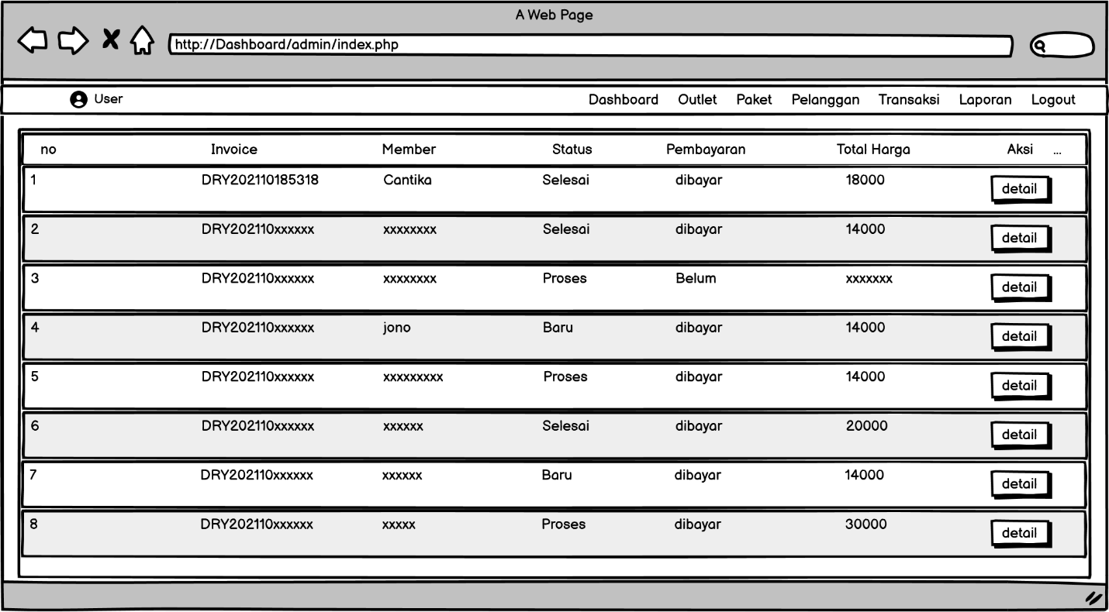

*Gambar 4.0 Mockup Dashboard Admin*

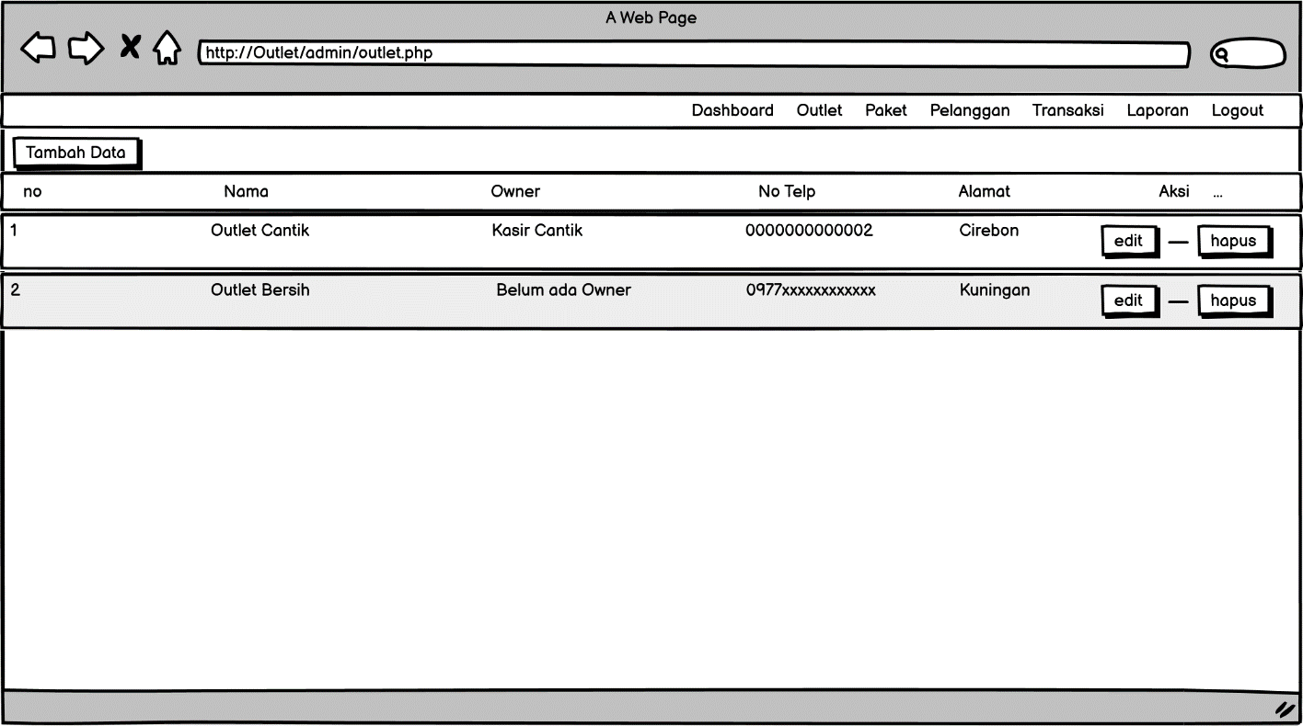

*Gambar4.1 Mockup Outlet Admin*

1. Tampilan Kasir

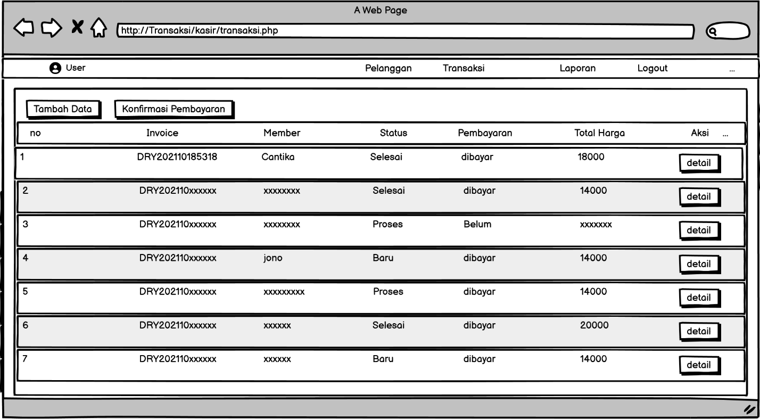

*Gambar 4.2Transaksi Dari Aktor Kasir*

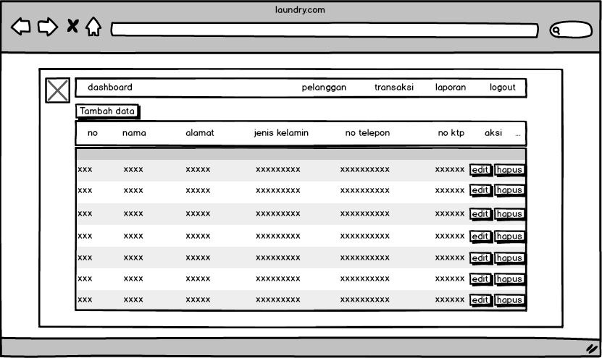

*Gambar4.3 Pelanggan Transaksi*

1. Tampilan owner

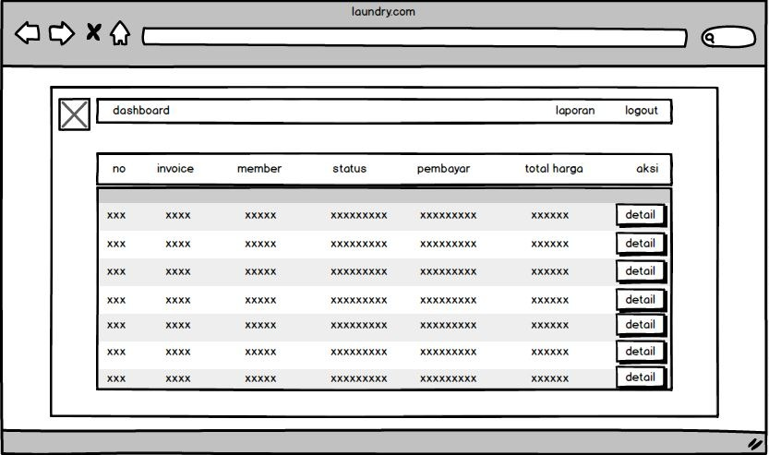

*Gambar4.4 Dashboard Owner*

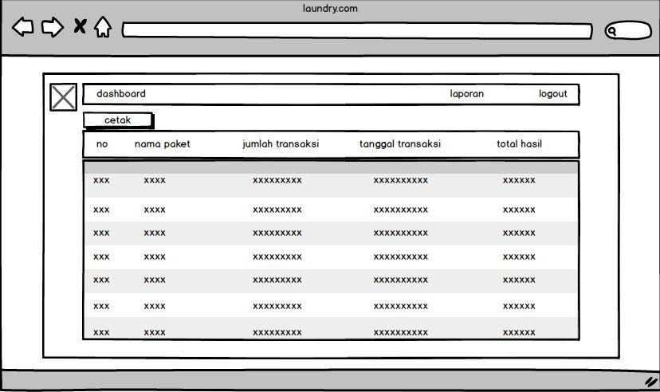

*Gambar 4.5 Laporan Owner*

# PEMBUATAN STRUKTUR WEB (HTML)

# Transaksi.php

|  |
| --- |
| <!DOCTYPE html>  <html lang="en">  <head>  <link href="../css/tabelc.css?version=<?= filemtime("../css/tabelc.css")?>" rel="stylesheet">  </head>  <body>  <?php  $title = 'transaksi';  require 'functions.php';  require 'navbar.php';  $query = "SELECT transaksi.*,member.nama_member , detail_transaksi.total_harga FROM transaksi INNER JOIN member ON member.id_member = transaksi.member_id INNER JOIN detail_transaksi ON detail_transaksi.transaksi_id = transaksi.id_transaksi ";  $data = ambildata($conn,$query);  ?>  <div>  <a href="transaksi_cari_member.php"><button class="btn2"> Tambah Data</button>  <a href="transaksi_konfirmasi.php"><button class="btn2"> konfirmasi pembayaran</button>  </div>  <table>  <thead>  <tr>  <th><label>no </label></th>  <th><label>Invoice</label></th>  <th><label>member</label></th>  <th><label>status</label></th>  <th><label>pembayaran</label></th>  <th><label>total harga</label></th>  <th width="15%"><label>Aksi</label></th>  </tr>  </thead>  <tbody>  <?php $no=1; foreach($data as $transaksi): ?>  <tr class="data-label">  <td><?= $no++ ?></td>  <td><?= $transaksi['kode_invoice'] ?></td>  <td><?= $transaksi['nama_member'] ?></td>  <td><?= $transaksi['status'] ?></td>  <td><?= $transaksi['status_bayar'] ?></td>  <td><?= $transaksi['total_harga'] ?></td>  <td width="15%"> <a href="transaksi_detail.php?id=<?= $transaksi['id_transaksi']; ?>"><button class="button1">detail</button></td>    </tr>  <?php endforeach; ?>  </tbody>  </table>  </body> |

1. PEMBUATAN STYLE WEB (CSS) File tabelc.css

|  |
| --- |
| body{  background: rgb(235, 235, 235) ;  }  table {  border: 10px solid rgb(235, 235, 235);  border-collapse: collapse;  margin: 0;  padding: 100px;  width: 100%;  table-layout: fixed;  }  table caption {  font-size: 1.5em;  margin: .5em 0 .75em;  }  table tr {  background-color: #44749d;  border: 0px;  padding: 10px;  border-radius: 3px;  }  table thead tr:first-child {  height: 5px;  border: 1px solid#44749d;  }  table th,  table td {  padding: 8px ;  text-align: center;  color: #44749d;  font-size: 14px;  font-family: Arial;  }  table td:nth-child(4) {  font-size: 18px;  }  table th {  font-size: .85em;  letter-spacing: .1em;  text-transform: Times New Roman;  background: #44749d;  color: #FFF;  }  tbody tr:nth-child(even) {  background-color: #F8F8FF;  }  tbody tr:nth-child(odd) {  background-color: #E6E6FA;  }  table tbody tr td .button1 {  background: #44749d;  color: #FFF;  font-size: 13px;  transition: all .5s;  padding: 15px 20px;  margin-top:5px;  margin-right:10px;  margin-bottom:10px;  margin-left:10px;  border: 0;  font-family: Arial;  }  table tbody tr td .button1:hover {  color: #c6d4e1;  letter-spacing: 1.0px;  box-shadow: 0px 5px 40px -10px rgba(0,0,0,0.57);  transition: all .3s;  padding: 10px 20px;  }  @media screen and (max-width: 600px) {  table {  border: 0;  }  table caption {  font-size: 1.3em;  }  table thead {  border: none;  clip: rect(0 0 0 0);  height: 1px;  margin: -1px;  overflow: hidden;  position: absolute;  width: 1px;  padding: 0;  }  table tr {  border-bottom: 3px solid #e1e5e9;  display: block;  margin-bottom: .625em;  }  table th,  table td {  padding: 0.625em;  }  table td {  border-bottom: 1px solid #e1e5e9;  display: block;  font-size: .8em;  text-align: right;  color: #9da9b9;  }  table td::before {  content: attr(data-label);  float: left;  font-weight: bold;  text-transform: uppercase;  color: #656971;  }  table td:last-child {  border-bottom: 0;  }  table td:nth-child(4) {  font-size: 0.8em;  }  button {  background-color: #c6d4e1;  }  }  .btn2 {  background-color: #44749d;  border: 10px solid rgb(235, 235, 235);  color: white;  padding: 7px 25px;  text-align: center;  text-decoration: none;  display: inline-block;  font-size: 18px;  width: 270px;  }    .h4 {  background-color: #44749d;  border: 10px solid rgb(235, 235, 235);  color: white;  padding: 7px 25px;  text-align: center;  text-decoration: none;  display: inline-block;  font-size: 18px;  width: 100%;  } |

1. PEMBUATAN KODE WEB (PHP/JS)

File Transaksi_Tambah.php

|  |
| --- |
| <!DOCTYPE html>  <html lang="en">  <head>  <link href="../css/edit.css?version=<?= filemtime("../css/edit.css")?>" rel="stylesheet">  </head>  <body>  <?php  $title = 'pengguna';  require 'functions.php';  $tgl_sekarang = Date('Y-m-d h:i:s');  $tujuh_hari = mktime(0,0,0,date("n"),date("j")+7,date("Y"));  $batas_waktu = date("Y-m-d h:i:s", $tujuh_hari);  $invoice = 'DRY'.Date('Ymdsi');  $user_id = $_SESSION['user_id'];  $member_id = $_GET['id'];  $outlet_id = ambilsatubaris($conn, "SELECT outlet_id FROM transaksi WHERE member_id = $member_id");  $outlet = ambilsatubaris($conn,'SELECT nama_outlet from outlet WHERE id_outlet = ' . $outlet_id['outlet_id']);  $member = ambilsatubaris($conn,'SELECT nama_member from member WHERE id_member = ' . $member_id);  $paket = ambildata($conn,'SELECT * FROM paket WHERE outlet_id = ' . $outlet_id['outlet_id']);  if(isset($_POST['btn-simpan'])){  $kode_invoice = $_POST['kode_invoice'];  $biaya_tambah = $_POST['biaya_tambahan'];  $diskon = $_POST['diskon'];  $pajak = $_POST['pajak'];  $outleta = $outlet_id['outlet_id'];    $query = "INSERT INTO transaksi (outlet_id,kode_invoice,member_id,tgl,batas_waktu,biaya_tambahan,diskon,pajak,status,status_bayar,user_id) VALUES ('$outleta','$kode_invoice','$member_id','$tgl_sekarang','$batas_waktu','$biaya_tambah','$diskon','$pajak','baru','belum','$user_id')";  $execute = bisa($conn,$query);  if ($execute == 1) {  $paket_id = $_POST['id_paket'];  $qty = $_POST['qty'];  $hargapaket = ambilsatubaris($conn,'SELECT harga from paket WHERE id_paket = ' . $paket_id);  $total1 = $hargapaket['harga'] * $qty;    if ($biaya_tambah != 0 && $pajak != 0 && $diskon != 0) {  $total3 = $total1 - ($total1 * $diskon / 100);  $total2 = $biaya_tambah + $total3;  $total_harga = $total2 + ($total2 * $pajak / 100);  } elseif ($biaya_tambah != 0 && $diskon != 0) {  $total2 = $total1 - ($total1 * $diskon / 100);  $total = $biaya_tambah + $total2;  } elseif ($biaya_tambah != 0 && $pajak != 0) {  $total2 = $total1 + $biaya_tambah;  $total_harga = $total2 + ($total2 * $pajak / 100);  } elseif ($diskon != 0 && $pajak != 0) {  $total2 = $total1 - ($total1 * $diskon / 100);  $total_harga = $total2 + ($total2 * $pajak / 100);  } elseif ($biaya_tambah != 0) {  $total_harga = $total1 + $biaya_tambah;  } elseif ($diskon != 0) {  $total_harga = $total1 - ($total1 * $diskon / 100);  } elseif ($pajak != 0) {  $total_harga = $total1 + ($total1 * $pajak / 100);  } else {  $total_harga = $total1;  }  $kode_invoice;  $transaksi = ambilsatubaris($conn,"SELECT * FROM transaksi WHERE kode_invoice = '" . $kode_invoice ."'");  $transaksi_id = $transaksi['id_transaksi'];    $sqlDetail = "INSERT INTO detail_transaksi (transaksi_id,paket_id,qty,total_harga) VALUES ('$transaksi_id','$paket_id','$qty','$total_harga')";  $executeDetail = bisa($conn,$sqlDetail);  if($executeDetail == 1){  header('location: transaksi_sukses.php?id='.$transaksi_id);  }else{  echo "Gagal Tambah Data";  }  }    }  ?>  <form id="form" method="POST">  <h1 id="title-form">tambah transaksii</h1>  <label>Kode Invoice</label>  <div class="content-inputs">  <input type="text" value="<?= $invoice ?>" name="kode_invoice" readonly="" class="input">  </div>  <label>Outlet</label>  <div class="content-inputs">  <input type="text" name="nama_outlet" value="<?= $outlet['nama_outlet'] ?>" readonly="" class="input">    </div>  <label>Pelanggan</label>  <div class="content-inputs">  <input type="text" name="nama_member" value="<?= $member['nama_member'] ?>" readonly="" class="input">  </div>  <label>Pilih Paket</label>  <div class="content-inputs">  <select name="id_paket" class="input">  <?php foreach ($paket as $key): ?>  <option value="<?= $key['id_paket'] ?>"><?= $key['nama_paket']; ?></option>  <?php endforeach ?>  </select>  </div>  <label>Jumlah</label>  <div class="content-inputs">  <input type="text" placeholder="0" name="qty" class="input">  </div>    <label>Biaya Tambahan</label>  <div class="content-inputs">  <input type="text" placeholder="0" name="biaya_tambahan" class="input">  </div>  <label>Diskon (%)</label>  <div class="content-inputs">  <input type="text" placeholder="0" name="diskon" class="input">  </div>  <label>Pajak</label>  <div class="content-inputs">  <input type="text" value="10" name="pajak" class="input" readonly>  </div>  <input type="submit" value="tambah" name="btn-simpan" class="btn">  </form>  </div>  </body>  </html> |

**CRUD file**

outlet_edit.php

|  |
| --- |
| <!DOCTYPE html>  <html lang="en">  <head>  <link href="../css/edit.css?version=<?= filemtime("../css/edit.css")?>" rel="stylesheet">  </head>  <body>  <?php  $title = 'outlet';  require 'functions.php';  $query = 'SELECT outlet.*, user.nama_user,user.id_user FROM outlet LEFT JOIN user ON user.outlet_id = outlet.id_outlet WHERE id_outlet = ' . $_GET['id'];  $data = ambilsatubaris($conn,$query);  $query2 = 'SELECT user.*,outlet.nama_outlet FROM outlet RIGHT JOIN user ON user.outlet_id = outlet.id_outlet WHERE user.role = "owner" order by user.outlet_id asc';  $data2 = ambildata($conn,$query2);  ($data);  if(isset($_POST['btn-simpan'])){  $nama = $_POST['nama_outlet'];  $alamat = $_POST['alamat_outlet'];  $telp = $_POST['telp_outlet'];  $query = "UPDATE outlet SET nama_outlet = '$nama' , alamat_outlet = '$alamat' , telp_outlet='$telp' WHERE id_outlet = " . $_GET['id'];      if($_POST['owner_id_new']){  $query2 = "UPDATE user SET outlet_id = '" . $_GET['id'] . "' WHERE id_user = " . $_POST['owner_id_new'];  $query3 = "UPDATE user SET outlet_id = null WHERE id_user = " . $data['id_user'];  $execute3 = bisa($conn,$query3);  }else{  $query2 = "UPDATE user SET outlet_id = '" . $_GET['id'] . "' WHERE id_user = " . $_POST['owner_id'];  }  $execute = bisa($conn,$query);  $execute2 = bisa($conn,$query2);  if($execute == 1 && $execute2 == 1){  $success = 'true';  $title = 'Berhasil';  $message = 'Berhasil Mengubah Data';  $type = 'success';  header('location: outlet.php?crud='.$success.'&msg='.$message.'&type='.$type.'&title='.$title);  }else{  echo 'Gagal Tambah Data';  }  }  ?>  <form id="form" method="POST">  <h1 id="title-form">edit outlet</h1>  <input type="hidden" value="<?= $data['id_outlet']; ?>" name="id_outlet">  <label>Nama Outlet</label>  <div class="content-inputs">  <input type="text" value="<?= $data['nama_outlet']; ?>" name="nama_outlet" class="input">  </div>  <label>Alamat Outlet</label>  <div class="content-inputs">  <input type="text" value="<?= $data['alamat_outlet']; ?>" name="alamat_outlet" class="input">    </div>  <label>Nomor Telepon</label>  <div class="content-inputs">  <input type="text" value="<?= $data['telp_outlet']; ?>" name="telp_outlet" class="input">  </div>  <?php if($data['nama_user'] == null): ?>  <label>Belum Ada Owner</label>  <div class="content-inputs">  <select name="owner_id" class="input">  <?php foreach ($data2 as $owner): ?>  <!-- <?= print_r($owner) ?> -->  <option value="<?= $owner['id_user'] ?>"><?= $owner['nama_user'] ?>  <?php if ($owner['outlet_id'] == null): ?>  ( Belum memiliki outlet )  <?php else: ?>  ( Owner di <?= $owner['nama_outlet'] ?> )  <?php endif ?>  </option>  <?php endforeach ?>  </select>  </div>  <?php else: ?>  <label>Owner Sekarang : <?= $data['nama_user']; ?></label>  <div class="content-inputs">  <select name="owner_id_new" class="input">  <option>Pilih Untuk Mengganti owner</option>  <?php foreach ($data2 as $owner): ?>  <option value="<?= $owner['id_user'] ?>"><?= $owner['nama_user'] ?>  <?php if ($owner['outlet_id'] == null): ?>  ( Belum memiliki outlet )  <?php else: ?>  ( Owner di <?= $owner['nama_outlet'] ?> )  <?php endif ?>  </option>  <?php endforeach ?>  </select>  </div>  <?php endif; ?>  <input type="submit" value="selesai" name="btn-simpan" class="btn">  </form>  </div>    <?php  ?>  </body>  </html> |

outlet_tambah.php

|  |
| --- |
| <!DOCTYPE html>  <html lang="en">  <head>  <link href="../css/edit.css?version=<?= filemtime("../css/edit.css")?>" rel="stylesheet">  </head>  <body>  <?php  $title = 'outlet';  require 'functions.php';  if(isset($_POST['btn-simpan'])){  $nama = $_POST['nama_outlet'];  $alamat = $_POST['alamat_outlet'];  $telp = $_POST['telp_outlet'];  $query = "INSERT INTO outlet (nama_outlet,alamat_outlet,telp_outlet) values ('$nama','$alamat','$telp')";    $execute = bisa($conn,$query);  if($execute == 1){  $success = 'true';  $title = 'Berhasil';  $message = 'Berhasil Simpan Data';  $type = 'success';  header('location: outlet.php?crud='.$success.'&msg='.$message.'&type='.$type.'&title='.$title);  }else{  echo "Gagal Tambah Data";  }  }  ?>  <form id="form" method="POST">  <h1 id="title-form">tambah outlet</h1>  <label>Nama Outlet</label>  <div class="content-inputs">  <input type="text" name="nama_outlet" class="input">  </div>  <label>Alamat Outlet</label>  <div class="content-inputs">  <input type="text" name="alamat_outlet" class="input">    </div>  <label>Nomor Telepon</label>  <div class="content-inputs">  <input type="text" name="telp_outlet" class="input">  </div>    <input type="submit" value="tambah" name="btn-simpan" class="btn">  </form>  </div> |

Outlet_hapus.php

|  |
| --- |
| <?php  require 'functions.php';  $sql = "DELETE FROM outlet WHERE id_outlet = " .$_GET['id'];  $exe = mysqli_query($conn, $sql);  if($exe){  $success = 'true';  $title = 'Berhasil';  $message = 'Menghapus Data';  $type = 'success';  header('location: outlet.php?crud='.$success.'&msg='.$message.'&type='.$type.'&title='.$title);  } |

1. UJI COBA

|  |  |  |  |  |  |  |  |  |
| --- | --- | --- | --- | --- | --- | --- | --- | --- |
| No. | Kode Uji | Nama | Kasus Uji | Kondisi Awal | Tes Skenario | Hasil Yang di Harapkan | Kondisi Akhir | Status Sesuai / Tidak Sesuai |
| 1 | TC1 | Login Admin | Semua form diisi dengan data akun admin yang benar | Admin mengisi form login dengan data yang sesuai | 1. Admin Mengisi form username dengan benar  2. Admin mengisi password dengan benar  3. Admin menekan tombol login | Halaman berpindah menuju halaman dashboard | Admin memasuki halaman dashboard admin | Sesuai |
| TC2 | Login Admin | Semua form diisi dengan data akun admin yang salah | Admin mengisi form login dengan data yang tidak sesuai | 1. Admin Mengisi form username dengan salah  2. Admin mengisi password dengan salah  3. Admin menekan tombol login | Halaman akan tetap di halaman login | Muncul pesan error bahwa username atau password salah | Sesuai |

1. REVISI
2. PENENTUAN DOMAIN DAN HOSTING

https://mdmlaundry.000webhostapp.com/

1. UPLOAD WEB KE HOSTING

<https://mdmlaundry.000webhostapp.com/>

1. UPLOAD WEB KE GITHUB

<https://github.com/dzaki34/UKK2023.git>