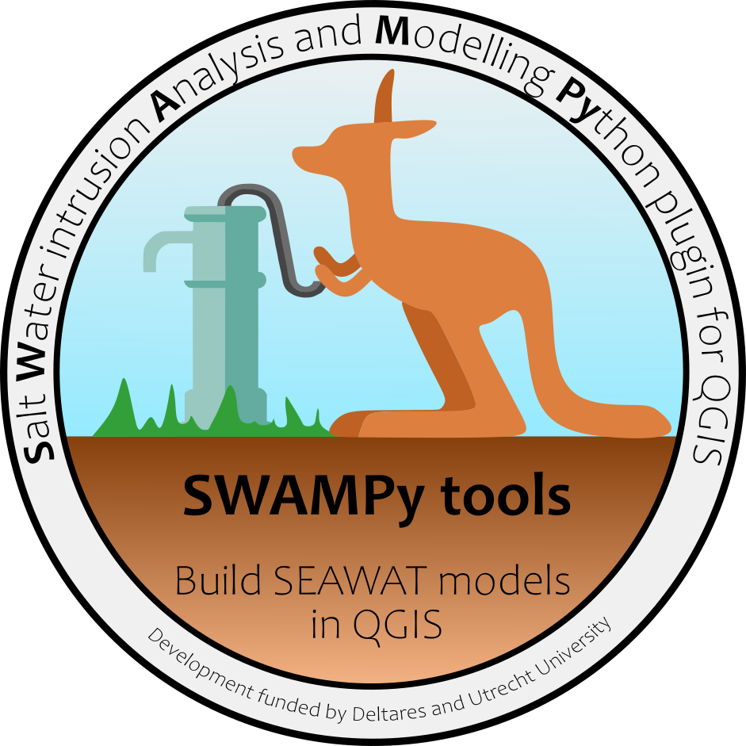

SWAMPy-tools tutorial and documentation

SWAMPy-tools tutorial and documentation

**By Daniel Zamrsky¹, Gualbert H.P. Oude Essink****2,1 and Marc F.P. Bierkens1,2**

1Department of Physical Geography, Utrecht University, Utrecht, The Netherlands

²Deltares Research Institute, Utrecht, The Netherlands

Utrecht, The Netherlands, 2021

**Contents**

1. Preface 1

2. Installation and setup 2

2.1. Installing QGIS 2

2.2. Installing SWAMPy-tools from a zip file 2

2.3. Access to Yoda server 3

2.4. SWAMPy-tools directories setup 3

3. Visualizing SEAWAT models via Model viewer 6

4. 2D model setup wizard - creating a SEAWAT model from scratch 9

4.1. Setting up input dataset directories 9

4.2. Cross-section and grid geometry 11

4.3. Defining geological conditions 14

4.4. SEAWAT model stress periods 17

4.5. Setting up initial conditions 20

4.6. SEAWAT parameters and executing the SEAWAT model 22

4.7. Visualizing the SEAWAT model output 23

# Preface

SWAMPy-tools is an open source QGIS plugin that allows user to build their own cross-sectional (2D) coastal variable-density groundwater flow models. The plugin itself uses several external Python libraries together with the SEAWAT code to build, run and export these models. Building a QGIS plugin was identified as the best out of all options to develop a tool to allow users to quickly build and run a SEAWAT model thanks to all the tools already available in QGIS to handle and visualize data. The tutorial laid out in this document will take you step by step through the process of building a SEAWAT model from scratch.

If you find any errors or bugs, please use the GitHub issues thread and post it there. Same applies for addition features and functionalities that you would like to see in future versions of SWAMPy-tools; every good idea is welcome to further improve this plugin.

SWAMPy-tools GitHub page - <https://github.com/swampytools/SWAMPy-tools>

SEAWAT code - <https://fl.water.usgs.gov/PDF_files/twri_6_A7_guo_langevin.pdf>

# Installation and setup

Below you will find a step-by-step guide to install the SWAMPy-tools plugin for QGIS. This plugin was developed for QGIS version 3.16 and should be compatible with any higher versions. It is highly possible that if you use a lower version of QGIS this plugin might not work correctly. In such case, please try to install QGIS 3.16 or higher and try installing SWAMPy-tools again.

## Installing QGIS

If you don’t have QGIS installed on your computer, or you have an older version than 3.16 please install/update the QGIS. You can find the installation files at <https://qgis.org/en/site/forusers/download.html>.

## Installing SWAMPy-tools from a zip file

SWAMPy-tools plugin is not yet available as official QGIS plugin and therefore can’t be installed via the official QGIS plugin repository. However, it can be installed from a zip file that is available in the GitHub repository by following the steps described below.

1. Download the **SWAMPy-tools.zip** file at <https://github.com/swampytools/SWAMPy-tools/blob/main/SWAMPy-tools.zip>
2. Open your QGIS application and open the **Plugins -> Manage and install plugins** menu.
3. 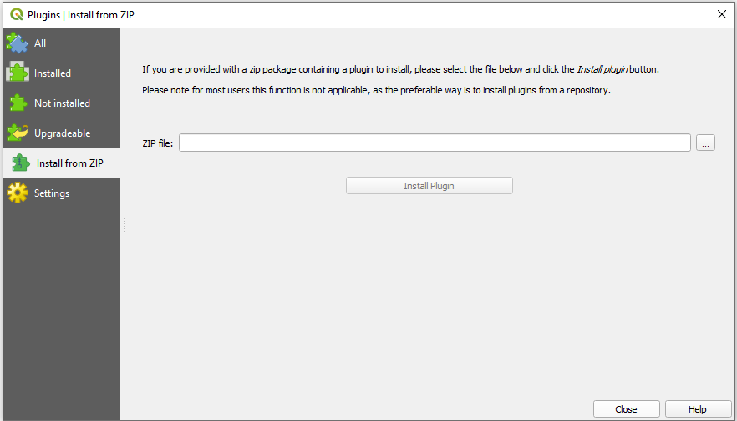Go to **Install from ZIP** tab and click on the **…** button to select the directory where you saved the **SWAMPy-tools.zip** file. Click **Install Plugin** to finalize the installation.
4. After the installation you will see this icon appear on the toolbar click on it to start the SWAMPy-tools plugin.

## Access to Yoda server

To download certain files, you will need access to the Yoda server at the Utrecht University. To get access you will need to register first, see <https://www.uu.nl/en/research/yoda/who-are-you/i-am-a-researcher-at-another-university-or-institute>. The information on how to get a log in is at <https://www.uu.nl/en/research/yoda/guide-to-yoda/i-want-to-start-using-yoda/i-want-to-log-in> under the Faculty of Geosciences. If you encounter any issues during this process please post an issue at our GitHub page or send an email to the author directly (can be found at GitHub as well).

## SWAMPy-tools directories setup

SWAMPy-tools uses several key datasets and layers to build and visualize SEAWAT groundwater models. Without those datasets being linked to the SWAMPy-tools plugin you will not be able to use its tools and functionalities. This part of the tutorial will help you find all the data necessary and link them to the SWAMPy-tools plugin.

1. When you open the SWAMPy-tools plugin you will see the Setup tab as shown below. It will provide you with some basic background information as well as two text edit lines at the bottom of the window (see the section highlighted by the black rectangle in the picture below). You can setup the two directories by either pasting a full directory into the text edit or clicking on the **…** button and selecting a file/folder from a folder explorer. The **coastline_layer.zip** file can be downloaded from <https://geo.data.uu.nl/research-global-coastal-gw-model/Global_coastline/>. The **Coastline layer** is important for both visualizing existing SEAWAT models as well as for creating your own further on and it must be specified!

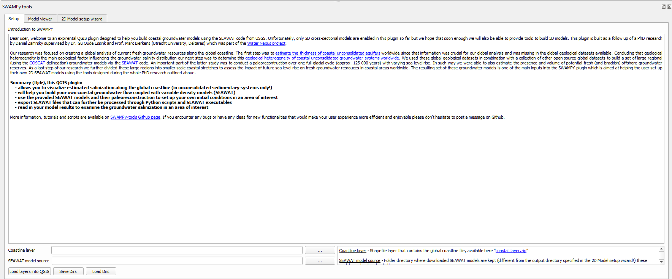

1. If you want to use the **Model viewer** to visualize regional effects of sea-level rise (SLR) on coastal groundwater you need to setup the directory where you will download and store these models (**SEAWAT model source**). The individual SEAWAT model output files are available through <https://geo.data.uu.nl/research-global-coastal-gw-model/GW_models_SLR/>. If you open this repository, you will see a list of files as shown below. The name of the individual files is in the format of **COSCATid**_SRM_**SRMid**.nc where **COSCATid** represents the identification code of the COSCAT region and the **SRMid** is the identifier of the sub-regional model in the given COSCAT region.
2. Once you specified the directories you can load the **Coastline layer** into the QGIS by clicking the **Load layers into QGIS** button (it might take a while to load so please be patient, if you randomly click somewhere in the QGIS application it might crash!). When the **Coastline layer** is finally loaded into the map view you will see it has a predefined style indicating which SEAWAT models are available on in your SEAWAT model source and can be visualized in the **Model viewer** tab, see the picture below.

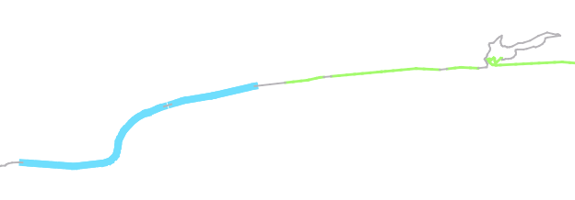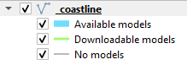

1. If you want to download additional SEAWAT models to visualize and they are indicated as “Downloadable models” you can go to the link specified in step 6 and download the corresponding model. To be sure you download the right SEAWAT model you can use the identification tool in QGIS (see below), click on a line segment while the Coastline layer is selected and display the **id_srm** attribute value.

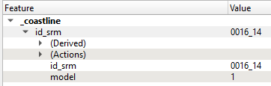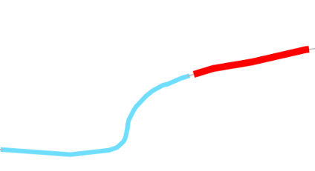

1. There are two additional buttons at the bottom of the window. You can use the **Save Dirs** button to save the specified directories as a file on your drive. This utility will appear again in the first step when you will build your SEAWAT model from scratch (see step 17). If you already used SWAMPy-tools and want to load the previously specified directories into the required fields you can use the **Load Dirs** button and select the file you saved previously. This will load all the directories into the required fields and save you the trouble of defining them individually every time you start using SWAMPy-tools.

# Visualizing SEAWAT models via Model viewer

Once your directories are correctly set up and you downloaded the SEAWAT models as described in the section 1.2 you can start visualizing the SEAWAT model output in the **Model viewer** tab.

1. 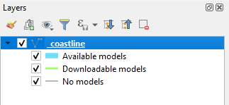While the Model viewer tab is open you can load the SEAWAT model results by using the **Select features** QGIS tool and selecting a feature from the **Coastline layer** (select only features with **Available models** – see step 7). Once you have selected the desired feature you can load the SEAWAT model into the **Model viewer**. Please make sure the _coastline layer is selected in the Layers QGIS window.

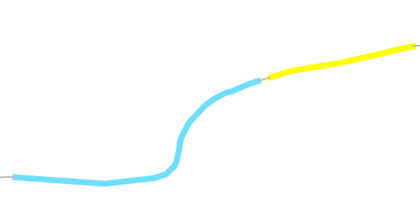

1. To add the SEAWAT model into the Model viewer click on the **Add model** button (black rectangle in the picture below). After you add the SEAWAT model to the **Model viewer** it will automatically plot a salinity profile at year 2000 (green rectangle), that for simplicity represents the present (these SEAWAT models span 30 000 years in the past and 500 years in the future). It will also add an item with the SEAWAT model name (**0016_14**) into the list on the right-hand side of the window (blue rectangle)

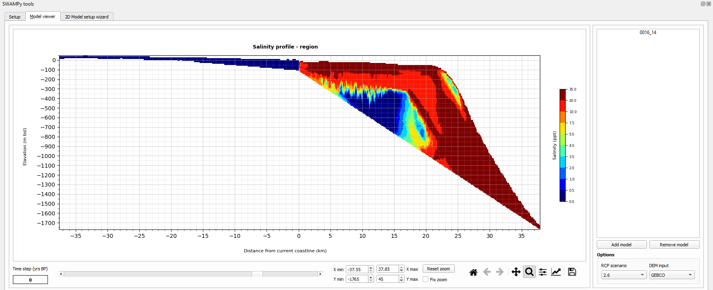

1. 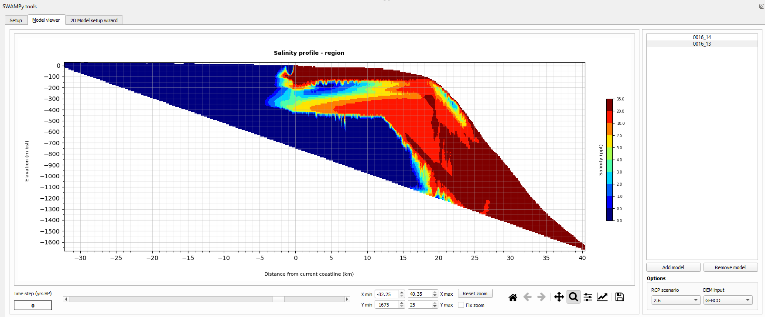If you add the second SEAWAT model you will see it added to the list of available models (0016_13) and the plot window will automatically show its salinity profile for the same time step. You can now switch between the SEAWAT models by selecting them in the list of available models.
2. In case you want to remove a SEAWAT model from the list you can simply click the **Remove model** button and it will be deleted from the list (it won’t be deleted from your folder don’t worry!).
3. Visualizing the salinity profiles can be adjusted by using several tools, explained below. If you want to select a different time step you can use the sliding bar at the bottom left part of the window (see zoomed picture below). You can either manually slide the bar in both direction or simply click on the arrows at either end of the sliding bar. The time step selected will be automatically changed and shown on the left from the sliding bar and the salinity profile will be re-drawn as well.
4. The zoom in the plot can be manually adjusted using the combo boxes below the plotting window (see picture below). For quick zooming in and out you can use the standard Matplotlib Python library toolbar (**Matplotlib bar** - black rectangle) by selecting the magnifying glass icon and dragging your mouse directly over an area in the plotting window. You can also reset the zoom by clicking the house button on the left of the **Matplotlib bar**. However, if you want to use a more precise zooming functionalities, you can manually specify the minimum and maximum X and Y coordinates (relative to the coastline position horizontally and to 0m sea level vertically), see the **Zooming tools** in the blue rectangle. To reset the zoom back to the full plot, use the **Reset zoom** button. Additionally, you can use the **Fix zoom** checkbox, if checked the zoom will be locked and applied to plotting salinity at different time step, RCP scenario or DEM input changes. It will also be

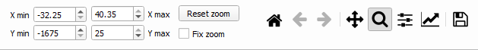

1. 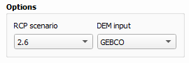The **Model viewer** is tailor made to visualize SEAWAT models that were built to analyze the effects of sea-level rise on coastal groundwater salinities. Several scenarios were examined and their results can be visualized by using the dropdown menus at the right bottom corner of the **Model viewer** tab, see picture below. You can choose from three different **RCP scenario** options and three different **DEM input** options. The salinity plot will automatically re-adjust.

# 2D model setup wizard - creating a SEAWAT model from scratch

In this part of the tutorial, you will learn how to create your own SEAWAT model from scratch in any (hopefully!) part of the global coastline. It is important to keep in mind that the approach presented here is suited only for areas with unconsolidated sediment systems – it is not designed to simulate groundwater conditions in porous karstic rock systems.

## Setting up input dataset directories

When you open the **Input datasets** tab you will see a list of dataset directories you will need to specify in order to use all the functionalities of SWAMPy-tools. An explanation, together with a link to download the necessary file(s), is provided in the right-hand side of the tab for each dataset.

1. Each row will consist of the dataset name (black), a text edit line where you specify the dataset directory (blue), the button **…** to select the directory in a file explorer (green) and a button **Load to map** which will load the dataset into QGIS as a layer (red). First you have to select a **Digital Elevation Model** input dataset (DEM). Without it, SWAMPy-tools won’t be able to create a cross-section. The DEM dataset has to be a raster and has to cover also the bathymetry (offshore) part of the desired model domain. A suggested option is the GEBCO global DEM dataset, accessible via <https://www.gebco.net/news_and_media/gebco_2014_grid.html>.



1. The **Coastline features** shapefile has almost identical geometry as the previously specified **Coastline layer** in the Setup tab, but it consists of single line features. This dataset is important (mandatory!) to build cross-sections perpendicular to the coastline and needs to be specified for SWAMPy-tools to work properly. The file can be found at <https://geo.data.uu.nl/research-global-coastal-gw-model/Global_coastline/> under the name "_coastline_single_lines.zip".
2. Coastal unconsolidated sediment thickness estimation is another dataset that can be used as input when building the cross-section. The **Total thickness** input parameter is based on the aquifer thickness estimation research (<https://essd.copernicus.org/articles/10/1591/2018/>) and dataset is available for download at <https://doi.pangaea.de/10.1594/PANGAEA.880771>. Defining this input dataset directory is not mandatory as thickness can be manually defined and changed by the user while building the cross-section itself (see step **X**)
3. The geology datasets enable users to define geological conditions in their SEAWAT model cross-sections based on several global datasets. If you don’t want to make use of the geological SWAMPy-tools functionalities it is not necessary to define these input datasets. If you do, then you need to first define the directory of the **Upper sediment thickness** which is based on the Global 1-km Gridded Thickness of Soil, Regolith, and Sedimentary Deposit Layers (<https://daac.ornl.gov/SOILS/guides/Global_Soil_Regolith_Sediment.html>).
4. The horizontal hydraulic conductivity (Hk) input is divided into two categories to match the SWAMPy-tools geological functionality. The latter fills the cross-section with combination of highly-permeable (aquifers) and low-permeable (aquitard) layers. Two recently developed global datasets can be used as a first order input into this functionality. The **Aquifer sediments Hk** input dataset corresponds to recently developed GLHYMPS 2.0 global dataset, that can be found at <https://dataverse.scholarsportal.info/dataset.xhtml?persistentId=doi:10.5683/SP2/TTJNIU>. The **Aquitard sediments Hk** is defined by the previous version of GLHYMPS and can be found at <https://dataverse.scholarsportal.info/dataset.xhtml?persistentId=doi:10.5683/SP2/DLGXYO> - please make sure you transform the original GDB file into a raster format first (you can use QGIS) before setting the directory path in the SWAMPy-tools. These two horizontal hydraulic conductivity input datasets don’t have to be defined in order to set up your cross-sectional SEAWAT model. You can also manually define the Hk values if you wish, see step **X**.
5. **Geological heterogeneity** input is the last dataset necessary for the SWAMPy-tools geological functionality. It is based on a global geological heterogeneity of unconsolidated sediments study (<https://www.frontiersin.org/articles/10.3389/feart.2019.00339/full>) and provides several quantified geological parameters that can be used to derive the shape and composition of individual aquifer and aquitard layers. The global input dataset file can be accessed at <https://geo.data.uu.nl/research-global-coastal-gw-model/Geological_heterogeneity/> under the name “geo_heterogeneity_shapefile.zip”, unpack the zip file before setting the directory path.
6. Groundwater recharge (RCH) is another very important input parameter for groundwater models. Since this parameter varies through time, a folder directory needs to be specified instead of a single input file. The **folder with RCH datasets** can contain a single or many individual RCH input files, and the user is able to select individual files when assigning RCH conditions further on, see step **X**. Global RCH estimation files for a large time span (from 20 000 years BP) can be found here <https://geo.data.uu.nl/research-global-coastal-gw-model/GW_recharge/>.
7. In order to run the SEAWAT model it is necessary to define a directory where you store the **SEAWAT executable** file which can be downloaded at <https://www.usgs.gov/software/seawat-a-computer-program-simulation-three-dimensional-variable-density-ground-water-flow> - click on the “Download SEAWAT program, source code, user guides, and example problems”. Set the directory to match the “swt_v4_00_05\exe\swt_v4x64.exe” file once you open and unzip the downloaded SEAWAT folder.
8. The last directory that you will specify is called **Output directory**, and it is the folder where all the SEAWAT model files (and temporary files during the model setup) will be stored. It is different from the **SEAWAT model source** folder specified in step 6. Please make sure that you define the **Output directory** on a drive that has enough free space in case you want to run multiple SEAWAT models over large time scales leading to larger space requirements.
9. As in the step 9, you can use the **Save Dirs** and **Load Dirs** buttons to save and load previously defined directories.

## Cross-section and grid geometry

With the input dataset directories set up we can now move to building the cross-sectional SEAWAT model itself. The first step is to define the geometry and active model area of the SEAWAT model. Once you open the **Cross-section and grid geometry** tab you will see the window shown on the picture below. It consists of three main areas, the parameter input window (black), the model list (blue) and the plotting window (green). The parameter input window is where all the cross-section parameters and dimensions are specified, along with few buttons that help finalize the cross-section set up. Once the cross-section is added as a model it will appear in the model list and also can be plotted in the plotting window. This part of the tutorial will guide you step by step through the process of building a cross-sectional model.

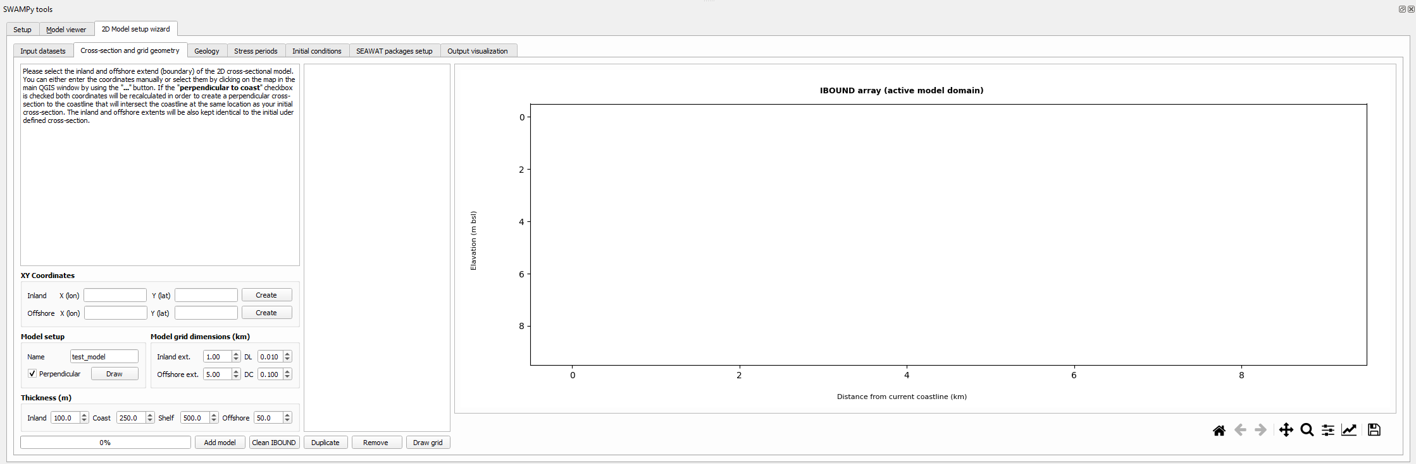

1. The concept of 2D cross-sectional models in the coastal zone is based on the assumption that lateral groundwater flow doesn’t influence the groundwater conditions in the model. This assumption is only valid if the cross-section is perpendicular to the coast as in such a case it can be assumed that the groundwater flow has predominantly land to coast direction, without any lateral groundwater flow occurring. To make sure this condition is satisfied when building the cross-sectional model, SWAMPy-tools includes a functionality that ensures that the built cross-section is perpendicular to the coastline. This means that the user defines only the inland and offshore extent of the cross-section which has to cross the coastline layer, the intersection of these two lines will then define the coastal point. SWAMPy-tools will then automatically calculate the position of a perpendicular cross-section passing through the same coastal point and having the same inland and offshore distances as in the original user defined cross-section.
2. 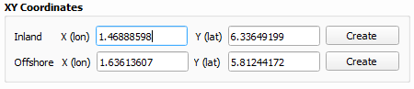First, we will define the inland and offshore extent of the cross-section. You can do this by click on the **Create** button next to the **Inland** and **Offshore** lines in the **XY Coordinates** section, as shown below. You can either select an inland and offshore point in the vicinity of the coordinates shown below, or you can copy past them from this tutorial. Inland point as x = 1.46888598 and y = 6.33649199 and offshore point as x = 1.63613607 and y = 5.81244172.
3. In the next step we will specify the model’s name and draw the cross-section. In the **Model setup section**, type in Model_1 in the **Name line edit** and make sure that the **Perpendicular** checkbox is checked. Leave the **Model grid dimensions (km)** parameter values as default for now and then click on the **Draw** button. It might take several seconds for the SWAMPy-tools to calculate the new cross-section position and to read in several input parameters from the input datasets along the cross-section. Once the process is finished you will see that a new cross-section will appear on the map – in dark blue color. Also, you will notice that the **XY Coordinates** values now changed and show the recalculated inland and offshore extent positions. You will also see the **Inland ext.** and **Offshore ext.** values updated, as well as the **Coast Thickness (m)** – if you specified the directory path to the thickness dataset (see step 19). Additionally, you will see that a folder with the Model_1 name was created in your **Output directory**. In there you will see that a subfolder called temp_files was created, if you look inside, you will see several temporary files created. Those are necessary for the creation of your SEAWAT model. If you open the cs_points.csv file you will see a table with individual points that are spaced equally (corresponding to the DC value) along the cross-section, all of them having a dist_coast_m value that shows the points distance from the coastline.
4. Before creating and active model domain (called IBOUND in SEAWAT models) you can make sure that the Thickness (m) parameters contain correct values. For now, we will leave the **Inland** thickness as 100m, we will change the **Coast** thickness to 200m, set the **Shelf** thickness to 750m and assign the **Offshore** thickness to 100m. The **Inland** thickness defines the model domain thickness at the inland extent of the cross-section. Similarly, the **Coast** thickness represents the thickness of the active model domain at the coast, the **Shelf** thickness at the calculated shelf break point (if found) and the **Offshore** thickness is the model domain thickness at the offshore extent of the cross-section.
5. 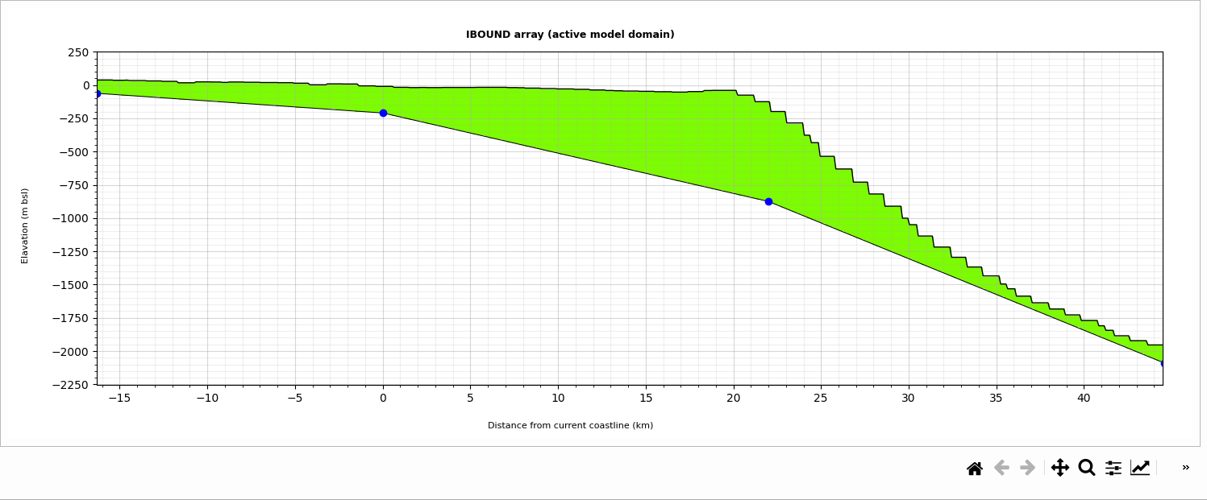With all the necessary parameters defined we can now create our first SEAWAT model. To do this click on the **Add model** button and wait till you see a plot of the IBOUND array in the plotting window, see picture below. You will also see Model_1 appear in the model list table. When you open the Model_1 folder in your Output directory you will see a set of new files created. If you reopen the cs_points.csv now, you will see a set of new columns appear - DEM, upp_sed_thk_dir, hk_aqf_dir, hk_aqt_dir. These now hold the values for several key input parameters that will appear further on during this tutorial.
6. Not always you will get an active model domain that doesn’t need any readjustments. To create such a scenario simply change the model Name to Model_2 and click on the Draw button. This will create a cross-section with the same extent as Model_1 and create a new folder called Model_2. Next, change the thickness values to match the picture below.
7. 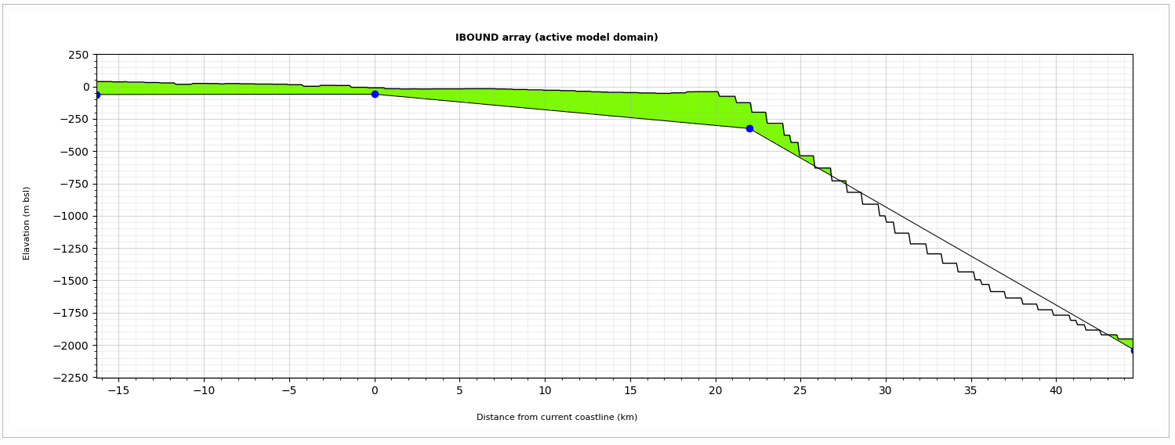Once you click on the Add model button, you will see that a new IBOUND array plot will appear (see picture below), as well as an additional item (Model_2) will be added to the model list.
8. 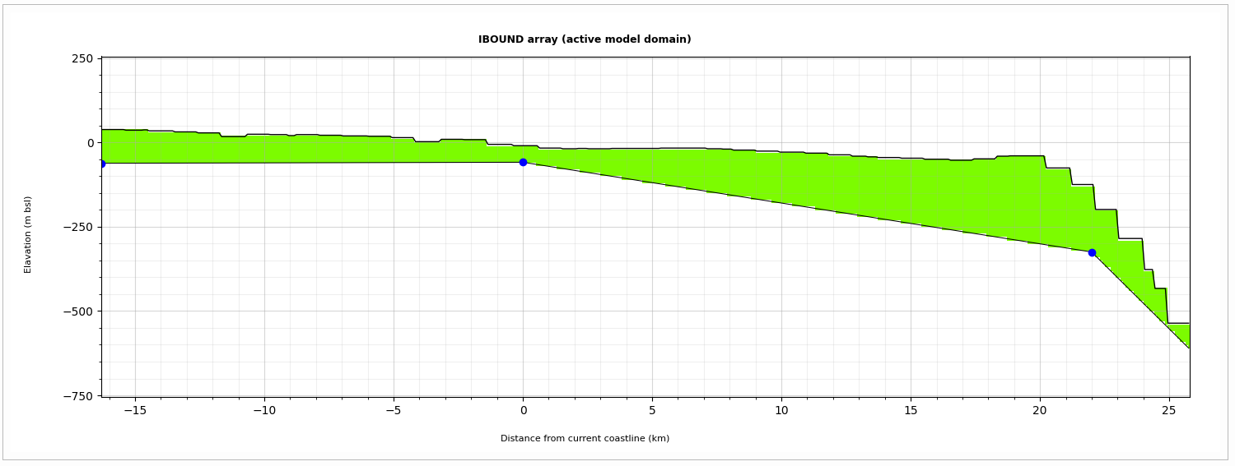As you can see the IBOUND array now contains two active model domain areas, the one at the offshore extent being separated from the main active model domain around the coastal zone. This is due to SWAMPy-tools automatically connecting the bottom points at the shelf and offshore extent, and in some cases this line overtops the bathymetry which results in an inactive model domain area. To fix this you can use the **Clean IBOUND** button which will create a new end of the cross-sectional model, as you can see on the picture below.

## Defining geological conditions

With the cross-sectional geometry defined, we can now move forward to the next step which is to define the geological conditions in the model domain. The layout of the Geology tab is identical to the previous Cross-section and grid geometry tab; the input parameter window (black) on the right, model list in the middle and the plotting window is positioned on the right, see picture below.

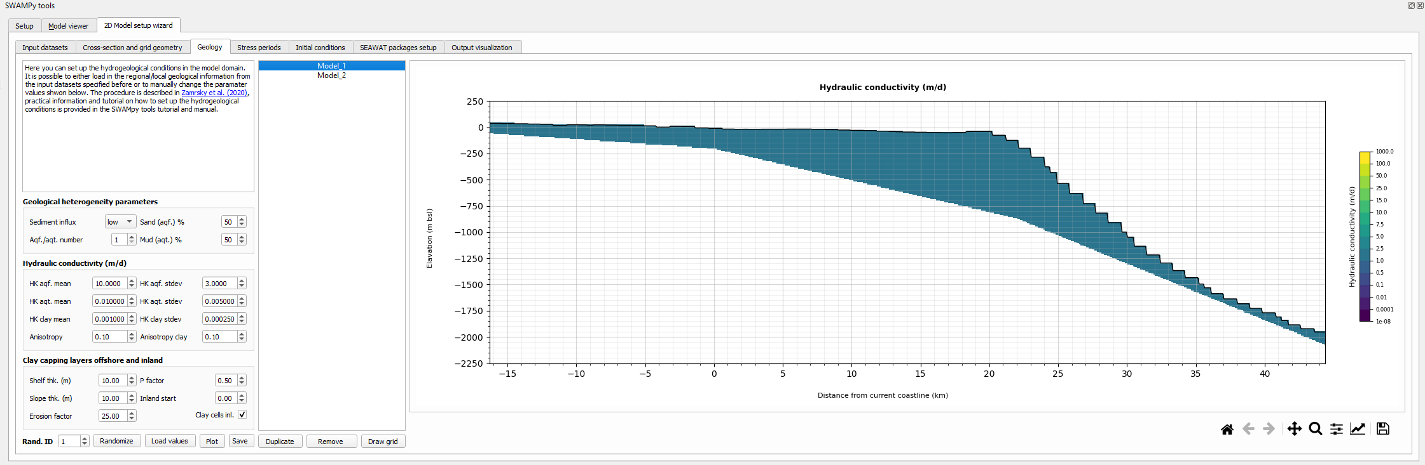

1. 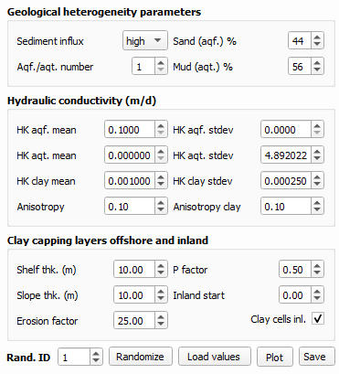First, make sure that Model_1 is selected in the model list, as that is the model we will be working on for the remainder of this tutorial. If you defined the geological input dataset directories (steps 20-22) click on the **Load values** button. This will automatically gather the various geological parameters for your cross-sectional model and load them into the parameter values in the parameter window (see picture on the right).

You can see that the **Sediment influx** value has been changed to high as well as the **Sand (aqf.) %** and **Mud (aqt.) %** values to 44 and 56 respectively. These values are based on the geological heterogeneity input dataset defined in step 22. The **Aqf./aqt. number** parameter stayed the same and is up to the user to manually change it if it is desirable. It describes the amount of aquifer-aquitard layer combinations, e.g., set it to 2 which means that there will be 2 aquifer layers and 2 aquitard layers created, their thickness randomly generated (based on the **Rand. ID** value). If you didn’t specify the geological input dataset directories you can manually set the parameter values to match the values specified above.

The next step is to define the **Hydraulic conductivity (m/d) values**. If you used the Load values button you will see the values updated automatically from the GLHYMPS (aquitard layers) and GLHYMPS 2 (aquifer layers) datasets defined in step 21. It can happen that aquifer layers will have lower Hk values than aquitard layers, which is counter intuitive of course. The reason why GLHYMPS 2 dataset is paired to the aquifer layers is that in general its values represent the hydraulic conductivity of the upper unconsolidated sediment layers which tend to have higher Hk values on average (by roughly one order of magnitude). If you load the GLHYMPS and GLHYMPS 2 datasets into the QGIS map view you will see that the values in the cross-section area are negative, i.e., -1052 for GLHYMPS 2 and -13 for GLHYMPS 1. The Hk values need to be transferred to the correct units (m/d) and that is achieved by using the formulas below:

for GLHYMPS

for GLHYMPS 2

Where k is the permeability value defined by GLHYMPS and GLHYMPS 2 respectively. This will give us 0.0003 m/d for the **Hk aqf. mean** value and 0.000001 m/d for the **Hk aqt. mean** value. It is up to the user to decide whether these values correspond to the conditions in the area of interest, keeping in mind they are based on global datasets and approximations. For this tutorial we will change the values and set the **Hk aqf. mean** to 2.5 m/d, the **Hk aqf. stdev** to 0.5 m/d, the **Hk aqt. mean** to 0.1 m/d and **Hk aqt. stdev** to 0.05 m/d. Alongside the mean values, there are also fields where the standard deviation for the Hk values can be specified (**Hk aqf. stdev** and Hk **aqt. stdev**). This allows for creating a randomized Hk input within each aquifer and aquitard layers, and thus simulating the real-world conditions where Hk values often vary within the same geological units. During the geology setup there will also be clay cells inserted into the aquitard layers, and their mean and stdev Hk values can be defined in the **Hk clay mean** and **Hk clay stdev** fields, leave the default values for this tutorial. The last part of defining the hydraulic conductivity conditions is to define the **Anisotropy** and **Anisotropy clay** values. Anisotropy describes the relation between horizontal (Hk) and vertical (Vk) hydraulic conductivity values, the Vk being calculated as Hk multiplied by the anisotropy value, again leave the default values for this tutorial.

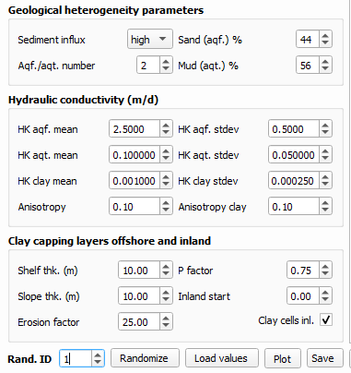In the last step of defining the geological conditions we will define the **Clay capping layers offshore and inland**. This process is set in place to simulate the deposition of low permeable (clay) layers during higher sea-level stands when the sediment deposition mostly consists of small particles (clay). The **Shelf thk. (m)** and the **Slope thk. (m)** represent the thickness of the offshore capping layers in the continental shelf and continental slope areas respectively. The **P factor** defines the probability that a given clay cell will be placed at the top of the aquitard layer, the value 0.5 means that there is 50% chance that the clay cell will be placed in the upper part of an aquitard layer. If the value is set to 1 then all clay cells will be placed at the upper part of an aquitard layer, for this tutorial set the value to be 0.75. The **Inland start** parameter defines the starting distance from coast (in the landward direction) where clay cells are inserted into the aquitard layers. These cells will only be inserted if the **Clay cells inl. checkbox** is ticked (leave it ticked in this tutorial). The last parameter, **Erosion factor**, defines the number of clay cells that will be removed before the geological profile is finalized, representing the natural erosion processes. The final set of geological parameter values for this tutorial is shown in the picture on the right.

1. At the bottom of the input parameter window, you can see several buttons. The **Randomize button** will randomly create a new scenario and change the Rand. ID value. This will mean that the thickness of each individual aquifer and aquitard layer will be changed, as well as the hydraulic conductivity of each individual cell – based on normal distribution of mean and stdev values defined in the **Hydraulic conductivity (m/d)** section. The erosion process will also be randomized and different clay cells will be removed than in any other random scenario. While leaving the value to be 1 and making sure that the Model_1 is selected in the model list, we can now click on the **Plot** button which will create the geological conditions and plot them in the plotting window, see picture below.

For more information and details about setting up the geological profile based on the parameters described above please check the research paper upon which this SWAMPy-tools functionality is based (<https://www.frontiersin.org/articles/10.3389/feart.2019.00339/full>). You can also play around with individual parameters and by using the **Plot** button visualize the individual changes on the final geological conditions. For this tutorial, please make sure that your final geological conditions for Model_1 match the one shown in the picture below.

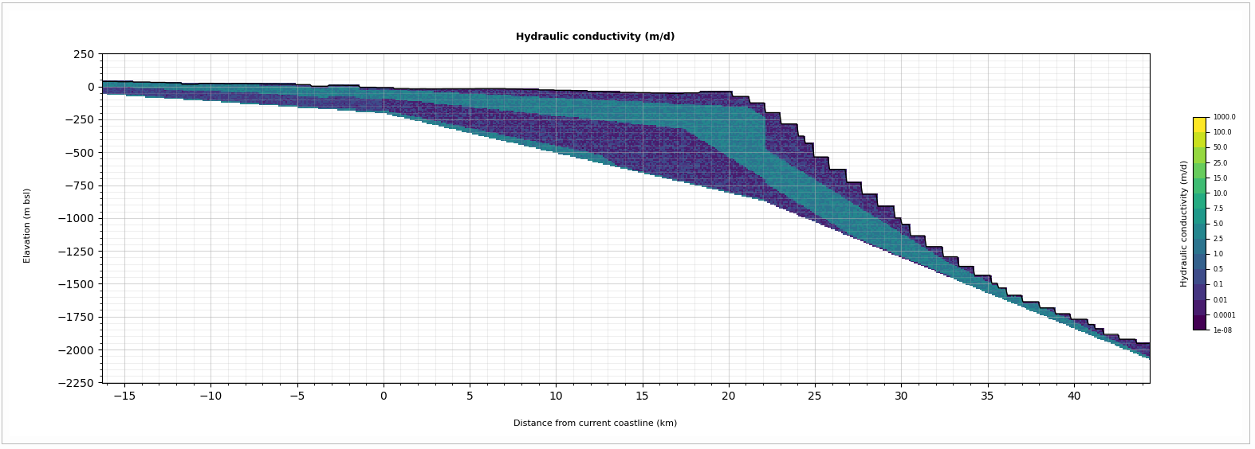

1. Now that we have created our geological conditions, we can use the **Save** button to save it and move to the next step of the tutorial.

## SEAWAT model stress periods

In the next stage we will define stress periods for the SEAWAT model. Stress periods allow us to change several boundary conditions and create multiple separated SEAWAT model runs with different temporal definitions. When you open the **Stress periods** tab you will see that it is split into the model list (black) and stress period table (blue).

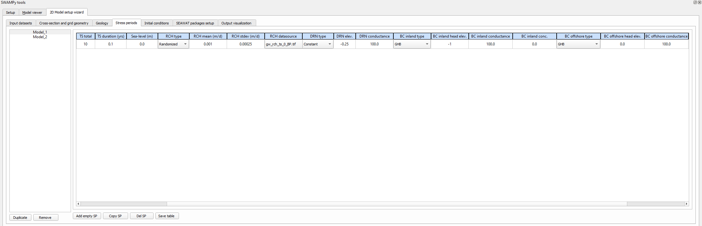

1. Make sure the Model_1 is selected in the model list and notice that there is already one stress period defined in the stress period table. It consists of multiple columns that can be grouped into several types. Here we will go through them step by step. First, we will examine the columns holding the temporal parameters and names of the stress periods. The **ID** column is automatically filled in when you add or remove stress periods. The user can also define a custom name for each stress period in the **Name** column. Each stress period has to have a defined length in the **Duration (yrs)** column and the total amount of time steps in the **TS total** column. The duration of each time step will then be auto filled in the TS duration (yrs), just to provide additional information to the user.
2. It is possible to define a different sea-level stage for each stress period, the value is relative to current sea level which is equal to 0m, this is filled in the **Sea-level (m)** column. Sea-level is important for defining which part of the model domain will receive fresh groundwater recharge (RCH), only applied to the areas located above the defined sea-level. In the **RCH type** column, you can select three different options of RCH implementation. If you don’t want to apply any recharge during the given stress period you can select the **None** option. The **Randomized** option assigns random recharge values to each cell above sea-level using a normal distribution defined by **RCH mean (m/d)** and **RCH stdev (m/d)** column values, the random scenario is defined by the **Rand. ID** parameter defined in the **Geology** tab. The last option, **Datasource**, allows the user to select an RCH input dataset (found in the **RCH folder** defined in step 23) from a dropdown menu. The values will then be extracted along the cross-section points and individual cells will then be assigned corresponding RCH value.
3. In a similar way we can define the drainage (DRN) conditions in the SEAWAT model. If you don’t want to include drainage in a given stress period simply select the **None** option in the **DRN type column**. The only other option is the **Constant** drainage input, which will set the drainage level to the value in **DRN elev.** Column – expressed as meters below surface level in every column where drainage will be assigned (above given sea-level). The last drainage parameter that needs to be assigned is the drainage conductance (**DRN conductance** column). The definition and calculation of the conductance term can be found in the SEAWAT (or MODFLOW) manuals. SWAMPy-tools can either use a constant conductance term (which is set to 100m²/d) or calculate it internally if the **DRN conductance** value is set to -1.
4. Next, we need to define both inland and offshore boundary conditions. There are two types available for both inland and offshore boundary conditions, the general head boundary (GHB) and constant head boundary (CHD), both of these can be selected in the **BC inland type** and **BC offshore type** columns. The CHD implements the boundary conditions through a fixed head and does not interact with the neighboring cells; it is thus an infinite source or sink of water entering or leaving the system. The GHB condition on the other hand calculates the flux through the boundary as always proportional to the difference in the boundary head and the head calculated in the cell in a given time step. The conductance (m²/d) is the factor that relates the difference in head to the rate of flow through the GHB boundary. The next step is then to define the head elevations for both inland and offshore boundary via the **BC inland head elev.** and **BC offshore head elev.** columns. If you want to assign head elevations based on the surface elevation fill in -1 in a given column (recommended only for inland boundary). The offshore part of the model domain will represent the submerged area by the sea. To simulate this condition, it is best to use the GHB and set the **BC offshore head elev.** to be equal to the **sea-level elevation** in a given stress period. The **BC inland conductance** and **BC offshore conductance** values define the conductance value implement in the boundary cells. It can either be set to be a constant value (default is 100m²/d) or calculated internally by setting it to -1. The last step when defining the boundary conditions is to specify the salinity concentration of the boundary cells in the **BC inland conc.** and **BC offshore conc.** columns. The salinity concentration is expressed in g/l TDS (total dissolved solids) and ranges between fresh water concentration (0 g/l TDS) and seawater concentration (35 g/l TDS).
5. At the bottom of the stress period table there are four buttons that help to add and remove stress periods as well as save the final stress period table. If you want to add a new empty row, use the **Add empty SP** button and a new row will appear. If you will only want to vary few boundary conditions between different stress periods you can use the **Copy SP** button. This will reproduce the last row in the stress period table. If you want to remove a row, use the **Del SP** button, which will then remove the last row in the stress period table. Once you are satisfied with your stress period setup you have to save the stress period table before moving to the next step, for that use the **Save table** button.
6. For our SEAWAT model we will define two stress periods. First, make sure that Model_1 is selected in the model list and then click on the **Copy SP** button. Now we have two stress periods defined and we can change some parameters before moving to the next step. For this tutorial we will only change the sea-level and the stress period duration. Your final stress period should look like shown in the picture below. Once you are done click on the **Save table** button and then on the **Initial conditions** tab.



## Setting up initial conditions

When you open the **Initial conditions** tab you will see that the layout is composed of three different windows. The model list (black) is located above the parameter value input window (blue) and the plotting window (green) takes up the majority of the space to the right of the model list and the parameter input window. Here we will set up the initial starting conditions for the SEAWAT model, both for groundwater heads and starting salinity. These initial conditions will be applied as input into the first stress period. For the following stress periods the end head elevation and salinity concentration of the previous stress period are taken as starting conditions.

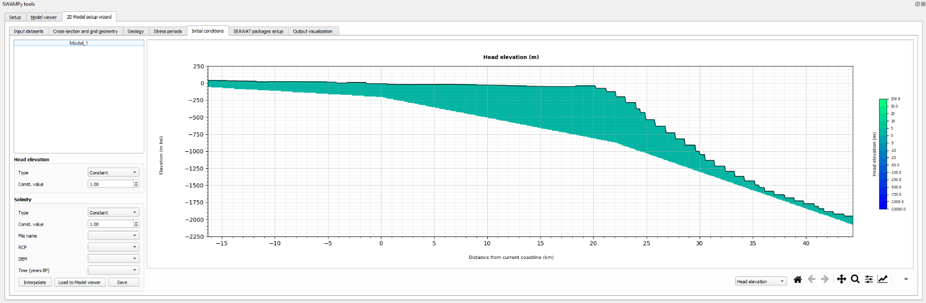

1. 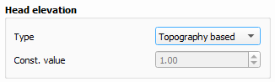First, we will define the initial head elevation. Make sue that Head elevation is selected in the dropdown menu below the plotting window and Model_1 is selected in the model list. In the **Head elevation** window (see below) you can select either **Constant** or **Topography based** options. If the **Constant** option is selected you can set the whole domain to have the same starting head elevation defined in the **Const. value** field. When the **Topography based** option is selected, SWAMPy-tools will assign the top elevation (from the DEM input) into all cells in a given model domain column. Selected the **Topography based** option and the plot will update itself. Next, click on the **Save** button at the bottom of the parameter input window to save the initial head elevation.
2. In the next step we will explore several options to define the initial salinity distribution. In the **Salinity window** you can see that there are three different options in the **Type** dropdown menu. By using the **Constant** option, you can set the initial salinity concentration to match a defined value (in the **Const. value** field). The second option is **Split at coast** which will assign all inland cells (with top elevation above sea-level) with fresh water salinity concentration (0 g/l TDS) and all offshore cells (below sea-level) with seawater salinity concentration (35 g/l TDS). The last option is to interpolate salinity concentration from a different SEAWAT model result. When you select the **Interpolated** option in the **Type** dropdown menu you will see that several additional dropdown menus at the bottom of the parameter input window become available, see below. Since our cross-section is located in the 0016_SRM_14 coastal stretch region we can go ahead and select it from the **File name** dropdown menu. If you then click on the **Load to Model viewer** button the model will be loaded into the **Model viewer**. Open the **Model viewer** tab and you can see the estimated salinity concentrations for different time steps, RCP scenarios and DEM input datasets (see Chapter 3). When you are sure which of these conditions you want to select you can come back to the Initial conditions tab and create your salinity initial conditions. For the purpose of this tutorial set the **RCP** to 45, **DEM** to gebco and **Time (years BP)** to 0, as shown 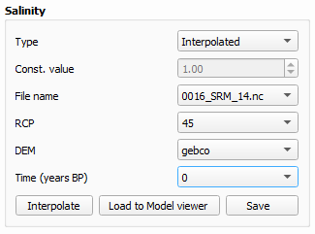below.
3. When all the parameter values are set click on the **Interpolate** button which will then interpolate the salinity concentration from the 0016_SRM_14 model into the shape of our tutorial SEAWAT model domain. This might take some time but it is performed in the background so you can keep using QGIS while the process is running.
4. 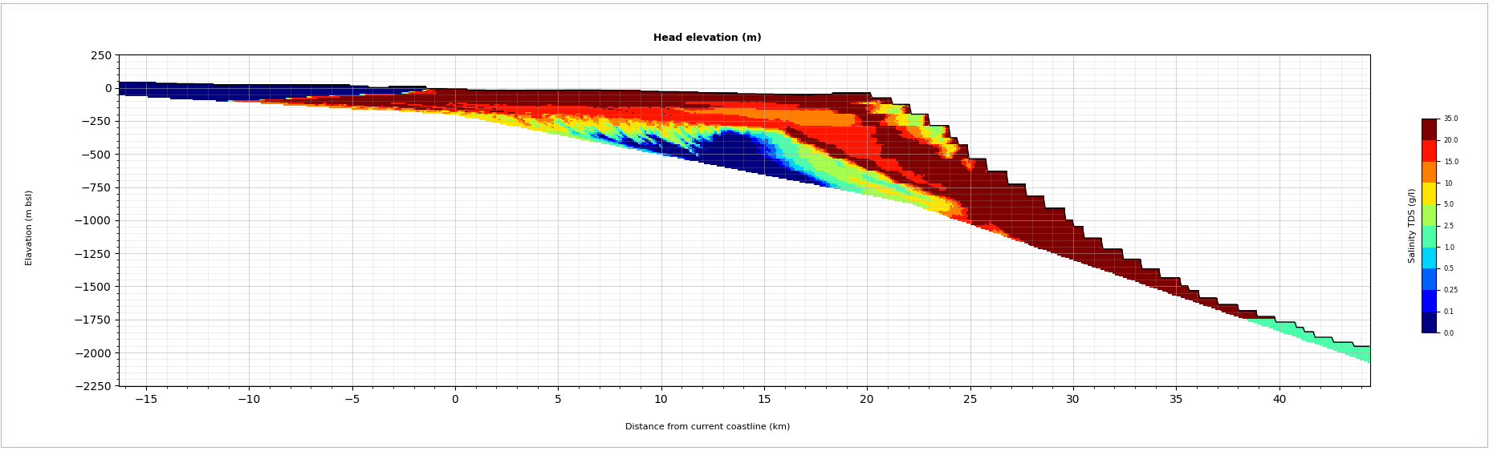Once the process is finished your initial salinity should match the picture below. You can now click on the **Save** button and move to the next step by opening the **SEAWAT packages setup** tab.

## SEAWAT parameters and executing the SEAWAT model

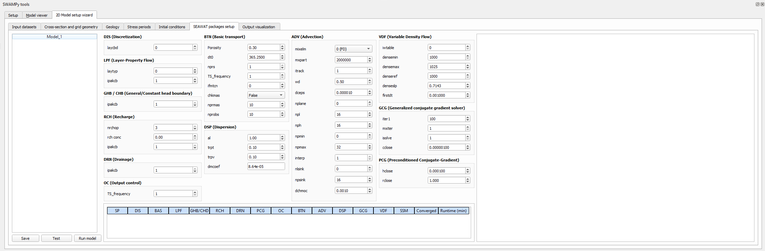In the last step before finally running our tutorial SEAWAT model, we need to define several key SEAWAT parameters. This can be done in the **SEAWAT packages setup** tab, see the picture below. The SEAWAT parameter window (blue) is positioned in the middle with the model list (black) to its left and a list file window to its right (green).

v

v

1. The amount of the different SEAWAT parameters can appear overwhelming but as you can see all the values are already pre-defined. For more details on each parameter please consult the MODFLOW and SEAWAT manuals. If you changed any parameters, please click on the **Save** button at the bottom of the model list window to save these changes before running the SEAWAT model. For the purposes of this tutorial, we will leave all fields as they are and while the Model_1 is selected in the model list we will test if our SEAWAT model is correctly set up. We can do this by clicking the **Test** button, which will run the SEAWAT model with the conditions defined for the first stress period. The only difference is the length of the stress period which will now be changed to 1 day. This will result only in a very fast short model run and its results will tell us if all MODFLOW and SEAWAT packages are set up correctly.
2. After the test run is finished you will see that the bottom of the SEAWAT parameter window the table was updated as well as new text in the list file window will appear. If all the cells in the table are green it means that all MODFLOW and SEAWAT packages were created correctly and the model ran without issues during the test run. The text in the list file window corresponds to the final MODFLOW list file and shows you for example the water budget. You will also notice that there is a new folder created in your output directory called **test_model**. You can explore the contents of this folder and you will see the MODFLOW and SEAWAT input and output files for the shortened stress period of the test run.
3. With the test run successfully finished we can now finally run our tutorial SEAWAT model by clicking on the **Run model** button. The SEAWAT model will run in the background and once it is finished you will see a notification at the right bottom corner of your screen. This might take a moment so feel free to make a coffee or reply to your long-postponed email duties.

## Visualizing the SEAWAT model output

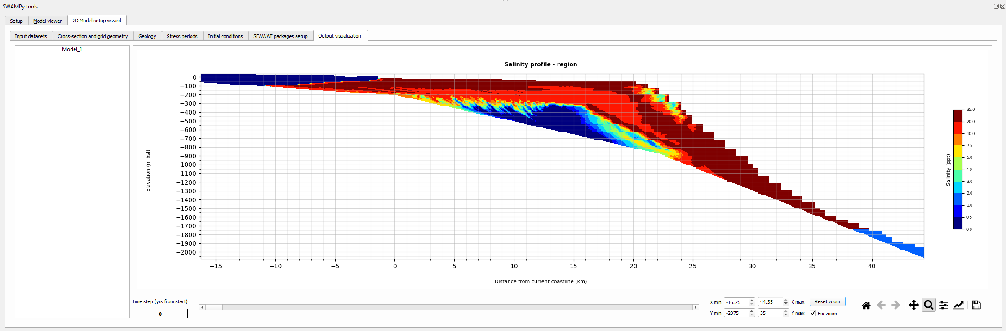Congratulations! If you arrived at this step, it means that your first SWAMPy-tools SEAWAT model finished successfully and we can now have a look at the estimated salinity concentration results! To do that open the **Output visualization** tab and you will see that the SEAWAT model results were already loaded.

1. If you want to examine the SEAWAT model results you can use the zooming tools and sliding bar to select different time steps below the plot. These tools are the same as for the **Model viewer**, see steps 14 and 15.
2. The SEAWAT model output (and input) is stored in the newly create **SEAWAT_model** folder that was created in your output directory. If you open the folder, you will see a separate subfolder for each stress period as well as the final SEAWAT output netcdf file (**final_SEAWAT_output.nc**).