Exercises Class 11-12-19 - Pipeline

Lais Silva Almeida Zanchetta, Daniel Ferreira Zanchetta

18/11/2019

## 1) Let’s play a bit with pipes. Using the pipeline operator perform the following operations:

### a) Compute the squared root of the squared of any number.

library(magrittr)  
  
var_quad <- function(x) x^2  
  
num_pipe_rsquared <- . %>% var_quad() %>% sqrt()  
num_pipe_rsquared(2)

## [1] 2

### b) Sample 1000 individuals from a normal distribution (mean = 5 , sd = 3), standardize the sample (subtract the mean and divide by the standard deviation, i.e., scale) and compute the max value.

rnorm(n=1000,mean=5,sd=3) %>% scale(.,center=TRUE, scale=TRUE) %>% max(.)

## [1] 3.2098

### c) Same as b) but plotting the density function before computing the max value.

#P.S.: It is not possible to use the plot density inside the pipeline.

plot_dens <- function(x) plot(density(x))  
  
rnorm(n=1000,mean=5,sd=3) %>% scale(.,center=TRUE, scale=TRUE) %T>% plot_dens(.) %>% max(.)

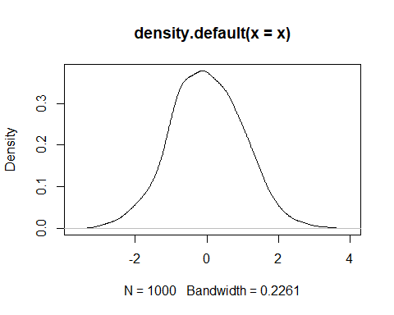

## [1] 3.314092

## 2. With the pisos dataset and using an only pipeline, compute the following transformations:

### a) Drop the duplicated individuals and compute the mean value of the flats (”Valor”) by district (”Dist”).

bcnpisos <- read.table(file.choose(), header=TRUE) #to read files in mac chosing the file you want from the fold  
  
library(dplyr)

##   
## Attaching package: 'dplyr'

## The following objects are masked from 'package:stats':  
##   
## filter, lag

## The following objects are masked from 'package:base':  
##   
## intersect, setdiff, setequal, union

distinct(bcnpisos) %>% group_by(Dist) %>% summarise(mean_flats = mean(Valor))

## # A tibble: 10 x 2  
## Dist mean_flats  
## <fct> <dbl>  
## 1 Ciutat_Vella 11523408.  
## 2 Eixample 21861301.  
## 3 Gracia 17401416   
## 4 Horta 15769832.  
## 5 Les_Corts 28754475.  
## 6 Nou_Barris 13352474.  
## 7 Sant_Andreu 15365746.  
## 8 Sant_Marti 15117212.  
## 9 Sants 15598655.  
## 10 Sarria 33022471.

### b) Drop the duplicated individuals, get the numeric features of the dataset and standardize it.

bcn_numeric <- distinct(bcnpisos) %>% .[,unlist(lapply(., is.numeric))] %>% scale(.,center = TRUE, scale = TRUE)  
head(bcn_numeric)

## Valor Superf Dorm Banys Edat ValSol  
## [1,] -1.3060214 -1.6157433 -0.9749402 -0.5875153 1.036136 -0.4258923  
## [2,] -1.0983483 -1.2884824 -2.0628190 -0.5875153 2.097013 -1.0909849  
## [3,] -0.9677313 -1.2736490 -0.9749402 -0.5875153 1.389761 -0.1672452  
## [4,] -0.7676190 -0.7013287 0.1129386 -0.5875153 2.097013 -0.6475898  
## [5,] 0.1816739 0.3802701 -0.9749402 1.2517340 -1.439244 -1.1648841  
## [6,] -0.8361111 -0.2285155 -0.9749402 -0.5875153 2.556726 -1.5343800

### c) Drop the duplicated individuals, add a new factor to the dataset ”Greater than is mean” with values (Y,N) indicating if the Value (”Valor”) of the flat is greater or not than the mean of the flats in the district.

dist_mean <- distinct(bcnpisos) %>% group_by(Dist) %>% summarise(mean_flats = mean(Valor))   
dist_greater <- distinct(bcnpisos) %>% left_join(y=dist_mean, by="Dist") %>% mutate("GREATER_THAN_IS_MEAN"=ifelse(Valor>mean_flats,"Y","N"))  
head(dist_greater)

## Valor Superf Dorm Banys Edat Estat Planta Dist ValSol  
## 1 4962780 31.41 2 1 70 1_MM Planta Ciutat_Vella 113322.15  
## 2 7001400 42.00 1 1 100 2_M Planta Ciutat_Vella 89407.53  
## 3 8283600 42.48 2 1 80 2_M Planta Ciutat_Vella 122622.28  
## 4 10248000 61.00 3 1 100 1_MM Planta Ciutat_Vella 105350.61  
## 5 19566720 96.00 2 2 0 5_MB Planta Ciutat_Vella 86750.35  
## 6 9575648 76.30 2 1 113 1_MM Atic Ciutat_Vella 73464.45  
## Tipus Ascens ExtInt Reforma mean_flats GREATER_THAN_IS_MEAN  
## 1 MANZ NO EXT REF15-20 11523408 N  
## 2 MANZ NO EXT REF1A5 11523408 N  
## 3 MANZ NO EXT RECIENREF 11523408 N  
## 4 MANZ SI EXT RECIENREF 11523408 N  
## 5 MANZ SI EXT OBRANUEVA 11523408 Y  
## 6 MANZ NO EXT REF10-15 11523408 N

## 3) Finally, you are asked to do a complete transformation of the pisos dataset. We want to analyse and visualize some general features of the districts of the city, characterizing a sample of flats.

### a) Propose R code for the transformation of this dataset. You are free to use any technique explained during the course (and others) but the use of some pipes will be valued positively (7 points).

library(dplyr)  
new_bcnpisos <- bcnpisos %>% distinct %>% group_by(Dist) %>% rename(DistrictName = Dist) %>% summarise('1Dorm' = sum(Dorm==1),'2Dorm' = sum(Dorm==2),'3Dorm' = sum(Dorm == 3), '4Dorm' = sum(Dorm == 4), '5Dorm' = sum(Dorm == 5), 'Valor' = mean(Valor, na.rm = TRUE), 'AscS' = sum(Ascens == 'SI'), 'AscN' = sum(Ascens == 'NO'), 'Atic' = sum(Planta == 'Atic'), 'Bajos' = sum(Planta == 'Bajos'), 'Planta' = sum(Planta == 'Planta'), 'Nous' = sum(Edat <= 10), 'SemiNous' = sum(Edat >=11 && Edat <=20), 'Vells' = sum(Edat >=21 && Edat<=50), 'MoltVells' = sum(Edat >= 51), 'Superf' = mean(Superf, na.rm = TRUE)  
)  
  
arrange(new_bcnpisos, DistrictName)

## # A tibble: 10 x 17  
## DistrictName `1Dorm` `2Dorm` `3Dorm` `4Dorm` `5Dorm` Valor AscS AscN  
## <fct> <int> <int> <int> <int> <int> <dbl> <int> <int>  
## 1 Ciutat_Vella 51 68 53 13 3 1.15e7 37 151  
## 2 Eixample 24 63 126 125 29 2.19e7 283 84  
## 3 Gracia 13 41 68 34 6 1.74e7 81 81  
## 4 Horta 12 52 139 45 1 1.58e7 111 138  
## 5 Les_Corts 1 13 33 31 5 2.88e7 68 15  
## 6 Nou_Barris 6 65 127 25 0 1.34e7 106 117  
## 7 Sant_Andreu 11 32 106 35 1 1.54e7 121 64  
## 8 Sant_Marti 16 70 187 51 1 1.51e7 209 116  
## 9 Sants 23 71 165 59 1 1.56e7 223 96  
## 10 Sarria 15 21 45 50 22 3.30e7 131 22  
## # ... with 8 more variables: Atic <int>, Bajos <int>, Planta <int>,  
## # Nous <int>, SemiNous <int>, Vells <int>, MoltVells <int>, Superf <dbl>

### b) Propose nice visualizations of this new dataset (3 points).

library(ggplot2)  
library(plotrix)  
library(dplyr)  
library(tidyr)

##   
## Attaching package: 'tidyr'

## The following object is masked from 'package:magrittr':  
##   
## extract

slices <- new_bcnpisos$Valor  
labels <- new_bcnpisos$DistrictName  
pie3D(slices,labels = labels, explode=0.25, main="District vs Valor")

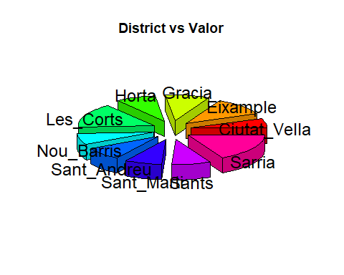

new_bcnpisos %>% arrange(desc(DistrictName)) %>% ggplot(aes(x=Superf,y=DistrictName, size=Valor))+  
 geom_point(alpha=0.5) +  
 scale_size(range = c(.1, 24), name="Valor (M)") +  
 theme(legend.position="bottom") +  
 ylab("Nombre Districto") +  
 xlab("Superficie") +  
 theme(axis.title.y = element_text(angle = 1))

