I2C - RS-485 adapter
Jaakko Ala-Paavola
September 29th, 2001
Status: Not implemented
Date | History
2001/09/28 | Initial draft
2001/09/29 | Added more PCBs

Table of contents
Introduction
Schematics
Printed Circuit Board
References

Introduction
The motivation of this project is to extend the widely supported I2C bus for longer distances to apply as a home control network. I2C specification [1] implements simple 2-wire data communication protocol suitable for communication between sensors and microcontrollers. Philips introduced the bus at early 70s, but it's still very usefull even today. Thank's to the old-age there are thousands of devices having I2C interface built-in. Practically all modern PC motherboards includes I2C bus for health status gathering and most operating systems have support for it, including Linux [2].
The drawback of the bus is it's electrical characteristics that allows bus length of only few meters. Originally the bus was designed for device internal communication, inter-ic as the name says, thus few meters was considered sufficient. To apply I2C protocol in house-wide control network, one have to convert electrical signal into form that better suits for longer distances. Multinode networks based on twisted pair differential signals are very good for the purpose. EIA/RS-485 [3] specifies such a network with maximum length of 1000 meters and 32 receivers and transmitters connected. With bridge-circuit one may multiply the number of nodes.
This document introduces a simple bi-directional I2C - RS-485 adapter.

Schematic diagram
Both buses are half-dublex bi-directional, thus the adapter must be bi-directional. In order to prevent signal loops the circuit has mutual exclusion in signal switching. Signal from one direction disables signals going to another direction.
I2C bus is active low ans RS-485 has active high, thus signal levels are inverted. This is done by NOR-gates. First NOR-port (IC2/1) is considered as an inverter with enable signal. Input signals of second NOR-port (IC2/2) are connected together, making the port work as a normal inverter. TTL-RS485 conversion is made by industry standard RS-485 tranceiver, there are plenty of manufacturers offering interchangeable parts [4].
I2C bus has two signals: data and clock, thus the circuit in figure 1 must be dublicated in the actual device.
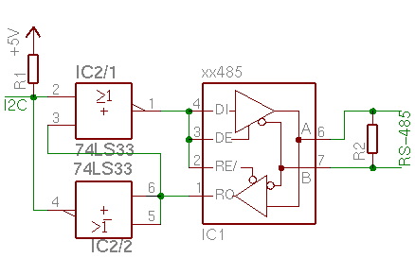
Figure 1. One half of the circuit.
Components

IC1 MAX485 / LTC485 / DS485 / SP485 / ADM485 / SN75167B / etc
RS485 tranceiver
IC2 74LS33 Quad-NOR, Open-Collector
R1 2,2 kOhm resistor
R2 220 Ohm resistor

Printed Circuit Board
The ensure reusability of design, the device is designed as a module, connected with a pin header connector to main application. There are three different PCBs presented here, all having the very same functionality.
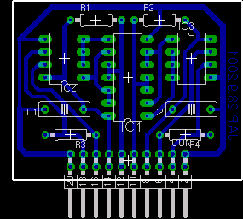 | 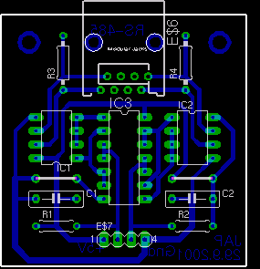 | 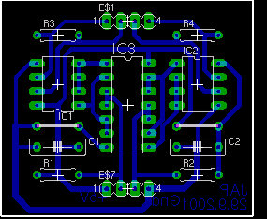
Figure 2. Printed circuit board
Components
IC1 74LS33
IC2 xx485
IC3 xx485
C1 100nF
C2 100nF
R1 2,2 kOhm
R2 2,2 kOhm
R3 220 Ohm
R4 220 Ohm
CON 20-pin connector
Table 1. Module interface specification
Pin | Function | Pin | Function
1, 2 | GND | 11, 12 | I2C 1
3, 4 | 485 2-A | 13, 14 | Vcc
5, 6 | 485 2-B | 15, 16 | 485 1-A
7, 8 | Vcc | 17, 18 | 485 1-B
9, 10 | I2C 2 | 19, 20 | GND
Pin order in the interface is mirror symmetric with both axis. The module can be connected which ever way.
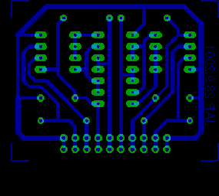 | 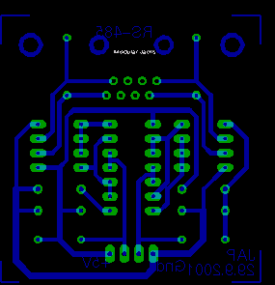 | 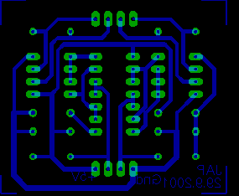
Figure 3. Solder side
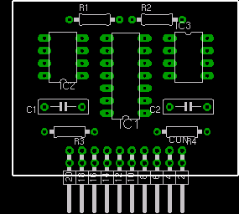 | 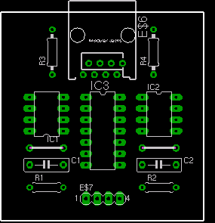 | 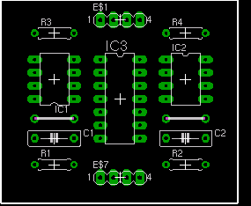
Figure 4. Component side
The schematic diagram and PCB are drawn with Eagle editor, made by German CadSoft [5].

References
1. I2C bus specification
http://www.semiconductors.philips.com/i2c/
2. I2C driver project for Linux
http://www.voxel.at/prj/i2c/
3. EIA/RS-485 Specification
http://www.rs-485.com/specs.htm
4. MAX485 Datasheet
http://pdfserv.maxim-ic.com/arpdf/MAX1487-MAX491.pdf
5. Eagle PCB & Schematic editor
http://www.cadsoft.de/
Up to higher level

