Install Jenkins on Ubuntu - https://phoenixnap.com/kb/install-jenkins-ubuntu

Step 1: Install Java
If you already have Java installed on your system, skip ahead to the next section.
It is recommended that you install OpenJDK from the default repositories. Open a terminal window and enter the following:
sudo apt update
sudo apt install openjdk-8-jdk
You’ll be asked to confirm the download and installation. Press Y and hit Enter, then allow the process to finish.

Step 2: Add the Jenkins Repository

wget -q -O - https://pkg.jenkins.io/debian/jenkins.io.key | sudo apt-key add -

Then add a Jenkins apt repository entry:

sudo sh -c 'echo deb https://pkg.jenkins.io/debian binary/ > /etc/apt/sources.list.d/jenkins.list'

Update your local package index, then finally install Jenkins:

sudo apt-get update
sudo apt-get install jenkins

Step 3: Set up Jenkins
1. To launch and set up Jenkins, open a web browser, and navigate to the IP address of your server:
http://ip_address_or_domain:8080
Use the actual IP address or domain name for the server you’re using Jenkins on.
2. You should see a page that prompts you to Unlock Jenkins. You’ll need the default password. You can get the default password by switching to a command line and entering the following:
sudo cat /var/lib/jenkins/secrets/initialAdminPassword
3. The system returns an alphanumeric code. Enter that code, then click Continue.
4. Next, you are prompted to either Install suggested plugins or Select plugins to install. It’s fine to simply install the suggested plugins. You can always install more plugins later. The system continues the initial Jenkins setup.
5. Then you will be prompted to Create First Admin User. Enter the credentials you want to use for your Jenkins administrator, then Save and Continue.
6. After this, you should set up the Instance Configuration. This is the preferred network address for this Jenkins installation. Confirm the address you want to use for your server. This is most likely the same address you used to get to this configuration page. When you’re satisfied, click Save and Finish.
7. You should see a page that says Jenkins is ready! You can click Start using Jenkins to open the Jenkins dashboard.

Step 4: Install docker
- Apt update
- Apt install docker.io
- Add Jenkins user to docker group sudo usermod -a -G docker Jenkins
- Restart the servers ; if you getting permission error when running docker command run the following chmod 777 /var/run/docker.sock

Step 5: Define webhook

- sudo wget -O /usr/local/bin/relay https://storage.googleapis.com/webhookrelay/downloads/relay-linux-amd64
- sudo chmod +wx /usr/local/bin/relay
- Login to : https://my.webhookrelay.com/register
- Create new token
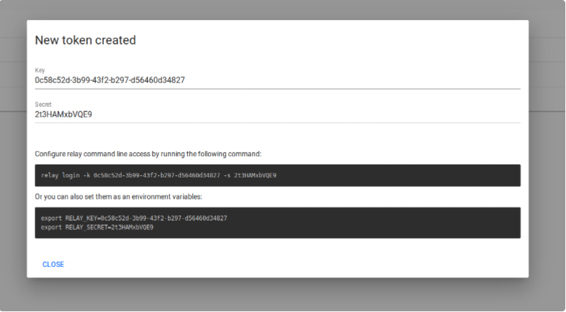

- Run the agent : relay login -k token-key-here -s token-secret-here
- Take the URL output and define it as the webhook link in github
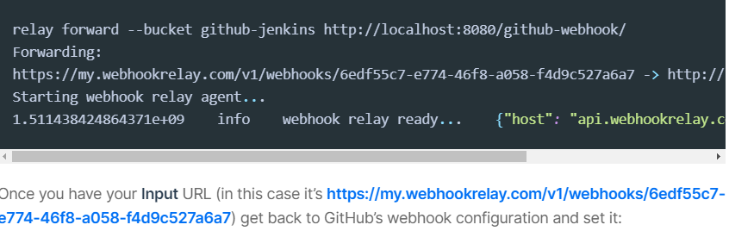

Install Jfrog doker repo on Ubuntu - https://www.jfrog.com/confluence/display/JFROG/JFrog+Container+Registry

- Disable IPv6 - https://www.thegeekdiary.com/how-to-disable-ipv6-on-ubuntu-18-04-bionic-beaver-linux/
1. Edit /etc/default/grub and append ipv6.disable=1 to GRUB_CMDLINE_LINUX and GRUB_CMDLINE_LINUX_DEFAULT like the following sample:
FROM:
GRUB_CMDLINE_LINUX_DEFAULT=""
GRUB_CMDLINE_LINUX=""
TO:
GRUB_CMDLINE_LINUX_DEFAULT="ipv6.disable=1"
GRUB_CMDLINE_LINUX="ipv6.disable=1"
2. Run the update-grub command to regenerate the grub.cfg file:
# update-grub
3. Reboot the system to disable IPv6 support.

Disabling IPv6 via sysctl settings
Alternatively, this can be done via sysctl settings.
1. To disable Ipv6 temporarily on the system apply the below sysctl settings:
$ sysctl -w net.ipv6.conf.all.disable_ipv6=1
$ sysctl -w net.ipv6.conf.default.disable_ipv6=1
$ sysctl -w net.ipv6.conf.lo.disable_ipv6=1
2. In order to make the above sysctl changes permanent, we need to add them to /etc/sysctl.conf confirguation file.
net.ipv6.conf.all.disable_ipv6=1
net.ipv6.conf.default.disable_ipv6=1
net.ipv6.conf.lo.disable_ipv6 = 1
3. Use “sysctl -p” to apply the changes from /etc/sysctl.conf file.
# sysctl -p
4. An output of 1 from the below command verifies that the IPv6 has been successfully disabled.
# cat /proc/sys/net/ipv6/conf/all/disable_ipv6

- Install docker : apt-get install docker.io
- Download deb file
- Install : dpkg -i <file-name>

Start Artifactory with:
> systemctl start artifactory.service

Check Artifactory status with:
> systemctl status artifactory.service
Installation directory was set to /opt/jfrog/artifactory
You can find more information in the log directory /opt/jfrog/artifactory/var/log
System configuration templates can be found under /opt/jfrog/artifactory/var/etc
Copy any configuration you want to modify from the template to /opt/jfrog/artifactory/var/etc/system.yaml

Triggering migration script, this will migrate if needed ...
Processing triggers for ureadahead (0.100.0-21) ...
Processing triggers for systemd (237-3ubuntu10.39) ...

- service artifactory start
- browse to http://,server-ip.:8081
  - admin
  - password
- View log : tail -f $ARTIFACTORY_HOME/logs/artifactory.log
- Create local repository
- Create virtual repository and assign the local repo *
- Create user
- Click on Jfrom Container registry
  - General à HTTP Setting
  - Docker access: Repository path
  - Server provided : embedded tomcat
  - Public server name : this what you will use on the next step
*The default installation is based on HTTP – therefore we need to create virtual repo and update docker client to receive HTTPS https://www.jfrog.com/confluence/display/JCR6X/Getting+Started+with+JFrog+Container+Registry+as+a+Docker+Registry

- From the docker client (From the server you want to run docker commands)
  - Create “daemon.json” file under /etc/docker
  - Update the file
{
"insecure-registries" : ["<jfrog-server-ip>:8082"]
}
  - In order to login run
docker login -u <username -step10> -p <username pass> ["<jfrog-server-ip>::8082

- In order to upload image run the following
  - Download image
  - Tag the image with the remote registry – for example
local image name : ngnix
local image tag : latest
local image id : ad4c705f24d3
remote local registry key : local
remote local registry ip: 10.201.55.76
docker image tag ad4c705f24d3 10.201.55.76:8082/local/nginx:latest
  - To upload run : docker image push 10.201.55.76:8082/local/nginx:latest
- Adding Jenkins plugin https://www.jfrog.com/confluence/display/JFROG/Configuring+Jenkins+Artifactory+Plug-in

