**Adapt Lake Mead releases to inflow to give managers more flexibility to slow reservoir draw down**

April 6, 2022

David E. Rosenberg[1]

|  |
| --- |
| **Key Points**   1. Current Lake Mead operations adapt to reservoir level not inflow. 2. When inflows are below 8 maf per year, Lake Mead will draw down to 1,020 feet (5.7 maf storage) in less than 3 years. 3. Draw down will speed when parties withdraw from their conservation accounts or apply credits to meet mandatory targets. 4. Adapt Lake Mead releases to inflow so parties can:    1. Slow reservoir draw down.    2. Avoid unanticipated draw down.    3. Manage all available water not just conserved water.    4. Have more flexibility to conserve and consume water independent of other parties. |

# Introduction

A 20-year Colorado River drought continues and Lake Mead draws down. As Lake Mead falls through 8 elevation tiers to 1,020 feet (5.7 million acre-feet [maf]), releases drop and mandatory water conservation targets for California, Arizona, Nevada, and Mexico grow to 1.375 maf per year (USBR, 2019). How will different reservoir inflows, releases, and additional water conservation efforts beyond mandatory targets speed or slow Lake Mead’s draw down, stabilization, and recovery?

This piece seeks to provoke thought and discussion to adapt Lake Mead releases to inflow not just elevation. The next two sections develop scenarios of Lake Mead inflow and additional water conservation above mandatory targets. Numerical simulations identify inflow and conservation triggers to draw down, stabilize, and recover Lake Mead. This piece shows that adapting Lake Mead releases to reservoir inflow can give the Lower Basin states, their contractors, and Mexico more flexibility to conserve water, slow draw down to 1,020 feet, and reduce unanticipated draw down. To adapt to inflow, the piece suggests parties split each year’s inflow. Splitting inflows builds on existing water agreements, gives parties more water than in their Lake Mead conservation accounts, and allows parties more flexibility to conserve and consume within their available water independent of other parties.

# Inflow Scenarios

Future Lake Mead inflows depend on Lake Powell releases and intervening Grand Canyon tributary flows between Glen Canyon Dam and Lake Mead. Lake Powell releases recently varied from 7 to 9 maf per year (Wang and Schmidt, 2020) but are difficult to forecast as Lake Powell draws down to historic low levels. The gaged data for Grand Canyon tributary flows span multiple decades to almost a century (Wang and Schmidt, 2020) and have year-to-year variations and sequential correlations (Rosenberg, 2021a; Salehabadi et al., 2020). These uncertainties can be described by scenarios(Wang et al., 2020). Prior Colorado River work developed scenarios of raw or resampled flow values from select periods in the gaged, paleo reconstructed, and forecast data sets (Salehabadi et al., 2020). Here, I formulate *steady* Lake Mead inflow scenarios—a 10 maf scenario has the same 10 maf value each year—and interpret scenarios with historical data (Table 1). Steady flow scenarios more transparently describe hydrologic assumptions and help identify triggers to adapt for periods of a few years or longer.

**Table 1. Lake Mead inflow scenarios**

|  |  |  |  |  |
| --- | --- | --- | --- | --- |
| **Scenario**  **(maf each year)** | **Powell Release**  **(maf each year)** | **Grand Canyon Tributary Flow (maf each year)** | **Years of Powell Release** | **Notes on Grand Canyon Tributary Flows** |
| 14 | 13 | 1 | 2011, 1997-1998, 1983–1987 | Average reported by Wang and Schmidt (2020) |
| 12 | 11 | 1 | 1996, 1999 | Average reported by Wang and Schmidt (2020) |
| 11 | 10 | 1 | 1973 | Average reported by Wang and Schmidt (2020) |
| 10 | 9 | 1 | 2012, 2015–2019 | Average reported by Wang and Schmidt (2020) |
| 9 | 8.2 | 0.8 | 2007, 2013 | Within interquartile range (Rosenberg, 2021a) |
| 9 | 8.1 | 0.9 | 2002, 2009–2010 | Within interquartile range (Rosenberg, 2021a) |
| 8.6 | 8.0 | 0.6 | 1989, 1992 | 3 year sequences (Rosenberg, 2021a) |
| 8.4 | 7.5 | 0.9 | 2014 | Within interquartile range (Rosenberg, 2021a) |
| 8 | 7.3 | 0.7 | 2017 | Sequences of up to 5 years (Rosenberg, 2021a) |
| 7 | 6.4 | 0.6 | Not observed; not in guidelines | 3 year sequences (Rosenberg, 2021a) |

For example, a Lake Mead inflow of 10 maf repeated each year represents inflow from Lake Powell releases in recent years and average Grand Canyon tributary flows. A Lake Mead inflow of 9 maf each year can mean a Lake Powell release of 8.2 maf and 0.8 maf of tributary flow, a Powell release of 8.1 maf and 0.9 maf tributary flow, or other combinations. A Lake Mead inflow of 8 maf each year represents a situation where Lake Mead storage exceeds Lake Powell storage and managers release 7 to 7.48 maf from Powell to try to balance the two reservoirs. Additionally, Grand Canyon tributary flows fall to 0.5 to 0.7 maf each year, representative of 3- to 5-year sequences in the gaged record (Rosenberg, 2021a). A Lake Mead inflow of 7 maf represents a value below all historical observations, is not defined in current operations, yet may occur when Lake Powell has insufficient storage to make a 7 maf balancing release.

Other intermediary inflow scenarios are possible and simulated but not shown in Table 1.

# Water Conservation Scenarios

Managers have options to conserve and release water from Lake Mead. One operations scenario is stick with current mandatory conservation targets that escalate as Lake Mead draws down. As a second scenario, the Lower Basin states and Mexico may increase their conservation efforts *above* their current mandatory targets. This increase could occur through a new agreement for larger mandatory conservation targets, by raising the cap on conservation account balances, or by more voluntary conservation that is non-recoverable. Parties can recover their conservation credits so long as the Lake Mead active storage minus the 5.7 maf protection volume (1,020 feet; USBR, 2019) exceeds the conservation account balances. The March 31, 2022 Lake Mead active storage of 8.5 maf (1,061 feet) minus the 5.7 maf protection volume equals the 2.8 maf conservation account balances (Rosenberg, 2021b).

# Numerical Simulations

**Table 2. Lake Mead simulation assumptions**

|  |  |  |
| --- | --- | --- |
| **Component** | **Value** | **Comment / Source** |
| Initial storage (maf) | 9.0 | August 2021 value |
| Inflow (maf each year) | 7 – 14 | Scenarios of steady inflow |
| Evaporate rate (feet/year) | 6.2 | 5.7 – 6.8 by Moreo (2015) |
| Precipitation (feet/year) | Ignore | (IBWC, 2021); Wang and Schmidt (2020) |
| Area-Storage relationship | Varies | CRSS (Wheeler et al., 2019) |
| Release target (maf/year) | 9.6 | Lower Basin + Mexico + Parker/Havasu evaporation and evapotranspiration |

The purpose of the numerical simulations is to show Lake Mead drawdown, stabilization, and recovery to different elevations under different reservoir inflow and water conservation scenarios. The simulations use an annual reservoir mass balance (Eq. 1, all units of maf per year), seven assumptions (Table 2), and are programmed as open-source software in the R language (Rosenberg, 2021c).

storage(*t*) = storage(*t–1*) + inflow – evaporation(*t*) – release(*t*) (Eq. 1)

Here, storage(*t*) and storage(*t–1*) are reservoir storage volumes in the current and prior year, inflow is the same value each year (steady), and evaporation volume is the evaporation rate multiplied by the lake area. Release in year *t* is the release target minus the mandatory water conservation target for the current reservoir tier minus additional conservation above the mandatory target. This draw down analysis excludes an adaptive feature of the current operations to protect elevation 1,020 feet when Lake Mead is forecast to fall below 1,030 feet (6.3 maf)(USBR, 2019). The analysis also excludes 0.5 maf per year of additional water conservation by the Lower Basin states that was announced in December 2021 but not yet contracted (500+ plan; Allhands, 2021). The stabilization analyses shows the additional conservation to protect elevations 1,025 and 1,060 feet.

# Lake Mead Draw Down

When Lake Mead inflows are below 8.4 maf each year, existing operations draw Lake Mead down to 1,025 feet before 2026 (Figure 1). This draw down occurs in 3 to 5 years with Lake Powell balancing releases below 7.5 maf.

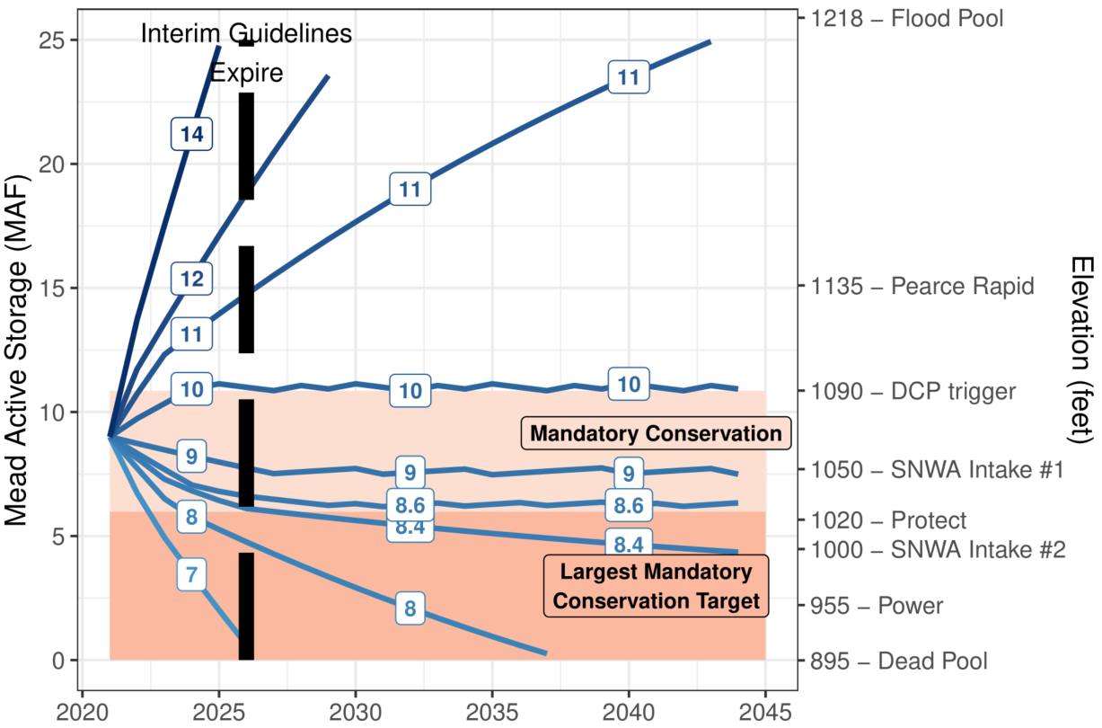

**Figure 1. Lake Mead draw down over time with existing operations and different scenarios of steady reservoir inflow (contours and boxes, million acre-feet per year).**

With Lake Mead inflows of 8.6 to 10 maf each year and Lake Powell releases of 7.6 to 9 maf each year, the current mandatory conservation targets will draw down and stabilize Lake Mead between 1,025 and 1,090 feet in 4 to 7 years (Figure 1). Lake Mead evaporation rates of 5.7 to 6.8 feet per year (Moreo, 2015) change storage volumes by at most 0.25 maf (results not shown).

# Stabilize Lake Mead

To stabilize Lake Mead’s level for different inflow values, find the annual release in Eq. 1 so that current year storage equals prior year storage (Figure 2, long-dashed blue line labeled “Release to stabilize reservoir level”). Releases above the long-dashed blue line draw down Lake Mead whereas releases below the line raise lake level. For inflows above 8.6 maf a year, the current mandatory conservation targets will stabilize Lake Mead at elevation 1,025 feet (Figure 2, dashed line intersects red area). The pink area shows the additional conservation above current mandatory targets to stabilize Lake Mead at each inflow value. To stabilize Lake Mead at 1,025 feet with 8 maf of annual inflow, parties conserve the mandatory target of 1.375 maf per year (Figure 2, red area) *plus* 0.7 maf per year or 2.0 maf total. Similarly, parties can stabilize Lake Mead at 1,060 feet with 9.8 maf of annual inflow or less by conserving their mandatory target, 500,000 acre-foot plan promise, and more.

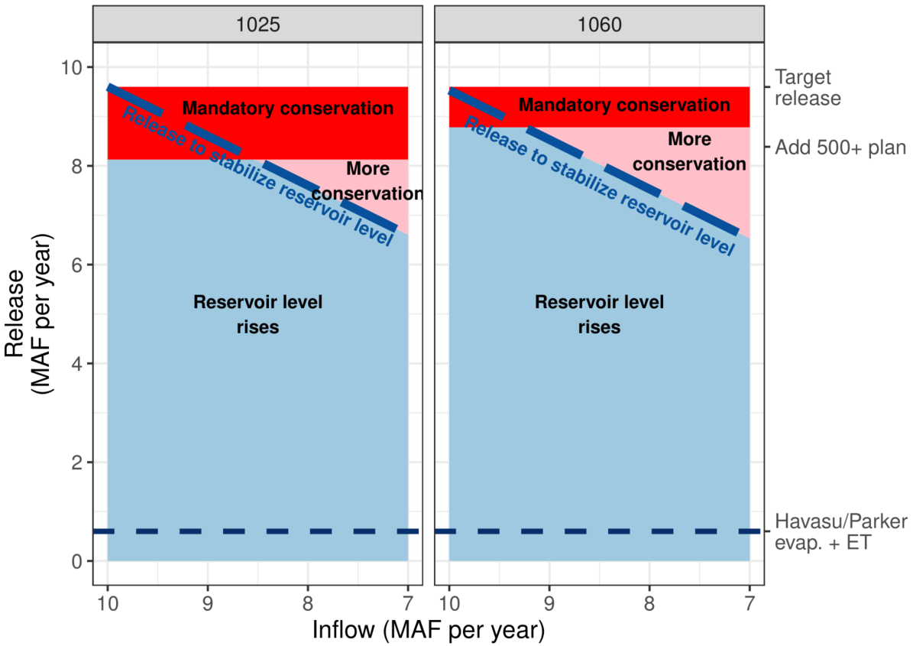

**Figure 2. Lake Mead releases to stabilize reservoir level for different inflows.**

# Recover Lake Mead

Lake Mead recovers when releases plus evaporation are less than inflows (releases below the long-dashed line in Figure 2). From elevation 1,050 feet, 9 maf each year of inflow and continuing mandatory conservation can stabilize Lake Mead at 1,050 feet while 10 maf each year will recover Lake Mead to 1,090 feet in 5 years (Figure 3, lines labeled 9 and 10 maf). A 5-year recovery can also occur with 9 maf inflow each year plus 1 maf of additional water conservation beyond the mandatory targets, or other combinations that sum to 10 maf each year (Figure 3, line labeled 10).

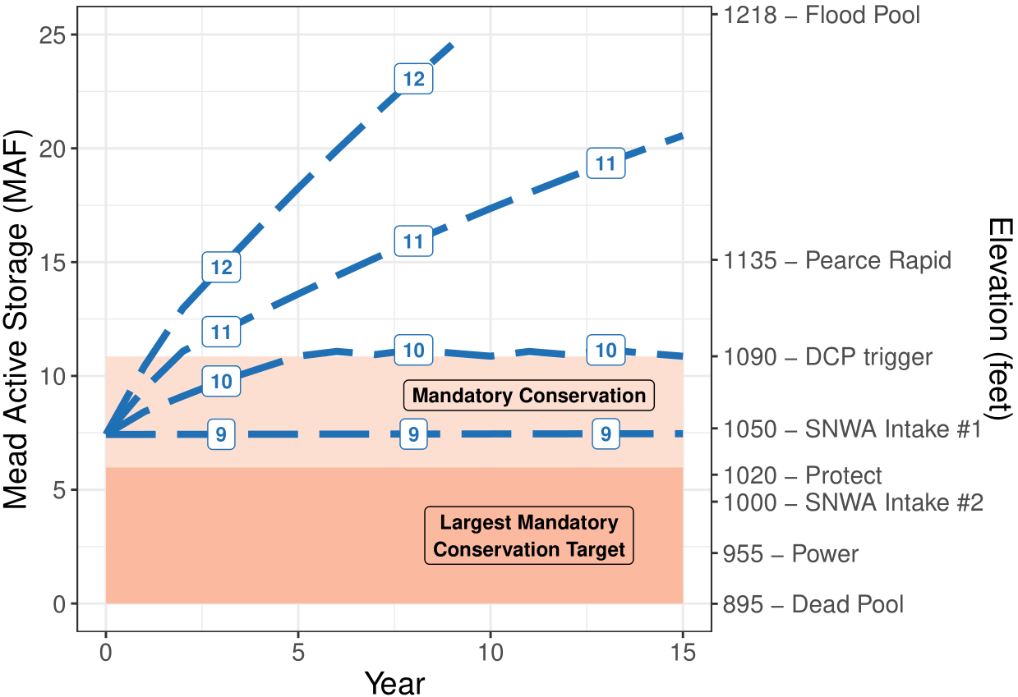

**Figure 3. Lake Mead recovery from 1,050 feet for different combinations of reservoir inflow and additional conservation above mandatory targets** **(maf per year).**

The draw down, stabilize, and recovery analyses exclude withdraw or conversion of conservation credits to meet mandatory targets. Withdraws and conversions will speed drawdown and lengthen recoveries because they increase reservoir releases. Conservation account withdraws and conversions are difficult to predict.

# Adapt Reservoir Releases to Inflow

Reservoir inflows affect Lake Mead’s drawdown, stabilization, and recovery. By adapting reservoir operations to inflows, parties can:

1. Slow draw down to elevation 1,020 feet.
2. Reduce unanticipated reservoir draw down.
3. Identify periods when water is more available and increase releases.
4. Define release and conservation actions by intent to draw down, stabilize, or recover reservoir storage.

Parties may not adapt reservoir releases to inflow when they:

1. Are unclear how to split additional conservation efforts.
2. Prefer to draw down Lake Mead below 1,020 feet than increase conservation and protect elevation 1,020 feet.

**These reasons signify a shrinking pie (lose-lose) water conflict – less reservoir inflow – that I believe the parties can convert into a more positive process.**

First, define a process to split each year’s inflow among parties. Parties can agree on shares or use their customary delivery targets, mandatory conservation volumes, and annual Lake Mead inflow (Appendix A). Second, compute each party’s available water as their share of reservoir inflow, plus share of reservoir storage, minus share of reservoir evaporation. In the first year of these adaptive operations, a party’s reservoir storage is their conservation account balance. Steps 1 and 2 give parties more water to manage than was in their conservation account. Step 2 also gives each party more flexibility to conserve, release, and consume water within their available water independent of other parties. Adapting releases to inflow converts the (a) existing operation of joint, negotiated, mandatory conservation targets specific to reservoir elevation, to a (b) more dynamic and flexible process where each party conserves or consumes its available water independent of other party’s choices. Adapting reservoir operations to inflow offers parties a more flexible, independent, and positive process to slow Lake Mead draw down.

The positive process is featured in flex accounts in a combined Lake Powell-Lake Mead system (Rosenberg, 2021d). Multiple participants connect to the online model, assign roles, track and split inflow, and conserve and consume within their available water independent of other parties. Download the tool, move into Google Sheets, invite colleagues, and adapt Colorado River reservoir releases to inflows.

# Data, Model, and Code Availability

The data, models, code, and directions to generate the Figures and Table A1 in this piece are available at <https://doi.org/10.5281/zenodo.5522835> (Rosenberg, 2021a; Rosenberg, 2021c; Rosenberg, 2021d).

Mahmudur Rahman Aveek (Utah State University) reproduced all figures and Table A1.

# Acknowledgements

26 Colorado River managers and experts gave feedback that improved the manuscript and/or flex accounts in a combined Lake Powell-Lake Mead system.

# Appendix A. Estimate Share of Reservoir Inflow from Customary Delivery Targets, Mandatory Conservation Volumes, Reservoir Elevation, and Annual Inflow.

This appendix describes one process to estimate Mexico’s and each Lower Basin party’s share of reservoir inflow. A share is estimated from a party’s customary delivery target, mandatory conservation volume (IBWC, 2021; USBR, 2019), reservoir elevation, and the annual inflow volume. Converting into shares gives parties more flexibility to adapt to changing inflows (Kuhn and Fleck, 2019). Converting into a share also allows the parties to build on their existing agreements (IBWC, 2021; USBR, 2019). Converting into shares also encourages the parties to consider a wider set of inflow scenarios. The Upper Basin states split inflow by share in their 1948 Compact (Carson et al., 1948).

As a start point, each party *p*’s percentage share of Lake Mead inflow at elevation *e* is the ratio of the (a) party’s individual delivery after mandatory conservation to (b) total delivery to all parties after all mandatory conservation (Eq. A1). Each party’s delivery is their Customary Deliveryp [maf per year] minus Mandatory Conservationp,e [maf per year]. The Customary Deliveries are 2.8, 0.3, 4.4, and 1.5 maf per year for Arizona, Nevada, California, and Mexico. Percentage shares of inflow are near identical for the 8 reservoir elevation tiers (Table A1).

|  |  |
| --- | --- |
| $${Share of Inflow}_{p,e} = \frac{\left({Customary Delivery}_{p}-{Mandatory Conservation}_{p,e}\right)}{\sum_{p}{\left({Customary Delivery}_{p}-{Mandatory Conservation}_{p,e}\right)}}$$ | (Eq. A1) |

**Table A1. Share of reservoir inflow calculated from customary deliveries and mandatory conservation volumes.**



# For annual reservoir inflow below approximately 9.0 maf per year, adjust percentages in Table A1 up for parties such as Mexico and California that have higher priority for delivery by the U.S.-Mexico treaty or earlier water uses in California’s Imperial Valley (IBWC, 2021; Kuhn and Fleck, 2019). There are many rationales and ways to adjust the percentages to include priority and inflow volume. In practice, parties can make new agreements to set percentage shares of inflow for different inflow volumes.

# To estimate a party’s volume share of inflow, start with the annual reservoir inflow, subtract 0.6 maf per year for Lake Havasu/Parker evapotranspiration and evapotranspiration, then multiply by the agreed percentage.References

Allhands, J. (2021). "It could take at least 500,000 acre-feet of water a year to keep Lake Mead from tanking." *Arizona Republic*, November 8, 2021.

Carson, C. A., Stone, C. H., Wilson, F. E., Watson, E. H., and Bishop, L. C. (1948). "Upper Colorado River Basin Compact." U.S. Bureau of Reclamation. <https://www.usbr.gov/lc/region/g1000/pdfiles/ucbsnact.pdf>. [Accessed on: September 7, 2021].

IBWC. (2021). "Minutes between the United States and Mexican Sections of the IBWC." United States Section. <https://www.ibwc.gov/Treaties_Minutes/Minutes.html>. [Accessed on: July 22, 2021].

Kuhn, E., and Fleck, J. (2019). *Science Be Dammed: How Ignoring Inconvenient Science Drained the Colorado River*, University of Arizona Press.

Moreo, M. T. (2015). "Evaporation data from Lake Mead and Lake Mohave, Nevada and Arizona, March 2010 through April 2015." U.S. Geological Survey Data Release. <http://dx.doi.org/10.5066/F79C6VG3>.

Rosenberg, D. E. (2021a). "Colorado River Coding: Grand Canyon Intervening Flow." GrandCanyonInterveningFlow folder. <https://doi.org/10.5281/zenodo.5522835>.

Rosenberg, D. E. (2021b). "Colorado River Coding: Intentionally Created Surplus for Lake Mead: Current Accounts and Next Steps." ICS folder. <https://doi.org/10.5281/zenodo.5522835>.

Rosenberg, D. E. (2021c). "Colorado River Coding: Lake Mead Steady Inflow Simulations." MeadInflowSimulations folder. <https://doi.org/10.5281/zenodo.5522835>.

Rosenberg, D. E. (2021d). "Colorado River Coding: Pilot flex accounting to encourage more water conservation in a combined Lake Powell-Lake Mead system." ModelMusings folder. <https://doi.org/10.5281/zenodo.5522835>.

Salehabadi, H., Tarboton, D., Kuhn, E., Udall, B., Wheeler, K., E.Rosenberg, D., Goeking, S., and Schmidt, J. C. (2020). "Stream flow and Losses of the Colorado River in the Southern Colorado Plateau." Center for Colorado River Studies, Utah State University, Logan, Utah. <https://qcnr.usu.edu/coloradoriver/files/WhitePaper4.pdf>.

USBR. (2019). "Agreement Concerning Colorado River Drought Contingency Management and Operations." U.S. Bureau of Reclamation, Washington, DC. <https://www.usbr.gov/dcp/finaldocs.html>.

Wang, J., Rosenberg, D. E., Schmidt, J. C., and Wheeler, K. G. (2020). "Managing the Colorado River for an Uncertain Future." Center for Colorado River Studies, Utah State University, Logan, Utah. <http://qcnr.usu.edu/coloradoriver/files/CCRS_White_Paper_3.pdf>.

Wang, J., and Schmidt, J. C. (2020). "Stream flow and Losses of the Colorado River in the Southern Colorado Plateau." Center for Colorado River Studies, Utah State University, Logan, Utah. <https://qcnr.usu.edu/coloradoriver/files/WhitePaper5.pdf>.

Wheeler, K. G., Schmidt, J. C., and Rosenberg, D. E. (2019). "Water Resource Modelling of the Colorado River – Present and Future Strategies." Center for Colorado River Studies, Utah State University, Logan, Utah. <https://qcnr.usu.edu/coloradoriver/files/WhitePaper2.pdf>.

# List of Figures

Figure 1. Lake Mead draw down over time with mandatory conservation and different scenarios of steady reservoir inflow (contours and boxes, million acre-feet per year).

Figure 2. Lake Mead releases to stabilize reservoir level for different inflows.

Figure 3. Lake Mead recovery from 1,050 feet for different combinations of reservoir inflow and additional conservation above mandatory targets (maf per year).

# List of Tables

Table 1. Lake Mead inflow scenarios

Table 2. Lake Mead simulation assumptions

Table A1. Share of reservoir inflow calculated from customary deliveries and mandatory conservation volumes.

1. Professor, Department of Civil and Environmental Engineering and Utah Water Research Laboratory, 8200 Old Main Hill, Utah State University, Logan, Utah, 84322-8200, A.M. ASCE, [david.rosenberg@usu.edu](mailto:david.rosenberg@usu.edu).