**Adapt Lake Mead releases to inflow to slow reservoir draw down**

David E. Rosenberg | Utah State University | [david.rosenberg@usu.edu](mailto:david.rosenberg@usu.edu) | @WaterModeler

September 4, 2021

|  |
| --- |
| **The Pearce Rapid is a major reservoir inflow point to Lake Mead**  **(**Photo by American Whitewater) |
| **Key Points**   1. Current Lake Mead operations adapt to reservoir level not inflow. 2. When inflows are below 8 maf per year, Lake Mead will draw down to 1,020 feet (5.7 maf storage) in less than 3 years. 3. Draw down will speed when parties withdraw from their conservation accounts or apply credits to meet mandatory targets. 4. Adapt reservoir releases to inflow to:    1. Slow Lake Mead draw down.    2. Avoid sudden large draw down.    3. Let parties manage all available water not just conserved water.    4. Give managers more flexibility to conserve and consume water independent of other parties. |

# Introduction

A 20-year Colorado River drought continues and Lake Mead draws down. As Lake Mead falls through 8 elevation tiers to 1,020 feet (5.7 million acre-feet [maf]), releases drop and mandatory water conservation targets grow to 1.375 maf per year (USBR, 2019). How will different reservoir inflows, releases, and additional water conservation efforts beyond mandatory targets speed or slow Lake Mead draw down, stabilization, and recovery?

This piece develops scenarios of Lake Mead inflow and additional water conservation that exceed mandatory targets and are more severe than prior hydrologic stress tests (Salehabadi et al., 2020; USBR, 2019). Numerical simulations identify inflow triggers to adapt releases and conservation efforts to stabilize and recover Lake Mead. This piece recommends to adapt Lake Mead releases to reservoir inflow. Adapting releases to inflow can slow Lake Mead draw down to 1,020 feet and prevent sudden draw down. To adapt to inflows, the Lower Basin states, their contractors, and Mexico may split each year’s inflow. This process gives parties more water to manage than in their Lake Mead conservation accounts. Adapting reservoir operations to inflows also offers parties more flexibility to conserve and consume water independent of other parties.

# Uncertain Future Inflows

Lake Mead inflows are the water available to the parties to use or conserve. Future inflow values depend on Lake Powell releases and intervening Grand Canyon tributary flows between Glen Canyon Dam and Lake Mead. The gaged data span multiple decades to almost a century (Wang and Schmidt, 2020) and have year-to-year variations and sequential correlations (Rosenberg, 2021a; Salehabadi et al., 2020). Lake Powell releases are effected by Lake Powell storage, upstream inflows, upstream consumptive use, and Lake Mead levels. Lake Powell releases become difficult to forecast as Lake Powell draws down to historic low levels. Uncertain Lake Mead inflows require a quantitative description as possible inflow scenarios (Wang et al., 2020). Prior Colorado River works included flow variability by drawing scenarios of raw or resampled flow values from select periods in the gaged, paleo reconstructed, and forecast data sets (Salehabadi and Tarboton, 2020). Here, I formulate six *steady* Lake Mead inflow scenarios—a 10 maf scenario has the same 10 maf value each year—and use historical data to interpret the scenarios (Table 1). Steady flow scenarios more transparently describe hydrologic assumptions and help identify trigger points to adapt for short (e.g. a few years for reservoir draw down) and long (e.g., a decade for reservoir recovery) periods.

**Table 1. Lake Mead inflow scenarios**

|  |  |  |  |  |
| --- | --- | --- | --- | --- |
| **Scenario**  **(maf each year)** | **Powell Release**  **(maf each year)** | **Grand Canyon Tributary Flow (maf each year)** | **Years of Powell Release** | **Notes on Grand Canyon Tributary Flows** |
| 14 | 13 | 1 | 2011, 1996–1999, 1983–1986 | Average reported by Wang and Schmidt (2020) |
| 10 | 9 | 1 | 2012, 2015–2019 | Average reported by Wang and Schmidt (2020) |
| 9 | 8.23 | 0.8 | 2007, 2013 | Within interquartile range (Rosenberg, 2021a) |
| 9 | 8.1 | 0.9 | 2002, 2009–2010 | Within interquartile range (Rosenberg, 2021a) |
| 8 | 7.3 | 0.7 | 2017 | Sequences of up to 5 years (Rosenberg, 2021a) |
| 7 | 6.4 | 0.6 | Not observed; not in guidelines | 3 year sequences (Rosenberg, 2021a) |

For example, a Lake Mead inflow of 14 maf repeated each year represents inflow observed during wet periods. This inflow could come from a Lake Powell release each year of 13 maf coupled with a Grand Canyon tributary flow of 1 maf every year.

A Lake Mead inflow of 9 maf each year can mean a Lake Powell release of 8.23 maf and 0.8 maf of tributary flow, a Powell release of 8.1 maf and 0.9 maf tributary flow, or other combinations.

A Lake Mead inflow of 8 maf each year represents a situation where Lake Mead storage exceeds Lake Powell storage and managers release 7.3 maf from Powell to balance the two reservoirs. In this scenario, Grand Canyon tributary flow falls to 0.7 maf each year, the average flow of 5-year sequences in the gaged record (Rosenberg, 2021a). Lake Powell releases may also vary from 7 to 7.48 maf each year.

A Lake Mead inflow of 7 maf represents a value below all historical observations and is not defined in the current reservoir operations. A Grand Canyon tributary flow of 0.6 maf and a Lake Powell release of 6.4 maf each year can occur if Lake Powell had insufficient storage to make the lowest balancing release of 7 maf per year.

Other intermediary inflow scenarios are possible and simulated but not shown in Table 1.

# Uncertain Conservation and Reservoir Releases

Managers have options to conserve and release water from Lake Mead. One operations scenario is stick with current mandatory conservation targets that escalate as Lake Mead draws down. As a second scenario, the Lower Basin states and Mexico may increase their conservation efforts *above* their current mandatory targets. This increase could occur through a new agreement for larger mandatory conservation targets, by raising the cap on conservation account balances, or by more voluntary conservation that is non-recoverable. Parties can recover their conservation credits so long as the Lake Mead active storage minus the 5.7 maf protection volume (1,020 feet; USBR, 2019) exceeds the conservation account balances. Presently, the 9.0 maf of Lake Mead active storage (1,068 feet) minus the 5.7 maf protection volume exceeds the 2.8 maf conservation account balances (Rosenberg, 2021b) by 0.5 maf.

# Numerical Simulations

**Table 2. Lake Mead simulation assumptions**

|  |  |  |
| --- | --- | --- |
| **Component** | **Value** | **Comment / Source** |
| Initial storage (maf) | 9.0 | August 2021 value |
| Inflow (maf each year) | 7 – 14 | Scenarios of steady inflow |
| Evaporate rate (feet/year) | 6.2 | 5.7 – 6.8 by Moreo (2015) |
| Precipitation (feet/year) | Ignore | Wang and Schmidt (2020) |
| Area-Storage relationship | Varies | CRSS (Wheeler et al., 2019) |
| Non-drought release target (maf/year) | 9.6 | Lower Basin + Mexico + Parker/Havasu evaporation and evapotranspiration |
| Release operations | Varies | Non-drought release target minus mandatory conservation target minus additional conservation. |

The purpose of the numerical simulations is to show Lake Mead drawdown, stabilization, and recovery to different elevations under different reservoir inflow and water conservation scenarios. The simulations use an annual reservoir mass balance (Eq. 1, all units of maf per year), seven assumptions (Table 2), and are programmed as open-source software in the R language (Rosenberg, 2021c).

storage(*t*) = storage(*t–1*) + inflow – evaporation(*t*) – release(*t*) (Eq. 1)

Here, storage(*t*) and storage(*t–1*) are reservoir storage volumes in the current and prior year, inflow is the same value each year (steady), and evaporation volume is the evaporation rate multiplied by the lake area. Lake area is interpolated from the volume-elevation-area curve from Colorado River Simulation System (CRSS) model data (Wheeler et al., 2019). Release in year *t* is the non-drought release target minus the mandatory water conservation target for the current reservoir tier minus any additional conservation above the mandatory target. This draw down analysis does not include an adaptive feature of the current operations to protect elevation 1,020 feet when Lake Mead is forecast to fall below 1,030 feet (6.3 maf)(USBR, 2019). The stabilization analyses shows the additional conservation required to protect elevation 1,020 feet.

# Lake Mead Draw Down

When Lake Mead inflows are below 8.4 maf each year, the existing operations draw Lake Mead down to 1,025 feet before 2026 (Figure 1). This draw down occurs in 3 to 5 years with Lake Powell balancing releases below 7.5 maf.

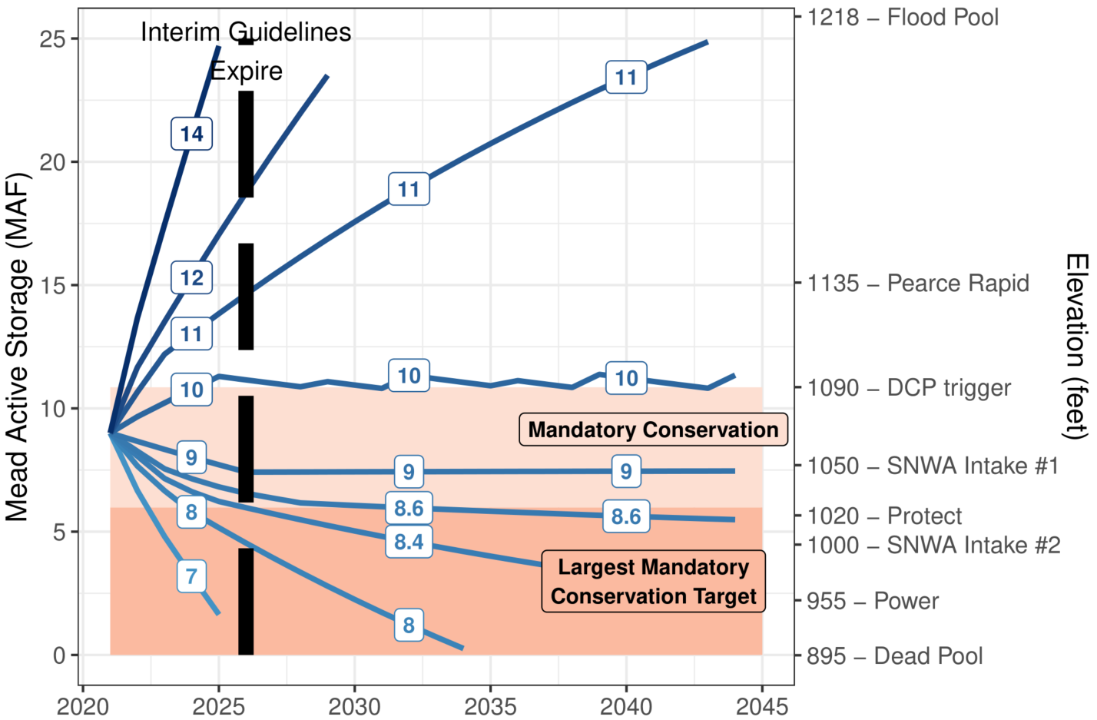

**Figure 1. Simulation of Lake Mead draw down over time with mandatory conservation and different scenarios of steady reservoir inflow (blue contours and white boxes, million acre-feet per year).**

With Lake Mead inflows of 8.6, 9, or 10 maf each year, the current mandatory conservation targets will draw down and stabilize Lake Mead between 1,025 and 1,090 feet in 4 to 7 years (Figure 1). These inflow scenarios represent historical Lake Powell releases of 7.6 to 9 maf each year. In the above analysis, Lake Mead evaporation rates of 5.7 to 6.8 feet per year (Moreo, 2015) change final storage volumes by at most 0.25 maf (results not shown).

# Stabilize Lake Mead

In Eq. 1, set current year storage equal to prior year storage to find the annual release that will adapt and stabilize reservoir level for specific inflow values (Figure 2, long-dashed blue line labeled “Release to stabilize reservoir level”). As reservoir inflow declines, the release volume must decline to stabilize the reservoir. Releases above the long-dashed blue line draw down Lake Mead whereas releases below the line raise lake level. For example, the current mandatory conservation targets will only stabilize Lake Mead at elevation 1,025 feet for inflows above 8.6 maf a year. (Figure 2, dashed blue line intersects red area). To stabilize Lake Mead at 1,025 feet with 8 maf of annual inflow, the Lower Basin states and contractors must conserve the mandatory target of 1.35 maf (Figure 2, red area) *plus* 0.7 maf (pink area) or 2.0 maf in total. More generally, the pink area shows the additional conservation above current mandatory targets to stabilize Lake Mead’s level for a specified inflow.

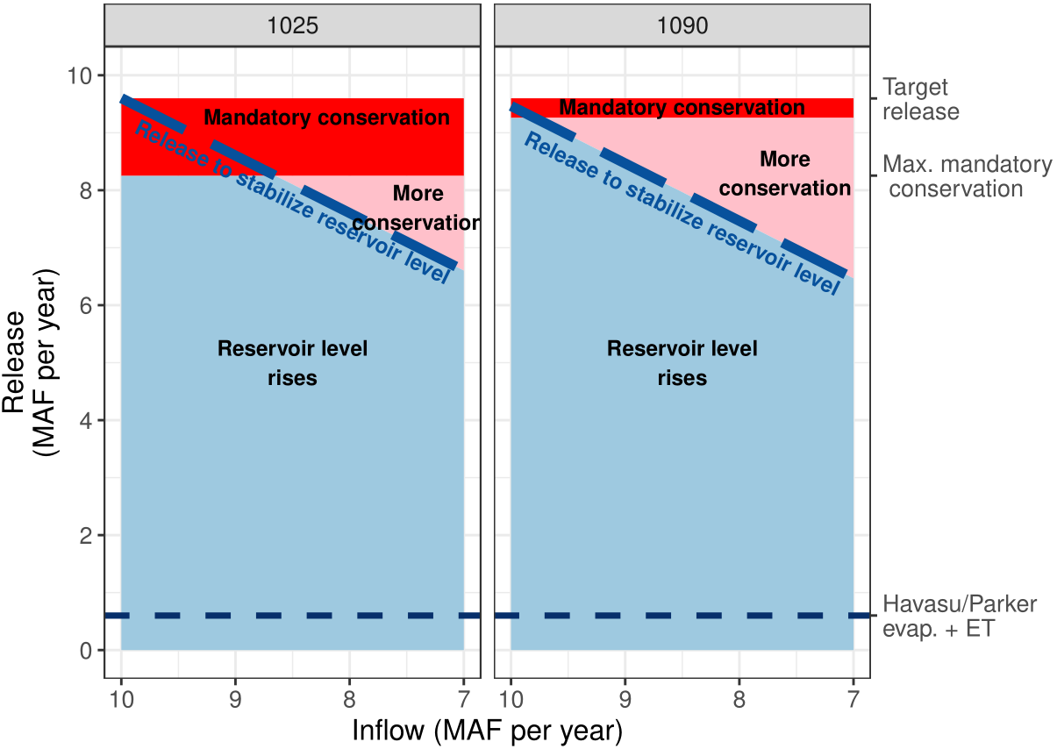

**Figure 2. Lake Mead releases to stabilize reservoir level for different inflows.**

# Recover Lake Mead

Lake Mead recovers when releases plus evaporation are less than inflows (releases below the long-dashed blue line in Figure 2). With continuing mandatory conservation targets and inflows greater than 10 maf each year, Lake Mead will recover from 1,050 to 1,090 feet in 5 years (Figure 3). The same recovery can also occur with 9 maf inflow each year plus 1 maf of additional water conservation beyond the mandatory targets, or other combinations that sum to 10 maf each year (Figure 3, dark blue long-dashed line labeled 10). When starting at 1,025 feet, 6 years of inflows of 10 maf each year and continued mandatory conservation targets can recover Lake Mead to 1,090 feet while 10 years of 9 maf inflow each year can recover the lake level to 1,050 feet. Other combinations of inflow and additional conservation beyond the mandatory targets also recover Lake Mead to 1,090 feet in six years (Figure 2, light dashed line labeled 10).

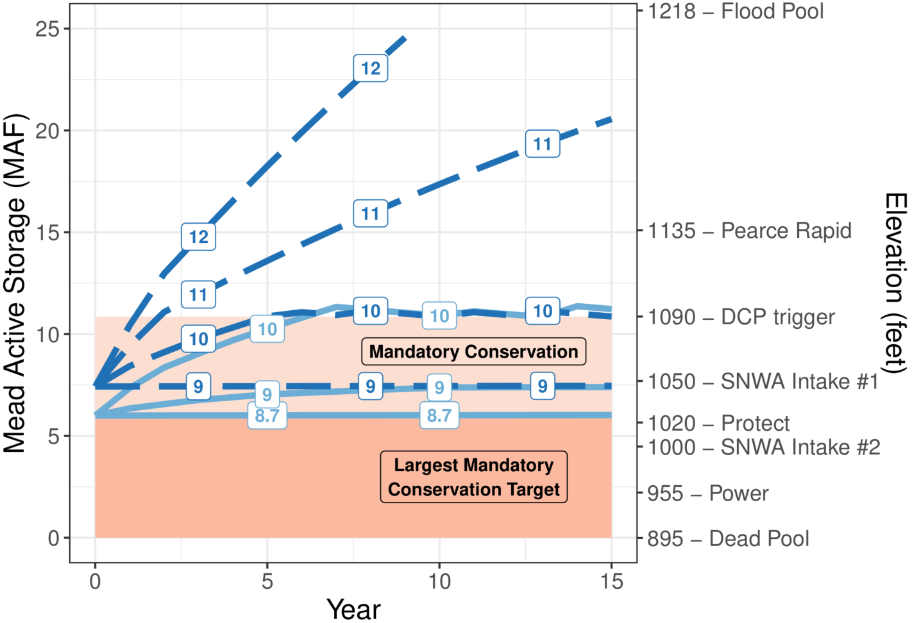

**Figure 3. Lake Mead recovery from 1,025 (light blue) and 1,050 feet (dark blue)**. Numeric line labels indicate the sum of reservoir inflow and additional conservation beyond mandatory targets (maf per year) needed to achieve the storage volume.

The draw down, stabilize, and recovery analyses have a caveat. The times for Lake Mead to draw down will speed when parties withdraw their conservation credits or convert credits to meet mandatory targets. Similarly, recovery times will lengthen. Every acre-feet of withdraw from a conservation account or conversion increases reservoir release by an acre-foot and speeds draw-down. Party’s withdraws from conservation accounts and conversions are difficult to predict.

# Adapt Reservoir Releases to Inflow

Reservoir inflows affect Lake Mead’s drawdown, stabilization, and recovery. By adapting reservoir releases, conservation, draw down, stabilization, and recovery operations to inflows, parties can:

1. Slow draw down to elevation 1,020 feet.
2. Reduce sudden or large reservoir draw down.
3. Identify periods when water is more available and increase releases.
4. Frame reservoir release and conservation decisions by intent to draw down, stabilize, or recover reservoir storage.

Parties may not adapt reservoir operations to inflow when they:

1. Want to stick with existing operations.
2. Are unclear how to split additional conservation.
3. Prefer to draw down Lake Mead below 1,020 feet rather than increase conservation efforts and protect elevation 1,020 feet.

**The three reasons illustrate a shrinking pie (lose-lose) conflict – less reservoir inflow – that I believe the parties can convert into a more positive process.** First, adapt reservoir releases to inflow – the available resource. Second, split each year’s inflow among the parties. Parties can negotiate shares or they can calculate shares at each Lake Mead elevation tier from their customary delivery targets and mandatory conservation volumes (Appendix A). Third, compute each party’s available water as their share of reservoir inflow, plus share of reservoir storage, minus share of reservoir evaporation. In the first year managers adapt releases to inflow, a party’s reservoir storage will be their conservation account balance plus share of the remaining active storage that is not the protection volume nor a conservation account balance. Steps 2 and 3 give parties more water to manage than was in their conservation account. The third step also gives each party more flexibility to conserve, release, and consume water within their available water independent of other parties. **Adapting reservoir operations to inflow offers parties a more flexible, independent, and positive process to manage Lake Mead**.

The positive process is built into a new cloud-based, interactive model for a combined Lake Powell-Lake Mead system (Rosenberg, 2021d). Multiple participants can synchronously connect, assign roles, track and split inflow, and conserve and consume within their available water independent of other parties. As participants track year-to-year storage and adapt their conservation choices to other participant’s moves, parties can discuss the positive features to include in renegotiations of Lake Mead and Lake Powell operations. Download the tool, move into Google Sheets, and invite colleagues. Adaptively manage Colorado River water!

# Data, Model, and Code Availability

The data, models, code, and directions to generate the figures and Table A1 in this piece are available at Rosenberg (2021a) and Rosenberg (2021c).

# Acknowledgements

16 Colorado River managers and experts gave feedback that improved the manuscript and/or the cloud-based interactive model of the Colorado River basin.

# Requested Citation

David E. Rosenberg (2021). "Adapt Lake Mead releases to inflow to slow reservoir draw down." Utah State University. Logan, Utah. <https://github.com/dzeke/ColoradoRiverCoding/raw/main/BlogDrafts/2-AdaptLakeMeadOperationsToInflowsToSlowReservoirDrawDown.docx>.

# Appendix A. Estimate Share of Reservoir Inflow from Customary Delivery Targets and Mandatory Conservation Volumes.

This appendix estimates Mexico’s and each Lower Basin party’s share of reservoir inflow from their customary delivery target and mandatory conservation volume listed in Minute 323 and the Lower Basin drought contingency plan (IBWC, 2021; USBR, 2019). Converting into a share is desirable and gives Lower Basin parties more flexibility to adapt to changing inflows (Kuhn and Fleck, 2019). Converting into a share also allows the parties to build on their existing agreements (IBWC, 2021; USBR, 2019) rather than negotiate a new agreement. The Upper Basin states split inflow by share in their 1948 Compact (Carson et al., 1948).

Each Lower Basin and Mexico party share of inflow depends on Lake Mead elevation because the mandatory conservation volumes vary by reservoir elevation. Each party *p*’s share of inflow at reservoir elevation *e* is the ratio of (a) the party’s individual delivery after mandatory conservation to (b) the total delivery to all parties after all mandatory conservation (Eq. 1). Delivery to each party *p* is their Customary Deliveryp [maf per year] minus the Mandatory Conservationp [maf per year]. The Customary Deliveries are 2.8, 0.3, 4.4, and 1.5 maf per year for Arizona, Nevada, California, and Mexico. The calculated shares of inflow are near identical for the 8 reservoir elevation tiers (Table A1).

|  |  |
| --- | --- |
|  | (Eq. 1) |

**Table A1. Share of reservoir inflow calculated from customary deliveries and mandatory conservation volumes.**



# References

Carson, C. A., Stone, C. H., Wilson, F. E., Watson, E. H., and Bishop, L. C. (1948). "Upper Colorado River Basin Compact." U.S. Bureau of Reclamation. <https://www.usbr.gov/lc/region/g1000/pdfiles/ucbsnact.pdf>. [Accessed on: September 7, 2021].

IBWC. (2021). "Minutes between the United States and Mexican Sections of the IBWC." United States Section. <https://www.ibwc.gov/Treaties_Minutes/Minutes.html>. [Accessed on: July 22, 2021].

Kuhn, E., and Fleck, J. (2019). *Science Be Dammed: How Ignoring Inconvenient Science Drained the Colorado River*, University of Arizona Press.

Moreo, M. T. (2015). "Evaporation data from Lake Mead and Lake Mohave, Nevada and Arizona, March 2010 through April 2015." U.S. Geological Survey Data Release. <http://dx.doi.org/10.5066/F79C6VG3>.

Rosenberg, D. E. (2021a). "Grand Canyon Intervening Flow." <https://github.com/dzeke/ColoradoRiverCoding/tree/master/GrandCanyonInterveningFlow>.

Rosenberg, D. E. (2021b). "Intentionally Created Surplus for Lake Mead: Current Accounts and Next Steps." <https://github.com/dzeke/ColoradoRiverCoding/tree/master/ICS>.

Rosenberg, D. E. (2021c). "Meady Steady Inflow Simulations." <https://github.com/dzeke/ColoradoRiverCoding/tree/main/MeadInflowSimulations>.

Rosenberg, D. E. (2021d). "Pilot flex accounting to encourage more water conservation in a combined Lake Powell-Lake Mead system." <https://github.com/dzeke/ColoradoRiverCoding/tree/main/ModelMusings>.

Salehabadi, H., and Tarboton, D. (2020). "Sequence-Average and Cumulative Flow Loss Analyses for Colorado River Streamflow at Lees Ferry." Hydroshare. <http://www.hydroshare.org/resource/bbe8dffacb07458783b2e6924aa615bb>. [Accessed on: May 11, 2021].

Salehabadi, H., Tarboton, D., Kuhn, E., Udall, B., Wheeler, K., E.Rosenberg, D., Goeking, S., and Schmidt, J. C. (2020). "Stream flow and Losses of the Colorado River in the Southern Colorado Plateau." Center for Colorado River Studies, Utah State University, Logan, Utah. <https://qcnr.usu.edu/coloradoriver/files/WhitePaper4.pdf>.

USBR. (2019). "Agreement Concerning Colorado River Drought Contingency Management and Operations." U.S. Bureau of Reclamation, Washington, DC. <https://www.usbr.gov/dcp/finaldocs.html>.

Wang, J., Rosenberg, D. E., Schmidt, J. C., and Wheeler, K. G. (2020). "Managing the Colorado River for an Uncertain Future." Center for Colorado River Studies, Utah State University, Logan, Utah. <http://qcnr.usu.edu/coloradoriver/files/CCRS_White_Paper_3.pdf>.

Wang, J., and Schmidt, J. C. (2020). "Stream flow and Losses of the Colorado River in the Southern Colorado Plateau." Center for Colorado River Studies, Utah State University, Logan, Utah. <https://qcnr.usu.edu/coloradoriver/files/WhitePaper5.pdf>.

Wheeler, K. G., Schmidt, J. C., and Rosenberg, D. E. (2019). "Water Resource Modelling of the Colorado River – Present and Future Strategies." Center for Colorado River Studies, Utah State University, Logan, Utah. <https://qcnr.usu.edu/coloradoriver/files/WhitePaper2.pdf>.