**Add reservoir inflow as new criteria to give Lake Mead managers more flexibility and independence to conserve water**

David E. Rosenberg | Utah State University | [david.rosenberg@usu.edu](mailto:david.rosenberg@usu.edu) | @WaterModeler

September 4, 2021

|  |
| --- |
| **The Pierce Rapid is a major reservoir inflow point to Lake Mead (**Photo by American Whitewater) |
| **Key Points**   1. Current Lake Mead releases key to reservoir level. 2. When reservoir inflows are below 8.6 maf per year, Lake Mead will draw down to 1,020 feet in less than 5 years. 3. Draw down will be faster when parties withdraw from their conservation accounts or use conservation credits to meet mandatory conservation targets. 4. Include reservoir inflow as a new release criteria to:    1. Avoid sudden large draw down.    2. Keep Lake Mead’s level at or above 1,020 feet.    3. Give managers more flexibility to conserve and consume water independent of other parties.    4. Let parties manage their water without negotiating larger, more painful, and joint mandatory conservation agreements. |

# Introduction

As a 20-year drought continues and Lake Mead draws down, the Lower Colorado River Basin states of Arizona, Nevada, and California plus Mexico must meet mandatory water conservation targets that grow to 1.375 million acre-feet (maf) per year as Lake Mead’s level falls (USBR, 2019). How will different reservoir inflows, releases, and additional water conservation efforts affect Lake Mead’s draw down, stabilization, and recovery?

This piece describes scenarios of possible Lake Mead inflow and scenarios of additional water conservation beyond current mandatory targets. Numerical simulations of reservoir storage show a need to adapt releases and conservation efforts to inflow to stabilize and recover Lake Mead. This piece recommends to add Lake Mead inflow as a new release criteria. Adding inflow as a new criteria will avoid sudden large draw down and keep Lake Mead’s level at or above the protection elevation of 1,020 feet (5.7 maf). Adding inflow as a new criteria will also give managers more flexibility to conserve and consume water independent of other parties. Parties choose their own management and risk strategies without negotiating larger, more painful, and collective mandatory conservation agreements.

# Uncertain Future Inflows

Lake Mead inflows are the water available to the Lower Basin states and contractors to use or conserve. Future inflow values depend on Lake Powell releases and intervening Grand Canyon tributary flows between Glen Canyon Dam and Lake Mead. The gaged data span multiple decades to almost a century (Wang and Schmidt, 2020) and have year-to-year variations and sequential correlations (Rosenberg, 2021a; Salehabadi et al., 2020). Lake Powell releases are effected by Lake Powell storage, upstream inflows, upstream consumptive use, and Lake Mead levels. Lake Powell releases become difficult to forecast as Lake Powell draws down to historic low levels. Uncertain Lake Mead inflows require a quantitative description as plausible or possible inflow scenarios (Wang et al., 2020). Here, I formulate six Lake Mead inflow scenarios and use historical data to interpret the scenarios (Table 1).

For example, a Lake Mead inflow of 14 maf repeated each year represents a large inflow value observed during wet periods. This inflow could come from a Lake Powell release each year of 13 maf coupled with a Grand Canyon tributary flow of 1 maf every year.

**Table 1. Lake Mead inflow scenarios**

|  |  |  |  |  |
| --- | --- | --- | --- | --- |
| **Scenario**  **(maf each year)** | **Powell Release**  **(maf each year)** | **Grand Canyon Tributary Flow (maf each year)** | **Years of Powell Release** | **Notes on Grand Canyon Tributary Flows** |
| 14 | 13 | 1 | 2011, 1996–1999, 1983–1986 | Average reported by Wang and Schmidt (2020) |
| 10 | 9 | 1 | 2012, 2015–2019 | Average reported by Wang and Schmidt (2020) |
| 9 | 8.23 | 0.8 | 2007, 2013 | Within interquartile range (Rosenberg, 2021a) |
| 9 | 8.1 | 0.9 | 2002, 2009–2010 | Within interquartile range (Rosenberg, 2021a) |
| 8 | 7.3 | 0.7 | 2017 | Sequences of up to 5 years (Rosenberg, 2021a) |
| 7 | 6.4 | 0.6 | Not observed; not in guidelines | 3 year sequences (Rosenberg, 2021a) |

A Lake Mead inflow of 9 maf each year can mean a Lake Powell release of 8.23 maf and 0.8 maf of tributary flow, a Powell release of 8.1 maf and 0.9 maf tributary flow, or other combinations.

A Lake Mead inflow of 8 maf each year represents a situation where Lake Mead storage exceeds Lake Powell storage and managers release 7.3 maf from Powell to balance the two reservoirs. In this scenario, Grand Canyon tributary flow falls to 0.7 maf each year, the average flow of 5-year sequences in the gaged record (Rosenberg, 2021a). Lake Powell releases may also vary from 7 to 7.48 maf each year.

A Lake Mead inflow of 7 maf represents a value below all historical observations and is not defined in the current reservoir operations. A Grand Canyon tributary flow of 0.6 maf and a Lake Powell release of 6.4 maf each year can occur if Lake Powell had insufficient storage to make the lowest balancing release of 7 maf per year.

Other intermediary inflow scenarios are possible and simulated but not shown in Table 1.

# Uncertain Conservation and Reservoir Releases

Managers have options to conserve and release water from Lake Mead. One operations scenario is stick with current mandatory conservation targets that escalate as Lake Mead draws down to 1,025 feet. As a second scenario, the Lower Basin states and Mexico may increase their conservation efforts *beyond* their current mandatory targets. This increase could occur through a new agreement for larger mandatory conservation targets or by allowing more voluntary conservation that parties credit and can recover at a later date. Alternatively, cap credits for voluntary conservation and make all additional conservation non-recoverable. Parties can recover their conservation credits so long as the Lake Mead active storage minus the 5.7 maf protection volume (1,020 feet; USBR, 2019) exceeds the conservation account balances. Presently, the 9.0 maf of Lake Mead active storage (1,068 feet) minus the 5.7 maf protection volume exceeds the 2.8 maf conservation account balances (Rosenberg, 2021b) by 0.5 maf. Uncertain conservation efforts propagate as uncertain reservoir releases.

# Uncertain Future Lake Levels

The August 2021 lake level of 1,068 feet and storage volume (9.0 maf) will change over time. Lake Mead drought operations consider these changes by specifying seven elevation ranges between 1,025 and 1,090 feet (tiers or elevation scenarios) and mandatory conservation targets for each elevation range.

# Numerical Simulations

**Table 2. Lake Mead simulation assumptions**

|  |  |  |
| --- | --- | --- |
| **Component** | **Value** | **Comment / Source** |
| Initial storage (maf) | 9.0 | August 2021 value |
| Inflow (maf each year) | 7 – 14 | Scenarios of steady inflow |
| Evaporate rate (feet/year) | 6.2 | 5.7 – 6.8 by Moreo (2015) |
| Precipitation (feet/year) | Ignore | Wang and Schmidt (2020) |
| Area-Storage relationship | Varies | CRSS (Wheeler et al., 2019) |
| Non-drought release target (maf/year) | 9.6 | Lower Basin + Mexico + Parker/Havasu evaporation and evapotranspiration |
| Release operations | Varies | Non-drought release target minus mandatory conservation target minus additional conservation. |

The purpose of the numerical simulations is to show Lake Mead’s drawdown, stabilization, and recovery to different elevations under different reservoir inflow and conservation scenarios. The simulations use an annual reservoir mass balance (Eq. 1, all units of maf per year) with seven assumptions (Table 2), and are programmed as open-source software in the R language (Rosenberg, 2021d).

storage(*t*) = storage(*t–1*) + inflow – evaporation(*t*) – release(*t*) (Eq. 1)

Here, storage(*t*) and storage(*t–1*) are reservoir storage volumes in the current and prior year, inflow is the same value each year (steady), and evaporation volume is the evaporation rate multiplied by the lake area. Lake area is interpolated from the volume-elevation-area curve for the reservoir using Colorado River Simulation System (CRSS) model data (Wheeler et al., 2019). Release in year *t* is the non-drought release target minus the mandatory water conservation target for the current reservoir storage value minus any additional conservation above the mandatory target. This draw down analysis does not include an adaptive feature of the current operations to protect elevation 1,020 feet when Lake Mead is forecast to fall below 1,030 feet (6.3 maf).

# Lake Mead Draw Down

When Lake Mead inflows are below 8.4 maf each year, the existing operations draw Mead’s level down to 1,025 feet before 2026 (Figure 1). This draw down occurs in 3 to 5 years with Lake Powell balancing releases below 7.5 maf.

With Lake Mead inflows of 8.6, 9, or 10 maf each year, the reservoir draws down and then stabilizes between 1,025 and 1,090 feet in 4 to 7 years (Figure 1). These inflow scenarios represent historical Lake Powell releases of 7.6 to 9 maf each year. In the above analysis, Lake Mead evaporation rates of 5.7 to 6.8 feet per year (Moreo, 2015) change final storage volumes by at most 0.25 maf (results not shown).

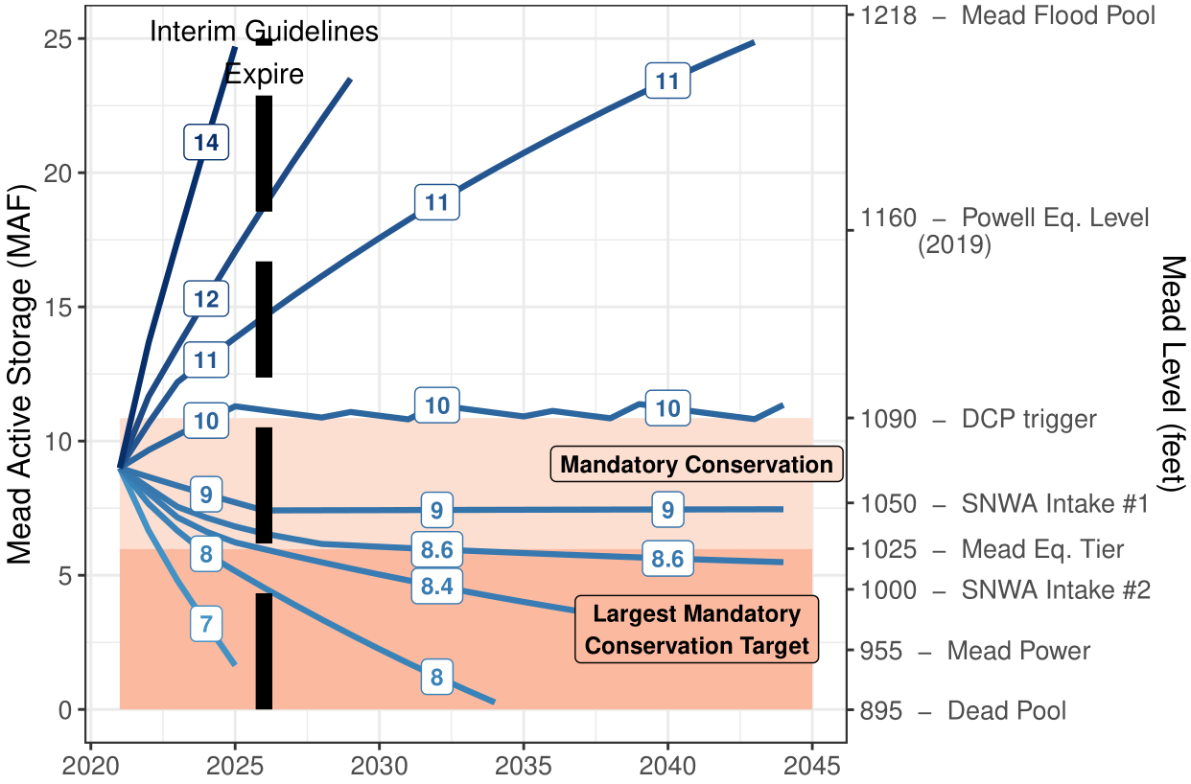

**Figure 1. Simulation of Lake Mead draw down over time with mandatory conservation and different scenarios of steady reservoir inflow (blue contours and white boxes, million acre-feet per year).**

# Stabilize Lake Mead

In Eq. 1, setting current year storage equal to prior year storage allows to find the annual release that stabilizes reservoir level for specific inflow values (Figure 2, long-dashed blue line labeled “Release to stabilize reservoir level”). As reservoir inflow declines, the release volume to stabilize declines. Releases above the long-dashed blue line draw down Lake Mead whereas releases below the line raise lake level. For example, to stabilize Lake Mead at 1,025 feet with 8 maf of annual inflow, the Lower Basin states and contractors must conserve the mandatory target of 1.35 maf (Figure 2, red area) *plus* 0.7 maf (pink area) or 2.0 maf in total. To stabilize Lake Mead at 1,090 feet with 8 maf of annual inflow, the parties must conserve 1.7 maf *more than* their mandatory conservation target.

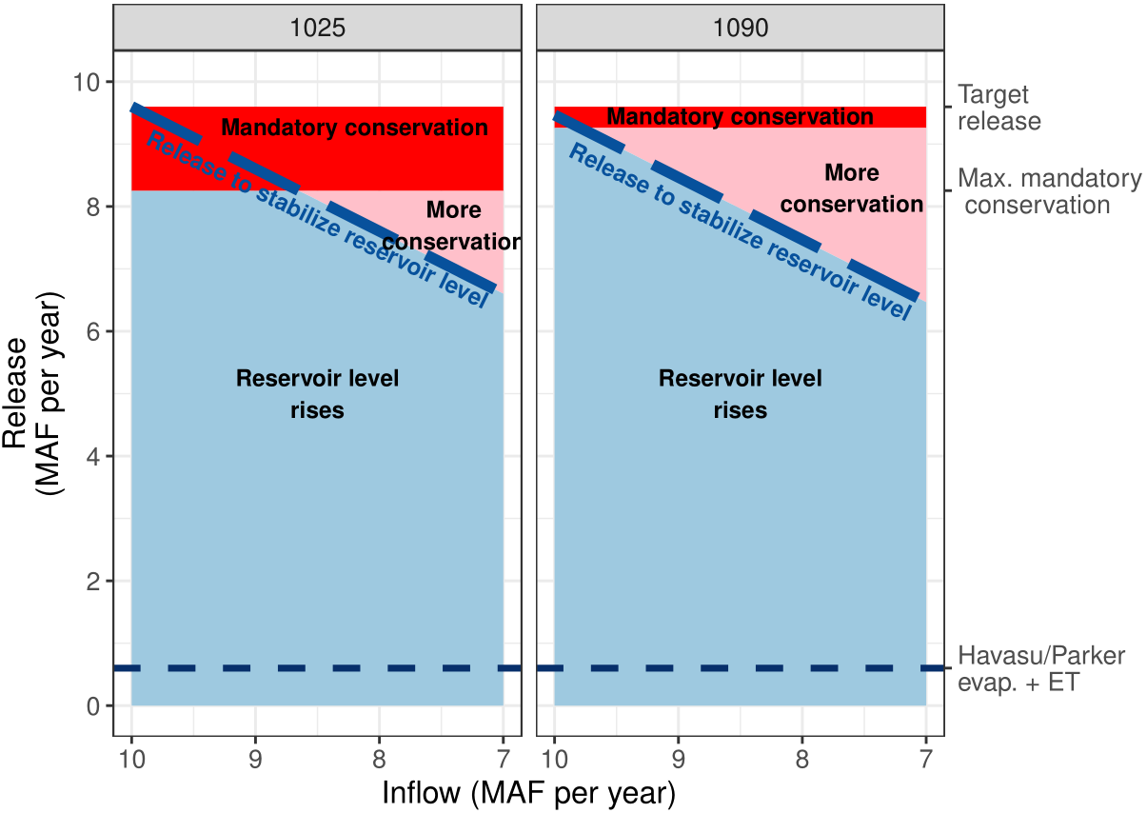

**Figure 2. Lake Mead releases to stabilize reservoir level for different inflows.**

# Recover Lake Mead

Lake Mead recovers when releases plus evaporation are less than inflows (releases below the long-dashed blue line in Figure 2). With continuing mandatory conservation targets and inflows greater than 10 maf each year, Lake Mead will recover from 1,050 to 1,090 feet in 5 years (Figure 3). The same recovery can also occur with 9 maf inflow each year plus 1 maf of additional water conservation beyond the mandatory targets, or other combinations that sum to 10 maf each year (Figure 3, dark blue long-dashed line labeled 10). When starting at 1,025 feet, 6 years of inflows of 10 maf each year and continued mandatory conservation targets can recover Lake Mead to 1,090 feet while 10 years of 9 maf inflow each year can recover the lake level to 1,050 feet. Other combinations of inflow and additional conservation beyond the mandatory targets also recover Lake Mead to 1,090 feet in six years (Figure 2, light dashed line labeled 10).

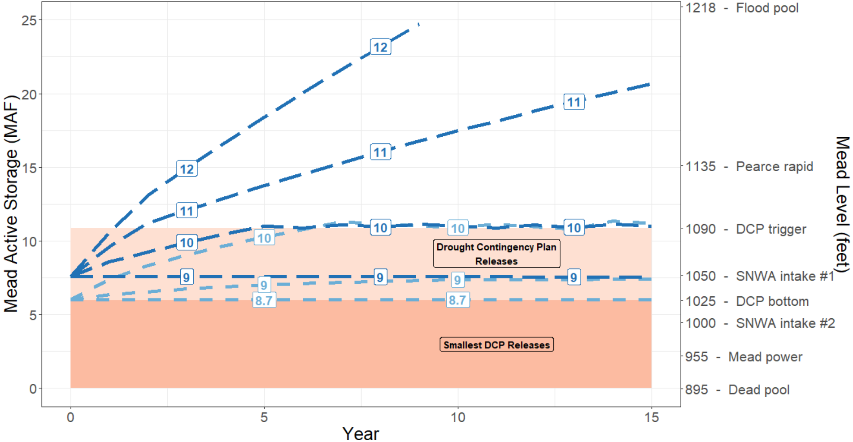

**Figure 3. Lake Mead recovery from draw down.** Dark and light blue lines show two reservoir start volumes. Blue line labels indicate the sum of reservoir inflow and additional conservation beyond mandatory targets (maf per year) needed to achieve the storage volume.

The analyses have a caveat. The times for Lake Mead to draw down will speed and slow to stabilize or recover when parties withdraw their conservation credits or convert conservation credits to meet mandatory targets. These manager actions increase reservoir releases and are difficult to predict.

# Include Reservoir Inflow as new Release Criteria

Reservoir inflows affect Lake Mead’s drawdown, stabilization, and recovery. Including reservoir inflow as a new release criteria will allow managers to:

1. More quickly adapt releases, conservation, stabilization, and recovery efforts to different reservoir inflows.
2. Avoid sudden or large reservoir draw down.
3. Identify periods when water is more available and it is ok to increase releases.
4. Frame reservoir release and conservation decisions by intent to draw down, stabilize, or recover reservoir storage.

Reasons to exclude reservoir inflow as a new operations criteria:

1. Parties may be unwilling to renegotiate operations that deliver less water.
2. Parties are unclear how to split additional conservation.
3. Parties may prefer to draw down Lake Mead below 1,020 feet rather than increase conservation efforts and protect elevation 1,020 feet.

The three reasons illustrate a shrinking pie (lose-lose) conflict that I believe the parties can convert into a more positive process. First, include reservoir inflow – the available resource – as a criteria and share the inflow among the parties. The parties can negotiate shares or they can calculate shares at each Lake Mead elevation tier from their customary delivery targets and mandatory conservation volumes (Appendix A). Next, add each party’s share of the reservoir inflow to their share of reservoir storage. Each party’s reservoir storage is their conservation account balance plus share of the remaining active storage that is not the protection volume nor a conservation account balance. This step gives parties more water to manage than presently in their conservation accounts. Last, give each party more flexibility to release, consume, and conserve water within their account balance independent of other parties and independent of the mandatory conservation targets. More flexibility and more independence to manage Colorado River water are positive. This process lets parties manage their water without negotiating larger, more painful, and joint mandatory conservation agreements.

The new reservoir inflow criteria and more flexible and independent process are illustrated in a new online, interactive model for a combined Lake Powell-Lake Mead system (Rosenberg, 2021c). Multiple participants can synchronously connect, manage, and discuss their conservation and consumption decisions while they track inflow, storage, and other participant’s moves. Download, move into Google Sheets, and try it!

**Data, Model, and Code Availability**

The data, models, code, and directions to generate the figures in this post are available on Github.com at Rosenberg (2021a) and Rosenberg (2021d).

**Acknowledgements**

16 Colorado River managers and experts gave feedback that improved the manuscript and/or interactive model that includes reservoir inflow as a release criteria.

**Requested Citation**

David E. Rosenberg (2021). "Add reservoir inflow as new criteria to give Lake Mead managers more independence and flexibility to conserve water." Utah State University. Logan, Utah. <https://github.com/dzeke/ColoradoRiverCoding/blob/master/BlogDrafts/2-AddReservoirInflowAsNewCriteriaToRecoverLakeMead.docx>.

**Appendix A. Estimate Share of Reservoir Inflow from Customary Delivery Targets and Mandatory Conservation Volumes.**

This appendix estimates each Lower Basin party’s share of reservoir inflow from their customary delivery target and mandatory conservation volume listed in their drought contingency plan (USBR, 2019). Converting into a share is desirable to give parties more flexibility to adapt to changing inflows (Kuhn and Fleck, 2019). Converting into a share also allows the parties to build on their existing drought contingency plan rather than negotiate a new agreement.

Each party’s share of inflow depends on reservoir elevation because the mandatory conservation volumes vary by reservoir elevation. Each party *p*’s share of inflow at reservoir elevation *e* is the ratio of (a) the party’s individual delivery after mandatory conservation to (b) the total delivery to all parties after all mandatory conservation (Eq. 1). Delivery to each party is their Customary Deliveryp [maf per year] minus the mandatory conservation [maf per year]. The Customary Deliveries are 2.8, 0.3, 4.4, and 1.5 maf per year for Arizona, Nevada, California, and Mexico. Table A1 shows the calculated shares of inflows at each reservoir elevation.

|  |  |
| --- | --- |
|  | (Eq. 1) |

**Table A1. Share of reservoir inflow calculated from customary deliveries and mandatory conservation volumes.**



**References**

Kuhn, E., and Fleck, J. (2019). *Science Be Dammed: How Ignoring Inconvenient Science Drained the Colorado River*, University of Arizona Press.

Moreo, M. T. (2015). "Evaporation data from Lake Mead and Lake Mohave, Nevada and Arizona, March 2010 through April 2015." U.S. Geological Survey Data Release. <http://dx.doi.org/10.5066/F79C6VG3>.

Rosenberg, D. E. (2021a). "Grand Canyon Intervening Flow." <https://github.com/dzeke/ColoradoRiverCoding/tree/master/GrandCanyonInterveningFlow>.

Rosenberg, D. E. (2021b). "Intentionally Created Surplus for Lake Mead: Current Accounts and Next Steps." <https://github.com/dzeke/ColoradoRiverCoding/tree/master/ICS>.

Rosenberg, D. E. (2021c). "Pilot flex accounting to encourage more water conservation in a combined Lake Powell-Lake Mead system." <https://github.com/dzeke/ColoradoRiverCoding/tree/main/ModelMusings>.

Rosenberg, D. E. (2021d). "Time to Mead Dead Pool." <https://github.com/dzeke/ColoradoRiverCoding/tree/master/TimeToDeadPool>.

Salehabadi, H., Tarboton, D., Kuhn, E., Udall, B., Wheeler, K., E.Rosenberg, D., Goeking, S., and Schmidt, J. C. (2020). "Stream flow and Losses of the Colorado River in the Southern Colorado Plateau." Center for Colorado River Studies, Utah State University, Logan, Utah. <https://qcnr.usu.edu/coloradoriver/files/WhitePaper4.pdf>.

USBR. (2019). "Agreement Concerning Colorado River Drought Contingency Management and Operations." U.S. Bureau of Reclamation, Washington, DC. <https://www.usbr.gov/dcp/finaldocs.html>.

Wang, J., Rosenberg, D. E., Schmidt, J. C., and Wheeler, K. G. (2020). "Managing the Colorado River for an Uncertain Future." Center for Colorado River Studies, Utah State University, Logan, Utah. <http://qcnr.usu.edu/coloradoriver/files/CCRS_White_Paper_3.pdf>.

Wang, J., and Schmidt, J. C. (2020). "Stream flow and Losses of the Colorado River in the Southern Colorado Plateau." Center for Colorado River Studies, Utah State University, Logan, Utah. <https://qcnr.usu.edu/coloradoriver/files/WhitePaper5.pdf>.

Wheeler, K. G., Schmidt, J. C., and Rosenberg, D. E. (2019). "Water Resource Modelling of the Colorado River – Present and Future Strategies." Center for Colorado River Studies, Utah State University, Logan, Utah. <https://qcnr.usu.edu/coloradoriver/files/WhitePaper2.pdf>.