**Add reservoir inflow as new criteria to recover Lake Mead from shortage**

David E. Rosenberg | Utah State University | [david.rosenberg@usu.edu](mailto:david.rosenberg@usu.edu) | @WaterModeler

June 20, 2021

This post is the second in a series titled **Encouraging more Water Conservation in the Colorado River Basin**.

* Part I is “[**Invest in Farm Water Conservation to Curtail *Buy and Dry***](http://www.inkstain.net/fleck/2021/06/invest-in-farm-water-conservation-to-curtail-buy-and-dry/)*”* (on Inkstain).

# Introduction

As a 20-year drought continues and Lake Mead draws down, the Lower Colorado River Basin states of Arizona, Nevada, and California plus Mexico must meet mandatory water conservation targets that grow to 1.38 million acre-feet (maf) per year USBR (2019). How will different reservoir inflows, releases, and additional water conservation efforts affect Lake Mead’s draw down, stabilization, and recovery?

This post describes scenarios of possible Lake Mead inflow and scenarios of additional water conservation beyond the current mandatory targets. Numerical simulations of reservoir storage, inflows, releases, and additional conservation efforts show the need to adapt releases and conservation efforts to inflow to stabilize and recover Lake Mead to 1,090 feet. The post recommends to include Lake Mead inflow as a new operations criteria to encourage more water conservation.

# Uncertain Future Inflows

Lake Mead inflows are the water available to the Lower Basin states and contractors to use or conserve. Future inflow values depend on Lake Powell releases and intervening tributary flows along the Grand Canyon between Lake Powell and Lake Mead. The gaged data span multiple decades to almost a century (Wang and Schmidt, 2020) and have year-to-year variations and sequential correlations (Rosenberg, 2021a; Salehabadi et al., 2020). Lake Powell releases are effected by Lake Mead storage, Lake Powell storage, upstream inflows, and upstream consumptive use. Lake Powell releases become difficult to forecast as Lake Powell draws down to historic low levels. These uncertainties require a quantitative description as plausible or possible inflow scenarios (Wang et al., 2020). Here, I formulate several Lake Mead inflow scenarios and use historical data to interpret the scenarios (Table 1).

For example, a Lake Mead inflow of 14 maf each year represents a large inflow value observed during wet periods. This inflow could come from a Lake Powell release each year of 13 maf coupled with a Grand Canyon tributary flow of 1 maf every year.

**Table 1. Lake Mead inflow scenarios**

|  |  |  |  |  |
| --- | --- | --- | --- | --- |
| **Scenario**  **(maf each year)** | **Powell Release**  **(maf each year)** | **Grand Canyon Tributary Flow (maf each year)** | **Years of Powell Release** | **Notes on Grand Canyon Tributary Flows** |
| 14 | 13 | 1 | 2011, 1996–1999, 1983–1986 | Average reported by Wang and Schmidt (2020) |
| 10 | 9 | 1 | 2012, 2015–2019 | Average reported by Wang and Schmidt (2020) |
| 9 | 8.23 | 0.8 | 2007, 2013 | Within interquartile range (Rosenberg, 2021a) |
| 9 | 8.1 | 0.9 | 2002, 2009–2010 | Within interquartile range (Rosenberg, 2021a) |
| 8 | 7.3 | 0.7 | 2017 | Sequences of up to 5 years (Rosenberg, 2021a) |
| 7 | 6.4 | 0.6 | Not observed; not in guidelines | 3 year sequences (Rosenberg, 2021a) |

A Lake Mead inflow value such as 9 maf each year can have multiple interpretations. For example, 9 maf each year can result from a Lake Powell release of 8.23 maf and 0.8 maf of tributary flow, a Powell release of 8.1 maf and 0.9 maf tributary flow, or other combinations.

A Lake Mead inflow of 8 maf each year represents a situation where Lake Mead storage exceeds Lake Powell storage and managers release 7.3 maf from Powell to balance the two reservoirs. In this scenario, Grand Canyon tributary flow falls to 0.7 maf each year, the average flow of 5-year sequences in the gaged record (Rosenberg, 2021a). Lake Powell releases may also vary from 7 to 7.48 maf each year.

A Lake Mead inflow of 7 maf represents a value below all historical observations and is not defined in the current reservoir operations. A Grand Canyon tributary flow of 0.6 maf and a Lake Powell release of 6.4 maf each year would occur if Lake Powell had insufficient storage to make the lowest balancing release of 7 maf per year.

Other intermediary inflow scenarios are possible and simulated but not shown in Table 1.

# Uncertain Future Reservoir Releases and Conservation

Managers have many options for releasing water from Lake Mead in the future. One future scenario for Lake Mead operations is to stick with the current mandatory conservation targets that escalate as Lake Mead draws down to 1,025 feet. As a second operations scenario, the Lower Basin states may increase their conservation efforts *beyond* their current mandatory targets. This increase could occur through a new agreement for larger mandatory water conservation targets or by allowing more voluntary conservation that users credit and can recover at a later date. Alternatively, cap the credits for voluntary conservation and make all additional conservation non-recoverable. The conservation credits can be recovered so long as the volume of credits stays below the physical and active water storage in Lake Mead. Once the conservation credits exceed the physical active storage, the credits expire and are unredeemable.

# Uncertain Future Lake Levels

The current lake level of 1,079 feet and storage volume (9.9 maf) will change over time. Lake Mead drought operations consider these changes by specifying seven elevation ranges between 1,025 and 1,090 feet (tiers or elevation scenarios) and mandatory conservation targets for each elevation range.

# Numerical Simulations

**Table 2. Lake Mead simulation assumptions**

|  |  |  |
| --- | --- | --- |
| **Component** | **Value** | **Comment / Source** |
| Initial storage (maf) | 9.9 | April 2021 value |
| Inflow (maf each year) | 7 – 14 | Scenarios of steady inflow |
| Evaporate rate (feet/year) | 6.2 | 5.7 – 6.8 by Moreo (2015) |
| Precipitation (feet/year) | Ignore | Wang and Schmidt (2020) |
| Area-Storage relationship | Varies | CRSS (Wheeler et al., 2019) |
| Non-drought release target (maf/year) | 9.6 | Lower Basin + Mexico + Parker/Havasu evaporation and evapotranspiration |
| Release operations | Varies | Non-drought release target minus mandatory conservation target minus additional conservation. |

The purpose of the numerical simulations is to show Lake Mead’s drawdown, stabilization, and recovery to 1,090 feet under different reservoir inflow and conservation scenarios. The simulations use an annual reservoir mass balance with seven assumptions (Table 2; Eq. 1). The mass balance relates the storage volume in current year *t* [storage(*t*)] to storage in the prior year [storage(*t–1*)], inflow, release, and evaporation (all units of maf). Calculations repeat through years *t*, *t+1*, *t+2*, …, and are programmed as open-source software in the R language (Rosenberg, 2021b).

Storage(*t*) = Storage(*t–1*) + inflow – evaporation(*t*) – release(*t*) (Eq. 1)

Here, inflow is the same value each year (steady) and the evaporation volume is the evaporation rate multiplied by the lake area. Lake area is interpolated from the volume-elevation-area curve for the reservoir using the Colorado River Simulation System (CRSS) model data (Wheeler et al., 2019). Release in year *t* is the non-drought release target minus the mandatory water conservation target for the current reservoir storage value minus any additional conservation above the mandatory target. When Lake Mead is forecast to fall below 1,030 feet, the current operations switch to protect elevation 1,020 feet whereas the draw down analysis continues to use the largest mandatory conservation target. In this draw down analysis, states and contractors meet the mandatory target with new conservation efforts, do not withdraw conservation credits, nor convert nor use conservation credits to meet mandatory targets. The later withdraws and conversions will increase releases and speed Lake Mead draw down.

# Lake Mead Draw Down

When Lake Mead inflows are below 8.6 maf each year, the existing drought operations draw Mead’s level down to 1,025 feet before 2026 (Figure 1). This draw down occurs with 3 to 5 years of Lake Powell balancing releases of 7 – 7.5 maf. The draw down will require new operations to protect elevation 1,020 feet.

With Lake Mead inflows of 8.6, 9, or 10 maf each year, the reservoir draws down and then stabilizes between 1,025 and 1,090 feet in six or seven years (Figure 1). These inflow scenarios are plausible and represent historical Lake Powell releases of 7 to 9 maf each year. In the above analysis, Lake Mead evaporation rates of 5.7 to 6.8 feet per year (Moreo, 2015) change final storage volumes by at most 0.25 maf (results not shown).

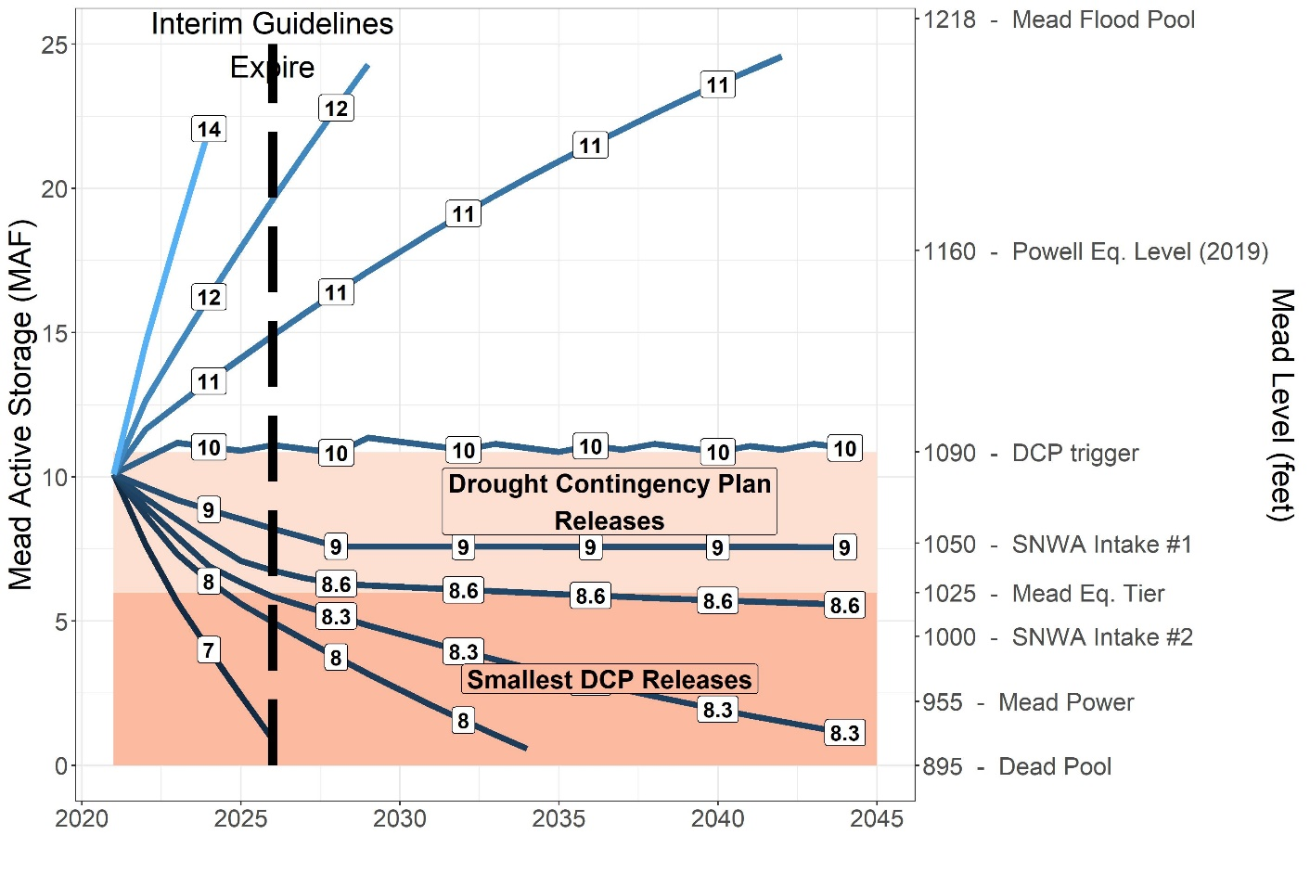

**Figure 1. Simulation of Lake Mead draw down over time with mandatory conservation and different scenarios of steady reservoir inflow (blue contours and white boxes, million acre-feet per year).**

# Stabilize Lake Mead

By setting current year storage equal to prior year storage, the reservoir mass balance can be solved to find the annual release that stabilizes the reservoir level for a specific inflow value. As reservoir inflow declines, the Lower Basin states and contractors must conserve more than their mandatory targets to stabilize Lake Mead’s level (Figure 2). To stabilize Lake Mead at 1,025 feet, each acre-foot drop in annual inflow below 8.7 maf requires the Lower Basin states and contractors to conserve one additional acre-foot beyond their mandatory conservation target. Thus, to stabilize Lake Mead at 1,025 feet with 8 maf of annual inflow, the Lower Basin states and contractors must conserve the mandatory target of 1.35 maf plus 0.7 maf or 2.0 maf in total. To stabilize Lake Mead at 1,090 feet where there is a smaller mandatory conservation target, the Lower Basin States and contractors must initiate additional water conservation when inflows

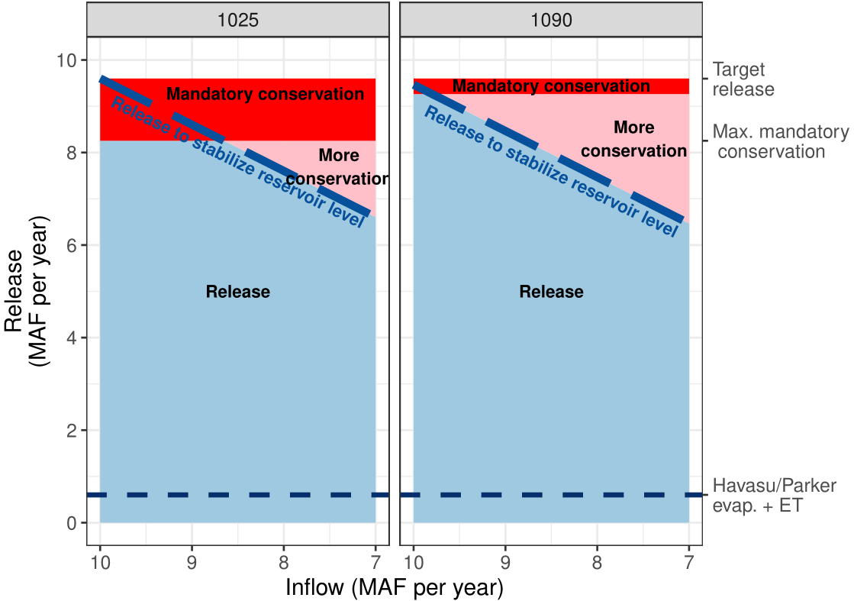

**Figure 2. Lake Mead releases to stabilize reservoir level for different inflows.**

drop below 9.7 maf per year. More generally, releases above the long dashed blue line labeled “Release to stabilize reservoir level” will draw down Lake Mead whereas releases below the line will raise the lake level.

# Recover Lake Mead

Lake Mead’s level recovers when releases plus evaporation are less than inflows (releases below the dashed blue line in Figure 2). By continuing the mandatory conservation targets, Lake Mead will recover from 1,050 to 1,090 feet in 5 years with sustained inflows greater than 10 maf each year (Figure 3). The same recovery can also occur with 9 maf inflow each year plus 1 maf of additional water conservation beyond the current drought operations, or other combinations that sum to 10 maf each year (Figure 3, dark blue long-dashed line labeled 10). When starting at 1,025 feet, 6 years of inflows of 10 maf each year and continued mandatory conservation targets will recover Lake Mead to 1,090 feet while 10 years of 9 maf inflow each year are needed to recover the lake level to 1,050. Other combinations of inflow and additional conservation beyond the mandatory targets will also recover Lake Mead to 1,090 feet in six years (Figure 2, light dashed line labeled 10).

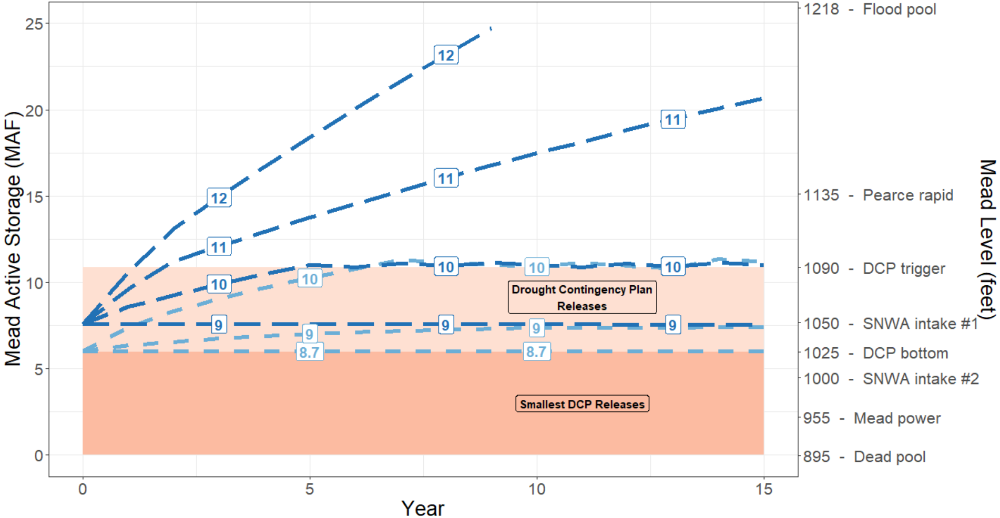

**Figure 3. Lake Mead recovery from two draw down levels.** Numeric line labels (maf per year) indicate the sum of reservoir inflow and additional conservation beyond mandatory targets.

# Include Reservoir Inflow as a new Operations Criteria

Reservoir inflows affect Lake Mead’s drawdown, stabilization, and recovery. When Lake Mead inflows are below 8.7 maf per year, the Lower Basin states and contractors must conserve more than their mandatory targets to stabilize or recover the reservoir. Including reservoir inflow as a new criteria for Lake Mead operations can encourage additional conservation beyond the mandatory targets. Other benefits to include reservoir inflow as a new operations criteria are:

1. More quickly adapt releases, conservation, stabilization, and recovery efforts to different reservoir inflows.
2. Avoid sudden or large reservoir draw down when reservoir inflow declines but releases stay steady.
3. Identify periods when water is more available and it is ok to increase releases.
4. Encourage managers to frame reservoir release and conservation decisions by whether they intend to draw down, stabilize, or recover reservoir storage.

One reason not to include reservoir inflow as a new operations criteria is the Lower Basin states and contractors spent much effort to negotiate the current Lake Mead operations. There may be insufficient political will to renegotiate the operations to include inflows, stabilization, and recovery.

Another reason is that the additional conservation needed to stabilize or recover the reservoir varies with inflow and must be split among the parties. The parties may prefer to delay renegotiations about how to conserve more water until the current situation further deteriorates.

As a third reason, the parties may prefer to draw down Lake Mead below 1,020 feet rather than conserve more than the mandatory targets, protect 1,020 feet, and begin reservoir stabilization efforts. Again, it may be easier to continue draw down than adopt additional conservation efforts.

The three reasons pose the difficult task to further reduce releases from the target release (red and pink in Figure 2). If the parties instead work from the bottom up and agree on how to split each year’s reservoir inflow, the parties can add the reservoir inflow to the existing storage and increase the water available to manage (blue in Figure 2). A share of the reservoir inflow and more available water gives each party more flexibility to decide how to independently release, consume, or conserve.

The next blog post proposes how to include reservoir inflow as a new operations criteria for Lake Mead. The post suggests how to prevent the parties from drawing down Lake Mead to zero storage (dead pool) and still give the parties more flexibility to make their release, conservation, and storage decisions independent of other parties.

**Data, Model, and Code Availability**

The data, models, code, and directions to generate the figures in this post are available on Github.com at Rosenberg (2021a) and Rosenberg (2021b).

**Acknowledgements**

This work is unfunded. Eric Kuhn, Jennifer Pitt, and David Tarboton made comments that improved an earlier version.

**Requested Citation**

David E. Rosenberg (2021). "Add reservoir inflow as new criteria to recover Lake Mead from shortage ". Utah State University. Logan, Utah. <https://github.com/dzeke/ColoradoRiverCoding/blob/master/BlogDrafts/2-AddReservoirInflowAsNewCriteriaToRecoverLakeMead.docx>

**References**

Moreo, M. T. (2015). "Evaporation data from Lake Mead and Lake Mohave, Nevada and Arizona, March 2010 through April 2015." U.S. Geological Survey Data Release. <http://dx.doi.org/10.5066/F79C6VG3>.

Rosenberg, D. E. (2021a). "Grand Canyon Intervening Flow." <https://github.com/dzeke/ColoradoRiverFutures/tree/master/GrandCanyonInterveningFlow>.

Rosenberg, D. E. (2021b). "Time to Mead Dead Pool." <https://github.com/dzeke/ColoradoRiverFutures/tree/master/TimeToDeadPool>.

Salehabadi, H., Tarboton, D., Kuhn, E., Udall, B., Wheeler, K., E.Rosenberg, D., Goeking, S., and Schmidt, J. C. (2020). "Stream flow and Losses of the Colorado River in the Southern Colorado Plateau." Center for Colorado River Studies, Utah State University, Logan, Utah. <https://qcnr.usu.edu/coloradoriver/files/WhitePaper4.pdf>.

USBR. (2019). "Agreement Concerning Colorado River Drought Contingency Management and Operations." U.S. Bureau of Reclamation, Washington, DC. <https://www.usbr.gov/dcp/finaldocs.html>.

Wang, J., Rosenberg, D. E., Schmidt, J. C., and Wheeler, K. G. (2020). "Managing the Colorado River for an Uncertain Future." Center for Colorado River Studies, Utah State University, Logan, Utah. <http://qcnr.usu.edu/coloradoriver/files/CCRS_White_Paper_3.pdf>.

Wang, J., and Schmidt, J. C. (2020). "Stream flow and Losses of the Colorado River in the Southern Colorado Plateau." Center for Colorado River Studies, Utah State University, Logan, Utah. <https://qcnr.usu.edu/coloradoriver/files/WhitePaper5.pdf>.

Wheeler, K. G., Schmidt, J. C., and Rosenberg, D. E. (2019). "Water Resource Modelling of the Colorado River – Present and Future Strategies." Center for Colorado River Studies, Utah State University, Logan, Utah. <https://qcnr.usu.edu/coloradoriver/files/WhitePaper2.pdf>.