**Give Colorado River managers more flexibility to conserve water in a combined Lake Powell-Lake Mead system**

David E. Rosenberg | Utah State University | [david.rosenberg@usu.edu](mailto:david.rosenberg@usu.edu) | @WaterModeler

June 20, 2021

**I**ntroduction

As the Colorado River basin becomes more arid, river flows and reservoir storage decline. Less water is available to parties. Current operations for Lake Mead define mandatory conservation schedules for the Lower Basin states and Mexico that increase as Lake Mead draws down (USBR, 2019). Additional operations define Lake Powell and Lake Mead volumes of 5.9 and 5.7 million-acre feet (3,525 and 1,020 feet) that parties will protect (USBR, 2019) by decreasing releases to match reservoir inflows and evaporation. How to convert these shrinking pie (lose-lose) tradeoffs into more positive arrangements?

This piece describes the existing voluntary and mandatory conservation programs for Lake Powell and Lake Mead and shows those programs will encourage reservoir draw down to protection levels. This piece also describes six changes to Colorado River operations to encourage more win-win outcomes for parties:

1. Manage combined system storage rather than separate reservoirs in separate basins.
2. Give parties flex accounts to manage all available water in the combined system not just prior conserved water.
3. Let parties conserve and consume within their available water independent of other parties.
4. Define available water as a party’s flex account balance, plus share of basin natural flow, minus share of reservoir evaporation, plus water purchases from other parties, minus sales.
5. Include reservoir storage and inflow as operations criteria not just reservoir elevations/tiers (Rosenberg, 2021a).
6. Show impacts of Lake Powell water elevation on release temperature and Grand Canyon fish.

These features can be tested in a new interactive, cloud-based model for the Colorado River basin. Multiple participants synchronously connect and role play Upper Basin, Lower Basin, Mexico, and other parties and their year-to-year choices to conserve, consume, and transact water. At each year end, participants jointly decide to physically split combined storage between Lake Powell and Lake Mead and track impacts on Grand Canyon fish and other players' choices. The purpose of the interactive model is to provoke thought and discussion on renegotiations of Colorado River operations which expire in 2026. Multiple static simulation models show Lake Powell and Lake Mead will draw down to their protection elevations in less than 5 years if future stream flows repeat recent flows {Rosenberg, 2021 #2796}. Now is the time to think about and discuss operational changes that engage more parties and improve outcomes for all parties.

# Existing Conservation Programs

Voluntary water conservation programs for Lake Mead allow Mexico, the Lower Basin states, and contractors to store water they conserve, get credit, and later withdraw the conserved water subject to restrictions on lake elevation and maximum annual withdrawal amounts (USBR, 2007) {IBWC, 2021 #2808}. Presently, the conservation accounts hold 2.8 maf of water—23% of current Lake Mead active storage—and have exceeded the 2.7 maf program cap (Figure 1; USBR, 2020). In recent years, annual conservation efforts are close to 0.625 maf per year program cap on annual deposits (Figure 2).

|  |  |
| --- | --- |
| **Figure 1. Conservation account balances (USBR, 2021)** | **Figure 2. Deposits (+) and withdrawals (-) from conservation accounts (USBR, 2021)** |

As Lake Mead falls from 9.9 to 6.0 maf of storage (1,090 to 1,025 feet), the Lower Basin states, their contractors, and Mexico must meet mandatory water conservation targets that grow from 0.24 to 1.38 maf per year USBR (2019). Any party can still withdraw water from a conservation account or convert and use conservation account water to meet a mandatory conservation target. Withdraws and conversions from a conservation account increase reservoir releases and draw down Lake Mead faster than if a party met their mandatory target by new conservation efforts that year. In 2020, California withdrew from its conservation account to substitute for low water availability in the Sierras while Arizona and Nevada converted. Together, the states conserved 43,000 acre-feet less in 2020 than in 2019. As a result, Lake Mead is 43,000 acre-feet lower than had the states sustained their prior conservation efforts.

Comparing each Lower Basin state’s 2020 conservation account balance to its mandatory conservation target shows the states have differing abilities to delay new conservation efforts (Figure 3). These differing abilities suggest the states may also have differing desires to lower the Lake Mead level and delay additional conservation efforts to stabilize the reservoir.

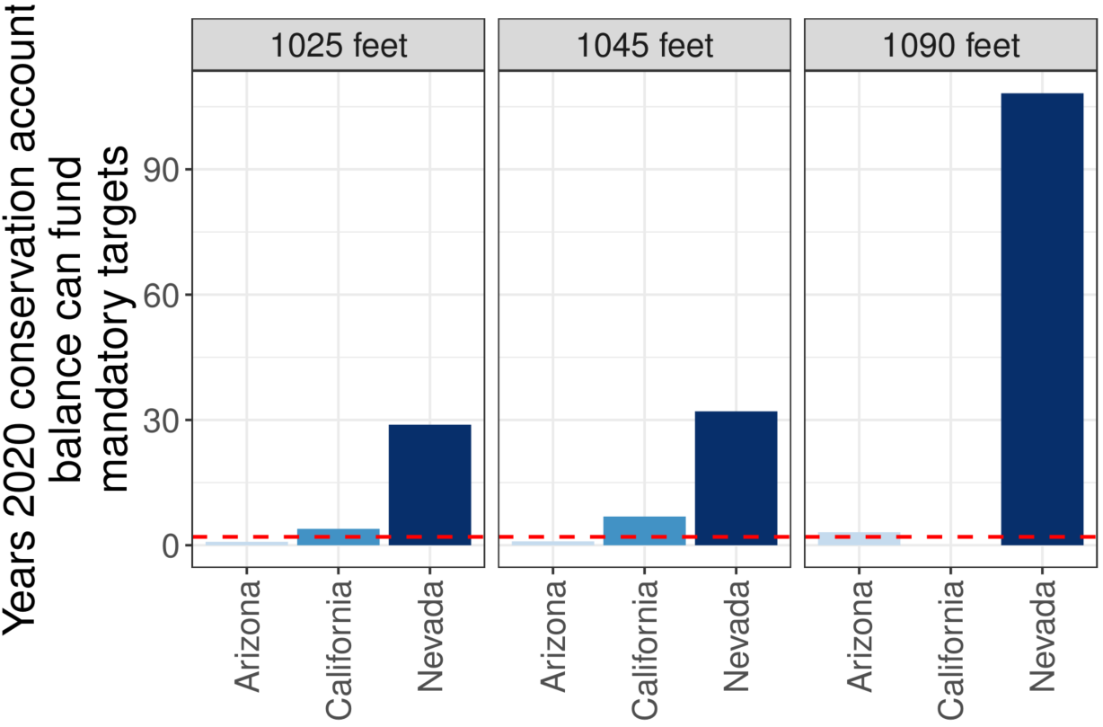

**Figure 3. Years 2020 conservation account balance can convert to meet mandatory targets and delay new conservation efforts. Dashed red line indicates 2 years.**

# Conservation Account Rules may Speed Reservoir Draw Down

The Lake Mead conservation accounts comprise only some of the available reservoir storage (Figure 4, left). Parties draw on the public pool according to the agreed rules for reservoir operations. As the public pool draws down, parties withdraw from their water conservation account to supplement limited withdraws allowed by the mandatory conservation targets. The withdraws from conservation accounts trigger a negative feedback that accelerates reservoir withdraw and withdraws from conservation accounts.

As reservoir storage draws down towards the total balance in all conservation accounts, the parties face increased pressure to withdraw from their conservation accounts. They face increased pressure because once physical reservoir storage falls *below* the total balance of all conservation accounts, the conservation credits become unredeemable. Bill Hasencamp from the Metropolitan Water District (MWD) of Southern California recently floated the idea that MWD might be ok to conserve a large volume and only recover a portion (Walton, 2021). That strategy works when all parties are on board. If not, there will be a conflict about who recovers their conserved water and who does not.

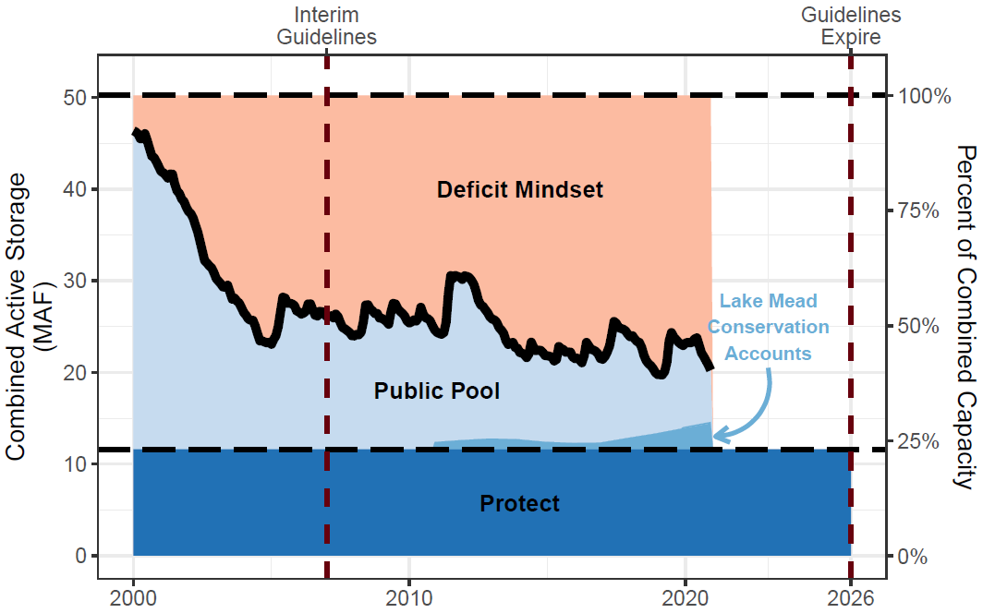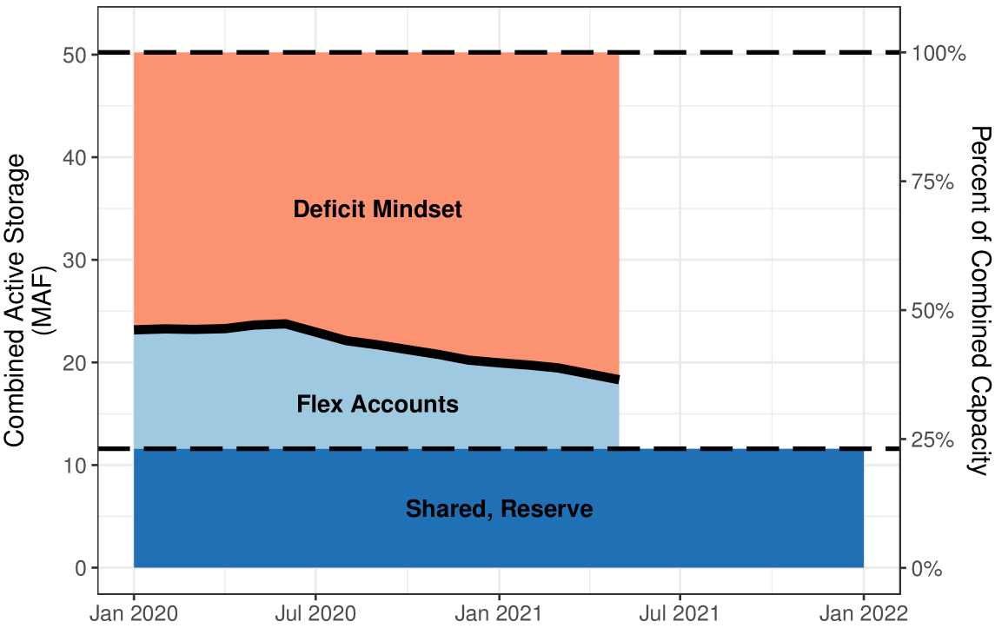

**Figure 4. Lake Mead conservation accounts for 2000 to present comprise some reservoir storage (left) whereas proposed flex accounts include all track available water (right).**

Similarly, once Lake Mead draws down towards 5.7 maf of storage, one party can persuade the other parties to lower the protection level rather than enact additional conservation efforts to stabilize the reservoir. Parties that were ok to expand conservation efforts will not increase their conservation efforts if one party continues their use. And if one or more parties continue their use, the remaining parties must conserve more than if all parties shared in the additional conservation. These disincentives encourage continued reservoir draw down.

Ironically and problematically, reservoir draw down will accelerate as parties empty their conservation accounts. This situation is a tragedy of the commons (Hardin, 1968) with a twist and complication of private water conservation accounts that presently comprise a small portion of the total reservoir storage.

Models that omit the tragedy of the commons behavior – such as {Rosenberg, 2021 #2796} -- will overestimate lake levels and underestimate the time to draw down to the protect elevation. For example, with inflows of 8.3 maf each year – corresponding to Lake Powell releases of ~ 7.3 maf each year -- Lake Mead may draw down to 1,020 feet in less than 5 years.

How to maneuver out of this mess?

# Proposal: Give managers more flexibility to conserve

This section proposes new flex accounts to track available water – reservoir storage plus each year’s inflow – as a fix to continued reservoir draw down. Setting up and using the accounts will require the parties to make some political choices. The reward for those choices is a reservoir that never draws down to dead pool, each party gets flexibility to manage their withdraw and conservation decisions independent of other users, an opportunity to manage all water rather than only prior conserved water, plus the opportunity to include some more stakeholders in Colorado River management. The steps to set up and use available water accounts are:

1. **Give an account to each party**. Who gets an account is a first set of political decisions. Obviously give each Lower Basin state contractor an individual account. Then there is an opportunity to follow through on recent pledges to include more stakeholders in management. For example, give an account to the U.S. and Mexican groups that secure water for the Colorado River Delta. Give our First Nations one or multiple accounts. Give the Salton Sea managers an account. Maybe others too. And to these accounts add two more. Create a “Havasu/Parker Evaporation and Evapotranspiration” account to ensure the instream uses downstream of Lake Mead are provided for. And create a “shared, reserve” account that is jointly managed *by consensus* by all parties.
2. **Assign the existing storage in Lake Mead to the accounts**. This assignment is a another set of political decisions. An easy assignment: give each Lower Basin contractor and Mexico their current balance in their Lake Mead water conservation and conversion accounts. Then retire the pilot water conservation accounting program. Scale up the popular, well used, and successful program to manage all water in Lake Mead. Next, assign some of the remaining storage to the “shared, reserve” account. This volume might be the current protect volume of 5.3 maf or lower. How low? I do not know. But the value could go lower than 2.0 maf (minimum power pool at elevation 950 feet) or lower if the parties compensate Reclamation for the cost to purchase lost energy on the open energy market. The “shared, reserve” account volume will be lowest volume Lake Mead draws down to because the assumption is all the parties will never consent to a release and thus the water will stay parked in the account and in the reservoir. Finally, assign the remaining active storage (current storage minus conservation account balances minus “shared, reserve” volume) among the users. I can only offer suggestions. Maybe the Lower Basin contractors get all the remaining storage and new users have the opportunity to conserve and build their account balances over time. Maybe there is a formula to assign the remaining storage among the parties. Regardless, I expect it will be easier to assign the remaining reservoir storage among parties (expanding pie) than negotiate ever larger cutbacks and mandatory conservation targets (shrinking pie).
3. **Assign each year’s reservoir inflow among the accounts**. This division is another set of political decisions and there are many possibilities. Easier choices here are 0.6 and 0.016 maf per year to Havasu/Parker and the Colorado River Delta per existing operations and the environmental section of Minute 323. By giving the “shared, reserve” account a share of inflow that offsets the account’s prorated share of reservoir evaporation, the account balance will stay steady from year to year. More difficult will be to assign each year’s remaining reservoir inflow among the Lower Basin states and remaining parties. These inflows vary year to year and require a dynamic assignment scheme (Rosenberg, 2021a). Also, the current mandatory conservation targets vary by reservoir elevations not inflows. If the remaining parties have difficulty to assign the reservoir inflow, they can try a few things. First, assign the remaining flow by percentages. Second, split the remaining flow volume into two portions. Assign one portion by a priority system and assign the second portion by percentages. This bicameral split would echo how the framers of the U.S. Constitution split representation in the U.S. Congress between a House of Representatives and a Senate. The split would ensure all states get some of the inflow. I do not presently have suggestions for how to assign each year’s inflow to our First Nations or the Salton Sea. I welcome further discussion. And like for reservoir storage, it should be easier to assign each year’s inflow among the parties than negotiate ever larger cutbacks and mandatory conservation targets.
4. **Then** **each year**: (a) observe the reservoir inflow (either prior year or forecast), (b) assign the inflow among the parties, (c) estimate each party’s share of the reservoir evaporation proportional to their account balance, and (d) calculate each party’s available water as their beginning of year account balance plus share of inflow minus share of evaporation. Next (e) parties decide the volume they will consumptive use or conserve/store, (f) calculate an end-of-year account balance, and (g) transfer the balance to the beginning of the next year.

This accounting by available water flips the ordering of the shared, reserve (public) and private pools in Lake Mead (Figure 4B). Even if all parties draw down their private accounts to zero, Lake Mead will only draw down to the storage of the shared, reserve account. Each party should find accounting by available water – the reservoir storage plus inflow -- attractive because they get more flexibility to make individual decisions on release and conservation independent of other parties and independent of the reservoir level. Additionally, each party gets the opportunity to manage a larger account balance than their present conservation account. To realize these benefits, the parties must conclude three new negotiations to award flex accounts to parties, assign the existing Lake Mead storage to parties, and assign future inflows to parties. The negotiations occur once, will include more parties, give parties a share of the existing reservoir storage and future inflows, and are an alternative to recurring negotiations to maintain existing conservation accounts that must increase water cutbacks and raise mandatory conservation targets. Several features of flex accounting differ from current operations and these new features seek to address the tragedy of the commons problem of Lake Mead draw down to the dead pool.

I encourage readers interested to further explore water availability accounting to download a prototype accounting tool {Rosenberg, 2021 #2789}. Move the Excel workbook into a Google sheet and invite two or more friends or colleagues to synchronously role play different parties. Role play with different number of parties, divisions of existing reservoir storage or inflows, reservoir inflow scenarios, and release and water conservation strategies for individual parties. Email feedback – things you like and things to improve – to [david.rosenberg@usu.edu](mailto:david.rosenberg@usu.edu).

A next post proposes water availability accounts for a combined Lake Powell-Lake Mead system.

# Data, Model, and Code Availability

The data, code, and directions to generate figures in this post are available on Github.com at Rosenberg (2021b).

# Acknowledgements

This work is unfunded. Eric Kuhn and Jennifer Pitt made comments to improve an earlier draft.

**Requested Citation**

David E. Rosenberg (2021). “Give Lake Mead managers more flexibility to conserve and stop draw down to the dead pool.” Utah State University, Logan, Utah. <https://github.com/dzeke/ColoradoRiverCoding/blob/master/BlogDrafts/3-GiveLakeMeadManagersMoreFlexibilityToConserveToStopDrawdownToDeadPool.docx>.

# References

Hardin, G. (1968). "The Tragedy of the Commons." *Science*, 162(3859), 1243-1248. <https://science.sciencemag.org/content/sci/162/3859/1243.full.pdf>.

Rosenberg, D. E. (2021a). "Add reservoir inflow as new criteria to recover Lake Mead." <https://github.com/dzeke/ColoradoRiverCoding/blob/master/BlogDrafts/2-AddReservoirInflowAsNewCriteriaToRecoverLakeMead.docx>.

Rosenberg, D. E. (2021b). "Intentionally Created Surplus for Lake Mead: Current Accounts and Next Steps." <https://github.com/dzeke/ColoradoRiverCoding/tree/master/ICS>.

Rosenberg, D. E. (2021c). "Pilot flex accounting to encourage more water conservation in a combined Lake Powell-Lake Mead system." <https://github.com/dzeke/ColoradoRiverCoding/tree/master/PilotFlexAccounting>.

USBR. (2007). "Record of Decision: Colorado River Interim Guidelines for Lower Basin Shortages and Coordinated Operations for Lakes Powell and Mead." U.S. Bureau of Reclamation. <https://www.usbr.gov/lc/region/programs/strategies/RecordofDecision.pdf>.

USBR. (2019). "Agreement Concerning Colorado River Drought Contingency Management and Operations." U.S. Bureau of Reclamation, Washington, DC. <https://www.usbr.gov/dcp/finaldocs.html>.

USBR. (2020). "Water Operations: Historic Data, Upper Colorado River Division." Upper Colorado River Division, U.S. Buruea of Reclamation. <https://www.usbr.gov/rsvrWater/HistoricalApp.html>. [Accessed on: June 16, 2020].

USBR. (2021). "Boulder Canyon Operations Office - Program and Activities: Water Accounting Reports." U.S. Bureau of Reclamation. <https://www.usbr.gov/lc/region/g4000/wtracct.html>.

Walton, B. (2021). "Amid Dire Colorado River Outlook, States Plan to Tap Their Lake Mead Savings Accounts." Circle of Blue. <https://www.circleofblue.org/2021/world/amid-dire-colorado-river-outlook-states-plan-to-tap-their-lake-mead-savings-accounts/>. [Accessed on: June 19, 2021].