Lessons from 26 Colorado River managers and experts experimenting with flex accounts in a combined Lake Powell-Lake Mead system

David E. Rosenberg

Utah State University | [david.rosenberg@usu.edu](mailto:david.rosenberg@usu.edu) | @WaterModeler

January 9, 2022

Target: *Journal of Water Resources Planning and Management*

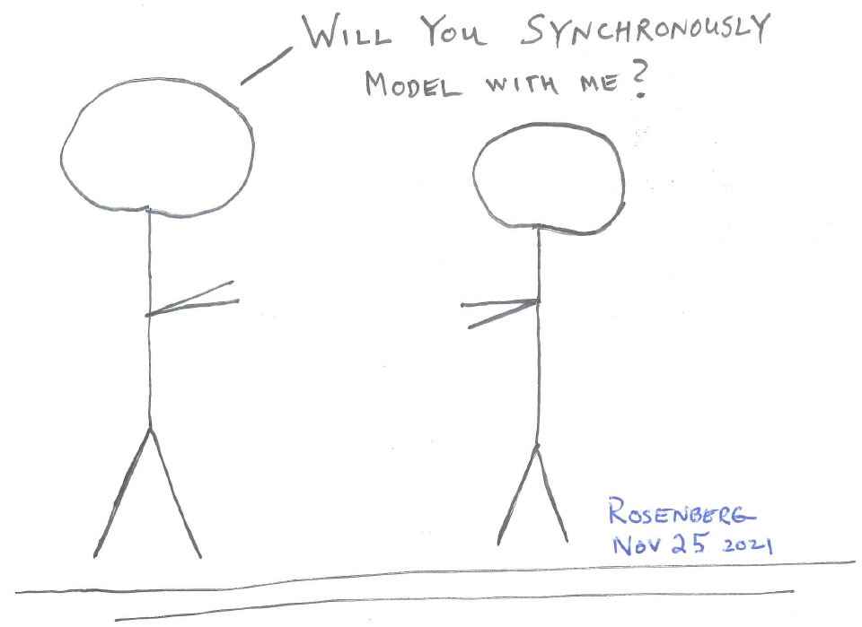

1. Start a digital adventure in a combined Lake Powell-Lake Mead system.

**Key Points**

1. Introduced flex accounts in a combined Lake Powell-Lake Mead system as an alternative to interim operations that expire in 2026.
2. Upper Basin, Lower Basin, Mexico, Colorado River Delta, and First Nations parties consumed and conserved within their account balance independent of other parties.
3. Synchronous modeling with 26 Colorado River managers and experts provoked discussion and 36 improvements.
4. Participants said share with others and flex accounts were too far from current operations.
5. Synthesized 10 lessons to improve model process, further river management, build trust, and produce more actionable insights.

# Introduction

As the Colorado River basin became more arid and Lake Powell and Lake Mead drew down to 32% of their combined active storage, I built, synchronously modeled, and improved flex accounts in a combined Lake Powell-Lake Mead system. Flex accounts in a combined system gave Upper Basin, Lower Basin, Mexico, Colorado River Delta, and First Nations parties more flexibility to conserve and consume water. They were an alternative to current operations that seek to equalize Lake Powell and Lake Mead storage, protect reservoir elevations 3,525 and 1,020 feet (5.9 and 5.7 million acre-feet [maf]), reduce Lower Basin and Mexico deliveries as Lake Mead draws down, and let those parties credit voluntary reductions from their historical allocations in Lake Mead accounts for later use (USBR, 2007; USBR, 2019). The current operations expire in 2026. This piece synthesizes lessons from my experience to synchronously model and discuss with 26 Colorado River managers and experts (Figure 1). Lessons suggest ways to improve model process, further river management, build trust, and produce more actionable insights (Van den Belt, 2004; Voinov et al., 2016). The next four sections describe the synchronous model process, existing operations, key steps for flex accounts in a combined system, and compare to existing operations. Three final sections share lessons from the discussion, their broader context, and conclusions.

# Synchronous Model Process

Synchronous modeling was a form of participatory modeling (Bourget, 2011; Langsdale et al., 2013; Michaud, 2013; Van den Belt, 2004; Wheeler et al., 2018) that added role play during a face-to-face or screen time meet with one or more participants. Synchronous modeling sought to provoke thought and discussion about current and future operations rather than forecast future conditions, simulate what if, or identify what was best. Like serious games (Ewen and Seibert, 2016; Madani et al., 2017; Schulze et al., 2015; Seibert and Vis, 2012), synchronous modeling was intended as an immersive experience. Synchronous modeling and role play differed from expert models that stakeholders do not see, management models that are too big, detailed, or immutable for participants to change, and collaborative models that participants build together (Van den Belt, 2004).

I solicited 32 Colorado River managers and experts from April – November, 2021. I held 14 synchronous modeling sessions in-person (1) or via Zoom (13). Participants were employed by the Federal Government, Upper Colorado River Commission, state agencies, water districts, consulting firms, universities, a non-governmental organization, a foundation, and a First Nation. Three people participated in two sessions, three people started but did not complete a session, two people declined a request to participate, and one person never responded. During the same period, I also held or supervised synchronous modeling sessions with 4 graduate students, 22 university colleagues, and 63 undergraduate students none of whom had expertise in the Colorado River basin. This piece focuses on feedback from the 26 Colorado River managers and experts who completed a session.

Sessions followed the general structure:

* I solicited participants through email or after recommendation by a prior participant.
* Sessions were held with 1 to 6 participants from the same organization.
* Sessions lasted 1 to 3 hours.
* There were 5 model roles. Each participant played one or more roles.
* In sessions with a small number of participants, I played one or more roles.
* Participants sometimes played their party, sometimes not.
* After role play of 1 to 5 years, I asked participants what they liked and what to improve.

The synchronous model was a Google Sheet -- online collaborative workbook (Rosenberg, 2021a). Up to five parties represented the Upper Basin, Lower Basin, Mexico, Colorado River Delta, and First Nations. Workbook rows represented the components of a water balance for a combined Lake Powell-Lake Mead system. Columns represented years. Participants entered individual and joint choices into spreadsheet cells.

# Existing Operations

Existing Colorado River operations comprise treaties, compacts, court cases, and agreements negotiated over 100 years (1922; Carson et al., 1948; IBWC, 2021; Ten Tribes Partnership, 2018; U.S. Bureau of Reclamation and National Park Service, 2016; USBR, 2007; USBR, 2019). These operations:

* Seek a Lake Powell release of 8.23 maf per year with allowances to equalize Lake Powell and Lake Mead storage (USBR, 2007).
* Protect elevations 3,525 and 1,020 feet in Lake Powell and Lake Mead that correspond to active storages of 5.9 and 5.7 maf (USBR, 2019).
* Reduce deliveries to the Lower Basin states and Mexico as Lake Mead draws down (IBWC, 2021; USBR, 2007; USBR, 2019).
* Allow the Lower Basin states and Mexico to store voluntary reductions from their historical allocations in Lake Mead accounts for later use (USBR, 2007).

Castle and Fleck (2019), Kuhn and Fleck (2019), MacDonnell et al. (1995), and USBR (2008) further describe the existing operations. The Colorado River Simulation System (CRSS) maintained by Reclamation encodes operations into 12 reservoirs, 29 flow gages, 520 water user objects, and 145 rules (Wheeler et al., 2019; Zagona et al., 2001).

# Flex accounts in a combined Lake Powell-Lake Mead system

Flex accounts intended to give parties more flexibility to make water conservation and consumption decisions independent of other parties. Flex accounts defined a region of combined management (Figure 2). The region stretched from the natural inflows to Lake Powell down to Lake Mead releases.

Within the region of combined management, five parties were given a flex account. Participants jointly managed a sixth account, called the shared water reserve. The total of all account balances equaled the combined active storage in Lake Powell and Lake Mead.

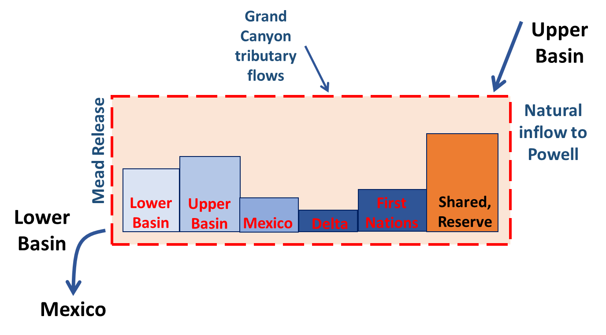

1. Region of combined management stretched from the natural inflows to Lake Powell down to Lake Mead releases.

Participants completed 7 model steps (Table 1). Each spreadsheet cell was color coded to indicate the action and decision required by participants. Below, each step is further described.

1. Steps to synchronously model flex accounts in a combined Lake Powell-Lake Mead system.



1. **Assigned accounts and roles; defined party strategy**. Early sessions had three or four parties (Upper Basin, Lower Basin, Mexico, and Colorado River Delta). Subsequent sessions added First Nations. The choice of accounts was a joint (political) decision by parties. This step made explicit who was included. Accounts drew standing from the 1922 Colorado River Compact, 1948 Upper Colorado River Basin Compact, 1944 U.S-Mexico Treaty, Minutes 319 and 323, and pledges to include our First Nations (Carson et al., 1948; IBWC, 2021; Ten Tribes Partnership, 2018; USBR, 2020). The First Nations account allowed First Nations to manage their water independently from the basin state in which the First Nation was located. This set up differed from current operations where basin states administer water rights for the First Nations within their state boundaries. There were many possibilities for accounts. Only a few assignments were explored.

A shared water reserve was also created and endowed with 11.6 maf of storage. This volume was the sum of the 5.9 and 5.7 maf protection volumes for Lake Powell and Lake Mead associated with elevations 3,525 and 1,020 feet (USBR, 2019). The shared water reserve was a backstop. The reserve prevented parties that drew down their account balance to zero to further draw down reservoir storage. At the same time, the reserve comprised 72% of the active storage in the combined system. If all parties agreed, the reserve could transfer water to a party in difficulty. Withdraws from the shared water reserve considered reduced hydropower generation at one or both reservoirs and warmer Glen Canyon Dam release temperatures that threated the status quo for native, endangered fish of the Grand Canyon.

Participants chose a strategy for their party for the next 1 to 5 years. Some Upper Basin strategies were increase water use, deliver 1922 Compact volume to Lower Basin, and conserve water to store water in Lake Powell and keep release temperatures cool for native fish. The model guide lists additional strategies for parties (Rosenberg, 2021d).

1. **Assigned all existing reservoir storage to accounts**. This step assigned all active reservoir storage at the model start to the accounts. The start volume varied from 21 to 16.2 maf as the actual Lake Powell and Lake Mead volumes drew down over the time period of synchronous model sessions. Assigning storage was also a joint (political) decision with many possibilities. Default values used existing agreements and operations to inform assignments. For example, assigned Mexico 0.17 maf that was the October 2020 balance in its Lake Mead conservation account (USBR, 2007; USBR, 2021). Assigned the Lower Basin the 2.8 maf balance in the Lake Mead conservation accounts for California, Arizona, and Nevada (USBR, 2007; USBR, 2021). Similarly, assigned the Upper Basin most of the Lake Powell storage that was not the protection volume. Assigned the shared water reserve 11.6 maf as described in Step 1 (USBR, 2019). These assignments gave each party the same or more reservoir storage as in a conservation account. The assignments allowed the Lower Basin and Mexico to move Lake Mead conservation account balances into a flex account.
2. **Selected year’s inflow and assigned to accounts**. Inflows were all flows to the combined system (Table 2). The natural flow to Lake Powell was a computed flow if users above Lake Powell did not store, divert, or consume water (Prairie, 2020; Wheeler et al., 2019). Crediting natural flow to the flex accounts allowed parties to deduct consumptive use and carry over unused volumes to the next year. Participants chose a Lake Powell natural inflow value each year (Figure 3). In many cases, participants chose values below the 2000 to 2020 average (Salehabadi et al., 2020) and below the Lake Powell release criteria of 8.23 maf per year.
3. Combined system inflows

|  |  |  |
| --- | --- | --- |
| **Location** | **Values**  **(maf/year)** | **Explanation** |
| Lake Powell natural flow | 7 to 19 | 3-year averages for dry to wet periods reconstructed from the historical (1905 to 2015) and paleo (1416 to 2015) periods (Meko et al., 2017; Prairie, 2020; Salehabadi et al., 2020). |
| Intervening Grand Canyon flow | 0.6 to 1.0 | 5-year sequence average for dry period and 30-year average. Includes Paria, Little Colorado, and Virgin rivers plus Grand Canyon seeps from Glen Canyon Dam to Lake Mead (Rosenberg, 2021b; Wang and Schmidt, 2020). |
| Hoover to Imperial Dam Intervening Flow | 0.2 | Estimated from the natural flow data set (Prairie, 2020). |

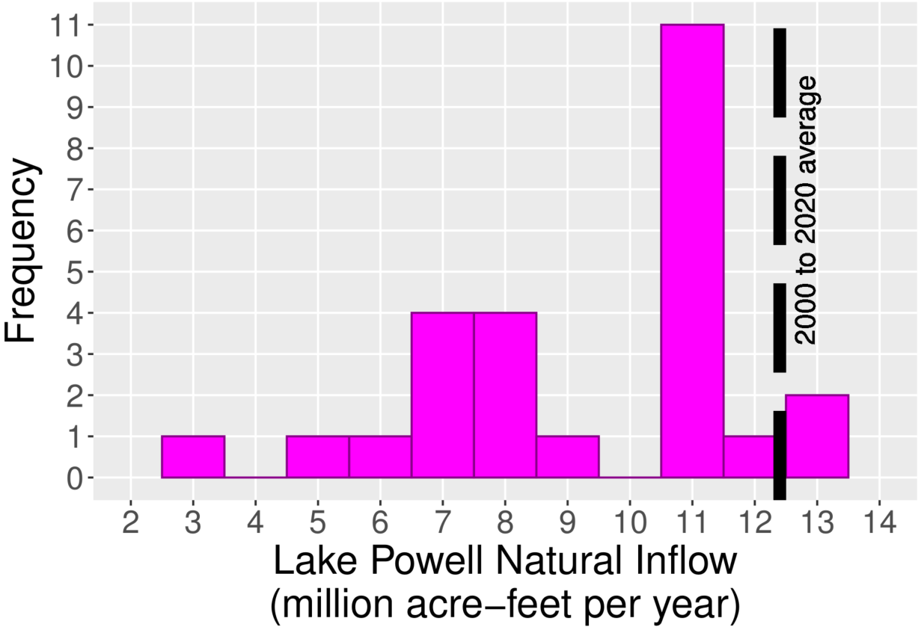

1. Participant choices for Lake Powell natural inflow.

Inflow assignments to accounts followed existing operations with changes for the shared water reserve and First Nations accounts that are not in current operations. For example:

* Assigned inflow to the shared water reserve that equaled the account’s share of reservoir evaporation. This assignment kept the shared water reserve balance steady and helped protect levels listed in the Upper and Lower Basin DCPs (USBR, 2019).
* Assigned Mexico 1.5 maf per year (1944 U.S.-Mexico Treaty) minus the mandatory conservation volume specified in Minutes 319 and 323 (IBWC, 2021). The mandatory conservation volume increased as Lake Mead level declined.
* Assigned the Colorado River Delta account 0.016 maf per year. That volume was 67% of the 9-year, 0.21 maf volume pledged by the U.S. and Mexico in Minute 323 (IBWC, 2021). This assignment required Delta managers to purchase additional water.
* Assigned First Nations 2.01 maf per year of their decreed water rights (Ten Tribes Partnership, 2018). That volume included 1.06 and 0.952 maf per year above and below Glen Canyon Dam and excluded claimed amounts.
* Split the next 6.55 maf per year of Lake Powell inflow between the Lower and Upper Basins. The 6.55 maf per year volume was the Lake Powell objective release of 8.23 maf per year, plus 0.02 maf per year Paria flow, minus half of Mexico’s assignment, minus 0.95 maf of decreed water rights for First Nations below Hoover Dam (Ten Tribes Partnership, 2018). The 6.55 maf was split because there were 2.3 and 3.5 maf per year of pre-1922 water rights in the Upper and Lower Basins (Leeflang, 2021) and I was unclear how to split at low Lake Powell natural flows.
* Last, assigned the Upper Basin any remaining Lake Powell natural flow.

1. **Calculated each party’s available water** as each party’s flex account balance (Step 2), plus share of inflow (Step 3), and minus share of reservoir evaporation (Eq. 1; all units maf). A party’s share of reservoir evaporation was the combined annual Lake Powell and Lake Mead evaporation prorated by the party’s share of the combined storage. Optional purchases from other party(s) increased available water while sales decreased a party’s available water. The optional transactions built on a feature of the Lower Basin drought contingency plan that let Lower Basin parties transfer their Lake Mead conservation account balance to another party (USBR, 2019).

|  |  |
| --- | --- |
|  | (Eq. 1) |

1. **Parties conserved and consumed within their available water independent of other parties.** Consumptive use withdrew from a flex account. Conservation made water in the account available next year. The Lower Basin, Mexico, Delta, and First Nations parties had diversion points from Lake Mead or downstream of Hoover Dam. Consumptive use from their flex account was synonymous with a withdraw from Hoover dam or Lake Mead. First Nations and Upper Basin parties had diversion points upstream of Lake Powell. Their flex accounts were credited their share of the *natural* flow. Then they diverted river water upstream of the reservoir. Last, their flex accounts were deducted the corresponding consumptive use. Each party’s end-of-year account balance was their available water (Step 4) minus consumption.
2. **Assigned the remaining combined storage to Lake Powell and Lake Mead.** The existing operations seek to equalize or split 50%/50% (USBR, 2007). This assignment was another joint (political) decision and gave parties flexibility to split in other amounts. Parties withdrew from their flex accounts whether water was physically stored in Lake Powell or Lake Mead. Two considerations to assign combined storage between Lake Powell and Lake Mead were:
   1. **Maintain the status quo for endangered, native fish of the Grand Canyon.** As Lake Powell draws down, the stored water heats (less stratification) and increases release water temperature through the hydropower turbines. Warm releases make the native, endangered fish of the Grand Canyon more susceptible to prey and extinction by non-native fish (Figure 4). Outcomes for native fish become highly uncertain (Figure 4, red) when Lake Powell storage drops to 5.9 maf (3,525 feet) and water continues to flow through the turbines (elevation 3,490 feet [4 maf]). Outcomes for native fish also become highly uncertain when Lake Powell storage drops to 1.4 maf (3,425 feet) and water is released through the low elevation river outlets (elevation 3,370 feet; 0 maf). Options to improve outcomes for native fish were store more water in Lake Powell, forego hydropower generation, and/or release more water through the river outlets.
   2. **Stay above minimum power pools.** Reservoir drawdown reduced hydropower generation and sped the time to reach minimum power pools where reservoirs no longer generate energy (Lake Powell an Lake Mead elevations of 3,490 and 955 feet; 4.0 and 2.2 maf). During the April to November 2021 period, the Western Area Power Authority delivered less energy to its customers (Arellano, 2021). Customers purchased additional energy from other sources.

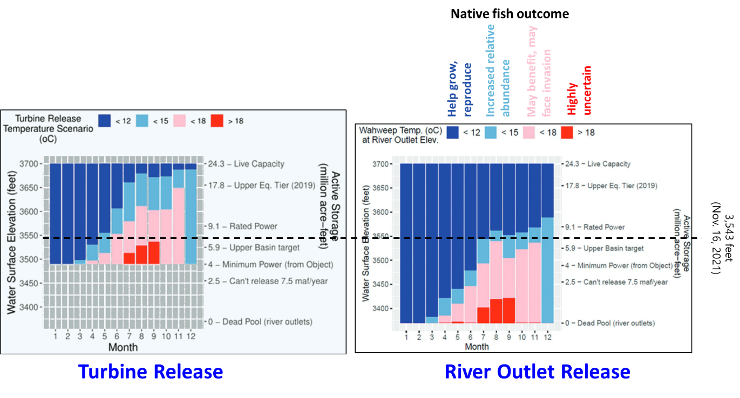

1. Releases through the Glen Canyon Dam turbines (left, 3,490 feet) require more stored water to sustain colder water releases for native fish of the Grand Canyon than releases through the river outlets (right, 3,370 feet) (adapted from Wheeler et al., 2021).
2. **Continued to next year.** All end of year account balances carried over to the beginning of the next year (Steps 3 to 6).

A spreadsheet model implemented the 7 steps in 142 rows on 1 master worksheet, 4 data support worksheets, a ReadMe worksheet, and a Versions worksheet (Rosenberg, 2021d). Each spreadsheet row on the master worksheet also linked to an online model guide.

# Compare Flex Accounts to Existing Operations

The major differences between existing operations and flex accounts for a combined Lake Powell-Lake Mead system are:

* Gave each party an account in the combined system rather than Lake Mead conservation accounts only for Lower Basin and Mexico parties.
* Allowed each party to manage all available water rather than only water in a Lake Mead conservation account.
* Parties managed the available water in their account year-to-year rather than make new joint agreements for more conservation as conditions declined.
* Allowed sales and trades between accounts in the combined system rather than only between Lake Mead conservation accounts.
* Adapted releases to inflow and storage rather than only storage (Rosenberg, Submitted).
* Defined a shared water reserve and allowed the reserve volume to vary over time rather than specify fixed protection elevations for Lake Powell and Lake Mead.
* Gave the Colorado River Delta and First Nations accounts in the combined system rather than require non-governmental organizations to secure water from the U.S. and Mexico for each pulse flow or administer First Nation’s water under state systems.
* Subtracted all Lake Mead and Lake Powell evaporation in proportion to the account balance rather than ignore ~500,000 acre-feet of Lake Mead evaporation and 160,000 to 230,000 acre-feet of Colorado River evapotranspiration prior to build Glen Canyon Dam (Fleck and Castle, 2022; Schmidt et al., 2016).
* Allowed parties more flexibility to split combined storage between Lake Powell and Lake Mead rather than equalize storage. More flexibility to store water in Lake Powell allowed colder releases to maintain the status quo for native, endangered fish of the Grand Canyon.

Flex accounts and current operations share many features such as encourage conservation, plan for shortages, and closer coordinate Lake Powell and Lake Mead operations (USBR, 2020). They both seek to address future controversies through consultation and negotiation not litigation.

# Lessons

This section identifies lessons for model process and river management.

**1. Listen**. The first participant told me to continue to provoke thought and discussion. During sessions, my role was to listen to what participants said (Table 3).

1. Positive statements about synchronous modeling and flex account experience

|  |  |
| --- | --- |
| **Things to like** | **More things to like** |
| * I like it / It's neat / It's fun. * Interactive. I see the effect of choices. * See yourself in the model. * See effects on native fish. * Drive a conversation around conservation with bad hydrology. * Facilitates thought and conservation. | * More holistic approach to basin management. * Make me think about the equity issue. How to factor in equity. * I like the gaming. * What it means to have and use my own water account. |

One participant suggested:

Start asking people from different parties to participate in the same session.

And another participant later wrote:

I think others will find the same value in the exercise that I have seen…. its thought provoking.

Lots of participants also encouraged to share with others and suggested specific people.

**2. Solicit feedback early.** In the early weeks, I shared a first version for Lake Powell with students and a colleague. They suggested to reduce the number of years to 5. The next week, a Colorado River manager liked the exercise and asked for a more complete picture for Lake Mead and down to the Mexico border. This comment kicked off a serial process where I met with new participant(s), solicited feedback, used time between meetings to improve the model, and met with new participants.

The serial process resulted in 36 model changes recorded in the *Versions* worksheet of the model (Rosenberg, 2021a). I grouped player decisions into dashboards, allowed participants to withdraw water from the shared water reserve, and redid the split of Lake Powell natural flow between the Upper Basin, Lower Basin, and Mexico. I also wrote a model guide and hyperlinked each spreadsheet row to a section in the guide (Rosenberg, 2021d). There were many more improvements. Regular feedback let the synchronous model of flex accounts evolve over time.

**3. Identify flashpoints.** Multiple participants raised the flashpoint to split Lake Powell natural inflow among the Upper and Lower Basin parties. Was the 75 maf each 10 years in Article III(d) of the 1922 Compact a delivery or non-deplete requirement (Beckstead and Hoerner, 2012)? Could the Upper Basin deliver less water in the 1st model year and store more to recoup an over-delivery by 4 maf in the prior 9 years? How to handle the 2.3 and 3.5 maf per year of pre-1922 water uses in the Upper and Lower Basins (Leeflang, 2021)? Participants voiced different views about the acceptability of these features. One participant described 4 or 5 or 6 maf per year of Lake Powell natural flow as unprecedented, never been done, and unclear what will happen.

These flashpoints identified the split of Lake Powell natural inflow below 8.23 maf per year as a win-lose conflict and zero-sum game. The model gave one party more water and another party less. The conflict also turned lose-lose – every party got less – as Lake Powell natural flows declined. This flashpoint made me see that it is difficult for a model to resolve win-lose and lose-lose conflicts. Instead, I identified the flash points.

**4. Catalogue win-lose and lose-lose conflicts.** Similar to identify flashpoints (lesson #3), I catalogued 4 other win-lose and 2 lose-lose tradeoffs (Table 4).

1. Conflicts in flex accounts for a combined system

|  |  |
| --- | --- |
| **Win-Lose** | **Lose-Lose** |
| 1. Split existing reservoir storage among parties. 2. Added a First Nations account. 3. Stored water in Lake Powell and Lake Mead. 4. Drew down shared water reserve. | 1. Flow decline as basin became more arid. 2. Charged reservoir evaporation to parties. |

It’s hard to know how or if parties will resolve these tradeoffs. There are many possibilities. Parties may stay stuck at the current point until a tradeoff is pushed outwards or linked to other conflicts. Thus, I turned many of these conflicts into participant choices. The synchronous model process let parties think about and discuss the choices.

**5. Prorate reservoir evaporation by account balance.** Splitting reservoir evaporation among accounts was a lose-lose conflict (lesson #5) because some or all of Lake Mead and Lake Powell evaporation is not counted in current operations (Fleck and Castle, 2022; Schmidt et al., 2016). Participants offered accolades and nods for the 7 spreadsheet rows that calculated the split. I believe prorating evaporation by account balance was seen favorably because:

1. Each party was treated the same. Parties with larger account balances shared more responsibility for reservoir evaporation.
2. The Upper and Lower Basins could shift some of their responsibility for evaporation onto other parties and the shared water reserve.
3. In model year 1, the shared water reserve had the largest account balance and was charged 72% of the combined reservoir evaporation.

Treating every party the same may help parties overcome a lose-lose conflict.

**6. Many options to govern draw down below the combined protection volume of 11.6 maf.** One participant recommended to keep the shared water reserve at 11.6 maf. Another participant noted that 11.6 maf is a lot of water and there may be circumstances to draw down the shared water reserve below the combined protection volume. A third participant suggested to trust a third party such as Reclamation to manage the shared water reserve. There was also a suggestion to allow parties to sell water to the shared water reserve if no other party wanted to buy. These comments identified multiple options to drawdown Lake Powell and Lake Mead below 11.6 maf.

**7. Link scarce water to more abundant money.** These days, money is more available than water. In 2021 we saw trillion dollar COVID-19 relief, infrastructure packages, regional, and local investments. The Lower Basin states of California, Arizona, Nevada, and the Federal government promised $200 million for a new plan to conserve 500,000 acre-feet each year (Allhands, 2021). In the flex account sessions, participants voluntarily sold and purchased water. For example, some participants who role played Mexico sold water to build non-water infrastructure projects. Some participants who role played the Upper Basin sold some water to get paid to conserve to prepare for mandatory cutbacks to meet 10-year delivery requirement. Trades were possible because flex accounts set up methods – split existing storage, split inflow, split evaporation – that defined the water each party had available to trade each year. Also, trades administratively transferred from one account to another within the combined system without physical movement. Linking scarce water to more available money gave participants more flexibility when their account balance was high or low.

**8. Combined management offered more flexibility.** Combined management offered parties more flexibility to store and access water in either Lake Powell or Lake Mead while sustain the status quo of cold water releases from Lake Powell for native, endangered fish of the Grand Canyon. Combined management also let parties conserve and consume independent of other parties. Parties managed all available water in the combined system not just water in Lake Mead conservation accounts. Participants managed their available water rather than wait to negotiate larger reductions from historical allocations. Combined management helped shift Upper and Lower Basin reservoir mindsets towards our reservoirs. Through numerous model improvements, I sought ways to give participants more flexibility to manage the combined water. Often, more flexibility meant more participant choices and fewer rules or spreadsheet formulas.

**9. Find common benefits such as more flexibility.** Lessons #5-8 combined to find common benefits for all parties as a way to escape win-lose and lose-lose water conflicts. Each party enjoyed a common benefit of more flexibility (lesson #8) each year because they had a flex account in the combined system. These common benefits treated each party the same (lesson #5).

**10. Recognize a model’s useful life.** Participants also said flex accounts were:

* Very different than current operations.
* A huge leap from management today and, when we roll up our sleeves, fraught with implementation issues.
* A heavy lift from existing management to whole basin management.
* Got over the initial freak out of breaking the existing operations.
* Easy to suggest a new operation. Harder to get it adopted.
* I don’t know how you would ever do it. Hard to get traction on things that are less difficult than this.

These comments discounted the model’s legitimacy and actionability (Van den Belt, 2004; Wheeler et al., 2018). I did not address these comments because flex accounts purposefully differed from current operations. Instead, I stopped soliciting feedback and wrote up the lessons from the experience as this manuscript.

# Broader Meaning

This work engaged 26 Colorado River managers and experts to synchronously model and discuss flex accounts in a combined Lake Powell-Lake Mead as an alternative to interim operations that expire in 2026. The engagement contrasted with no/little stakeholder interaction for 42 studies of environmental water decisions (Horne et al., 2016) and many participatory model efforts that extracted data from participants (Voinov et al., 2016). The sequential process of meet, solicit feedback, improve, and meet with new participants generated 36 model improvements. The sequential engagement process differed from the build-translate approach most researchers use to build a model on their own then present findings at their project end.

Synchronous modeling of flex accounts provoked multiple discussion threads such as this is fun, I see effects on native fish, I see myself in the model, think about equity, the 8.23 maf Lake Powell release criteria is a flash point and win-lose conflict, give parties common benefits like more flexibility, share the work with others, and flex accounts strayed too far from current operations. The later comment raised issues of legitimacy and actionability that may stem from participants:

* Chose within the model confines rather than define, construct, modify, test, and validate their own model (Voinov et al., 2016).
* Never engaged with people from other parties.
* Focused on one future operation rather than screen multiple possible future operations.

As the Colorado River basin becomes more arid, I see an important next step is to organize more collaborative modeling efforts where creative, grounded, productive, and connected participants together generate, validate, and test innovative ideas. In short, participants learn together and help share findings with their communities. Joint learning can build trust and generate more actionable insights (Van den Belt, 2004; Voinov et al., 2016).

# Conclusions

As Lake Powell and Lake Mead drew down to 32% of their active capacity, I introduced flex accounts in a combined Powell- Mead system as an alternative to interim operations that equalize storage, protect a combined volume of 11.6 maf, and expire in 2026. Upper Basin, Lower Basin, Mexico, Colorado River Delta, and First Nations parties consumed and conserved within their account balance independent of other parties. Synchronous modeling with 26 Colorado River managers and experts provoked 36 improvements and multiple discussion threads. Discussion included this is fun, I see effects on native fish, I see myself in the model, think about equity, share the work with others, and flex accounts strayed too far from current operations. From the experience I learned to listen, solicit feedback early, identify flash points as win-lose conflicts, prorate reservoir evaporation by account balance, link scarce water to more abundant money, find common benefits such as more flexibility for all parties, and recognize a model’s useful life. I see an important next step is to organize more collaborative efforts with multiple parties that build trust and produce more actionable insights.

# Data, Model, and Code Availability

The data, model, code, and directions to use flex accounts for a combined Lake Powell-Lake Mead system are available at Rosenberg (2021c). The data and code to generate Figures 3 and 4 are available at Rosenberg (2021c) and Rosenberg (2020).

# Acknowledgements

I appreciate the time, engagement, thought, and discussion that the 26 participants contributed. This work benefited from a $50 donation from a private individual. The donation was used to purchase software to generate the online model guide. This work represents the views of the author not Utah State University.

# Requested Citation

David E. Rosenberg (2022). “Lessons from synchronously modeling a combined Lake Powell-Lake Mead system with 26 Colorado River managers and experts.” Utah State University, Logan, Utah. <https://github.com/dzeke/ColoradoRiverCoding/raw/main/BlogDrafts/3-LessonsFromSynchronouslyModelCombinedLakePowellLakeMeadSystemWith26ColoradoRiverManagersExperts.docx>.

# References

(1922). "Colorado River Compact." <https://www.usbr.gov/lc/region/pao/pdfiles/crcompct.pdf>. [Accessed on: October 5, 2021].

Allhands, J. (2021). "It could take at least 500,000 acre-feet of water a year to keep Lake Mead from tanking." *Arizona Republic*, November 8, 2021.

Arellano, A. (2021). *Colorado River Water Users Association*, Las Vegas, NV.

Beckstead, B., and Hoerner, C. (2012). "Does the Upper Basin have a Delivery Obligation or an Obligation Not to Deplete the Flow of the Colorado River at Lee Ferry?", Colorado River Governance Initiative. <http://www.waterpolicy.info/wp-content/uploads/2015/09/Delivery-Obligation-memo.pdf>.

Bourget, L. (2011). "Converging Waters: Integrating collaborative modeling with participatory processes to make water resources decisions." Mass-White, U.S. Army Corps of Engineers, Institute for Water Resources, Washington, D.C., 218.

Carson, C. A., Stone, C. H., Wilson, F. E., Watson, E. H., and Bishop, L. C. (1948). "Upper Colorado River Basin Compact." U.S. Bureau of Reclamation. <https://www.usbr.gov/lc/region/g1000/pdfiles/ucbsnact.pdf>. [Accessed on: September 7, 2021].

Castle, A., and Fleck, J. (2019). "The Risk of Curtailment under the Colorado River Compact." <http://dx.doi.org/10.2139/ssrn.3483654>.

Ewen, T., and Seibert, J. (2016). "Learning about water resource sharing through game play." *Hydrol. Earth Syst. Sci.*, 20(10), 4079-4091. <https://www.hydrol-earth-syst-sci.net/20/4079/2016/>.

Fleck, J., and Castle, A. (2022). "Green Light for Adaptive Policies on the Colorado River." *Water*, 14(1), 2. <https://www.mdpi.com/2073-4441/14/1/2>.

Horne, A., Szemis, J. M., Kaur, S., Webb, J. A., Stewardson, M. J., Costa, A., and Boland, N. (2016). "Optimization tools for environmental water decisions: A review of strengths, weaknesses, and opportunities to improve adoption." *Environmental Modelling & Software*, 84, 326-338. <http://www.sciencedirect.com/science/article/pii/S1364815216302936>.

IBWC. (2021). "Minutes between the United States and Mexican Sections of the IBWC." United States Section. <https://www.ibwc.gov/Treaties_Minutes/Minutes.html>. [Accessed on: July 22, 2021].

Kuhn, E., and Fleck, J. (2019). *Science Be Dammed: How Ignoring Inconvenient Science Drained the Colorado River*, University of Arizona Press.

Langsdale, S., Beall, A., Bourget, E., Hagen, E., Kudlas, S., Palmer, R., Tate, D., and Werick, W. (2013). "Collaborative Modeling for Decision Support in Water Resources: Principles and Best Practices." *Journal of the American Water Resources Association*, 49(3), 629-638. <http://dx.doi.org/10.1111/jawr.12065>.

(Leeflang, B.). (2021). "Colorado River Coding: Pre 1922 Compact Water Use." <https://github.com/dzeke/ColoradoRiverCoding/tree/main/Pre1922CompactWaterUse>.

MacDonnell, L. J., Getches, D. H., and Hugenberg, W. C. (1995). "The Law of the Colorado River: Coping with severe sustained drought." *JAWRA Journal of the American Water Resources Association*, 31(5), 825-836. <http://dx.doi.org/10.1111/j.1752-1688.1995.tb03404.x>.

Madani, K., Pierce, T. W., and Mirchi, A. (2017). "Serious games on environmental management." *Sustainable Cities and Society*, 29, 1-11. <http://www.sciencedirect.com/science/article/pii/S2210670716301834>.

Meko, D., Bigio, E., and Woodhouse, C. A. (2017). "Colorado River at Lees Ferry, CO River (Updated Skill)." *Treeflow*. <https://www.treeflow.info/content/upper-colorado#field-ms-calibration-validation>.

Michaud, W. R. (2013). "Evaluating the Outcomes of Collaborative Modeling for Decision Support." *Journal of the American Water Resources Association*, 49(3), 693-699. <http://dx.doi.org/10.1111/jawr.12066>.

Prairie, J. (2020). "Colorado River Basin Natural Flow and Salt Data." U.S. Bureau of Reclamation. <https://www.usbr.gov/lc/region/g4000/NaturalFlow/current.html>.

Rosenberg, D. E. (2020). "How does Lake Powell water storage influence release temperatures and Grand Canyon fishes?", Utah State University. <https://doi.org/10.5281/zenodo.4345405>.

Rosenberg, D. E. (2021a). "Colorado River Coding: Flex accounting to encourage more water conservation in a combined Lake Powell-Lake Mead system." Utah State University. <https://github.com/dzeke/ColoradoRiverCoding/tree/main/ModelMusings>.

Rosenberg, D. E. (2021b). "Colorado River Coding: Grand Canyon Intervening Flow." GrandCanyonInterveningFlow folder. <https://doi.org/10.5281/zenodo.5522835>.

Rosenberg, D. E. (2021c). "Colorado River Coding: Intentionally Created Surplus for Lake Mead: Current Accounts and Next Steps." ICS folder. <https://doi.org/10.5281/zenodo.5522835>.

Rosenberg, D. E. (2021d). "Colorado River Coding: Pilot flex accounting to encourage more water conservation in a combined Lake Powell-Lake Mead system." ModelMusings folder. <https://doi.org/10.5281/zenodo.5522835>.

Rosenberg, D. E. (Submitted). "Adapt Lake Mead releases to inflow to give managers more flexibility to slow reservoir draw down." *Submitted to Journal of Water Resources Planning and Management*(170), 10. <https://digitalcommons.usu.edu/water_pubs/170/>.

Salehabadi, H., Tarboton, D., Kuhn, E., Udall, B., Wheeler, K., E.Rosenberg, D., Goeking, S., and Schmidt, J. C. (2020). "Stream flow and Losses of the Colorado River in the Southern Colorado Plateau." Center for Colorado River Studies, Utah State University, Logan, Utah. <https://qcnr.usu.edu/coloradoriver/files/WhitePaper4.pdf>.

Schmidt, J. C., Kraft, M., Tuzlak, D., and Walker, A. (2016). "Fill Mead First: a technical assessment." Utah State University, Logan, Utah. <https://qcnr.usu.edu/wats/colorado_river_studies/files/documents/Fill_Mead_First_Analysis.pdf>.

Schulze, J., Martin, R., Finger, A., Henzen, C., Lindner, M., Pietzsch, K., Werntze, A., Zander, U., and Seppelt, R. (2015). "Design, implementation and test of a serious online game for exploring complex relationships of sustainable land management and human well-being." *Environmental Modelling & Software*, 65(0), 58-66. <http://www.sciencedirect.com/science/article/pii/S1364815214003557>.

Seibert, J., and Vis, M. J. P. (2012). "Irrigania – a web-based game about sharing water resources." *Hydrol. Earth Syst. Sci.*, 16(8), 2523-2530. <http://www.hydrol-earth-syst-sci.net/16/2523/2012/>.

Ten Tribes Partnership. (2018). "Colorado River Basin Ten Tribes Partnership Tribal Water Study." U.S. Department of the Interior, Bureau of Reclamation, Ten Tribes Partnership. <https://www.usbr.gov/lc/region/programs/crbstudy/tws/finalreport.html>.

U.S. Bureau of Reclamation, and National Park Service. (2016). "Glen Canyon Dam Long-Term Experimental and Management Plan Final Environmental Impact Statement." <http://ltempeis.anl.gov/documents/final-eis/>.

USBR. (2007). "Record of Decision: Colorado River Interim Guidelines for Lower Basin Shortages and Coordinated Operations for Lakes Powell and Mead." U.S. Bureau of Reclamation. <https://www.usbr.gov/lc/region/programs/strategies/RecordofDecision.pdf>.

USBR. (2008). "Law of the River." Bureau of Reclamation. <https://www.usbr.gov/lc/region/g1000/lawofrvr.html>. [Accessed on: Dec. 8, 2021].

USBR. (2019). "Agreement Concerning Colorado River Drought Contingency Management and Operations." U.S. Bureau of Reclamation, Washington, DC. <https://www.usbr.gov/dcp/finaldocs.html>.

USBR. (2020). "Review of the Colorado River Interim Guidelines for Lower Basin Shortages and Coordinated Operations for Lake Powell and Lake Mead." U.S. Bureau of Reclamation, U.S. Department of Interior. <https://www.usbr.gov/ColoradoRiverBasin/documents/7.D.Review_FinalReport_12-18-2020.pdf>.

USBR. (2021). "Boulder Canyon Operations Office - Program and Activities: Water Accounting Reports." U.S. Bureau of Reclamation. <https://www.usbr.gov/lc/region/g4000/wtracct.html>.

Van den Belt, M. (2004). *Mediated modeling: A systems dynamics approach to environmental consensus building*, Island Press, Washington. <https://islandpress.org/books/mediated-modeling>.

Voinov, A., Kolagani, N., McCall, M. K., Glynn, P. D., Kragt, M. E., Ostermann, F. O., Pierce, S. A., and Ramu, P. (2016). "Modelling with stakeholders – Next generation." *Environmental Modelling & Software*, 77, 196-220. <http://www.sciencedirect.com/science/article/pii/S1364815215301055>.

Wang, J., and Schmidt, J. C. (2020). "Stream flow and Losses of the Colorado River in the Southern Colorado Plateau." Center for Colorado River Studies, Utah State University, Logan, Utah. <https://qcnr.usu.edu/coloradoriver/files/WhitePaper5.pdf>.

Wheeler, K., Kuhn, E., Bruckerhoff, L., Udall, B., Wang, J., Gilbert, L., Goeking, S., Kasprak, A., Mihalevich, B., Neilson, B., Salehabadi, H., and Schmidt, J. C. (2021). "Alternative Management Paradigms for the Future of the Colorado and Green Rivers." Center for Colorado River Studies, Utah State University, Logan, Utah. <https://qcnr.usu.edu/coloradoriver/files/WhitePaper_6.pdf>.

Wheeler, K. G., Robinson, C. J., and Bark, R. H. (2018). "Modelling to bridge many boundaries: the Colorado and Murray-Darling River basins." *Regional Environmental Change*, 18(6), 1607-1619. <https://doi.org/10.1007/s10113-018-1304-z>.

Wheeler, K. G., Schmidt, J. C., and Rosenberg, D. E. (2019). "Water Resource Modelling of the Colorado River – Present and Future Strategies." Center for Colorado River Studies, Utah State University, Logan, Utah. <https://qcnr.usu.edu/coloradoriver/files/WhitePaper2.pdf>.

Zagona, E. A., Fulp, T. J., Shane, R., Magee, T., and Goranflo, H. M. (2001). "Riverware: A Generalized Tool for Complex Reservoir System Modeling." *JAWRA Journal of the American Water Resources Association*, 37(4), 913-929. <https://onlinelibrary.wiley.com/doi/abs/10.1111/j.1752-1688.2001.tb05522.x>.